INTERNATIONAL TELECOMMUNICATION UNION |  | Focus Group on  Driver Distraction
TELECOMMUNICATION
STANDARDIZATION SECTOR
STUDY PERIOD 2009-2012
English only
Original: English
Unterschleissheim, Munich, Germany
27-28 June 2012
MEETING ANNOUNCEMENT
Source: | TSB
Title: | Fifth meeting of the Focus Group on Driver Distraction (FG Distraction)  Unterschleissheim, Munich, Germany, 27-28 June 2012

1 The fifth meeting of the FG Distraction is scheduled to take place at BMW Training Academy in Unterschleissheim, Munich, Germany, from 27-28 June 2012 inclusive, at the kind invitation of the BMW, Germany. This meeting will be collocated with the Collaboration on ITS communication meeting (26 June 2012).
2 The results from the last meeting of FG Distraction will be available by 11 May 2012 at http://ifa.itu.int/t/fg/distraction/docs/1204-tro/out/. Please note that a TIES or Guest account will be required to access these documents. If you do not have a TIES account, a Guest account can be created by going to: http://www.itu.int/ITU-T/edh/faqs-guest.html.
3 The FG Distraction is open to ITU Member States, Sector Members and Associates. It is also open to any individual from a country which is a member of ITU and who is willing to contribute to the work. This includes individuals who are also members or representatives of interested standards development organizations.
4 The items for discussion at the meeting will be made available on the Focus Group web page:
http://www.itu.int/en/ITU-T/focusgroups/distraction/Pages/default.aspx. A draft agenda prepared by the Focus Group management is provided as Annex 1. Information related to the meeting and contributions received will be made available on the Focus Group web page.
The meeting will open at 0900 hours on 27 June 2012. Participant registration will begin at 0830 hours at the BMW Training Academy. No registration fee is required for participating in this meeting.
The discussions will be held in English only.
The documents will be made publicly available for this meeting. In preparing documents please use the basic template for the FG documents available from the Focus Group web page. Participants shall submit input documents to FG Distraction in electronic format to TSB as follows:
- contact TSB at tsbfgdistraction@itu.int to receive a number (nnnn) for each document
- prepare documents with a file name as follows: fg-distraction-i-nnnn (with the appropriate file extension)
- using an FTP client, upload the document to the document drop folder in the FG Distraction FTP area, namely:
Host name: ifa.itu.int
Path: /t/fg/distraction/docs/incoming
Note: contents of the document drop box can be read with a web browser at: http://ifa.itu.int/t/fg/distraction/docs/incoming/.
Documents will be processed by TSB and moved to the relevant read only folder: http://ifa.itu.int/t/fg/distraction/docs/1206-mun/in/.
Meeting documents can also be quickly and easily viewed and downloaded by clicking on the “Meeting Documents” link on the FG Distraction website.
In agreement with the Focus Group management, the deadline for document submission for this meeting is 20 June 2012. Please note that this is a paperless meeting.
5 Wireless LAN facilities are available for use by delegates at the venue. Detailed information is available on site.
6 For practical information, please refer to the Annex 2 of this document.
7 Remote Participation: You can participate remotely at the FG Distraction meeting. As a remote delegate you will be able to hear discussions, see documents and presentations and interact with the remote meeting host. If you wish to participate as a remote delegate, you need to register in advance at http://www.itu.int/en/ITU-T/focusgroups/distraction/Pages/default.aspx
Remote participation instructions will be made available on the same website.
7 To enable TSB to make the necessary arrangements concerning the organization of the Focus Group meeting, please register via the on-line form at: http://www.itu.int/reg/tsg/3000400 as soon as possible, but not later than 13 June 2012. Please note that pre-registration of participants to the meeting is carried out exclusively online. To easily provide you with any updates concerning the meeting planning, please fill in your valid e-mail address on your registration form.
8 We would remind you that citizens of some countries are required to obtain a visa in order to enter and spend any time in Germany. The visa must be requested and obtained from the office (embassy or consulate) representing Germany in your country or, if there is no such office in your country, from the one that is closest to the country of departure. Please be aware that visa approval might take time so kindly make your visa request as soon as possible.

ANNEX 1
Draft meeting agenda
Day 1 – 27 June 2012
08:30 – 09:00 Registration and set-up
09:00 – 09:30 Opening of meeting, welcome of participants, and approval of agenda
09:30 – 10:30 Review liaison statements and input documents
10:30 – 10:45 COFFEE BREAK
10:45 – 12:00 Discuss contributions
12:00 – 13:00 LUNCH BREAK
13:00 – 14:30 Discuss contributions
14:30 – 14:45 COFFEE BREAK
14:45 – 17:00 Discuss G.V2A

Day 2 – 28 June 2012
09:00 – 10:30 Discuss G.SAM
10:30 – 10:45 COFFEE BREAK
10:45 – 12:00 Discuss P.UIA
12:00 – 13:00 Review discussions, AOB, wrap-up, plan next meeting, and closure of the meeting

ANNEX 2
Practical Information
- Venue

BMW Trainingsakademie
Röntgenstraße 7
85716 Unterschleissheim
Germany

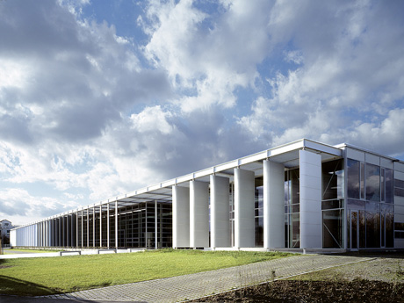

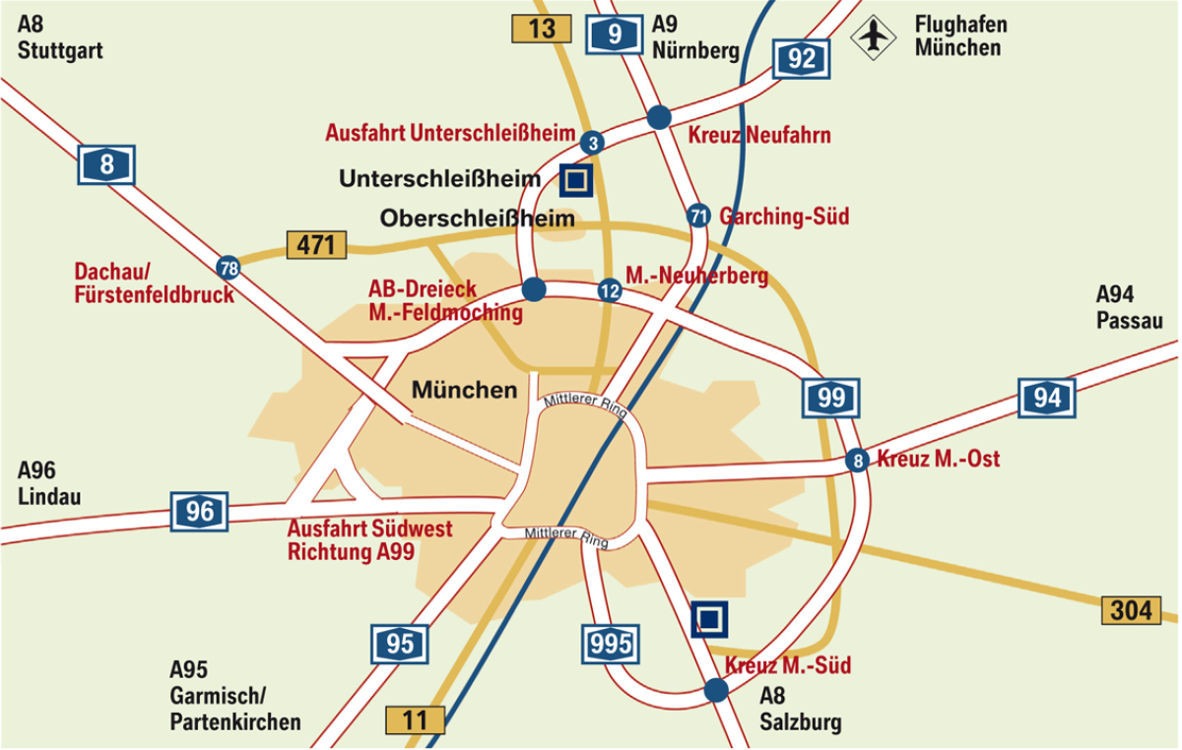
- Public transport

From the airport by train (S-Bahn):
- In the Airport central building (marked with “Z”) take the “S1”-Train -direction Munich - and get off at Unterschleissheim (5th stop, single ticket: 7,50 EURO)
- Then take regional bus 219 B. From the stop Röntgenstrasse it is only a few minutes’ walk to BMW Trainingsakademie or hotel Victor’s or Dolce.
- (Alternatively, take a taxi from the S1-Stop Unterschleissheim)

Alternatively take a taxi from the airport (about 21 km, 20 minutes).
- Hotels

Victor's Residenz-Hotel Munich

Keplerstrasse 14

85716 Unterschleissheim

Tel: +49 (0) 89 / 321 030 9

Fax: +49 (0) 89 / 321 038 99

E-Mail: info.muenchen@victors.de

Website: www.victors.de/deutsch/hotels/hotel/index.php?standort=Muenchen

There is a quota of 20 rooms reserved at this hotel, which is just opposite the Trainingsakademie from the 25th (arrival) until 29th (departure) of June. The reservation quota expires on 15 May 2012.

Single room incl. breakfast: 88 Euro / room / night
Double room incl. breakfast: 118 Euro / room / night

Individual reservation and payment at the hotel is obligatory for the participants.

Another hotel about 400m from the Trainingsakademie is:

Dolce Hotel Munich

Andreas-Danzer-Weg 1

85716 Unterschleissheim

Tel: +49 (0) 89 / 370 530 0

Website: www.dolcemunich.com

Reservation is on your own responsibility
- Restaurants in Unterschleissheim

Sapori

Bezirksstraße 5, Unterschleissheim
Tel: +49 (0) 89 / 321 200 55

www.sapori-m.de

Gasthaus Alter Wirt

Hauptstraße 36, Unterschleissheim
Tel: +49 (0) 89 / 370 734 0
www.alterwirt-ush.de

L´Albatros
Hauptstrasse 40, Unterschleissheim
Tel: +49 (0) 89 / 310 692 6

www.lalbatros.de

Athene
Max-Planck-Strasse 7, Unterschleissheim
Tel: +49 (0) 89 / 310 955 3

www.athene-unterschleissheim.de

Golden Palast
Landshuter Straße 22, Unterschleissheim
Tel: +49 (0) 89 / 370 641 661

www.goldenpalast-ush.de

- Host contact person

Name: Dr Joachim Scholten
E-Mail: Joachim.Scholten@bmw.de
Tel: +49 (0) 89 / 382 323 12

