Standardization Sector
ITU-T Focus Group Technical Report
(04/2024)
ITU-T Focus Group on Testbeds Federations for IMT-2020 and beyond
(FG-TBFxG)
FG-TBFxG-TR-D0.2
Testbeds Federation roadmap
ITUPublications | International Telecommunication Union

Pre-published version
ITU-T FG-TBFxG-TR-D0.2
Testbeds Federation roadmap
Summary
This technical report specifies the index and relation to Technical Specifications and Technical Reports developed by the Focus Group on Testbeds Federation (FG-TBFxG).
Keywords
testbeds federation; roadmap; index; specifications; reports
Note
This is an informative ITU-T publication. Mandatory provisions, such as those found in ITU-T Recommendations, are outside the scope of this publication. This publication should only be referenced bibliographically in ITU-T Recommendations.
Acknowledgement
This Technical Report was prepared under the leadership of Giulio Maggiore (Telecom Italia, Italy), who served as the FG-TBFxG chair.
It is based on the contributions of various authors who participated in the Focus Group activities.
Brecht Vermeulen (Ghent University/imec, Belgium) served as the main Editor of this Technical Report.
Mr Denis Andreev (FG-TBFxG Advisor) and Ms Emmanuelle Labare (FG-TBFxG Assistant) served as the FG-TBFxG Secretariat.
Change Log
This document contains Version 1.0 of the ITU-T FG-TBFxG D0.2 Technical Report “Testbeds Federation roadmap” approved at FG-TBFxG eighth meeting held in Sophia Antipolis, France from 10 to 12 April 2024.

Editor: | Brecht Vermeulen,  Ghent University/imec, Belgium | Email: brecht.vermeulen@UGent.be

© ITU 2024
All rights reserved. No part of this publication may be reproduced, by any means whatsoever, without the prior written permission of ITU.

Table of contents
1. Scope 5
2. References 5
3. Terms and definitions 5
3.1. Terms defined elsewhere 5
3.2. Terms defined in this Technical Report 5
4. Abbreviations 5
5. Reference model and mapping of the FG-TBFxG deliverables 5
6. List of FG-TBFxG deliverables 7

Scope
The scope of this roadmap is to provide an overall index and relation of the Technical Specifications and Technical Reports developed by Focus Group on Testbeds Federations for IMT-2020 and beyond (FG-TBFxG).
The stakeholders are encouraged to arrange a proof-of-concept based on the deliverables approved by FG-TBFxG.

References
[ITU-T Q.4068] Recommendation ITU-T Q.4068 (08/2021), Open application program interfaces (APIs) for interoperable testbed federations.

Terms and definitions

Terms defined elsewhere
This Technical Report uses the following terms defined elsewhere:
3.1.1 Testbed [ITU-T Q.4068]: Platform to realise scientific tests with new technologies on an environment fully controlled by experimenters.

Terms defined in this Technical Report
None

Abbreviations
API | Application Programming Interface
GUI | Graphical User Interface
ONP | Open Networking Platform
Rfp | Reference Point

Reference model and mapping of the FG-TBFxG deliverables
The reference model used by the Focus Group as a basis is defined in Recommendation ITU-T Q.4068. The figure 1 shows the generic federated testbed model [ITU-T Q.4068].
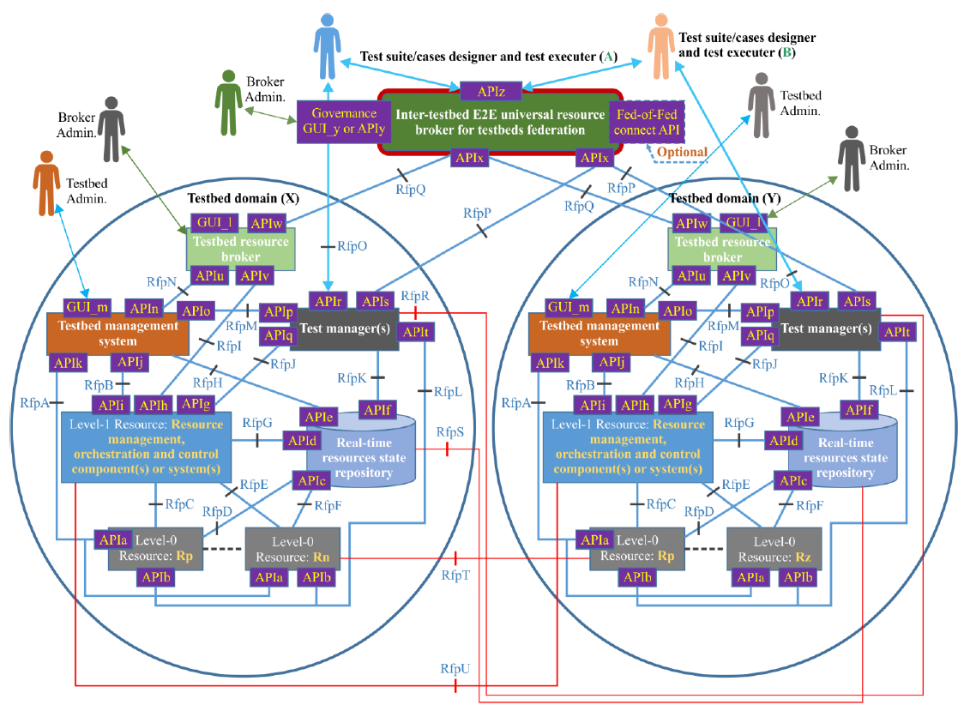
Figure 1: Generic federated testbed model [ITU-T Q.4068]
More specifically the primary objectives and the scope of the deliverables developed by FG-TBFxG focus on the reference points and interfaces relevant for the federated testbeds(the other APIs and reference points are also relevant but were outside of FG-TBFxG scope). Among the requirements for APIs, the FG-TBFxG considered the following reference points: RfpO, RfpP, RfpQ, RfpR, RfpS, RfpT, RfpU, APIr, APIs, APIw, APIx, APIy/GUI_y, APIz.

List of FG-TBFxG deliverables
Deliverable # | Title of output document | Scope
D0.1 | Technical Specification: Federated testbeds taxonomy | This Technical Specification contains all the terms and their definitions used in the context of testbeds federation. It provides the references to the ITU-T Recommendations and other references defining existing terms related to testbeds federation. The sources of the definitions are published ITU-T Recommendations and other standards published by other SDOs. This Technical Specification presents the taxonomy for federated testbeds.
D0.2 | Technical Report: Testbeds Federation roadmap | The scope of this roadmap is to provide an overall index and relation of the Technical Specifications and Technical Reports developed by Focus Group on Testbeds Federations for IMT-2020 and beyond (FG-TBFxG).  The stakeholders are encouraged to arrange a proof-of-concept based on the deliverables approved by FG-TBFxG.
D1.1 | Technical Report: Use Cases for Federated Testbeds and business scenarios | This technical report serves as a guide for extracting target functionality of available use cases on testbeds and its federations and mapping them to different segments (e.g. network segments as MEC, Core, RAN, Transport). The use cases descriptions (e.g. requirements, features, challenges, KPIs, etc.) are used for developing general requirements for APIs to be used in testbed federations.
D2.1 | Technical Specification: User requirements and reference model for Testbed as a Service | This document is the Technical Specification of the user requirements and reference model for Testbed as a Service (TaaS). It defines the specific requirements for TaaS with the user’s perspective. This Technical Specification describes the interconnection of testbeds through the testbed management system. Other aspects like business, polices and monetization are taken into account in this Technical Specification. The Technical Specification is also leveraging the experience and results gained by international research projects in this domain, such as F-Interop, Fed4FIRE+, PAWR, and SLICES.
D2.2 | Technical Specification: Testbed as a Service APIs descriptions and interoperability requirements | This document describes the Testbed as a Service APIs and interoperability requirements. The APIs specified in this document are dedicated exclusively to TaaS. Integration, interoperability and extensibility of the TaaS are also studied in this Technical Specification.
D3.1 | Technical Specification: Evolution of the Testbeds Federations Reference Model | The scope covers the following items that complement topics covered in Recommendation ITU-T Q.4068:  - “APIs Invocations Framework” that clarifies how Generic APIs invoke testbed-specific APIs.  - Workflow Scenario Illustration involving a user accessing and using a testbeds federations ecosystem based on the testbeds federations reference model APIs defined in ITU-T Q.4068 and the extensions listed in FG-TBFxG deliverable D2.2.  - Security Framework that should be applied to the testbeds federations reference model defined in ITU-T Q.4068.  A guide on how to perform instantiations of the testbeds federations reference model (ITU-T Q.4068) in creating testbeds that exhibit the capability to federate with other testbeds due to their conformance to the “Testbed domain concept” prescribed by the reference model defined in ITU-T Q.4068 and to their implementation of APIs for federation of testbeds. Guiding Illustrations on how instantiations of the testbeds federations reference model (ITU-T Q.4068) should be carried out by the global community. It also serves a guide to transforming existing testbeds so that they conform to the testbed domain concept prescribed by the reference model and to their implementation of APIs for federation of testbeds. It serves as a guide to testbeds owners and developers on how to apply the reference model (ITU-T Q.4068) in clean-slate or green field development of testbeds. It also provides testbed developers/implementers with guidance on how transformations or enhancements/evolutions may be pursued by the global community to make existing IMT-2020/5G related testbeds APIs fit or conform to the testbeds federations reference model (ITU-T Q.4068) and its “APIs Invocations Framework”.  - Important Key Performance Indicators (KPIs) for framing and capturing the performance of federated testbeds as individual testbeds and testbeds federations themselves. Several KPI categories are covered in relation to federated testbeds, including availability and resilience KPIs, cost/performance related KPIs, and testbed services KPIs. The KPIs, as outlined in this document, capture the essential features and requirements necessary to make federation of testbeds successful from a technical/utility as well as business/commercial point of view. As such, important KPIs for framing and capturing the performance of federated testbeds and testbeds federations themselves are defined in this document. KPIs specific to federation of testbeds help assess the sustainability of testbeds federations ecosystem from the perspective of technical/utility as well as business/commercial point of view.
D3.2 | Technical Report: Guide on development and maintenance of ONPs (Open Networking Platforms) and federations for IMT-2020 and beyond | The Technical Report provides a guide on how to foster the development and maintenance of multi SDO/Fora standards-driven ONPs for standards-driven innovation, Multi-SDO standards harmonization, and validation of pre-deployment technology use cases in IMT-2020 and beyond, can be achieved.  The Technical Report might be used by deferent stakeholders on the following:  - steps and processes that should be pursued by the ICT industry towards developing and maintaining ONPs for IMT-2020 and beyond, and the use of the testbeds federations reference model defined in [ITU-T Q.4068] and APIs in building ONPs;  - perspectives on how ICT industry can engage SDOs/Fora which may be able to join the ecosystem around establishments, funding, facilitations, exposure of ONPs to key targeted users, and maintenance of ONPs;  - the nature and composition of ONPs required for certain scenarios;  - how to build an ONP and identify barriers to overcome;  - how to enable the federation of multiple ONPs across administrative domains and geographical areas;  - needs for funding schemes and how to leverage existing testbeds, while providing recommendations on how certain types of testbeds for IMT-2020 can be transformed to conform to the reference model for federated testbeds defined in [ITU-T Q.4068].  The stakeholders of this Technical Report are but not limited to Open Source/Hardware projects, SDOs/Fora, R&D projects.
D3.3 | Technical Report: Use of open-source and open hardware projects/products in testbed federations for IMT-2020 and beyond | This Technical Report is to serve as a guide on the use of open-source and open hardware projects/products in testbed federations for IMT-2020/5G and beyond that conform to the reference model for testbeds federations (ITU-T Q.4068) and its APIs.  In applying this technical report in considering open-source and open hardware in building testbeds and implementing the federation of the testbeds, it is also necessary to consider existing testbeds that may be easy to adopt and enhance with the open source and open hardware-based components, while at the same time transforming the existing testbeds to conform to the testbeds federations reference model (ITU-T Q.4068). Use cases (FG-TBFxG deliverable D1.1) for testbeds federations so need to be taken into account when applying the technical report. But not only adopting existing testbeds where possible but also considering applicable test scenarios or test specifications or test plans that may also be available from certain communities such as Standards Development Organizations (SDOs) or Fora.

______________________

