Standardization Sector
ITU-T Focus Group Technical Report
(04/2024)
ITU-T Focus Group on Testbeds Federations for IMT-2020 and beyond
(FG-TBFxG)
FG-TBFxG-TR-D3.2
Guide on development and maintenance of ONPs (Open Networking Platforms) and federations for IMT-2020 and beyond
ITUPublications | International Telecommunication Union

Pre-published version
ITU-T FG-TBFxG-TR-D3.2
Guide on development and maintenance of ONPs (Open Networking Platforms) and federations for IMT-2020 and beyond
Summary
This Technical Report describes the concept of an Open Networking Platform (ONP) as a special testbed built for the purpose of validation of the fusion of Multi-SDO/Fora standards, harmonization, and trials on the use and interworking of the standards from different SDO/Fora that as target for the integration testing and harmonization objectives.
The Technical Report is to provide the definition of steps that can be pursued by the ICT industry towards developing, operationalizing and maintaining ONPs for IMT-2020 and beyond. One of the main aspects of this document is the use of the federated testbeds reference model and APIs (as a metamodel) to build ONPs. The case presented for ONPs in this present document should be treated as a special use case and ICT industry requirement for testbeds federations for addressing as being driven by SDOs/Fora requirements specifically.
The industry (SDOs/Fora, 5G network operators, telecom equipment suppliers, enterprises, SMEs, users) are in dire need of Open Networking Testbeds (ONTs) for use in validation of the fusion of Multi-SDO/Fora standards, harmonization, and trials through industry-Grade proving grounds testbeds. Unfortunately, most of the ONTs available (e.g., for 5G) are mainly suitable for research purposes only and are not built based on standards and for standards validations based on SDOs/Fora standards-driven requirements as drivers for building the testbeds. In some viewpoint the proposed ONTs and approach that encourages standards driven innovations—an approach that enables resultant solutions to be quickly accepted and consumed by the industry than proprietary non-standards driven innovations that often face low intake due to not integrating well with components built based on ICT industry standards. In fact deployments of the evolving and new technologies multiple standards coming from different SDOs/Fora often need to be deployed and made to interwork with each other. Testbeds are a good instrument to deploy and interwork Multi-SDO/Fora standards and validate their interworking so that any problems discovered get to be communicated to the responsible SDOs/Fora that are makers of the standards in order for issues to be resolved and for harmonization of the standards to take place.
What would help to achieve this goal is to create special testbeds in form of ONPs that are built based on the inputs and priorities from the Multi-SDOs/Fora pertaining to the standards that need to be interworked and tested at a particular timeframe of which the SDOs/Fora need feedback from the test activities. ONPs can primarily serve this purpose as instruments for validation of the fusion of Multi-SDO/Fora standards, harmonization, and trials through industry-grade proving grounds testbeds, as standalone and as federated testbeds. Secondly, it can also foster standards driven innovation and help serve as a playground (proving ground) for network operators and enterprises (including small organizations that do not have resources to build own testbeds) to use in trying out new technology pre-deployment real use cases for 5G and beyond, based on ICT industry harmonized and cross-SDO/Fora fusion of standards within the ONP as the fundamental requirement and enabler.
The Technical Report also focuses on:
- The role of testbeds federations reference model based on Recommendation [ITU-T Q.4068] in designing ONPs and federating them as federated testbeds;
- The categories of stakeholders which can benefit from ONPs, with a focus on the benefits to specific stakeholders;
- The methods for maintenance and sustenance of ONPs.
NOTE-1: ONP as a special use case for testbed federations. The work presented in this Technical Report on the concept of ONP and federation of ONPs is an example of use cases for testbeds federations (along with other use cases compiled in FG-TBFxG deliverable [ITU-T FG-TBFxG D1.1]) since the case presented for ONPs as a special case for testbeds and federated testbeds requirement. ONPs should be treated as a special use case and industry requirement for testbeds federations.
NOTE-2: ONP also can be used as a special “Testbed-as -a Service” (TaaS) - a concept described in deliverable [ITU-T FG-TBFxG D2.1]. There is a relationship between TaaS concept and ONP concept as an ONP can be viewed as a special case for TaaS.
NOTE-3: in addition, ONP can benefit from insights derived from IEEE 5G & Beyond Testbed Initiative [b-IEEE-TI] and therefore, there is need for ONP implementers to explore such initiatives in order to derive insights on how such a testbed and processes involved in its build, use and maintenance present certain characteristics of relevance to consider when designing, building and using ONPs and federating them with other types of testbeds.
Keywords
Open Networking Platforms; testbed(s); testbeds federations reference model; proving ground; playground; APIs; testbeds federation; IMT-2020; 5G.
Note
This is an informative ITU-T publication. Mandatory provisions, such as those found in ITU-T Recommendations, are outside the scope of this publication. This publication should only be referenced bibliographically in ITU-T Recommendations.
Acknowledgement
This Technical Report was prepared under the leadership of Giulio Maggiore (Telecom Italia, Italy), Ranganai Chaparadza (Capgemini Engineering, Germany) and Tayeb Ben Meriem (IPv6 Forum, France), who served as the FG-TBFxG chair, FG-TBFxG vice-chair/WG3 chair and FG-TBFxG vice-chair/WG3 vice-chair respectively.
It is based on the contributions of various authors who participated in the Focus Group activities. FG-TBFxG appreciates Dr. Taesang Choi (ETRI, Korea Rep.of) for his inputs to this Technical Report.
Ranganai Chaparadza (Capgemini Engineering, Germany), Tayeb Ben Meriem (IPv6 Forum, France) and Muslim Elkotob (Vodafone, Germany) served as the main Editors of this Technical Report.
Mr Denis Andreev (FG-TBFxG Advisor) and Ms Emmanuelle Labare (FG-TBFxG Assistant) served as the FG-TBFxG Secretariat.
Change Log
This document contains Version 1.0 of the ITU-T FG-TBFxG D3.2 Technical Report “Guide on development and maintenance of ONPs (Open Networking Platforms) and federations for IMT-2020 and beyond” approved at FG-TBFxG eighth meeting held in Sophia Antipolis, France from 10 to 12 April 2024.

Editor: | Ranganai Chaparadza  Capgemini Engineering, Germany | Email: ranganai.chaparadza@capgemini.com
Editor: | Tayeb Ben Meriem  IPv6 Forum, France | Email: tay.b52@yahoo.com
Editor: | Muslim Elkotob  Vodafone, Germany | Email: muslim.elkotob@vodafone.com
© ITU 2024
All rights reserved. No part of this publication may be reproduced, by any means whatsoever, without the prior written permission of ITU.

Table of contents
1. Scope 5
2. References 5
3. Terms and definitions 6
3.1 Terms defined elsewhere 6
3.2 Terms defined here 6
4. Abbreviations 6
5. Introduction 6
6. Concept of ONP, its federations and deployment flavours 7
7. The role of the reference model for testbeds federations on design and implementation of ONPs 11
8. Guide for stakeholders 14
9. Instruments suitable for sustainability in development and maintenance of ONPs 15
Bibliography 16

1. Scope
The Technical Report provides a guide on how to foster the development and maintenance of multi SDO/Fora standards-driven ONPs for standards-driven innovation, Multi-SDO standards harmonization, and validation of pre-deployment technology use cases in IMT-2020 and beyond, can be achieved.
The Technical Report might be used by deferent stakeholders on the following:
- steps and processes that should be pursued by the ICT industry towards developing and maintaining ONPs for IMT-2020 and beyond, and the use of the testbeds federations reference model defined in [ITU-T Q.4068] and APIs in building ONPs;
- perspectives on how ICT industry can engage SDOs/Fora which may be able to join the ecosystem around establishments, funding, facilitations, exposure of ONPs to key targeted users, and maintenance of ONPs;
- the nature and composition of ONPs required for certain scenarios;
- how to build an ONP and identify barriers to overcome;
- how to enable the federation of multiple ONPs across administrative domains and geographical areas;
- needs for funding schemes and how to leverage existing testbeds, while providing recommendations on how certain types of testbeds for IMT-2020 can be transformed to conform to the reference model for federated testbeds defined in [ITU-T Q.4068].
The stakeholders of this Technical Report are but not limited to Open Source/Hardware projects, SDOs/Fora, R&D projects.

2. References
[ITU-T Q.4068] Recommendation ITU-T Q.4068 (2021), Open application program interfaces (APIs) for interoperable testbed federations
[ITU-T FG-TBFxG D1.1] ITU-T FG-TBFxG Technical Report D1.1, Use cases for Federated testbeds and business scenarios
[ITU-T FG-TBFxG D2.1] ITU-T FG-TBFxG Technical Specification D2.1, User requirements and reference model for Testbed as a Service
[ETSI TS103195-2] ETSI TS 103 195-2, v.1.1.1 (2018-05), Autonomic network engineering for the self-managing Future Internet (AFI); Generic Autonomic Network Architecture; Part 2: An Architectural Reference Model for Autonomic Networking, Cognitive Networking and Self-Management;
[ETSI TR 103 747] ETSI TR 103 747, v.1.1.1, (2021-11), Core Network and Interoperability Testing (INT/WG AFI); Federated GANA Knowledge Planes (KPs) for Multi-Domain Autonomic Management & Control (AMC) of Slices in the NGMN® 5G End-to-End Architecture Framework;

3. Terms and definitions

3.1 Terms defined elsewhere
None

3.2 Terms defined here
None

4. Abbreviations
AMC | Autonomic Management and Control
API | Application Programming Interface
CSP | Communications Service Provider
EC | European Commission
GANA | Generic Autonomic Networking Architecture
GENI | Global Environment for Networking Innovations
ETSI | European Telecommunications Standards Institute
FIRE | Future Internet Research and Experimentation
FWA | Fixed Wireless Access
MEC | Multi-Access Edge Computing
MoU | Memorandum of Understanding
ONP | Open Networking Platform
ONT | Open Networking Testbeds
ICT | Information and Communication Technologies
ISV | Independent Software Vendor
IEEE | Institute of Electrical and Electronics Engineers
IoT | Internet of Things
O-RAN | Open Radio Access Network
ONP | Open Networking Platform
PoC | Proof of Concept
RAN | Radio Access Network
SME | Small and Medium Enterprise
SDO | Standards Development Organization
TaaS | Testbed-as-a-Service
TIP | Telecom Infrastructure Project
5GTTI | 5G Trial and Testing Initiative

5. Introduction
This Technical Report was developed to answer the request of the need to develop a guide to serve as an ICT industry recommendations that should be used in fostering the development and maintenance of multi SDO/Fora standards-driven ONPs. At the ITU-ETSI-IEEE Joint SDOs Brainstorming Workshop [b-ITU-Workshop-TBF-2021], a concept of ONPs was presented. In a simplified view, an ONP(s) is to be considered as a layground (proving ground) for trying out new technology pre-deployment real use cases for 5G and beyond, based on ICT industry harmonized and cross-SDO/Fora fusion of standards within the ONP as the fundamental requirement and enabler, while leveraging as much as possible open source and open hardware products to build an ONP.
The Technical Report also defines an ecosystem for establishing and maintaining standards-driven ONPs that are testbeds oriented.

6. Concept of ONP, its federations and deployment flavours
An ONP maybe a single testbed or a group of testbeds that form a unified/integrated system (platform). Therefore, ONP offers an opportunity to existing research-driven testbed platforms to be quickly aligned and onboarded in this operational and standard-based style to deliver immediate benefit to the industry with reduced overhead and reduced long cycle adaption process.
The building of ONPs needs to be driven by the need for Multi-SDO/Fora standards fusion and by the testbeds federation reference model and APIs defined in [ITU-T Q.4068]. Being “Open” in ONP means an easily and openly accessible facility (testbed) to innovators to integrate deployment-ready (production level quality) products and services and also to testers based on a non-restrictive access policy to users (though having clear procedures defined for access and use of the facility), and also enabling open access for voluntary contributors of software and hardware components (mainly open software and open hardware, but also commercial products where necessary) to contribute them into the ONP platform for non-commercial objectives.
The Figure 1 shows an example of processes that can be involved in build, operation and maintenance of an ONP(s) and provides detailed ONP ecosystem (environment) and its interactions with building blocks as key components. It also identifies the main actors and their roles in this ecosystem. To be noted, such an ecosystem is not rigid, rather it is flexible and allow continuously onboarding new actors that bring assets or consume offered services under profitable business model and sharing created value.
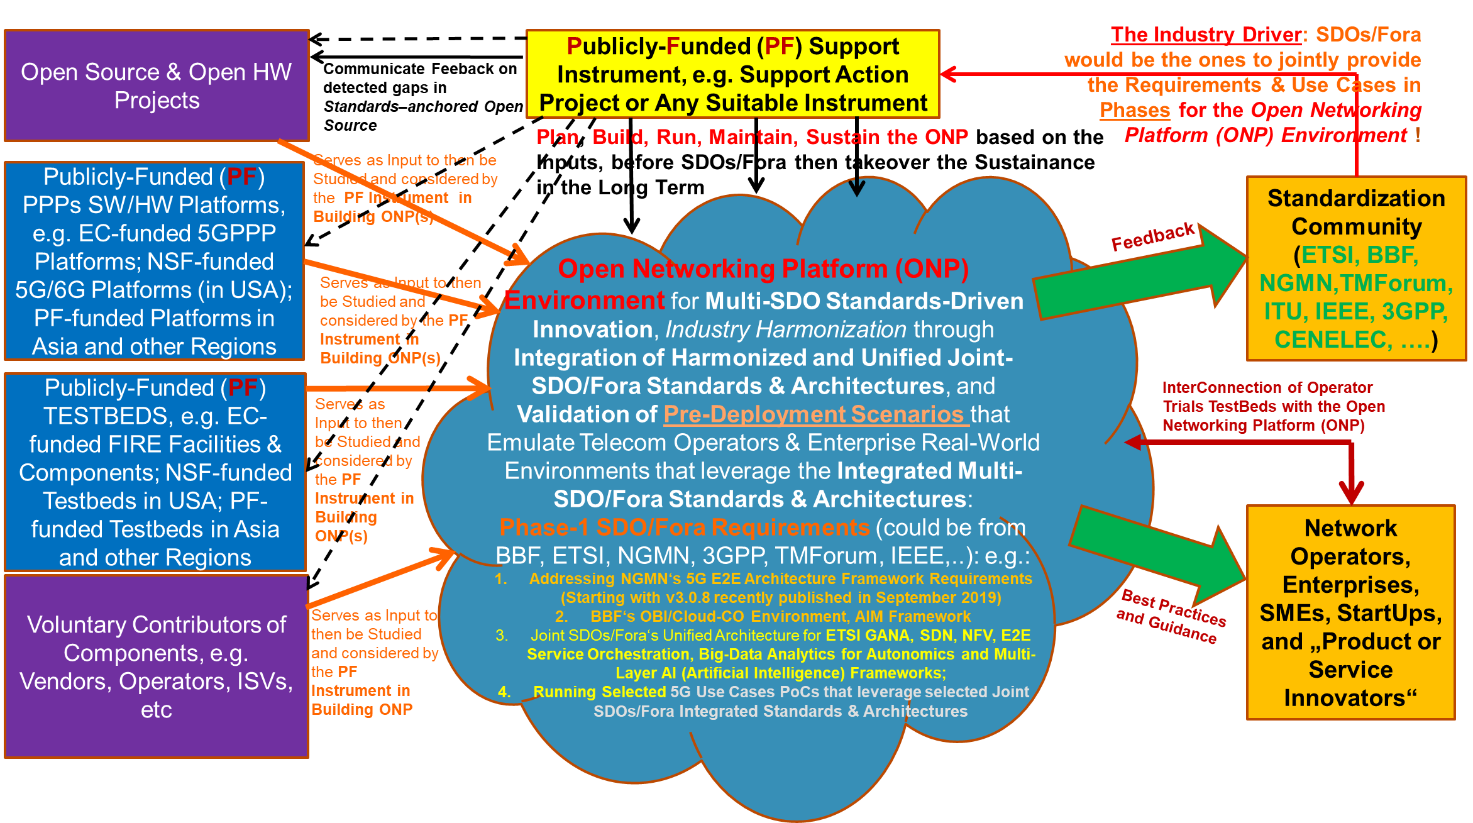
Figure 1: ONP Ecosystem
Table 1 lists and describes the key building blocks of the ONP ecosystem as well as well as involved actors and associated roles within this ONP ecosystem. It also includes “Touch Points” where interactions between building blocks take place for value creation and sharing as well as service delivery and insights exchange.
Table 1: Key building blocks and actors of the ONP ecosystem
ONP building block Name | Description | Actor(s) and their Role(s) | Interface for interactions
Sustainable Instrument (Project)  “Touch Point A” | The following processes are executed: THINK, BUILD, RUN, MAINTAIN, SUSTAIN | Take care of those processes associated with ONP operationalization. Could be the owner of ONP himself but not necessarily | A to C  A to F
ONP Environment  “Touch Point C” | Core component, built under consensus driven Multi SDO approach (Multi-Standards-based packages).  operational test scenarios and test cases  validation framework | Governor / administrator / owner of the ONP (consensus based, or voting model -based approach) | C to F  C to G
Open Source and Open Hardware Projects  “Touch Point D” | Open-source assets | Open-source communities | D to C
Government funded Testbeds (EC, NSF / US, Asia)  “Touch Point X” | Assets of relevance | Project Leaders and Experts | X to C
Voluntary Contributors of components  “Touch Point E” | Components from their product offering Catalogues | Operators, CSPs, ISVs, telecom products and service suppliers, OSS vendors | E to C
Standards in various areas (Networks, Services, Operations & Maintenance, Security, ….)  “Touch Point F” | Standards and other published standardized frameworks. requirements, business scenarios, use cases, and expecting feedbacks on gaps, errors detected during testing and validation process undertaken once ONP instantiated and operationalized | All SDOs / for a (no restriction)  They play role of “prosumers”. They provide Standards and consume results emerged after validation of their standards by ONP | F to C  F to A
Commercial products and services, Testbeds  “Touch Point G” | They expect consuming takeaways, best practices emerging from ONP operationalizing their assets to help them fine tuning their product lines, product offering catalogues | Network Operators, SMEs, enterprises, startups, products and services innovators | G to C

The characteristics of a desirable Multi-SDO/Fora standards-driven ONP are listed and described in Table 2.
Table 2: Key characteristics of the ONP Platform
ONP Platform Characteristic # | Description
ONP Platform Characteristic # 1  “ONP as Manageable & Federable Ecosystem per design” | - An ONP is specially designed and built to be a manageable ecosystem that can be considered as a testbed platform for enabling IMT-2020 and beyond, and can be federated with other platforms of relevant value, e.g. ICT industry-grade IMT-2020 platforms availed by some testbeds owners
ONP Platform Characteristic # 2  “ONP as Neutral Environment” | - An ONP is neutral environment that is meant to be an open integration and test platform that enables to test certain targeted standards fusions and use cases from the SDOs/Fora that provide inputs for the fusion of standards selected for fusion and validations at a particular time.
ONP Platform Characteristic # 3  “ONP is built upon *Glass Box & **Black Box”  *Open source  **Commercial | - An ONP should be built upon open source and open hardware products as much as possible while allowing for open contributions of commercial products when necessary but not necessarily for commercial purposes.
ONP Platform Characteristic # 4  “Interoperability of ONPs” | - An ONP is meant to enable standards interoperability and provide an easily and openly accessible facility to innovators to integrate deployment-ready (production level quality) products and services and to testers
ONP Platform Characteristic # 5  “ONP Governance” | - ONP should be governed by the standards community (SDOs/Fora) & open-source and open hardware projects that get involved.
ONP Platform Characteristic # 6  “ONP as Muti-Stakeholders / Multi-SDO Platform” | - An ONP can be a multi-stakeholder co-funded open platform environment that is built and tested to specifically support the requirements and use cases from collaborating standardization/industry communities (taking a phased approach to accommodating Multi-SDOs/Fora and requirements for Multi-SDO/Fora standards fusions and validations and harmonization)
ONP Platform Characteristic # 7  “ONP as Service Broker to various Stakeholders” | - An ONP helps network operators, telecom equipment suppliers, enterprises, SMEs and startups obtain realistic and practical guidance on how to use the harmonized standards and frameworks, and open platforms (including open source/hardware & commercial platforms) for business innovation, products and services innovation; and guidance on how to create cost effective approaches to creating migration paths from the complex legacy networks
ONP Platform Characteristic # 8  “ ONP as scalable and sustainable Platform” | - An ONP should accommodate more and more use cases for enablers for IMT-2020 and beyond once an ONP has been established.  NOTE: the SDOs/Fora communities attended ITU-ETSI-IEEE Workshop [b-ITU-Workshop-TBF-2021] expressed interest to the ONP platforms
ONP Platform Characteristic # 9  “OBP as Playground to various Stakeholders” | - An ONP is to be considered as a playground (proving ground) for trying out pre-deployment use cases by network operators, enterprises and even SDOs/Fora based on industry harmonized and cross-SDO/Fora interworking standards (in order to implement cross-SDO industry harmonization of Multi-SDO/Fora standards).
ONP Platform Characteristic # 10  “ONP offers “Test as a Service” | - ONPs can benefit even small operators and SMEs that do not have capital to invest in testbeds facilities for standards based products innovations and testing.
ONP Platform Characteristic # 11  “ONP exhibits both Global & Single view” | - A federation of ONPs should be viewed as global testbed(s) platform but single ONP should have a central place (hosted by one of the partners that gets selected for that role),

NOTE-1: This Guide shall also serve to offer Guidance to IMT-2020 and beyond industrial and research projects on how to use the testbeds federations reference model defined in [ITU-T Q.4068] to contribute to the development of the APIs being prescribed by the testbeds reference model, and also contribute to various instantiations cases of the reference model in the development of ONPs.
NOTE-2: The concept of ONPs and the testbeds federations reference model [ITU-T Q.4068] and its APIs have great potential to capitalize on the achievements and investments made by the publicly funded R&D Projects as examples in Europe, USA, Asia and others (e.g., software platforms, such as EC 5GPPP Platforms [b-EC-5GPP]) and Testbeds facilities like Fed4FIRE [b-Fed4Fire], GENI [b-GENI], etc. by fostering the contributions of certain components from such facilities into the building process for ONPs.

7. The role of the reference model for testbeds federations on design and implementation of ONPs
7.1. Overview of the reference model for testbed federation
The Figure 2 shows the generic model for testbeds federations as defined in [ITU-T Q.4068].
The concept of an ONP maps to the testbed domain concept in general, or on a lower level of granularity and abstraction it could represent a composition of a Level-1 resource in combination with an integrated set of Level-0 resources, or it could represent a level-0 resource.
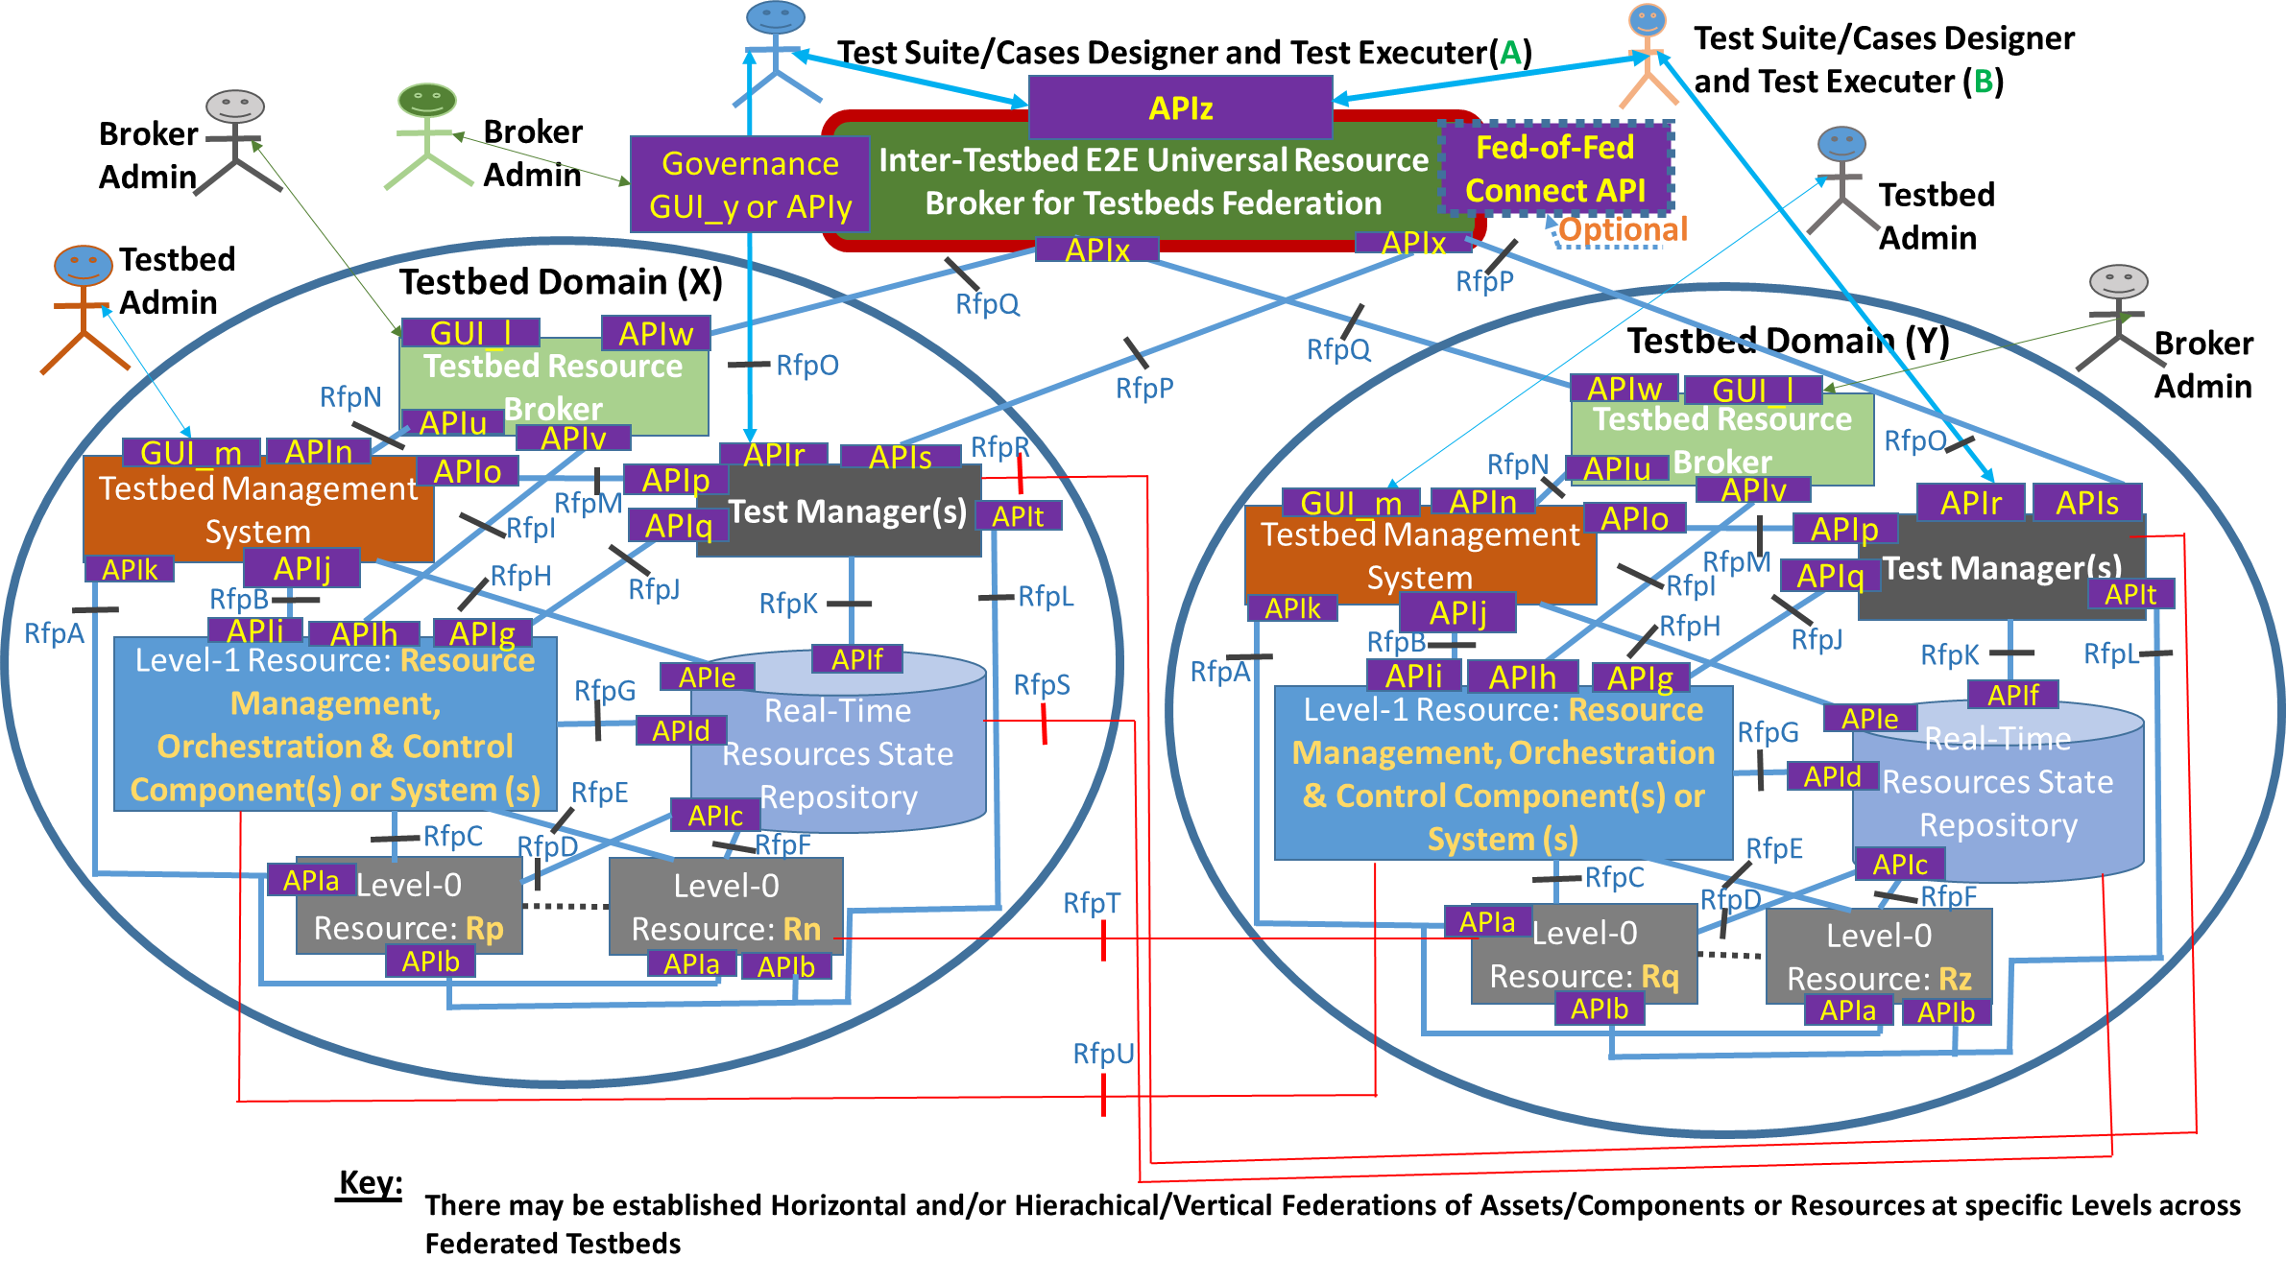
Figure 2: Generic federated testbed model [ref. ITU-T Q.4068]
7.2. Mapping blueprint of ONP with the reference model for testbed federation
The Figure 3 shows a mapping blueprint to compare and contrast of the reference model for testbed federation defined in [ITU-T Q.4068] and ONP Model.
It is built upon various perspectives described in the previous figures and tables.
- Building blocks
- Touch points vs reference points / APIs / GUI
- Actors and their roles
- Characteristics
- Interactions
- Interactions
- Business scenarios
- Use cases
- Business models
- Business canvas
- Others
This mapping blueprint (as a design blueprint) can be instantiated and mechanized onto various real-time implementations for various use cases, needs and purposes.
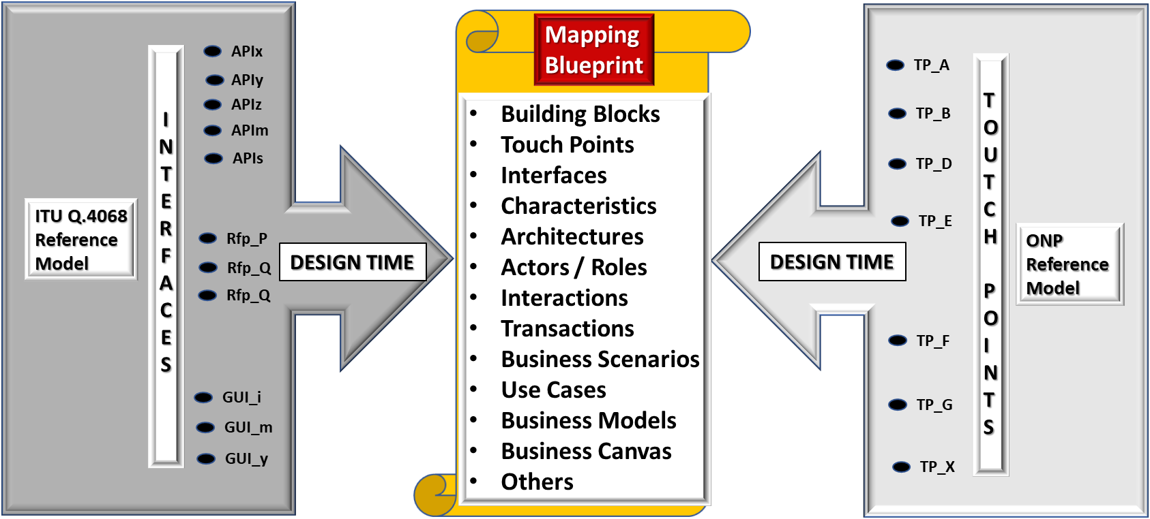
Figure 3: Mapping blueprint on comparison of the reference model for testbed federation [ITU-T Q.4068] with ONP reference model
NOTE 3: To make this mapping blueprint easy to use, it needs to be automated, meaning populated under a “machine readable” language such as JSON. Once operationalized, the outcome can be translated or made available in human understandable language exposing directly interpretable and consumable indicators upon expected purposes. This aspect is useful but goes beyond design blueprint and is not in the scope of this Technical Report. It pertains to tooling development aspect.
7.3. Mapping of the reference model for testbed federation and ONP at stakeholders level (Run-Time)
This mapping aims at leveraging reference model’s [ITU-T Q.4068] well defined stakeholder roles in order to prevent specific definitions of such common roles in the ONP space. ONP can be seen viewed from reference model perspective [ITU-T Q.4068] as a specific reference implementation. The mapping exercise is a pre-requisite to make ONP aligned to maximize the benefit it gets from reference model [ITU-T Q.4068] as standard.
The Figure 4 depicts this mapping of the blueprint at real-time phase.
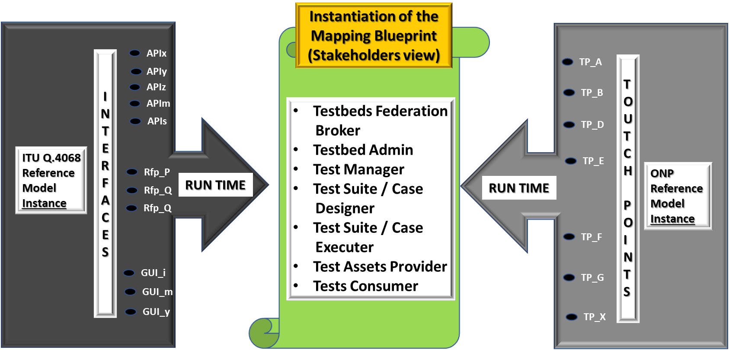
Figure 4: Mapping of the blueprint at real-time phase

8. Guide for stakeholders
8.1. Objectives
This part focuses on selected types of ONPs in order to illustrate how this Technical Report can be exercised and used, e.g., federation of ONPs for converged access networks that include the FWA and cable network architectures and their associated Autonomic Management and Control (AMC) ETSI GANA KP [ETSI TS 103 195-2], as well as MEC edge and transport networks for 5G networks and their associated AMC ETSI GANA KP as illustrated in [ETSI TR 103 747].
The variety of testbeds that can be built as ONPs and get federated means bringing various SDOs/Fora and open source and open hardware projects closer together in standards validation, harmonization and standards-driven innovation, due to ONPs concept and [ITU-T Q.4068].
8.2 Benefits
This Technical Report is bound to offer the following value :
- serve as a guiding blueprint for promoting the idea of developing and maintaining ONPs for 5G and beyond by SDOs/Fora and other stakeholders such as open-source projects and open hardware projects/forums. This also opens opportunities for industry to invest more in open platforms that enable SMEs to enhance their business models by leveraging the ONPs ecosystem or by contributing to the development of the ONPs ecosystem that enables them to innovate, develop and test products and bring them to market much faster due to ONPs.
- serve to offer guidance to research communities and ICT industry working on 5G and beyond on how to use the testbeds reference model [ITU-T Q.4068] to contribute to the development of the APIs being prescribed by the testbeds reference model, and also contribute to various instantiations cases of the reference model in the development of ONPs. The concept of ONPs and the testbeds reference model and its APIs have great potential to capitalize on the achievements and investments made by public funding organizations by fostering the contributions of certain components from such facilities into the building process for ONPs while conforming to the testbeds reference model [ITU-T Q.4068]. That enables interoperability and federation of testbeds of varying types of testbeds for Internet-of-Things (IoT), RAN (Radio Access Network), MEC (Multi-Access Edge Computing), transport network, core network, data centre, industrial Internet, etc.
- help the ICT industry to identify regulatory aspects and security implications of relevance to ONPs federations and engage the relevant stakeholders to address such aspects.
- shed light on roles that research communities and the ICT industry (Solutions vendors/suppliers, CSPs, enterprises, and SDOs/Fora can play in this desired ecosystem on ONPs that should be built based on the reference model [ITU-T Q.4068] now and into the future. The softwarization and disaggregation of ICT networks, 5G and beyond trends benefit from ONP’s concept. Open-source and open hardware projects/forums can help contribute to the building of ONPs testbeds that conform to the testbeds federation reference model and its associated APIs [ITU-T Q.4068]. Open-source and open hardware projects can also make efforts on the instantiations of the testbeds federations reference model in building industry-grade new testbeds and/or perform transformations of existing Testbeds to meet such requirements and provide Testbed-as-a-Service (TaaS) service offering.
NOTE 4: SMEs and Independent Software Vendors (ISVs) can build business models/products based on the concept of ONPs, because there is a huge potential for some SMEs and ISVs to tap into becoming integrators of testbeds ONPs and offer TaaS business model in cases where certain ONPs may require users to pay administrative fee for accessing and using the ONP.

9. Instruments suitable for sustainability in development and maintenance of ONPs
This chapter provides examples of potential instruments suitable for sustainability in development and maintenance of ONPs.
There are two categories of stakeholders who could play some role in providing instruments (that include testbeds facilities and/or funding for testbeds build and maintenance):
- Instruments under leadership and control of institutions-driven stakeholders.
The following Instruments are useful for consideration, but not limited to these. They could be potential candidates in sustaining the ONP the ecosystem:
- Funded Projects (e.g. public funded projects);
- Government funded initiatives (e.g. government funded projects);
- Cross-government/standardization/standards-driven innovation projects
- Neutral SDOs/Fora or other kinds of organizations could play some role. The following bodies seem appropriate as examples:
- TM Forum established a concept named “Catalyst” Instrument (Playground) [b-TMF-Catalyst] that brings together stakeholders (CSPs, ICT solutions suppliers, OSS vendors, ISVs, SMEs, start-ups, consumers, regulators) for trying out and testing products and solutions to help industry to mature new technologies faster;
- ETSI, through its Plug Test instrument [b-ETSI-PT] could also play such a host role of the ONP and its sustainability;
- NGMN, through its 5G Trial and Testing Initiative (5GTTI) projects [b-NGMN-5GTTI-1] assets that could possibly be availed for the use of building and maintaining ONPs. This also enables to take into consideration the experiences and ideas advanced by TTI Projects [b-NGMN-5GTTI-2, b-NGMN-5GTTI-3].
- Joint SDO/Multi-SDO instrument as part of an established MoU (that needs to be created or updated and extended for this ONP sustainability matter).
- ONP implementers could possibly leverage and explore in order to derive insights from the 5G platform built by IEEE 5G testbed initiative [b-IEEE-TI], as the platform supports federation or testbeds interconnect capabilities. Also, IEEE 5G platform [b-IEEE-TI] testbed and processes involved in its build, its use and maintenance present certain characteristics of relevance to consider when designing, building and using ONPs and federating them with other types of testbeds.

Other enablers for sustainability of the ONP ecosystem include having users non-free access for using an ONP facility.

Bibliography
[b-IEEE-TI] https://futurenetworks.ieee.org/topics/5g-testbed
[b-ITU-Workshop-TBF-2021] ITU-ETSI-IEEE Joint SDOs Brainstorming Workshop on Testbeds Federations for 5G and Beyond: Interoperability, Standardization, Reference Model and APIs, https://itu.int/go/BTF4-5G
[b-TMF-Catalyst] https://www.tmforum.org/catalysts/join-in/;
[b-ETSI-PT] https://www.etsi.org/events/plugtests;
[b-NGMN-5GTTI-1] https://www.ngmn.org/wp-content/uploads/221216-Definition-of-the-Testing-Framework-for-the-NGMN-5G-Trial-and-Testing-Initiative-Phase-2_v1.8.pdf;
[b-NGMN-5GTTI-2] https://www.ngmn.org/publications/pre-commercial-networks-trials-major-conclusions-v2.html;
[b-NGMN-5GTTI-3] https://www.ngmn.org/publications/definition-of-the-testing-framework-for-the-ngmn-5g-tti-interoperability.html.
[b-Fed4Fire] Fed4FIRE+ project. https://www.fed4fire.eu/
[b-GENI] GENI website. https://www.geni.net/.
[b-EC-5GPP] EC-5GPP. https://5g-ppp.eu/
_______________________

