INTERNATIONAL TELECOMMUNICATION UNION |  | Joint Coordination Activity  On Accessibility and Human Factors
TELECOMMUNICATION  STANDARDIZATION SECTOR  STUDY PERIOD 2013-2016 |  | Doc 104
English only
Original: English
 | Geneva, 6 November 2013
Source: | Rapporteur Q26/16 a.i.
Title: | Information accessibility work in ISO/IEC (Guide 71 and JTC1 SWG-A)

The following information was provided by Ms Kate Grant (UK) on the updates of ISO/IEC activities on accessibility, in particular ISO/IEC Guide 71 and JTC1 SWG-A.

Update on accessibility-related standardisation activities.

1 Guide 71
The penultimate draft is being reviewed by committee members prior to the meeting in US in December after which it is hoped it will be in shape for submission to SMB and TMB and the final phase of commenting by NBs etc.
The guide details issues to consider in support of accessibility in the standards development process, describes how to apply the guide and considers strategies for addressing user accessibility needs and design considerations in standards.
The guide identifies two complementary approaches to integrating accessibility into a specific standard:
- a system goals approach, which can be used to identify user accessibility needs that can, in turn, be used to identify accessibility-related requirements and recommendations for a standardization project
- a human characteristics approach, which can be used to identify considerations for accessible design that can, in turn, also be used to identify accessibility-related requirements and recommendations for a standardization project
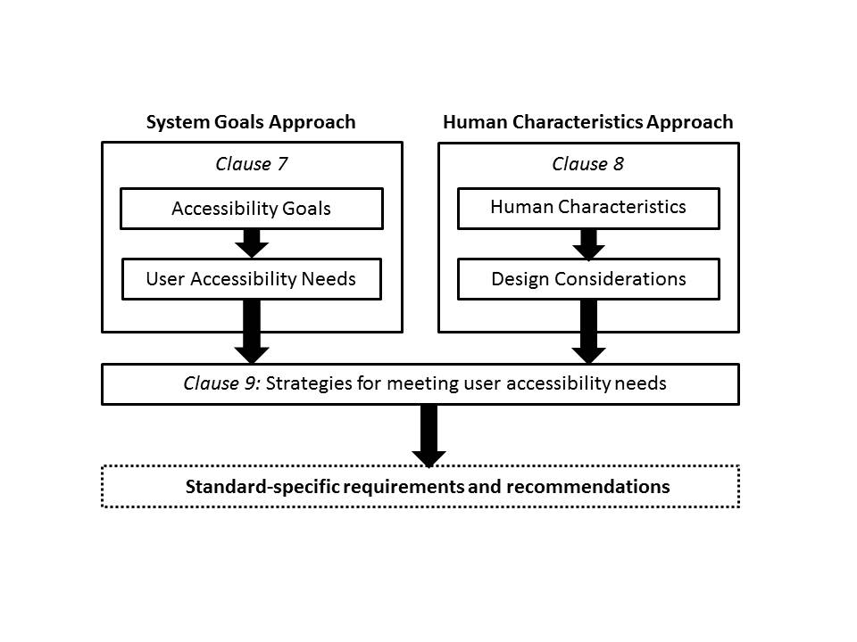
Two approaches to identifying standard-specific requirements and recommendations to address accessibility

1.1 Systems Goal Approach
Eleven goals have been identified and the guide provides an explanation of the goal, the background, a short discussion, a paragraph on applying the goal and lists some typical user accessibility needs associated with the goal.
- Suitability for the widest range of users
- Conformity with user expectations
- Support for individualization
- Approachability
- Perceivability
- Understandability
- Controllability
- Support for usability
- Error tolerance
- Equitable use
- Compatibility with other systems
1.2 Human Characteristics Approach
A separate clause provides information on human abilities and characteristics as well as deduced design considerations. The information on abilities and characteristics is organized according to the human body structures, functions, associated impairments and the consequences for overall functioning in terms of activity limitations and participation restrictions. There are separate clauses on sensory functions, immunological system functions, physical abilities and characteristics, cognitive abilities. Where terminology used to describe human abilities and characteristics is directly from the ICF it is followed by the appropriate ICF reference codes for Human Functions and Human Structures.

1.3 Timetable
Dec 9-11, 2013 6th plenary in Washington, DC
Dec 22, 2013 Finalize Draft
Jan 15, 2014 CD vote/review
Mar 15, 2014 End of CD vote
Mar 16, 2014 Review of comments
Apr 15, 2014 Technical Enquiry vote starts
Aug 15, 2014 Technical Enquiry vote ends
Oct 15, 2014 Publication

2 ISO/IEC JTC 1 SWG-A
The SWG-A has not had a physical meeting, there have been three teleconferences. There are 4 AHGs, the AHG dealing with the revision of the User Needs Summary is currently in hibernation until the work on Guide 71 is completed, since the updating and transition of TR29138 Parts 1 and 3 are awaiting finalisation of Guide 71.The inventory of “Inventory of accessibility and accessibility-related information technology standards and specifications” (formerly TR 29138-2) has been updated and is now available from the ISO Online Browsing Platform (https://www.iso.org/obp/ui/ type “inventory of accessibility” into the search box.. AHG 16’s work has led to some guidance on producing accessible documentation being made available on the SWG-A web site; see http://www.jtc1access.org/guidance.htm . There is now an AHG to look at individualisation/personalisation issues as they relate to accessibility.

3 IEC AAL activities
IEC SMB SG5 was set up to manage and coordinate Ambient Assisted Living (AAL) standardization work in IEC TCs, to establish and achieve interoperability and interconnectivity of AAL systems, and accessible design of their user interface. AAL systems encompass products, services, environments and facilities used to support those whose independence, safety, wellbeing and autonomy are compromised by their physical or mental status.
IEC SMB SG5 ToR are to:
- summarize the status of standardization in this field (inside and outside IEC),
- make an inventory of existing standards and standardization projects in progress,
- engage key stakeholders interested in AAL standardization work in IEC,
- define a structure for the coordination of cross TC/SC work, where required,
- monitor TC/SC work to highlight any overlap of work or potential inconsistencies,
- liaise to ISO, ITU, and other organizations,
- take into consideration the economic aspects of AAL, e.g. by identifying international market potential, identifying market drivers,
- consequently describe the state of the art as well as to identify potential gaps, to address the IEC standardization needed on AAL,
- fill these gaps by drawing a roadmap with a timeline that includes a reference architecture and prospective standardization projects.
At the recent meeting in Tokyo the 3 subteams (status (ie the survey of standardisation activities), modelling and data security) reported and a consolidated activity report was provided to the IEC SMB. It was recommended that the SG should transform into the new IEC structure a “systems evaluation group” and finalise its report covering all the items in the SG5 ToR in 2014. At that time it may become a Systems Committee within IEC.
IEC TC100 began a Stage 0 project to compile use cases for AAL in the area of audio, video and multimedia systems and equipment and produce a TR which includes use cases classified in accordance with SG5 work
  - Communication and social interaction use case scenario (1)
  - Entertainment use case scenarios (4)
  - Daily life support (1).
  - Safety, security and privacy at home Use Case Scenario (0)
  - Monitoring, Healthcare and Wellness Use Case Scenario (3)
  - Active aging use case scenario (2)
  - Mobility use case scenario (1)
The AAL TR is about to be balloted by NCs. (see also presentation to ITU FG/AVA workshop)
As a result of the work in this project team there is likely to be an NP for a functional specification focusing on accessibility and usability of TVs and control of access to, and consumption of, digital content through the TV in close partnership between industry and user groups. Additionally the universAAL framework specification has been processed as a PAS in IEC TC100.
In September the TC100 plenary agreed, in principle, to the establishment of a new TA in IEC TC 100. This TA will focus on AAL, accessibility and user interfaces (within the overall scope of IEC TC 100 - To prepare international publications in the field of audio, video and multimedia systems and equipment.) The scope and ToR will be developed for approval in Seattle AGM meeting May 2014.
________________

