 | INTERNATIONAL TELECOMMUNICATION UNION  TELECOMMUNICATION  STANDARDIZATION SECTOR  STUDY PERIOD 2017-2020 |  |  | JCA-AHF-362
 |  |  |  | JCA-AHF
 |  |  |  | Original: English
Question(s): |  | N/A | Geneva, 11 June 2019
DOCUMENT
Source: |  | Telefon AB - LM Ericsson
Title: |  | Utilising the skills of Deaf interpreters with new technology
Purpose: |  | Information
Contact: |  | Lesley McGilp  Telefon AB - LM Ericsson  Sweden |  |  | Tel: + +44 (0) 208 495 9655  E-mail: lesley.mcgilp@ericsson.com

Keywords: | Interpretation; Deaf; Sign Language
Abstract: | Utilize the skills of Deaf employees to provide live signed news/programming.
Utilising the skills of Deaf interpreters with new tech
Red Bee Media (RBM) is a part of Ericsson Group and is a global broadcast and media service provider. RBM makes every effort to remove barriers to facilitate the full utilization of the skills that our employees can bring to our business. Given our work in Accessibility Services, we focus in particular on ensuring that our Deaf and hard of hearing colleagues can take as full a role as possible in service delivery. Reasonable adjustment is made where possible, and technology is leveraged to create equality in the working environment.
Historically – What do we do

Red Bee Media have provided Sign language Translation for both pre-recorded and live programmes for nearly twenty years, achieving this through utilising the skills of our internal Deaf staff and freelancers; additionally we provide real-time and offline captioning as well as Audio Description services.
Historically we have had to use hearing interpreters consistently throughout the year to deliver the daily signed live news – as a Deaf translator would be unable to follow the programme’s audio independently. This was delivered 5 days a week in the past, 3 years ago we expanded this service to cover 7 days a week. Simultaneously we have provided a real-time captioning service using the respeaking technique, combined with script data from the newsroom computer system.

Utilising our Deaf Translators

Our Deaf Translators are trained appropriately and are formally recognised.

Utilising our Deaf Translators more effectively has always been a goal we’ve worked towards. Using software, Subito our real-time caption creation platform, and Intersub our web caption presentation interface, we can drive forward with our new initiative.

We now have our trailblazing project which sees our Deaf translators providing live signed news.

How this works:

A respeaker delivers a live subtitle feed on air utilising the Subito platform; this creates a datastream that can be distributed in real-time to both the playout facility and end customer, and to the InterSub platform for non-broadcast presentation. InterSub is presented into the signing studio, where the live subtitles are then read from a screen as a form of real-time teleprompter. This is how we receive the source language, which we then put into BSL to deliver the live news.
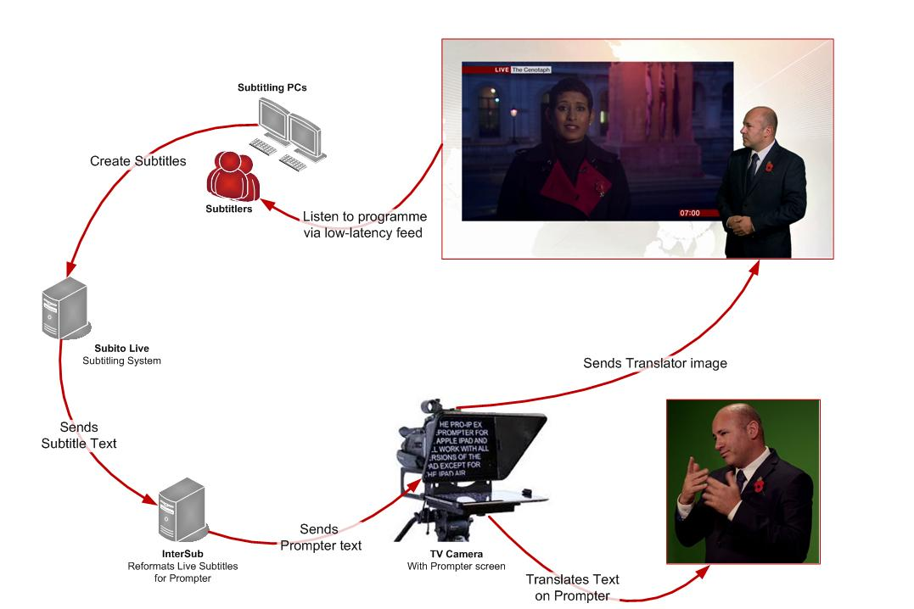

This pilot scheme is in conjunction with the BBC innovation team. On a regular basis, typically at weekends, we deliver 30 minutes of live signed news with a Deaf interpreter.
This is a first, not only in the UK, but globally.
Recruitment is easier - we have a greater diverse pool of talent now and we are not limited by the fact that someone is Deaf or hearing in this domain; it is important to note that skills are the same regardless of whether someone is Deaf or hearing.
We deliver the live signed news with a Deaf interpreter once a month to develop skills and talent. This ultimately promotes a standard of teamwork that poses no barriers.
Our provision of live signing has increased in other areas too. With UK Broadcaster Channel 4, we have delivered the following for the last summer and winter Paralympics:
- Opening/Closing ceremonies for the Paralympics
- A half hour daily Paralympics highlights show.
- The Last Leg – a one hour live satirical comedy show.

Most recently we delivered 7 hours of live signing for C4’s Stand Up to Cancer, where we had seven Deaf interpreters working from InterSub from 7pm-2am.

Here is a short clip showing you our work in action.
https://www.youtube.com/watch?time_continue=119&v=87Y4cnz9Qrk
________________

