|  |  |  |  |  |  |
| --- | --- | --- | --- | --- | --- |
| D:\usr\campos\TSB-Reference\Logos\ITU\sigleITU.gif | INTERNATIONAL TELECOMMUNICATION UNION  **TELECOMMUNICATION STANDARDIZATION SECTOR**  STUDY PERIOD 2017-2020 | | | | JCA-AHF-393 |
|  |  | | | | **JCA-AHF** |
|  |  | | | | **Original: English** |
| **Question(s):** | | N/A | | E-meeting, 21 May 2020 | |
| **DOCUMENT** | | | | | |
| **Source:** | | UK National Association of Deafened People (NADP) | | | |
| **Title:** | | Audio visual accessibility during a world crisis | | | |
| **Purpose:** | | Proposal | | | |
| **Contact:** | | Lidia Best NADP, UK | E-mail: [lidia.best@ties.itu.int](mailto:lidia.best@ties.itu.int) | | |
| **Contact:** | | Andrea Saks G3ict, USA | E-mail: [andrea@andreasaks.onmicrosoft.com](mailto:andrea@andreasaks.onmicrosoft.com) | | |

|  |  |
| --- | --- |
| **Keywords:** | Covid 19; sign language interpretation; audio visual media; captioning; |
| **Abstract:** | This is an overview of lack of accessibility of audio-visual main TV channels during current COVID 19 pandemic. Following the examples presented it is proposed for new work item on functional displays of sign language interpretation and captioning in audio-visual media. The new work item could also have technical requirements of equipment being developed in a way that is compatible with functionality requirement when both sign language interpretation and captioning is used by user. |

**Introduction**

Since global pandemic COVID 19 has started, national briefings and health information to protect health and lives has been an important part of governments strategies. Main broadcasting news and television channels have become an important focus of informing the public on latest restrictions and actions by authorities.

Following reports related to the lack of information in EU countries, I conducted a survey with the EFHOH Facebook group, asking for feedback on the accessibility of government briefings.

While most of countries have been providing sign language interpretation and live captioning, the quality of the provision varied. There are also instances of the lack of accessibility which is worrying. COVID 19 should be treated on par with emergency preparedness. Yet my review of the audio-visual media accessibility with a focus on the main TV broadcasters, which is usually the main way of viewing for older people, has shown that TV accessibility is not taken seriously by broadcasters and government agencies, because it is not being provided at the same level as emergency preparedness. Below are examples:

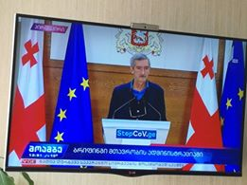 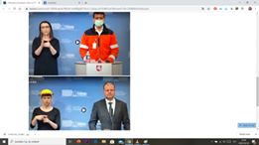

Georgia Lithuania

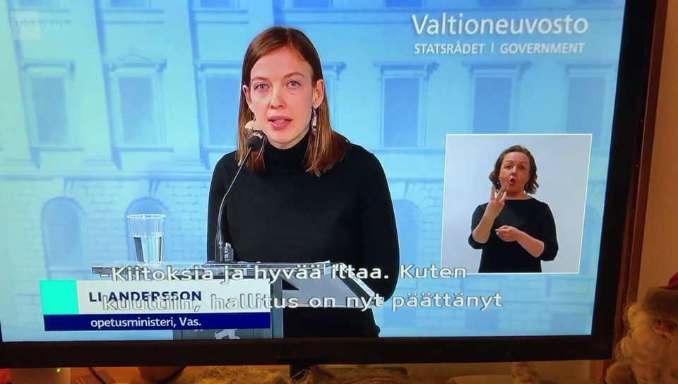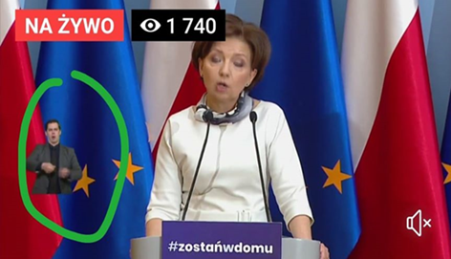

Finland Poland

With the exception of Finland in this selection, the countries above had no live captioning (Georgia, Lithuania, Poland). Example: the broadcast from Poland shows sign language interpretation did not meet recognized functionality requirements due to placement and size of sign language interpreter on the screen during COVID 19 briefings. The European Union of the Deaf has prepared a useful review of sign language access in the EU <https://www.eud.eu/news/covid-19/?fbclid=IwAR0UXz-K619F5iU1lGBq8aNeZJVw_Pwhr42V9gKCYZV7FP_qoFRlu20rOjE>

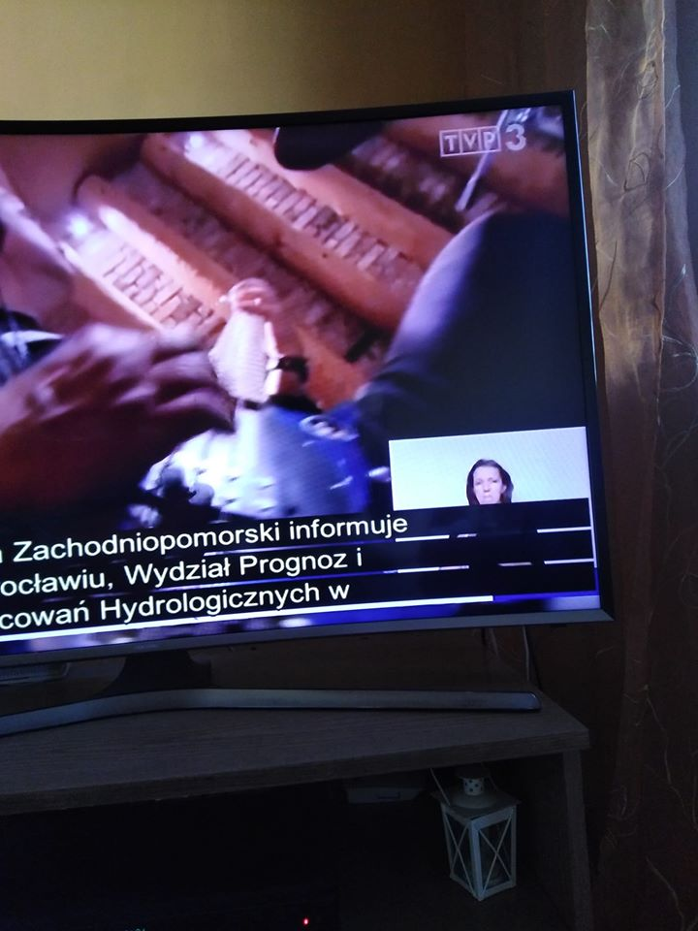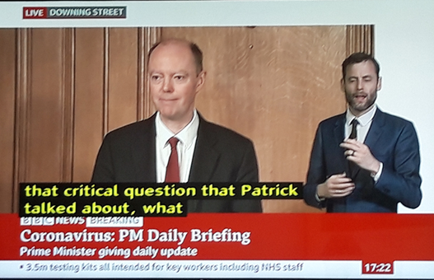

Poland 2 UK/ England

The second selection depicting Polish news shows both live captioning and a sign language presentation and both are displayed simultaneously.by the broadcaster. We see a lack of a shared space principle which is observed by the UK and Finland broadcasters. Here are some examples from Poland and Finland, Please noted that captioning is not easily separated from picture in the correct way as it is in UK. This makes the captioning unreadable and therefor unusable for many viewers who are persons who are deaf, hard of hearing, deafblind and especially those with age related visual impairme

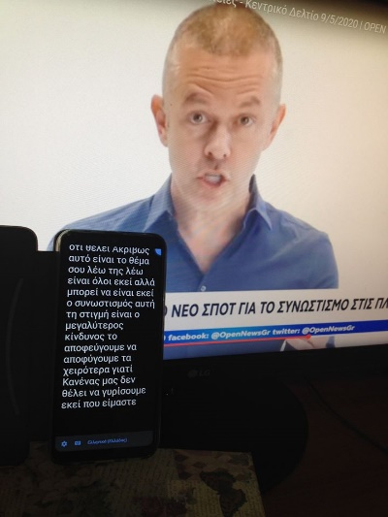Another example is from Greece. While there is sign language interpretation on Greek TV, there are no live captions and viewers who are deaf and hard of hearing who don’t know sign language are left to resort to use speech to text apps installed in their mobile phones. This does not take into account older persons who do not know modern technology. This problem happens not only in Greece but many other countries where persons who are deaf and hard of hearing viewers have complained about the lack of accessibility of both real time captioning and the use of recorded repeated news captioning.

Broadcasters alongside Governments have a duty of care towards all citizens including persons who are deaf or hard of hearing and those with age related disabilities.

Following examples presented, it is proposed to start a new work item on functional requirements for presenting sign language interpretation and captioning in audio-visual media. The new work item need to cover minimum technical requirements to be met while developing equipment which provides accessibility such as decoders, boxes, television sets taking into account shared space for captioning and sign interpretation.

Secondly, a request to send liaison to  IRG-AVA which has many broadcasters in its membership to remind them of their responsibilities and need to consult closely with user representatives to ensure no one is left behind during a crisis.

End

________________