Practical information for the participants
Meeting of the ITU-T SG5 Regional Group for Africa (SG5RG-AFR)
7–9 May 2024
Ouagadougou, Burkina Faso

1 Meeting venue
Ouagadougou, from 7 to 9 May 2024 at the Hotel Silmandé: https://sopatelsilmande.com.

2 Transportation and site information
All the travel information, including flight number, dates and arrival and departure times, must be sent to the local focal point for the meeting organization, WhatsApp: +226 66 52 22 14.
The host will arrange the transportation of the delegates as follows:
– Upon arrival at Ouagadougou International Airport to the designated hotel;
– Upon departure from the designated hotel to Ouagadougou International Airport;
– To and from the meeting venue: From the designated hotels to the meeting venue, and the return trip.
Urban transport:
OKALM Taxis are available in Ouagadougou: reservation through WhatsApp at +226 75 50 50 50.

3 Passports, visas and invitation letters
Citizens of UEMOA countries may cross the border using an identity card or a passport. Non-citizens must obtain a visa from the diplomatic or consular offices of Burkina Faso, or when they enter Burkina Faso (airport/border post).
Burkina Faso has signed specific visa exemption agreements with certain countries. We invite you to enquire with your country’s Department of Foreign Affairs.
The delegates must present an invitation letter, provided by the host, the Ministry of Digital Transformation, Post and Electronic Communication of Burkina Faso, with a full address and clearly indicating the purpose of the trip to Burkina Faso.
To view the visa application procedure, please click on the following link: https://www.visaburkina.bf/les-visas-dentree-au-burkina-faso-le-visa-court-sejour/.
Visa focal point: TRAORE Lionel, e-mail: lionel.traore@tic.gov.bf, WhatsApp: +226 70 50 75 55
The deadline for requesting the visa support letter is 9 April 2024.
VISA REQUEST FORM REQUIREMENTS
- Valid passport
- Request form provided by the competent authority, duly completed, dated and signed
- Recent identity photo, in colour on a white background, in 3.5 x 4.5 cm format
- Document stating the purpose of the trip to Burkina Faso (Invitation letter)
- A health insurance attestation covering the entire period of the trip
- Vaccination certificate
NB: A yellow fever vaccination is obligatory for entry into Burkina Faso. The vaccination certificate must be presented at the airport.

4 Climate – during the month of May
Tropical Climate (Sudan-Sahel region). In Ouagadougou, the minimum temperature varies from 27° in the morning to 38 degrees in the afternoon.

5 Hotels
We recommend that you reserve a room in one of the following hotels:
HOTEL SOPATEL SILMANDE
(Meeting venue, with preferential rates)
ROOM CATEGORY | ROOM RATES
STANDARD ROOM  (Breakfast included) | 85 000 XOF (West African CFA franc)/ 130 euros
Contact: +226 25 35 62 62
E-mail: reservations@sopatelsilmande.com

HOTEL BRAVIA
ROOM CATEGORY | ROOM RATES
STANDARD ROOM | 120 000 XOF/184 euros
BUSINESS ROOM | 130 000 XOF/199 euros
BREAKFAST | 10 000 XOF/15 euros
Contact: +226 77 00 22 26
E-mail: reservation.bravia@braviahotels.com

HOTEL SAMI
ROOM CATEGORY | ROOM RATES
STANDARD ROOM | 55 000 XOF/84 euros
EXECUTIVE ROOM | 65 000 XOF/99 euros
BREAKFAST | 7 500 XOF/12 euros
Contact: +226 25 31 72 78/79/82
E-mail: sph@fasonet.bf

HOTEL PALM BEACH
ROOM CATEGORY | ROOM RATES
SINGLE PRIVILEGE ROOM | 60 000 XOF/92 euros
DOUBLE PRIVILEGE ROOM | 70 000 XOF/106 euros
STANDARD ROOM | 50 000 XOF/76,32 euros
STANDARD DOUBLE ROOM | 60 000 XOF/92 euros
BREAKFAST BUFFET | 5 000 XOF/8 euros
Contact: +226 25 31 09 91
E-mail: resapalmbeach@fasonet.bf
HOTEL RAMADA PEARL
ROOM CATEGORY | ROOM RATES
CLASSIC ROOM | 90 500 XOF/137 euros
TWIN ROOM | 100 500 XOF/153 euros
BREAKFAST BUFFET | 8 000 XOF/12 euros
Contact: +226 25 65 03 00
E-mail: reservation@ramadapearlhotel.com
HOTEL PACIFIC
ROOM CATEGORY | ROOM RATES
STANDARD ROOM | 51 000 XOF/78 euros
DOUBLE ROOM | 58 000 XOF/89 euros
SINGLE PRIVILEGE ROOM | 62 000 XOF/95 euros
DOUBLE PRIVILEGE ROOM | 65 000 XOF/99 euros
SINGLE PREMIUM ROOM | 91 000 XOF/139 euros
DOUBLE PREMIUM ROOM | 94 000 XOF/143 euros
BREAKFAST BUFFET | 5 000 XOF/8 euros
Contact: +226 25 31 30 37
E-mail: hotel.pacific@fasonet.bf
HOTEL SPLENDIDE
ROOM CATEGORY | ROOM RATES
SINGLE ROOM | 75 300 XOF/115 euros
DOUBLE ROOM | 85 300 XOF/130 euros
BREAKFAST | 6 000 XOF/9 euros
Contact: +226 25 31 72 78/79/82
E-mail: sph@fasonet.bf
Please note that the transport will be provided exclusively to and from the above list of recommended hotels, which are located close to the meeting venue.
NB: The recommended hotels are a maximum of 4 to 6 kilometers from the meeting venue.

6 Electricity
In Burkina Faso, C-type C and E-type plugs are used. The network voltage is 220 V with a frequency of 50 Hz.
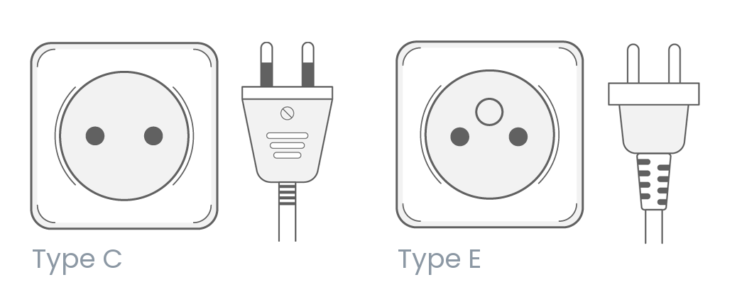

7 Useful information
Euro rate: 1 euro = ~ XOF 655 (West African CFA francs)
US dollar rate: 1 US dollar = ~ XOF 600 (West African CFA francs)
The online exchange rates can be found at: http://www.xe.com/

8 Additional information
Tips: Not obligatory
Time zone: GMT (Africa/Ouagadougou, GMT)
Emergency numbers: In case of emergency, please dial the following numbers according to your needs:
– National Fire Brigade: 18
– Police: 17
– National Monitoring and Alert Centre: 1010
– Yalgado Ouédraogo Teaching Hospital: 50 30 06 43
– International Polyclinic: 50 48 35 28/29
– Genêts Clinic: 80 11 00 88 (Toll free)
– Gendarmerie: 16
The city and the country:
– Official language: French
Other languages (local): Moore, Dioula, Bobos, Gulmancéma, Foulfouldé
– Area: 274 000 km²
– Population: ~ 22 million inhabitants
– Capital: Ouagadougou (around 2.5 million inhabitants)
– Other major cities: Bobo Dioulasso, Koudougou, Ouahigouya, Banfora, Dédougou, Fada N’Gourma
– Religion: Islam (63.8%), Christianity (26.3%) and traditional religions (9%)
– Telephone dialing code for Burkina Faso: + 226
– Monuments and tourist sites to visit:
• National Heroes Monument
• Filmmakers’ Square
• The Sacred Crocodiles of Bazoulé
• The Bangr-Weoogo Urban Park
• The site of the granite sculpture of Laongo
• Ouagadougou Handicraft Village
• The Thomas Sankara Memorial
• The National Museum
– Shopping in Ouagadougou:
In most of the supermarkets, the prices are fixed. Conversely, in the Ouagadougou Central Market, in the shopping malls (handicraft shops) and in the popular markets, the prices are negotiable.
For more information on what you can do in the city, please visit:
– OFFICE NATIONAL DU TOURISME BURKINABE: https://www.ontb.bf/.
– MAIRIE DE OUAGADOUGOU: https://mairie-ouaga.bf/vivre-a-ouaga/culture-tourisme/espace-culturel.

9 Contact persons
OUEDRAOGO Ahmed Noël, country point focal for the organization:
E-mail: noel.ouedraogo@tic.gov.bf
Tel. (WhatsApp): +226 66 52 22 14
______________

