Annex 1
JUNA HUBIN HOTEL
WUXI, CHINA
PRACTICAL INFORMATION FOR PARTICIPANTS
Forum/SG20/JCA-IoT and SC&C

Meeting Venue
China is pleased to welcome participants to the ITU-T Study Group 20 Plenary Meeting and relevant events, which will take place in Wuxi, China from 3 to 13 December 2018. The meetings will be held at JUNA HUBIN HOTEL.
The contact detail of the venue is as follows:
Address : NO.1 Huanhu Road,Wuxi, P.R.China
Phone : +86 510 85101888
Fax : +86 510 81186688
Email : hbhotelsales@sina.com
http://www.wuxihubinhotel.com/
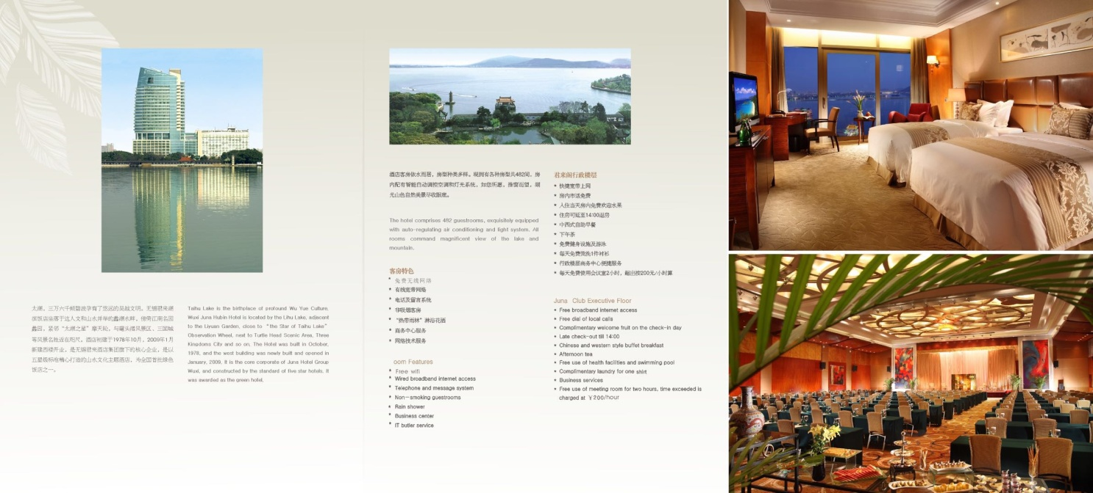
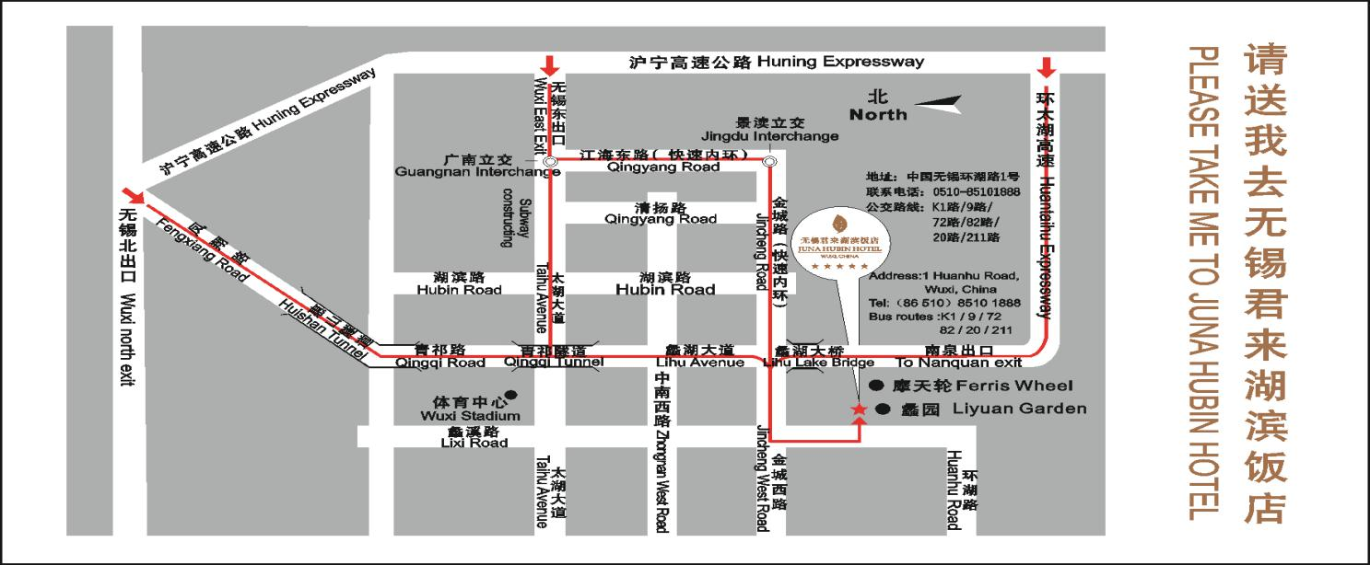

Transportation and site information
Come to the venue:
- From Wuxi Sunan Shuofang International Airport
The venue is about 30km from Wuxi Sunan Shuofang International Airport（无锡苏南硕放国际机场, IATA: WUX, ICAO: ZSWX, http://www.wuxiairport.com/）. It takes about 40 minutes by car to the venue.
- From Wuxi East Railway Station
The venue is about 35km from Wuxi East Railway Station（无锡东站）. It takes about 40 minutes by car to the venue.
- From Wuxi Railway Station
The venue is about 20km from Wuxi Railway Station（无锡站）. It takes about 25 minutes by car to the venue.
- From Shanghai Hongqiao International Airport
The passengers are recommended to transfer by HSR（High Speed Railway）from Shanghai to Wuxi.
Shanghai Hongqiao International Airport （上海虹桥国际机场, IATA: SHA, ICAO: ZSSS, http://www.shanghaiairport.com/index_hqjc.html ）is close to Shanghai Hongqiao Railway station, about 300 meters on foot. The passengers who fly to Shanghai Hongqiao Airport can transfer to:
- Wuxi East Railway Station（无锡东站）. It takes about 40 minutes by HSR.
- Wuxi Railway Station（无锡站）. It takes about 60 minutes by HSR.
- From Shanghai Pudong International Airport
The passengers who fly to Shanghai Pudong International Airport （上海浦东国际机场, IATA: PVG, ICAO: ZSPD, http://www.shanghaiairport.com/index_pdjc.html ）are recommended to firstly transfer to Shanghai Hongqiao Railway Station and then transfer to Wuxi referring to the above routes.
There are 4 options from Shanghai Pudong International Airport to Shanghai Hongqiao Railway Station:
- Option 1: by Metro. Passengers can take metro line 2 from Shanghai Pudong Airport to Hongqiao Railway Station directly. It takes about 90 minutes and ticket fare is RMB 9 Yuan. Operation hour for metro line 2 is from 06:00 to 22:00.
- Option 2: by Taxi. Distance from Shanghai Pudong Airport to Hongqiao Railway Station is 60-70km. Depending on travel itinerary, taxi fare ranges from RMB 220 to 260 Yuan in daytime.
- Option 3: Maglev+Metro. Are you curious about maglev trains and want to experience it yourself? If yes, you can then travel by maglev from Pudong Airport to Longyang Road station and change Metro line 2 to get to Shanghai Hongqiao Railway Station. Inconvenience is that you have to go through a couple of transfers to travel this way.
- Option 4 : by Bus. You can take a bus from Pudong Airport to Hongqiao International Airport, then walking about 10 minutes from Hongqiao Airport to Hongqiao Railway Station.
Public Taxi
- Public Taxi is readily available at all terminals at Wuxi Sunan Shuofang International Airport（无锡苏南硕放国际机场）, Wuxi East Railway Station（无锡东站）and Wuxi Railway Station（无锡站）.
- All taxis are metered. Fares are strictly charged according to the taxi meter.

Passports and Visas
All foreign visitors entering China must possess a valid passport. The passport must be valid for at least six months after arrival date in China. Visitors from countries whose citizens require a visa should at the earliest time and well in advance of travel apply for a visa at a Chinese Embassy. At the following webpage of the Ministry of Foreign Affairs you will find the necessary information, http://cs.mfa.gov.cn/wgrlh/ .
You may need a letter of invitation from the China host, which you will need to present to the Embassy in your area in order to obtain your visa. The visa must be requested as soon as possible and at least four (4) weeks before the start date of the meeting.
For an invitation letter, please see Annex 2.

Climate in December
The climate in Wuxi during December can be summarized as cool and reasonably dry.
December is in the winter in Wuxi and is typically the 3rd coldest month of the year. Daytime maximum temperatures average around a cool 10°C (50°F), whilst at night 1°C (34°F) is normal.
Monthly average values of the temperature and precipitation in Wuxi are given in the table below:
 | December
Average Max Temperature | 11C / 52F
Average Minimum Temperature | 4C / 39F
Sunshine hours | 10 ½ hours
Average Precipitation | 30-35 mm
https://www.travelchinaguide.com/climate/wuxi.htm

Hotels
The rates below include one buffet breakfast and 15% service charge.
Building | Room type | Price(RMB) | Contact persons
Building A | Twin/King | 450 | Mr Xu ChuanQi - Sales manager of WUXI JUNA HUBIN hotel  Email:704571454@qq.com  Mobile:+86 18915359956  Reservation: +86 510 81185688  Ms QIN Yan-- Sales manager of Wuxi JUNA HUBIN hotel  Email:  735192245@qq.com,  QY13093007555@foxmail.com .  Mobile: +86 13093007555  Reservation : +86 510 81185688
Building B | Twin/King | 580
Hotel reservation should be made by participants directly with the contact person as soon as possible, just in case the hotel is full.
Please check cancellation policies with the hotel when booking.

Internet access and wireless coverage
All meeting rooms will have a wireless network with access to the Internet. Every guest room offers a high-speed Internet access for free.

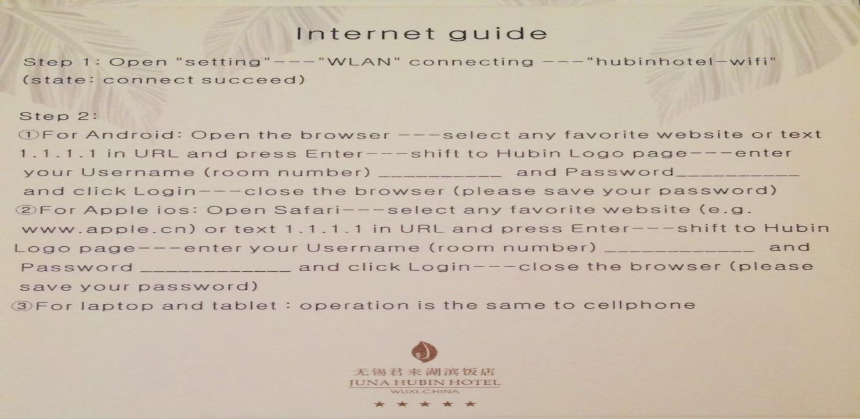

Electricity
In Mainland China, Hong Kong and Macau, the common power voltage is 220 Volt 50 Hz AC.
There are two kinds of sockets widely used in Mainland : type A and type I. The type A can also accept plugs of type C or F, which are commonly seen in most European countries.
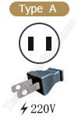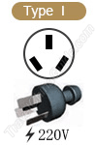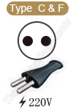

Useful information
Currency exchange
The official currency accepted in China is the Chinese Yuan Renminbi (CNY).

Online exchange rates are shown at:http://www.xe.com/
Exchange rate as of 29 September 2018:
US Dollar: 1$ | 6.73 CNY
Euro: 1€ | 7.66 CNY
Major foreign currencies may be exchanged to Renminbi (CNY) at foreign exchange banks. Official banking hours can vary slightly, but in general are from 8:30 a.m. to 5:30 p.m. Cash can be easily withdrawn 24/7 from the numerous ATMs spread in the city as well as in hotel.
Most hotels, restaurants, railway stations, department stores and shops accept major credit cards (UnionPay, American Express, JCB, MasterCard and VISA). Usually there is a sticker at the entrance indicating which cards are accepted. In particular, the electronic payments such as Alipay and WeChat payment are also supported.
Communication
Hotel | +86 510 85101888
Police | 110
Fire department | 119
Ambulance | 120

About Wuxi
Wuxi -- Pearl of Taihu Lake
Wuxi is a medium-sized city situated beside Taihu Lake in southeast Jiangsu Province. The total area of the city is 4650sq.km, with population 6.5 million by the end of 2017. The Nanjing-Shanghai Railway and the Beijing-Hangzhou Grand Canal pass through the city.
Wuxi is a famous tourist resort. The landscape of the city embodies the beauty of the Yangtze, the Grand Canal, the Taihu Lake, fountains, caves and gardens and is characteristic of the unique features of a water village in southern China. Wuxi takes over the most beautiful corner of the Taihu Lake and on the shore of that Lake are famous parks such as Turtle-head Peninsula Park, Lee Garden, Plun Garden and Xihui Park. Humanitarian and historical relics wellknown at home and abroad are all located in the whole city. To name only a few, they are the Donglin College, Native House of Zhang Wentian, Native House of Xu Xiake, Huangshen Fort, Taibo Temple, Taibo Tomb and Memorial House of Xu Beihong, etc. In recent years, the Wuxi National Tourist Resort Zone at Mashan has completed a few large sightseeing and amusement projects such as the International Angling Center, the Moon-bay Vacational Village and the Linshan Scenic Spot. The Wuxi Taihu Film & Television City has built the theme parks such as “City of Tang Dynasty”, “City of Three Kingdoms” and “City of Water Margin”. In the past few years, Wuxi is evaluated as one of China’s ten major tourist cities, and early this year, it is listed in the first group as one of “ China’s Excellent Tourist Cities” by the National Tourism Administration.

General information
Dinner /American Express/Visa/JCB/Master card service can be used in hotel.
The local time is UTC/GMT +8hours.
Tipping is not customary in China.
Cars in China have their steering wheel on the left. Cars drive on the right.
English is widely understood in major hotels, restaurants, banks and businesses.

Contact persons
ITU Coordinator | Visa request Coordinators
Ms Cristina Bueti  ITU-T  Tel: +41 22 730 6301  Fax: +41 22 730 5853  E-mail: tsbsg20@itu.int | Ms Huan Lin  Email: linhuan@caict.ac.cn  Ms Huimin Li  Email: lihuimin1@caict.ac.cn
 | Hotel reservation Coordinators
Mr Xu ChuanQi - Sales manager of WUXI JUNA HUBIN hotel
Email:704571454@qq.com
Mobile:+86 18915359956
Reservation: +86 510 81185688
Ms QIN yan - Sales manager of WUXI JUNA HUBIN hotel
Mobile: +8613093007555
Email: 735192245@qq.com
Reservation: +86 510 81185688
Annex 2
INVITATION LETTER REQUEST INFORMATION
All foreign visitors entering China must have a valid passport. Visitors from countries whose citizens require a visa should at the earliest time and well in advance of travel apply for a visa at a Chinese Embassy. You may need a letter of invitation from the China host, which you will need to present to the Embassy in your area in order to obtain your visa. The visa must be requested as soon as possible and at least four (4) weeks before the start date of the meeting and obtained from the office (embassy or consulate) representing China in your country or, if there is no such office in your country, from the one that is closest to the country of departure. In order to obtain the invitation letter, please:
- Provide the information below (please fill in electronically)
- Provide the electronic copy of your passport (the name, date of birth, nationality, passport number, valid date of passport, etc. must be seen clearly)
- Send as email attachments to linhuan@caict.ac.cn or lihuimin1@caict.ac.cn. Please mark as reference in the subject “Invitation letter request for ITU-T SG20 meeting” before 10 November 2018:
(It is recommended to scan your passport page and email it to us so that it is discernible and can be used)
Given name (First name)
Family name (Last name)
Gender (Male/Female)
Date of Birth (dd/mm/yy)
Place of Birth
Nationality
Passport number
Passport Issuing Country
Issuing Date (dd/mm/yy)
Expiry Date (dd/mm/yy)
Visa application office:
Embassy of the P.R. China or Consulate General/Consulate/Office?
If you choose Embassy, in which country will you apply for a visa?
If you choose Consulate General/Consulate/Office, in which city will you apply for a visa?
Occupation and Job title
Name of Company/Organization
Company/Organization mailing address |  | Address
 |  | Postal Code
 |  | Country
Telephone number
Fax number
Email address
Your stay in China | Date of arrival (dd/mm/yy)
 | Date of departure (dd/mm/yy)
 | Days of Stay
Reason
Is this your first visit to China? (yes/no)
______________

