**Practical Information for Participants**

**ITU-T Study Group 5“Environment, EMF, Climate Change and Circular Economy” meeting**

**17–21 June 2024**

**Wroclaw University of Science and Technology (WUST), Wroclaw, Poland**

## Venue of event

The Wroclaw University of Science and Technology is pleased to welcome participants in the ITU-T Study Group 5 meeting, which will take place in Wroclaw, Poland from 17–21 June 2024. The meeting will be held at the Bibliotech building of the Wroclaw University of Science and Technology, Wroclaw, Poland. Wireless access to the Internet is provided at the venue at all times.

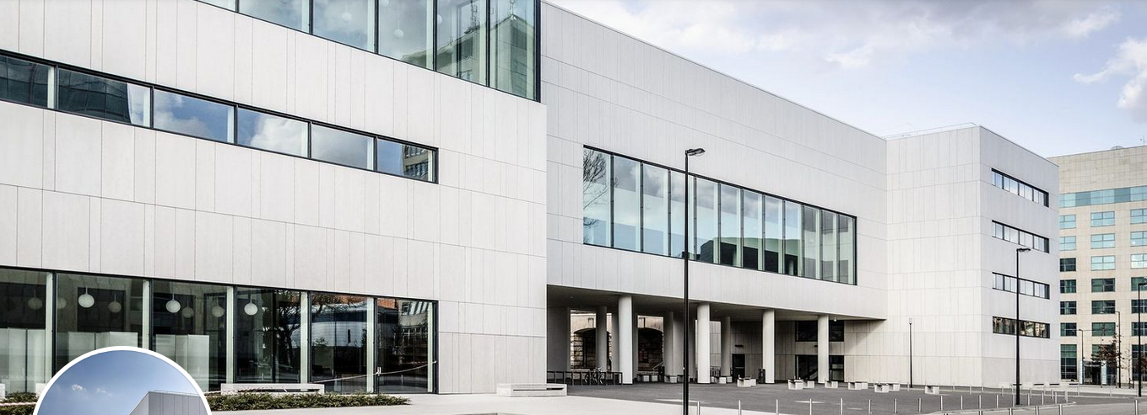

Bibliotech building (D21) in the main campus of the University

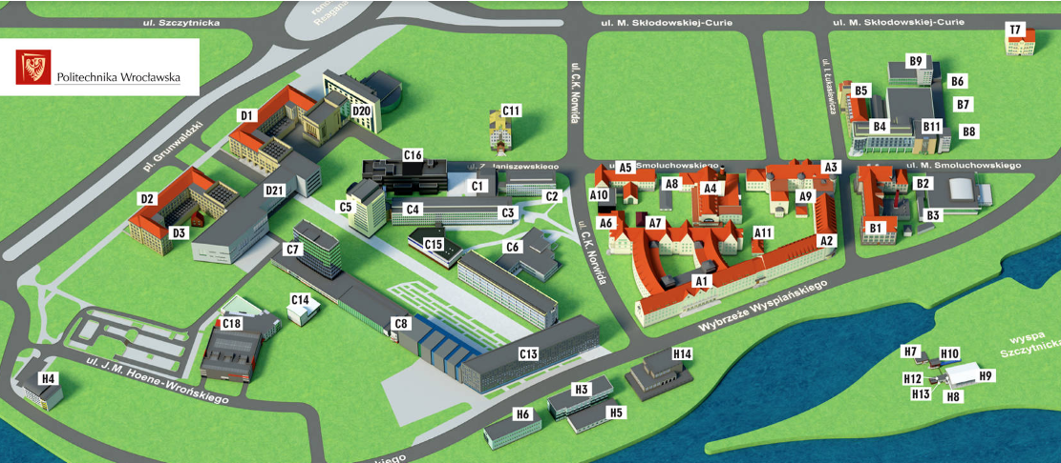

Map of the University main campus

## Access:

Participants are responsible for making their own travel arrangements to and from the airport.

**Address:**

**Bibliotech building of Wroclaw University of Science and Technology**

**In Polish: Biblioteka Główna Politechniki Wrocławskiej**

Wyb. Wyspianskiegi 27 Street, 50–370 Wroclaw, Poland

<https://pwr.edu.pl/en/>

Due to its proximity to Reagan roundabout traffic junction, WUST can be reached easily by car, bus and tram.

Participants arriving at Wrocław Airport (Strachowice) can get to WUST by taxi or public transport.

**By Public transport**

**From Wroclaw Airport** (Strachowice) by bus 106 (during the day) or 206 (during the night) to Wroclaw Main Railway Station and Central Bus Station (taking approx. 40–50 minutes).

From here, change to transportation from Wroclaw Main Railway Station and Central Bus Station towards Most Grunwaldzki or Plac Grunwaldzki.

The University campus can be reached from the Main Railway Station by direct buses 145 and 146, or by trams 2, 4, 12, and 19. Tram and bus stops are located on the left-hand side of the main exit from the railway station hall. The destination stops are Most Grunwaldzki or Plac Grunwaldzki (Reagan roundabound).

**Main Public Transportation** Bus and tram tickets cost PLN 4.60 (approx. 1.1 euros). You can pay on board with Visa or Mastercard.

Wroclaw University of Science and Technology main campus is located near the city centre.

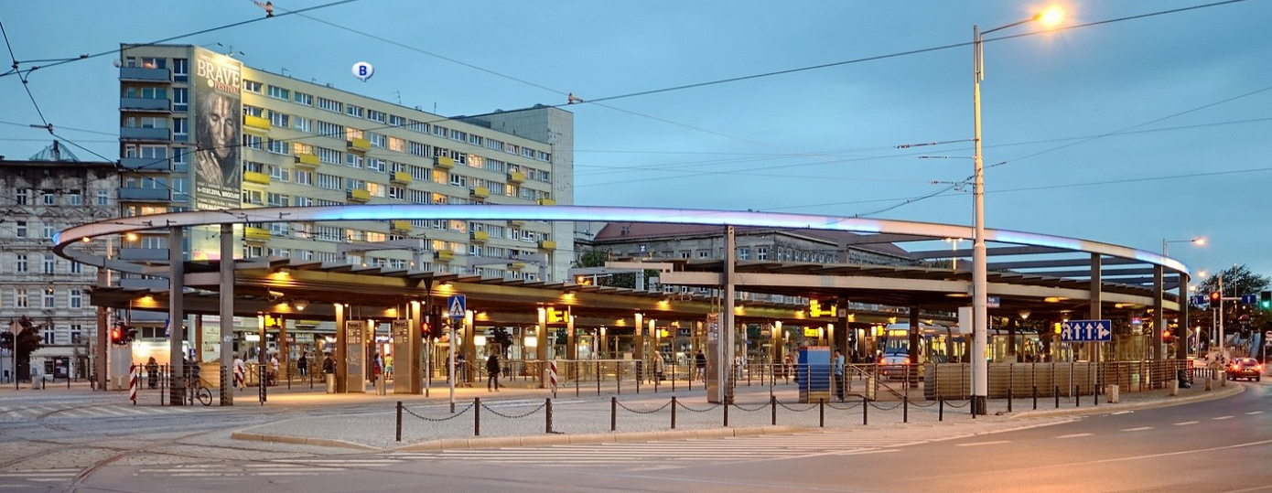

Reagan roundabout traffic junction

**By taxi**

Taxi service can be ordered on demand via an App (such as Uber or Bolt), which costs approx. PLN 55–70.

or

You may consider ordering a taxi in advance via online services such as booking.com

**3. Passports, visas and invitation letters**

Citizens of EU and Schengen countries are required to present a valid passport or identity card.

**The Uniform Schengen Visa** is valid within the Schengen Area and permits its holder to remain in the territory of all of Schengen Area Member Countries for a maximum of 90 days during a 180-day period.

**Schengen Visa with limited territorial validity** is valid within the territory of one or more Schengen Area Member States, but not in all the Schengen Area Member States, and permits its holder to remain in their territories for a maximum of 90 days during a 180-day period.

Participants who require visa must contact the competent diplomatic or consular authorities of Poland and apply for a Schengen short-stay (C) visa at least three weeks prior to their intended date of arrival in Poland. In countries where Poland does not have a diplomatic or consular representation, visa applications can be submitted to the consular authority of a State party to the Schengen Agreement acting on behalf of Poland.

**What documents are needed when applying for a C-type visa?**

► A travel document (passport document), which:

* is valid for at least three months after the planned date for leaving the Schengen Area or, in the event of multiple visits, after the planned date for the last departure from the Schengen Area;
* contains at least two blank pages; and
* was issued during the last ten years.

► A visa application, duly filled in and signed.

► A photograph.

► Proof of visa payment.

► Medical travel insurance, the coverage of which amounts to not less than EUR 30,000, valid throughout the Schengen Area, and covering all expenses that may arise in connection with the need to return for medical reasons, a medical emergency, urgent hospitalization or death.

► Supporting documents:

* A document confirming the purpose of travel.
* A document confirming possession of adequate financial resources to cover the costs of living during the planned stay and to cover the costs of return to the country of origin or residence, or to cover the costs of transit to a third country, which will definitely give permission for entry, or documents confirming that the applicant can legally obtain such funds.
* A document concerning accommodation or possession of financial resources to cover the costs of accommodation.
* A document that permits an assessment to be made as to whether the applicant will leave the Schengen Area before the visa expires.

Supporting documents may be different depending on the country in which a visa application is submitted.

For more details, please contact the relevant consular post.

At the following webpage of the Ministry of Foreign Affairs, you will find the necessary information: https://www.gov.pl/web/diplomacy/visas.

You may need a letter of invitation from the Polish host, which you will have to present to the Embassy in your area in order to obtain your visa.

Upon request, Wroclaw University of Science and Technology will provide participants who are officially registered for the ITU-T SG5 meeting with an invitation letter in order to facilitate the processing of their visa applications. Applicants should address such requests, together with a scanned copy of their passport (pages with photo, date of issue and expiry date), as well as their occupation/position within their company/organization, to Wroclaw University of Science and Technology.

Before requesting the visa letter, experts must ensure that they are fully registered for the ITU‑T SG5 meeting and that their registration request has been approved by the focal point of their organization.

For an invitation letter, please see Annex 1.

## 4. Climate – during June

The average temperature in Wroclaw in June for a typical day ranges from **a high of 24°C (75°F) to a low of 13°C (55°F)**. Some would describe it as mildly cool with a gentle breeze. For comparison, the hottest month in Wroclaw, August, has days with highs of 26°C (79°F) and lows of 15°C (58°F). Wroclaw in June usually receives moderate rainfall, averaging around 81 mm for the month. When we look at the climate data from the last 30 years, we can expect around 14 days of rain.

## 5. Hotels

Booking your accommodation prior to arrival is highly recommended.

The following suggested hotels offer discounts for guests of the Wroclaw University of Science and Technology:

**ACCOR Hotels:**

Booking at: www.accorhotels.com

Company name: POLITECHNIKA WROCLAWSKA

Company identification no.: AS193613

Discount code: PO639PL131

**1. The Bridge Wroclaw - MGallery\*\*\*\*\*** (within walking distance of the meeting venue)

Address: Plac Katedralny 8, 50-329 WROCŁAW

Telephone: (+48) 71 727 31 00

e-mail: [HB1Z1@accor.com](mailto:HB1Z1@accor.com)

<https://www.accorhotels.com/pl/hotel-B1Z1-the-bridge-wroclaw-mgallery/index.shtml>

Discount: 10% off the price of the day

**2.** **Hotel Mercure Wrocław Panorama** **** (near the meeting venue)

Address: Plac Dominikański 1, 50-159 WROCŁAW

Telephone: (+48) 71 323 27 00; fax: (+48) 71 344 36 81

e-mail: [h3374-re@accor.com](mailto:h3374-re@accor.com)

<http://www.mercure.com/pl/hotel-3374-hotel-mercure-wroclaw-centrum/index.shtml>

discount: 10% off the price of the day

**3.** **Novotel Wrocław Centrum \*\*\*\***

Address: ul. Powstańców Śląskich 7, 53-332 WROCŁAW

Telephone: (+48) 71 722 49 00, fax: (+48) 71 722 49 99

e-mail: [ha073@accor.com](mailto:ha073@accor.com)

<https://www.accorhotels.com/gb/hotel-A073-novotel-wroclaw-centrum/index.shtml>

discount: 10% off the price of the day

**4. Sofitel Wroclaw Old Town\*\*\*\*\***

Address: ul. Św. Mikołaja 67, 50-127 WROCŁAW

Telephone: (+48) 71 3588300; fax: (+48) 71 3588301

e-mail: [h5345@sofitel.com](mailto:h5345@sofitel.com)

<https://sofitel.accorhotels.com/gb/hotel-5345-sofitel-wroclaw-old-town/index.shtml#origin=sofitel>

Discount: 10% off the price of the day

**5. IBIS Wroclaw Centrum Hotel \*\*\***

Address: ul. Powstańców Śląskich 7b, 53-332 WROCŁAW

Telephone: (+48) 71 7224950; fax: (+48) 71 7224955

e-mail: [ha074@accor.com](mailto:ha074@accor.com)

<https://www.accorhotels.com/pl/hotel-A074-ibis-wroclaw-centrum/index.shtml#origin=ibis>

Discount: 5% off the price of the day

**Other hotels:**

**6. Hotel HP Park Plaza Wroclaw **** (**[**https://hotelepark.pl/en/wroclaw/contact**](https://hotelepark.pl/en/wroclaw/contact)**)**

Address: ul. Drobnera 11/13, 50-257 WROCŁAW

Discount: 13% off the price published on our website <https://wroclaw.hotelepark.pl/> (Discount code: ITUSG5). The price includes breakfast, free access to a dry sauna, bicycles and the gym.

Telephone ([+48) 71 320 84 50](tel:+48713208450), fax: ([+48) 71 320 84 59](tel:+48713208459)

e-mail: [hpwroclaw@hotelepark.pl](mailto:hpwroclaw@hotelepark.pl)

**7. Hotel im. Jana Pawła II **** (<http://www.hotel-jp2.pl/en/>)**

Address: Św. Idziego 2, 50-328 WROCŁAW

Telephone: (+48) 71 327 14 00, fax: (+48) 71 322 16 92

e-mail: [hotel@hotel-jp2.p](mailto:hotel@hotel-jp2.pl?Subject=Hotel%20im.%20Jana%20Pawła%20II)l

Participants will be able to contact the hotel by telephone or e-mail and will receive a reservation, according to availability, at preferential prices:

PLN 290 / single room with breakfast (per night)

PLN 340 / double room for single use with breakfast (per night) night

PLN 450 / double room with breakfast (per night)

**8. Art hotel \*\*\*\*** [**https://www.arthotel.pl/en/**](https://www.arthotel.pl/en/)

**Address:** Kiełbaśnicza 20, 50-110 WROCŁAW

Telephone: (+48) 71 78 77 100, room reservation (+48) 661 120 300

Discount: 10% off the price of the day (Discount code: ITU SG5)

<https://booking.profitroom.com/pl/arthotel/details/offer/525516?code=ITUSG5&no-cache=&currency=PLN>

The price includes breakfast and Wi-Fi access

e-mail: [rezerwacja@arthotel.pl](mailto:rezerwacja@arthotel.pl)

**Hotel reservations should be made directly by the participants with the hotel contact person or through the website as soon as possible, in order to guarantee availability of hotel rooms.**

Please check the cancellation policies with the hotel when booking.

## 6. Electricity

The standard supply is 230 volts, 50 Hz. A standard voltage converter and an adapter should be sufficient for conversion (type E). Kindly bring the correct adapter for your equipment.

The additional pinhole system is used. Please find below an image for reference:

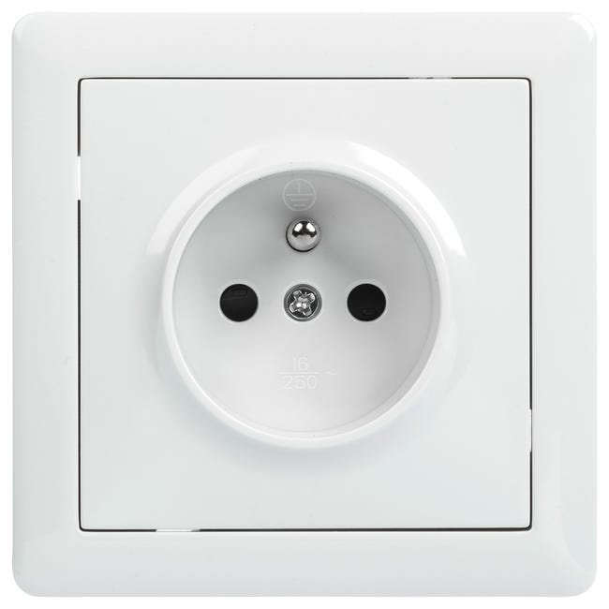

**7. Currency exchange:**

The official currency accepted in Poland is the PLN (Polish złoty) with 1 ZŁOTY = 100 GROSZ (cent). Credit cards are widely accepted across the country, including in restaurants, hotels and shops. Major foreign currencies may be exchanged for PLN at hotels, cantors and foreign exchange banks. Official banking hours can vary slightly, but in general are from 0830 until 1700.

Please bear in mind that banks are generally closed during weekends and holidays.

Cash (PLN) can be withdrawn 24/7 at the numerous ATMs spread across the city.

Most hotels, restaurants, car rental agencies, department stores and shops accept major credit cards (e.g., MasterCard, VISA, American Express, Diners Club). Usually, there is a sticker at the entrance indicating which cards are accepted.

**8. Language:**

Polish is the official language in Poland; however, English is widely understood in major hotels, restaurants, banks and businesses.

**9. Time Zone**:

Polish time is in the Central European Zone (CET), which is one hour ahead of Greenwich, Warsaw / CEST, GMT+1.

## 10. First aid medical service

Pharmacies in Wrocław are usually open between 0800 and 2200 (with some operating 24/7) with a different opening hours schedule for weekends and public holidays. Please visit Google Maps to find the nearest open pharmacy (in Polish: apteka).

Emergency services are available 24/7 at number 112

*Useful Emergency Numbers*

* Police: 997
* European Emergency Number: 112
* Fire Brigade: 998
* First aid/Emergency room and ambulance: 999
* Municipal police: 986

## 11. Additional information

## About Wroclaw:

**Wrocław**, city, capital of [Dolnośląskie](https://www.britannica.com/place/Dolnoslaskie) województwo (province), southwestern [Poland](https://www.britannica.com/place/Poland). It lies along the [Oder River](https://www.britannica.com/place/Oder-River) at its confluence with the Oława, Ślęza, Bystrzyca, and Widawa rivers. A large industrial centre situated in Dolny Śląsk (Lower Silesia), Wrocław is the fourth largest city in Poland. Pop. (2011) 630,131; (2017 est.) 638,586. *Altitude*:Wroclaw is located at 114 m / 370 ft above sea level.

*Transportation*: Public Transportation in Wroclaw consists of buses, trams and night buses. More information is available on the following website:  
[https://mpk.wroc.pl/lang/en#](https://mpk.wroc.pl/lang/en); https://www.wroclaw.pl/en/transport-in-wroclaw.

Wroclaw has one airport, namely Strachowice

**Viewpoints, monuments, restaurants, accommodation, museums:**

## Beauty is another reason why Wrocław is worth visiting! The old town is a maze of cobblestoned alleys. The vibrant central market square is picture-perfect, with colourful buildings painted in bright green, yellow and pink hues. It boasts one of the largest market squares in Europe. Traditional Polish cuisine takes centre stage with a variety of pierogi, from savory to sweet fillings, complemented by potato pancakes and soups. Offering traditional Polish cuisine with a modern twist, visitors appreciate the hearty portions of dishes like bigos, pierogi, and schnitzel in a warm setting. Touristic information on Wroclaw can be found at:

<https://www.wroclawguide.com/en/things-to-do-in-wroclaw/> <https://dolnyslask.travel/?lang=en>

## 12. Contacts

|  |  |
| --- | --- |
| **ITU Coordinator** | **Visa request and Host Country Coordinator** |
| Ms Reyna Úbeda  ITU-T Project Officer  Tel: +41 22 730 5356  Fax: +41 22 730 5853  E-mail: [tsbsg5@itu.int](mailto:tsbsg5@itu.int) | Prof. Ryszard Zielinski  E-mail: [ryszard.zielinski@pwr.edu.pl](mailto:ryszard.zielinski@pwr.edu.pl)  and in copy  Dr Fryderyk Lewicki  Email: [fryderyk.lewicki@orange.com](mailto:fryderyk.lewicki@orange.com) |

**Annex 1**

**INVITATION LETTER REQUEST INFORMATION**

All foreign visitors entering Poland must have a valid passport. Visitors from countries **whose citizens require a visa should, at the earliest opportunity, and well in advance of travel, apply for a visa at a Polish Embassy.**

You may need a letter of invitation from the Polish host, which you will need to present to the Embassy in your area in order to obtain your visa. The visa must be requested as soon as possible from the office (Embassy or Consulate) representing Poland in your country or, if there is no such office in your country, from the one that is closest to your country of departure. In order to obtain the invitation letter, please:

1. Provide the information below (**please fill in electronically**)
2. Provide the electronic copy of your passport (full name, date of birth, nationality, passport number, valid date of passport, etc. must be seen clearly)
3. Send as e-mail attachments to: [ryszard.zielinski@pwr.edu.pl](mailto:ryszard.zielinski@pwr.edu.pl), fryderyk.lewicki@orange.com and copy [tsbsg5@itu.int](mailto:tsbsg5@itu.int). Please mark as reference in the subject **“Invitation letter request for** **ITU‑T SG5 meeting”**.

(It is recommended to scan your passport page and e-mail it to us so that it is discernible and can be used)

|  |  |  |  |
| --- | --- | --- | --- |
| Given name (First name) | | |  |
| Family name (Last name) | | |  |
| Gender (Male/Female) | | |  |
| Date of Birth (dd/mm/yy) | | |  |
| Place of Birth | | |  |
| Nationality | | |  |
| Passport number | | |  |
| Passport Issuing Country | | |  |
| Issuing Date (dd/mm/yy) | | |  |
| Expiry Date (dd/mm/yy) | | |  |
| Visa application office:  Embassy of Poland or Consulate General/Consulate/Office? | | |  |
| If you choose Embassy, in which country will you apply for a visa? | | |  |
| If you choose Consulate General/Consulate/Office, in which city will you apply for a visa? | | |  |
| Occupation and Job title | | |  |
| Name of Company/Organization | | |  |
| Company/Organization mailing address | | Address |  |
| Postal Code |  |
| Country |  |
| Telephone number | | |  |
| Fax number | | |  |
| E-mail address | | |  |
| Your stay in Poland | Date of arrival (dd/mm/yy) | |  |
| Date of departure (dd/mm/yy) | |  |
| Days of Stay | |  |
| Reason for visit | | |  |
| Is this your first visit to Poland? (yes/no) | | |  |

______________