Importance of backhaul in ICT infrastructure

Ministry of Internal Affairs and Communications, Japan, elaborate why we would like to add “backhaul” to ITU contribution to HLPF, and disseminate the importance of this.

Mobile data traffic increased four thousand times between 2005 and 2015, and it did 400 million times between 2000 and 2015. Mobile data traffic will grow at a CAGR of 53 percent between 2015 and 2020, reaching 30.6 EB per month by 2020.

The forecast of world’s Mobile data traffic
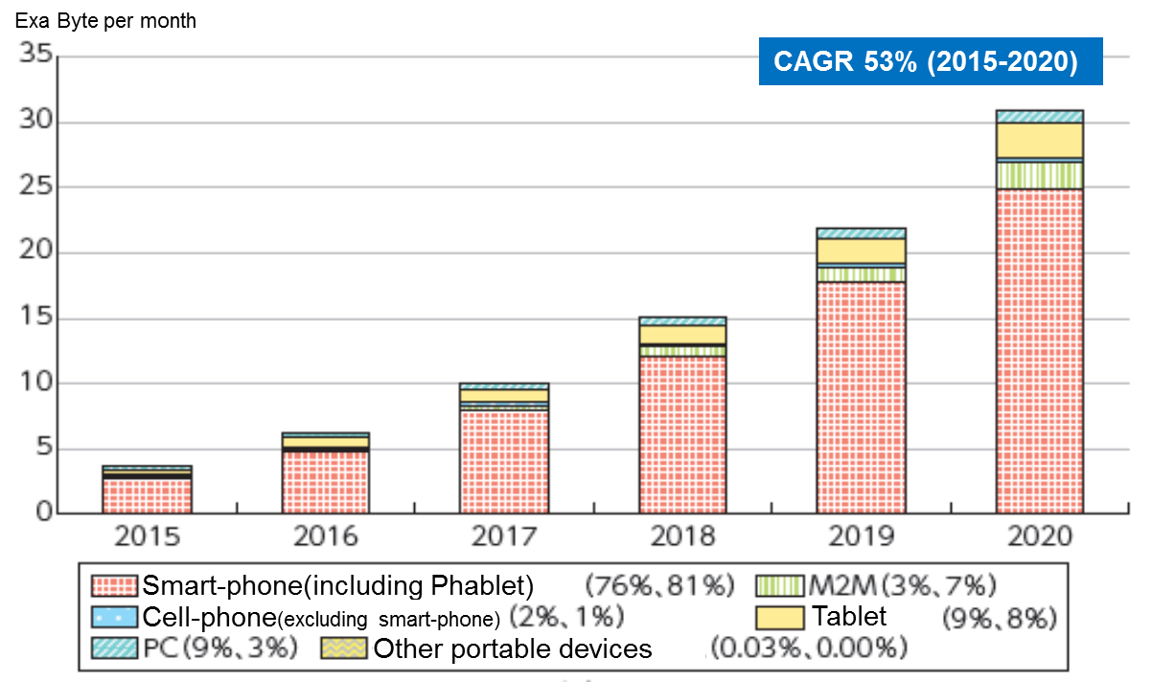
* Each figure in parentheses shows the percentage in 2015 and in 2020.
* CAGR: Compound Annual Growth Rate
* Source: Cisco VNI Mobile, 2016

As shown in the figure above, the amount of mobile data traffic has been increasing every year. When we enter 5G era, further increase of the mobile data traffic will be easily predicted because IoT will be common in our future daily life, such as connected car, robot and censer.
In order for everyone to enjoy the benefits of coming 5G era, it is important to build sustainable, high-quality broadband network.

Today, in case of the development of mobile broadband internet access, more emphasis tends to be placed on improving the speed between the base station and mobile devices, and less on backhaul. However, low-speed backhaul will be the bottleneck in the massive mobile data traffic.
Based on our experience of Japan national broadband plan, we believe that it is essential to prepare high-speed backhaul such as by optical fiber cable so that we can maximize the potential of ICT in the future, and people can access online information, knowledge and services of their choice without any stress.

Increasing the amount of data traffic will lead to new businesses and services, and as a result, employment and wealth will be created and economic growth will be accelerated. In this sense, building mobile broadband network designed with high-speed backhaul is the key factor.

