GUIDELINES FOR SUBMITTING PAPERS

TO THE ITU JOURNAL: ICT DISCOVERIES

First Author¹, Second Author¹, and Third Author²
¹Affilitation A, Country
²Affiliation B, Country

Abstract – This document provides detailed guidelines for submitting papers to the ITU Journal: ICT Discoveries. Papers must be in American English and in black ink. The abstract should appear in italics at the top, about 1.2 cm/0.5 inch below the title and author’s area. Leave two returns between the title and the author’s area, and between the author’s area and the abstract. Separate abstract and keywords with a return. The abstract should normally contain 100 to 150 words, and in no case shall it exceed 200 words. All symbols used in the abstract should be defined, and in the text the first time used. Do not cite references in the abstract.

Keywords – One, two, three, four, five (List approximately five keywords in alphabetical order, separated by commas.)

NOTE: Title, abstract and keywords must be identical to the ones submitted electronically in EDAS – Editor’s Assistant. Use Times New Roman font, 9-point for notes if needed.

1. INTRODUCTION

This document provides detailed guidelines for submitting papers to the ITU Journal: ICT Discoveries. The next sections describe style, fonts and spacing to adopt. Please use this Microsoft Word document as a template. ITU will do the final formatting of your paper.
Please address any enquiries or suggestions about these submitting guidelines to the ITU Editorial Team at journal@itu.int.

2. SUBMITTING YOUR PAPER

Papers must be in English and in black ink. Papers must be submitted electronically on the ITU’s peer review platform, EDAS – Editor’s Assistant, at http://edas.info/23814. If you have used EDAS before, use your login credentials to enter EDAS. If you do not have an EDAS account, click on the "create a new account" link to create a new EDAS account. After creating an account, you can use your newly obtained user name and password to submit a paper.

3. FORMATTING YOUR PAPER

Papers must be within three to eight pages, including abstract, figures, tables and references. Each paper must contain an abstract, which should approximately be between 100-150 words, and in no case, should it exceed 200 words.
All text, illustrations and charts must be kept within a print area of 17.5 cm/6.9 inches wide by 24.4 cm/9.6 inches high. Do not write anything outside the print area. The top margin must be 2.5 cm/1 inch, except for the title page, and the left and right margins must be 1.75 cm/0.69 inch. All text must be in a two-column format. Columns are to be 8.5 cm/3.35 inches wide, with a 0.5 cm/0.20 inch space between them. Text must be fully justified, A4 size (21 cm wide by 29.7 cm long, or 8.27 inches by 11.7 inches). If the last page of your paper is only partially filled, arrange the columns so that they are evenly balanced if possible, rather than having one long column.
The paper proposal must be submitted as an unprotected Adobe’s Portable Document Format (PDF) file. All fonts must be embedded and the file should contain no bookmarks. These are strict publisher’s requirements. Look for information regarding embedding fonts and bookmark generation in the EDAS help page at https://edas.info/listFAQ.php?c=23814.
Ensure that the paper complies with these guidelines. EDAS will reject non-compliant papers.

4. PAGE TITLE SECTION

The paper title (on the first page) should begin 3.5 cm/1.38 inches from the top edge of the page, centered, in uppercase letters, and in Times New Roman font 14-point, bold face type.
The authors’ name(s) and affiliation(s) are to appear below the title in capital and lower case letters, and in Times New Roman font, 11-point.

5. TYPE-STYLE AND FONTS

Main text should appear in Times New Roman font, 11-point. Please use single line spacing, with 0-point before and after.

6. MAJOR HEADINGS

Major headings (for example, “1. Introduction”) should appear in Times New Roman font, 12-point, all capital letters, bold face, at the left margin, with one blank line before, and one blank line after. Use a period (“.”) after the heading number, not a colon.

6.1. Subheadings

Subheadings should appear in Times New Roman font, 11-point, in lower case (initial word capitalized), and in bold face. They should start at the left margin with one blank line before, and one blank line after. Use a period (“.”) after the subheading number, not a colon.

6.1.1. Sub-subheadings

Sub-subheadings, as in this paragraph, are discouraged. However, if you must use them, they should appear in Times New Roman font, 11-point, in lower case (initial word capitalized), and in italics. They should start at the left margin with one blank line before, and one blank line after. Use a period (“.”) after the sub-subheading number, not a colon.

7. IMAGES

Images (figures and tables) can be either color or black and white prints. Images must appear within the designated margins. Caption and number every image. Figure captions must be placed on the bottom, not top, of the figure. Table captions must be located on the top of the table. Use the abbreviation “Fig.” but do not abbreviate “Table”. Figures and tables should be numbered numerically. Figure and table captions and text should appear in Times New Roman font, 10-point, single spaced. Keep titles with images using column breaks if necessary.

Table 1. Use cases, applications, and requirements

 | 5G PPP/  5GMF | METIS | 5G Forum
Use cases and/or applications | Stadium traffic | Stadium traffic;  Traffic efficiency and safety | Smart cars;  Medical  education;  Games;  Disaster relief
Peak data rate | 10 Gb/s | 10 Gb/s | 50 Gb/s
Data volume | 10 Tb/s/km² | 9 Gbytes/h in busy periods;  500 GB/mo  /subscriber | —
Number of devices | 1 M/km² | 300 K/access point | —
End-to-end latency | 5 ms | 5 ms | 1 ms

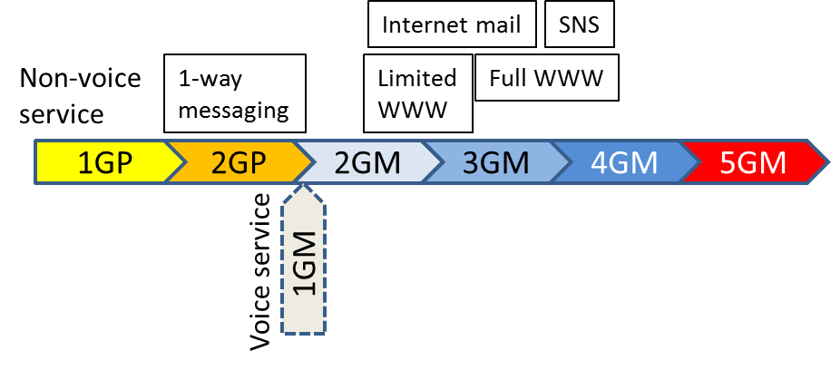
Fig. 1. Evolution of non-voice applications in Japan

8. FOOTNOTES

Use footnotes sparingly (or not at all!) and place them at the bottom of the column on the page on which they are referenced. Use Times New Roman font, 9-point, single-spaced. To help your readers, avoid using footnotes altogether and include necessary peripheral observations in the text (within parentheses, if you prefer, as in this sentence).

9. USING REFERENCES

List and number all bibliographical references at the end of the paper. Use the provided “References” style for formatting it. The references should be numbered in order of appearance in the document. When referring to them in the text, type the corresponding reference number in square brackets as shown at the end of this sentence [1].

10. PAGE NUMBERING

Please number all pages in your paper on the right bottom side.

11. AUTHORING RECOMMENDATIONS

Define abbreviations and acronyms the first time they are used in the text, even if they have already been defined in the abstract. Abbreviations and acronyms should be avoided in the title.
Units should be expressed as much as possible in international units, and a dot (“.”) should be used to express decimal points (not “,”).

12. PUBLICATION POLICY

The ITU Journal supports open access publishing. Published papers will be digital, online and freely downloadable by the wider public with permitted reuse. Permitted third party (re)use will be governed by the Creative Commons user license “Attribution-NonCommercial-NoDerivs 3.0 IGO (CC BY-NC-ND 3.0 IGO)” – available at https://creativecommons.org/licenses/by-nc-nd/3.0/igo/.
Upon acceptance of a paper, the author will be asked to complete and return via email a copyright transfer form duly signed.

13. REVIEW POLICY

All papers are single-blind peer reviewed. Each paper is assigned to at least three reviewers, who will evaluate the paper according to the following criteria:
- Quality: Does it reflect excellence of research work? Is the paper technically sound?
- Originality: Provides a novel approach, does the paper discuss new/unpublished work? Does it contain significant additional material to that already published? (For research articles only, not applicable for review articles, tutorials and case studies)
- Clarity: Does the paper clearly communicate its message? Are tables and graphics clear to read and labeled appropriately?
- Relevance: How well does the content fit the ITU Journal’s objectives (interdisciplinarity, bridge between theory and application, international dialogue) and the issue’s theme? Is the paper of interest to the readership of the ITU Journal?
- References: Does the article contain the appropriate referencing to provide adequate context for the present work?
- Summary of evaluation
- Overall recommendation
- Reviewer familiarity
All papers submitted for review are also scanned for plagiarism. At least two favorable reviews out of three are required for a paper to be considered for publication.

14. CONCLUSION

The main conclusions may be presented in a short final section. This section is not required.

ACKNOWLEDGEMENT

You may list here colleagues, sponsors and financial supporter that you wish to acknowledge. This section is not required.

REFERENCES

[1] A.B. Smith, C.D. Jones, and E.F. Roberts, “Article Title,” Journal, Publisher, Location, pp. 1-10, Date.

[2] S.F. de Campos Neto and W. Karapetian, "Performance of ITU-T G.729 CS-ACELP speech codec with narrowband signals," IEEE Communication Magazine, vol. 35 no. 9, pp. 82-91, 1997.

Footnote to appear at bottom of the column on the page. Use Times New Roman font, 9-point.

