ITU Plenipotentiary Conference 2010 (PP-10)
Guadalajara (Mexico)

PP-10 DOCUMENTS

USER GUIDE
The ITU PP-10 Sync Application has been configured to synchronize PP-10 documents on demand with the ITU FTP server in Geneva and Mexico to your local drive. For first time download, you will need Internet access to launch the ITU PP-10 Sync Application. This will allow you to copy the latest versions of published PP-10 documents: Contributions (C), Administrative Documents (ADM), Information Documents (INF), and Temporary Documents (DT, DL) as soon as they are available.

Step 1: Downloading the ITU PP-10 Sync Application
To download the ITU PP-10 Sync Application, go to:
http://www.itu.int/plenipotentiary/2010/docs-proposals/index.html

Installing the Application
There are two options to install the ITU PP-10 Sync Application as shown below:
- PP10-setup.exe (recommended option) is a PC setup program that installs PP-10 Menu and Sync program to C:\ITU PP-10\. It creates an ITU PP-10 program group and shortcut to desktop.
- To install, run PP10-setup.exe and follow the instructions.

- PP10-unzip.exe - is an alternative PC program in case you do not have the right to install applications on your laptop. It unzips the files to your C: drive, or a drive of your choice, and must be kept on the root folder. It does not create a program group nor shortcut to desktop. To start the program, execute "C:\ITU PP-10\PP10.exe".
- To install, run PP10-unzip.exe. Select drive to unzip (C:\ drive by default) and then click Unzip button.

Step 2: Synchronizing (copying) PP-10 documents

Starting up ITU PP-10 Menu
- Click Start>All Programs> ITU Plenipotentiary Conference 2010>Launch ITU PP-10 Menu.
- If this is your first time to use this application, select "Internet synchronization" or "On-site Synchronization" to download the PP-10 documents.
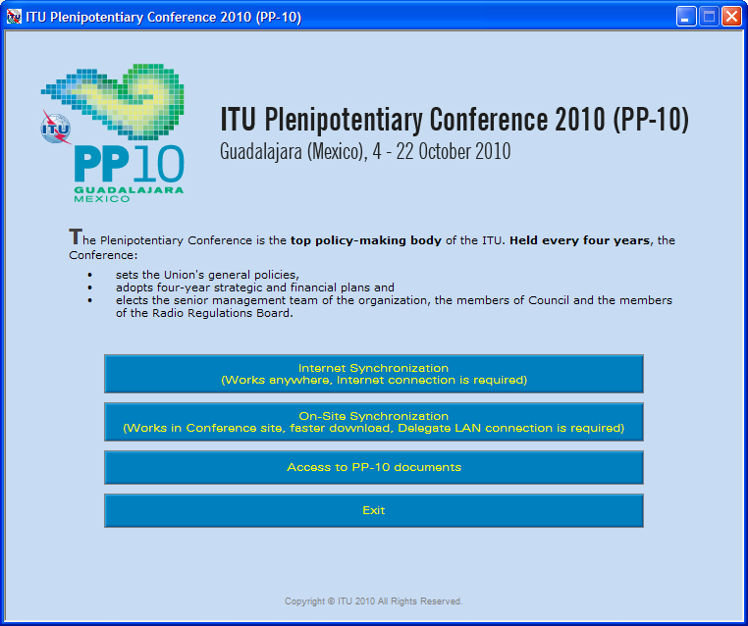

Synchronizing PP-10 documents
- Click on the "Internet Synchronization" button to copy or update your document collection from anywhere with Internet connection (office, home, hotel, internet café, etc.).
OR
- Click on the "On-site Synchronization" button to start to copy or update your document collection if you are located within the PP Conference site. This option will be available during PP-10 and provides faster synchronization as the documents are downloaded from an onsite server.
- Select the language(s) of your choice.
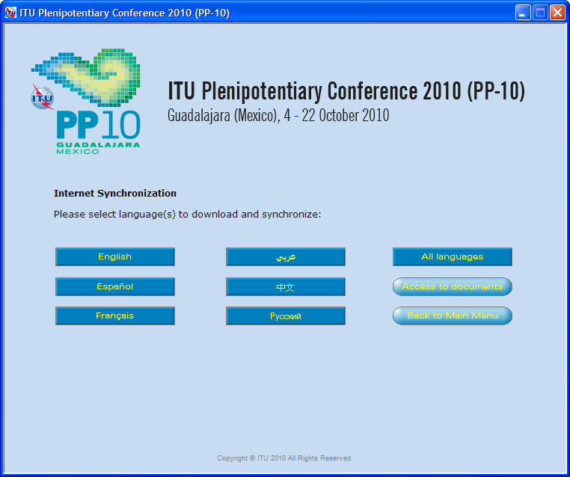
4. Once the language(s) have been selected, synchronization will begin.
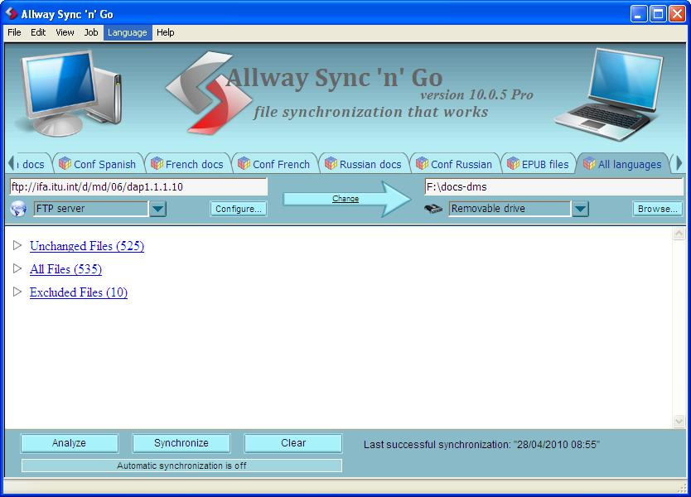
Notes:
- The first time you use it, it may take a few moments to synchronize all the documents posted.
- On-site synchronization may download faster
- Synchronization is set to run on demand; you may launch it at any time from the menu by clicking on the synchronize button, see step 3.
- The application AllwaySync'n'Go will be loaded after selecting a language. After a successful synchronization, it will disappear but if there is a problem, it will remain open and user needs to fix the problem by contacting the ITU Support team.

Step 3: Accessing ITU PP-10 documents
1. Click on “Access to PP-10 documents” to show Documents and proposal page. This menu will give you access to the documents even if you are not connected to the internet.
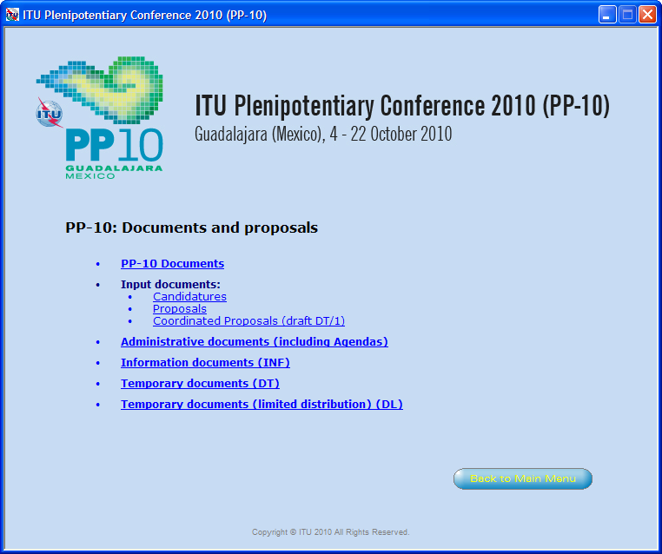
- When you select any option above, it will load the corresponding html page.
Note: A warning such as "To help protect your security, Internet Explorer has restricted from running the scripts or ActiveX controls that could access your computer.", click on it and select "Allow Blocked Content...".
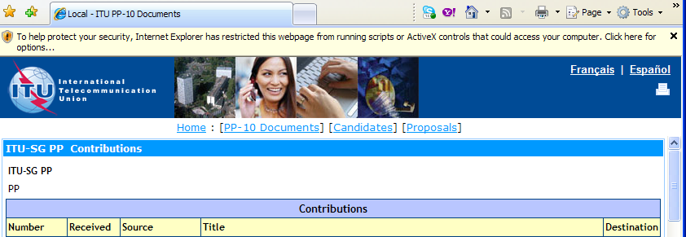

Other issues

Trouble-shooting: First time use
- The first time you use the program, this window may appear. Click on the "Unblock" button to continue. Synchronization is launched. The application synchronizes the USB key by adding the new files or replacing the modified files.
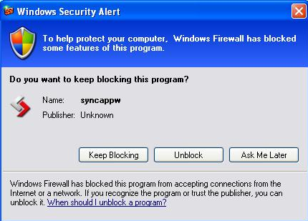
If synchronization of documents does not start
- Go to “Control Panel”
- Run Windows Firewall
- Select the “Exception” tab and enable "Display notification when Windows Firewall blocks a program".
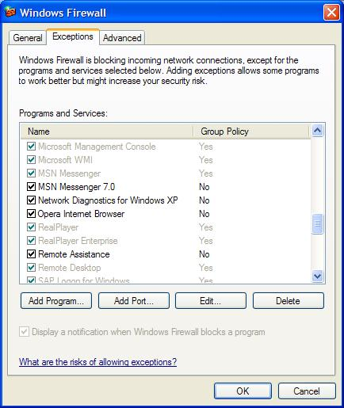
- Closing the application-Click on File/Exit if the application is open.
OR
- Right-click on the AllwaySync icon shown on the toolbar and select Exit if the application is closed.

If you experience problems in accessing or synchronizing documents, please contact our IT assistance and support service by calling the Conference Helpdesk service.
International Telecommunication Union
Place des Nations
CH-1211 GENEVA 20
Switzerland

Annex A: Microsoft Office Compatibility Pack for Word, Excel, and PowerPoint 2007 File Formats for other languages

Important note for users of Office 2003 programs
With the introduction of Office 2007 in ITU, an increasing number of Conference documents will be available in Word 2007 (.docx), Excel 2007 (.xlsx) or PowerPoint 2007 (pptx).
To open and save Word 2007, Excel 2007, and PowerPoint 2007 files in Microsoft Office 2000, Office XP and Office 2003, users should first download and install “Microsoft Office Compatibility Pack for Word, Excel, and PowerPoint File Formats”.
By installing this compatibility pack, you will be able to open, edit, and save files using the file formats in newer versions of Word, Excel, and PowerPoint . The compatibility pack can also be used in conjunction with the Microsoft Office Word Viewer 2003, Excel Viewer 2003, and PowerPoint Viewer 2003 to view files saved in these formats.
To install the compatibility pack, click here. Download the pack by clicking on the “download” button (see below). For other languages, see Annex A.
http://www.microsoft.com/downloads/details.aspx?FamilyID=4f97ab2f-1f7d-49a3-9123-7ca3e703b916&displaylang=en
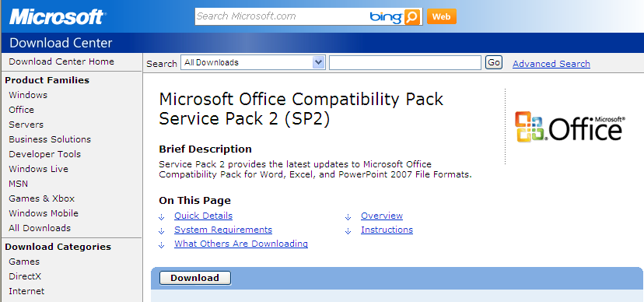

In case of difficulty, please contact the Conference Service Desk.

French:
http://www.microsoft.com/downloads/details.aspx?FamilyID=4f97ab2f-1f7d-49a3-9123-7ca3e703b916&displaylang=fr
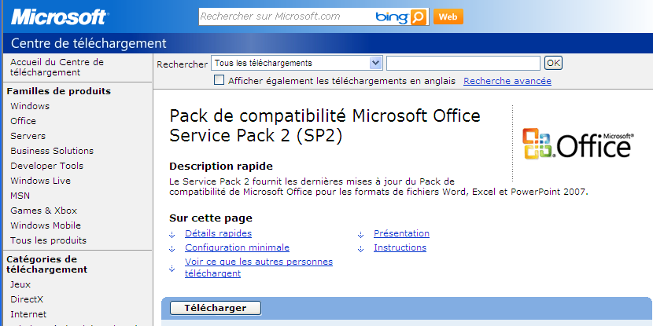

Spanish:
http://www.microsoft.com/downloads/details.aspx?FamilyID=4f97ab2f-1f7d-49a3-9123-7ca3e703b916&displaylang=es
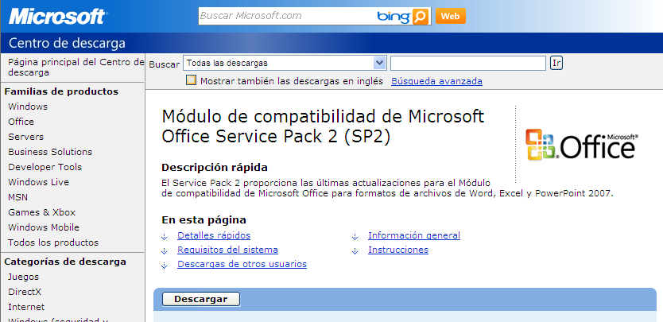

Arabic:
http://www.microsoft.com/downloads/details.aspx?FamilyID=4f97ab2f-1f7d-49a3-9123-7ca3e703b916&displaylang=ar
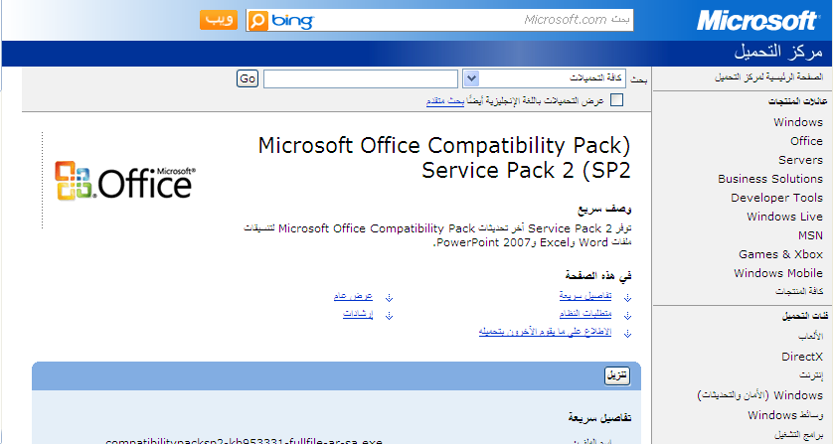

Russian:
http://www.microsoft.com/downloads/details.aspx?FamilyID=4f97ab2f-1f7d-49a3-9123-7ca3e703b916&displaylang=ru
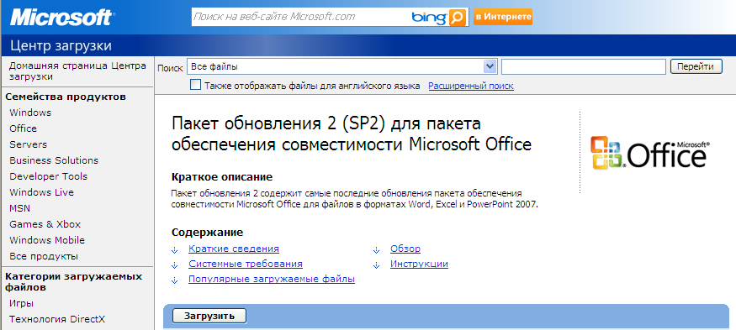

Chinese:
http://www.microsoft.com/downloads/details.aspx?FamilyID=4f97ab2f-1f7d-49a3-9123-7ca3e703b916&displaylang=zh-cn
