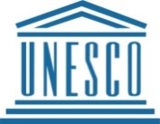
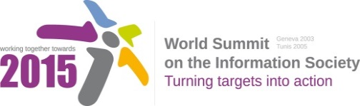

Document Number: V1.1/C/ALC7/E- Science

Note: This document consolidates the comments received by WSIS Stakeholders from the 9th October to 17th November. All the detailed submissions are available at:
http://www.itu.int/wsis/review/mpp/pages/consolidated-texts.html

This serves as an input to the 2nd Physical meeting and could be considered as the proposal for the 1st draft to be considered by the meeting.
This document has been developed keeping in mind the Principles.
Please note that the Geneva Declaration and the Geneva Plan of Action still remain valid until further decisions by the General Assembly.

Draft WSIS+10 Vision for WSIS Beyond 2015

С7. ICT Applications: E-Science

1. Vision
For the post-2015 era, we envision inclusive Knowledge Societies, in which e-Science will revolutionize science by changing: the way in which research is conducted; how the scientific agenda is defined; who participates in it; how the results and data are shared; the pace at which policymakers, scientists and individuals access knowledge; and who participates in the policy follow up of research outcomes. E-Science will improve the interface between policy, science and society by facilitating: more evidenced based policy actions; greater involvement of citizens in policy and scientific processes; more partnerships, better harmonized policy efforts and improved sustainability of outcomes.

2. Pillars
- Improve access to scientific assessments on climate change, biodiversity and ecosystem services and agriculture by creating a web-based platform (with complementary mobile applications) based on a multidisciplinary knowledge system that critically reviews and synthesize new knowledge in as real time a as possible.
- Use e-science to promote data and knowledge exchange, provide relevant and timely information for citizens, scientists and policy-makers that will improve decision making, science, policy and society relations and standards of living, particularly for marginalized communities.
- Strengthen policy and programme activities in Citizen Science by encouraging the use of the internet and mobile technologies to facilitate greater participation of civil society in the entire scientific process.
- Facilitate more public and private partnerships to promote e-science in the post 2015 development agenda.
- Develop information networks for researchers, teachers, information intermediaries and students to support the exchange of ideas and scientific information between research and education institutions across continents.
- Provide access for scientific society to data and to publications of universities, scientific organizations and scientific and technical libraries based on aggregated information resources.
3. Targets
- Promote greater involvement of marginalized segments of society, particularly youth and indigenous peoples, in citizen science.
- Indicator: Percentage of target population actively engaging in citizen science activities.
- Indicator: Percentage of UNESCO-led or supported citizen science initiatives.
- Indicator: Percentage of e-science activities with gender or age focus.
- Establish a web-based platform to improve access to scientific assessments on climate change, biodiversity and ecosystem services and agriculture.
- Indicator: Web-based platform with mobile applications created and functional.
- Indicator: Number of users of the platform.
- Indicator: Number of gender focused policy options included in assessments.
- Enable the establishment of global system to monitor the level of development for e-Educational services and assessment of quality in e-Learning.
- Indicator: Web-based platform with created and operational mobile applications.
- Indicator: Number of relevant structures covered by the monitoring.
- Indicator: Assessment of quality in e-Learning.

