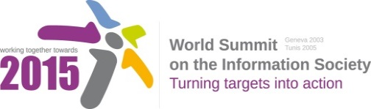
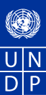
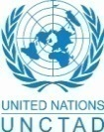
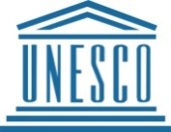
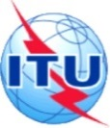
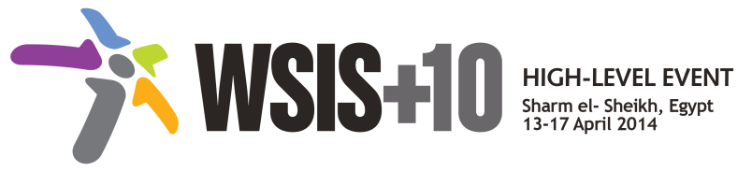

Document Number : WSIS+10/3/43
Submission by: ISOC, Civil Society
Please note that this is a submission for the Third Physical meeting of the WSIS +10 MPP to be held on the 17th and 18th of February.
Document Number: V1.1/C/ALC3

Note: This document consolidates the comments received by WSIS Stakeholders from the 9th October to 17th November. All the detailed submissions are available at:
http://www.itu.int/wsis/review/mpp/pages/consolidated-texts.html

This serves as an input to the 2nd Physical meeting and could be considered as the proposal for the 1st draft to be considered by the meeting.
This document has been developed keeping in mind the Principles.
Please note that the Geneva Declaration and the Geneva Plan of Action still remain valid until further decisions by the General Assembly.

Draft WSIS+10 Vision for WSIS Beyond 2015

С3. Access to information and knowledge

1. Vision
For the post-2015 agenda, we envision inclusive Knowledge Societies to facilitate access to information and knowledge all the world's people, including people coming from previously marginalized groups and regions in addition to persons with impairments. A significant portion of knowledge flows and innovations should contribute to support human rights and the attainment of development goals.
2. Pillars
- Government-led open data, FOSS, and other open solution strategies and resources promoted in all countries and languages.

- Project support for expanding and enhancing access to information in the public domain or alternative: Strong policy, programme and project support for expanding and enhancing public access to information

- Enhance international solidarity to promote exchange of experiences and research within and across nations and regions in the context of information and knowledge societies.
- initiatives focused on youth, elderly and the poor that emphasize the role of information-based development entrepreneurial activities.
- Media and Information literacy as a core element of all formal, non-formal and life-long learning initiatives.
- Information literacy emphasized as a core element of all formal, non-formal and life-long learning initiatives to promote healthy ageing and foster independent living solutions for the aged and the impaired.

- National efforts undertaken to promote access to development content – accessibility standards, accessible and inclusive ICTs, multilingual/culturally diverse content and tools.
- Strong commitment to creating, developing and supporting sustainable multi-purpose community public access points providing affordable or free-of-charge access for all citizens to ICTs
- Continue the ongoing multi-stakeholder consultative and participatory processes for creating a post-2015 strategy, linking the Action Line C3 Access to Information to the post-2015 development agenda.

3. Targets
- Governments to undertake necessary efforts to support expansion of public domain, accessibility of public information services and products through the use of FOSS, open data and open solutions.
- Indicator: Relevant national policies implemented.

- Enhancing levels of Media and Information Literacy levels, and mass media and communications amongst school age population.
- Indicator: % of schools with teachers trained to offer a MIL curriculum.
- Indicator: Relevant lifelong educational and learning programmes and initiatives developed.

- Development and integration of accessible and inclusive ICTs including for persons with disabilities.
- Indicator: Relevant national ICT teacher training programmes.
- Indicator: Relevant ICT training / tertiary education programmes included elements of accessible and inclusive ICT design

