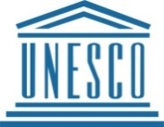
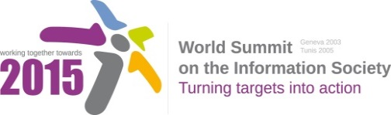

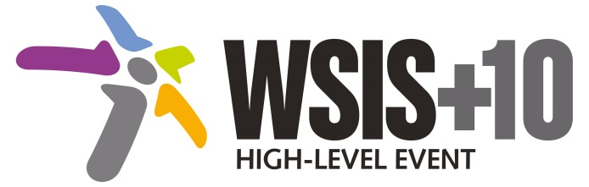

Document Number: WSIS+10/4/45
Note: This document is a clean version of the 1st reading to facilitate discussions in the 4th Physical meeting to be held on 14-17 April 2014.
Document Number: V2/C/ALC10

Note: This document is the result of the first reading of the document number V1.1/C/ALC10 and reflects the changes and comments received at the third physical meeting of the WSIS+10 MPP. This document is available at: http://www.itu.int/wsis/review/mpp/pages/consolidated-texts.html

This document has been developed keeping in mind the Principles.
Please note that the Geneva Declaration and the Geneva Plan of Action still remain valid until further decisions by the General Assembly.

Draft WSIS+10 Vision for WSIS Beyond 2015
С10. Ethical Dimensions of the Information Society
1. Vision
We envision inclusive Knowledge Societies, in which all stakeholders are well informed of ethical challenges and have adequate tools to support them in their decision making process; they regularly seek opportunities to engage and share their experiences among themselves.
- Alt we envision an inclusive Information Society, in which all stakeholders are informed of ethical challenges and policy makers have adequate tools to support them in their decision making process, through open and inclusive spaces of information sharing, dialogue and consultations
[New para] Brazil, Government: We reinforce our common understanding that the ethical dimension of the Information Society is a key aspect of future development and deployment of ICTs, which should carry in its design the respect for individual rights and well-being, the overall social and economic development of societies and peaceful cooperation among nations.
2. Pillars
- Give consideration to the ethical principles that bear on technological and social issues in the information society and underlie specific regulatory frameworks, whether or not such principles are enshrined in existing normative instruments or codes of conduct.
- Strengthen regional and national capacity in to analyse, discuss and respond to the ethical challenges of the information society.
- Promote international, multistakeholder and interdisciplinary reflection and debate on the ethical challenges of emerging technologies and the information society. Such reflection and debate should have a multi-tiered dimension that connects to policy and advisory bodies, with particular attention to participation of developing countries and sensitivity to their needs.
- Raise awareness of the ethical implications of the information society, particularly among young people, along with life-long education initiatives to equip all citizens with the skills and competence to participate actively and knowledgeably in the information society. Affirm that global guidelines or principles for online code of ethics must be rooted in international human rights frameworks, such as the Universal Declaration of Human Rights, which protects the right to freedom of expression and association, among other rights.
3. Targets
- Strengthen capacity of policy-makers to analyse, discuss, respond and also communicate with stakeholder about the ethical challenges of the Internet
  - Benchmark - Conduct capacity building based on gap analysis.
- Examine the ethical principles that impact technological and social issues in the information society and underlie specific regulatory frameworks, whether or not such principles are enshrined in existing normative instruments or codes of conduct.

