 | INTERNATIONAL TELECOMMUNICATION UNION  Workshop on Radio Spectrum Management for a Converging World | Document: RSM/08  February 2004  Original: English
Geneva — ITU New Initiatives Programme — 16-18 February 2004

Background Paper:
advanced wireless technologies and spectrum management


International Telecommunication Union

This paper has been prepared by Taylor Reynolds (taylor.reynolds@itu.int), Strategy and Policy Unit, ITU as part of a Workshop on Radio Spectrum Management for a Converging World jointly produced under the New Initiatives programme of the Office of the Secretary General and the Radiocommunication Bureau. The workshop manager is Eric Lie (eric.lie@itu.int), and the series is organized under the overall responsibility of Tim Kelly (tim.kelly@itu.int) , Head, ITU Strategy and Policy Unit (SPU). This paper has been edited and formatted by Joanna Goodrick (Joanna.goodrick@itu.int). A complementary paper on the topic of Spectrum Management and Advanced Wireless Technologies as well as case studies on spectrum management in Australia, Guatemala and the United Kingdom can be found at: http://www.itu.int/osg/sec/spu/ni/spectrum/.
The views expressed in this paper are those of the author and do not necessarily reflect the opinions of ITU or its membership.

1 Introduction 4
2 Technologies 4
2.1 Spread spectrum 5
2.1.1 Ultra-wide band (UWB) 7
2.2 Smart antennas 9
2.3 Mesh networks (collaborative gain networks) 11
2.4 Software defined radios 13
2.4.1 Agile radios 13
3 Policy implications 15
3.1 Current spectrum allocation model 15
3.2 The policy decisions of new technology 16
3.2.1 Allowing underlays 16
3.2.2 Developing noise temperature measures 17
3.2.3 Allowing coexistence models 18
3.2.4 Creating unlicensed or license-exempt spectrum 19
3.2.5 Cleaning up unused spectrum 20
3.2.6 Allowing for multi-purpose radios 20
3.2.7 Developing specific regulatory models to cover mesh networks 20
3.2.8 Complex decisions for regulators 21
3.3 Experimenting with spectrum 21
3.3.1 Spectrum commons experiment 22
3.3.2 Privatizing spectrum 23
3.4 Experiences with liberalized spectrum policy 24
3.4.1 CB Radio 24
3.4.2 Family radio service (FRS) 25
3.4.3 Guard bands 25
3.4.4 Wi-Fi and WLAN technologies 26
3.4.5 Experiment conclusions 26
3.5 Conclusions and policy recommendations 27
3.5.1 Allow low power underlays to accommodate ultra wide band technologies. 28
3.5.2 Set aside certain bands for experimentation with agile radios. 28
3.5.3 Create a technology advisory group 28

Introduction
The eighteenth-nineteenth century political economist Thomas Malthus (1766-1834) never met “Wi-Fi”. In fact, Malthus missed out on many other enormous leaps in technology and productivity, many of which have kept food production, in the aggregate, ahead of the world’s population growth. The food supply turned out to be not as “scarce” as Malthus had originally believed because technology and innovation have drastically increased yields beyond what was thought possible at the end of the eighteenth century. Indeed, we have largely escaped Malthus’ dire predictions because technology has enabled a much more efficient use of a scarce resource, land.
While Malthus’ concerns were based on the ever-increasing population, similar “scarcity” arguments have been, and are still being made about the radio spectrum. While the number of spectrum users and uses continually increases, the amount of spectrum is still considered a limited resource. Historically, this concern has been addressed by assigning exclusive, valuable spectrum property rights for one use.
However, many have argued that this system makes the same miscalculations about the “productivity” of spectrum as Malthus made on the productivity of farm production in the late 1700s. They argue that spectrum isn’t as “scarce” as it appears because new technologies make much more effective use of spectrum, mitigating the scarcity problem. Essentially, technological advances, if implemented, could outpace the growth of our demand for spectrum in the same way aggregate food production has outgrown population growth.
This paper will examine technologies and polices that can help make better use of spectrum. Section two will examine some of the most promising technologies that are offering to allow higher bandwidth with less interference. Section three will then look at the policy implications of these technologies, many of which may require significant deviation from current spectrum allocation policies.

Technologies
Traditional radio communications assume the receiving equipment is “dumb”, in the sense that it has limited ability to differentiate between the true signal and background noise. The only way to ensure that the radio understands the communication is to have a signal from the transmitter that is received much stronger than the background noise around it on the same frequency. This high signal-to-noise ratio alerts the radio that there is a signal containing information. If the signal being sent from the transmitter isn’t strong enough, the simple radio has no way of differentiating between the true signal and noise, and it misses the information (see Figure 1).
Many authors have made a case that the current spectrum system is outdated and based on a model from the early 1900s, when radios were indeed simple and incapable of any complex signal processing. The only way to send information effectively to a simple radio was to ensure the sender could have the strongest signal in the air and this was accomplished with exclusive licences. However, in the twenty-first century, the computing power of processors in radio equipment is sufficiently complex to sift through noise and pick out information intended for a specific receiver. This process of taking advantage of processing power to improve receptions and transmissions is called processor gain.
Processing gain is just one of the many radio advances that has highlighted the need for changes in spectrum management. This section will look at several of these technologies that are changing the way regulators look at spectrum allocation. These include spread spectrum technologies such as ultra-wide band, smart antennas, mesh networks, and software defined radios. These technologies are starting to appear in economies around the world and regulators will soon be, if they are not already, faced with the difficult decisions of which technologies to embrace and how. Therefore, this section aims to serve policy-makers as a brief introduction to some of the most promising technologies in terms of spectrum management.
Figure 1: An easily confused “dumb” radio
In the figure on the left, the signal-to-noise ratio is strong and a simple receiver is able to easily pick up and decode the signal. However, the figure on the right shows a situation where the simple radio, when faced with two strong similar signals, is unable to differentiate between the two and decode the transmission. In order to remedy this situation given on the right, policy makers have traditionally chosen to award exclusive licenses based on distance/power, frequency, and time.
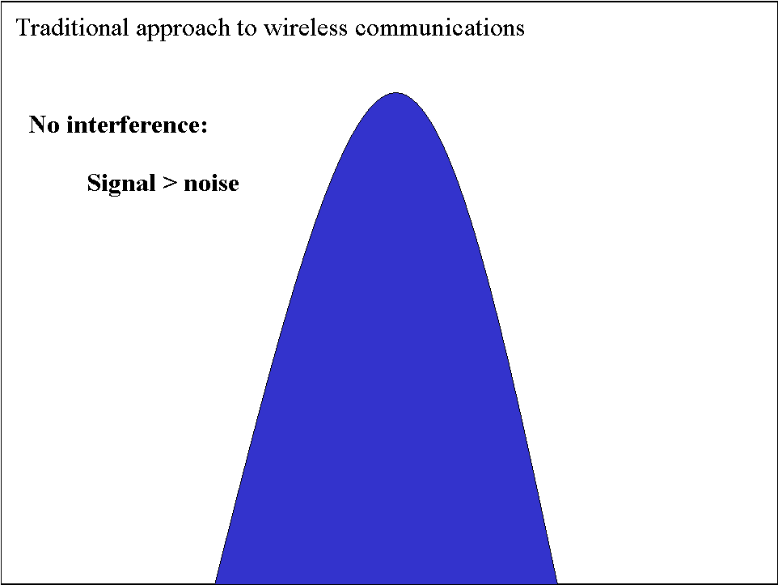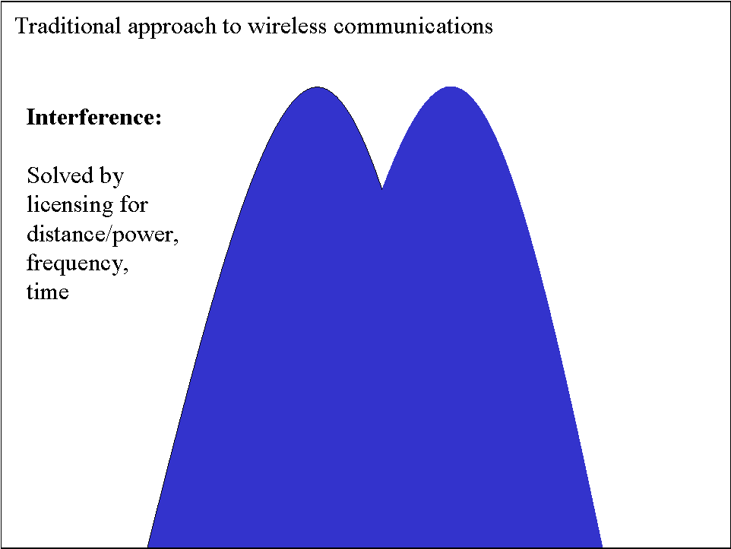
Source: ITU adapted from Yochai Benkler, Some Economics of Wireless Communications, Harvard Journal of Law & Technology, Vol 16:1, Fall 2002.

Spread spectrum
Militaries are always concerned about establishing, securing and maintaining communication links. For several decades, spread spectrum technologies have been a key component of military communications. Recently, they’ve been moving into commercial use for many of the same benefits the military has taken advantage of for years. They provide a certain level of security, are resistant to interference, and can provide robust, high-speed communication.
Spread spectrum technologies send information over a much wider band than the actual bandwidth of the information by using a code to either modify the carrier wave or to define a hopping pattern for frequencies. These codes are known as “pseudo-random”, and sometimes as “pseudo-noise". They are "pseudo" because there is an underlying, but secret pattern. Both the transmitting and receiving radios know the pre-defined code sequence in order to code and decode the information at both ends of the transmission. However, to radios without the code, the signals appear to only be radio frequency noise.
Spread spectrum radios may use the same total power levels of similar narrowband radios but that power is spread over a wide range of frequencies, leaving each slice of frequency relatively low power. This lower power level is a key benefit of spread spectrum technologies because it allows narrowband and spread spectrum (wideband) radios to coexist with each other.
Narrowband radios will not suffer from the coexistence of spread spectrum because the transmission power on any given frequency is so low that their signals aren’t even distinguishable from the “noise floor.” Wideband radios are also not effected by the existence of narrowband transmissions because the signal is so wide that interference on a narrow stream will have negligible effect and can be accommodated.
Spread spectrum codes are used in different ways, depending on the type of system. Each system uses the codes to transform and send a signal over a wide range of frequencies but they are fundamentally different in their approaches. The two different systems are direct sequence (DS) and frequency hopping (FH) (see Figure 2).
Figure 2: Direct sequencing (DSSS) vs. frequency hopping spread spectrum (FHSS)
Both direct sequencing and frequency hopping techniques are used to spread data out across a range of spectrum. DSSS essentially spreads out the carrier signal, allowing for a much lower power transmission (left figure). FSSS can use the same frequency range but uses a narrow signal over a constantly rotating set of frequencies.
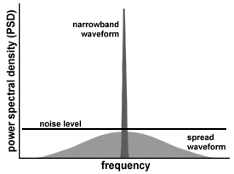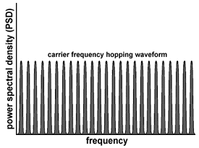
Source: Futaba.com at http://www.futaba.com/IRC/irctechlib.htm.
Direct sequence
Direct sequence systems combine the information being sent with a high-speed code sequence as a way to modify the carrier signal. The original data is combined with a higher-rate chipping code that divides and separates the original data and uses it to manipulate the carrier wave over a range of frequencies. The chipping code includes a redundant bit pattern for each transmitted bit, increasing the signal’s resistance to interference. That means that even if some bits are lost in the transmission to interference, the original data stream can be rebuilt from other redundant pieces. One of the most successful implementations of DSSS has been the IEEE 802.11b standard, commonly known as Wi-Fi (see Box 1).
Box 1: Wi-Fi – an extremely successful application of DSSS
How high-rate DSSS has helped large number of Wi-Fi users connect
Wi-Fi (802.11b) has been an astounding success in an otherwise gloomy moment for the telecommunications sector. The standard has allowed wireless users to connect to wireless area networks at speeds of up to 11 Mbit/s. Access points can commonly serve up to 32 simultaneous users due to the standard’s use of DSSS.
802.11b (developed in 1999) is an extension of the 802.11 standard (developed in 1997). 802.11 allowed for both FHSS and DSSS spread spectrum techniques, even though the two were incompatible with each other. FHSS equipment arrived first to the market because it was cheaper to produce and required less processing power for transmissions. However, as processing power became less expensive, DSSS became the favoured solution. DSSS was preferred to FHSS for several reasons. First, DSSS provides longer ranges for users due to the more rigorous S/N requirements of FHSS. Second, DSSS provides higher data rates from individual physical layers than is possible with FHSS. However, DSSS also suffers in some areas where FHSS would have excelled. DSSS can tolerate less signal interference than FHSS because the signal is still stronger in some frequencies than others. There is also lower output when access points are put together.
Currently Wi-Fi products are still the most popular wireless networking products in the world. However, 802.11a and 802.11g products using another spread spectrum technique, OFDM, promise even higher speeds (up to 54 mbit/s) and are becoming increasingly used.
Sources: O’Reilly Network at: http://www.oreillynet.com/pub/a/wireless/2001/03/02/802.11b_facts.html
and “IEEE 802.11 Standard Overview” by Jim Geier at InformIT.com.

Frequency hopping
Frequency hopping spread spectrum (FHSS) is a technology that makes more efficient use of spectrum by constantly hopping/broadcasting/hopping among a designated range of frequencies in a predictable pattern. A single “hop" typically has a maximum dwell time of 400 ms, rotating through a minimum of 75 different frequencies. Both the transmitting and receiving radios must be perfectly synchronized to recover the broadcast information.
FHSS technologies help reduce interference by decreasing the chance that two different radios in an area are broadcasting in the same frequency at exactly the same time. This means that a narrowband radio signal at a certain frequency would only bump into interference 1/75 of the time in the presence of an FHSS signal. Multiple FHSS systems effectively coexist together very well because, if timed correctly, they will never interfere and can offer an undisturbed, single channel.
Orthogonal frequency division multiplexing
DSSS and FHSS are the two main components of spread spectrum technology. However, new wireless LAN technology is popularising another modulation technique known as Orthogonal Frequency Division Multiplexing (OFDM). OFDM makes use of multiple frequencies as a way to increase the bandwidth or throughput in a wireless system. Instead of using a single carrier way to transmit data, OFDM breaks down data information into several streams that are broadcast simultaneously, on different frequencies, to a receiver that collects and reassembles them. This multi-channel approach makes OFDM less susceptible to multipath and other RF interference.
OFDM is used by both IEEE 802.11a and IEEE 802.11g networking protocols, as a way to boost transmission speeds above those possible with 802.11b (Wi-Fi).

Ultra-wide band (UWB)
While DSSS, FHSS, and OFDM have all increased the amount of data that wireless users can send efficiently, a new technology is promising to be much more efficient at even lower power levels, ultra-wide band. Ultra-wide band is one of the most anticipated radio frequency technologies because it can transmit data at very high speeds by sending the transmission over a wide range of frequencies but at very low power levels. UWB is not in widespread use but many governments around the world are considering its implications.
UWB is a very effective use of radio spectrum and offers great improvements in reception. By employing a wide range of frequencies, UWB allows for effective transmission through objects, including walls and the ground. UWB can penetrate obstacles that would severely hamper communication using traditional higher-powered, narrow band radio waves. This is especially important for radio applications that suffer from multipath problems.
Multipath is a type of signal distortion that occurs when the original signal, and a reflected signal arrive at different times, "confusing" the receiving radio. One good example of multipath is when a car radio’s reception deteriorates at a stoplight but pulling the car a metre forward improves the signal. The signal deteriorates momentarily, in a certain position, because the radio is receiving the original signal, as well as a slightly late echo that essentially cancel each other out. Moving slightly can remove the “echo” and the radio plays normally again. UWB does not suffer from multipath like other narrowband radios because its signals penetrate dense objects, rather than bounce off of them.
UWB uses a different method of transmitting data than typical radios. Traditional radio technologies use various carrier waves to send data information. The carrier wave is tuned to a specific frequency and the data is superimposed on the wave by adjusting either its frequency or amplitude. Typical examples would be FM and AM radio (see Figure 3, left).
While traditional radio technologies embed their data onto carrier sine waves, UWB instead uses very fast pulses to represent the zeros and ones of digital communication (see Figure 3, right). In order for receivers and transmitters to effectively communicate, they must be precisely timed to send and receive pulses within an accuracy of a trillionth of second.

Figures 3:
Narrowband transmissions “piggyback” data on top of a carrier wave by slightly changing the amplitude of the wave, the frequency, or the phase. Wideband transmissions use no carrier wave and rely solely on individual pulses of power. Data is conveyed by changing the polarity, amplitude, or the pulse position.
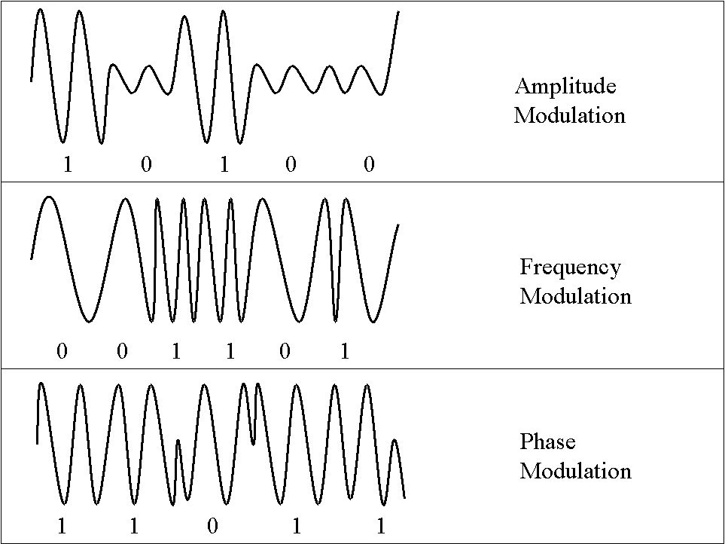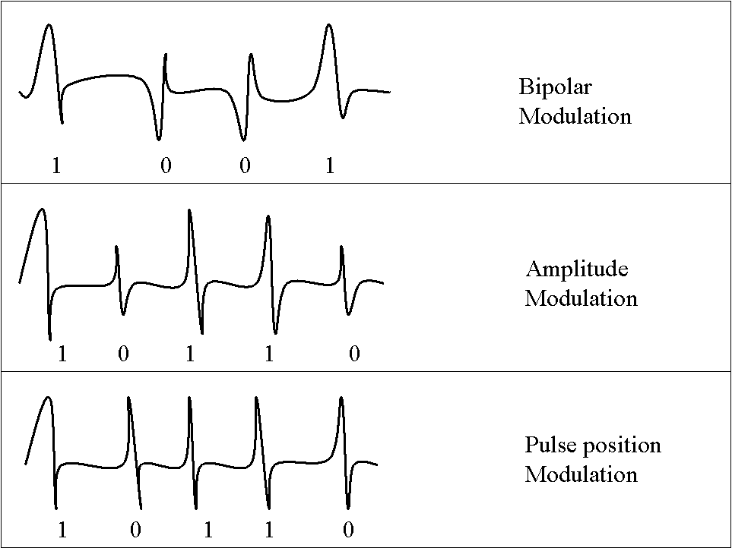
Narrowband transmissions Wideband transmissions
Source: ITU adapted from Scientific American, “Radio-Signal Technicalities”, May 4, 2002 at: http://www.sciam.com.
One of the most striking elements of UWB communications is the ability to communicate below the noise floor, often referred to as “underlay” (see Figure 4). In theory, this implies that UWB could operate in the same bands as licensed spectrum without causing any harmful interference. Not surprisingly, many spectrum owners have been sceptical over fears that an “unproven technology” will cause problems in the bands they have paid for (see section 3.2.1 for more information).
Figure 4: UWB operating below the “noise floor”
UWB operates at a much lower power than traditional radio uses. The power use is so low that it is indistinguishable from ever-present “noise”
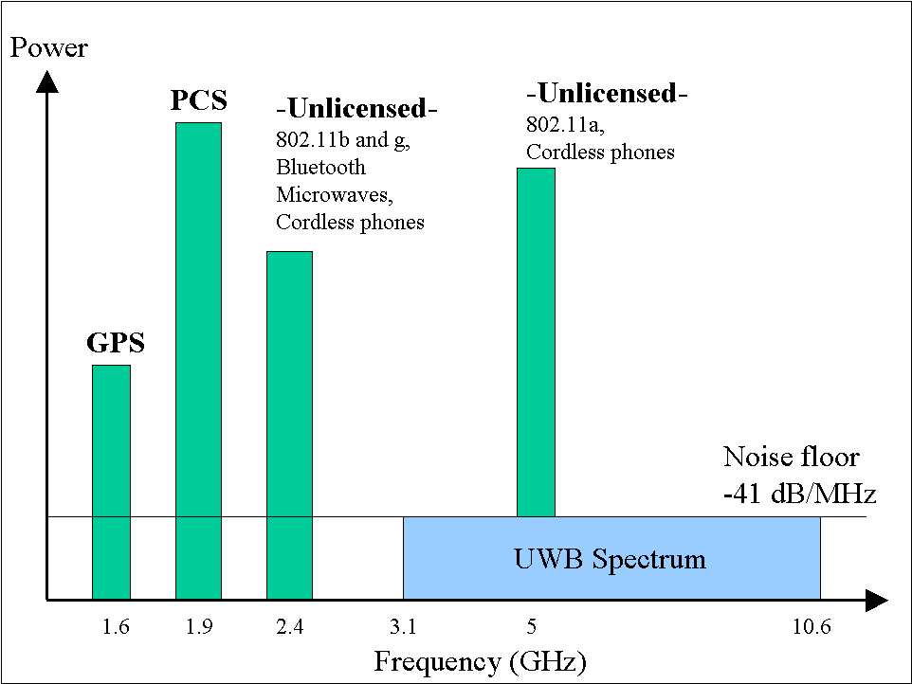
Source: ITU adapted from Intel at http://www.intel.com/idf/us/fall2003/presentations/F03USIRDS75_OS.pdf .
One of the most promising uses of UWB is home networking and other short-range, high bandwidth applications. Limiting the power of the pulse could make more effective use of underused spectrum in a home. Much like small FM radio transmitters that broadcast within a few feet to a car radio from a portable MP3 player, UWB could make use of the spectrum in a small area to increase connectivity, without interfering with the spectrum owner’s operation. Sample applications for UWB include, home networking of phone, cable, and data through a building.

Smart antennas
UWB and other spread spectrum technologies change the way data is sent to increase spectrum efficiency. However, one of the best ways to increase the capacity and reliability of a radio network is to focus on improving the ability of the radio to listen, via its antenna and the radio's signal processing power. While antennas play a key role in any radio communication, they often receive very little engineering attention as a percentage of the overall work that goes into a piece of electronic radio equipment. Building better antennas is one way to drastically increase the overall efficiency of a network.
Smart antennas are used for three main purposes. First, they are effective at suppressing interference. Second, the can effectively combat multipath, a situation where signal “echoes” cancel out the direct signal and the transmission is disturbed. Finally, smart antennas are used to effectively increase wireless capacity in a system.
There are many new “smart antennas” technologies on the market and the term smart antenna doesn’t refer to just one technology in general. In fact, the term may be a bit of a misnomer. Antennas are simply the ports through which RF energy is sent to and received from other RF devices — so the antennas are not smart per se. Rather, the digital signal processor does the thinking and analysis of RF signals that give the unit its intelligence.
Figure 5: Making antennas more intelligent
One key way of reducing interference and adding more users to a given radio transmitter is to employ smart antennas that can help concentrate signals towards users and away from others where the signal would increase interference. The figure on the left compares an omni-directional antenna on a tower with a sectorized antenna to cover the same area. The sectorized-antenna offers better reception, suffers from less interference and can accommodate more users. The image on the right shows how the coverage footprint increases by adding a second antenna to listen in a cell. This process of “combined diversity” can drastically improve reception and coverage by comparing, processing, and making use of information received from both antennas.
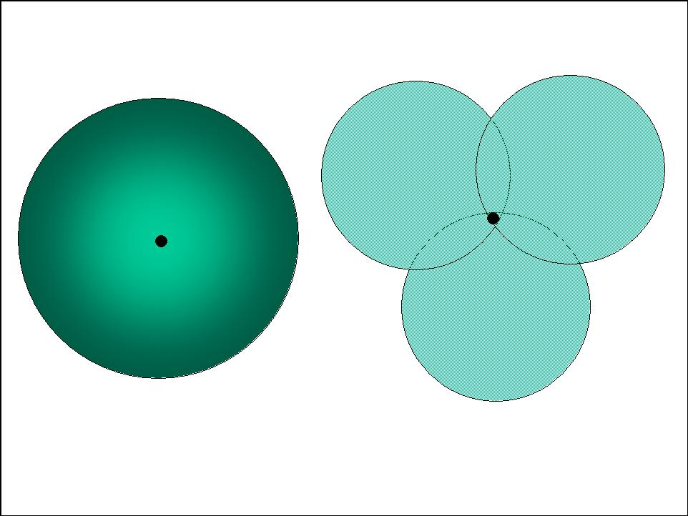
Source: ITU adapted from IEC.
Most smart antennas work the same way our brain interprets sound waves arriving in both our ears to determine the location of a noise. If a person were sitting in a completely dark room, she should still be able to determine an approximate location of a radio positioned in the room with her through a process known as localization. The sound waves travelling from the radio hit each of her ears at slightly different times and also at slightly different volumes. Her brain then makes the necessary calculations to determine from which direction the music is coming. Smart antennas make use of this same principle. The digital signal processor attempts to perform similar calculations to determine the source of an incoming transmission by listening to two antennas and processing the signals (see Figure 5).
Knowing where a transmission is coming from is vital in telecommunications because it allows the antenna to focus a signal in one specific location, either to listen better or to avoid broadcasting a response in all directions as is done with an omni-directional antenna. When an omni-directional antenna transmits an RF signal in all directions, there are more chances for the signal to cause interference with other RF devices, especially in a narrow frequency band. The problem compounds when more users are added to a given transmission tower, causing connections to be dropped and broadcast quality to deteriorate.
In addition to knowing which direction a sound is coming from, smart antennas can help the radio better understand transmissions coming in, even with high levels of interference. This is commonly known as the "cocktail party effect". Cocktail parties are often held in large rooms with many groups of people having many different conversations. The overall noise level in the room can be very high (i.e. interference) but people can still communicate with one another because of a process called auditory stream segregation. This means that listeners in the cocktail party tune in specifically to speech coming from a certain direction and are able to process the voices even in the presence of other noise. However, a recording of the same conversation could be unintelligible because the listener would miss this important directional data, leaving all voices combined together.
Once a smart antenna can determine the approximate location of a particular user, there are several other technologies that can help send and receive “better-targeted” transmissions. These technologies are broken down into two main groups, switched beam and adaptive antennas (see Figure 6).
- Switched beam antennas
A switched beam antenna can adjust sensitivity in any of a fixed number of directions. The 360 degree circle around the antenna is broken up into “fixed” sectors and the radio can then increase sensitivity in the sector where a user is located. The sectors are formed by combining the output of multiple antenna to focus on a narrow area, an area even more narrow than could be achieved with a directional antenna.
Benefits of switched beam antennas are they are relatively simple and low cost. However, disadvantages include the need for “inter-cell handoffs” between sectors, an inability mitigate multipath interference where the interference is close to the desired signal, and the lack of ability to take advantage of coherent multipaths.
- Adaptive array antennas
Adaptive antennas (sometimes called software antennas) are different than switched beam antenna because they are much more dynamic at tracking a user and continuously adjusting sensitivity based on the actual position of the user, rather than the sector he or she is in. Adaptive antenna systems use complex algorithms to process signals, locate users, and change sensitivity. Benefits include the ability to block signals coming from the direction of an interferer, the absence of inter-cell handoffs since the user is continually tracked, and the ability to combine coherent multipath signals. The disadvantages are the systems are much more complex, and therefore more expensive than switched beam systems. This complexity also requires more processing capability at the tower.
Figure 6: Switched beam and adaptive array antennas
Smart antennas fall into two main categories, switched beam and adaptive array antennas
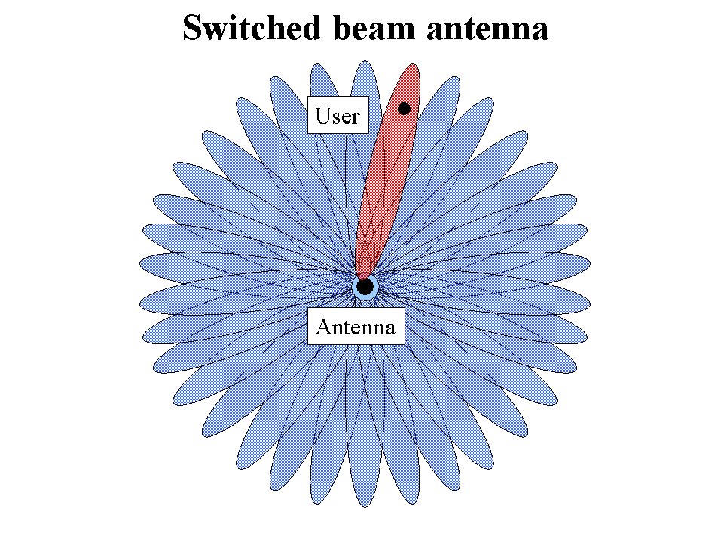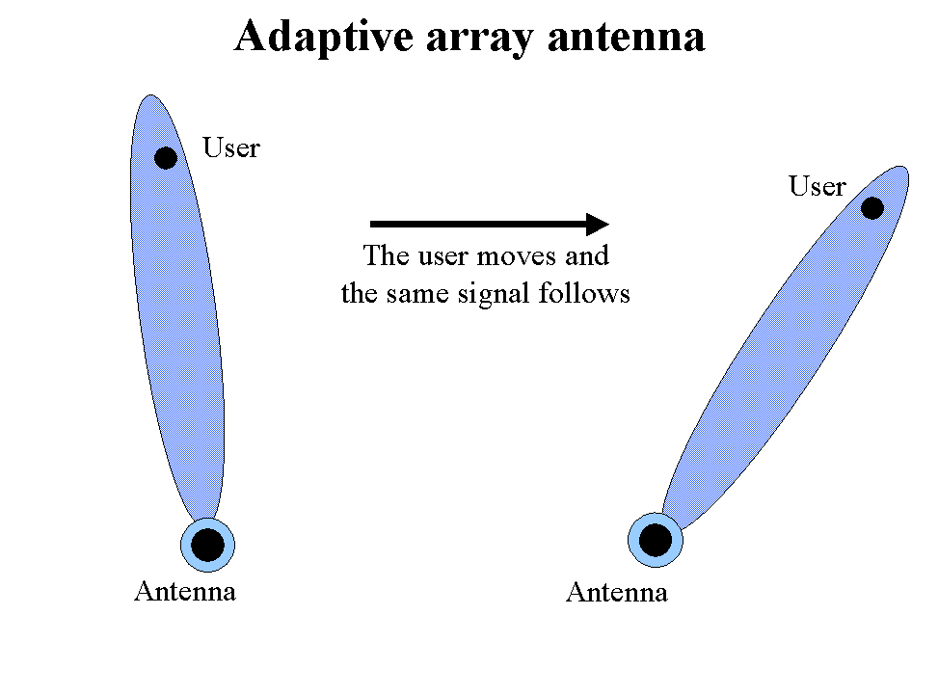
Source: ITU adapted from IEC.
Smart antenna technologies such as switched beam and adaptive array antennas have the ability to significantly reduce the amount of radio frequency interference in a given area. When combined with spread spectrum technologies such as ultra-wide band, these technologies can greatly increase spectrum capacity while limiting interference. Both types of technologies are starting to appear in a new kind of network that proponents say will change spectrum needs forever, mesh networks.

Mesh networks (collaborative gain networks)
Rumours can spread like wildfire. A good piece of gossip, if always passed on to three other people, takes only five iterations to reach nearly 250 people. Based on this theory, after only 21 iterations, the entire world could know. Mesh networks are a type of network based on this principle; every person (radio or node) receiving information can also be used to pass information along.
By definition, a mesh network is a local area network (or LAN) where each device on the network simultaneously connects to and communicates with all devices in range. Devices can then communicate with each over by passing transmissions (e.g. messages) using other devices as intermediaries. The illustrations in Figure 7 show mesh networks with five nodes. Each node is shown as a sphere, and connections are shown as straight lines. The connections can be wired or wireless.
Figure 7: Mesh network topology
Wireless devices on a mesh network don’t need to be able to broadcast long distances They only need to be able to transmit as far as the next user on the network (see left figure). By using other devices to pass transmissions along, mesh network transmissions can cover long distances. Devices on a mesh network form connections with every other device within transmission/reception range (see right figure) forming a robust network.
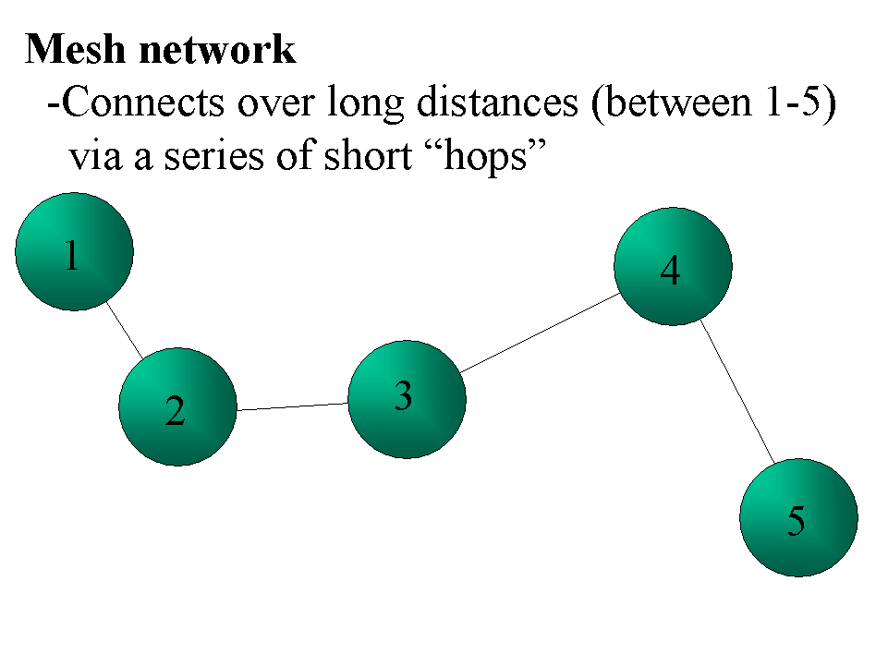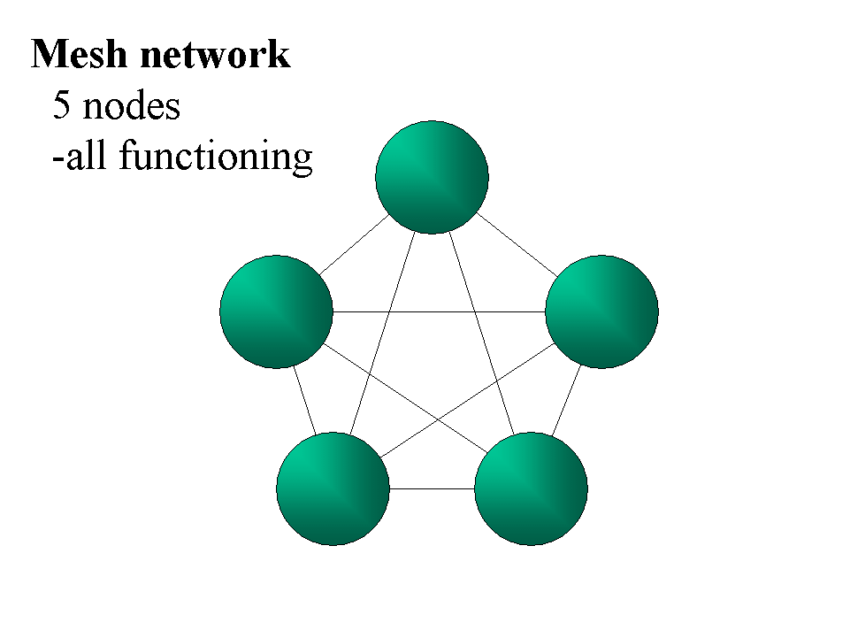
Source: ITU.
The benefits for networking are dramatic. First, mesh networks expand their reach, by their very nature, as the number of users increase. This represents an extremely cost effective way of expanding network access. In addition, increasing the number of users in an area actually increases bandwidth, rather than reducing it like traditional radio communication services such as mobile telephony (see Box 2). Mesh networks are also extremely resilient to one node not being able to pass on the information. The intelligent network can easily reroute transmissions around a problem area by simply finding another user within radio range (see Figure 8).
Box 2: Could a mobile mesh network end the need for mobile spectrum licensing?
How a mobile mesh network needs
Mobile operators have recently paid large sums for radio spectrum in 3G auctions. The high bidding prices reflected perceived value of the spectrum, and to some degree, over optimism about the state of mobile technology and market conditions. If mesh networking becomes a practical reality, 3G auctions may be a thing of the past. There may be no need for operators to buy large blocks of spectrum for mobile users.
Instead, a mesh, mobile network could do away with the majority of cell towers by using other mobile users to carry their mobile traffic. In densely populated areas, mobile phones would only need a small amount of power to broadcast since they would only need to reach the next user, rather than the cell tower. This low-power transmission could even take place in license-exempt areas of the spectrum. Alternatively, mobile phones could use UWB technology at such low power levels that transmissions would fall below the noise floor.
While mesh networking may hold a key for a more effective mobile network, its emergence may still be some time off. Since handsets will function as routing equipment, they’ll need to be more complex. In addition, there are definite privacy issues to be addressed as well if data traffic must be passed one by many users along the way to its destination. Finally, advances in battery technology will play a key role as phones will constantly need to remain powered on and transmitting to pass along other traffic. However, the success of a similar network model, the Internet itself, shows there is promise in the technology.
Source: ITU.
Rescue service personnel have been very interested in using mesh networks in disaster areas. While individual radios may be out of reach of the home base, a mesh network could use other radios in a chain, to repeat the information back to base, over long distances.
Mesh networks have several key implications for spectrum management. First, mesh networks reduce the need for long distance radio transmission because the signal need only be strong enough to reach another user. This means mesh networks can use higher-speed, shorter-range frequencies than are currently used for many radio communications. The minimal ranges needed for data transmission between users could even open up technologies such as UWB, which require a wide range of spectrum but at very low power levels.
The vision of mesh networking will be closer to a reality when radios in the network become instantly upgradeable and configurable via their software. While mesh networks are in their early stages of development, many new radios are fully configurable via software, rather than hardware upgrades. This new class of radio technology is called software-defined radio.
Figure 8: The resiliency of mesh networks
Mesh networking is extremely effective at bypassing dead nodes on the network (left figure) and navigating around impenetrable objects (right figure). Every node (or device) on the network acts both as a client but also as a router, passing on information to other devices in range.
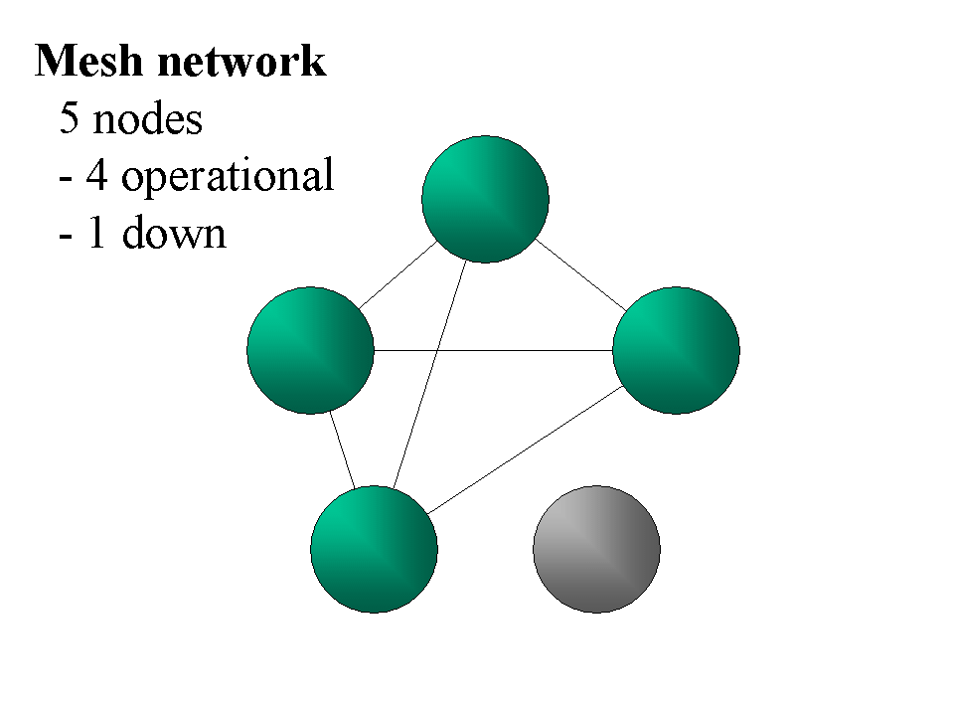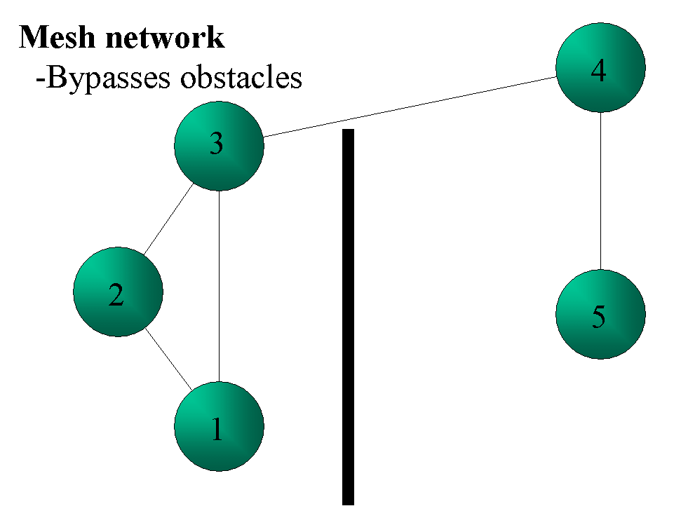
Source: ITU adapted from searchnetworking.com.

Software-defined radios
A software-defined radio (SDR) is a wireless communication device in which the transmitter modulation is generated or defined by a computer, and the receiver uses a computer to recover the signal intelligence. To select the desired modulation type, the proper programs must be run by microcomputers that control the transmitter and receiver.
SDRs show great promise due to their ability to be re-programmed on the fly to accommodate different regulatory structures (e.g. different countries) by adjusting frequencies, bandwidth, and directionality. Essentially, SDRs are radios that can be upgraded by changing software, similar to a firmware upgrade. This allows more effective use of expensive hardware and infrastructure.
The communication industries have a lot to gain from SDR technologies because one device will be able to handle multiple frequency bands and transmission protocols and be quickly upgraded through new software. Eventually this could mean that a user's mobile phone, cordless phone, pager, and WLAN connectivity could be provided by the same radio, simply by using sophisticated software. The radio is simply a generic terminal that receives its functionality from the software that runs it. While software defined radio is a general term, a specific type of SDR, agile radio, offers to make spectrum allocation much more efficient.

Agile radios
Agile radios act as frequency scavengers. They are an innovative technology that aims to make use of periods of inactivity on a wide range of spectrum. An agile radio will broadcast on an unused frequency until it “senses” another radio trying to use the same frequency. At that moment, the radio “hops” frequency to another temporarily unused portion of the radio spectrum. Agile radios are very promising because they can vastly increase the amount of available bandwidth (some estimate 10 times current levels) without requiring any new frequency allocations (see Figure 9, left).
Figure 9: Agile radios
Agile radios can “hop” from one unused frequency to another as way to take advantage of unused spectrum (left figure). However, they also can introduce interference to third parties when radios are out of range of each other but both within range of a third receiver (right figure).

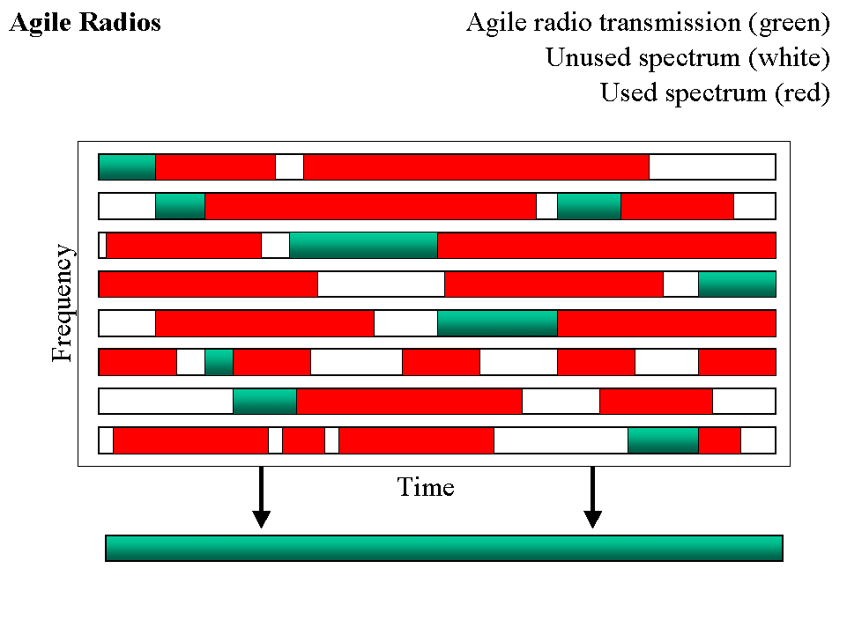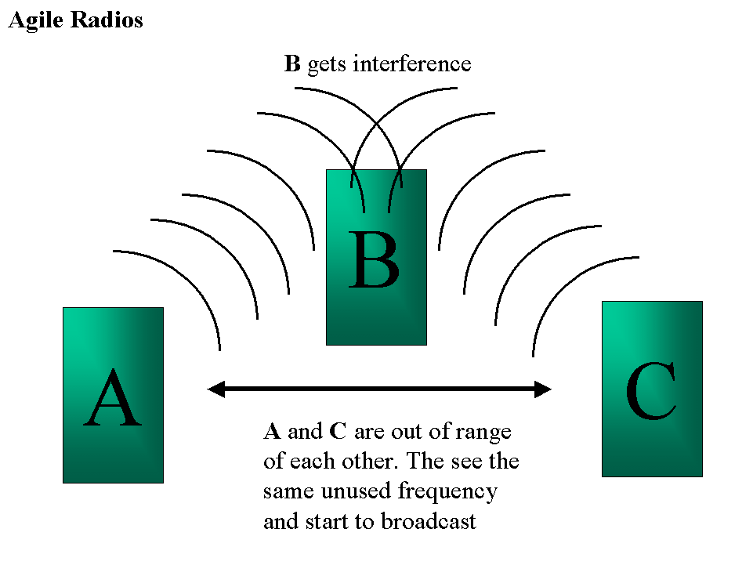
Benefits Drawbacks
Source: ITU.
Agile radios have the potential to be very successful by taking advantage of the inherent properties of radio transmission: time, location, and frequency. Licenses have traditionally been awarded to give spectrum owners exclusive rights in a given location, on a specified frequency, at a given period of time. However studies have shown that large amounts of spectrum lie fallow. A broadcasting radio may be using a given frequency at a certain time, but not in the area where an agile radio would be operating. That creates an unused block spectrum over a small amount of time that could be used by others in the location.
Agile radios are still in development and implementations could be several years off. However, they bring up some very important policy questions that must be addressed and will be covered in the following section.
Agile radios also suffer from some technological problems that will need to be addressed. First, agile radios can suffer from the “hidden terminal” problem (see Figure 9, right). This is a situation where there are two radios that are out of range of each other and find the same unused frequency. A third radio, located between the two radios and within range of both, receives two different transmissions at the same time, on the same frequency. This results in interference that could not have been anticipated by either of the two broadcasting radios.
Conclusion
The new technologies listed above show great promise in how to make more effective use of spectrum. However, technology is only one element in a complex process. Radio spectrum policy-makers must decide how these technologies can and should be used. The decisions they face are often difficult due to a lack of a test bed for these emerging technologies. This leaves regulators making decisions before technologies are tested in the market. As a result, policy makers often choose to be conservative with policy decisions.
The following section examines some of the main policy questions raised by these new technologies and looks at what some governments have done to address them.

Policy implications
The previous section looked into several technologies that could drastically change how spectrum is used. However, these new technologies can only be implemented if current regulatory models change to allow their use. It is therefore vital that regulators, engineers and economists understand the implications of the technology and how current regulatory schemes will have to adapt if these technologies are going to succeed.
Making changes in current regulatory schemes is not without risk. It is understandable that regulators have been hesitant to change the status quo. A poor policy could wreak havoc on a system, which while not always efficient, is considered by most to be stable and to work. As such, this section examines how these new technologies could fit into a regulatory structure with the least amount of disruption. The section will draw heavily from academic papers arguing for different types of policy changes.
The first section will examine the current spectrum allocation system and look at why it is insufficient to deal with new advances in technology. The next section will look at the main decisions policy makers face, including the difficulties of competing interests and unproven technology. The third section will examine ways academics and experts have suggested testing various implementations before adopting them full-scale. Fourth, the section will include a series of previous successful and unsuccessful test cases of untraditional spectrum management. Finally, the section will end with suggestions for policy-makers ready to move towards regulatory change.

Current spectrum allocation model
The current model of spectrum allocation in the US has been exported to most of the world. It makes sense then to understand the background behind the decisions that prompted the US government to become involved in spectrum management.
Radio broadcasting made its debut in 1920 and numerous broadcasters began to appear in 1921. Initially, broadcasters would simply build a station and start broadcasting, with no thought for ownership of the spectrum. However, interference became a big issue as multiple broadcasters started to appear in the same locations. A de facto solution appeared where the first broadcaster on the frequency claimed and owned the rights.
The US Government essentially supported these claims until 1926 when the Department of Commerce announced they were no longer valid. Immediately new broadcasters quickly entered the market broadcasting on the same frequencies as established broadcasters and creating immense interference. This prompted the US Government to take action, passing the Radio Act of 1927 and establishing the Federal Radio Agency, which would eventually become the FCC in 1934.
From the 1930s, radio spectrum in the US has largely been handed out based on applications to the FCC. Any company wishing to broadcast on an unused frequency in a certain location must submit a formal application to the FCC. The FCC then opens this process up to the public, requesting applications from other for the same frequencies. Finally, the FCC holds a hearing to decide which of the applicants (if any others applied) would best serve the public interest with the frequency. Once decided, the FCC issues the licenCe, along with certain restrictions on how the frequency band is used.
This licensing process has long been criticized by economists, many of whom would prefer a system that allows for market exchange of licences for various uses. Currently, awarded licences cannot be freely traded on the open market without FCC approval. Second, the licences disallow any other use of the spectrum than what was contained in the original application. This traditional method of spectrum allocation is still used for most spectrum allocations around the world, with some notable exceptions including swaths of unlicensed public frequencies and auctions for IMT-2000 (3G) mobile spectrum.
Exceptions to the rule
Governments have sometimes departed from the norm in the licensing process. Two of the most common examples are setting aside unlicensed spectrum bands for public use and holding auctions for IMT-2000 (3G) spectrum.
Government have allowed and facilitated public use of unlicensed spectrum by only requiring equipment manufacturers to adhere to certain restrictions on power and interference (e.g. Part 15 requirements from the FCC). Unlicensed spectrum has been a phenomenal success around the world because innovators have been allowed to invest in research and development without initial, up-front investments for spectrum licenses. This has made unlicensed bands a haven for new technology, something governments are keen to continue.
Many 3G mobile spectrum allocations around the world were also a step away from traditional spectrum allocation models because they used auctions as a mechanism to award licenses to companies that valued the licenses most. Some of these auctions were deemed a great success while others seem to have been so costly to licensees that services have not been able to develop normally.
Problems with the current system
Despite these recent licensing changes, the majority of spectrum allocations still fall under the previous traditional application process. Regulators around the world understand that this traditional spectrum allocation process has some serious drawbacks and many are looking for innovative solutions to make better use of spectrum space. Some of the key problems with traditional spectrum licensing methods are that they:
- Can limit for innovative uses of new technology;
- Do not ensure spectrum is used efficiently (or even used) after licenses are issued;
- Prohibit licensees from changing how they use the spectrum to offer new services;
- Are too restrictive on low-powered devices.
At the time the policies were debated and put into place, policy-makers were bound by limitations of early technology. Now as the technology has greatly improved, the existing spectrum structure has remained. The situation has become even more difficult as devices dependent on the old structure are abundant in most countries of the world.
Policy makers thus must proceed carefully in order to make more effective use of spectrum but to also ensure that legacy devices will still retain functionality.

The policy decisions of new technology
Technologies described in section two, such as ultra-wideband and agile radios, cannot legally exist without changes to spectrum policy. This section will look at the types of changes necessary to make use of new technologies with the least amount of disturbance to existing devices and licensees. These include decisions allowing underlays, developing noise temperature measures, developing coexistence models, creating new unlicensed spectrum, clearing underused spectrum and allowing multipurpose radios.

Allowing underlays
All electronic devices produce radiation at various frequencies, whether they are intentional radiators or not. This means that as long as there are electronic devices, there will always be at least some level of interference, commonly referred to as the noise floor. Engineers build licensed devices that must be able to withstand low levels of interference; that is they must be able to send and receive signals above the noise floor.
Underlays take advantage of traditional radio's built-in resistance to noise by keeping all communications at such low power levels that the transmissions blend in with other interference beneath the noise floor. Licensed radios can then continue in normal operation without even sensing simultaneous broadcasts from the underlay equipment on the same frequency (see Box 3).
Underlay technologies such as ultra-wide band offer the potential to drastically increase spectrum efficiency. The key decision for policy makers is whether these technologies will work as advertised. In theory, the economic gains to allowing underlays would be hard for any regulatory agency to ignore. If the technologies are successful, ultra-wide band technologies will likely be a fundamental way to transmit information in the future. As such, regulators must pay careful attention to technological and regulatory advances in the field.
Box 3: Comparing underlays to a quiet house
Both humans and radios must always be able to tolerate a certain level of noise
One of the easiest ways to understand the principle of underlays is to compare its transmissions to the incidental noises in a typical residence. At night when people sleep, most prefer to have the house as quiet as possible. However, there will always be a low level of noise present in the house at all times.
Clocks tick, water may drip, and electrical devices hum, but at such low levels that they usually don't disturb those who are trying to sleep. During the day, these small noises have little or no effect on conversations taking place in the residence because their volume is so much lower than that of human conversation.
Underlays work on the same principle. As long as the radio emissions are at a low enough power level (i.e. quiet), they can coexist with the (i.e. loud) higher-power transmissions of the licensee without being noticed.
Future infrastructure such as mesh networks may require ultra-wide band technologies for their backbone communications. Since mesh networks don't need to transmit over long distances (i.e. users only need to be able to reach another user), the lower power and wider frequencies of ultra-wide band make it ideal technology.
The FCC is taking ultra-wide band very seriously and approved a low-powered version of the technology in February 2002. Initially the US Department of Defense had concerns that UWB signals would interfere with the GPS navigation system. After extensive testing, the FCC found that UWB would not cause significant disruption at low power levels. The FCC took a cautious approach to UWB, limiting the range of the technology to roughly 30 feet, close enough for home networking indoors. If systems in development work as planned the FCC had mentioned that it would be willing to increase the power limits in the initial ruling.
The FCC decision was an important step for UWB and underlay technology worldwide, in part because there was huge opposition to the technology from licensees. Current license owners are strongly against allowing new services on the same frequencies to which they have legal, exclusive right. The situation is even more complicated when the licensees have bid and paid for exclusive rights in the frequency range, as has been common in recent mobile licenses. Operators who have radio licenses argue that allowing unlicensed devices to operate in licensed bands at low power will hinder the operator's "future network design flexibility as well as their ability to introduce more efficient technologies and systems”.
In response, some may argue that current license holders don't own the rights to the frequencies per se because interference from other devices will always be present. Instead, spectrum rights are essentially a right to a "lack of significant interference". This idea would imply that allowing unlicensed devices to operate below the noise floor would not be contrary to the original agreements between regulators and operators.
Many regulatory bodies may decide whether to adopt UWB after they see the results of the US implementation of UWB and underlays. Even regulators decide to postpone UWB decisions, they should at least be planning for the technology. As mentioned earlier, some analysts are predicting that UWB will form the backbone of future wireless networks. By looking into the matter now, regulators will stay one step ahead.

Developing noise temperature measures
One of the key prerequisites for an underlay system is a regulatory definition of the noise floor, or how much interference is too much for legacy radios. Once the acceptable noise floor is established, underlay technologies can be allowed to broadcast below it. Several regulators are looking into a more dynamic version of a fixed noise floor for all equipment. By developing a "noise temperature" (sometimes called "interference temperature") devices can monitor the amount of interference in an area and adjust their emitting power accordingly. Higher noise temperatures correspond to higher levels of interference. Several regulators, including the FCC's Spectrum Policy Task Force, have been looking into way to improve spectrum efficiency by using interference temperature measures. Noise temperature systems thus offer a dynamic and flexible way to ensure the effective use of localized spectrum.
Corollary systems have been used in non-telecommunication infrastructure around the world as a way to ease other types of congestion. Civil engineers have made effective use of automobile traffic controlling mechanisms in congested cities with great success. At times of peak usage, traffic lights on highway entrances allow only one car at a time to enter. During off-peak hours, cars are allowed to enter with no restrictions. Noise temperature systems would apply the same principles to spectrum in a given area and may greatly increase efficiency.
A noise-temperature based system would be very different from the current system where regulators limit the transmitting power of all devices permanently as a preventive measure to prevent high levels of interference in any given place. It would allow for different power levels in different areas depending on the noise temperature, an efficient use of spectrum.
Currently, there is no standard system for measuring noise temperature. However, the FCC has requested comment on how such a system would work. There are two main ways a potential service could operate. In the first, each RF device would continually take its own measurements of the noise temperature and make its transmission decisions based on the results. Licensed and unlicensed devices would require different parameters to ensure that licensed devices received the highest priority. Such a system would likely be the most efficient because devices would be able to monitor their immediate surroundings before making the transmission decision. However, this precision comes at a cost; the complexity of the transmitting equipment will need to increase, consequently increasing the cost of individual devices.
Another option is to have stand-alone reporting stations measure the noise temperature in their vicinity and then broadcast the corresponding permissions/non-permissions to transmitters in its area. These transmissions would offer different information for licensed and unlicensed radios. The transmitted permissions may be as simple as a "yes or no" signal or more complex signal specifying maximum power levels for each type of radio.
This would allow a much more effective use of spectrum in a given location. Local, unlicensed devices could make use of licensed frequencies as long as there were either no transmissions at a given time or if the noise temperature was low enough for both signals to coexist without significant erosion of the licensed signal.
While both options are currently under consideration, the advancements in smart-radio technology and processing power should allow radios to be able to make the decisions themselves, thus reducing infrastructure cost and making the most efficient use of spectrum.
Box 4: Noise temperature in basements
How new noise temperature measurement can allow faster transmissions between devices in previous RF dead zones
TV and radio reception can be particularly difficult in concrete basements. Proper antennas are required in order to pull quality signals into this "RF quiet area". However, the quiet nature of concrete basements could make them perfect for consumer devices that base their transmissions on the noise temperature of a given area. The lower the noise temperature, the higher power unlicensed devices can use to transmit. This means that devices located in a basement could make more powerful use of licensed frequencies to pass information back and forth.
Given the quiet nature of the environment, unlicensed devices such as TV's, VCR's, DVD players, and home networking equipment could transmit at low power over licensed frequencies to share very high-speed data back and forth, wirelessly.
Despite the promised benefits of such a system, many licensees are strongly against the use of noise temperature measures and underlays as a way to open up their licensed spectrum to unlicensed users. This is not surprising given their reliance on interference-free transmissions. However, disallowing all use of spectrum, even when not in use, comes at a very high welfare cost.

Allowing coexistence models
Agile radio technology, like UWB, has the potential to make much more efficient use of the radio spectrum if the technology is allowed by regulators. However, the amount of spectrum agile radios will be able to salvage depends on the frequencies in which they're allowed to operate. If agile radios are only allowed to operate in small, open bands then the efficiency gains will be relatively small. However, once the technology is proven, policy makers may be able to open up vast areas of licensed spectrum for use. This could vastly increase spectrum use, even in large cities (see Box 5). Regulators must come up with "coexistence models" that dictate protocols for transmitting on and vacating licensed frequency bands in order to take advantage of fallow spectrum.
Box 5: Spectrum is easier to find than parking in Washington DC
How spectrum in large cities may not be as scarce as once believed
In June 2003, Shared Spectrum Co. ran a test in downtown Washington DC to see how effectively spectrum bands were being used. After setting up their equipment on a rooftop, the engineers set off to measure spectrum usage in of the most "spectrum-congested" areas of Washington DC. The equipment measured the amount of usage during an 8-hour period between the 30 MHz and 3GHz bands and returned some surprising results. The engineers examined several high-traffic frequency bands and found that only 19-40 per cent of the spectrum was occupied at any given time throughout the eight-hour period.
The results were surprising for Washington DC because the city boasts high uses of wireless technologies including mobile phones, pagers, e-mail devices, and Wi-Fi in addition to TV, radio, air-traffic, and military use. In an area as congested as Washington DC, these findings highlight problems with current spectrum allocation. Much of the licensed spectrum is greatly underused.
The company running the tests likens the situation to "every licensed operator having their own road to go to work." Indeed companies such as Shared Spectrum Co. are counting on regulatory approval of their technologies that would force carriers to effectively share the roads with them.
Source: Mark McHenry of Shared Spectrum and BusinessWeek "Beyond Wi-Fi: A New Wireless Age" at: http://www.businessweek.com/magazine/content/03_50/b3862098.htm.
While many of the policy questions surrounding UWB are similar to those for agile radios, there are some key differences. First, agile radio technology uses narrower transmissions and thus sends those transmissions at higher power levels. When power levels increase, the chance of interference increases as well. Second, since agile radio and licensed broadcasts can't effectively exist in the same exact time space, the technology of agile radios must be robust enough to immediately detect a licensed transmission and vacate the frequency before causing interference.
For these reasons, regulators may prefer to initially license agile radios to operate in certain frequency bands with low existing usage and robust technology. If the technology works well in these "test bands" then policy makers could increase the number of allowable frequencies. The narrowband nature of coexistence models makes they somewhat easier for regulators than UWB, because of the limited amount of frequencies involved.

Creating unlicensed or license-exempt spectrum
Current spectrum license holders, as mentioned above, have been reluctant to have other devices share their spectrum, regardless of the technology. Instead, many have argued for governments to increase the amount of unlicensed bands as a way to accommodate new devices and spectrum uses. In this way, licence holders would still be able to flourish under the current system of exclusive licensing. By clearing and making new spectrum bands available to unlicensed or commons use, license holders argue that the government can more than satisfy current demand for unlicensed spectrum, without risking potential interference with current licensed operations.
While the arguments made by carriers are understandable, they neglect one of the key benefits of underlays, the ability to reduce the power levels of all devices sending information. Opening up more spectrum to unlicensed devices will indeed increase the number of unlicensed devices that can be operated in an area. However, while technologies in unlicensed bands or spectrum commons will likely use spread spectrum technologies for efficiency, they will be unable to take full advantage of the bandwidth and reduced power of technologies such as UWB, which would require much wider swaths of frequency to operate. Devices operating in the unlicensed bands will still be required to broadcast at higher power levels, which in turn have the potential to create more interference.
Some licensees have tried to make unlicensed bands and underlays mutually exclusive when in reality, new spectrum policy should include both. Thoughtful spectrum policy should indeed create more unlicensed areas for technology, but should also strongly consider allowing the use of UWB technologies, at least at very low power levels. Section 3.3.2 will explain the benefits new technologies can offer in unlicensed bands and suggest policy strategies for unlicensed bands.

Cleaning up unused spectrum
One of the first spectrum policy changes that regulators should consider is how to clean up unused bands and reallocate them to other uses. Spectrum lies fallow around the world in different regulatory regimes and putting it to better use through reallocation should be a major policy consideration.
As technology improves the amount spectrum needed for certain transmissions decreases. However, traditional regulatory schemes have often been unable or unwilling to recover spectrum that isn't used effectively. The case becomes even more difficult in situations where licensees have bought spectrum, rather than simply receiving it from an application process.
The process of clearing bands can be difficult and depends on the type of agreements regulators have with licensees. Given the problems regulators are having clearing bands, any new spectrum licenses should include use provisions and a recovery option if the spectrum falls into greatly inefficient use.
While agile radios and ultra-wide band are two technologies can theoretically re-use existing licensed bandwidth, policy makers should also consider cleaning up the licensed bands to find underused spectrum and reassign it.
Benkler and others have argued the importance of clear "recovery options" and governments are now looking into effective ways to reassign spectrum in the most cost-effective and fair manner. A good example of governments making necessary legal changes to clear and recover spectrum is the Australian Communications Authority Act of 1997 that allows the government to move existing licensees and reclaim spectrum for more efficient uses.

Allowing for multi-purpose radios
One of the most promising elements of software defined radio technologies will be the ability for one generic radio device to function as an all-in-one communication tool. Such a device could conceivable work as a mobile phone, cordless phone, GPS, and Internet data connection. Traditionally, each type of device would fall under different regulatory requirements and equipment must confirm to different regulations. However, if a generic device were to be able to "transform" into new types of devices based on the internal software, regulatory bodies must decide how to categorise such a device and how the approval process would function.
This raises some difficult questions for regulators since rather than focusing on the hardware elements of electronic devices (such as Part 15 approval of the FCC), the key approval must lie with the software that controls the radio.

Developing specific regulatory models to cover mesh networks
Mesh networks may be one of the most disruptive technologies to current regulatory schemes because it will drastically change the definition of a telecommunication provider. Regulators across the world are already struggling to determine if Voice over IP (VoIP) providers are subject to the same regulations as current voice operators. Now, with groups of users able to form their own ad hoc networks capable of internal communication, the regulatory questions multiply.
This complexity of mesh networking also affects regulatory decisions on how to allocate spectrum. Mesh networks, by the very nature, require different wireless connectivity than many other wireless data technologies. For the most part, mesh networks must be able to handle large amounts of traffic over short distances. This is because mesh networks only need to reach the next user to pass on information, rather than a distant, central tower that serves a given area.
Currently, wireless communication providers use narrowband signals at high power levels to reach users, requiring dedicated spectrum at favourable frequencies. However, the demands of a mesh network may be just the opposite with users taking advantage transmissions spread over a wide range of frequencies, but at very low power.
In addition, mesh networks must be able to withstand interference that could occur in a congested area where residential housing is close and compact. If mesh networks were to rely on narrowband communications, large apartment buildings could have high interference as devices in each apartment attempt to broadcast at the same time. The obvious solution would be UWB technologies using low power, spread spectrum propagation. However, other new technologies such as software defined radios and smart antenna would also play a key role and also need to be approved by regulatory bodies.

Complex decisions for regulators
Changing regulatory structures is a difficult process, especially when incumbent licensees have political and financial clout. What may seem like a "cut and dry" decision for regulators can actually become very complicated, especially in situations where legacy and new policies must coexist.
An example of this complexity is an innovative firm in the US that found a way to broadcast on spectrum reserved for satellites without causing noticeable interference. While the technology is a success, the decision of how to allocate co-existence rights has become a contentious issue (see Box 6).
Box 6: The complexities of spectrum reform – Northpoint
Satellites from the south; Northpoint from the north
In the early 1990's Carmen and Saleem Tawil noticed that all the satellite TV dishes in their area were pointing south to pick up signals. Saleem determined that if all satellites were broadcasting from the South on their frequencies, he could broadcast cable television signals from terrestrial towers, at the same frequency, from the North without causing noticeable inference.
After creating a team of lobbyists and business experts, the Tawil's new company Northpoint approached the FCC in order to use the same spectrum as the satellite TV providers such as DirectTV and EchoStar. The FCC looked at the technology and after extensive testing, ruled that the technology (Multichannel video distribution and data service – MVDDS) could indeed be used without noticeable interference to current licensees. Then the problem of how to allocate the license unfolded.
Satellite TV providers, in general, received use of their frequencies for free from the FCC through an assignment process. However, current views in spectrum management at the FCC have moved towards auctions as a way to ensure the spectrum goes to the most efficient use and also to raise money for the government. Northpoint argues that forcing it to bid on a license for the spectrum would equate to an unfair competitive advantage to satellite providers, which never paid for their licenses.
The stakes are huge with estimates putting the value of the spectrum at auction between US$ 60-100 million. With such large money involved, both sides have built massive lobbying structures to push the government towards their respective positions. Groups opposed to awarding a license to Northpoint for free are outraged by why they see as a windfall payment to Northpoint from the government. Some have even speculated that Northpoint will quickly turn around and sell the spectrum if it receives the license for free.
The Northpoint dilemma playing out in the United States is an excellent example of the difficult task regulators face when integrating new technologies into existing spectrum rights regimes.
Source: WSJ, "Fact meets Fiction: Maybe K Street has room for 'K Street', Sept 23, 2003.

Experimenting with spectrum
Spectrum policy is no exception to the adage that what looks good on paper can be much more difficult to put into practice. Policy-makers around the world are struggling to find the best way to accommodate new technologies without causing disruption to existing license holders. The problem compounds as licence holders put up stiff resistance to any spectrum policy changes that could affect the strength or reception of their signals.
Several authors have come up with solutions to "test the waters" of certain technologies before allowing them to be used on heavily populated bands. The results of these tests will be reported in the following section with analysis of what the results may mean.
Yochai Benkler has been one of the strongest supporters of spectrum policy change and has suggested a series of experiments to see which policies work and which don't. Benkler's work looks at two drastically different spectrum regimes. In one, spectrum becomes a public good through a spectrum donation to a public trust. The trust must then allow all devices to use the frequencies as long as they adhere to a common set of standards and regulations. This is commonly known as the "spectrum commons." The second regime gives full spectrum rights to spectrum owners that can be traded and used as the owners see fit. While much of existing literature already focuses on the benefits and drawbacks of each the systems, this section will look at how each type of regulatory structure could implement the new technologies in section two.
Academics are currently debating which of the two methods is the most efficient or even if either of the plans is feasible. Benkler suggests several spectrum experiments that implement both, on a limited scale. Then the successful trials can be expanded if they work and spectrum reclaimed if the trials fail.

Spectrum commons experiment
The spectrum commons may offer a fast way to move new technologies into certain frequency bands. Rather than relying on one spectrum owner with a limited license to innovate, the spectrum commons would be able to make communal regulatory decisions for the frequencies under its jurisdiction. For example, a spectrum commons could mandate the use of software-defined radios as a precondition for public use of the spectrum. Then when new technologies appear, the software in all radios can be quickly upgraded. The commons may also require the use of spread spectrum technologies, smart antennas, as well as software etiquette for radios. The belief is that the commons can adapt and reinvent itself much more quickly than regulatory agencies can.
In a spectrum commons experiment, governments would set up large areas of spectrum commons for a guaranteed initial time frame. This is important because it allows equipment manufacturers an incentive to develop and market equipment that could be used in the band. The spectrum commons would be opened to public use, subject to a minimum set of equipment rules and etiquette. Equipment using the band would have to adhere to the "rules of the commons" in order to use the frequencies. This equipment certification would be applied by manufacturers in order to use the common frequencies.
Benkler refers to the certification process as Part 16, a fictional extension of the FCC's Part 15 certification process for RF emitting electronics. Part 15 certification is a way to ensure that the radio interference emitted from electronic devices is not above a certain threshold considered acceptable for licensed frequency users (see Box 7). The process has been very successful in the US with all intentional, incidental, and unintentional radiating devices required to be certified before their sale and use in the US.
Box 7: The FCC's Part 15 rules
The FCC's Part 15 rules were introduced in 1938 when the regulatory body first allowed unlicensed devices to be sold and operated. These devices were not allowed to generate emissions above a certain threshold, in order to protect licensed operations. The rules were initially devised to cover devices such as wireless record players and carrier current communication systems. Throughout the years, the allowable power limits of Part 15 devices have increased along with the range of frequencies where they can be used. This led to dramatic increases in wireless technology use, including garage door openers, television remote controls, and cordless telephones. In 1985, the rules were again changed to allow spread spectrum technologies that are now commonly used for cordless phones and wireless LAN applications.
Currently, the Part 15 rules apply to three categories of radiators that must be tested and approved before sale.
1. Unintentional radiators
Unintentional radiators are devices that generate RF energy internally, or send RF signals to associated equipment via connected wiring, but which are not intended to radiate RF energy through the air. Examples include computer CPU boards and power supplies. The components and enclosures of these devices must be shielded sufficiently to limit the amount of RF energy that escapes.
2. Incidental radiators
Incidental radiators are devices, like electric motors, that generate radio frequency energy during the course of operation although the devices are not intentionally designed to generate or emit RF energy.
3. Intentional radiators
Intentional radiators are devices that intentionally generate and emit RF energy by radiation or induction.
Source: FCC, "Unlicensed and Unshackled: A Joint OSP-OET White Paper on Ulicensed Devices and Their Regulatory Issues", May 2003.
A "Part 16" process would be slightly different than the current Part 15 rules in the US. One of the main differences would be the main goal of the certification. The Part 15 rules are in place to ensure that unlicensed devices do not significantly interfere with a licensed user's right to use a certain amount of spectrum. Part 16 rules, in contrast, would be more of a method to protect the rights of all users in the spectrum commons. These new rules could mandate power restrictions, software defined radios, "smart" technologies such as frequency hopping or other technologies that could be used to coordinate the use of the commons. With a new set of "Part 16" rules in place, manufacturers could build equipment to required specifications and then sell it on the open market.
In addition to introducing a new certification process such as Part 16, regulators would also need to set aside a wide enough swath of frequencies to ensure a solid test of the spectrum commons idea. If the frequencies given for the test are not wide enough and clear of licensed operation, any new technologies will be hampered from taking full advantage of the spectrum. This will require regulators to clear some large bands of spectrum for the commons trial, in a usable frequency range. Benkler suggests the 700 MHz UHF bands in the US as an ideal range.
Finally, the government must be able to reassign the spectrum after a certain period of time if the trail is not a success. This ensures that the prime spectrum ranges set aside for the experiment won't become another used spectrum block needing reform after a failed experiment. In the event that the experiment is a success, Benkler suggests expanding the frequencies, eventually leading to a point where the whole frequency spectrum is treated as a spectrum commons.

Privatizing spectrum
Many authors have recommended that regulators look into a spectrum commons but economists have long been arguing for a different type of spectrum change, privatisation. Economists have argued that the market will take care of many of the current problems plaguing the system with the introduction of tradable spectrum rights and its unrestricted use. Some have even called for a "Big Bang" auction that could theoretically put all frequencies on the auction block (see Box 8).
Box 8: Technology and the Big Bang Auction
Kwerel & Williams of the FCC have called for a “Big Bang” auction of spectrum rights in the US in order to make more efficient use of spectrum. The auction would be announced a year in advance and current licensees could decide whether they wanted to participate or not. If a licensee decided to put the auction up for bidding, they still could decide against accepting the final bid. If the bid is accepted, the current licensee would receive the bid money. From then on, markets would dictate the price of spectrum. Proponents of the system want to ensure that spectrum is held by the highest bidder, and hope this corresponds with the most efficient use.
New radio technologies would be very much tied to the market allocation process. Operators could implement new technologies such as smart antenna, spread spectrum, and agile radios as a way to reduce their spectrum requirements. Any spectrum that could be spared through better technology could then be sold to the highest bidder on the open market.
Source: Kwerel & Williams, "A Proposal for a Rapid Transition to Market Allocation of Spectrum" at:
http://hraunfoss.fcc.gov/edocs_public/attachmatch/DOC-228552A1.pdf.
Under current rules around the world, a spectrum license is very specific as to how it can be used. Free-market advocates argue that by allowing licensees freer use of assigned spectrum bands, the efficiency of the band with increase. One area where this will be clear is the use of smart antenna. The types of services mobile operators can offer increase with the implementation of new technologies such as smart antennas. Since smart antennas can track uses and send them narrow transmissions, other users in the same cell receive less interference. The higher-quality transmissions may make the band more suitable for data transmission than voice, if users are willing to pay more for data. In such a circumstance, the operator could either change the type of service offered or sell the license to the highest bidder, who would then attempt to make use of the spectrum in the most effective way.
The economic connection between the introduction of new technologies and property rights in spectrum is clear. Bid winners have the incentive to use the most efficient technology to recover the costs of their winning bids. If property rights are bought and sold on the open market, bidders will theoretically bid up to the point where economic profits are zero (i.e. earning a "typical rate of return"). This creates huge incentives to use the most efficient technology in order to be able to outbid, and outperform other potential bidders for the band. Operators will do all they can to increase the efficiency of the band. Or, if they cannot, someone with better technology would be willing to pay an attractive price to the current owner to take it over.
The impact of new technologies and spectrum property rights is even more pronounced if the regulatory scheme allows license owners to divide their allotted frequency and sell it off in parts. As technologies improve the licensee can use less spectrum for the same service, and sell or rent the unused portion on the market. This creates and incentive for licensees to use the most efficient technologies available.
Despite the economic rational for free spectrum trading markets, they are largely untested and may or may not produce a more effective use of licensed spectrum. Opponents of spectrum trading has recently used 3G license auctions as examples of how markets have led to ineffective use of spectrum, namely through the extremely high bids for spectrum and the resulting inability of operators to afford the infrastructure to roll out services. Indeed, many licensed 3G frequencies have yet to come into commercial use, leaving a valuable frequency untapped for the time being.
Because of the ambiguity several authors have suggested using test bands open for free-market trading. Governments could consider clearing new bands for an experiment that would allow unrestricted use in the band by the licensee with the ability to trade the spectrum. Just as with Benkler's spectrum commons experiment, governments must include a recovery option for the spectrum if the experiment does not work well.

Experiences with liberalized spectrum policy
New telecommunication technologies are threatening to upend current regulatory schemes but policy makers are not without previous experiences to draw lessons from. This section will look at the results of unconventional spectrum policy and how these results can help form a roadmap for the decisions policy-makers are currently facing.

Citizen band (CB) Radio
The United States has had a long history with open-access radio and the mass popularity of radio communication arguably began with the introduction of citizen band (CB) radio in late 1950's. In 1958, the FCC announced the assignment of the 26.965-27.225MHz band (22 channels) to class CB radio. The technology caught on quickly with hobbyists until the 1970s when the CB radio moved more into the mainstream.
CB radio was licensed differently than previous spectrum because it was open to free use, subject to a minimum set of usage guidelines and specifications for the radios. The FCC required users to obtain an inexpensive licence and buy equipment that met power and interference restrictions.
Initially, radio enthusiasts were the first to adopt the technology. However, CB radios quickly became popular with long-haul truckers who used the radios to communicate with each other, sharing information such as the lowest price fuelling stations, road conditions and the location of speed traps. CB's were quickly becoming a tool for drivers as an early mobile communication tool. However, the CB phenomenon was short lived, with late 1970's falling back to pre-boom levels, and staying low for the 25 years which followed (see Box 9).
Box 9: The rise and decline of CB radio

In the early 1970's, truckers and radio enthusiasts made up the vast majority of CB operators in the US; the same can be said nearly 25 years later. However, for a brief period in around 1975, CB radios became an "essential" communication tool for many ordinary drivers on the road.
By the mid 1970's, the CB radio fad was in full swing with popular movies such as "Smokey and the Bandit" showing icons talking on CB radios in order to escape from law enforcement. This propelled CB into the public view with CB unit sales soaring in 1975. Users enthralled with the ability to talk to one another, over long distances, for free. Despite original success, the trend didn't last long with unit sales in 1979 dropping quickly to pre-1975 levels and remaining steady for the next 25 years.
There is debate about what really happened to CB radio in the US. Initially, authors pointed to interference problems as more users appeared. As the airways jammed, users became disenchanted with the service and stopped using it. However, recent studies such as those done by Ting, Bauer, and Wildman have pointed to fad phenomena as an examination of the precipitous climb and subsequent fall of CB equipment sales and usage.
What is clear is that early success of a new technology in a new spectrum space does not guarantee long-term success.
Source: Carol Ting, Johannes M. Bauer, Steven S. Wildman, "The U.S. experience with non-traditional approaches to spectrum management: Tragedies of the commons and other myths reconsidered".

Family radio service (FRS)
While the debate may rage on about the reasons behind the quick growth and subsequent fall of CB radios the US market may be experiencing a similar phenomenon with family radio service (FRS) and general mobile radio service (GMRS) walkie-talkies. FRS radios use 14 channels between 462 and 467 MHz and have a clear line-of-sight range of roughly two miles. Radio manufacturers also often include a range of CTCSS tones to increase the number of possible non-interrupted conversations on the network. Users do not need a license to operate the radios and the spectrum is intended to be for non-commercial use.
In addition to FRS, consumers can also buy FRS/GMRS radios, which require an FCC licence to operate in the GMRS bands. What has been interesting is that the equipment is commonly available to consumers, most of whom do not bother to apply for the GMRS license, or know the regulations on the specific bands (e.g. the need to periodically state your FCC call numbers).
The radios have been a huge success in the American market and it remains to be seen if the service starts to suffer as the number of users increases. What is clear is that in its current form, the system is a success. Many Americans feel much more comfortable with a pocket walkie-talkie than they would with a large CB radio to carry around.

Guard bands
In 1997, the US started an innovative experiment a few frequency bands that acted as buffers between public-service frequency bands. Rather than leaving the buffer frequencies unused, policy makers decided to assign the frequencies to "band managers" that could coordinate use on the frequencies around the US. For example, the band managers could sell the right to use a certain frequency along a main highway or transportation network through several states at a time. The belief was that a band manager would be more efficient in allocating small-scale uses than potential users having to go through the FCC licensing process. The FCC set aside the guard bands given in blue in Figure 10.
While the idea was certainly innovative, the results of the experiment have not been a success so far. Rather than putting the new frequency bands into immediate use, one of the main guard-band managers, Nextel, has proposed combining the public safety bands with its newly awarded licenses in a an exchange for frequency in the 2 GHz range. In general, the bands have been slow to come into use despite the high expectations of policy makers and operators. Operators will be further delayed in rolling out viable services until the FCC decides on the Nextel proposal.
Figure 10: Guard bands

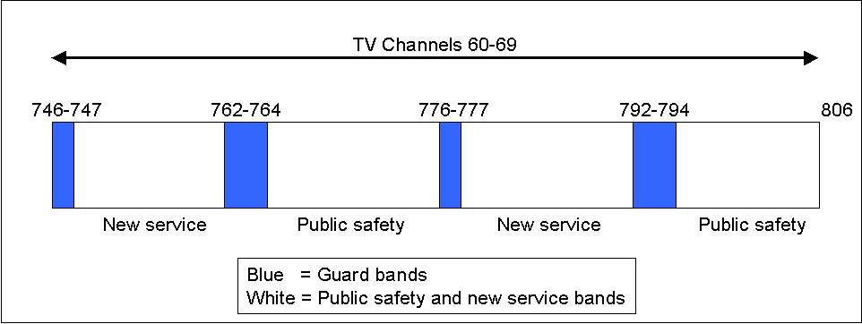

Source: ITU adapted from Carol Ting, Johannes M. Bauer, Steven S. Wildman, "The U.S. experience with non-traditional approaches to spectrum management: Tragedies of the commons and other myths reconsidered".
The guard band experiment offers a small, but interesting glimpse into what a private property approach to spectrum management would be like. Ironically, the slow progress on the band is a result of firms looking out for their own financial interests, exactly the behaviour that markets are supposed to reward.
Despite, the poor performance of the guard band project, policy makers must be cautious before writing the privatization process off as a failure. First, the FCC is still in the early stages of the experiment and the bands may very well be successful in the long run. It should also be taken into consideration that any experiment functioning in the context of a much larger legacy allocation model will encounter unique difficulties. Nextel's lack of progress on their allocated bands is directly tied to their desire to obtain another swath of frequency. If the market for spectrum were truly competitive, Nextel could have eliminated this first step of the acquisition and essentially bid exactly for the spectrum it wanted.

Wi-Fi and WLAN technologies
While some open spectrum tests have failed to produce results policy makers were looking for, the success of Wi-Fi and other WLAN technologies has surprised regulators and business leaders alike. Through the successful marketing of the Wi-Fi brand of interoperability, WECA has been able to push the IEEE 802.11b,a, and g standards around the world.
Wi-Fi and other WLAN technologies make use of unlicensed spectrum in the 2.4 and 5 GHz ranges and Wi-Fi in particular must share the 2.4 GHz range with cordless phones and microwaves. Wi-Fi use around the world may still be in early stages but its spread spectrum technology has allowed more effective use of spectrum. Even congested areas such as airports have had good success with managing a large number of WLAN users in a small area.

Experiment conclusions
Policy-makers can find many commonalities between CB radio, FRS/GMRS, and now Wi-Fi. First, spectrum for all three technologies was allocated for public use and each of the technologies has seen an initial surge of interest and sales. What remains to be seen is what happens to each of the three technologies and the frequencies they use after the initial excitement over the products wears off.
Most likely, the Wi-Fi will be the long-term winner because of its use of cutting-edge technology to fit more users into a single communications space. FRS/GMRS radios, while popular now, could become susceptible to a CB radio-type rise and fall if new technologies are not allowed to be introduced into the bands.
Companies are eager to make better and more productive use of the FRS/GMRS frequencies but current restrictions on the types of communications allowed on the channels and technical make-up of the radios will have a dampening effect on the continued effective use of the airways (see Box 10).
Box 10: Confining a RINO
How Garmin's location based services are limited by FCC restrictions on the use of GMRS frequencies
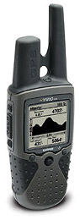
Garmin is best known for its global positioning system (GPS) products but has recently entered the FRS/GMRS market with a product called the RINO (Radio Integrated Navigation Outdoors). The RINO 130 functions as both a GPS and a two-way radio. Earlier versions of the radio (110 and 120) have been popular with outdoor users because the units combine the functionality of two devices in one.
One of the most appealing features of the RINO is the ability for users to "beam" their location to other RINO users. The GPS in the unit determines a user's latitude and longitude, which can then be sent over an FRS radio channel to other RINO users, appearing as a waypoint in their GPS. This allows them to see the location of the people on the GPS screen with whom they are communicating. The feature is an excellent way for people to locate each other in crowds or outdoor settings.
In order to include the beaming functionality into the RINO, Garmin had to overcome a difficult regulatory obstacle, sending data on a voice-only channel. Garmin petitioned the FCC and initially received a waver allowing the transmission of location data on FRS channels. Eventually the FCC made a formal rule change allowing for radios to send location data on FRS channels.

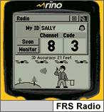 This leads to a situation where GMRS users coordinate a quick channel switch to FRS frequencies with everyone participating in the conversation. Once they are all on the same FRS channel, they quickly beam their locations to one another. Then, once everyone has received the beam, they switch back to the longer-range GMRS channels to resume communications.
The range of the location beaming service is currently limited to the 2-mile range of FRS, even though the radios are capable of reaching 5 miles on GMRS channels. Garmin has also petitioned for the FCC to allow beaming on GMRS channels but there has been no decision as of yet. This leads to an awkward situation for current radio users.
Users who purchase the radios are likely to choose the GMRS channels because of the increased range of the radios, but by doing so, cannot use the location beaming technology.
While current FCC regulations may not allow the "beaming" of locations over GMRS, the software defined radio technology in the RINO allows for it to be quickly upgraded to allow GMRS beaming if the FCC decides to allow it on the channels.
The RINO experience highlights how spectrum policy and regulations can hinder the use of new communication technologies until regulatory bodies are able to make the necessary policy changes. At the same time, the RINO experience highlights how new technologies such as software-defined radios are ensuring that regulatory changes are quickly applied to existing equipment.
Source: Garmin.
The secret to success in spectrum reform with new technologies may be how open those frequencies are to innovation. Opening up spectrum for public use played a key role in the success of CB, FRS/GMRS, and now Wi-Fi. However, both the CB and FRS/GMRS frequencies are public but not open to innovation. Wi-Fi's spectrum allocation at 2.4 GHz, on the other hand, is a fertile ground for innovation. If technologies aren't allowed to adapt in the spectrum space they can die out as fads, as happened with CB's popularity.
The experiment with guard bands has also shown that freedom to innovate within a spectrum band, in itself, is not sufficient to ensure effective use. If the band is privately owned there will still be other factors that can delay and hinder service rollouts.
Some combination of the two seems to be working well at the moment with 2.4 GHz and the new 5 GHz space agreed upon at the ITU World Radiocommunication Conference (WRC) in 2003. First, equipment manufacturers are allowed to innovate with technologies, subject to certain minimum restrictions. This allows for new and innovative uses of the spectrum and helps prevent "fad" use. Second, the band is open up for public use, ensuring that there is no one licensee that can keep the spectrum fallow for any period of time.

Policy recommendations
The future of spectrum management has never been more exciting, or more complex. Evolving technologies are making RF communication much more efficient and it is clear that spectrum policy will need to adjust to take advantage of these new technologies. However, regulators face the daunting task of deciding how to change the structure of spectrum allocation, a task not to be taken lightly. This section will make several key policy suggestions based on the issues highlighted in section 3.2. These policy recommendations are not exhaustive but rather represent the most pressing needs, and potentially most efficient changes that could come from changes in spectrum management.

Allow low power underlays to accommodate ultra wide band technologies
Regulators should initially focus their attention on underlays since they offer the highest efficiency returns for the least amount of interference. Devices that can communicate under the noise floor should initially be allowed at low power levels to ensure they do not disrupt licensed communications. The initial power level should be set as to allow UWB devices to communicate throughout a household. This allows the regulator to take an initial small step into the technology before making a commitment to allow higher-power communications. Interference temperature measures should also be considered as a possible way for UWB transmissions to use higher power in certain areas. Regulators should also make the available bands for UWB as wide as possible, decreasing the need for high power levels for short-range communication.
Initial UWB transmissions would be limited in range but policy makers should also examine how longer UWB transmissions could fit into mesh networks. For the time being, short-range transmissions can be allowed with longer-range technologies approved as technology improves and if initial UWB deployments are successful.

Set aside certain bands for experimentation with agile radios
In addition to extracting new spectrum uses from the noise floor, regulators should set aside some bands for testing agile radios. Agile radios offer the possibility to recover vast amounts of unused spectrum and should be allowed if tests show the technology to work effectively without significant interference. The higher-power transmissions of agile radios force regulators to be more cautious with allowing their use in licensed bands. As a result, regulators should proceed with initial tests before implementing coexistence policies on a wide range of frequencies for agile radios.

Create a technology advisory group
A technology advisory group can help policy makers prepare for technological changes and their repercussions on spectrum management. Regulators should make the formation of a technical advisory group a priority. This has been done in several countries around the world with great success.
Two countries offer excellent examples of groups assigned to follow technology and its effect on spectrum. The FCC's Spectrum Task Force has been instrumental in helping the US test and implement new spectrum policy. COMREG, the Irish regulator, has instituted a forward-looking programme that helps identify emerging technological trends to prepare for future regulatory impact. Setting up a technical advisory group, or task force to follow the regulatory impact of new technologies on spectrum is a simple, but productive way for regulators to prepare for future technological changes.
A technical advisory group can also play a key role in helping policy-makers decide on many of the other questions introduced in section 3.2. As these technologies are continuing to develop, policy papers will inevitably become outdated. However, an expert technical group can effectively follow the development of new technologies and advise regulators on which seem the most promising and required courses of action.

Conclusion
New technologies are changing the way regulators need to manage the frequency spectrum. Careful and thoughtful consideration of key new technologies can greatly improve the efficiency of the radio spectrum. The decisions regulators face are difficult but several technologies such as ultra-wide band and agile radios may offer immediate solutions to scarce spectrum problems. Indeed, regulators may be able to overcome dire predictions of spectrum saturation by incorporating new, efficient technologies into their regulatory schemes.

In 1948, Claude Shannon developed a theory that explains how using a wide band of frequencies to encode and send information allows communication to take place at a lower signal-to-noise ratio. In essence, this means that spreading a transmission over a wide range of frequencies over a wide range of frequencies allows for power levels at any given frequency that are non-distinguishable from the noise floor.
See Webopedia’s description of DSSS at: http://www.webopedia.com/TERM/D/DSSS.html.
See Webopedia’s site for a the definition of FHSS at: http://www.webopedia.com/TERM/F/FHSS.html.
From the Ultra-Wideband working group’s FAQ at: http://www.uwb.org/faqs.html.
See http://www.ececs.uc.edu/~radhakri/Research2.htm#switched_vs_adaptive for a good comparison of switched bean and adaptive array antennas.
Intel offers a detailed review of SDR at: http://www.intel.com/update/contents/wi07031.htm.
Faulhaber and Farber provide an excellent background on how the current system came into being.
Quote from ATT in "Wireless Industry Still Wary of Use of Spectrum 'Underlays'.
Statement from Mark McHenry of Shared Spectrum Co. (Feb 6, 2004).
See Carol Ting, Johannes M. Bauer, Steven S. Wildman, "The U.S. experience with non-traditional approaches to spectrum management: Tragedies of the commons and other myths reconsidered" at: http://quello.msu.edu/wp/wp-05-03.pdf.

