    Joint Collaborative Team on Video Coding (JCT-VC)  of ITU-T SG16 WP3 and ISO/IEC JTC1/SC29/WG11  2nd Meeting: Geneva, CH, 21-28 July, 2010 | Document: JCTVC-B026

Title: | Decoder-Side Motion Estimation with Modified Reference List
Status: | Input Document to JCT-VC
Purpose: | Information
Author(s) or  Contact(s): | Sven Klomp  Marco Munderloh  Jörn Ostermann  Institut für Informationsverarbeitung  Appelstraße 9a  30167 Hannover  Germany | Tel:  Email: | +49-511-762-19590  klomp@tnt.uni-hannover.de
Source: | Leibniz Universität Hannover
_____________________________

Abstract
Recent research revealed that the data rate can be reduced by performing additional motion estimation at the decoder. As only already decoded data is used, no additional data has to be transmitted.
This document gives an update of the results presented in [1] on the performance of decoder-side motion estimation (DSME) with new test sequences. A dense motion vector field is estimated which reduces the rate by 6.9% in average compared to the H.264/AVC anchors at the same quality.

Content
Abstract 1
Content 1
1 Introduction 2
2 DSME Architecture 2
2.1 Bidirectional true motion estimation 2
3 Performance Evaluation 3
3.1 Class A 3
3.2 Class B 4
3.3 Complexity 5
4 Conclusions 5
5 References 5
6 Patent rights declaration(s) 5

Introduction
The goal of decoder-side motion estimation (DSME) is to overcome the drawbacks of conventional motion estimation, where large block sizes increase the prediction error and smaller block sizes increase the data rate for motion vectors, respectively.

DSME Architecture
In DSME as proposed in [2], the current frame is predicted by performing motion estimation on adjacent frames at the decoder. This so called DSME frame is then fed into the reference picture buffer of a conventional coder to be used as an additional reference frame (Figure 1). The coder is now able to use the DSME frame as a reference for each macroblock. The conventional tools of the coder are now able to use the frame for prediction and coding in addition to the other reference frames. Since the interpolated frame is already motion compensated, the motion vector of the conventional motion estimation block is always zero, if the DSME frame is used for predicting a block.
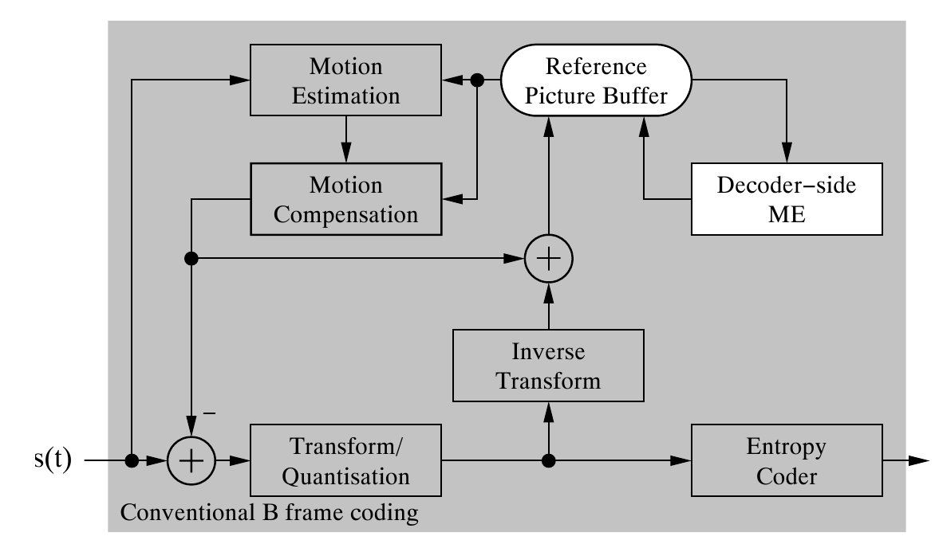
Figure 1: DSME architecture
Instead of inserting the DSME frame into the reference picture buffer, it is also possible to implement an additional macroblock mode for DSME. This mode would indicate that this block is predicted by using the DSME frame and only the residual might be send as additional data.
Due to this simple and flexible architecture, the motion estimation algorithm can be easily exchanged. In the following section, an improved motion estimation algorithm is proposed, which allows better prediction of the current frame.

Bidirectional true motion estimation
To prevent wrong motion vectors due to local minima, a hierarchical motion estimation scheme is used. In every hierarchy level, the block size is reduced to get a finer vector field. Since the coarse motion was already estimated in the previous levels, the search range is also decreased for each hierarchy level.
In the first iteration, the motion is estimated with a block size of 64x64 pixels. The two reference frames $F_{−}$ and$F_{+}$, which are used to estimate the motion, are low-pass filtered to prevent local minima due to the large search range. For all other iterations, the unfiltered references frames are used since the search ranges are smaller as mentioned before.
At each hierarchy level, the motion vectors between the previous and the next frame ($F_{−}$,$F_{+}$) are estimated using a conventional block matching algorithm by minimising the mean squared differences (MSD). The matching window of the motion estimation is slightly larger than the block size during motion compensation for smaller blocks to be more robust against image noise.
The search area of the current hierarchy level $H_{n}$ depends on the motion vectors of the previous hierarchy level $H_{n−1}$ as depicted in Figure 2.
Figure 2: Previous and current hierarchy level; Search range is depicted in red
The nine neighbouring motion vectors of the previous level $H_{n−1}$ are applied to the current block and define a set of starting points for the motion estimation. Thus, the current block is able to follow the motion of every neighbouring block if necessary.
To reduce noise in the motion vector field caused by small block sizes, the motion search is switched to a candidate based approach at a block size of smaller than 8x8. The motion vector for the current block is hereby set to one of the surrounding motion vector candidates without further refinement. This forces small blocks to decide to which motion object they belong and is achieved by setting the search range for those hierarchical levels to zero: the blocks `latch' to motion vector candidates of the previous level. The resulting motion vector field can adapt to object borders more accurately.
If the last iteration of forward motion search is finished, the motion vectors are aligned to the block grid of the current frame$F_{0}$. Thereafter, the vector field is smoothed using a vector median filter weighted by the mean absolute differences (MAD) of the displaced blocks [6] to eliminate outliers.
After the motion vector field is estimated, the intermediate frame $F_{0}$ is predicted by assuming linear motion between the previous ($F_{−}$) and the next frame ($F_{+}$). This is done by halving the motion vectors and averaging the displaced pixels from both frames.

Performance Evaluation
The performance evaluations are based on class A and B of the test set proposed in the Call for Proposals [3]. The decoder-side motion estimation algorithms were implemented in the JM software version 16.2 [4] and the same configuration parameters as for the alpha anchors were used. Bjontegaard Delta [5] is used to evaluate the performance.

Class A
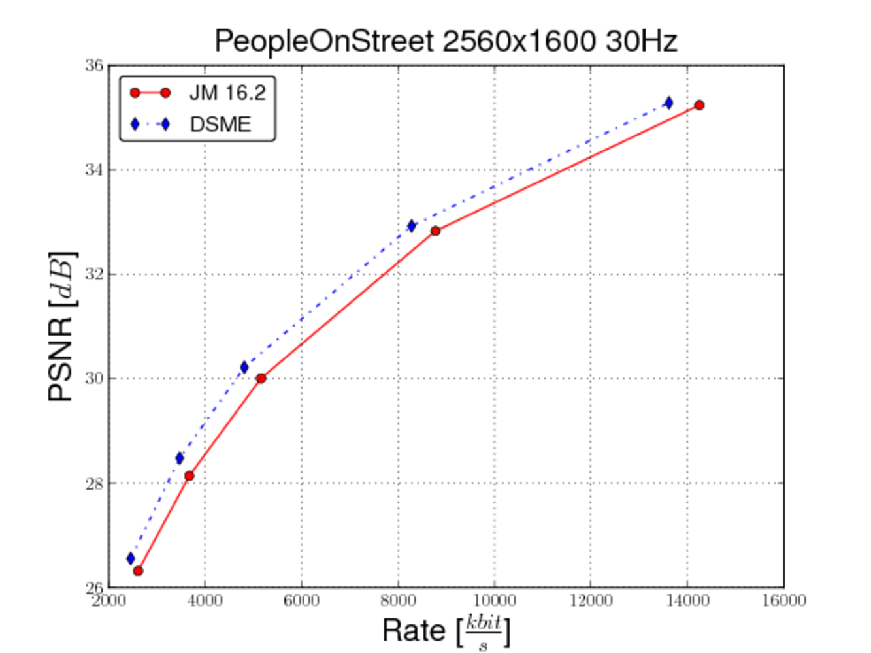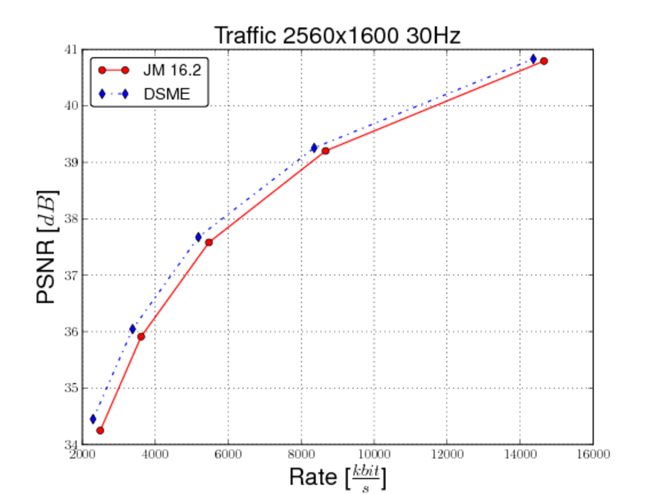^

Sequence | BD-PSNR [dB] | BD-Rate [%]
PeopleOnStreet | 0.59 | -10.03
Traffic | 0.34 | -8.56

Class B
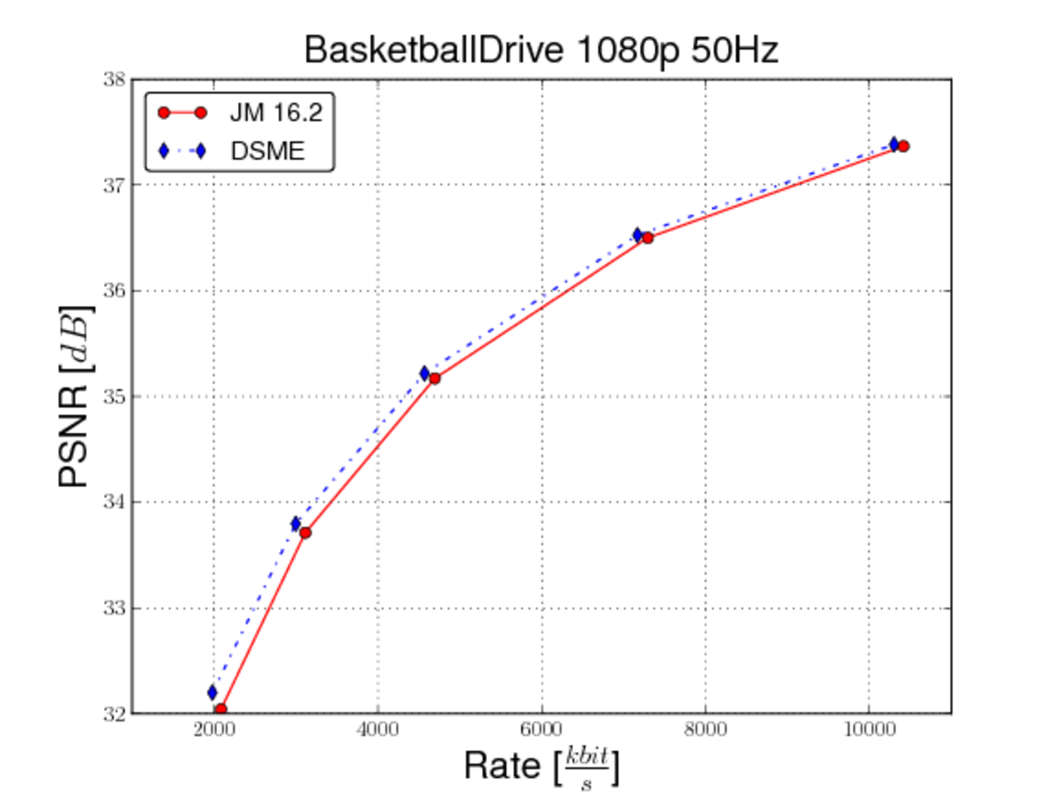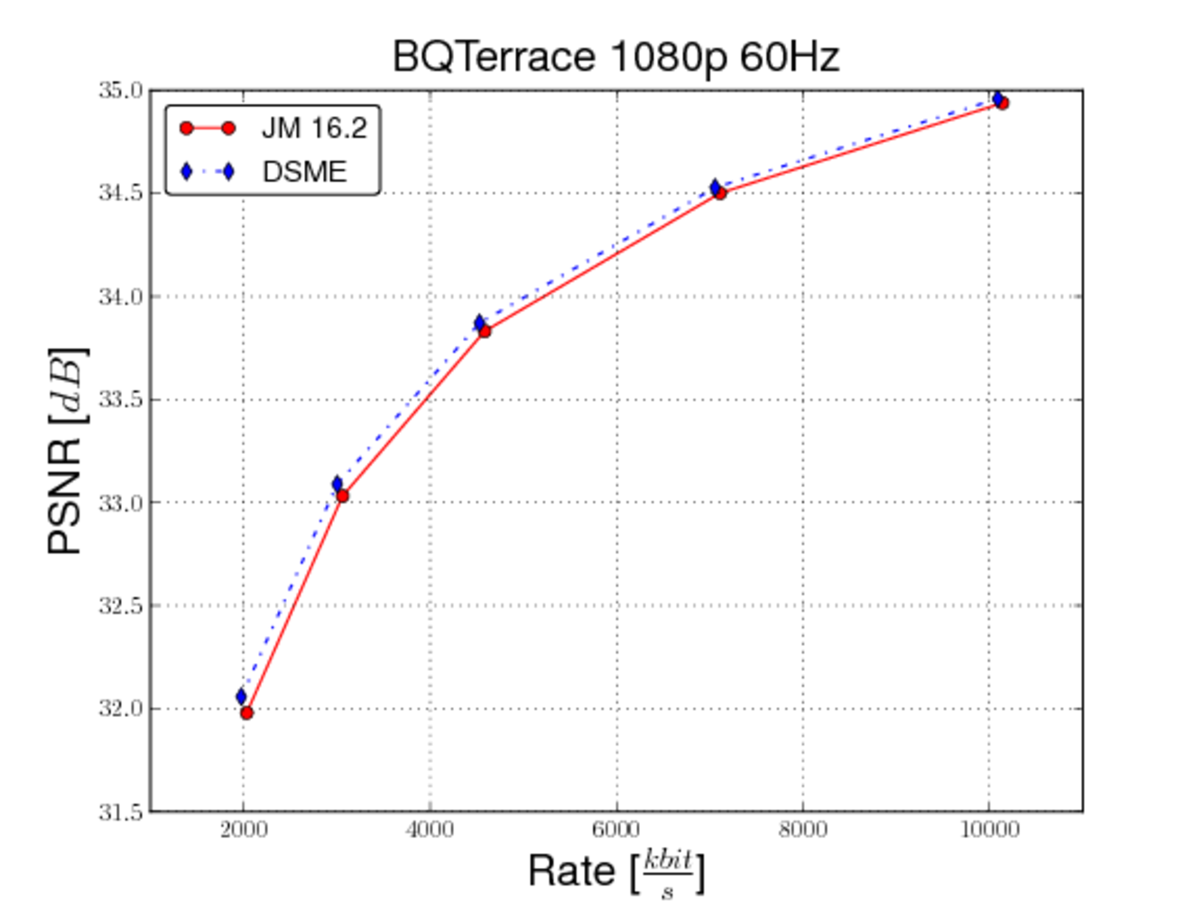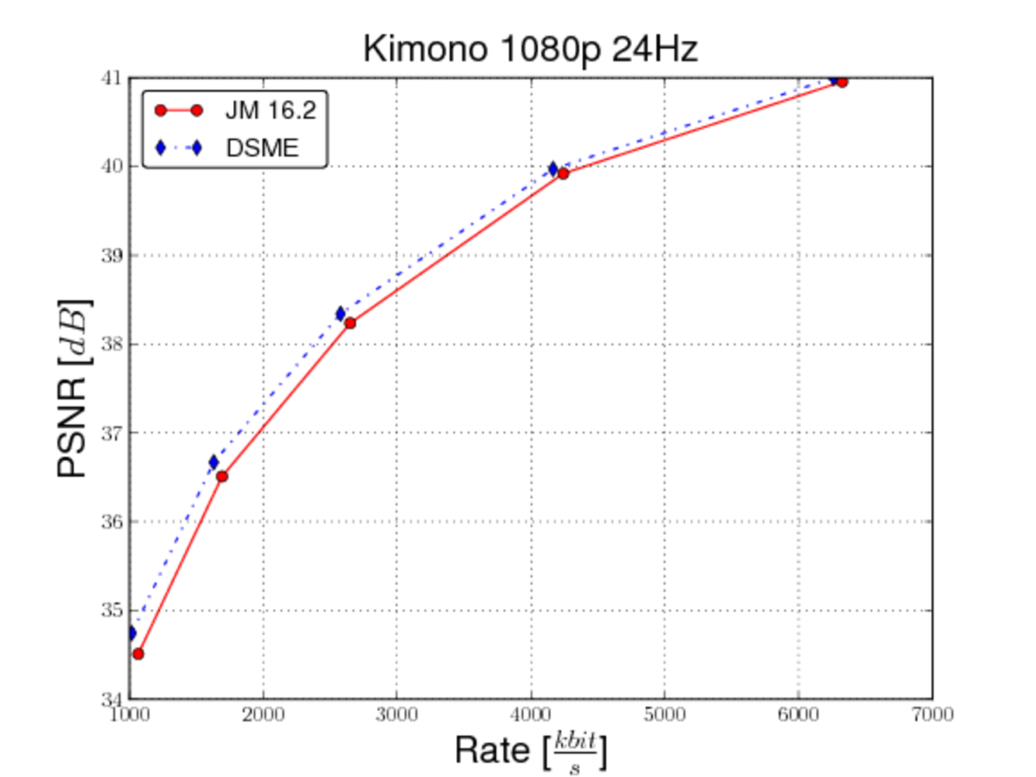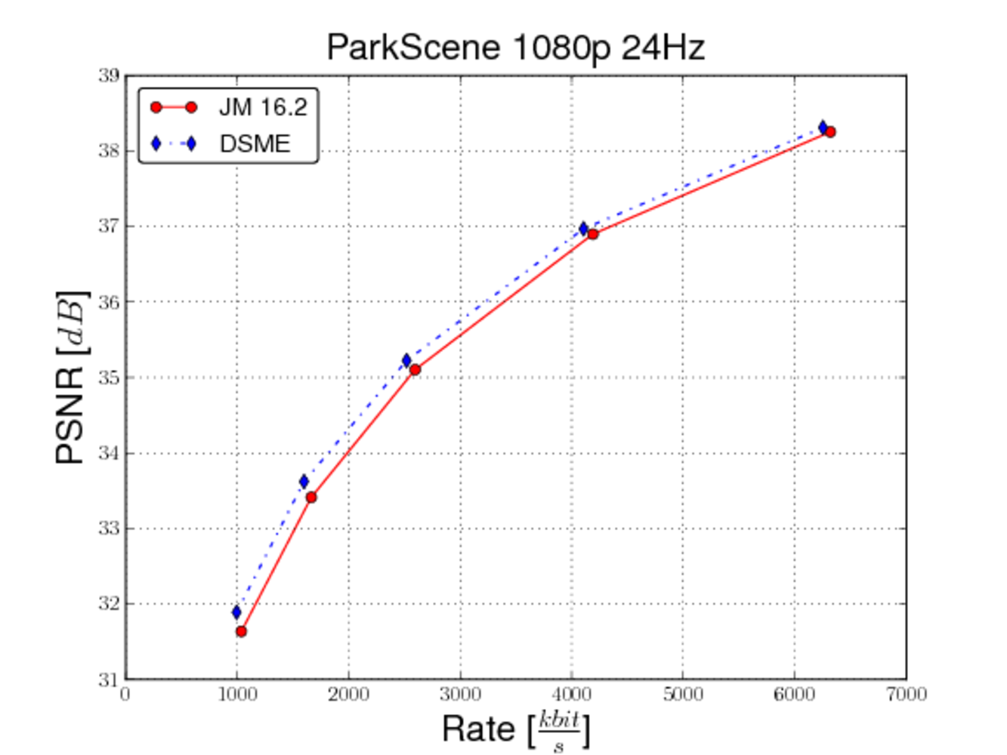

Sequence | BD-PSNR [dB] | BD-Rate [%]
BasketballDrive | 0.19 | -5,25
BQTerrace | 0.08 | -4.13
Cactus | 0.21 | -6.41
Kimono | 0.26 | -6.57
ParkScene | 0.29 | -7.48

Complexity
The proposed architecture introduces additional computational efforts at the encoder and also at the decoder. Until now, almost no particular efforts were made to optimise the algorithms complexity and the current decoder won’t work in real-time. However, similar motion estimation algorithms are used for temporal upscaling in nowadays flat screen TVs with 100 and 200 Hz techniques which may be combined with DSME.

Conclusions
The advantages of decoder-side motion estimation are investigated and compared to the common H.264/AVC coding, in which the encoder performs all motion estimation tasks solely. For the Class A sequences, the rate was reduced by up to 10%. The gain for Class B with 7% is slightly lower.

References
[1] S. Klomp, J. Ostermann, “Decoder-side Motion Estimation for Improved Prediction,” ISO/IEC JTC1/SC29/WG11, MPEG Meeting, London, UK, June 2009, Doc. M16570.
[2] S. Klomp, M. Munderloh, Y. Vatis, and J. Ostermann, “Decoder-Side Block Motion Estimation for H.264 / MPEG-4 AVC Based Video Coding”, IEEE International Symposium on Circuits and Systems, pp. 1641-1644, Taipei, Taiwan, May 2009.
[3] ITU-T Q6/16 Visual Coding and ISO/IEC JTC1/SC29/WG11, “Joint Call for Proposals on Video Compression Technology”, N11113, January 2010, Kyoto, JP.
[4] H.264/AVC Reference Software, http://iphome.hhi.de/suehring/tml/download/ version 16.2, 12th November 2009.
[5] G. Bjontegaard, “Improvements of the BD-PSNR model”, ITU-T SG16/Q6, 35th VCEG Meeting, Berlin, Germany, 16th - 18th July, 2008, Doc.VCEG-AI11.
[6] L. Alparone, M. Barni, F. Bartolini, and V. Cappellini, “Adaptive weighted vector-median ﬁlters for motion ﬁelds smoothing,” in IEEE ICASSP, Georgia, USA, May 1996.

Patent rights declaration(s)
Leibniz Universität Hannover may have IPR relating to the technology described in this contribution and, conditioned on reciprocity, is prepared to grant licenses under reasonable and non-discriminatory terms as necessary for implementation of the resulting ITU-T Recommendation | ISO/IEC International Standard (per box 2 of the ITU-T/ITU-R/ISO/IEC patent statement and licensing declaration form).

