    Joint Collaborative Team on Video Coding (JCT-VC)  of ITU-T SG16 WP3 and ISO/IEC JTC1/SC29/WG11  2nd Meeting: Geneva, CH, 21-28 July, 2010 | Document: JCTVC-B044

Title: | TE2: Adaptive scaling for bit depth compression on IBDI
Status: | Input Document to JCT-VC
Purpose: | Proposal
Author(s) or  Contact(s): | Takeshi Chujoh  Taichro Shiodera  Tomoo Yamakage  1, Komukai-Toshiba-cho, Saiwai-ku, Kawasaki, 212-8582, Japan | Tel:  Email: | +81-44-549-2288  takeshi.chujoh@toshiba.co.jp
Source: | TOSHIBA Corporation
_____________________________

Abstract
In this contribution, detailed results of an adaptive scaling for bit depth compression on IBDI are reported. This is one of proposals in Tool Experiment 2 on IBDI and memory compression. The purposes of this tool experiment are to improve coding efficiency by increasing internal process of video codec while minimizing reference frame memory access bandwidth and to reduce reference frame memory access bandwidth and reference frame memory size. This contribution shows a solution of the first purpose and as experimental results, the loss bitrate is average of 0.13% for bit depth compression on IBDI.

Introduction
At Dresden JCT-VC meeting, Tool Experiment 2 on IBDI and memory compression [1] was established and the following two issues have been discussed;
- improvement of coding efficiency by increasing internal process of video codec while minimizing reference frame memory access bandwidth,
- reduction of reference frame memory access bandwidth and reference frame memory size.
Although these two issues seem to be similar and integrated approaches have been proposed, the source entropy is not increased by increasing internal bit-depth and the first issue has a character different the second issue technically. This contribution shows one of the solutions for the first issue.

Adaptive scaling for bit depth compression
IBDI (Internal Bit Depth Increase) is a coding tool that increases the bit depth of input picture at encoder side and decreases the bit depth of output picture to input bit depth. By increasing internal bit depth, the accuracy of all internal processes is increased. This intends to reduce the rounding error of intra-fame prediction, spatial transform, in-loop filtering in order to improve coding efficiency.
For example, by increasing from 8-bit to 12-bit, DPB (Decode Picture Buffer) will be required 1.5 times of memory capacity and 1.5 times of memory bandwidth compared to storing the 8-bit depth. This is one of the most important problems about complexity. Therefore, JCTVC-A117 [2] introduced an adaptive scaling for bit depth compression. This method includes a scaling process by block and a de-scaling process by pixel. The scaling algorithm in the case of 4-bit increase is as follows:
- obtain the minimum pixel value min and the maximum pixel value max of 4x4 block,
- calculate an 8-bit minimum pixel value M (= min >> 4),
- calculate a dynamic range R between max and (M<<4),
- decide the scaling value S so that R becomes less than (128 << S),
- if S is equal to 4, then calculate sixteen storing pixel values P (= (pixel_value+8)>>4) by using fixed scaling, store P and M is set to 0, else calculate sixteen storing pixel values P (= (pixel_value - (M<<4))>>S) and store S, M, and P.
Although stored format on DPB is non-normative, for example, 1-bit flag by 4x4 block indicates fixed scaling or adaptive scaling and if the flag indicates fixed scaling, sixteen 8-bit values P are described and if the flag indicates adaptive scaling, an 2-bit value S, an 8-bit minimum pixel value M and sixteen 7-bit value P are described.
The de-scaling algorithm is as follows:
- read S, M and P,
- calculate the de-scaling value D (= (P << S) + (M<<4) + ((S!=4 || S!=0)? (1<<(S-1)):0) ) and use D as the pixel value.
Figure 1 explains the relationship of above values.
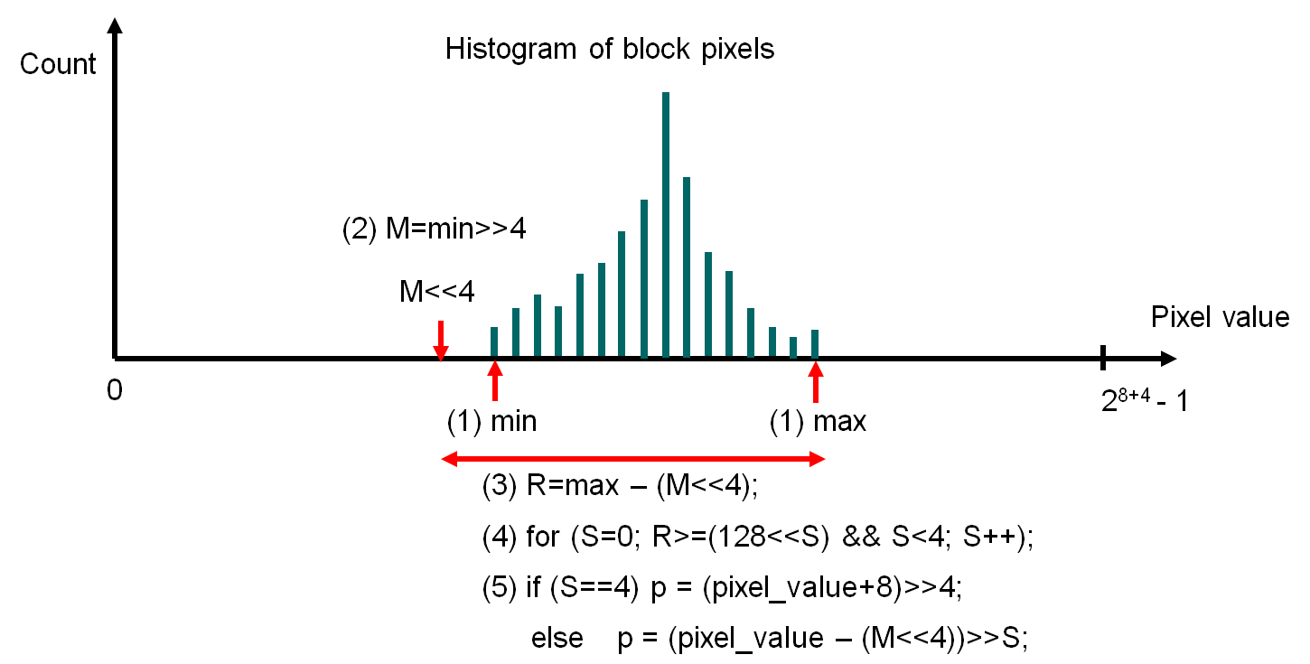

Figure 1 Bit depth compression process

Actually, this algorithm is a loss less compression on 8-bit depth level. This means that fixed scaling pixel value matches pixel value, which is adaptive de-scaled firstly and is fixed scaled secondary. Therefore, adaptive scaling can get the results surely better than fixed scaling.
In addition, since the scaling process is similar to filtering process, it is possible to integrate this method and in-loop/de-blocking filtering process.

Experimental results
The simulation was conducted for all sequences of WQVGA, WVGA, 720p, 1080p and cropped 4kx2k based on the recommended simulation common conditions, JCTVC-A302r1 [1]. The 5-point BD-rate (%) is measured according to RBJM macro with third parameter equal to 4 proposed by JCTVC-B031 [5]. Table 1 indicates the results of loss coding efficiency of adaptive scaling and fixed scaling compared to IBDI anchors. Since there values show loss results from anchor condition, the smaller values mean better results. While fixed scaling losses 0.94% on average, adaptive scaling only losses 0.13% on average.

Table 1 Loss BD-rate (%) of adaptive scaling and fixed scaling
 |  |  | CS1 |  | CS2
 |  |  | Adaptive | Fixed | Adaptive | Fixed
A | S01 | Traffic | 0.288 | 1.013 | N/A | N/A
A | S02 | PeopleOnStreet | 0.055 | 0.731 | N/A | N/A
B | S03 | Kimono | 0.000 | 0.533 | 0.078 | 1.346
B | S04 | ParkScene | 0.003 | 0.504 | 0.113 | 1.309
B | S05 | Cactus | -0.014 | 0.493 | 0.243 | 1.202
B | S06 | BasketballDrive | 0.125 | 0.592 | 0.121 | 1.232
B | S07 | BQTerrace | 0.029 | 0.926 | 0.436 | 1.751
C | S08 | BasketballDrill | -0.027 | 0.201 | 0.052 | 1.416
C | S09 | BQMall | -0.022 | 0.298 | 0.038 | 0.640
C | S10 | PartyScene | -0.049 | 0.120 | 0.291 | 0.693
C | S11 | RaceHorses | 0.136 | 0.223 | 0.141 | 0.366
D | S12 | BasketballPass | -0.075 | 0.302 | 0.038 | 0.551
D | S13 | BQSquare | 0.246 | 0.432 | 0.206 | 0.579
D | S14 | BlowingBubbles | 0.024 | 0.397 | 0.046 | 0.713
D | S15 | RaceHorses | 0.055 | 0.180 | 0.159 | 0.271
E | S16 | Vidyo1 | N/A | N/A | 0.456 | 4.201
E | S17 | Vidyo3 | N/A | N/A | 0.648 | 3.004
E | S18 | Vidyo4 | N/A | N/A | 0.284 | 3.346
Class A |  |  | 0.172 | 0.872 | N/A | N/A
Class B |  |  | 0.028 | 0.610 | 0.198 | 1.368
Class C |  |  | 0.010 | 0.210 | 0.131 | 0.779
Class D |  |  | 0.062 | 0.328 | 0.112 | 0.529
Class E |  |  | N/A | N/A | 0.462 | 3.517
Total |  |  | 0.052 | 0.463 | 0.209 | 1.414

Although the results of compression ratio depend on the compression format, in the case of presented format in section 2, the compression ratio is 7.71-bit on average. Maximum ratio is 7.77-bit and minimum ratio is 7.69-bit. The ratio of all sequences is less than 8-bit depth.
The complexity is measured by the encoding and decoding time. The measurement values are output of encoder and decoder and the decoder does not output decoded image. The OS is Windows XP SP2 64-bit, the CPU is Xeon® W3565, 3.2GHz and the compiler is Visual C++ 2005. Table 2 indicates the results of increase rate of average encoding and decoding times. The results of adaptive scaling and fixed scaling are not significantly different.

Table 2 Increase rate (%) of average encoding and decoding times
Proponent | Adaptive |  | Fixed
Condition | CS1 | CS2 | CS1 | CS2
Encoding Time | 0.39 | 1.88 | 0.85 | 4.85
Decoding Time | 5.94 | 6.67 | 5.66 | 7.78

In addition, as subjective quality checking of decoded sequences, the subjective quality difference caused by adaptive scaling is visually negligible.

Conclusion
In this contribution, the experimental results of adaptive scaling for bit depth compression on IBDI were shown. As experimental results, the bitrate loss by adaptive scaling was average of 0.13% and that value is definitely smaller than the value of fixed rounding. Since additional complexity is negligible, we think that the integration of this method and in-loop/de-blocking filtering process is a good solution.

Reference
[1] T. Chujoh, “Tool Experiment 2 on IBDI and memory compression,” JCT-VC Document, JCTVC-A302r1, Dresden, April 2010.
[2] T. Chujoh, A. Tanizawa and T. Yamakage, “Description of video coding technology proposal by TOSHIBA,” JCT-VC Document, JCTVC-A117, San Jose, April 2010.
[3] S. Pateux, “Tools for proposal evaluations,” JCT-VC Document, JCTVC-A031, Dresden, April 2010.

Patent rights declaration(s)
TOSHIBA Corporation may have IPR relating to the technology described in this contribution and, conditioned on reciprocity, is prepared to grant licenses under reasonable and non-discriminatory terms as necessary for implementation of the resulting ITU-T Recommendation | ISO/IEC International Standard (per box 2 of the ITU-T/ITU-R/ISO/IEC patent statement and licensing declaration form).

