    Joint Collaborative Team on Video Coding (JCT-VC)  of ITU-T SG16 WP3 and ISO/IEC JTC1/SC29/WG11  2nd Meeting: Geneva, CH, 21-28 July, 2010 | Document: JCTVC-B051

Title: | Region-based adaptive interpolation filter
Status: | Input Document to JCT-VC
Purpose: | Proposal
Author(s) or  Contact(s): | Shohei Matsuo  Yukihiro Bandoh  Seishi Takamura  Hirohisa Jozawa  1-1, Hikari-no-oka, Yokosuka-shi, Kanagawa 239-0847, JAPAN | Tel:  Email: | +81-46-859-2070  matsuo.shohei@lab.ntt.co.jp
Source: | NTT (Nippon Telegraph and Telephone) Corporation
_____________________________

Abstract
This document reports the enhancement of AIF employed in KTA. Conventional AIF optimizes the filter coefficients on a frame-by-frame basis. When an original image has uniform texture or movement, conventional AIF is adequate. However, when the image has multiple movements or each region of the image has different texture, the coding efficiency could improve by using region-by-region interpolation filter. The proposal was implemented in KTA to evaluate its performance. With the anchor of KTA 2.6r1, the average BD-rate gain for the P-frame of the proposal compared to SAIF was about 0.6 points (SAIF: 5.0%, proposal: 5.6%) for the HEVC CfP sequences. The maximum gain was about 2.3 points (SAIF: 4.3%, proposal: 6.6%) for the sequence “Cactus”.

Introduction
In H.264/AVC, a 6-tap filter with weights [(1, −5, 20, 20, −5, 1)/32] is used to interpolate the pixels at half-pel position. The coefficient values of the filter are constant regardless of the characteristics of the input video sequences. To improve the performance of interpolation, adaptive interpolation filters (2D-AIF [1], SAIF [2]) were proposed. Each AIF derives the optimal filter coefficients for each frame. In this contribution, the enhanced AIF is proposed.

Region-Based AIF

Basic idea
In SAIF, filter coefficients are optimized on a frame-by-frame basis. When the image has plural regions each of which has different characteristics (motion, texture, etc.), single filter coefficients set may not be the optimal option. Instead, region-based AIF (RBAIF) approach is expected to perform better (see Fig. 1). In the proposal, the optimal filter coefficients are calculated for each region. Additional filter coefficients are coded and sent to the decoder.

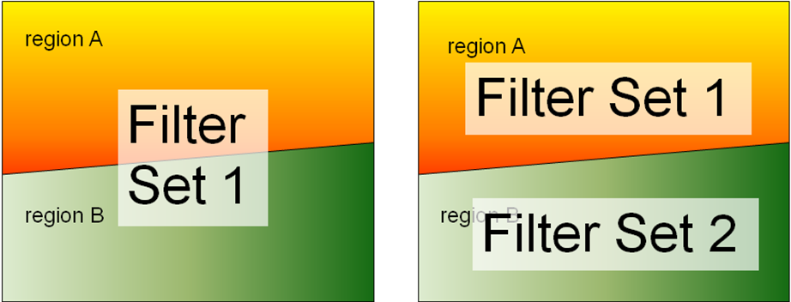
Fig. 1: Difference between conventional AIF (left) and proposed AIF (right).

Detailed algorithm
In RBAIF, the frame is divided into multiple regions according to coding information. Several region-dividing modes are predefined, and the RD cost of each mode is calculated. Finally, the best region-dividing mode is chosen and sent to the decoder. The proposed scheme can have arbitrary number of regions. In the current specific implementation, each 4x4-block is classified into two or three or four region types. The number of region types depends on the region-dividing mode. Each region is assigned its own coefficient set. The details for region-dividing modes are shown in Tab. 1.
In Tab. 1, α and β represent the threshold values determined by the MV histogram to satisfy the numbers of blocks in Region-1 and Region-2 are almost same. W and H represent the width and height of the frame, respectively.

Tab. 1: Definition of region-dividing modes.
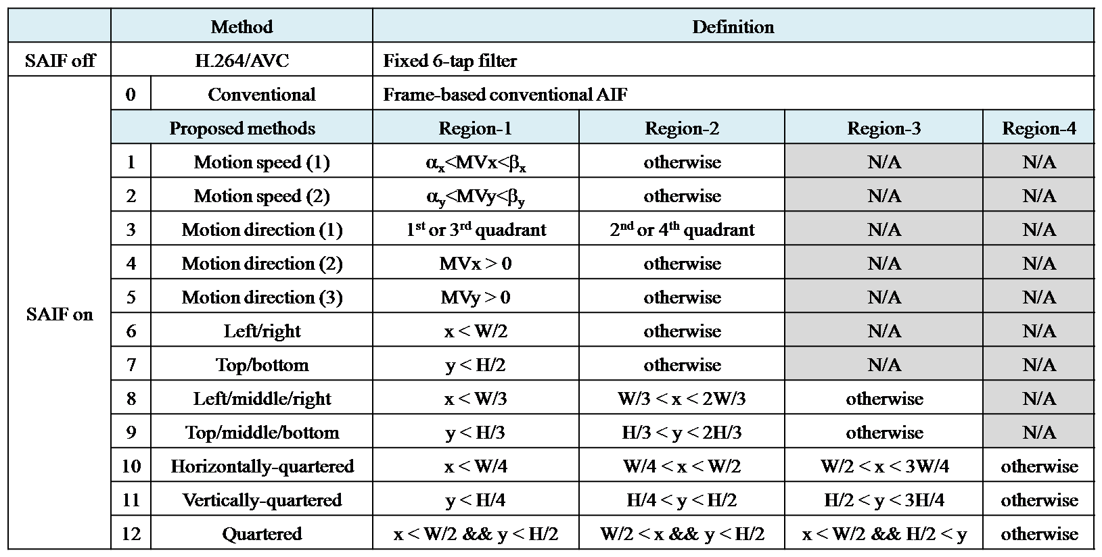

Please note that no additional information is needed to signal the block classification. Based on the region-dividing mode, the decoder decides the region each block belongs to. The proposal is currently an extension of SAIF in terms of filter coefficient coding. Of course, the concept of the proposal can be also coupled with other AIF methods.

Experimental results
The proposal has been implemented in KTA 2.6r1. It is noted that the proposed method is only applied to luminance signal. The simulation conditions were as follows.

- GOP structure: IPPP
- QP values: QP(I)=22, 27, 32, 37 / QP(P)=QP(I)+1
- Number of encoded frames: 2 frames
- Interpolation Filter: SAIF (UseAdaptiveFilter=2 and other KTA tools were turned off.)
- Other parameters were same as the default parameters in KTA2.6r1-encoder.cfg.

The objective performance is shown in Tab. 2. The gains (BD-rate and BD-PSNR [3] for the first P-frame) with the anchor of KTA 2.6r1 are calculated. “Δ” represents the BD-rate difference between SAIF and RBAIF. The average gain of BD-rate was about 0.6 points (SAIF: 5.0%, RBAIF: 5.6%). The maximum gain was about 2.3 points (SAIF: 4.3%, RBAIF: 6.6%) for the sequence “Cactus”.

Tab. 2: RD-performance compared to KTA2.6r1 (H.264/AVC 6-tap filter).
Class | BD-PSNR [dB] |  |  | BD-rate [%] |  |  | Maximum Δ of BD-rate
Class | SAIF | RBAIF | Δ | SAIF | RBAIF | Δ | Maximum Δ of BD-rate
A | 0.219 | 0.239 | 0.019 | −5.867 | −6.365 | −0.498 | Traffic: −0.786
B | 0.189 | 0.218 | 0.029 | −6.812 | −7.829 | −1.017 | Cactus: −2.306
C | 0.126 | 0.148 | 0.022 | −2.929 | −3.419 | −0.490 | PartyScene: −1.431
D | 0.177 | 0.180 | 0.003 | −4.356 | −4.448 | −0.092 | BQSquare: −0.570
E | 0.166 | 0.195 | 0.028 | −5.218 | −5.925 | −0.707 | Vidyo3: −2.059
All | 0.172 | 0.192 | 0.021 | −5.033 | −5.618 | −0.585

Conclusion
In this contribution, a region-based AIF technique was proposed. Average gain of coding efficiency against conventional SAIF was about 0.6 points (SAIF BD-rate=5.0%, proposal BD-rate=5.6%). The proposal can be applied to other AIF methods such as 2D-AIF and EAIF that have already been employed in KTA software. More effective region-dividing methods will be investigated.
It is recommended to incorporate the proposal into HEVC.

References
[1] Y. Vatis, B. Edler, D. T. Nguyen and J. Osterman., “Two-dimensional non-separable adaptive wiener interpolation filter for H.264/AVC,” ITU-T SG16 Q.6 Document, VCEG-Z17r1, 26th VCEG Meeting, Busan, Korea, April 2005.
[2] S. Wittmann and T. Wedi., “Separable adaptive interpolation filter for video coding,” in Proc. International Conference on Image Processing (ICIP) 2008, San Diego, California, USA, October 2008.
[3] G. Bjontegaard, “Calculation of average PSNR differences between RD-curves,” ITU-T SG16 Q.6 Document, VCEG-M33, 13th VCEG Meeting, Austin, Texas, USA, April 2001.

Patent rights declaration(s)
NTT Corporation may have IPR relating to the technology described in this contribution and, conditioned on reciprocity, is prepared to grant licenses under reasonable and non-discriminatory terms as necessary for implementation of the resulting ITU-T Recommendation | ISO/IEC International Standard (per box 2 of the ITU-T/ITU-R/ISO/IEC patent statement and licensing declaration form).

