    Joint Collaborative Team on Video Coding (JCT-VC)  of ITU-T SG16 WP3 and ISO/IEC JTC1/SC29/WG11  2nd Meeting: Geneva, CH, 21-28 July, 2010 | Document: JCTVC-B052

Title: | TE3: Adaptive Global Motion Temporal Prediction
Status: | Input Document to JCT-VC
Purpose: | Proposal
Author(s) or  Contact(s): | Andreas Krutz, Alexander Glantz, and Thomas Sikora  Technische Universität Berlin, Sekr. EN1, Einsteinufer 17, 10587 Berlin, Germany | Email: | krutz@nue.tu-berlin.de  glantz@nue.tu-berlin.de  sikora@nue.tu-berlin.de
Source: | Technische Universität Berlin
_____________________________

Abstract
This document presents the results for Subtest 1 of Tool Experiment 3 (Inter Prediction in HEVC) [1]. The tool presented herein is a novel prediction mode, i.e. Adaptive Global Motion Temporal Prediction (GMTP), for hybrid video coding environments that is based on global motion compensation and optionally on temporal filtering of spatially aligned pictures. Once a GMTP picture is available, the encoder chooses the macroblock types by means of rate-distortion optimization (RDO). If it chooses to encode a block using GMTP, only the type identifier is sent inside the macroblock header. No further information, e.g. coded block pattern, quantization parameters and coefficients are included in the bitstream for that block. This is a new GMTPSKIP mode.
The method has been evaluated using a set of 33 test sequences, including classes A to D of the CfP [3]. The evaluation follows the experimental conditions of [1]. The new prediction mode has been incorporated into the H.264/AVC reference software JM 17.0 [4]. Bit rate savings of up to 33% (BBC-Pan-13 sequence) could be reached.

Proposed Method

General concept
The core of the method presented herein is a refined motion prediction based on short-term and long-term global motion estimation. Multiple previously decoded reference pictures from the past and/or future can be used in combination in order to arrive at a precise prediction signal. Figure 1 shows a coding environment that is based on the proposed Adaptive Global Motion Temporal Prediction.

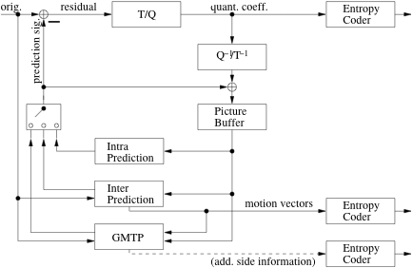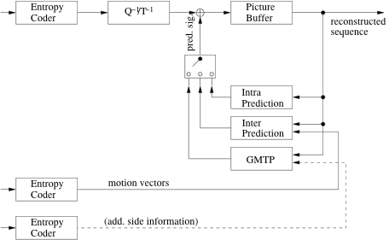
Figure 1 - Encoder and decoder based on Adaptive Global Motion Temporal Prediction

For prediction signal generation, global motion parameters are estimated between the current picture and a number N of previously decoded pictures at the encoder, resulting in a set of short-term global motion parameters, e.g. based on an 8-parameter perspective motion model, which can then be combined to long-term parameters. These long-term parameters can then be used to compensate the global motion between those N pictures and the current picture, which is illustrated in Figure 2.

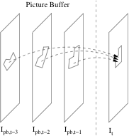
Figure 2 - Generation of a prediction signal for the current picture. The pictures inside the decoded picture buffer can be past and/or future pictures in display order.

For each pixel in a block of the current picture, the N related pixels in the N decoded pictures are blended together, e.g. using a median filter, to generate a predicted value with reduced coding noise. The encoder can adaptively choose an optimal number of pictures N by means of error minimization between prediction signal and original.
Once available, the encoder chooses the macroblock types by means of rate-distortion optimization. If it chooses to encode a block using GMTP, only the type identifier is sent inside the macroblock header. No further information, e.g. coded block pattern, quantization parameters or coefficients are included in the bitstream for that block. This corresponds to the SKIP mode. However, the prediction quality is generally better. The encoder sends additional side information to the receiver, i.e. global motion parameters and number N of pictures used for filtering on a slice/picture level.

Motion model and motion parameter estimation
Many video sequences have been recorded with a moving and zooming camera, resulting in complex motion in sequences to be coded. Higher-order motion models can efficiently account for the motion a camera performs. In the method presented herein, an 8-parametric higher-order motion model (the well-known perspective motion model) is used:
$$\begin{aligned}x_{q}=\frac{m_{0}x_{p}+m_{1}y_{p}+m_{2}}{m_{6}x_{p}+m_{7}y_{p}+1} \\ y_{q}=\frac{m_{3}x_{p}+m_{4}y_{p}+m_{5}}{m_{6}x_{p}+m_{7}y_{p}+1}\end{aligned}$$
In the above equation, (x_{p},y_{p})^{T} is the location of a pixel in picture I_{p} and (x_{q},y_{q})^{T} is its corresponding position in picture I_{q}. The parameters m₀ to m₇ describe the motion by means of translation, scaling, rotation, and perspective transformation. The matrix below describes these parameters between frame p and q.
$W_{p,q}=\left[\begin{matrix}m_{0,p,q} & m_{1,p,q} & m_{2,p,q} \\ m_{3,p,q} & m_{4,p,q} & m_{5,p,q} \\ m_{6,p,q} & m_{7,p,q} & 1\end{matrix}\right]$.
The global motion estimation algorithm used herein derives a homography W for a pair of pictures from a motion vector field available in common bitstreams using a Helmholtz Tradeoff Estimator (HTE). The HTE is a robust estimator with the ability of detecting up to 80% of outliers in a given dataset for an underlying model using subsets. For every randomly chosen subset out of a given motion vector field, a perspective transformation matrix W is calculated. In the next step, every motion vector position is transformed using W. The λth percentile of the distances between estimated and true motion vector destinations computes a standard deviation that is used to part the subset into inliers and outliers. Here, λ depends on the desired outlier tolerance. All inliers are used to calculate a final homography W_{s} by least squares for every subset. The homography belonging to the subset with the highest rating in terms of amount of inliers vs. inlier variance is taken as the final homography. For further information see [2].

Concatenation of short-term global motion parameters
Long-term motion parameters are then derived by accumulating a set of previously estimated/decoded short-term motion parameters
$T=\left\{W_{0,1},W_{1,2},K,W_{N−2,N−1}\right\}$,
as is exemplary shown in Figure 3. The accumulation is done by simple matrix multiplication. In that way, the motion between any arbitrary pair of pictures from the set is obtained.
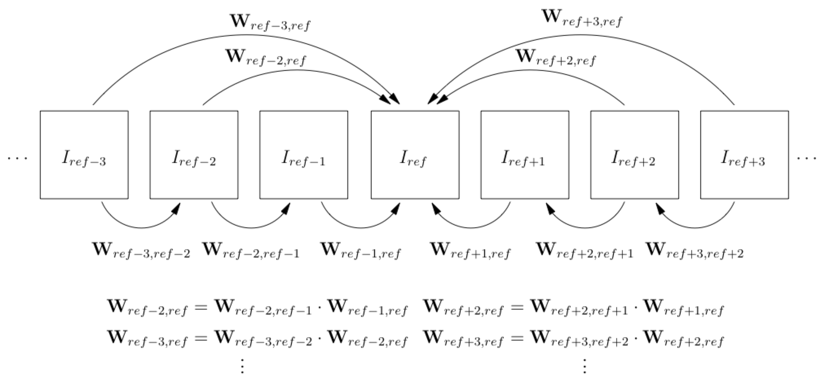
Figure 3 - Generation of long-term global motion parameters.

Bitstream organization
Besides the common bitstream, the information shown in Table 1 is sent to the receiver.

Table 1 - Description of additional side information in bitstream.
Name | Location | Description
GMTP enabled | Picture parameter set | Enables Adaptive GMTP inside the coder (1 bit) globally once for the complete sequence
Global motion parameters | Slice header | 256 bit global motion parameter set (4 byte floating point precision per parameter, 8 parameters for perspective motion model)
N | Slice header | Number of pictures used for filtering (coded as unsigned exp-golomb code)

The information inside the slice header is appended at the end, resulting in the slice header data syntax shown in Table 2. The macroblock layer syntax changed according to Table 3.

Table 2 - Slice header data syntax.
slice_header() {
// receive common slice header information
if( GMTPEnabled == TRUE ) {
for( i = 0; i <8; ++i ) {
// receive 32 bit floating point number
}
N = ue_v( “SH: filter length”, currStream );
}
}
Table 3 - Macroblock layer syntax.
macroblock_layer() {
mb_type
if( mb_type == GMTP ) {
// receive no more information
} else {
// receive common information depending on mb_type
}
}

Experimental evaluation

Experimental conditions
For experimental evaluation, the proposed prediction mode has been incorporated into the H.264/AVC reference software JM 17.0 [4]. The settings follow constraint set 2 from the CfP [3]. Additionally to the conditions described in [1], the method has been evaluated using all sequences released for the CfP as well as four sequences listed in Table 4. Other than demanded in [1], the complete sequences were coded.

Table 4 - Sequences used for experimental evaluation besides the sequences released for the CfP.
Name | Source | Resolution | Frames | FPS
Basketball | ZDF, German television | 1024x576 | 300 | 25
BBC-Pan-13 | BBC documentary Planet Earth | 720x576 | 110 | 25
Desert | BBC documentary Planet Earth | 720x576 | 240 | 25
Entertainment | RAI, Italian television | 720x576 | 250 | 25

Rate-distortion performance
The results have been evaluated on the basis of BD-measures [5], [6]. Table 5 to Table 9 show the results obtained for all test sequences as well as average BD-measures for every class. It is distinguished between high bit rate regions and low bit rate regions. High regions are defined by the set of QPPSlice values {22,27,32,37}, low regions are defined by the set of QPPSlice {32,37,42,47}. The filter length has been fixed to N=1, meaning no temporal filtering is performed for these first experiments. Figure 4 to Figure 7 show exemplary rate-distortion curves.
The maximum gain among all test sequences in the lower bit rate regions is 33.07% for the BBC-Pan-13 test sequence (14.94% for BQTerrace considering only the CfP sequences). In the higher bit rate regions also, 11.12% could be gained for Flowervase_416x240. However, loss in rate-distortion performance could be observed as well. The occurrence of loss seems to correlate with the resolution of the sequence meaning the smaller the resolution the more probable its occurrence. Additionally, the loss for sequences like RaceHorses of either resolution seems obvious since in that sequence no global motion exists. This matter is further discussed in Section 2.4. However, Table 10 shows average saving results per class assuming that a sophisticated encoder is able to automatically switch on or off GMTP coding on a picture basis. This could be done either by motion analysis of a picture or rate-distortion optimization on a picture level.

Table 5 - Results for Class A
Sequence | BD-Rate High [%] | BD-PSNR High [dB] | BD-Rate Low [%] | BD-PSNR Low [dB]
ParkJoy 000-249 | 0.19 | -0.01 | -0.26 | 0.01
ParkJoy 250-499 | 0.08 | -0.00 | -0.21 | 0.01
PeopleOnStreet | -0.31 | 0.01 | -0.37 | 0.02
Traffic | -3.79 | 0.13 | -3.43 | 0.16
Average | -0.96 | 0.03 | -1.07 | 0.05

Table 6 - Results for Class B
Sequence | BD-Rate High [%] | BD-PSNR High [dB] | BD-Rate Low [%] | BD-PSNR Low [dB]
BasketballDrive | -0.73 | 0.02 | -4.47 | 0.20
BQTerrace | -1.71 | 0.08 | -14.94 | 0.64
Cactus | -0.31 | 0.01 | -0.05 | 0.00
ChristmasTree | -0.39 | 0.02 | -3.79 | 0.14
Kimono1 | -0.25 | 0.01 | -5.26 | 0.28
ParkScene | -0.68 | 0.02 | -3.31 | 0.12
Tennis | 0.01 | 0.00 | -0.54 | 0.03
Wisley2 | -2.83 | 0.11 | -12.31 | 0.42
Average | -0.86 | 0.03 | -5.58 | 0.23

Table 7 - Results for Class C
Sequence | BD-Rate High [%] | BD-PSNR High [dB] | BD-Rate Low [%] | BD-PSNR Low [dB]
BasketballDrill | -0.63 | 0.03 | 2.36 | 0.10
BQMall | -0.67 | 0.03 | -1.21 | 0.07
Flowervase_832x480 | -5.13 | 0.21 | -11.81 | 0.56
Keiba_832x480 | -3.09 | 0.13 | -9.98 | 0.55
Mobisode2_832x480 | -1.46 | 0.04 | 3.08 | -0.19
PartyScene | -4.69 | 0.22 | -2.44 | 0.10
RaceHorses_832x480 | 0.17 | -0.01 | 0.09 | -0.00
Average | -2.21 | 0.09 | -2.84 | 0.17

Table 8 - Results for Class D
Sequence | BD-Rate High [%] | BD-PSNR High [dB] | BD-Rate Low [%] | BD-PSNR Low [dB]
BasketballPass | 1.04 | -0.05 | 4.55 | -0.21
BlowingBubbles | -0.97 | 0.04 | 8.20 | -0.29
BQSquare | -3.86 | 0.18 | -3.80 | 0.13
Flowervase_416x240 | -11.12 | 0.57 | 10.82 | -0.96
Keiba_416x240 | -2.46 | 0.14 | -2.57 | 0.15
Mobisode2_416x240 | 3.39 | -0.19 | 18.07 | -1.45
RaceHorses_416x240 | 0.95 | -0.05 | 3.85 | 0.16
Average | -1.86 | 0.09 | 5.59 | -0.35

Table 9 - Results for other sequences
Sequence | BD-Rate High [%] | BD-PSNR High [dB] | BD-Rate Low [%] | BD-PSNR Low [dB]
Basketball | -0.51 | 0.02 | -11.33 | 0.60
BBC-Pan-13 | -9.63 | 0.48 | -33.07 | 2.86
Desert | -1.58 | 0.06 | -8.36 | 0.61
Entertainment | -1.72 | 0.08 | -5.49 | 0.27
Average | -3.36 | 0.16 | -14.56 | 1.09

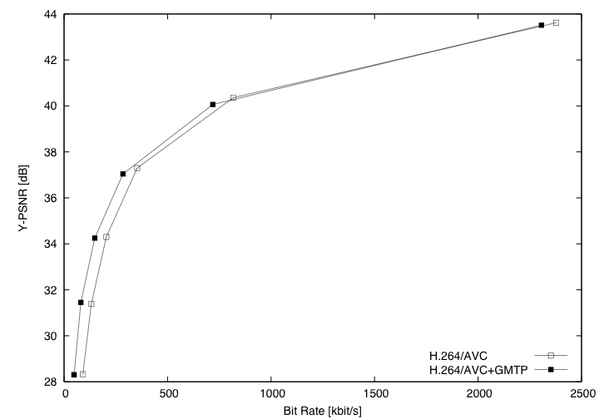  Figure 4 - RD curves for BBC-Pan-13 | 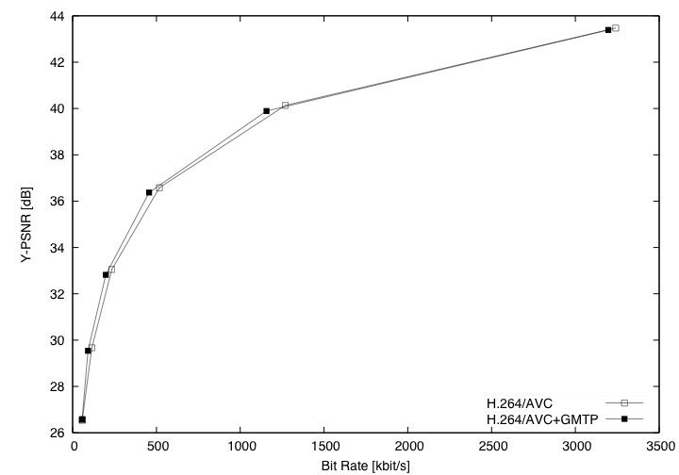  Figure 5 - RD curves for Flowervase 832x480
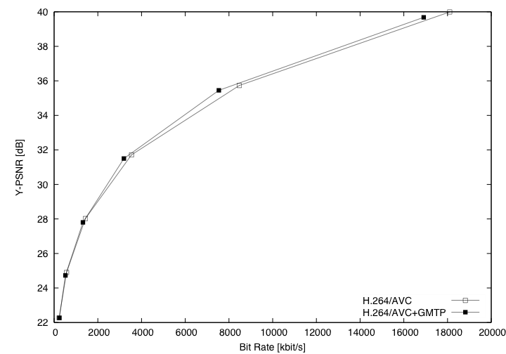  Figure 6 - RD curves for PartyScene | 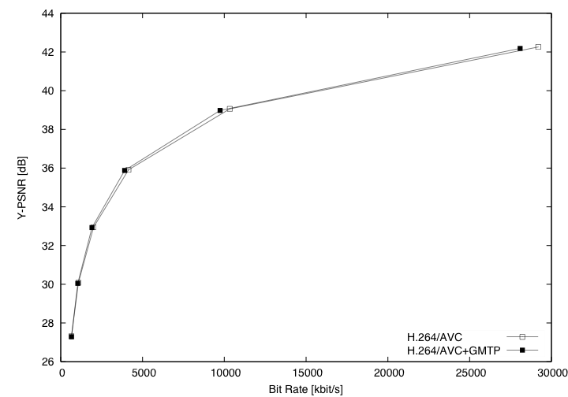  Figure 7 - RD curves for Traffic

Table 10 – Average savings per class assuming picture-based RDO that results in gain only.
Class | BD-Rate High [%] | BD-PSNR High [dB] | BD-Rate Low [%] | BD-PSNR Low [dB]
A | -1.03 | 0.04 | -1.07 | 0.05
B | -0.86 | 0.03 | -5.58 | 0.23
C | -2,24 | 0.09 | -3.63 | 0.18
D | -2.63 | 0.13 | -0.91 | 0.02
Other | -3.36 | 0.16 | -14.56 | 1.09

Complexity
The complexity of the new prediction mode has been evaluated as multiple of coding time used for the references. With factor 1.05, the encoder’s complexity is only marginally larger than the reference’s. This can be explained with the reduced amount of bits for coding a GMTP macroblock since no information is sent besides the macroblock type identifier. Still, coding is slightly more complex due to additional computation like picture transformation and interpolation. Time for global motion estimation is excluded from these results, since global motion parameter files were supplied to the encoder. However, the motion vector-based approach used herein follows the description from 1.2. It is a very low complex method taking about 900 ms per picture and does therefore not drastically influence the complexity results. A factor of 1.2 should be a good estimate for the factor including GME.

Discussion
The general idea of the approach presented above is to significantly reduce the amounts of bits needed to send a given sequence while accepting a slight decrease in objective quality. Looking at an example for the average bit rate distribution per picture in Figure 8 one can clearly see that this goal indeed is achieved. Here, bits spent on header and mode information has increased. This is due to the fact that every slice header contains a set of eight global motion parameters. Additionally, the introduction of another macroblock mode besides common prediction modes (14 in the reference software JM 17.0) changes statistics in a negative way. However, bits spent on motion vector information, coded block pattern, and coefficients could be significantly reduced making up for the loss in header and mode information.

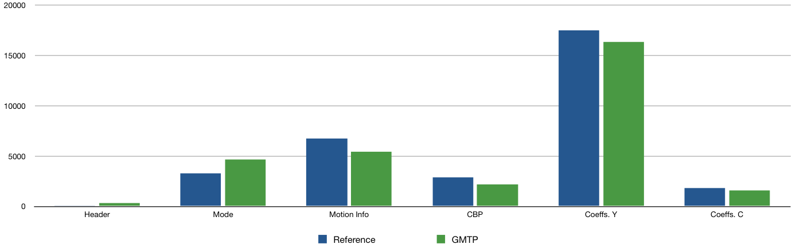
Figure 8 - Average bit rate distribution per picture (BBC-Pan-13, QP 27)
The rate-distortion performance of the coder can probably be increased if further techniques like differential coding of global motion parameters are employed. Additionally, the Lagrange parameter λ in the Lagrangian cost function used in RDO has not been adapted to the new set of modes. Since λ has been found empirically, further increase in rate-distortion performance is expected if it is readjusted.
A problem found in the experimental evaluation is the loss observed for small resolutions and a large amount of non-global motion in sequences. The problem with resolution very probably linked to the small amount of macroblocks available in such a sequence. In that case the reduction of motion information, coded block pattern and coefficients does not make up for the larger header and mode information. Additionally, since the new mode is based on the idea of global motion compensation, sequences not containing global motion do not use that mode leading to bad rate-distortion performance.

Conclusion
In this contribution, a novel prediction mode based on global motion compensation and temporal filtering of spatially aligned pictures has been presented. Experimental results show that depending on resolution and content of the sequence encoded, bit rate savings up to 33% are possible. Since, to the authors’ knowledge, none of the proposals from the CfP deals with motion compensation of more complex than translational motion, it is proposed to further improve the technique presented herein and adopt it into the current TMuC. This lets the experts get the opportunity to verify this tool in various test conditions and with different coding tools on a large set of video sequences.

Patent rights declaration(s)
(NOTE – Activities in the JCT-VC and contributions to the JCT-VC are subject to the common patent policy for ITU-T/ITU-R/ISO/IEC. A statement of that policy can be found at
http://www.itu.int/ITU-T/dbase/patent/patent-policy.html, with further information available at http://www.itu.int/ITU-T/ipr/index.html and in the ISO/IEC Directives. The form to be used for the formal reporting of patent rights to ITU-T/ITU-R/ISO/IEC can be found at http://www.itu.int/ITU-T/ipr/index.html. Contributions to the JCT-VC proposing normative technical content shall contain a non-binding informal notice of whether the submitter may have patent rights that would be necessary for implementation of the resulting standard. The provided informal notice shall indicate the category of anticipated licensing terms according to the ITU-T/ITU-R/ISO/IEC patent statement and licensing declaration form. This obligation to provide an informal notice is supplemental to, and does not replace, any existing obligations of parties with technology included in a final or draft standard to submit formal IPR declarations to ITU-T/ITU-R/ISO/IEC. An example of an informal IPR notification statement for a contribution is provided below.)

Technische Universität Berlin may have IPR relating to the technology described in this contribution and, conditioned on reciprocity, is prepared to grant licenses under reasonable and non-discriminatory terms as necessary for implementation of the resulting ITU-T Recommendation | ISO/IEC International Standard (per box 2 of the ITU-T/ITU-R/ISO/IEC patent statement and licensing declaration form).

References
[1] | A. Krutz, A. Glantz, T. Sikora, J. Park, S. Park, E. Francois, P. Yin, X. Zheng, H. Yu, W.-J. Han, and W.-H. Peng, “Tool Experiment 3: Inter Prediction in HEVC,” Doc. JCTVC-A303, Joint Collaborative Team on Video Coding (JCT-VC) of ITU-T VCEG and ISO/IEC MPEG, Dresden, Germany, Apr 2010
[2] | M. Tok, A. Glantz, M. G. Arvanitidou, A. Krutz, and T. Sikora, “Compressed Domain Global Motion Estimation using the Helmholtz Tradeoff Estimator,” Proceedings of the 17th IEEE International Conference on Image Processing (ICIP 2010), Hong Kong, Sep 2010
[3] | ISO/IEC JTC1/SC29/WG11, “Joint Call for Proposals on Video Compression Technology,” MPEG Document N11113, Jan 2010
[4] | K. Sühring, http://iphome.hhi.de/suehring/tml/download/, 07/01/2010
[5] | G. Bjontegaard, “Calculation of Average PSNR Differences between RD curves,” ITU-T SG16/Q6, 13th VCEG meeting, Austin, Texas, USA, Apr 2001, Doc. VCEG-M33
[6] | G. Bjontegaard, “Improvements of the BD-PSNR model,” ITU-T SG16/Q6, 35th VCEG meeting, Berlin, Germany, Jul 2008, Doc. VCEG-A111

