    Joint Collaborative Team on Video Coding (JCT-VC)  of ITU-T SG16 WP3 and ISO/IEC JTC1/SC29/WG11  2nd Meeting: Geneva, CH, 21-28 July, 2010 | Document: JCTVC-B076

Title: | TE1: Decoder-Side Motion Vector Derivation with Switchable Template Matching
Status: | Input Document to JCT-VC
Purpose: | Proposal
Authors: | Yu-Wen Huang*, Ching-Yeh Chen*,  Chih-Wei Hsu*, Jian-Liang Lin*,  Yu-Pao Tsai*, Jicheng An#, and  Shawmin Lei*  *No. 1, Dusing Rd. 1, Hsinchu Science Park, Hsinchu, Taiwan 30078  #North Building 10F, Raycom Infotech Park Tower C, No. 2, Kexueyuan South Rd., Haidian District, Beijing, China 100190 | Tel:  Email: | Contact: Shawmin Lei  +886-3-567-0766 ext.25555  shawmin.lei@mediatek.com
Source: | MediaTek Inc.
_____________________________

Abstract
This contribution describes MediaTek’s work on decoder-side motion vector derivation (DMVD). In prior arts, template matching (TM) is always used to obtain motion information. In this proposal, it is suggested to adopt a switchable TM, and therefore two DMVD modes, DMVD_DIRECT and DMVD_TM, are provided. For DMVD_DIRECT, TM is disabled. A corresponding decoder utilizes only reference picture indices and motion vectors (MVs) of neighboring coding units (CUs) to derive motion information of a current CU with help from a corresponding encoder telling which spatial-temporal neighbors should be used. For DMVD_TM, TM is enabled. The TM search algorithm begins with an initial stage followed by a refinement stage. Moreover, adaptive template shape and boundary weighting are newly developed to improve the coding efficiency with low complexity overhead. Simulation results of two operating points are shown. The less complex operating point allows DMVD_DIRECT only. It achieves 5.35% and 5.63% average bit rate reductions for the TE1-DMVD Alpha and Gamma common test conditions, respectively, while the average decoding times are increased by 23% and 30% in comparison with the anchor that disables DMVD. For the more complex operating point, DMVD_DIRECT and DMVD_TM are both allowed. Average bitrate reductions become 7.24% and 7.66% for Alpha and Gamma, respectively, while the average decoding times are increased by 87% and 99%.

Introduction

DMVD was first proposed by RWTH Aachen University [1][2][3][4][5][6]. The main concept is that since reference picture indices and MVs can be derived by TM on both encoder and decoder sides, they do not have to be transmitted. Moreover, multi-hypothesis prediction (MHP) with DMVD is used to further improve the coding efficiency. Besides RWTH Aachen University, we also proposed our DMVD in [7] at the first JCT-VC meeting in April 2010. More than 10 companies or institutes developed their own DMVD techniques or showed interests in DMVD as well. Therefore, Tool Experiment 1 on DMVD (TE1-DMVD) [8] was formed at the end of the meeting. TE1-DMVD Alpha and Gamma common test conditions have been defined and can be downloaded from [9] for TE1-DMVD group members. Recently, we keep improving our DMVD to achieve better coding efficiency and less decoding complexity. The most significant difference from prior arts is that TM can be turned on or off. When TM is off, we call this mode DMVD_DIRECT. When TM is on, we call it DMVD_TM. Generally speaking, DMVD_DIRECT can achieve lower decoding complexity while DMVD_TM can achieve higher coding efficiency. The rest of this contribution is organized as follows. The proposed DMVD algorithm will be described in Section 2, compression performance will be discussed in Section 3, complexity analysis will be shown in Section 4, and finally Section 5 gives a conclusion.

Algorithm description

First, we describe common properties of our DMVD work. In this proposal, DMVD MV precision is designed to be the same as normal MV precision, i.e. quarter pixel accuracy in our work, for the sake of reducing complexity, although it was allowed to be higher than normal MV precision in our prior work [7]. Like RWTH Aachen University, we also avoid reconstruction of DMVD CUs during bitstream parsing. This is done by setting reference picture indices and motion vector differences (MVDs) of causal DMVD CUs to zero when the context formation for context-based adaptive binary arithmetic coding (CABAC) is performed. However, real values of the reference picture indices and MVs of causal DMVD CUs are still used for MV prediction during reconstruction of a current CU in order to prevent significant loss of coding efficiency.

Currently, our DMVD implementation is based on KTA2.6r1 [9]. DMVD is allowed for three levels of CUs including 16x16, 32x32, and 64x64. A dmvd_enable_flag is sent for each supported 2Nx2N CU (N=8, 16, 32) when “the current CU is not split into four NxN CUs” and “the current CU is not coded with 2NxN or Nx2N prediction unit (PU) mode” in order to distinguish between the conventional 2Nx2N PU mode and the proposed DMVD mode. If DMVD is applied, a dmvd_no_residue_flag is further sent for the current CU to indicate if prediction residues are coded or not, and a dmvd_template_match_flag is also sent for the current CU to select between DMVD_DIRECT and DMVD_TM, which will be described in Section 2.1 and Section 2.2, respectively. Please note that the PU size of a DMVD CU is the same as the CU size when dmvd_no_residue_flag is 1 and is the same as the transform unit (TU) size when dmvd_no_residue_flag is 0. Consequently, the PU size for DMVD is adaptive at CU level without additional side information. Please also note that the PU size for DMVD_TM has the same meaning as the target size defined by RWTH Aachen University.

In B-pictures, PUs can be coded with bi-directional prediction (BI_PRED). In this case, there are two lists (LIST_0 and LIST_1) for BI_PRED PUs. For each DMVD BI_PRED PU, LIST_0 motion and LIST_1 motion are derived independently. After LIST_0 prediction and LIST_1 prediction are both generated, the final prediction is the average of the predictions of the two lists. In the following algorithm description, it is assumed that a list index has been given for processing the current CU.

DMVD_DIRECT mode

When dmvd_template_match_flag is 0, DMVD_DIRECT is applied. For each PU of a DMVD CU, motion information is derived from neighboring coded CUs. For each DMVD_DIRECT CU, a dmvd_use_switch_left_upper_flag is further transmitted. When dmvd_use_switch_left_upper_flag is 0, a spatial-temporal direct mode is used; otherwise, a left-upper direct mode is used. The two modes are denoted as DMVD_DIRECT_ST and DMVD_DIRECT_LU, which will be further explained in Section 2.1.1 and Section 2.1.2, respectively.

Spatial-temporal direct mode

For DMVD_DIRECT_ST CUs, MHP is performed using reference picture indices and MVs derived from spatial neighboring CUs or temporal CUs. The choice of blocks for motion derivation depends on the location of each PU. Figure 1 shows an example of spatial-temporal candidates for a PU denoted as P_{i}. Let MI_{a}, MI_{b}, …, and MI_{f} represent motion information (MI, including a reference picture index and a MV of the currently given list) of spatial candidate block a, b, …, and f, respectively, and let MI_{T}, MI_{U}, …, and MI_{L} represent MI of temporal candidate block T, U, …, and L in a reference picture, respectively. Please note that block a, b, …, and f belong to prior CUs and are neighboring to the current CU. For each DMVD_DIRECT_ST CU, a dmvd_temporal_flag is sent if the current picture has a non-intra reference picture. When dmvd_temporal_flag is 0, MI is derived from spatial candidates, and it is referred as DMVD_DIRECT_S. Prediction of the current list for the DMVD_DIRECT_S PU is a weighted sum of the motion compensated predictions from MI_{a}, MI_{b}, MI_{c}, MI_{d}, MI_{e}, and MI_{f}. The weights are 1/4 for MI_{a}, 1/4 for MI_{b}, and 1/8 for the rest. When dmvd_temporal_flag is 1, MI is derived from temporal candidates, and it is referred as DMVD_DIRECT_T. Prediction of the current list for the DMVD_DIRECT_T PU is a weighted sum of the motion compensated predictions from MI_{T}, MI_{U}, MI_{D}, MI_{R} and MI_{L}. The weights are 1/2 for MI_{T} and 1/8 for the rest. If the current picture does not have any non-intra reference picture, the dmvd_temporal_flag is not sent, and spatial candidates are always used.

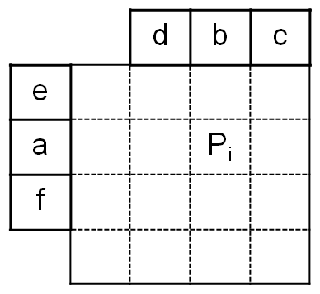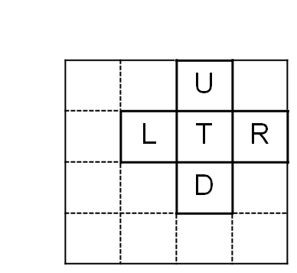
Figure 1 Candidates of DMVD_DIRECT_ST mode

For each temporal candidate of a DMVD_DIRECT_T PU in a P-picture where only LIST_0 prediction is considered, its reference picture index and MV are directly used for MHP of the current PU. An example is shown in Figure 2 where the subscript means a picture id. Let the picture id values of the current picture and the previous picture be k and j, respectively. Please note that the current block can be the current PU, i.e. the P_{i} in Figure 1, and its four neighboring PUs because there are 5 temporal candidates. The refIdxL0_{k} and the mvL0_{k} of the current block are set equal to the refIdxL0_{j} and the mvL0_{j} of the co-located block in LIST_0, respectively. However, for each temporal candidate of a DMVD_DIRECT_T PU in a B-picture, its reference picture index is set to 0, and its MV is scaled according to temporal distances. Since a B-picture has LIST_0 co-located blocks and LIST_1 co-located blocks and each co-located block has up to two lists, MI of each temporal candidate can be derived from four possible directions as shown in Figure 3. The left part of Figure 3 shows the case when LIST_0 prediction is considered for the current PU, while the right part of Figure 3 shows the case when LIST_1 prediction is considered. The numbers marked for the four directions indicate the priority. Let k be the picture id of current picture, let picture j and picture l denote the first reference picture in LIST_0 and the first reference picture in LIST_1, respectively, let mvL0_{l} represent the LIST_0 MV of the co-located block in picture l, and let mvL1_{j} represent the LIST_1 MV of the co-located block in picture j. For LIST_0 MHP, mvL0_{l} has the highest priority and will be chosen for scaling if it exists, and for LIST_1 MHP, mvL1_{j} has the highest priority and will be chosen for scaling if it exists. If the highest priority MV is not available, MVs with lower priorities will be subsequently checked.

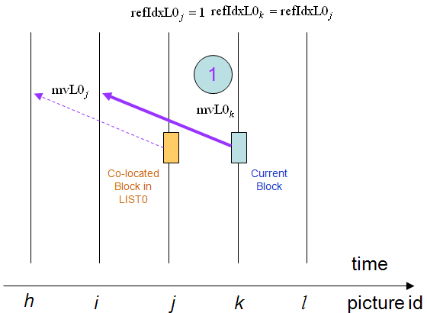
Figure 2 Derivation of MI when the current PU is DMVD_DIRECT_T in a P-picture

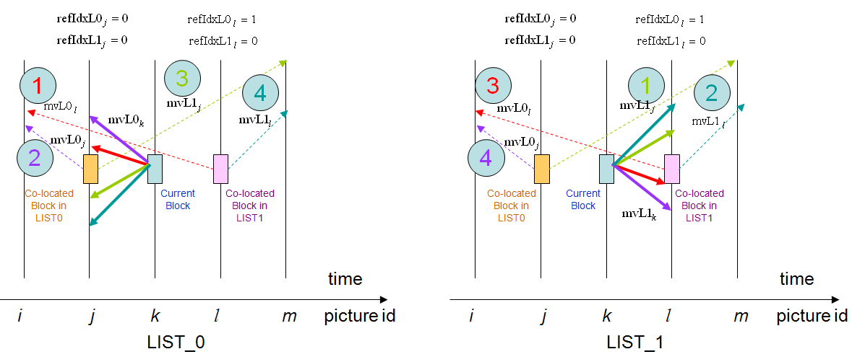
Figure 3 Derivation of MI when the current PU is DMVD_DIRECT_T in a B-picture

Left-upper direct mode

For DMVD_DIRECT_LU CUs, MHP is performed using the reference picture indices and MVs derived from the left neighboring CUs or the upper neighboring CUs. The choice of blocks for motion derivation also depends on the location of each PU. As shown in Figure 4, block a, e, and f are left candidates, and block b, c, and d are upper candidates. For each DMVD_DIRECT_LU CU, a dmvd_upper_flag is sent. When dmvd_upper_flag is 0, MI is derived from left candidates, and it is referred as DMVD_DIRECT_L. Prediction of the current list for the DMVD_DIRECT_L PU is a weighted sum of the motion compensated predictions from MI_{a}, MI_{e}, and MI_{f}. The weights are 1/2 for MI_{a} and 1/4 for the rest. When dmvd_upper_flag is 1, MI is derived from upper candidates, and it is referred as DMVD_DIRECT_U. Prediction of the current list for the DMVD_DIRECT_U PU is a weighted sum of the motion compensated predictions from MI_{b}, MI_{c} and MI_{d}. The weights are 1/2 for MI_{b} and 1/4 for the rest.

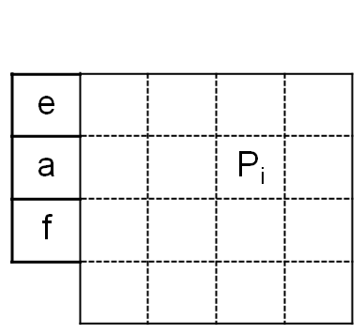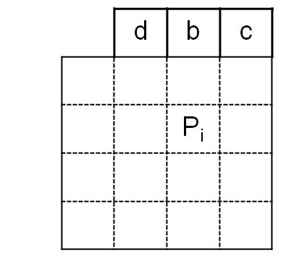
Figure 4 Derivation of motion when the current PU is DMVD_DIRECT_T in a B-picture

DMVD_TM mode

When dmvd_template_match_flag is 1, DMVD_TM is applied. For each PU of a DMVD_TM CU, motion information is derived by TM. A few DMVD_TM parameters including hypothesis number, matching criterion, boundary weighting, and template shape, are provided at picture parameter set (PPS) or CU level.

Hypothesis number

MHP is also allowed for DMVD_TM, and the hypothesis number for TM is conveyed in the PPS. In all our experiments, 4-hypothesis prediction is used.

Matching criterion

In the PPS, there are two matching criterion options for TM distortion calculation. One is sum of absolute differences (SAD) and the other is sum of square differences (SSD). In all our experiments, SSD is used.

Boundary weighting

In DMVD, template pixels instead of target pixels are used to derive motion information. Boundary pixels within the template nearby the current PU as shown in Figure 5 are assumed to have higher correlation to the current PU than non-boundary ones. Thus, during TM distortion calculation, different weightings are applied for boundary and non-boundary pixels to improve the motion accuracy. In our current implementation, different weightings are achieved by bitwise left shift of each boundary pixel distortion. No multiplication is used, so the complexity overhead is very limited. The boundary weighting parameter is conveyed in the PPS. In all our experiments, 2-bit left shift is used.

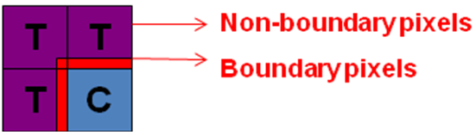
Figure 5 Illustration of boundary pixels in the template

Template shape

In addition to the L-shape template, 3 more template shapes are allowed. The L-shape mode, left mode, upper mode, and corner mode are shown in Figure 6. For each DMVD_TM CU, dmvd_tm_mode_b1 and dmvd_tm_mode_b0 are compressed by CABAC and sent to decoders for signaling the best mode. For easier explanation, neighboring 4x4 blocks to be included in the template region are numbered from 1 to 2N+1 as shown in Figure 6, where N depends on the CU size. The L-shape template contains all 4x4 blocks numbered from 1 to 2N+1, while left, upper, and corner modes contain 4x4 blocks numbered from 1 to N, from N+2 to 2N+1, and from N/2+1 to 3/2N+1, respectively. Multiple template shapes not only provide more accurate TM results especially for object boundaries but also reduce average decoding complexity due to smaller templates may be selected.

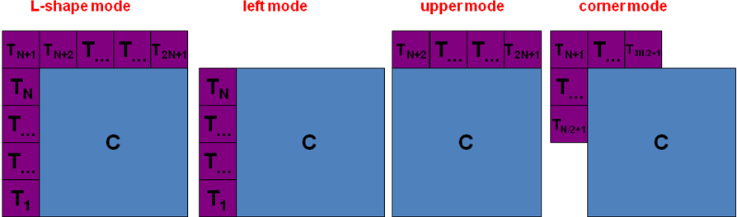
Figure 6 Illustration of 4 modes of template shapes

Initial search candidates

Given a list, up to 11 initial candidates are searched for each PU of a DMVD_TM CU. The 11 initial candidates are the same as the DMVD_DIRECT_ST candidates shown in Figure 1. Assume the hypothesis number is N, after the initial search, we keep the N candidates with the lowest distortions for the following refinement search.

Refinement search

After the best N candidates are found, a distortion check mechanism is performed to replace the candidates having large distortions by the candidate having the minimum distortion. The distortion threshold is set to the minimum distortion multiplied by a factor. The ratio of the threshold value to the minimum distortion is coded in the PPS and is fixed in all our experiments. After candidate replacement, a MHP refinement is applied as follows. Only the N/2 candidates with larger distortions will be sequentially refined one at a time. During refinement of a candidate, the other N-1 candidates are fixed. The refinement search pattern has a cross shape with five points. That is, when a to-be-refined candidate has a MV equal to (mvx, mvy), TM for the four MVs, denoted as (mvx-1, mvy), (mvx+1, mvy), (mvx, mvy-1), and (mvx, mvy+1), respectively, will be performed additionally. Although the other N-1 candidates are fixed, they are still involved in the refinement because the matching criterion in the refinement search stage is very different from that in the initial search stage. The initial search calculates the distortion between the template of the current picture and that of one reference picture, while the refinement search calculates the distortion between the template of the current picture and the N-hypothesis template of one or multiple reference pictures from the N candidates. The N-hypothesis template is generated as an average of the N motion compensated predictions of templates. The concept is similar to the BI_PRED iterative search in KTA software [9] (“BiPredMotionEstimation” in the encoder configuration) and can be regarded as a joint optimization of N candidates.

Modified binarization for CU modes in B-slices

The occurrence frequencies of square PUs increase significantly due to our DMVD. For 2Nx2N CUs in B slices, the occurrence frequency of splitting into four NxN CUs becomes much larger than those of 2NxN and Nx2N PU modes. Hence, we modify the binarization codeword of CU and PU modes in B slices. The original binarization for CU modes in B-slices is shown on the left side of Table 1, and the modified binarization is shown on the right side of Table 1. Please note that Table 1 is used not only for N=16 but also for N=32 and N=64.

Table 1 Binarization for CU modes in B-slices
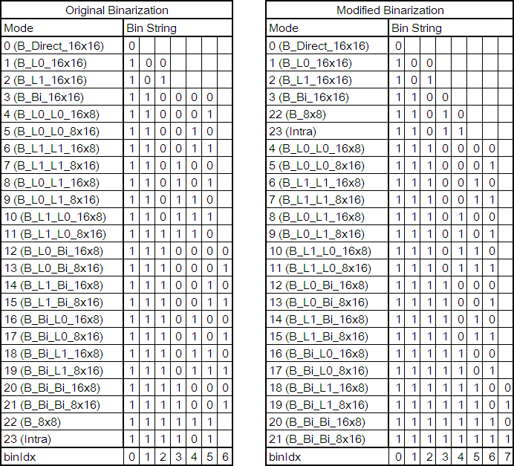

Compression performance discussion

There are two common test conditions defined by TE1-DMVD. The Alpha condition uses hierarchical B (HB) structure where the length of group of pictures (GOP) is 8. Periodic insertion of intra pictures is enabled for random access applications. The Gamma condition uses IPPP structure for low delay applications. Only the first picture is intra coded. In order to save time, 100 pictures are simulated for each sequence. Other common settings are single-pass picture encoding, H.264 weighted prediction disabled, internal bit depth increase (IBDI) disabled, NumberReferenceFrames=4, UseAdaptiveFilter=0, MVCompetition=0, UseIntraMDDT=1, UseHPFilter=1, UseAdaptiveLoopFilter=1, UseExtMB=1 (32x32), UseRDO_Q=0. The anchor bitstreams are generated with DMVD disabled. All details of test conditions can be found at [9]. Table 2 shows the BD-rates of two operating points for Alpha and Gamma conditions. The less complex operating point enables DMVD_DIRECT only and on average achieves 5.35% and 5.63% bitrate reductions for Alpha and Gamma, respectively. The more complex operating point enables both DMVD_DIRECT and DMVD_TM and on average achieves 7.24% and 7.66% bitrate reductions for Alpha and Gamma, respectively.

Table 2 BD-rates under TE1-DMVD test conditions
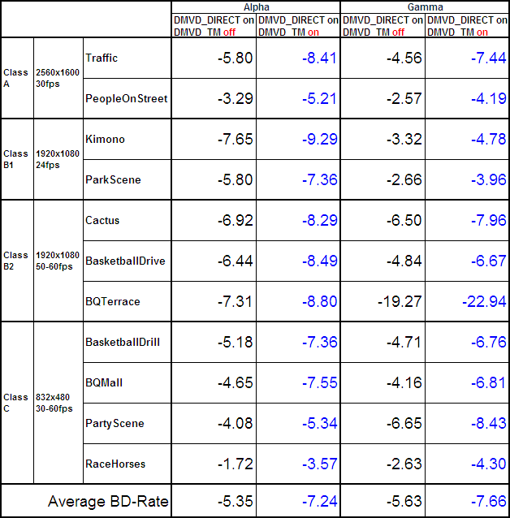

We also use test conditions defined by ourselves to see how DMVD interacts with more coding tools. The GOP structures for Alpha and Gamma are the same, but the sequences become those used in the call for proposal (CfP) jointly issued by MPEG and VCEG. In order to save simulation time, the lengths of simulated sequences are 1/10 of those in the CfP. Other common settings are multi-pass picture encoding, H.264 weighted prediction enabled, IBDI enabled (4-bit increase), NumberReferenceFrames=4, UseAdaptiveFilter=0, MVCompetition=1, UseIntraMDDT=1, UseHPFilter=1, UseAdaptiveLoopFilter=1, UseExtMB=2 (64x64), UseRDO_Q=1, UseNewOffset=1. The anchor bitstreams are generated with DMVD disabled. Table 3 shows the BD-rates of two operating points for Alpha and Gamma conditions. The less complex operating point enables DMVD_DIRECT only and on average achieves 3.59% and 4.38% bitrate reductions for Alpha and Gamma, respectively. The more complex operating point enables both DMVD_DIRECT and DMVD_TM and on average achieves 5.36% and 6.08% bitrate reductions for Alpha and Gamma, respectively. It can be seen that although many additional coding tools are enabled as the anchor, most of the coding gain from DMVD is still maintained. BD-rate reductions are decreased for 1%-2% only.

Table 3 BD-rates under MediaTek test conditions
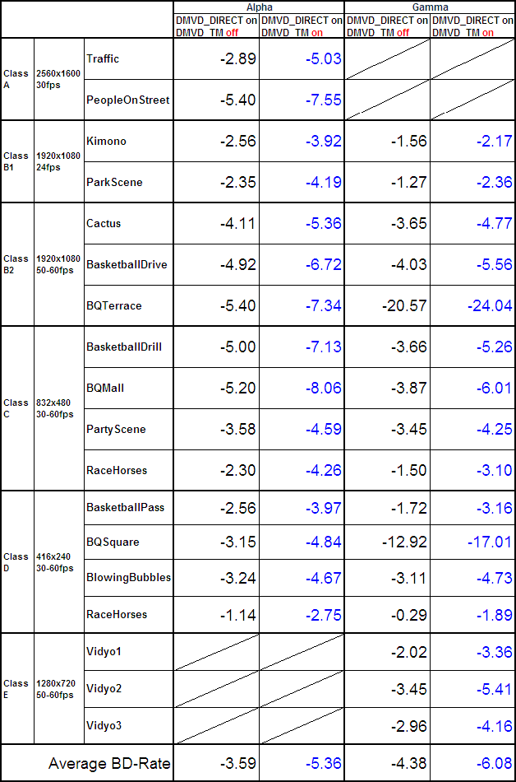

Complexity analysis

The complexity of DMVD under TE1-DMVD test conditions is shown in Table 4. For DMVD_DIRECT only, the encoding complexity and the decoding complexity are increased by 59% and 26%, respectively, under Alpha condition, and are increased by 31% and 33%, respectively, under Gamma condition. When DMVD_TM is enabled in addition to DMVD_DIRECT, the increase of encoding complexity and that of decoding complexity become 153% and 87%, respectively, under Alpha condition, and become 74% and 99%, respectively, under Gamma condition. Please note that these numbers are averaged from all test points of all simulation sequences instead of a particular case.

Table 4 Normalized run times under TE1-DMVD test conditions
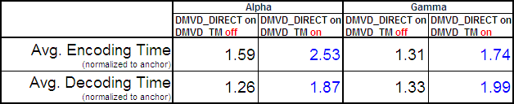

The complexity of DMVD under MediaTek test conditions is shown in Table 5. For DMVD_DIRECT only, the encoding complexity and the decoding complexity are increased by 110% and 20%, respectively, under Alpha condition, and are increased by 64% and 23%, respectively, under Gamma condition. When DMVD_TM is enabled in addition to DMVD_DIRECT, the increase of encoding complexity and that of decoding complexity becomes 277% and 109%, respectively, under Alpha condition, and becomes 147% and 71%, respectively, under Gamma condition. Please note that these numbers are averaged from all test points of all simulation sequences instead of a particular case.

Table 5 Normalized run times under MediaTek test conditions
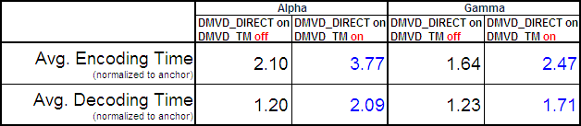

Conclusion

MediaTek developed a DMVD work with switchable TM. When TM is off and on, DMVD can provide more than 5% and 7% of bitrate reductions, respectively, under the TE1-DMVD test conditions. Meanwhile, the increases of decoding complexity are about 25% and 90%, respectively. We conclude that DMVD can be a potential coding tool for the next generation video coding standard.

Patent rights declaration

MediaTek Inc. may have IPR relating to the technology described in this contribution and, conditioned on reciprocity, is prepared to grant licenses under reasonable and non-discriminatory terms as necessary for implementation of the resulting ITU-T Recommendation | ISO/IEC International Standard (per box 2 of the ITU-T/ITU-R/ISO/IEC patent statement and licensing declaration form).

References
- Steffen Kamp, Michael Evertz, and Mathias Wien, “Decoder Side Motion Vector Derivation,” ITU-T SG16 Q.6 Document, VCEG-AG16, Oct. 2007.
- Steffen Kamp, Michael Evertz, and Mathias Wien, “Decoder Side Motion Vector Derivation with Multiple Reference Frames,” ITU-T SG16 Q.6 Document, VCEG-AH15, Jan. 2008.
- Steffen Kamp and Mathias Wien, “Error Accumulation in Motion Compensation in P and B Slices,” Joint Video Team Document, JVT-AA039, Apr. 2008.
- Steffen Kamp and Mathias Wien, “Multi-Hypothesis Prediction with Decoder Side Motion Vector Derivation,” Joint Video Team Document, JVT-AA040, Apr. 2008.
- Steffen Kamp, Benjamin Bross, and Mathias Wien, “Fast Decoder Side Motion Vector Derivation,” ITU-T SG16 Q.6 Document, VCEG-AJ18, Oct. 2008.
- Steffen Kamp and Mathias Wien, “Description of Video Coding Technology Proposal by RWTH Aachen University,” Document of Joint Collaborative Team on Video Coding, JCTVC-A112, Apr. 2010.
- Yu-Wen Huang, Chih-Ming Fu, Yu-Pao Tsai, Jian-Liang Lin, Yulin Chang, Jyh-Huei Guo, Ching-Yeh Chen, Shawmin Lei, Xun Guo, Yongying Gao, Kai Zhang, and Jicheng An, “A Technical Description of MediaTek’s Proposal to the JCT-VC CfP,” Document of Joint Collaborative Team on Video Coding, JCTVC-A109, Apr. 2010.
- Mathias Wien and Yu-Jen Chiu, “Tool Experiment 1: Decoder-Side Motion Vector Derivation,” Document of Joint Collaborative Team on Video Coding, JCTVC-A301, Apr. 2010.
- https://svn.rwth-aachen.de/repos/ient_jctvc_dmvd
- VCEG KTA2.6r1 Software, http://iphome.hhi.de/suehring/tml/download/KTA/jm11.0kta2.6r1.zip

