    Joint Collaborative Team on Video Coding (JCT-VC)  of ITU-T SG16 WP3 and ISO/IEC JTC1/SC29/WG11  2nd Meeting: Geneva, CH, 21-28 July, 2010 | Document: JCTVC-B077

Title: | In-Loop Adaptive Restoration
Status: | Input Document to JCT-VC
Purpose: | Proposal
Authors: | Yu-Wen Huang*, Chih-Ming Fu*,  Ching-Yeh Chen*, Chia-Yang Tsai*,  Yongying Gao#, Jicheng An#,  Kai Zhang#, and Shawmin Lei*  *No. 1, Dusing Rd. 1, Hsinchu Science Park, Hsinchu, Taiwan 30078  #North Building 10F, Raycom Infotech Park Tower C, No. 2, Kexueyuan South Rd., Haidian District, Beijing, China 100190 | Tel:  Email: | Contact: Shawmin Lei  +886-3-567-0766 ext.25555  shawmin.lei@mediatek.com
Source: | MediaTek Inc.
_____________________________

Abstract
This contribution describes MediaTek’s work on in-loop adaptive restoration (AR). The framework of AR is composed of three stages including improved deblocking filter (IDF), quadtree-based adaptive restoration (QAR), and picture-based adaptive offset (PAO). IDF is an improvement of H.264 deblocking filter for intra coding units (CUs). QAR can split a picture into multi-level quadtree partitions, and each partition can be enhanced by Wiener filtering or band offset or edge offset. PAO classifies pixels into different groups and calculates an offset for each group. IDF, QAR, and PAO are all adaptive restoration methods reducing errors between reconstructed pixels and original pixels of a current picture. Simulation results show that in comparison with the in-loop filtering ad-hoc group (AHG) anchor which enables quadtree-based adaptive loop filter (QALF), internal bit depth increase (IBDI), and other KTA tools, the proposed AR can achieve 3.76% and 3.61% bitrate reductions for Alpha and Gamma test conditions, respectively. The encoding complexity is increased by 6% and 21% for Alpha and Gamma, respectively, and the decoder complexity is increased by 14% and 10%, respectively.

Introduction

AR is a technique that can reduce errors between noisy signals and desired signals. In this contribution, the location of in-loop AR is arranged between the reconstruction unit and reference picture buffer, as shown in Figure 1. The AR unit is designed for reducing errors between reconstructed pixels and original pixels of a current picture. Moreover, the current picture restored by AR is saved into the reference picture buffer for better prediction of subsequent pictures. Since our application is video coding, the AR information is compressed by entropy coding and transmitted from encoders to decoders. In this way, blind restoration is avoided on the decoder side, and the coding efficiency can be significantly improved. The rest of this contribution is organized as follows. The proposed AR algorithm will be described in Section 2, compression performance will be discussed in Section 3, complexity analysis will be shown in Section 4, and finally Section 5 gives a conclusion.

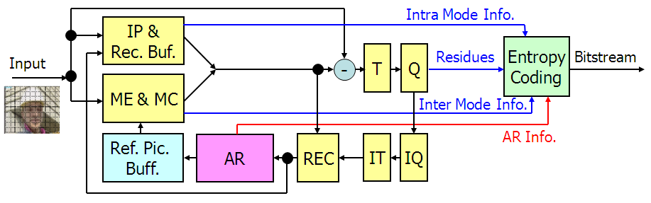
Figure 1 Encoder block diagram with AR

Algorithm description

The framework of the proposed AR is shown in Figure 2. Three stages, IDF, QAR, and PAO are cascaded. In our work, IDF is always enabled. QAR and PAO can be enabled or disabled by performing rate-distortion optimization (RDO), which is an encoder-only issue. The software platform we chose is KTA2.6r1 [1].

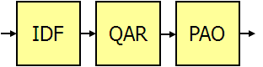
Figure 2 Framework of the proposed AR

Improved deblocking filter (IDF)

The proposed IDF is based on H.264 deblocking filter and is targeted for intra CUs. Two major improvements are developed.

Modified boundary strength and thresholds (MBST)

The H.264 deblocking filter (DF) for intra edges (edges with at least one adjacent block coded in intra) is improved as follows.

- Removal of the highest boundary strength (BS) and its corresponding filtering process
In H.264 DF, intra CU edges are assigned with BS=4 and are filtered by a strong filter [2]. However, for CUs coded with intra 4x4 and intra 8x8 modes, there are no significant differences between CU edges and inner 4x4 or 8x8 edges, so it is unreasonable to filter CU edges and inner edges differently. Therefore, we propose to remove the strongest filter aiming at intra CU edges and to filter intra CU edges with the normal filter (BS=3) same as that for intra 4x4 or 8x8 inner edges. This modification improves objective quality while maintaining subjective quality.

- Adjusting thresholds for intra edges
In H.264 DF, there are two thresholds, alpha and beta, used for both intra edges and inter edges (edges with two adjacent blocks coded in inter). However, according to our experiences, the thresholds for intra edges should be different from those for inter edges. Specifically, we propose to use three new thresholds, alpha1, beta1, and beta2, to replace the original alpha in Equation (1) of [2] (|p₀-q₀|<α), the original beta in Equation (2) of [2] (|p₁-p₀|<β) and Equation (3) of [2] (|q₁-q₀|<β), and the original beta in Equation (8) of [2] (|p₂-p₀|<β) and Equation (9) of [2] (|q₂-q₀|<β), respectively, for intra edges. As for inter edges, the original alpha and beta are used. The proposed and original thresholds are shown in Figure 3.

Figure 3 Proposed thresholds and original thresholds for deblocking

- Adjusting the clipping values.
In H.264 DF, BS is used as an index of table look-up for the value of the clipping parameter c1 used in Equation (16) of [2] and Equation (17) of [2]. For luma, we replace the c1 value for BS=3 by the c1 value for BS=2. For chroma, we replace its clipping value c0, which is equal to c1 plus 1 in H.264 DF, by c1.

Mode dependent deblocking filter (MDDF)

Intuitively, there are various directions of textures in natural images. The H.264 DF that only filters vertically or horizontally may often destroy the texture directions. Since intra prediction mode can represent the texture direction in a block, we introduce an MDDF method for intra CUs. In MDDF, intra prediction modes of the blocks on both sides of the to-be-filtered edge should be considered in addition to the pixels across the to-be-filtered edge. Three different cases are developed as follows.

- Two blocks with the same intra prediction mode not parallel to the to-be-filtered edge
If the two blocks hold the same intra prediction mode that is not parallel to the to-be-filtered edge, then the edge between them are filtered along the intra prediction direction. As shown in Figure 4, solid arrows denote intra prediction directions, and dotted arrows denote new filter directions. The filtering kernel is kept the same as that in H.264/AVC. The only difference is that the pixels involved in the filtering process become those along the new filter direction.

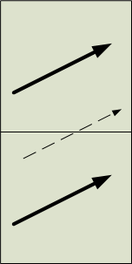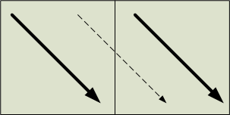
Figure 4 Case 1 in MDDF

- Two blocks with different intra prediction modes
As shown in Figure 5, if the two blocks hold different intra prediction modes, then the edge between them are filtered horizontally or vertically, but the filtering strength is weakened. In such a case, the filtering kernel is kept the same as that in H.264/AVC. The only difference is that the clipping value t_{C0} becomes
(1)

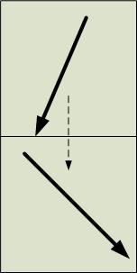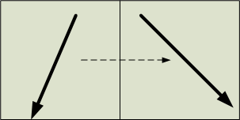
Figure 5 Case 2 in MDDF

- Two blocks with the same intra prediction mode parallel to the to-be-filtered edge
If the two blocks hold the same intra prediction mode that is parallel to the edge between them, then the filter direction is still horizontal or vertical, as shown in Figure 6, but the filtering strength is weakened even more. In such a case, the filtering kernel is kept the same as that in H.264/AVC. The only difference is that the clipping values t_{C} and t_{C0} are adjusted as
(2)
(3)

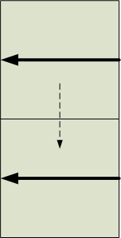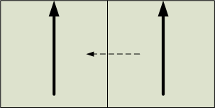
Figure 6 Case 3 in MDDF

Quadtree-based adaptive restoration (QAR)

In prior, we proposed improved multiple quadtree-based adaptive loop filter (IMQALF) [3] based on Toshiba’s QALF [4][5] and our improved quadtree-based adaptive loop filter (IQALF) [6]. Here, we further propose quadtree-based adaptive restoration (QAR) to enhance the coding efficiency. The chroma processing of QAR is the same as that of IMQALF, which is also the same as that of QALF. For luma, the main difference between QAR and IMQALF is that besides Wiener filtering, adaptive offsets are allowed to restore reconstructed pixels for each picture partition. The basic flow of QAR is summarized as follows. First, a top-down splitting strategy is adopted to divide a luma picture into multi-level quadtree partitions by using a rate-distortion (RD) criterion, as shown in Figure 7. Second, each luma picture partition can be further divided into blocks, and each luma picture partition can choose an adaptive loop filter (ALF) method or an adaptive offset (AO) method for restoration. The ALF method can select a 1-filter mode and a 2-filter mode, and the filter can be a new filter with transmitted coefficients or a time-delayed filter without any transmitted coefficients. The AO method can select a localized band offset (LBO) mode or a localized edge offset (LEO) mode. For each block in one partition, a restoration flag is transmitted. If the 2-filter mode of the ALF method is chosen for the partition, the restoration flags are used to indicate a first filter or a second filter, as shown in Figure 8; otherwise, each restoration flag is used to indicate whether the restoration is on or off for the block.

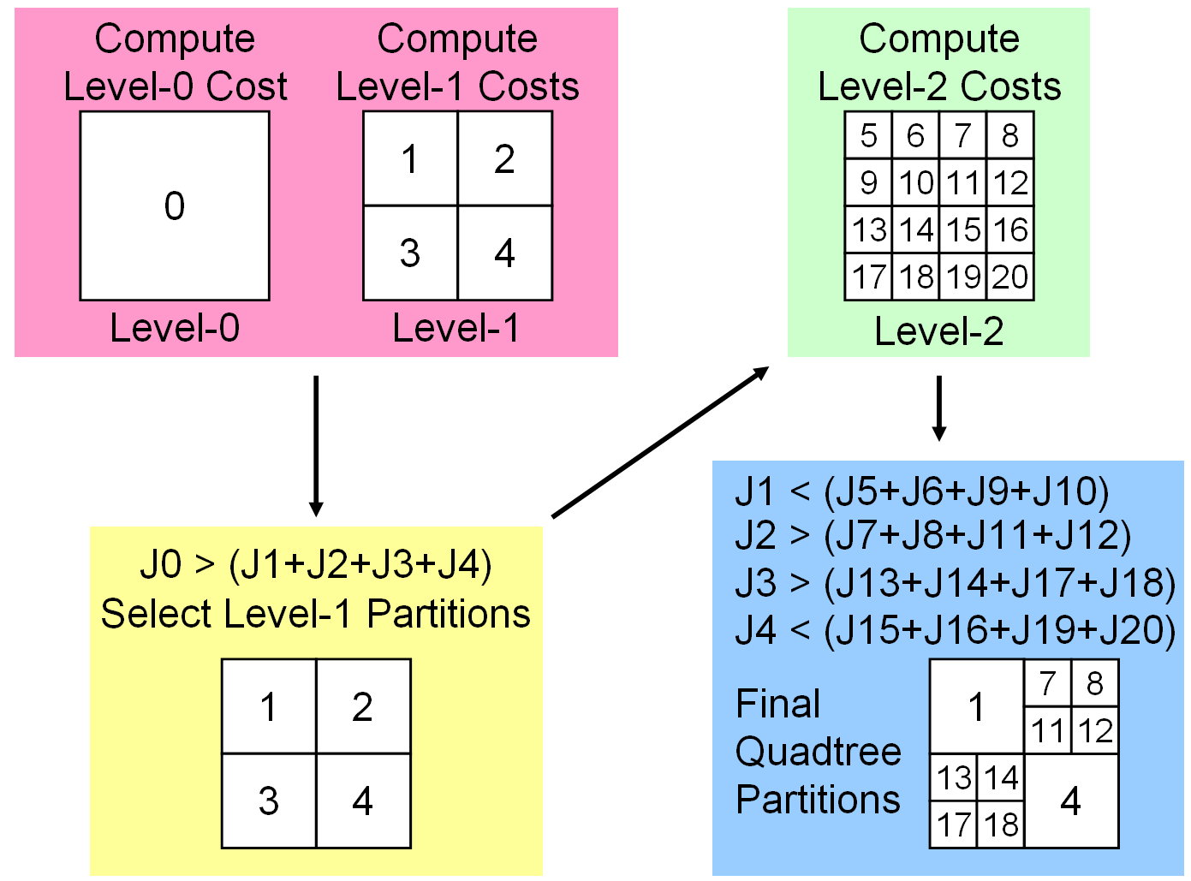
Figure 7 Example of a 3-level quadtree structure

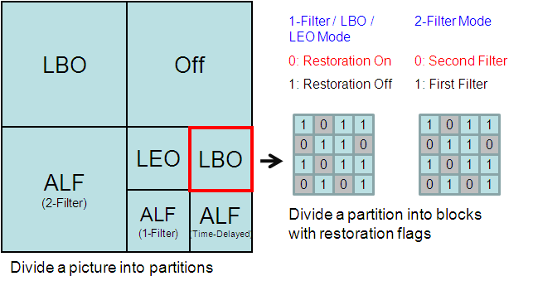
Figure 8 Example of further dividing a partition into blocks

Adaptive loop filter (ALF)

For the ALF process in the proposed QAR scheme, we adopt IMQALF [3]. After the top-down splitting, the luma picture is divided into quadtree partitions. For each luma picture partition, Wiener filtering technique is exploited. There are three major features in the proposed IMQALF process: multiple filters at picture level, multiple filters at partition level, and time-delayed filtering.

- Multiple filters at picture level
The optimal filter may vary significantly for different parts of a picture. The proposed QAR scheme splits one picture into several partitions. Each partition can have its own restoration process. Therefore, multiple filters are allowed at picture level. In our current implementation, the maximum number of quadtree partitions is 256 (5 levels); the options of Wiener filter shapes are 5x5, 7x7, and 9x9; 1/2-symmetry is used for filter coefficients.

- Multiple filters at partition level
To further exploit the localized property for restoration, multiple filters are also allowed at partition level. In our current implementation, the supported maximum number of filters in one partition is 2. The corresponding process for one partition is summarized as follows. First, the variance of errors between all original pixels and deblocked pixels in the partition is calculated. Then, the variance of errors between all original pixels and deblocked pixels in each block is calculated. Next, blocks are classified into two groups by comparing the block error variance with the partition error variance. Finally, two Wiener filters are derived for the two groups separately. The RD cost of the 2-filter mode will be compared with that of the 1-filter mode.

- Time-delayed filtering
It was designed to transmit filter coefficients of every ALF partition. However, sometimes the optimal filter of a partition can be quite similar to those of prior pictures. If the filter coefficients of prior pictures are already stored in a buffer, it is not necessary to transmit filter coefficients for such a partition. Therefore, the bitrate for coding filter coefficients can be effectively reduced. In our current implementation, there are 3 groups of buffers for storing time-delayed 5x5, 7x7, and 9x9 filter coefficients respectively; each group has 8 buffers.

Adaptive offset (AO)

The AO method for a partition includes an LBO mode and an LEO mode, which are extended from band correction (BDC) and extreme correction (EXC) [7] presented by Samsung and BBC at the first JCT-VC meeting in April 2010, respectively. In our work, both LBO and LEO are only applied for luma. The basic concept of LBO is that pixels in one partition are classified into several bands based on their luma values, and for each band one offset is used for restoration. The flow of LBO is stated as follows. First, the minimum and maximum pixel values in one partition are found. Next, based on the minimum and maximum, the interval of each band is decided. We support two kinds of band classification. One is to classify into 16 uniform bands, and the other is to classify into 12 non-uniform bands. The band classification method is indicated by one flag for each LBO partition. It is not necessary to transmit the minimum and maximum values because they are also known by decoders.

As for the LEO, the major difference from EXC is the pattern used for pixel classification. In EXC, only one pattern is used to classify the center pixel as shown in Figure 9. In LEO, besides the cross pattern, we also adopt a diagonal cross pattern for pixel classification, as shown in Figure 10. One flag is sent to indicate which pattern is used in LEO. Based on the selected pattern and the conditions of 7 categories in Table 1, all pixels in one partition are classified into different categories. Except category 6, one offset is derived and sent for each category.

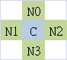
Figure 9 Cross pattern for EXC and LEO

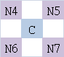
Figure 10 Diagonal cross pattern for LEO

Table 1 Conditions of 7 Categories for LEO
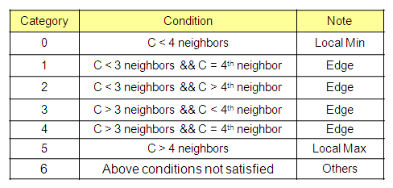

Picture-based adaptive offset (PAO)

PAO includes picture-based band offset (PBO) and picture-based edge offset (PEO). PBO is located after QAR and is followed by PEO. PBO and PEO are very similar to LBO and LEO, respectively, except that PBO and PEO are applied for the entire picture instead of one partition, and except a few different details as follows. First, PBO supports 16-band uniform classification for luma and 4-band uniform classification for chroma, while LBO supports 16-band uniform classification and 12-band non-uniform classification for luma only and is not applied for chroma. In addition, for PBO luma, minimum and maximum are always set to 0 and 255, respectively, for band classification of 8-bit pixels. For PBO chroma, real minimum and maximum pixel values are found and used for band classification. For PBO luma and chroma, offset values are predicted, so only offset prediction errors are transmitted. However, for LBO luma, real minimum and maximum pixel values are used, and offsets are not predicted before transmission. Last, PEO uses the cross pattern only, while LEO can use the cross pattern and the diagonal pattern.

Picture-based adaptive clipping (PAC)

The concept of PAC is to send the range (minimum and maximum) of original pixels in the current picture to decoders. If a pixel is out of the range after reconstruction, it will be clipped to the minimum or the maximum. The minimum and maximum can be predicted before transmission. In our work, PAC can be applied after IDF, QAR, PBO, and PEO for luma.

Compression performance discussion

There are two common test conditions defined by the in-loop filtering AHG. The Alpha condition uses hierarchical B (HB) structure where the length of group of pictures (GOP) is 8. Periodic insertion of intra pictures is enabled for random access applications. The Gamma condition uses IPPP structure for low delay applications. Only the first picture is intra coded. In order to save time, about 2 seconds of each video are used for simulation. Other common settings are multi-pass picture encoding, H.264 weighted prediction on, internal bit depth increase (IBDI) on (4-bit increase), NumberReferenceFrames=4, UseAdaptiveFilter=0, MVCompetition=1, UseIntraMDDT=1, UseHPFilter=4 (SIFO), UseExtMB=2 (64x64), UseRDO_Q=1, UseNewOffset=1. The RDO_Q contains only transform coefficient refinement but no loop of multiple QP values, which is done by modifying the source code according to the regulation of the in-loop filtering AHG. The anchor bitstreams are generated with QALF enabled (UseAdaptiveLoopFilter=1). In order to test our IDF, which only improves intra CUs, we add an Intra test condition where only intra pictures are used in the simulation. Table 2 shows the BD-rates for Alpha, Gamma, and Intra conditions. First, when IDF is additionally turned on, the average bitrate reduction is 2.71% under the Intra condition. Next, when QAR is used to replace QALF, the average bitrate reductions are 1.88% and 2.76% for Alpha and Gamma, respectively. When QAR replaces QALF and IDF is on, the average bitrate reductions become 3.34% and 3.61% for Alpha and Gamma, respectively. Finally, when IDF, QAR, and PAO are all enabled, the average bitrate reduction increases to 3.76% for Alpha. According to our experience, PAO cannot lead to bitrate reduction for Gamma but only increases complexity, so we omit the corresponding data.

Table 2 BD-rates when IBDI is on
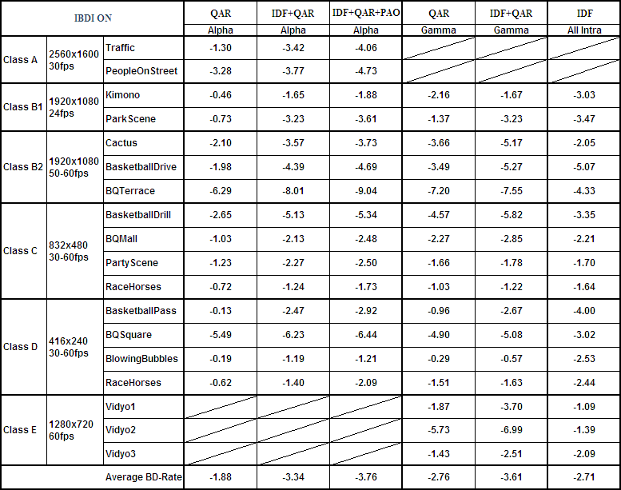

It is also encouraged by the in-loop filtering AHG to show the data when IBDI is off. The related data are shown in Table 3. First, when IDF is additionally turned on, the average bitrate reduction is 2.73% under the Intra condition. Next, when QAR is used to replace QALF, the average bitrate reductions are 1.88% and 2.75% for Alpha and Gamma, respectively. When QAR replaces QALF and IDF is on, the average bitrate reductions become 3.54% and 3.81% for Alpha and Gamma, respectively. Finally, when IDF, QAR, and PAO are all enabled, the average bitrate reduction increases to 4.06% for Alpha. According to our experience, PAO cannot lead to bitrate reduction for Gamma but only increases complexity, so we omit the corresponding data. It can be seen that in comparison with the IBDI-on case, BD-rate reductions for the IBDI-off case tend to increase slightly. For Alpha with IDF, QAR, and PAO all enabled, the average BD-rate reduction increases by 0.3%.

Table 3 BD-rates when IBDI is off
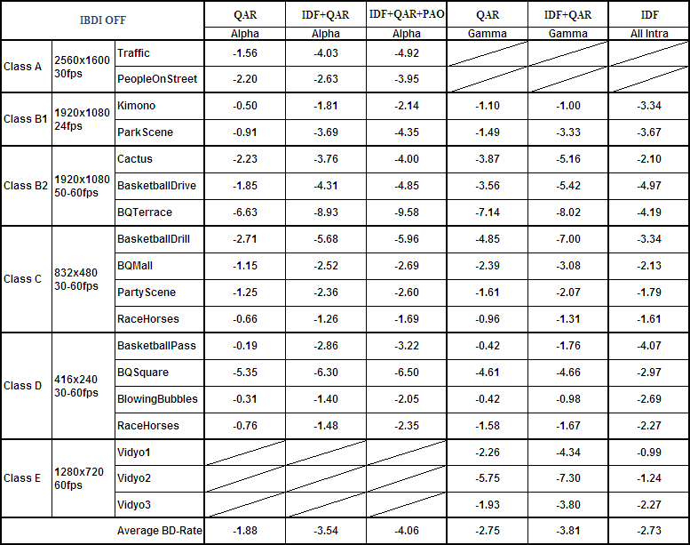

Complexity analysis

The complexity of AR under AHG test conditions is shown in Table 4. The encoding complexity and decoding complexity under Alpha condition when IDF, QAR, and PAO are enabled are increased by 6% and 14%, respectively. The encoding complexity and decoding complexity under Gamma condition when IDF and QAR are enabled are increased by 21% and 10%, respectively. Please note that these numbers are averaged from all test points of all simulation sequences instead of a particular case.

Table 4 Normalized run times when IBDI is on
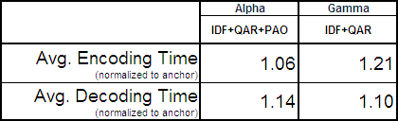

Conclusion

MediaTek developed an AR framework with three stages including IDF, QAR, and PAO. IDF, QAR, and PAO are suggested to be enabled for the Alpha condition, while only IDF and QAR are recommended for the Gamma condition. The achieved average bitrate reductions are 3.76% and 3.61% for Alpha and Gamma, respectively, in comparison with the anchor which enables QALF and IBDI. The corresponding encoding complexity increase is 6%-21%, and the decoding complexity increase is 10%-14%. We conclude that IDF, QAR, and PAO can be potential coding tools for the next generation video coding standard.

Patent rights declaration

MediaTek Inc. may have IPR relating to the technology described in this contribution and, conditioned on reciprocity, is prepared to grant licenses under reasonable and non-discriminatory terms as necessary for implementation of the resulting ITU-T Recommendation | ISO/IEC International Standard (per box 2 of the ITU-T/ITU-R/ISO/IEC patent statement and licensing declaration form).

References
- VCEG KTA2.6r1 Software, http://iphome.hhi.de/suehring/tml/download/KTA/jm11.0kta2.6r1.zip
- Peter List, Anthony Joch, Jani Lainema, Gisle Bjøntegaard, and Marta Karczewicz, “Adaptive Deblocking Filter,” IEEE Transactions on Circuits and Systems for Video Technology, vol. 13, no. 7, pp. 614-619, Jul. 2003.
- Yu-Wen Huang, Chih-Ming Fu, Yu-Pao Tsai, Jian-Liang Lin, Yulin Chang, Jyh-Huei Guo, Ching-Yeh Chen, Shawmin Lei, Xun Guo, Yongying Gao, Kai Zhang, and Jicheng An, “A Technical Description of MediaTek’s Proposal to the JCT-VC CfP,” Document of Joint Collaborative Team on Video Coding, JCTVC-A109, Apr. 2010.
- Takeshi Chujoh, Naofumi Wada, and Goki Yasuda, “Quadtree-based Adaptive Loop Filter,” ITU-T SG16 Contribution, C181, Jan. 2009.
- Takeshi Chujoh, Naofumi Wada, Takashi Watanabe, Goki Yasuda, and Tomoo Yamakage, “Specification and Experimental Results of Quadtree-based Adaptive Loop Filter,” ITU-T SG16 Q.6 Document, VCEG-AK22, Apr. 2009.
- Yu-Wen Huang, Chih-Ming Fu, Xun Guo, and Shawmin Lei, “Improved Quadtree-based Adaptive Loop Filter,” ITU-T SG16 Q.6 Document, VCEG-AL24, Jul. 2009.
- Ken McCann, Woo-Jin Han, and Il-Koo Kim, “Samsung’s Response to the Call for Proposals on Video Compression Technology,” Document of Joint Collaborative Team on Video Coding, JCTVC-A124, Apr. 2010.

