    Joint Collaborative Team on Video Coding (JCT-VC)  of ITU-T SG16 WP3 and ISO/IEC JTC1/SC29/WG11  2nd Meeting: Geneva, CH, 21-28 July, 2010 | Document: JCTVC-B094

Title: | Simplified motion vector coding method
Status: | Input Document to JCT-VC
Purpose: | Proposal
Author(s) or  Contact(s): | Frank Bossen, Philipp Kosse  3240 Hillview Ave  Palo Alto CA 94304 USA | Tel:  Email: | +1 650 496 4742  bossen@docomolabs-usa.com
Source: | DOCOMO USA Labs
_____________________________

Abstract
A method for coding motion vector data is presented. It is based on the method previously proposed in document JCTVC-A114. It achieves coding efficiency similar to the methods included in the TMuC software while providing reduced complexity as parsing of motion vector data is simplified and the number of motion vector predictors is reduced.

Introduction
Efficient coding of motion vector data is an important component of advanced video codecs, in particular at lower bitrates where the proportion of the total bits used to encode this data can become significant. While efficient coding is important, complexity matters too, and efficient methods with reduced complexity should be sought. This contribution presents a simple yet efficient method for coding motion vector data.

Technical description
The implemented motion vector coding method is based on the method described in JCTVC-A114. In a first step, a list of motion vector candidates is formed from up to three motion vector predictors: a left, a top and a collocated predictor.
The process of getting a left and a top predictor is shown in Figure 1.

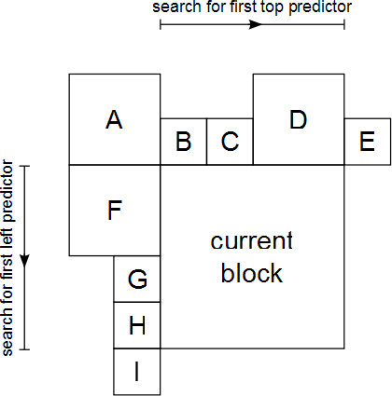
Figure 1: Search directions for left and top predictor

For the left predictor, the list of all neighboring blocks (F, G, H) left of the current block is searched for the first available motion vector. A motion vector is considered available if the vector exists and the reference frame index of the searched block is identical to the reference index of the current block. The search is performed from top to bottom, and only the first available predictor is added to the list of candidates.
The top predictor is derived in a similar fashion, searching the top neighboring blocks from left to right. If a vector is found and the vector is identical to the left predictor, it is not considered as available and the search is continued.
The third predictor is derived from the collocated block. If the collocated block has a motion vector, it is scaled according to the current temporal distance between the current frame and the reference frame.
The list of predictors is then decimated by removing duplicate predictors.
Three different entropy coder contexts are used to encode the predictor index:
- If zero or one predictor is in the list of candidates: no index is encoded
- If there are two predictors and one of them is the temporal: context #2 is used
- If there are two predictors, and they are derived from top and left neighboring blocks: context #0 or #1 is used, based on the local gradient of the motion vector field
- If there are three predictors, the index is unary encoded, using context #0 or #1 for the first bit, and context #2 for the second bit. The decision on context #0 or #1 for the first bit is based on the local gradient of the motion vector field
The context selection based on the local gradient is as follows:
Let A, B and C be the motion vectors in the neighborhood of the current block, as depicted in Figure 2. If |C-A| is smaller or equal to |C-B| then the second context (#1) is used. Otherwise the first context (#0) is used. The absolute difference between two motion vectors is defined as the horizontal absolute difference plus the vertical absolute difference.
Figure 2: Motion vectors used for context determination.

Unlike in the TMuC software, the candidate list is not pruned according to the motion vector difference.

Results
The simulation results presented in this section were obtained with revision 11 of the TMuC software. All macros and tools are enabled in the configuration files, except for the HHI_IMVP and HHI_AMVP_OFF macros, which are set as follows for the various test cases:
- Interleaved Motion Vector Prediction (IMP): HHI_IMVP 1 and HHI_AMVP_OFF 1
- Competitive Interleaved Motion Vector Prediction (IMP_competitive): HHI_IMVP 1 and HHI_AMVP_OFF 0
- Advanced Motion Vector Prediction (AMVP): HHI_IMVP 0 and HHI_AMVP_OFF 0.
- The described new method (CDCM): HHI_IMVP 0 and HHI_AMVP_OFF 0.
Simulations were conducted using the 4 lowest QP values specified for each sequence in the batch files available in the TMuC software package. The full 10s are coded for each sequence.
Figure 3 shows the simulation results for the four test cases with IMP used as the reference, using the HB7I1.1s coding structure (i.e., hierarchical B-frame coding structure with an I-frame every 1.1 seconds). On average the new method achieves a bitrate gain of +0.28% and is performing as good as the competitive IMP.
Figure 4 shows the simulation results for the HP3 coding structure (i.e., hierarchical P-frame coding structure with no reordering and only one initial I-frame). The new method achieves an average bitrate gain of +0.43% whereas competitive IMP gains only +0.22%.
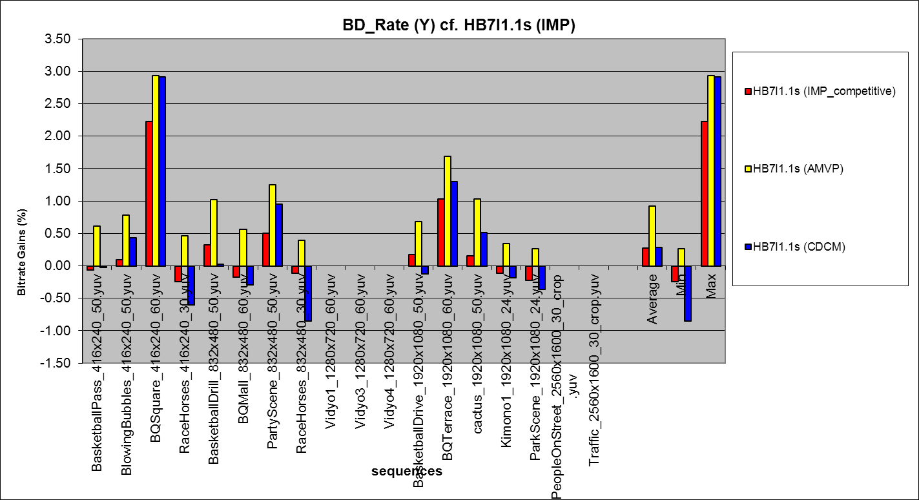
Figure 3: Simulation results for HB7I1.1s
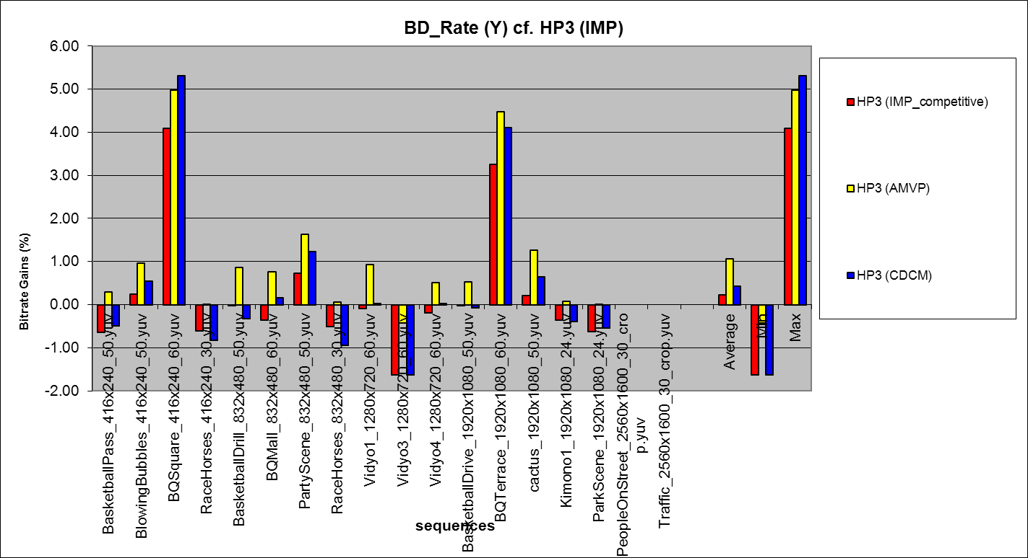
Figure 4: Simulation results for HP3

Discussion and conclusion
Results show that the coding efficiency of the proposed motion vector coding method is comparable to the methods implemented in the TMuC software.
Furthermore the proposed motion vector coding method is less complex than the methods implemented in the TMuC software in several aspects:
- The maximum number of predictors is 3 whereas IMP uses up to 15 predictors and AMVP up to 5.
- Parsing of the predictor index does not rely on motion vector data decoded for the current partition as in AMVP. In AMVP the set of predictors is pruned after decoding the motion vector difference. Thus a predictor construction process affecting parsing of the predictor index takes place while parsing motion vector data associated with the current partition. Such a dependency adversely affects the complexity of the finite state machine typically used for the parsing of the bitstream in hardware implementations. In the proposed method the dependency of the predictor index parsing is limited to the reference index which can take only a much small number of values and may thus be more easily pre-computed.
- IMP requires sorting of the predictors. While the theoretical maximum number of predictors has not be derived, such a sorting operation may turn out to be quite complex in the worst case.
We suggest that coding of motion vector data, including the proposed method, should be further studied to determine the best method for an initial TM. We further suggest to set up a core/tool experiment for this study, which should also take into account complexity issues.

Patent rights declaration(s)
NTT DOCOMO, Inc. may have IPR relating to the technology described in this contribution and, conditioned on reciprocity, is prepared to grant licenses under reasonable and non-discriminatory terms as necessary for implementation of the resulting ITU-T Recommendation | ISO/IEC International Standard (per box 2 of the ITU-T/ITU-R/ISO/IEC patent statement and licensing declaration form).

Count was obtained by printing out the size of the list of predictors for a simple coding case. Actual theoretical maximum may be even larger.

