Joint Video Team (JVT) of ISO/IEC MPEG & ITU-T VCEG  (ISO/IEC JTC1/SC29/WG11 and ITU-T SG16 Q.6)  15th Meeting: Busan, KR, 16-22 April, 2005 | Document: JVT-O060  Filename: JVT-O060.doc  NOTE – That first character after the dash up there in the document number is an "O", not a zero.

Title: | Improved SNR scalability for J-SVM
Status: | Input Document to JVT
Purpose: | Proposal
Author(s) or  Contact(s): | Isabelle Amonou, Nathalie Cammas, Sylvain Kervadec, Stephane Pateux  France Telecom Division R&D  4, rue du clos Courtel. BP 59  35 512 Cesson Sevigne.  FRANCE | Tel:  Email: | +33 2 99 12 44 77  isabelle.amonou@francetelecom.com  nathalie.cammas@francetelecom.com  sylvain.kervadec@francetelecom.com  stephane.pateux@francetelecom.com
Source: | France Telecom Division R&D
_____________________________

Introduction
This document presents an improvement of the SNR scalability in the J-SVM [1].
In the current J-SVM implementation, SNR scalability is performed using iterative quantization of the residue. In the base layer, an AVC quantization is performed, then in the successive FGS layer a quantization on the residue is performed using the same AVC quantization. However since in the FGS layers, quantization levels are expected to be limited in range and to have different properties, two modes are distinguished: significant coefficient and non-significant coefficient.
For significant coefficients, quantization of the residue is called refinement information and is limited to the value: -1, 0, +1.
For non-significant coefficients, quantization of the residue is not limited but is highly expected to be -1, 0, +1. Other values are possible due to non embedded quantization intervals and skipping of coefficients.
This progressive quantization scheme differs from bit-plane coding technique in the way that successive quantization intervals are not embedded and then does not fully exploit redundancy between successive FGS layers.
We thus propose in this contribution a new progressive quantization with embedded quantization intervals based on an initial quantization compatible with the AVC syntax.

Proposed progressive quantization technique
We first briefly recall the principle of the uniform quantization with dead-zone used in AVC and its current scalable extension used in J-SVM. Proposed progressive quantization is then described.

Quantization with dead-zone
The quantization used in AVC is a uniform quantization with a dead-zone that can be expressed by the following equations:
$\text{Quantif}:x↦\text{Quantif}\left(x,Q\right)=\left\lfloor \frac{x+\text{signe}(x)∗f∗Q}{Q}\right\rfloor$, where $f∈\left[0,12\right]$
$$\text{InvQuantif}:i↦\text{InvQuantif}(i,Q)=\left\{\begin{matrix}0 & \text{if} i\text{==}0 \\ \left(i−f+α\right)\text{.}Q & \text{otherwise}\end{matrix}\right.$$
The f parameter corresponds to the dead-zone parameter (typically f=1/3 is used for intra frames while f=1/6 is used for inter frames). The α parameter corresponds to an offset placement of the reconstruction value in the quantization interval (typically α is close to 0 for very peak pdf and close to ½ for close to uniform pdf). In AVC, we have α=f so that it is not necessary on the decoder side to know what is the parameter of the dead-zone interval. Fig. 1 shows an illustration of such quantization intervals and reconstruction value.
0

(1+α-f)Q
α.Q

(1-f).Q

(2-f).Q

-(1-f).Q

(2+α-f)Q
- Illustration of quantization with a dead-zone
Quantization with a dead-zone is of great interest for compression efficiency and the tuning of f is also important in order to get good performances ([2][3]).

Progressive quantization of J-SVM
In the J-SVM the SNR scalability is performed using successive quantization of the residue. Fig. 2 and Fig. 3 illustrate the successive quantization process. From these figures, it can be observed that quantization intervals are not embedded and that depending on the context some symbols may not be observed. For example refinements with value -1 should not be observed in the first FGS layer when f=1/6, and is very unexpected for f=1/3. Further resulting quantization intervals (defined by the intersection of successive quantization intervals) and associated reconstruction values are non homogeneous. Their widths vary and the position of the reconstruction value is not the same for all intervals (for f=1/3 the reconstruction value could even be outside the intersection of the quantization intervals! – see refinement -1 in first FGS layer).
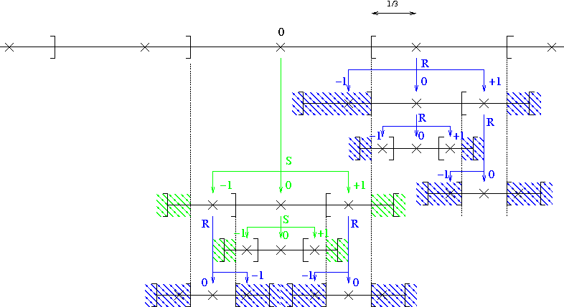
- Illustration of the progressive quantization of the J-SVM with f=1/3. Dashed areas correspond to realisations that should not be observed.
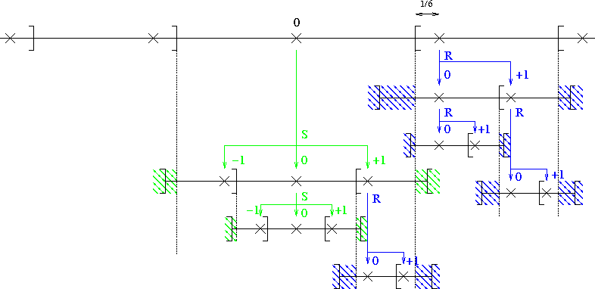
- Illustration of the progressive quantization of the J-SVM with f=1/6. Dashed areas correspond to realisations that should not be observed.
Further in the current implementation of the J-SVM, progressive quantization is not performed directly on the coefficients. While reconstruction at the decoder is performed by adding refinement to coefficients prior to the final inverse spatial transform (4x4 or 8x8), an inverse transform is performed between each quantization iterations at the decoder. Due to some rounding artifacts, the coefficients of the residue may be different if the difference is performed in the spatial domain or in the transform domain. Moreover the quantization of the Luma DC coefficient for Intra 16x16 mode is performed after the 4x4 spatial transform of DC coefficients in the Base Layer while this transform is not performed in the following FGS layers. This non application of the DC transform in the FGS layer is then not fully coherent with the notion of significant/non-significant coefficient.
All these phenomena could then impact on the performance of the SNR scalabilily. We then propose an alternative progressive quantization that does not have these drawbacks.

Progressive quantization with a dead-zone
The proposed progressive quantization is based on the use of embedded quantization intervals. Similar to the well-known bit plane coding technique, quantization intervals associated to significant values are split in two equal intervals (see Fig. 4).
- Illustration of embedded quantization intervals for significant coefficients. A quantization intervals is split into two equal parts.
For non significant coefficients, since AVC quantization is used in the base layer, it is not generally feasible to split equally the quantization interval associated to the 0 value. Thus we propose an adaptive splitting of this interval (see Fig. 5). Whenever the quantization interval associated to the 0 value (i.e. the dead-zone) is sufficiently large, quantization intervals associated to new significant are inserted on both sides. Note that these new significant quantization intervals are of same length than other intervals associated to non zero value.
- Illustration of the adaptive splitting of the quantization interval associated to non-significant coefficients. Intervals associated to new significant coefficients have a length equal to the quantization step.
Using this splitting technique, the resulting quantization scheme remains a uniform quantization with a dead-zone. The size of the dead-zone is then different across FGS levels. Further splitting of the dead-zone interval may be optionally skipped for coding performance (kind of skipping of new significant coefficients). Allowing this skipping leads to have quantized index for new significant coefficients that may be different from ±1. This is not a problem since this is already allowed by the syntax of J-SVM for coding newly significant coefficients.
Since the placement of the reconstruction value in the quantization intervals is of main importance for the quality of reconstruction we then propose to make an offset of the reconstruction value at each FGS layer (as illustrated on Fig. 4). Inverse quantization is then defined by the following process:
Base Layer decoding: Inverse AVC quantization
Parameter Initialization: OffsetNS=0
Loop over FGS layers
Set Q=Q/2 // Half value of quantization step
GetOffset(Offset) // Get value of the offset to apply on coeffs
OffsetNS += Offset // Update offset to apply to new significant
If (FlagShiftNS)
OffsetNS += Q // Update offset new significant if needed
EndIf
Loop over coefficients
If (IsSignificant(coeff))
ReadRefinementInfo(i) // Read 0 or 1
coeff += signe(coeff)*(i*Q + offsetS)
Else
ReadSignificantInfo(i) // 0, ±1, ±2 , …
If (i!=0)
Coeff = i*Q + signe(i)*offsetNS
EndIf
EndIf
EndLoop
EndLoop
In the proposed technique the offset applied to the already significant coefficient (offsetS) and the newly significant coefficient (offsetNS) is different. The offset for the newly significant coefficient is introduced in order to accumulate all the offsets until current iteration so that new significant coefficients will have the same offset. Apart from being updated at each iteration by accumulating the offset of current quantization iteration, the offsetNS can be additionally increased by the value of the current quantization step (offsetNS+=Q). This additional updating (see FlagShiftNS) of offsetNS is necessary in the case where no quantization intervals for newly significant coefficients could be created. A flag is then transmitted in order to signal this updating of offsetNS. Note that we could skip the transmission of this flag in the case where the decoder could know when it should occur (i.e. by knowing dead-zone parameter f), but this will not be in line with AVC spirit (dead zone parameter f is not known at the decoder and any selection could be used by the encoder).

Experimental results
In order to estimate the performance of the proposed progressive quantization, implementation has been made in current J-SVM software v.1.
- Proposed progressive quantization has been implemented for I and P frames (i.e. for routine MCTFEncoder::xEncodeLowPassPictures).
- Progressive quantization of the coefficients is performed in the transform domain.
- Progressive quantization of DC coefficients for intra16 mode is performed in the 4x4 DC transform domain.
- Coefficient skipping is disabled in order to fairly compare both quantization algorithms.
Fig. 6, Fig. 7, Fig. 8 and Fig. 9 show comparison between our proposed FGS quantization and SVM FGS quantization. Since we modify only the encoding of low pass frames (I and P) only PSNRs of low pass frames are plotted. PSNRs are computed using non truncated FGS levels. In these tests we used a mono-level MCTF on CIF 30Hz sequences.
We can observe on these curves that we have a gain on both luma and chroma informations. Estimated gain is around 0.2 dB where it can be fairly estimated (e.g. at FGS2 quality level where bit-rate is similar)).
- Comparison between proposed progressive quantization and J-SVM. Results for sequence Bus.
- Comparison between proposed progressive quantization and J-SVM. Results for sequence Football.
- Comparison between proposed progressive quantization and J-SVM. Results for sequence Foreman.
- Comparison between proposed progressive quantization and J-SVM. Results for sequence Mobile.
Fig. 10 and Fig. 11 shows results for higher rates for Football and Mobile sequences. Same observations can be made. PSNR gain is even higher (around 1.3dB for FGS3 layer on Mobile).
- Comparison between proposed quantization and J-SVM for high rates. Results for sequence Football
- Comparison between proposed quantization and J-SVM for high rates. Results for sequence Mobile

Conclusion
We have proposed a new progressive quantization technique for SNR scalability. This progressive quantization uses embedded quantization intervals that are more suited for progressive coding. Early results on I and P frames have shown promising performances.
Further developments have to be made in order to evaluate the full benefits of the proposed technique:
- Application to B frames.
- Coefficients skipping heuristic to defined in order to optimize the proposed progressive technique (i.e. as is done in current J-SVM).
- Coefficient classification for defining the offset (since all coefficients do not have same statistical properties).

References
- ITU-T and ISO/IEC JTC1, “Scalable Video Coding - Working Draft 1”, JVT-N020, Jan 2005
- G. J. Sullivan, " Adaptive quantization encoding technique using an equal expected-value rule ", JVT standards contribution JVT-N011
- A. M. Tourapis, J. Boyce, "Performance evaluation of 8x8 transform vs. coefficient adaptive deadzone consideration", JVT standards contribution JVT-K035

(Append for Proposal Documents)

JVT Patent Disclosure Form

International Telecommunication Union  Telecommunication Standardization Sector | International Organization for Standardization | International Electrotechnical Commission
 |  | 
Joint Video Coding Experts Group - Patent Disclosure Form
(Typically one per contribution and one per Standard | Recommendation)

Please send to:
JVT Rapporteur Gary Sullivan, Microsoft Corp., One Microsoft Way, Bldg. 9, Redmond WA 98052-6399, USA
Email (preferred): Gary.Sullivan@itu.int Fax: +1 425 706 7329 (+1 425 70MSFAX)

This form provides the ITU-T | ISO/IEC Joint Video Coding Experts Group (JVT) with information about the patent status of techniques used in or proposed for incorporation in a Recommendation | Standard. JVT requires that all technical contributions be accompanied with this form. Anyone with knowledge of any patent affecting the use of JVT work, of their own or of any other entity (“third parties”), is strongly encouraged to submit this form as well.

This information will be maintained in a “living list” by JVT during the progress of their work, on a best effort basis. If a given technical proposal is not incorporated in a Recommendation | Standard, the relevant patent information will be removed from the “living list”. The intent is that the JVT experts should know in advance of any patent issues with particular proposals or techniques, so that these may be addressed well before final approval.

This is not a binding legal document; it is provided to JVT for information only, on a best effort, good faith basis. Please submit corrected or updated forms if your knowledge or situation changes.

This form is not a substitute for the ITU ISO IEC Patent Statement and Licensing Declaration, which should be submitted by Patent Holders to the ITU TSB Director and ISO Secretary General before final approval.

Submitting Organization or Person:
Organization name
Mailing address
Country
Contact person
Telephone
Fax
Email
Place and date of submission
Relevant Recommendation | Standard and, if applicable, Contribution:
Name (ex: “JVT”)
Title
Contribution number

(Form continues on next page)

Disclosure information – Submitting Organization/Person (choose one box)
2.0 The submitter is not aware of having any granted, pending, or planned patents associated with the technical content of the Recommendation | Standard or Contribution.

or,
The submitter (Patent Holder) has granted, pending, or planned patents associated with the technical content of the Recommendation | Standard or Contribution. In which case,

2.1 The Patent Holder is prepared to grant – on the basis of reciprocity for the above Recommendation | Standard – a free license to an unrestricted number of applicants on a worldwide, non-discriminatory basis to manufacture, use and/or sell implementations of the above Recommendation | Standard.
2.2 The Patent Holder is prepared to grant – on the basis of reciprocity for the above Recommendation | Standard – a license to an unrestricted number of applicants on a worldwide, non-discriminatory basis and on reasonable terms and conditions to manufacture, use and/ or sell implementations of the above Recommendation | Standard.

Such negotiations are left to the parties concerned and are performed outside the ITU | ISO/IEC.
2.2.1 The same as box 2.2 above, but in addition the Patent Holder is prepared to grant a “royalty-free” license to anyone on condition that all other patent holders do the same.
2.3 The Patent Holder is unwilling to grant licenses according to the provisions of either 2.1, 2.2, or 2.2.1 above. In this case, the following information must be provided as part of this declaration:
- patent registration/application number;
- an indication of which portions of the Recommendation | Standard are affected.
- a description of the patent claims covering the Recommendation | Standard;
In the case of any box other than 2.0 above, please provide the following:
Patent number(s)/status
Inventor(s)/Assignee(s)
Relevance to JVT
Any other remarks:
(please provide attachments if more space is needed)

(form continues on next page)
Third party patent information – fill in based on your best knowledge of relevant patents granted, pending, or planned by other people or by organizations other than your own.

Disclosure information – Third Party Patents (choose one box)
3.1 The submitter is not aware of any granted, pending, or planned patents held by third parties associated with the technical content of the Recommendation | Standard or Contribution.

3.2 The submitter believes third parties may have granted, pending, or planned patents associated with the technical content of the Recommendation | Standard or Contribution.

For box 3.2, please provide as much information as is known (provide attachments if more space needed) - JVT will attempt to contact third parties to obtain more information:

3rd party name(s)
Mailing address
Country
Contact person
Telephone
Fax
Email
Patent number/status
Inventor/Assignee
Relevance to JVT

Any other comments or remarks:

This work has been partially realized within IST European co-funded project DANAE under contract IST-1-507113.

