CE8: ROI-based Scalable Video Coding

Coordinator: Institute for Infocomm Research (Zhongkang Lu)
Proponent  (Company, Contact Person, Email) | Verification Partner  (Company, Contact Person, Email)
National Chiao-Tung University  Wen-Hsiao Peng  pawn@mail.si2lab.org | ICU, ETRI  Truong Cong Thang  tcthang@icu.ac.kr  Haechul Choi  choihc@etri.re.kr
ICU, ETRI  Truong Cong Thang  tcthang@icu.ac.kr  Haechul Choi  choihc@etri.re.kr | Institute for Infocomm Research  Zhongkang Lu  zklu@i2r.a-star.edu.sg
Institute for Infocomm Research  Zhongkang Lu  zklu@i2r.a-star.edu.sg | Panasonic Singapore Laboratories  Shen Shengmei  shen@psl.com.sg

Functionality/Problem Addressed
The CE addresses the region-of-interest functionality, which can also achieve progressive refinement and flexible slice structure. In SVC WD1.0, a coarse ROI functionality can be achieved by flexible macroblock order (FMO) and possibly QP adaptation scheme. To fully understand the advantages and disadvantages of the existing approach and possibly improvement offered by using a new approach, we like to do a further investigation on the above issues.

The CE will integrate a ROI description into the current JSVM reference software, and investigate different ways to support the ROI-based scalable video coding, including ROI-based fine granular scalability (FGS), ROI-based spatial scalability, and ROI-based coarse granular scalability (CGS).

Description of tools
Tool1: Selective enhancement functionality to scalable video coding (JVT-O020)
Regions-of-interest (ROI) is a desirable feature in some applications as described in the requirement document of MPEG-4 Part 10 Amd. 1 Scalable Video Coding (SVC), N6880. For those applications, the clients at the decoder side may require to receive a better decoded quality in the ROIs when the pre-encoded scalable bit-stream is truncated. Currently, the JSVM1.0 of SVC does not support ROI functionality. In this proposal, we develop a graceful and arbitrary shape selective enhancement scheme to provide the ROI functionality in SVC.
To provide the ROI functionality based on cyclical block coding, we proposed to code each block unequally in a coding cycle. For illustration, Fig. 1 and Fig. 2 show the differences between the cyclical block coding and our prioritized coding scheme. For simplicity, we use the notation of (EOB, Run, Level) symbol to represent the coefficients of a block that are to be coded in a coding cycle of significance pass. In Fig. 1, the cyclical block coding equally encodes each block with one (EOB, Run, Level) symbol (or one refinement symbol) in every cycle. However, as shown in Fig. 2, to offer the ROI functionality, we should encode the blocks in the ROIs with more symbols by enabling the coding prior to the blocks which are outside the ROIs. We can further extend this concept to enable the coding of different ROIs at different cycles to have graceful selective enhancement. For example in Fig. 2, we have selected two ROIs. The coding of the highest priority region ROI 1, which includes Block 0, is enabled prior to the rest of blocks. After two coding cycles, the coding of ROI 2 which is of lower priority is activated subsequently. In particular, the coding of ROI 2 is started before the coding of background region, i.e., Block 2 and Block 3. With such prioritization, the blocks in the ROIs will be coded with more symbols at the end of each cycle. When the enhancement-layer is truncated, the blocks in the ROIs will be firstly decoded and updated.

Figure 1: Cyclical block coding.

Figure 2: Prioritized cyclical block coding for the ROI functionality.

For specifying the priority of a ROI, we use the number of shifting cycles which is defined as the number of coding cycles in the ROI before the coding of background region. For example, the number of shifting cycles of ROI 1 in Fig. 2 is 2, which means that the Block 0 has to be coded with 2 cycles before the coding of background region. Higher number of shifting cycles means higher coding priority. For more detail description of this tool, please refer to [1].

Tool2: Spatial scalability of multiple ROIs (JVT-O037)
With spatial scalability of multiple ROIs, two main issues are that 1) there may be some overlapped regions between ROIs and 2) ROIs may have different resolutions. We follow the concept of slice group of MPEG-4 AVC in describing the independent regions. In the coding mechanism, we consider the following solution to improve the coding efficiency:
- To support different spatial resolutions for different ROIs, we introduce the concept of virtual parts in layers.
- To avoid duplicate coding of overlapped regions in multiple ROIs, we propose to encode the overlapped regions in the manner that they will be independently decodable.
The above concepts can be illustrated by the example in Fig. 3. In this example, originally the video is displayed at 4CIF size. But a user, who is staying on a bus and using a wireless PDA, may request "I only want to see ROI 1 at one fourth size and ROI 2 at half size". In this case, there is one overlapped region (denoted as OR) between the two ROIs. We denote (ROI_x - OR) as the part of ROI_x subtracted by OR.
Then, for this request, the provider may initially encode ROI 1 at QCIF layer and ROI 2 at both QCIF and CIF layers. He may add one more layer, which is 4CIF, to display the video at a high-end device.
Specifically, at the QCIF layer, (ROI_1 - OR), (ROI_2 - OR), and the OR are encoded as three independently decodable regions. At the CIF layer, only (ROI_2 - OR) and OR are enhanced. However, to allow this stream to be used as a lower layer for further enhancement, we put a "virtual part" for (ROI_1 - OR). This area has no actual video data, but could be filled by the data upscaled from its lower layer (in this example the QCIF layer).

Then the two sub-bitstreams for the two ROIs can be extracted and displayed simultaneously on the user's device (they can be displayed side by side, "overlappedly", or in two separate windows, etc.).

The usefulness of the above mechanism is verified by comparing with the current mechanism of JSVM1.0, where the overlapped regions and virtual parts are not considered.
QCIF layer
CIF layer
4CIF layer
ROI 1
(ROI_2-OR)
Overlapped area
(OR)
Contents to be displayed
Virtual part
(ROI_1 - OR)
ROI 2

Fig. 3: Illustration of providing ROIs with different resolutions and overlapped region

Tool3: CGS on Scalable Video Coding (JVT-O056)

The details are provided in document JVT-O056/M11844[3].

The perceptual ROI description will be used to generate the QP profiles, and to realize the CGS in the current JSVM reference software. The diagram of generating QP profile from a perceptual ROI description is given in Fig. 4. The rate-distortion model that is given in equation (1) is used to normalize the QP values into a proper range, so that the generated bits by the proposed ROI based CGS scheme are close to those without ROI.
(1)

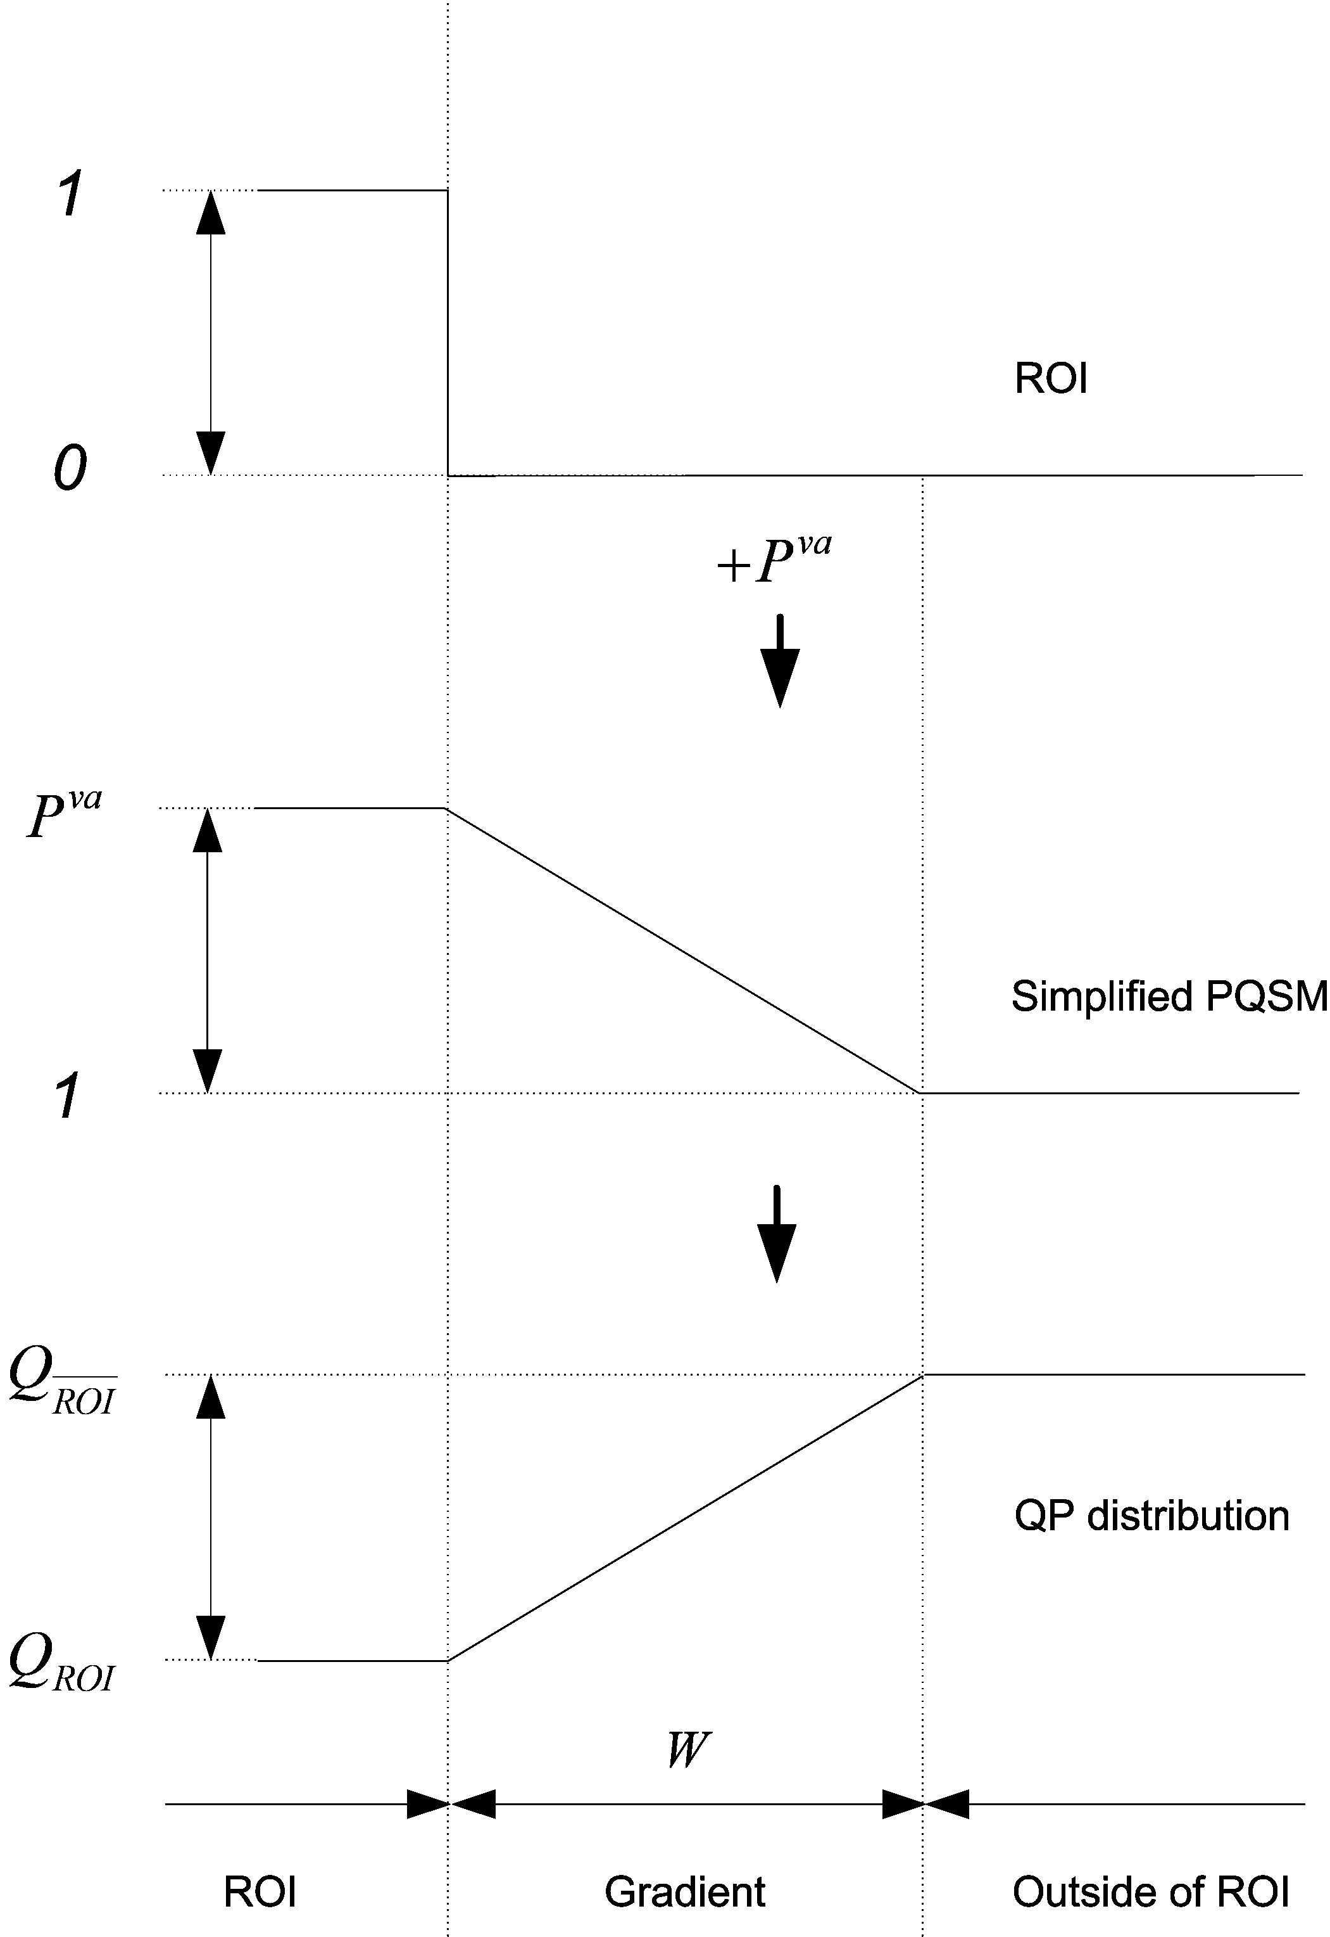

Figure 4: A flowchart of generating QP profile.
The ROI-based CGS is realized by putting more MVFs into ROI than outside of ROI, so that the macro blocks inside ROI have finer scalability for motion vectors. Moreover, MVF and residual image are always matched in the ROI where there may be mismatch outside the ROI. In this way, computational resources can be saved to ROIs.

Expected gains
Expected gains include improvement on coding efficiency and new functionality, which is not supported by WD1.0 of SVC.

Core experiments conditions

Software
The JSVM 2 reference software released at this 72st MPEG meeting will be used by all the participants to this CE. The test sets and ROI descriptions in the CE will be discussed and agreed by all participants (Busan+1W).

Coding conditions
All experiments done using latest JSVM software updated on Busan meeting with necessary modifications, if any.

Test set

Test set 1 for tool1 and tool3:
Test sequences: ‘Foreman’, ‘Stephan’, ‘Singer’ and ‘News’
CIF@30Hz
2 enhance layers (FGS & CGS)
Bitrate: up to 512K bps, base layer is determined by QP of configuration file.
GOP size: 1, 16
ROI resolution: rectangle, MB.
ROI masks will be delivered later (Busan+1W)

Test set 2 for tool2:
4CIF(704x576) surveillance video with 2 ROIs will be used as a test clip. And the size of overlapped region is varied. For test of virtual part, 4CIF clip is encoded with 3 layer configurations, where first ROI is in the layer 0 and the second ROI is in the layer 1, and layer 2. Spatial scaling factor is 2 between layers.
- TBA about test sequence (e.g. surveillance video in MPEG-7 test set).

Evaluation criteria

Experiment 1:
Experiment 1 is to evaluate the coding efficiency of tool1 and tool3. In experiment 1, the proposed tool 1 should compare with JSVM without FMO and JSVM with FMO. The evaluation of coding efficiency will be realized by comparing the PSNR values of ROI regions and outside of ROI region, compressed file size, and subjective viewing ratings.

Experiment 2:
Experiment 1 is to evaluate the coding efficiency of tool2. Proposal will be added to J-SVM1.0 software delivered after Busan meeting.
Bitstreams, PSNR and decoded sequences will be provided and compared.

Coding efficiency regarding the overlapped region (OR) handling and the virtual part
Test 1: Coding efficiency of
- when each ROI is encoded independently (without considering overlapped region)
- when ROIs are encoded with considering overlapped region (as in JVT-O037)
Test 2: Coding efficiency of
a. encoding without considering virtual parts
b. inter-layer coding with virtual parts (as in JVT-O037)

Time lines
Busan+1W: The test sets, ROI descriptions and syntax in the CE are agreed by all participants.
Experimental results and cross-verification completed for the July Porland meeting (if we ask for subjective quality comparison experiments).

References
- Wen-Hsiao Peng, Adding Selective Enhancement Functionality to Scalable Video Coding, JVT-O020, Busan, KR, 16-22 April, 2005.
- Truong Cong Thang, Tae Meon Bae, Yong Ju Jung, Yong Man Ro, Jae-Gon Kim, Haechul Choi, Jin-Woo Hong, Spatial Scalability of Multiple ROIs in Surveillance Video, JVT-O037, Busan, KR, 16-22 April, 2005.
- Zhongkang Lu, Weisi Lin, Zhengguo Li, Keng Pang Lim, Xiao Lin, Susanto Rahardja, Ee Ping Ong and Susu Yao, Perceptual Region-of-interest (ROI) based Scalable Video Coding, JVT-O056, Busan, KR, 16-22 April, 2005.

