Joint Video Team (JVT) of ISO/IEC MPEG & ITU-T VCEG  (ISO/IEC JTC1/SC29/WG11 and ITU-T SG16 Q.6)  17th Meeting: Nice, FR, 14-21 October, 2005 | Document: JVT-Q017  Filename: input.doc

Title: | On High Level Syntax Related to ROI for Scalable Video Coding
Status: | Input Document to JVT
Purpose: | Proposal
Author(s) or  Contact(s): | Zhengguo Li,  Zhongkang Lu,  Susanto Rahardja,  Xiao Lin,  Keng Pang Lim,  Weisi Lin,  Jinghong Zheng  Wei Yao  Institute for Infocomm Research,  21 Heng Mui Keng Terrace, Singapore 119613 | Tel:  Email: | +65 6874 6774  ezgli@i2r.a-star.edu.sg  +65 6874 6720  zklu@i2r.a-star.edu.sg  +65 6874 8221  rsusanto@i2r.a-star.edu.sg  +65 6874 1946  linxiao@i2r.a-star.edu.sg  +65 6874 4303  kplim@i2r.a-star.edu.sg  +65 6874 8527  wslin@i2r.a-star.edu.sg  +65 6874 1957 jhzheng@i2r.a-star.edu.sg  +65 6874 6744  wyao@i2r.a-star.edu.sg
Source: | Institute for Infocomm Research
_____________________________

Introduction
This contribution consists of two parts. One is on the geometrical relationship between two successive spatial resolutions, which is based on the proposal from Sharp [1]. The other is on the prediction between syntaxes in picture parameter set and slice header that are related to ROI [2].

Proposal

Geometrical Relationship Between Two Successive Spatial Resolutions
Consider two successive spatial layers, a lower layer (considered as base layer) and a higher layer (considered as enhancement layer), that is shown in Figure 1 [1]. Width and height of enhancement layer pictures are denoted as w_{enh} and h_{enh}, respectively. In the same way, dimensions of the corresponding base layer picture are respectively denoted as w_{base} and h_{base}. The picture at the base layer is a subsampled version of a sub-region of the enhancement layer picture, of dimensions w_{extract} and h_{extract}, positioned at coordinates (x_{orig},y_{orig}) in the enhancement layer picture coordinates system.

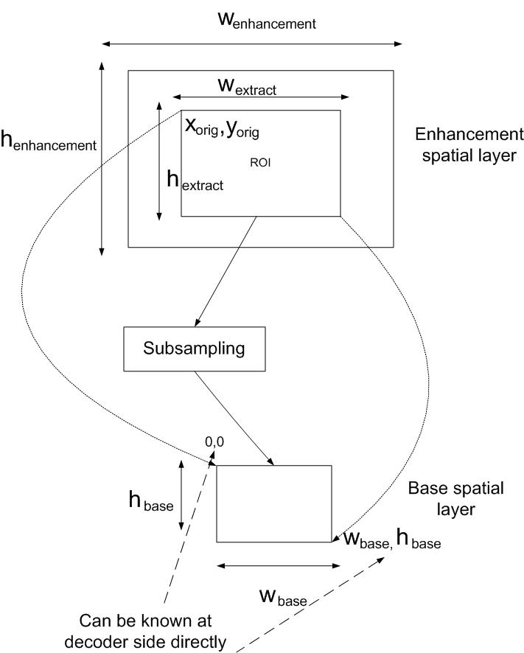

Figure 1: The relationship between two successive layers
Note that
$\frac{w_{\text{extreact}}}{h_{\text{extract}}}≈\frac{w_{\text{base}}}{h_{\text{base}}}$. (1)
Since w_{base} and h_{base} are available from the picture parameter set syntax, only four parameters (x_{orig}, y_{orig}, w_{enh} -w_{extract}- x_{orig}, h_{enh} -h_{extrac,t}- y_{orig}) need to be coded. Instead of coding four paramters (x_{orig}, y_{orig}, w_{enh} -w_{extract}- x_{orig}, h_{enh} -h_{extrac,t}- y_{orig}) directly as in [1], we either code four parameters (x_{orig} , y_{orig} , w_{enh} -w_{extract}- x_{orig}, h’_{extrac,t}) with h’_{extrac,t} given by
$h'_{\text{extract}}=h_{\text{extract}}−\frac{h_{\text{base}}∗w_{\text{extract}}}{w_{\text{base}}}$, (2)
or code four parameters (x_{orig} , y_{orig} , w’_{extract}, h_{enh} -h_{extrac,t}- y_{orig t}) with w’_{extrac,t} given by
$w'_{\text{extract}}=w_{\text{extract}}−\frac{w_{\text{base}}∗w_{\text{extract}}}{h_{\text{base}}}$. (3)
Equations (2) or (3) can also be used to code the relationship between the same ROI in two successive resolutions when the ROI-based scalable video coding is studied.

Prediction between syntaxes in PPS and slice header
The syntax related to ROI in PPS and slice header are given in Tables 1 and 2, respectively [3][4].
Table 1 Picture parameter set RBSP syntax
picture_parameter_set_rbsp( ) { | C | Descriptor
… | .. | …
slice_group_map_type | 1 | ue(v)
… | .. | …
if(slice_group_map_type==2){ | … | …
for(iGroup=0;iGroup<=num_slice_groups_minus1;iGroup++){
top_left[iGroup] | 1 | ue(v)
bottom_right[iGroup] | 1 | ue(v)
}}…}

Table 2 Slice header in scalable extension syntax
slice_header_in_scalable_extension( ) { | C | Descriptor
first_mb_in_slice | 2 | ue(v)
… | .. | …
pic_parameter_set_id | 2 | ue(v)
…} | … | …

We have an observation from Table 2 as below:

A slice can be decoded correctly only when both the corresponding PPS syntax and slice header syntax are received correctly.

Based on this observation, we propose a prediction scheme between the syntaxes in both PPS and slice header that are related to ROI. Specifically, our prediction scheme is on the coding of first_mb_in_slice [2]. Since we have information on the top left corners of all ROIs in the current picture after the PPS is decoded, all Top_Left[iGroup]’s are used as reference values to predict all first_mb_in_slice’s in the current picture. In other words, we code the following two items:

- iGroup, the ID of ROI with the top left corner around first_mb_in_slice, and its value is 0 if it is not presented;
- The relative address of the first MB in the slice with respect to (w.r.t) the top left corner of the ROI.

Thus, our slice header in scalable extension syntax is given by

Table 3 Slice header in scalable extension syntax
slice_header_in_scalable_extension( ) { | C | Descriptor
pic_parameter_set_id | 2 | ue(v)
if(slice_group_map_type==2){
iGroup | 2 | ue(v)
first_mb_in_slice_wrt_top_left[iGroup] | 2 | ue(v)
}
…} | … | …

References

- S. J. Sun, Edouard Francois, “Extended Spatial Scalability with Picture-Level Adaption”, ISO/IEC JTC1/SC29/WG11 and ITU-T SG16 Q.6, 15th Meeting/JVT-O008, Bushan, Korea, April, 2005.
- Z. K. Lu, S. W. Lin, Z. G. Li, K. P. Lim, X. Lin, S. Rahardja, E. P. Ong, S. S. Yao, “Perceptual Region-of-interest (ROI) based Scalable Video Coding”, ISO/IEC JTC1/SC29/WG11 and ITU-T SG16 Q.6, 15th Meeting/JVT-O056, Bushan, Korea, April, 2005.
- G. Sullivan, T. Wiegand, D. Marpe, A. Luthra, "Text of ISO/IEC 14496 10 Advanced Video Coding 3rd Edition", document MPEG-N6540, Redmond, WA, USA, July 2004.
- J. Reichel, H. Schwarz, M. Wien, “Scalable Video Coding - Working Draft 1”, document JVT-N020, Joint Video Team (JVT) of ISO/IEC MPEG & ITU-T VCEG, Hong Kong, CN, 17 –21 January, 2005.
- J. Ohm, , "Three-Dimensional Sub-band Coding with Motion Compensation," IEEE Trans. on Image Processing, Vol. 3 No. 9, pp. 559571, Sept. 1994.

(Append for Proposal Documents)

JVT Patent Disclosure Form

International Telecommunication Union  Telecommunication Standardization Sector | International Organization for Standardization | International Electrotechnical Commission
 |  | 
Joint Video Coding Experts Group - Patent Disclosure Form
(Typically one per contribution and one per Standard | Recommendation)

Please send to:
JVT Rapporteur Gary Sullivan, Microsoft Corp., One Microsoft Way, Bldg. 9, Redmond WA 98052-6399, USA
Email (preferred): Gary.Sullivan@itu.int Fax: +1 425 706 7329 (+1 425 70MSFAX)

This form provides the ITU-T | ISO/IEC Joint Video Coding Experts Group (JVT) with information about the patent status of techniques used in or proposed for incorporation in a Recommendation | Standard. JVT requires that all technical contributions be accompanied with this form. Anyone with knowledge of any patent affecting the use of JVT work, of their own or of any other entity (“third parties”), is strongly encouraged to submit this form as well.

This information will be maintained in a “living list” by JVT during the progress of their work, on a best effort basis. If a given technical proposal is not incorporated in a Recommendation | Standard, the relevant patent information will be removed from the “living list”. The intent is that the JVT experts should know in advance of any patent issues with particular proposals or techniques, so that these may be addressed well before final approval.

This is not a binding legal document; it is provided to JVT for information only, on a best effort, good faith basis. Please submit corrected or updated forms if your knowledge or situation changes.

This form is not a substitute for the ITU ISO IEC Patent Statement and Licensing Declaration, which should be submitted by Patent Holders to the ITU TSB Director and ISO Secretary General before final approval.

Submitting Organization or Person:
Organization name | Institute for Infocomm Research
Mailing address | Heng Mui Keng Terrace, 21
Country | Singapore
Contact person | Zhengguo LI
Telephone | 6568746774
Fax | 6567744998
Email | ezgli@i2r.a-star.edu.sg
Place and date of submission | France, 17-21 Oct, 2005
Relevant Recommendation | Standard and, if applicable, Contribution:
Name (ex: “JVT”) |  | ITU-T Rec. H.264 | ISO/IEC 14496-10
Title |  | On High Level Syntax Related to ROI for Scalable Video Coding
Contribution number |  | JVT-Qxxx

(Form continues on next page)

Disclosure information – Submitting Organization/Person (choose one box)
2.0 The submitter is not aware of having any granted, pending, or planned patents associated with the technical content of the Recommendation | Standard or Contribution.

or,
The submitter (Patent Holder) has granted, pending, or planned patents associated with the technical content of the Recommendation | Standard or Contribution. In which case,

 | 2.1 The Patent Holder is prepared to grant – on the basis of reciprocity for the above Recommendation | Standard – a free license to an unrestricted number of applicants on a worldwide, non-discriminatory basis to manufacture, use and/or sell implementations of the above Recommendation | Standard.
2.2 The Patent Holder is prepared to grant – on the basis of reciprocity for the above Recommendation | Standard – a license to an unrestricted number of applicants on a worldwide, non-discriminatory basis and on reasonable terms and conditions to manufacture, use and/ or sell implementations of the above Recommendation | Standard.

Such negotiations are left to the parties concerned and are performed outside the ITU | ISO/IEC.
X | 2.2.1 The same as box 2.2 above, but in addition the Patent Holder is prepared to grant a “royalty-free” license to anyone on condition that all other patent holders do the same.
2.3 The Patent Holder is unwilling to grant licenses according to the provisions of either 2.1, 2.2, or 2.2.1 above. In this case, the following information must be provided as part of this declaration:
- patent registration/application number;
- an indication of which portions of the Recommendation | Standard are affected.
- a description of the patent claims covering the Recommendation | Standard;
In the case of any box other than 2.0 above, please provide the following:
Patent number(s)/status
Inventor(s)/Assignee(s)
Relevance to JVT
Any other remarks:
(please provide attachments if more space is needed)

(form continues on next page)
Third party patent information – fill in based on your best knowledge of relevant patents granted, pending, or planned by other people or by organizations other than your own.

Disclosure information – Third Party Patents (choose one box)
X | 3.1 The submitter is not aware of any granted, pending, or planned patents held by third parties associated with the technical content of the Recommendation | Standard or Contribution.
 | 3.2 The submitter believes third parties may have granted, pending, or planned patents associated with the technical content of the Recommendation | Standard or Contribution.
For box 3.2, please provide as much information as is known (provide attachments if more space needed) - JVT will attempt to contact third parties to obtain more information:

3rd party name(s)
Mailing address
Country
Contact person
Telephone
Fax
Email
Patent number/status
Inventor/Assignee
Relevance to JVT

Any other comments or remarks:

