Joint Video Team (JVT) of ISO/IEC MPEG & ITU-T VCEG  (ISO/IEC JTC1/SC29/WG11 and ITU-T SG16 Q.6)  17th Meeting: Nice, FR, 14-21 October, 2005 | Document: JVT-Q037r1  Filename: JVT-Q037r1.doc

Title: | 14-Bit Support in the Advanced 4:4:4 Profile(s)
Status: | Input Document to JVT
Purpose: | Proposal
Author(s) or  Contact(s): | Pankaj Topiwala  7150 Riverwood Dr.  Columbia, MD 1046 USA  Alexis Tourapis  7150 Riverwood Dr.  Columbia, MD 1046 USA  Haoping Yu  Corporate Research, Thomson Inc  101 West 103rd Street, Indianapolis, IN 46290 USA | Tel:  Email:  Tel:  Email:  Tel:  Email: | 410-309-6066  pankaj@fastvdo.com  410-309-6066  alexis@fastvdo.com  1 317-587-3085  haoping.yu@thomson.net
Source: | FastVDO and Thomson
_____________________________

Abstract
We call for support of 14-bit input video sample data in the upcoming Advanced 4:4:4 Profile(s).
Applications using existing 14-bit video sensors ranging from military surveillance to emerging commercial television and film industry require 14-bit support.

Introduction
The current High 4:4:4 Profile can support up to 12-bit sample data. However, several applications currently use 14-bit video sensors. While bit truncation (or more sophisticated bit packing techniques) can be used as a method of downgrading to 12-bits, we assert that 14-bit support is in fact natural within the context of very high-quality coding. This will provide even broader application support at none to negligible complexity surplus, while future-proofing the upcoming Advanced 4:4:4 standard in a certain direction (e.g., bitdepth). Furthermore, we contend that it is easily incorporated into the H.264/AVC standard. The reference software (with essentially no changes) already supports this functionality. The required changes to the text, on a preliminary pass, appear to be simple, as outlined below. We therefore suggest the adoption of 14-bit support.

Required Changes
Although one may originally suggest that adding 14bit support into the standard text may not exactly be trivial since one may need to extend the QP range and provide appropriate extensions in terms of the color bit depth, further inspection of the existing text proves otherwise. In fact, the committee has done a wonderful job in extending the standard from 8 bits to higher bit-depths up to 12bits using a very generic representation. Such representation immediately allows also the support of 14bits by only extending the allowable range of the syntax elements bit_depth_luma_minus8 and bit_depth_chroma_minus8 from [0,4] to [0,6].

More specifically, it appears that one only needs to modify section 7.4.2.1 as to state that:
bit_depth_luma_minus8 specifies the bit depth of the samples of the luma array and the value of the luma quantisation parameter range offset QpBdOffset_{Y}, as specified by
BitDepth_{Y} = 8 + bit_depth_luma_minus8 (7-1)
QpBdOffset_{Y} = 6 * bit_depth_luma_minus8 (7-2)
When bit_depth_luma_minus8 is not present, it shall be inferred to be equal to 0. bit_depth_luma_minus8 shall be in the range of 0 to 6, inclusive.
bit_depth_chroma_minus8 specifies the bit depth of the samples of the chroma arrays and the value of the chroma quantisation parameter range offset QpBdOffset_{C}, as specified by
BitDepth_{C} = 8 + bit_depth_chroma_minus8 (7-3)
QpBdOffset_{C} = 6 * ( bit_depth_chroma_minus8 + residual_colour_transform_flag ) (7-4)
When bit_depth_chroma_minus8 is not present, it shall be inferred to be equal to 0. bit_depth_chroma_minus8 shall be in the range of 0 to 6, inclusive.

The above extension and the assignments made to BitDepth_{Y}, BitDepth_{C}, and QpBdOffset_{Y}, QpBdOffset_{C} seem to automatically provide the support needed for 14bit encoding.

Similarly, we have also observed that very minor changes were needed in the reference software as to provide support for such content. In fact, no changes were required in the decoder, while the only changes needed in the encoder were related to extending the input configuration parsing files to support 14 bits, but also dynamically allocating based on bit-depth some of the arrays used within the transform/quantization process. Furthermore, some bugs relating to the lambda computation have also been corrected.

To evaluate performance, we have considered a true 14bit monochrome (infrared) VGA resolution sequence named as candle (Figure 1) but also extended some of the known 8bit sequences, such as foreman, stefan, and football to 14bits (Figure 2). Extension was made by essentially shifting the original values by 6 bits and the addition of gaussian noise with σ²=64. Note that noise added was completely uncorrelated from frame to frame but also component to component.

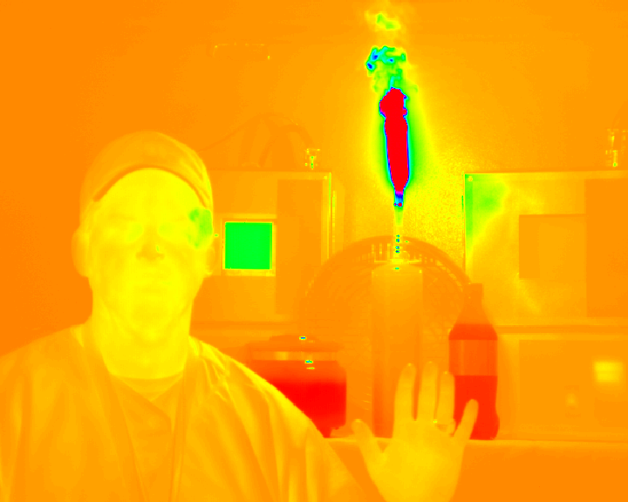 | 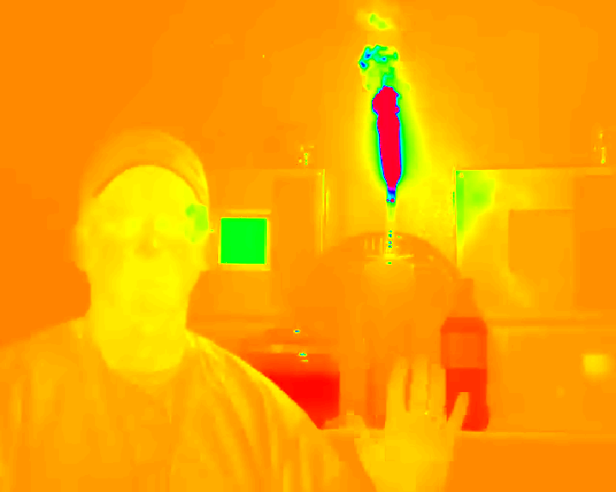
(a) | (b)
Figure 1. Frame 0 of monochrome 14bit Infrared sequence (candle). (a) original (b) coded using QP 20.

The RD curve for encoding the IR sequence Candle can be seen in Figure 3. For the encoding we have selected the High 4:4:4 profile with an IBBPBBP GOP structure, full Macroblock and Picture level RD Optimization, and QP values ranging from -20 to 36 (using intervals of 4). In Figure 4 the RD performance, using similar conditions, for the sequence foreman (monochrome) is also presented. Note that the slope of the plot is a bit unconventional, but one may relate that behavior to the actual characteristics of the noise added (i.e. completely uncorrelated frame by frame Gaussian noise). Such would have an immediate impact in both the Motion Estimation & Compensation processes, and therefore the resulting RD performance.

We should also point out that the current JM software lacks support of PCM modes when using CABAC in the encoder, which also has a severe impact at very low QPs (extremely high rates). In fact one may observe that also the encoder tends to pack a significant amount of stuffing words when using CABAC at such QPs, and that the performance of the encoder is actually better when using CAVLC (which already supports PCM modes).


(a) | (b)
Figure 2. Original 8bit (a) and 14bit extended (b) frame 0 of the Foreman CIF resolution sequence.

Figure 3. RD Performance of 14bit sequence Candle
Figure 4. RD Performance of 14bit extended sequence foreman

(Append for Proposal Documents)

JVT Patent Disclosure Form

International Telecommunication Union  Telecommunication Standardization Sector | International Organization for Standardization | International Electrotechnical Commission
 |  | 
Joint Video Coding Experts Group - Patent Disclosure Form
(Typically one per contribution and one per Standard | Recommendation)

Please send to:
JVT Rapporteur Gary Sullivan, Microsoft Corp., One Microsoft Way, Bldg. 9, Redmond WA 98052-6399, USA
Email (preferred): Gary.Sullivan@itu.int Fax: +1 425 706 7329 (+1 425 70MSFAX)

This form provides the ITU-T | ISO/IEC Joint Video Coding Experts Group (JVT) with information about the patent status of techniques used in or proposed for incorporation in a Recommendation | Standard. JVT requires that all technical contributions be accompanied with this form. Anyone with knowledge of any patent affecting the use of JVT work, of their own or of any other entity (“third parties”), is strongly encouraged to submit this form as well.

This information will be maintained in a “living list” by JVT during the progress of their work, on a best effort basis. If a given technical proposal is not incorporated in a Recommendation | Standard, the relevant patent information will be removed from the “living list”. The intent is that the JVT experts should know in advance of any patent issues with particular proposals or techniques, so that these may be addressed well before final approval.

This is not a binding legal document; it is provided to JVT for information only, on a best effort, good faith basis. Please submit corrected or updated forms if your knowledge or situation changes.

This form is not a substitute for the ITU ISO IEC Patent Statement and Licensing Declaration, which should be submitted by Patent Holders to the ITU TSB Director and ISO Secretary General before final approval.

Submitting Organization or Person:
Organization name | FastVDO
Mailing address | 7150 Riverwood Dr.,  Columbia, MD 21046
Country | USA
Contact person | Pankaj Topiwala
Telephone | 410-309-6066
Fax | 410-309-6554
Email | pankaj@fastvdo.com
Place and date of submission | Nice, France, 2005/10/11
Relevant Recommendation | Standard and, if applicable, Contribution:
Name (ex: “JVT”) |  | H.264/AVC
Title
Contribution number |  | JVT-Q037

(Form continues on next page)

Disclosure information – Submitting Organization/Person (choose one box)
2.0 The submitter is not aware of having any granted, pending, or planned patents associated with the technical content of the Recommendation | Standard or Contribution.

or,
The submitter (Patent Holder) has granted, pending, or planned patents associated with the technical content of the Recommendation | Standard or Contribution. In which case,

x | 2.1 The Patent Holder is prepared to grant – on the basis of reciprocity for the above Recommendation | Standard – a free license to an unrestricted number of applicants on a worldwide, non-discriminatory basis to manufacture, use and/or sell implementations of the above Recommendation | Standard.
2.2 The Patent Holder is prepared to grant – on the basis of reciprocity for the above Recommendation | Standard – a license to an unrestricted number of applicants on a worldwide, non-discriminatory basis and on reasonable terms and conditions to manufacture, use and/ or sell implementations of the above Recommendation | Standard.

Such negotiations are left to the parties concerned and are performed outside the ITU | ISO/IEC.
 | 2.2.1 The same as box 2.2 above, but in addition the Patent Holder is prepared to grant a “royalty-free” license to anyone on condition that all other patent holders do the same.
2.3 The Patent Holder is unwilling to grant licenses according to the provisions of either 2.1, 2.2, or 2.2.1 above. In this case, the following information must be provided as part of this declaration:
- patent registration/application number;
- an indication of which portions of the Recommendation | Standard are affected.
- a description of the patent claims covering the Recommendation | Standard;
In the case of any box other than 2.0 above, please provide the following:
Patent number(s)/status
Inventor(s)/Assignee(s)
Relevance to JVT
Any other remarks:
(please provide attachments if more space is needed)

(form continues on next page)
Third party patent information – fill in based on your best knowledge of relevant patents granted, pending, or planned by other people or by organizations other than your own.

Disclosure information – Third Party Patents (choose one box)
X | 3.1 The submitter is not aware of any granted, pending, or planned patents held by third parties associated with the technical content of the Recommendation | Standard or Contribution.
 | 3.2 The submitter believes third parties may have granted, pending, or planned patents associated with the technical content of the Recommendation | Standard or Contribution.
For box 3.2, please provide as much information as is known (provide attachments if more space needed) - JVT will attempt to contact third parties to obtain more information:

3rd party name(s)
Mailing address
Country
Contact person
Telephone
Fax
Email
Patent number/status
Inventor/Assignee
Relevance to JVT

Any other comments or remarks:

