UIT - Secteur de la normalisation des télécommunications
ITU - Telecommunication Standardization Sector
UIT - Sector de Normalización de las Telecomunicaciones

Study Period 2001-2004

16 D.xxx

Porto Seguro, 28. May - 8. June 2001
E
Question(s): 6

SOURCE*: | Detlev Marpe, Gabi Blaettermann, Tobias Hinz, Guido Heising, and Thomas Wiegand  Image Processing Department  Heinrich-Hertz-Institute  Einsteinufer 37  10587 Berlin  Germany

TITLE: Improving coding efficiency of H.26L using CABAC
___________________

Introduction
In a number of previous contributions [1][2], it has been shown that the context-based adaptive binary arithmetic coding (CABAC) method can significantly improve the coding efficiency of the current H.26L test model [3]. The advantages of our approach are threefold compared to entropy coding using a fixed, universal table of variable length codes (UVLC):

- Context modeling provides estimates of conditional probabilities of the coding symbols. Utilizing suitable context models, given inter-symbol redundancy can be exploited by switching between different probability models according to already coded symbols in the neighborhood of the current symbol to encode.
- Arithmetic codes permit non-integer number of bits to be assigned to each symbol of the alphabet. Thus the symbols can be coded almost at their entropy rate. This is extremely beneficial for symbol probabilities much greater than 0.5, which often occur with efficient context modeling. In this case, a variable length code has to spend at least one bit in contrast to arithmetic codes, which may use a fraction of one bit.
- Adaptive arithmetic codes permit the entropy coder to adapt itself to non-stationary symbol statistics. For instance, the statistics of motion vector magnitudes vary over space and time as well as for different sequences and bit-rates. Hence, an adaptive model taking into account the cumulative probabilities of already coded motion vectors leads to a better fit of the arithmetic codes to the current symbol statistics.

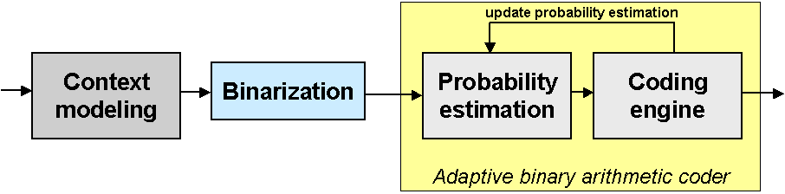

Figure 1: Generic block diagram of CABAC entropy coding scheme

In the following, we give a short overview of the main coding elements of our proposed entropy coding scheme as depicted in Figure 1. Suppose a symbol related to an arbitrary syntax element is given, then, in a first step, a suitable model is chosen according to a set of past observations. This process of constructing a model conditioned on neighboring symbols is commonly referred to as context modeling and is the first step in the entropy coding scheme. The particular context models that are designed for each given syntax model are described in [1]. If a given symbol is non-binary valued, it will be mapped onto a sequence of binary decisions, so-called bins, in a second step. The actual binarization is done according to a given binary tree, as specified in [1]. Finally, each binary decision is encoded with the adaptive binary arithmetic coding (AC) engine using the probability estimates, which have been provided either by the context modeling stage or by the binarization process itself. The provided models serve as a probability estimation of the related bins. After encoding of each bin, the related model will be updated with the encoded binary symbol. Hence, the model keeps track of the actual statistics.
In this contribution, we discuss some optimization strategies to further improve the coding efficiency of the CABAC approach. We present some preliminary results, which indicate that there is still room for further improvements without increasing the computational complexity.

Optimization Strategies

Context Modeling
The true underlying statistics of all syntax elements of real sources of interest is almost always too complex to be fit by a computable model, so that on the one hand, optimization of context models is an ill-defined problem, which cannot be solved analytically. On the other hand, we believe that the ad-hoc design of the context models given in [1][2] is not optimal with regard to coding efficiency. Next we will sketch some possibilities for an improved design of context models especially for those syntax elements, which contribute most to the overall bit rate.
Context models for motion vector data as defined in [2] does not take into account the type of a given macro block. Since the prediction of motion vector components for different block shapes is formed by different predictors it is likely that the statistics of prediction residuals show some sort of systematical bias, which can be captured by constructing suitable context models in addition to those given in [2].
Context modeling of texture syntax elements shall be revisited. For instance, there is no external model used for coding of Run and Level information, although it is obvious that the statistics of Level information will depend on the scan position, such that the magnitude of quantized coefficients for higher frequencies shows a different pdf than that for lower frequencies.

Binarization and Number of Internal Probability Models
The number of internal models, i.e. the number of bins of a given binarization, which will be discriminated by using different probability models, has to be optimized. The ad-hoc choice given in [2] is by no means optimal and should be revisited especially for those syntax elements contributing most to the overall bit rate.

Adapting to Nonstationarity
The periodical rescaling of the counts associated with a given probability model helps to adapt to the spatial and/or time varying statistics of a given syntax elements. Currently, the threshold for triggering this rescaling event is defined globally and depends only on the resolution of the video source. However, it is clear, that this threshold should be adapted to the type of syntax element as well as to some external coding parameters, such as the quality parameter.

Experimental Results
Preliminary results show that increasing the number of models used for coding the binarized runs yields an overall 1% bit rate reduction for different QPs (8,18,28). Another 0-1% bit rate savings could be achieved by using a context model for coding the Level information such that the selection of a model is triggered by a threshold decision with respect to the sum of the magnitudes of Levels seen so far in a given block. More experimental results will be given at the meeting.

References

- Detlev Marpe, Gabi Blättermann, Thomas Wiegand, “Adaptive Codes for H.26L“, ITU-T Study Group 16/Question 6, Doc. VCEG-L13, Eibsee, Deutschland, Jan. 2001.
- Detlev Marpe, Gabi Blättermann, Guido Heising, Thomas Wiegand, “Further Results for CABAC Entropy Coding Scheme“, ITU-T Study Group 16/Question 6, Doc. VCEG-M59, Austin, USA, 2.-4. April 2001.
- Gisle Bjontegaard, “H.26L Test Model Long Term Number 7 (TML-7) draft0”, ITU-T Study Group 16/Question 6, Doc. VCEG-M81, Austin, USA, 3. May 2001.

____________________

