ITU - Telecommunications Standardization Sector  STUDY GROUP 16 Question 6  Video Coding Experts Group (VCEG)  50th Meeting: March-April 2014, Valencia, Spain | Document VCEG-AX13

Status | Draft
Title | Report of the formal subjective assessment of the Submission in response to the Joint Call for Proposal (JCfP) for new technologies in the area of Screen Content Coding (SCC).
Authors | Vittorio Baroncini⁽¹⁾, Giovanni Saverio Blasi⁽²⁾, Touradj Ebrahimi⁽³⁾, Philippe Hanhart⁽³⁾, Naeem Razam⁽⁴⁾, Ivan Zupancic⁽²⁾.  (1) FUB, (2) QMUL, (3) EPFL, (4) UWS

Executive Summary
This document is the report of the formal subjective assessment performed to evaluate the Submission received by ISO and ITU in response to the Joint Call for Proposal (JCfP) for new technologies in the area of Screen Content Coding (SCC).
Seven companies submitted a proposal in response to the SCC JCfP. All the Submissions were made providing the requested material in the due way and in the due time, and therefore accepted for the formal subjective assessment.
The seven Proposals were evaluated together with an Anchor encoder implemented using the HEVC encoder as reported in [1]
The result of the formal subjective assessment showed a clear improvement of several Proponent in comparison to the Anchor. Furthermore the several Proponents showed a visual quality very close to the full transparency at all the coding conditions and for most of the source video material.
The results of the formal subjective assessment are summarized in form of tables and graphs in chapter five of this report.

Introduction
In this is the report the activities undertaken to subjectively evaluate the Submission in response to the Call for Proposal for new technologies for the Screen Content Coding [1] are described.
The Joint Call for Proposal received seven Submissions; all the Proponents provided the requested material in the due way and in the due time as specified by the CfP document [1], and performed all the other logistic actions required to complete the Submission, that the Test Coordinator and the Chairs of the JCTVC group required to do during the submission period.
This report describes the activities done to perform the visual subjective assessment of the received Submissions and it is done of five chapters.
The second chapter describes the logistic actions performed to properly and timely receive the video files from the Proponents.
The third chapter describes the activities performed to verify the usability of the test procedure described in the CfP document and to select the more suitable test method.
The fourth chapter describes logistics necessary to the Test Laboratories to perform the subjective assessment tests.
The fifth chapter provides the results of the formal subjective assessment of the video material provided by the Proponents in form of tables and graphs.

Logistics of the Submitted Test Material
To perform the subjective evaluation of the Submissions the Proponents provided a set of 60 coded video files; the coded files were in two video formats, i.e. 1080p and 720p, and in two coding conditions, i.e. All Intra (AI) and Low Delay (LD).
The Test Coordinator and the JCTVC chairs provided to the Proponents submitting a Proposal the detailed instructions necessary to deliver the their coded files; this process foresaw two different ways, with the aim of making the files availability more safe and quick to the Test Coordinator; this also because the time scale of the whole submission and evaluation process was really tight.
An FTP site was set up by the University of AACHEN creating a folder for each Proponent, protected by username and password. A super user profile was created to allow to the Test Coordinator to download the video files.
A folder for each Proponent was created (username and password protected) to allow the upload of the encoded bit-streams, together with the decoder and the decoding scripts. This allowed to the Test Manager an early availability of the encoded files and a quicker distribution to the Test Laboratories. The encoded files of the Anchor are available at the Hannover University FTP site in form of bit streams.
All the Proponents are assigned with a code that allows them to name their video files in an unambiguous way, as defined in the CfP document; the code is made of the letter P followed by a two digit numerical code starting from 11. The Anchor files are treated as they come from a Proponent and they are labelled using the code P10. So the results reported in this document refers to 8 proponents (including the Anchor) whose codes range from P10 to P17.
The Proponents mailed to the Test Coordinator an HDD containing the bit-streams, the decoded files and the decoder executable with the decoding instructions and scripts. The disks sent by the Proponents are brought to the MPEG meeting and sent to the Chairs of the JCTVC group as proof of the Proponents’ Submissions and made available for verification to the Video Chairs. The Proponents brought all the other encoded files (that were not subjectively evaluated) in a separate HDD to the JCTVC meeting.
The CfP document specifies a procedure to create the side-by-side files putting aside the reference video clips with the coded video files for each test point.
This was done using an executable program running under Windows and designed and kindly provided by the SCC experts. Two Test Laboratories (EPFL and FUB) took care of producing the side-by-side files, on the basis of the parameters selection made by the Test Coordinator, mainly for the case of the 1080p video resolution.
In this case, due to the impossibility of fitting two 1920 files into a 2560 wide screen, the SCC experts decided to select a portion of the 1920 x 1080 images converting them into 1480 x 1080 images. It was left to the Test Coordinator the selection of the 1480 portion of the 1920 images. This was done image by image selecting the starting points as specified in the table here below:
Resolution | Sequence name | code | Shift value
1920x1080 | FlyingGraphics  Desktop  Console  SocialnetworkMap  MissionControlClip3p | S01  S02  S03  S04  S05 | 360  20  30  500  600

The creation of the side-by-side file was completed before the beginning of the test. Being the size of files resulting from the creation of the side-by-side files very big, they were stored into the disks sent to the Test Coordinator by the Proponents. These files will be available to the experts at the MPEG meeting.

Activities performed to improve and select the subjective test protocol
The CfP document [1] describes a method to evaluate in a side by side fashion the video files provided by the Proponents.
The Test Coordinator made a long activity to tune up the player selected by the SCC experts, and implemented by means of an Excel macro.
The macro was checked for its correct functionalities and improved to a final version thanks to the strong support of MPEG experts.
Then a dry run test activity was undertaken by FUB and EPFL to verify some aspects related to the cognitive effort asked to the naïve viewers by the side by side subjective testing protocol.
Side by side dry runs trial were done also with the participation of experts from the Queen Mary University and the also in that case it resulted that many participants got confused by the marking system. At the beginning of each session the viewing subjects often asked to get further explanation about the meaning of positive/negative grading values.
For this reason at FUB was run another side by side test session modifying (see Figure 2) the scoring labels from numerical values to arrows pointing in opposite directions; but the result was again very poor.
In many cases it happened that the same test point was graded in a complete opposite way; this happened also inside a test session to which only 6 viewers were participating.
All participants complained about testing conditions.
Especially for some sequences, where the movements were so fast that it was very difficult to look at the “same time” to the “same thing” in the two sides of the videos.
After many side by side dry-run tests, it was decided to abandon the side by side test method for the below listed reasons.
- the differences in colour between the original and the encoded video clips (one of the major reasons that led to the selection of a side by side comparison test protocol) were not that evident to justify the protocol,
- the displacement of the areas of interest over a wide screen size (21,5:9 for the 1080p case and 32:9 for the 720p case) required very wide and quick fovea movements for the almost totality of the test sequences, preventing the viewers to perform a correct and proper evaluation of the differences among the two halves of the screen,
- the test protocol was requiring to the viewing subjects three different cognitive efforts at the same time, i.e. localization of the “best” picture, evaluation of the difference in quality, selection of the proper radeon button to click when voting.
The first two efforts remained high even when the subjects were given the possibility to watch more than one time the video.
The third effort created a lot of problems too, in what the presence of an impairment (mainly when the detection was challenging) may push the viewer to use the scale on the same side where the impairment was detected; and this may lead to a wrong vote.
This also because the side by side test protocol uses an horizontal (see Figure 1) bilateral voting scale, that also changing the scale and the captions tends to lead some confusion if not very well explained when training the test subjects. Also changing the positive and negative numbers with arrows did not avoid the tendency to a misuse of the voting scale (see Figure 2).
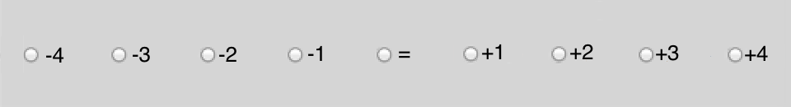
Figure 1
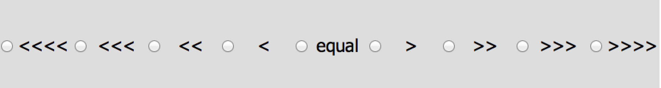
Figure 2
This misuse of the scale happened some times also in the case of “expert” viewers.
Finally the high motion present in the majority of the test images did not allowed to immediately select an evaluation “attention area” to the viewing subjects, that were lost among the too many details and most of the cases were not able to detect any difference between the right and the left portions of the screen.
To properly assess the differences between the two testing protocols the four Test Laboratories run several (short) test session using the side by side protocol, that demonstrated how the ability to discriminate the differences in quality was strongly lower than what provided by other classic test method (e.g. the ITU in force Recommendations).
At this point the Managers of the Test Laboratories and the Test Coordinator, begun an analysis of the existing protocols (already and successfully used in previous MPEG tests) and the selection was made among the DSCQS method and the DCR method [2].
Considering the wide range of quality of the encoded video files, ranging from medium low to very high quality the DCR method was used.
This method was also chosen to decrease the cognitive task that the DSCQS asks for, where the viewers do not know that there is a reference and the two images shown on the screen must be evaluated separately. With the DCR test method, the viewing subjects are clearly asked to evaluate if (and eventually how much) the coded and “reference” video clips differ to each other.
This evaluation process led therefore to select the DCR test method (as specified by ITU-T Recommendation P.910) using an 11 levels degradation scale ranging from 0 to 10.
The score 10 must be used when there is no difference between the “uncompressed reference” and the score 0 is used when there is an evident difference and an evidence of very low quality in the coded video clips.
Further details about the DCR method are described in Appendix A.
An important support to this testing effort was provided by the author of the videoplayer sw program that contributed with a new version of this program (already in use inside MPEG since a long time so far) allowing playing very big video files under Windows 7.

Test Laboratories
A complete evaluation of the received Submissions was divided in four slots, on the basis of the two video resolutions (1080p and 720p) and the two coding constrains (AI and LD).
On the basis of this subdivision the Test Laboratories agreed to share the test workload of the test sessions generating a scheme of slots assignment able to produce a redundant 2:1 execution of the required test sessions as summarized in Table 1.
The complete set of test sessions necessary to completely test a resolution and a coding condition were done twice allowing a higher number of viewers for each test point.

 | Video resolution
Coding Condition | 1080p | 720p
All Intra | EPFL / QMUL | EPFL / UWS
Low Delay | FUB / QMUL | FUB / UWS
Table 1
The tests were performed in 4 Laboratories located in Europe, i.e.:
- Ecole Politecnique de Lausanne (EPFL),
- Queen Mary University of London (QMUL),
- University of West of Scotland (UWS),
- Fondazione Ugo Bordoni (FUB).
Further details of the Laboratory set-up are provided in Appendix B

Results of the formal subjective assessment

5.1 Resolution 1080p - Low Delay

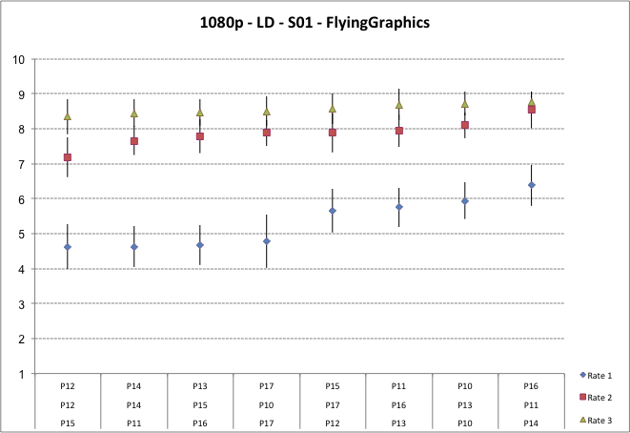

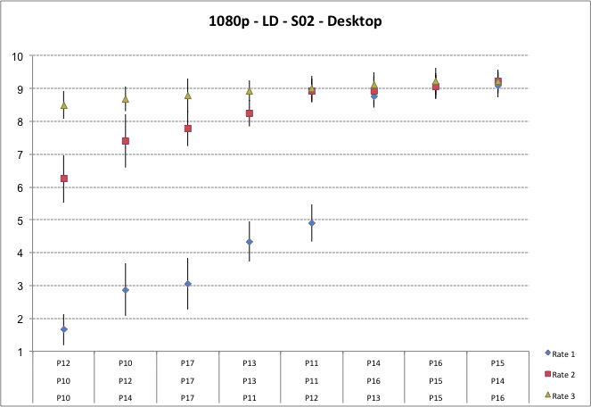

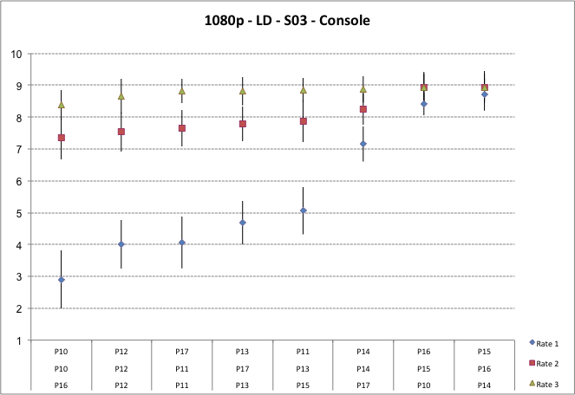

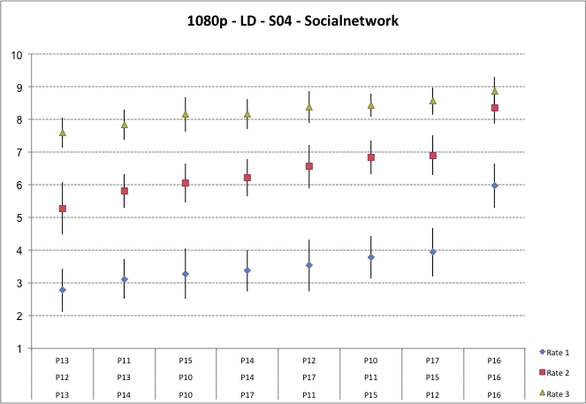

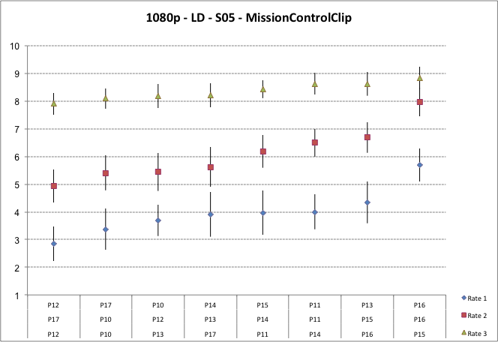

5.2 Resolution 1080p – All Intra

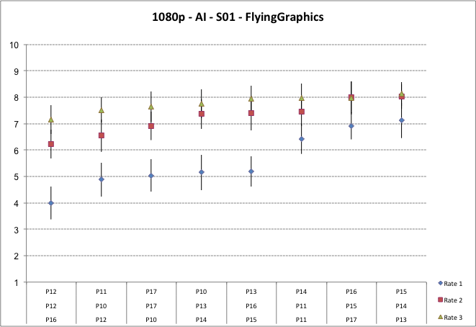

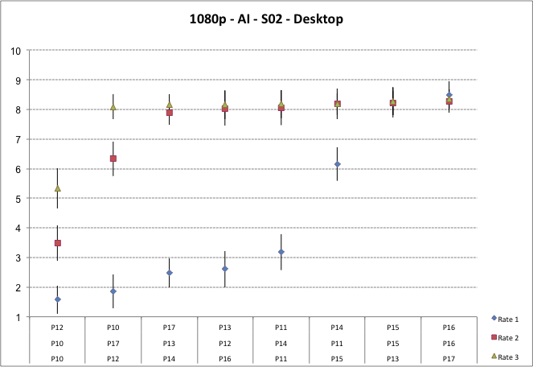

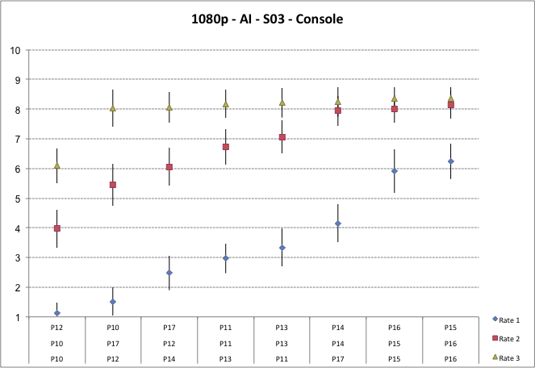

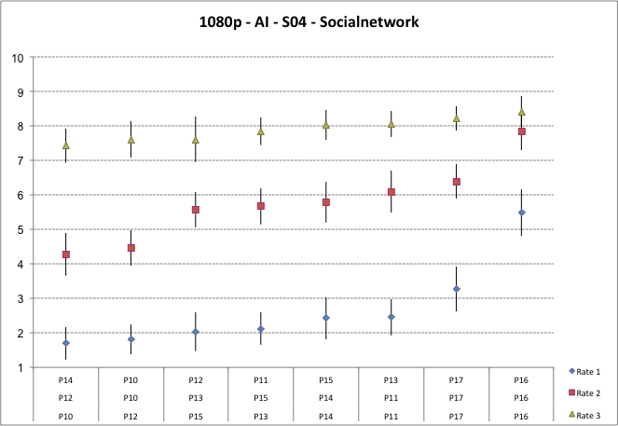

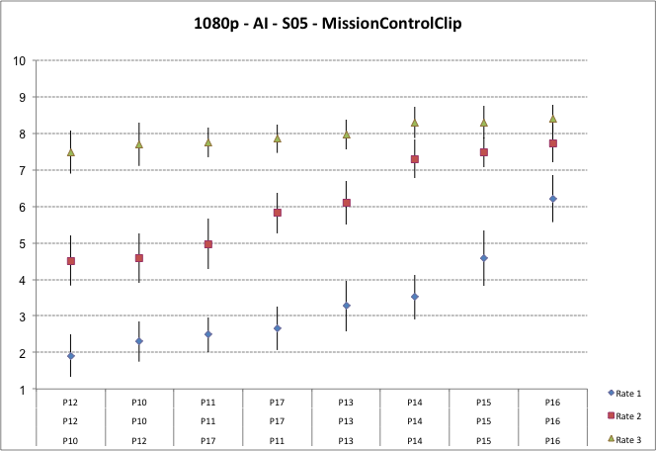

5.3 Resolution 720p - Low Delay

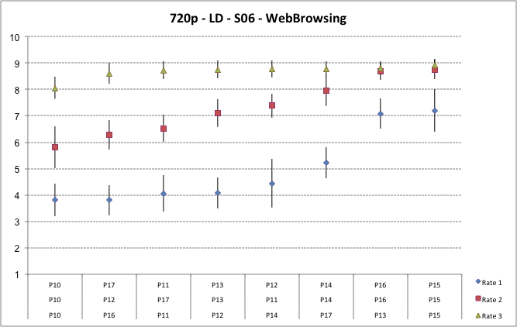

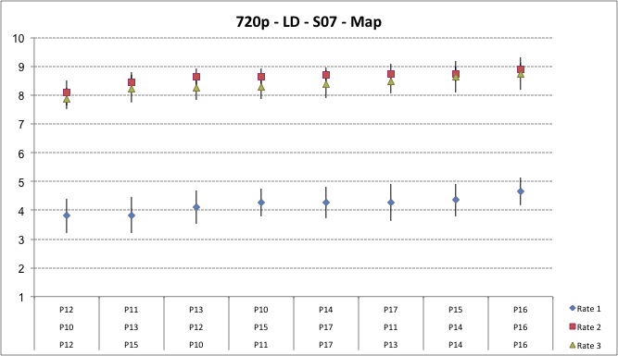

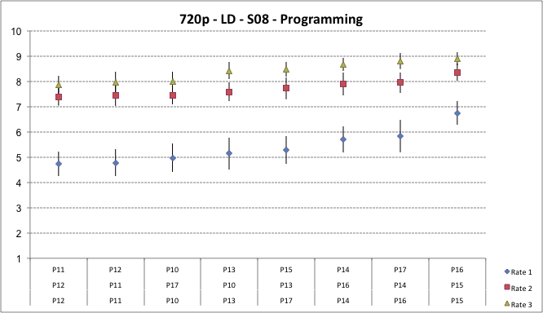

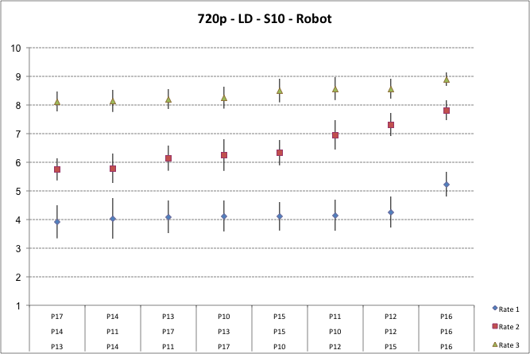

5.4 Resolution 720p – All Intra

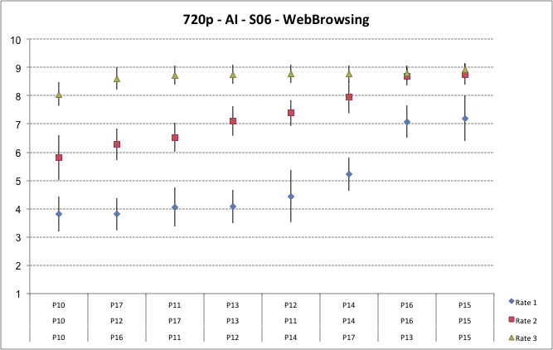

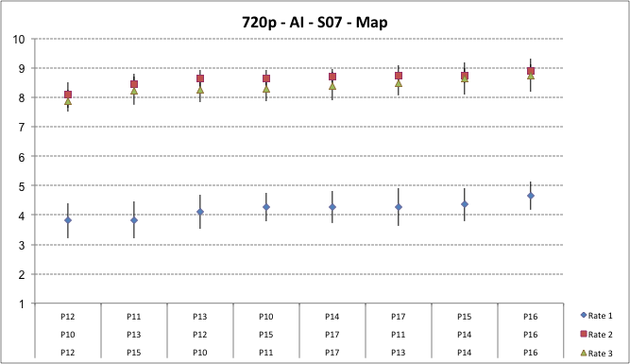

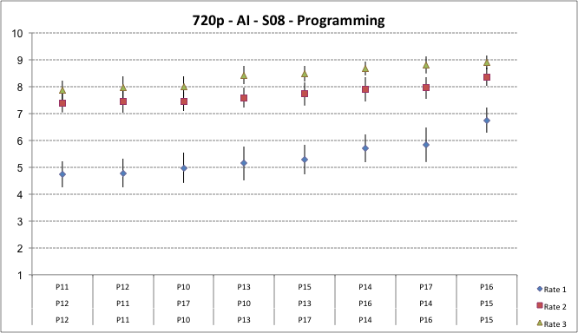

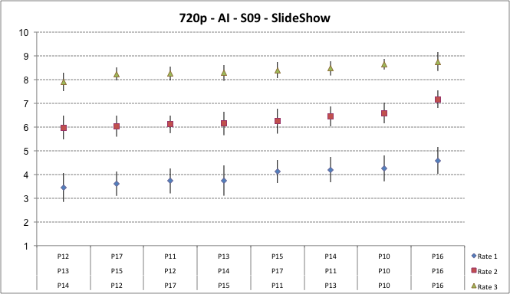

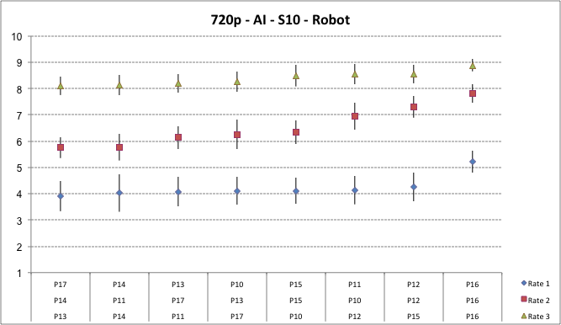

Appendix A – DCR test method
The test method adopted for this evaluation is DCR (Degradation Category Rating) [2].
A.1 Degradation Category Rating (DCR)
This test method is commonly adopted when the material to be evaluated shows a range of visual quality that well distributes across all quality scales.
This method will be used under the schema of evaluation of the quality (and not of the impairment); for this reason a quality rating scale made of 11 levels will be adopted, ranging from "0" (lowest quality) to "10" (highest quality). The test will be held in three different laboratories located in countries speaking different languages: This implies that it is better not to use categorical adjectives (e.g. excellent good fair etc.) to avoid any bias due to a possible different interpretation by naive subjects speaking different languages.
All the video material used for these tests will consist of video clips of 10 seconds duration.
The structure of the Basic Test Cell (BTC) of DCR method is made of the following steps (see Figure 3):
- a mid grey screen showing the letter “A” in the middle (1 second);
- the SRC video clip (original not coded);
- a mid grey screen showing the letter “B” in the middle (1 second);
- the coded video clip to evaluate;
- a mid grey screen showing the message “Vote_N”, where N is a progressive number indicating the BTC to vote.

A
B
Figure 3 - DCR BTC

A.2 How to express the visual quality opinion with DCR
The viewers will be asked to express their vote putting a number inside a box on the scoring sheet, made of a numbered section for each BTC; each section has a box wherein which the viewer shall write the score ranging from 0 to 10 (see Figure 4) [2]. By writing a score of “10”, the subject will express an opinion of “best” quality, while by writing a score of “0” the subject will express an opinion of “worst” quality.
The vote has to be written when the message "Vote N" appears on the screen. The number "N" is a numerical progressive indication on the screen aiming to help the viewing subjects to use the appropriate box of the scoring sheet.
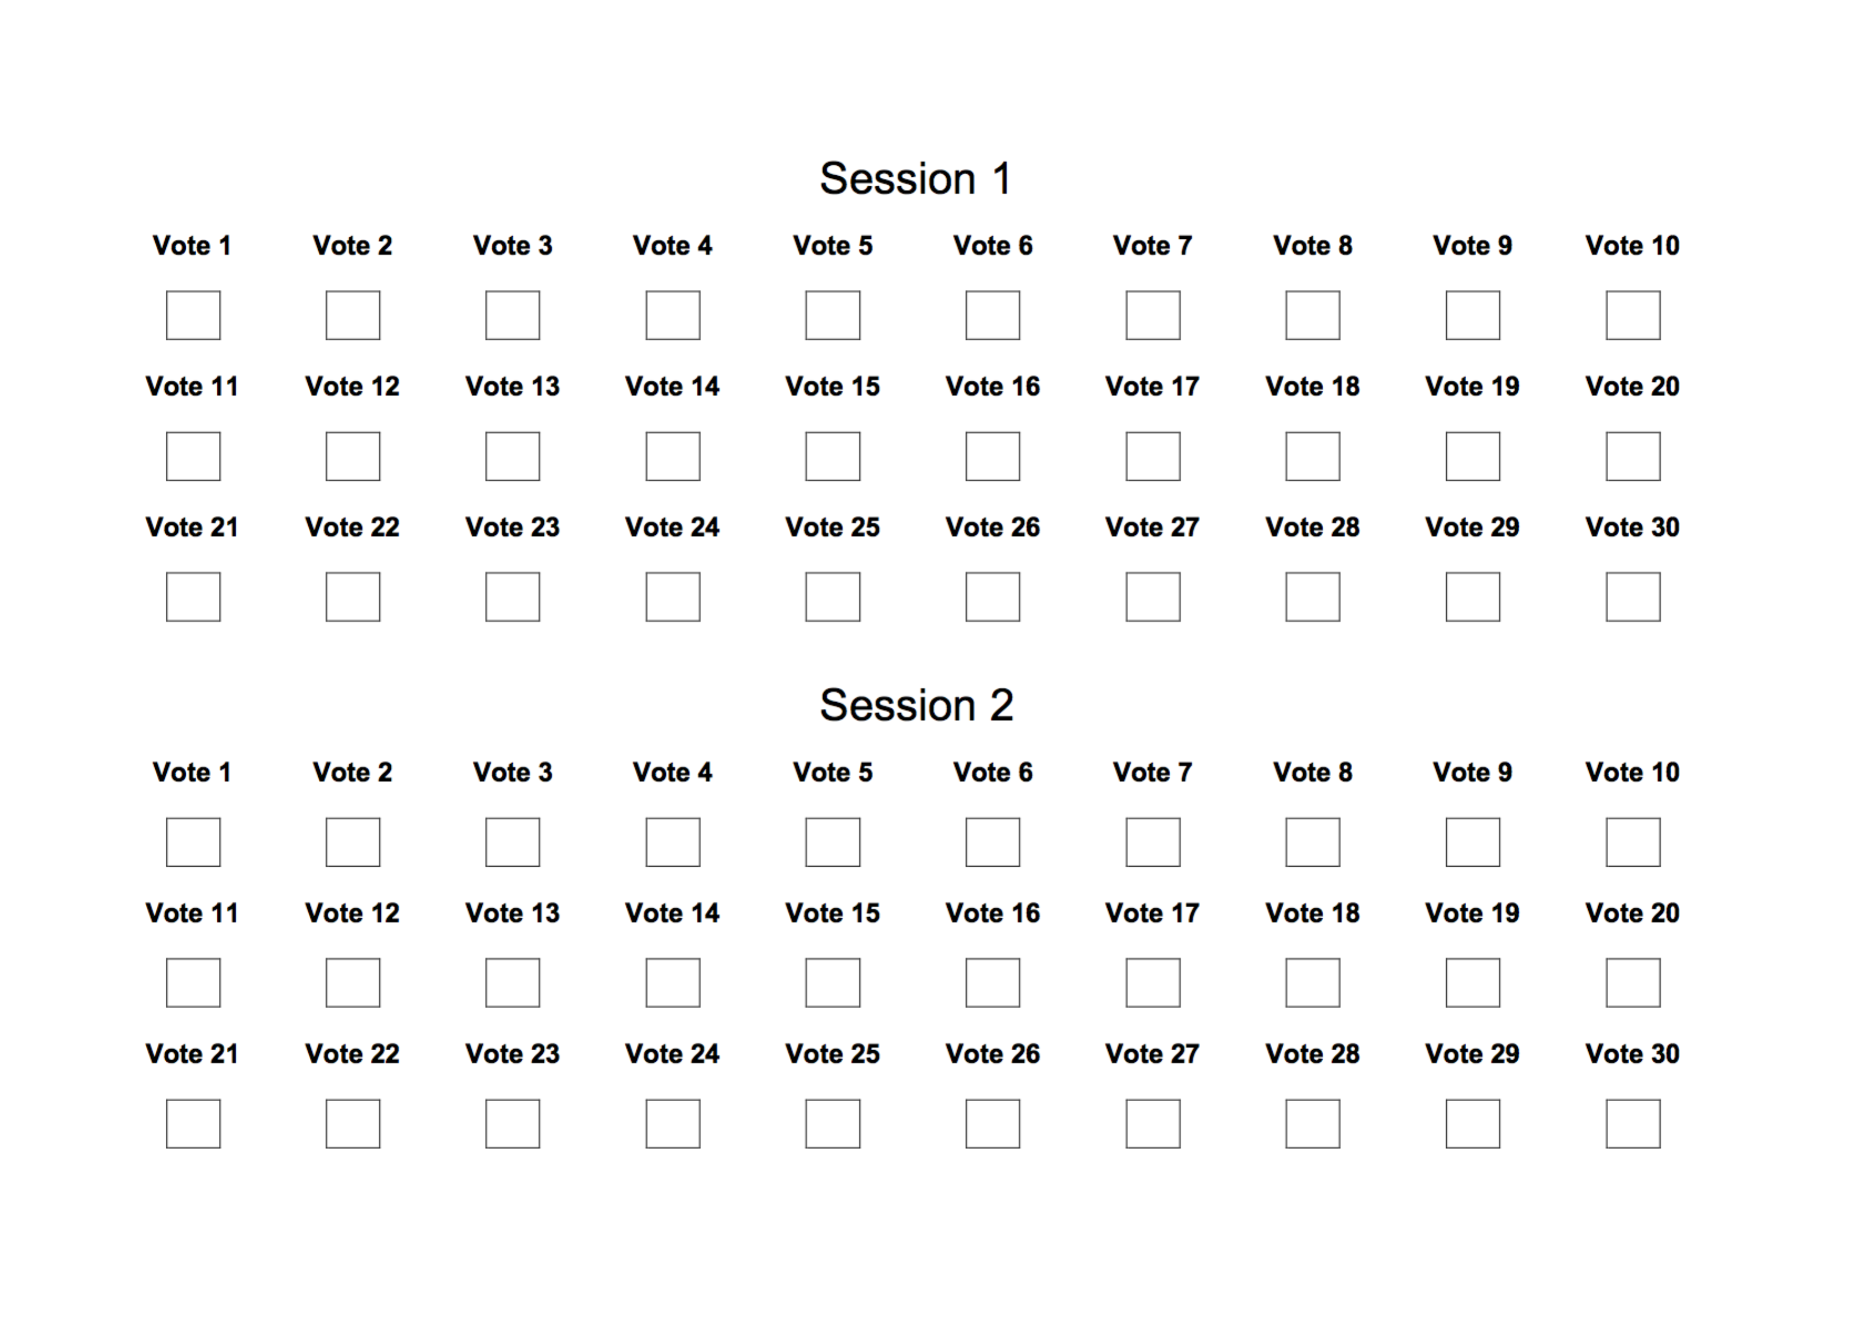
Figure 4 -Example of DCR test method scoring sheet for 30 BTC test sessions
A.4 Training of the test subjects
A good outcome of a test is highly dependent on a proper training of the test subjects.
For this purpose, each subject has to be trained by means of a short practice (training) session. In the case of the SCC test the training was particularly accurate and focused on the detection of area where degradations between source and coded video clips could be more easily visible. To better train the viewing subjects a snapshot of each source video clips was prepared highlighting the areas of “major interest”.
The current literature suggests that video material used for the training session to be different from those of the test, but the impairments introduced by the coding have to be as much as possible similar to those in the test. In the case of the SCC test the level of difficulty in detecting the impairment was so high that it was agreed to use the same content of the actual test.
Being the training phase very long and accurate, no stabilization phase was applied at the beginning of the SCC test sessions; this choice allowed to make the test sessions more short a easy for naïve viewers.

Appendix B – Short Test Laboratories setup description
B.1 EPFL
Experiments were conducted at EPFL’s MMSPG test laboratory, which fulfils the recommendations for the subjective evaluation of visual data issued by ITU-R [1].
B 1.1 Laboratory set-up
The test room is equipped with a controlled lighting system with a 6500 K colour temperature and an ambient luminance at 15% of the maximum screen luminance, whereas the colour of all the background walls and curtains present in the test area are in mid grey. The laboratory setup is intended to ensure the reproducibility of the subjective tests results by avoiding unintended influence of external factors.
To display the test stimuli, three Eizo CG301W LCD monitors with a native resolution of 2560×1600 pixels were used. The monitors were calibrated using an X-Rite i1Display Pro colour calibration device according to the following profile: sRGB gamut, D65 white point, 120 cd/m² brightness, and minimum black level.
The experiment involved two subjects per monitor assessing the test material. The subjects were seated in a row perpendicular to the centre of the monitor, at a distance of about 4.8 and 3.2 times the picture height for the 720p and 1080p contents, respectively, as suggested in [2].

B 1.2 Test session
The overall experiment was split into 12 sessions. Each session was composed of 20 basic test cells (BTC), corresponding to approximately 10 minutes each. For each resolution, the test material was randomly distributed over six test sessions. To reduce contextual effects, the stimuli orders of display were randomized applying different permutation for each group of subjects, whereas the same content was never shown consecutively.
Each subject took part to exactly three sessions and evaluated contents corresponding to only one resolution. Between the sessions, the subjects took a 10 minutes break.
A total of 72 naive subjects (38 females and 34 males) took part in the experiments, leading to a total of 18 ratings per test sample. Subjects were between 18 and 33 years old with an average of 23.3 years of age. All subjects were screened for correct visual acuity and color vision using Snellen and Ishiara charts, respectively.
B.2 QMUL
The tests at QMUL were done in the Multimedia and Vision Lab within the School of Electronic Engineering and Computer Science, Queen Mary University of London.

B 2.1 Laboratory set-up
The test room was set to a uniform brightness of 15 lux. This was measured at all the points where people were seated using a Minolta Autometer IIIF. The maximum screen luminance of both displays was calibrated using an X-Rite i1Display Pro colour calibration device according to the following profile: sRGB gamut, D65 white point, 120 cd/m² brightness, and minimum black level. Grey panels were used as a background to the displays to set the correct environment for the tests.
The displays used for the test are those depicted in Figure 5; in details they are:
- Display 1: 58”, resolution 1920x1080, Panasonic TH 58PZ800B Plasma screen
- Display 2: 27”, resolution 2560x1440, Dell UltraSharp U2713HM​

The experiment involved three subjects in front of Display 1, and one subject in front of Display 2 assessing the test material. The subjects in front of display 1 were seated at a distance of about 2.5 the height of the display, while the subjects in front of display 2 were seated at a distance of about 1.5 the height of the display, as suggested by the Test Coordinator.

The laboratory set-up at QMUL is depicted in Figure 5.

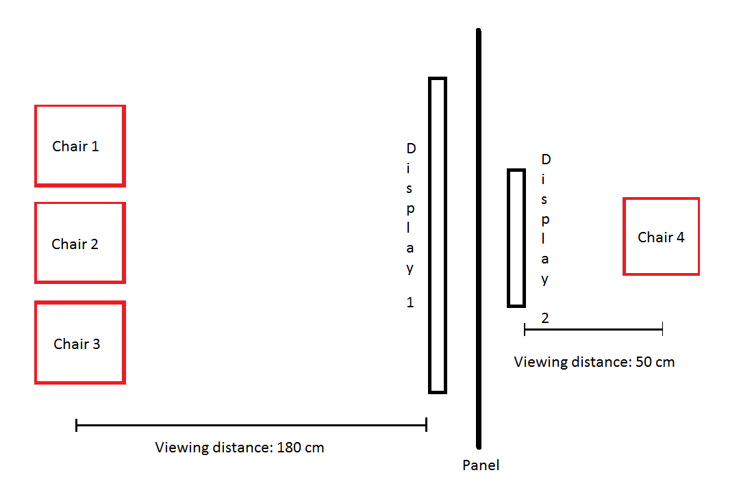
Figure 5 – Laboratory set-up at QMUL
B 2.2 Test session
The overall experiment was split into 8 sessions. Each session was composed of 30 basic test cells (BTC), corresponding to approximately 13 minutes each. Participants were sitting in the random positions in each session. Also, to reduce contextual effects in each session, a random selection of test points was shown in a random order.
Each subject took part in all eight sessions and evaluated all the content. Between the sessions, the subjects took a 15 minutes break.
A total of 16 naive subjects (9 females and 7 males) took part in all the sessions, leading to a total of 16 ratings per test sample. Subjects were between 21 and 30 years old, with an average of 26.8 years of age. All subjects were screened for correct visual acuity and colour vision using Snellen and Ishiara charts, respectively.
B.3 UWS
The tests were performed at the premises of the School of Computing, University of West of Scotland (UWS).
B 3.1 Laboratory set-up
The test room was equipped with two LCD monitor HPZR30W receiving input from a high performance servers that was able to play Full HD raw content in real time. The ambient lighting consisted of neon lamps with 6500 K colour temperature and the wall colour was mid grey. One subject per monitor is allowed to sit of each screen at a distance about 3 times the height of the stimuli however they are allowed to move forward or backward on the fixed chair. Both the screen are separated by wall panel.
The subjective evaluation at UWS for 720p (AI and LD) was split into 6 sessions. Each session was composed of 40 stimuli of approximately 20 minutes each. For each configuration (AI and LD), the test material was randomly distributed over six test sessions. The stimuli orders in each test sessions were randomised.
All the subjects were screened, before running the test, using Snellen Chart and Ishiara tables; the average age of the subject was 26.5 years.
B.4 FUB Laboratory set-up
The DCR test sessions were run using a brand new 47” TV set (LG 47LA740).
All the local post-processing and filter features were disabled.
The display mode was set to “research only” for an optimal use of the screen.
Two subjects were seated at 1,5 H from the monitor.
A total of 8 sessions of 30 BTC each were run with the participation of 16 valid viewing subjects all screened for visual acuity and colour blindness.
All the subjects were aging from 18 to 24, 12 males and 4 females, the majority of which were university students.
For the Side by Side test sessions a brand new 27” Philips 2560 x 1400 resolution monitor (272P4QPJKES); for the SbS test sessions only one subject at a time was seated in front of the monitor and interacted with the player.
Background luminance was 14 lux. Peak luminance of the displays was 300 cd/m² for the 27” monitor and 220 cd/m² for the LG TV set.
References
[1] ISO/IEC JTC1/SC29/WG11, MPEG2014/N14175 “Joint Call for Proposals for Coding of Screen Content”; January 2014, San Jose, USA
[2] International Telecommunication Union Standardization Sector; Recommendation ITU-T P.910 “Subjective video quality assessment methods for multimedia applications”
[3] ITU-R BT.2022, “General viewing conditions for subjective assessment of quality of SDTV and HDTV television pictures on flat panel displays,” International Telecommunication Union, August 2012.

Acknowledgements
Thanks to Jens Ohm, Mathias Wien and University of AACHEN for hosting the FTP site.
Thanks to Haoping Hu and Rick Wang for the strong support received in the implementation of the SbS Player and for the implementation of the SW utility to create the side by side files.
Thanks to the Test Managers strongly committed and hard working at EPFL (Philippe Hanhart), UWS (Naeem Ramzan), QMUL (Saverio Blasi and Ivan Zupancic) and FUB (Vittorio and Giacomo Baroncini).
Thanks to the author (David Flynn) of the new version of the YUV Video Player compiled for Windows; this new version was used for both the side by side and DCR test sessions testing activities, allowing a smooth play-out of very big video files as well as the execution of long DCR test sessions.

