|  |  |
| --- | --- |
| **ITU - Telecommunications Standardization Sector**  STUDY GROUP 16 Question 6  **Video Coding Experts Group (VCEG)**  50th Meeting: 31 March – 3 April 2014, Valencia, Spain | Document VCEG-AX90 |

|  |  |
| --- | --- |
| **Source** | **Q6/16 Rapporteur (prepared jointly with ISO/IEC JTC1/SC29/WG11 (MPEG)** |
| **Title** | **Results of CfP on Screen Content Coding Tools for HEVC** |
| **Purpose** | **Report** |
| **Status** | **Approved (Q6/16, April 2014)** |

# Abstract

This report summarizes the result of the Joint Call for Proposals for Coding of Screen Content [1], for possibly extending High Efficiency Video Coding (HEVC) by associated tools. Seven responses to the Joint Call for Proposals were received during the April 2014 meetings of ITU-T SG 16/Q.6 (VCEG) and ISO/IEC JTC 1/SC 29/WG 11 (MPEG). Screen Content Coding is defined as the coding of video containing a significant proportion of rendered (moving or static) graphics, text, or animation rather than, or in addition to, camera-captured video scenes. Substantial benefit in compression was observed in the submissions for such type of content. As a result, it was concluded that the responses provided justification for launching a new standardization project with the goal of extending HEVC, tentatively to be finalized in late 2015. The technical development will be performed by JCT-VC.

# Introduction

The Joint Call for Proposals had been issued by the JCT-VC parent bodies at their meetings of January 2014 in San José, US [1]. Seven responses to the Joint Call for Proposals were received and evaluated [4]–[10]. The Joint Call for Proposals requested information in two test conditions: Lossy and mathematically lossless, and for each category, three coding constraint conditions were defined:

* **C1**: All Intra (AI)
  + All pictures are coded as Intra pictures
* **C2**: Low delay (LD)
  + The first picture is an Intra picture, and there are no backward references for inter prediction (bi-prediction may be applied, but only without picture reordering)
* **C3**: Random Access (RA)
  + Intra picture every 16, 32, and 64 pictures for 20 fps, 30 fps, and 60 fps sequences, respectively

Both categories and all conditions were mandatory in terms of delivering results. A total of 12 test sequences were used with spatial resolutions of 1280x720 (5), 1920x1080 (5) and 2560x1440 (2), each with RGB and YCbCr colour format representations, 4:4:4, progressive sampling. The test material as listed in Table 1 included screen content such as text and graphics, mixed screen and camera captured content as well as animated graphics.

Table 1 – Test Sequences

|  |  |  |  |  |  |
| --- | --- | --- | --- | --- | --- |
| **Resolution** | **Sequence name** | **Sxx** | **fps** | **Frames to be encoded** | **Copyright conditions (Annex B)** |
| 1920x1080 | sc_flyingGraphics_1920x1080_60  sc_desktop_1920x1080_60  sc_console_1920x1080_60  sc_socialnetworkMap_1920x1080_60  sc_MissionControlClip3_1920x1080_60p | S01  S02  S03  S04  S05 | 60  60  60  60  60 | 0-599  0-599  0-599  0-599  0-599 | CC1  CC1  CC1  CC1  CC2 |
| 1280x720 | sc_web_browsing_1280x720_30  sc_map_1280x720_60  sc_programming_1280x720_60  sc_SlideShow_1280x720_20  sc_robot_1280x720_30 | S06  S07  S08  S09  S10 | 30  60  60  20  30 | 0-299  0-599  0-599  0-499  0-299 | CC3  CC4  CC1  CC5  CC6 |
| 2560x1440 | sc_Basketball_Screen_2560x1440_60p  sc_MissionControlClip2_2560x1440_60p | S11  S12 | 60  60 | 322-621  120-419 | CC7  CC8 |

PSNR performance of four lossy rate points and the rate for lossless coding was required to be reported for all sequences, constraint conditions and both colour formats, such that a total of 360 encoded bit streams had to be produced for each proposal submission. 60 of these cases were also undergoing formal subjective testing, namely the sequences S01 … S10 with RGB colour format and the three lowest lossy rate points for the C1 and C2 constraint conditions.

# Tools in proposals and objective performance summary

The study of tools included in the proposals showed many commonalities in terms of the basic concepts, however with various differences in detailed implementation as well as encoder and decoder complexity. The following categories of tools were identified from the proposals:

* Block based intra block copy with various aspects of partitioning, search range, mode switching and displacement vector coding;
* Line based intra copy;
* Palette mode with various aspects of coding the colour palette itself as well as the indices;
* String matching based on dictionary coding;
* Cross component prediction and adaptive colour transform;
* Miscellaneous small modifications of existing tools (such as de-blocking, RDPCM, etc.);
* Encoder-only modifications.

From the PSNR results provided, the more extensive combinations of tools provided an average bit rate reduction (over all sequences and rate points), compared to the anchors, of about 25% for the lossy case in RGB, and 20% for YCbCr in the C1 (all intra) condition. For C2/C3 (low delay and random access inter), the average bit rate reduction was in the range of approx. 20% for RGB and around 15% for YCbCr. For lossless compression, bit rate savings were reported in the range of 35% for all three constraint conditions, when encoding RGB sequences. For YCbCr, the lossless savings were in a similar range as stated above for the lossless case.

In a more detailed analysis it was concluded that intra block copy with extended search range gives some of the most significant benefit. It is however understood that more investigation is necessary for a more detailed analysis of compression versus complexity benefits. Various areas were identified from the list above for further investigation in core experiments that will be executed in JCT-VC.

# Results of formal subjective testing

## Introduction

In this section, the activities undertaken to subjectively evaluate the submissions are described. All proponents provided the requested material as required and in due time as specified by the CfP document [1], and performed all the other logistic actions required to complete the Submission. The seven proposals were evaluated together with an Anchor encoder implemented using the HEVC Range Extensions encoder as described in [1]

## Preparation and activities performed to improve and select the subjective test protocol

The CfP document [1] describes a method to evaluate, in a side-by-side fashion, the video files provided by the Proponents for each test point.

This was done using an executable program running under Windows that was designed and kindly provided by participating experts. Two Test Laboratories (EPFL and FUB) took care of producing the side-by-side files, on the basis of the parameters selection made by the Test Coordinator, mainly for the case of the 1080p video resolution.

In this case, due to the impossibility of fitting two 1920 files into a 2560 wide screen, the participating experts decided to select a portion of the 1920 x 1080 images converting them into 1480 x 1080 images. The selection of the 1480 portion of the 1920 images was left to the Test Coordinator. This was done image-by-image, selecting the starting points as specified in Table 2 here below:

Table 2 – Selected portion of test sequences

|  |  |  |  |
| --- | --- | --- | --- |
| Resolution | Sequence name | code | Shift value |
| 1920x1080 | FlyingGraphics  Desktop  Console  SocialnetworkMap  MissionControlClip3p | S01  S02  S03  S04  S05 | 360  20  30  500  600 |

The creation of the side-by-side file was completed before the beginning of the test. Being the size of files resulting from the creation of the side-by-side files very big, they were stored into the disks sent to the Test Coordinator by the Proponents. These files were available to the experts at the meeting.

The Test Coordinator made a substantial activity to tune up the player selected by the experts, and implemented by means of an Excel macro. The macro was checked for its correct functionalities and improved to a final version thanks to the strong support of participating experts.

Then a dry run test activity was undertaken by FUB and EPFL to verify some aspects related to the cognitive effort asked to the naïve viewers by the side by side subjective testing protocol.

A side-by-side dry run trial was also done with the participation of experts from the Queen Mary University, and also in that case it resulted that many participants got confused by the marking system. At the beginning of each session, the viewing subjects often asked to get further explanation about the meaning of positive/negative grading values.

For this reason another side-by-side test session was run at FUB, modifying (see Figure 2) the scoring labels from numerical values to arrows pointing in opposite directions; but the result was again very poor.

In many cases it happened that the same test point was graded in a complete opposite way; this happened also inside a test session to which only 6 viewers were participating.

All participants complained about testing conditions.

Especially for some sequences, where the movements were so fast that it was very difficult to look at the “same time” at the “same thing” on the two sides of the video display.

Thus, after many side by side dry-run tests, it was decided to abandon the side-by-side test method for the below listed reasons.

* The differences in colour between the original and the encoded video clips (one of the major reasons that led to the selection of a side by side comparison test protocol) were not that evident to justify the protocol,
* The displacement of the areas of interest over a wide screen size (21,5:9 for the 1080p case and 32:9 for the 720p case) required very wide and quick fovea movements for the almost totality of the test sequences, preventing the viewers to perform a correct and proper evaluation of the differences among the two halves of the screen,
* The test protocol was requiring to the viewing subjects three different cognitive efforts at the same time, i.e. localization of the “best” picture, evaluation of the difference in quality, selection of the proper radeon button to click when voting.

The first two efforts remained high even when the subjects were given the possibility to watch more than one time the video.

The third effort created a lot of problems too, in what the presence of an impairment (mainly when the detection was challenging) may push the viewer to use the scale on the same side where the impairment was detected; and this may lead to a wrong vote.

This also was because the side by side test protocol uses a horizontal (see Figure 1) bilateral voting scale, that also changing the scale and the captions tends to lead some confusion if not very well explained when training the test subjects. Also changing the positive and negative numbers with arrows did not avoid the tendency to a misuse of the voting scale (see Figure 2).

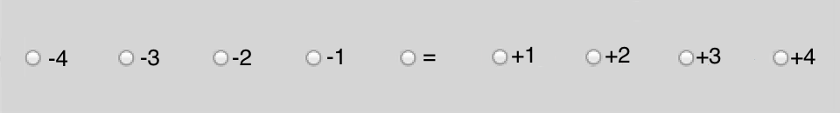

Figure 1 – Example voting scale



Figure 2 – Alternative formatting of formatting scale

This misuse of the scale happened sometimes also in the case of “expert” viewers.

Finally the high motion present in the majority of the test images did not allowed to immediately select an evaluation “attention area” to the viewing subjects, that were lost among the too many details and most of the cases were not able to detect any difference between the right and the left portions of the screen.

To properly assess the differences between the two testing protocols the four Test Laboratories run several (short) test session using the side by side protocol, that demonstrated how the ability to discriminate the differences in quality was strongly lower than what provided by other classic test method (e.g. the ITU in force Recommendations).

At this point the Managers of the Test Laboratories and the Test Coordinator, begun an analysis of the existing protocols (already and successfully used in previous tests) and the selection was made among the DSCQS method and the DCR method [2].

Considering the wide range of quality of the encoded video files, ranging from medium low to very high quality the DCR method was used.

This method was also chosen to decrease the cognitive task that the DSCQS asks for, where the viewers do not know that there is a reference and the two images shown on the screen must be evaluated separately. With the DCR test method, the viewing subjects are clearly asked to evaluate if (and eventually how much) the coded and “reference” video clips differ to each other.

This evaluation process led therefore to select the DCR test method (as specified by ITU-T Recommendation P.910) using an 11-level degradation scale ranging from 0 to 10.

The score 10 was instructed to be used when there is no difference between the “uncompressed reference” and the score 0 to be used when there is an evident difference and an evidence of very low quality in the coded video clips.

Further details about the DCR method are described in Appendix A.

An important support to this testing effort was provided by the author of the Video-player software program that contributed with a new version of this program (already in use inside MPEG and VCEG for a significant period of time) allowing playing very big video files under Windows 7.

## Test Laboratories

A complete evaluation of the received Submissions was divided in four slots, on the basis of the two video resolutions (1080p and 720p) and the two coding constrains (AI and LD).

On the basis of this subdivision the Test Laboratories agreed to share the test workload of the test sessions generating a scheme of slots assignment able to produce a redundant 2:1 execution of the required test sessions as summarized in Table 3.

The complete set of test sessions necessary to completely test a resolution and a coding condition were done twice allowing a higher number of viewers for each test point.

Table 3

|  |  |  |
| --- | --- | --- |
|  | Video resolution | |
| Coding Condition | 1080p | 720p |
| All Intra | EPFL / QMUL | EPFL / UWS |
| Low Delay | FUB / QMUL | FUB / UWS |

The tests were performed in four Laboratories located in Europe, i.e.:

* École Polytechnique Fédérale de Lausanne (EPFL),
* Queen Mary University of London (QMUL),
* University of West of Scotland (UWS),
* Fondazione Ugo Bordoni (FUB).

Further details of the Laboratory set-up are provided in Appendix B.

## Results of the formal subjective assessment

The results of the formal subjective assessment test executed to evaluate the Submissions in response to the Screen Content Coding Joint Call for Proposal are reported in this chapter as tables and graphs.

To avoid the inclusion of a huge amount of graphs, the graphical presentation of the results is here done grouping together, for a given combination of video source, screen resolution and coding constrain, the results related to the three bit rates foreseen in the CfP.

In Figure 3 is reported an example of how information is placed in the graphs of this chapter.

The Y-axis represents the MOS (Mean Opinion Scores) assigned to each test point.

The X-axis represents the Proponents participating to the CfP.

There are three lines of labels along the X-axis identifying the Proponents.

The first (upper) X-axis line of labels provides the ranking of the Proponents (on the basis of increasing MOS values) obtained encoding the specified video clip (in the example “Socialnetwork”) at the bit rate 1 (the lower bit rate); the MOS values associated to this ranking are plotted with a diamond symbol in blue colour (in Figure 3 those MOS values are rounded by a dotted blue line).

The second (mid) X-axis line provides the ranking of the Proponents at bit rate 2; the MOS values associated to this ranking are plotted with a square symbol in red colour (in Figure 3 those MOS values are rounded by a dotted red line).

The third (mid) X-axis line provides the ranking of the Proponents at bit rate 3 (the higher bit rate); the MOS values associated to this ranking are plotted with a triangle symbol in green colour (in Figure 3, those MOS values are rounded by a dotted green line).

This representation allows to verify at glance the performance of a Proponent’s Submission and to compare it with the other Submissions.

In the graphs reported in this report P10 is the code assigned to the Anchor.



Figure 3 – example of representation of the data in the graphs

### Resolution 1080p - Low Delay

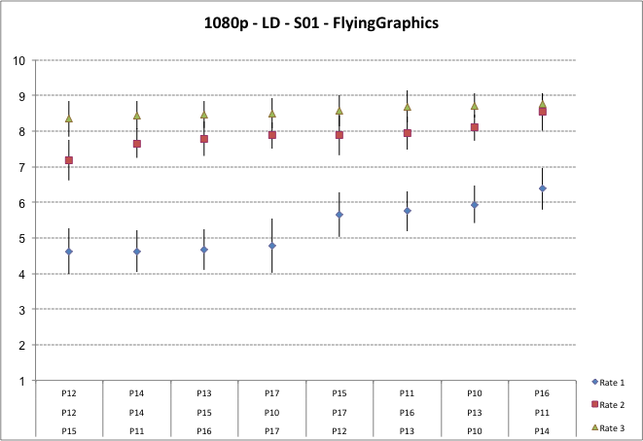

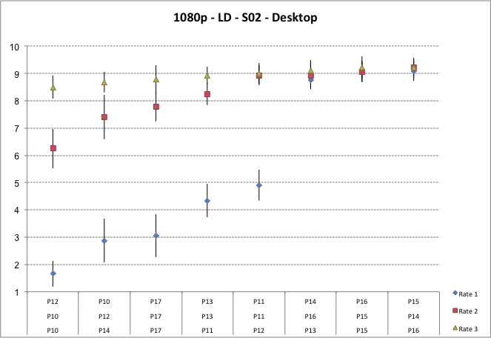

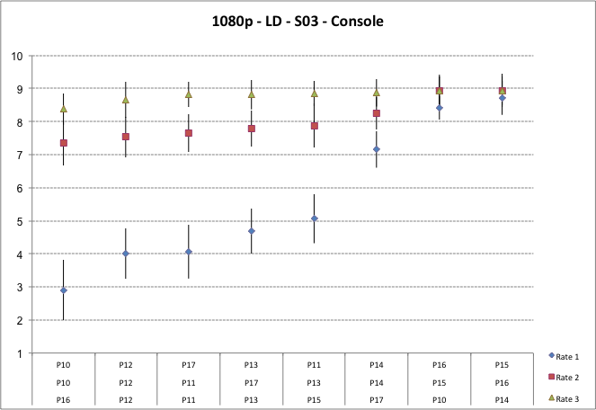

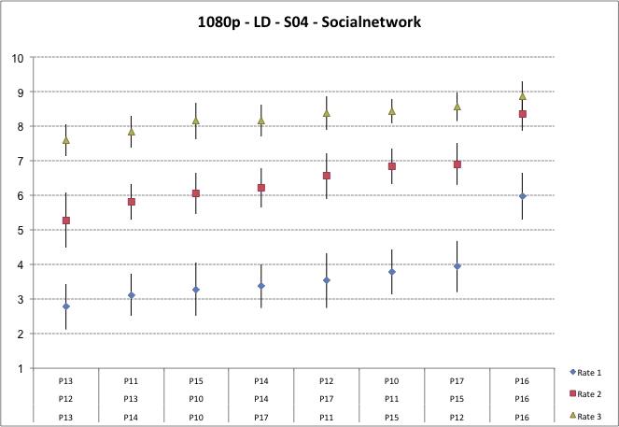

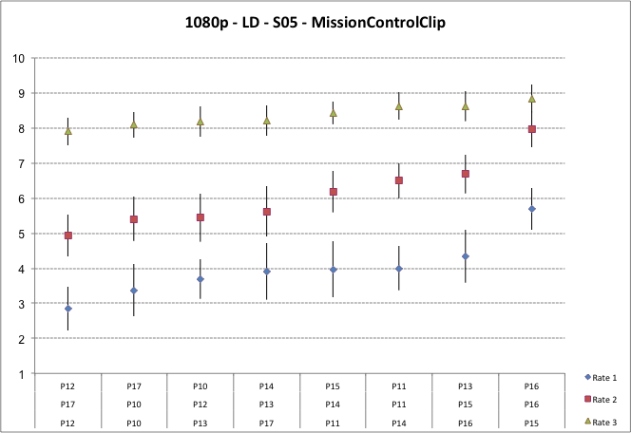

### Resolution 1080p – All Intra

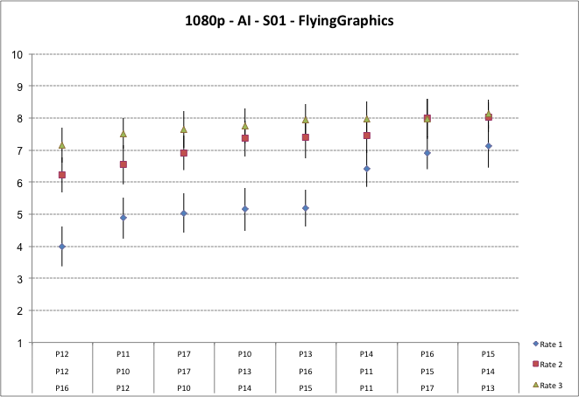

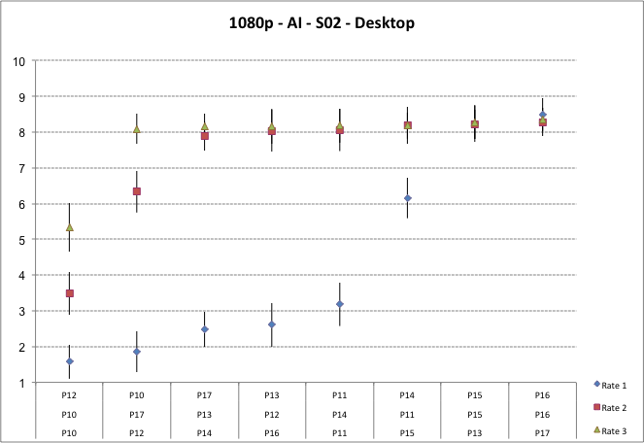

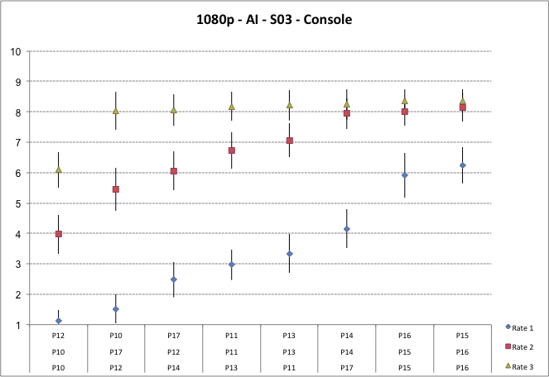

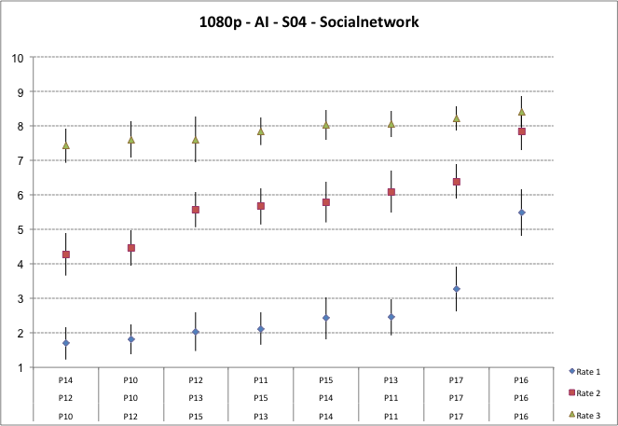

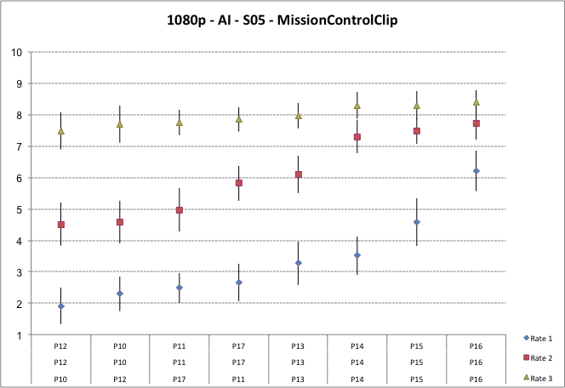

### Resolution 720p - Low Delay

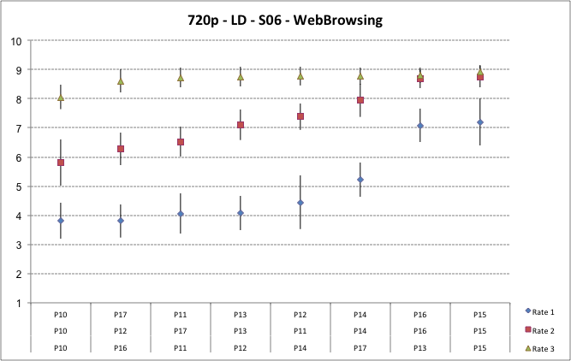

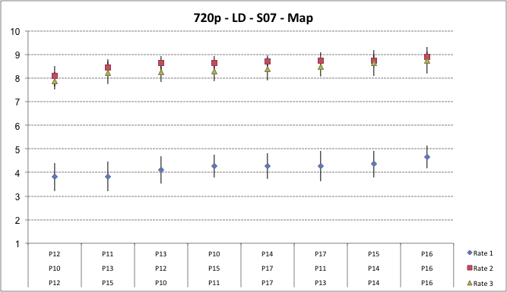

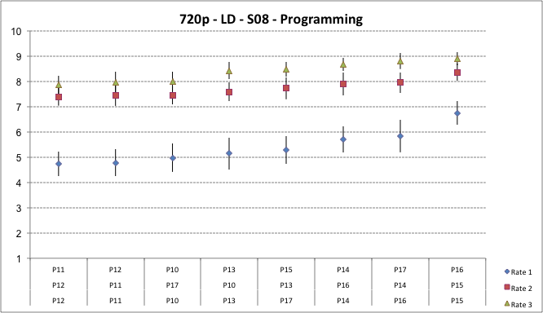

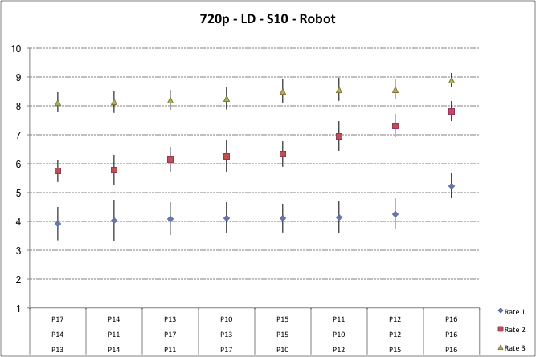

### Resolution 720p – All Intra

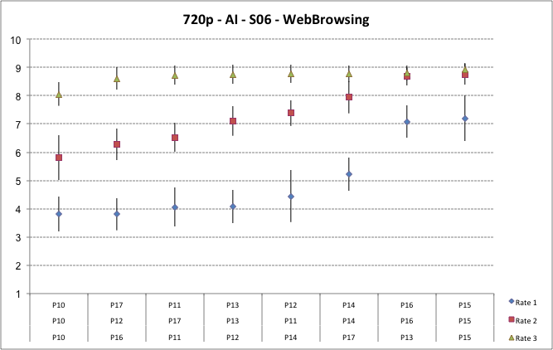

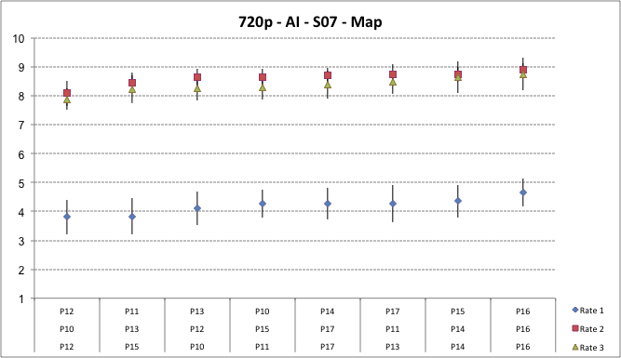

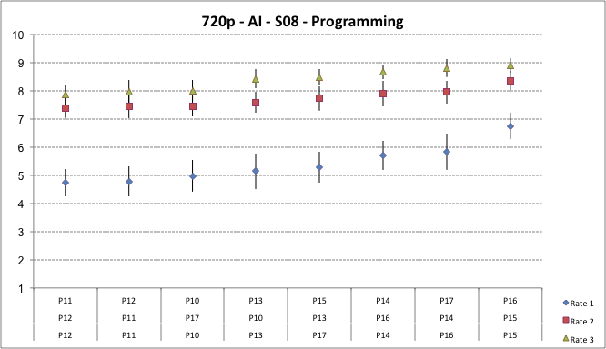

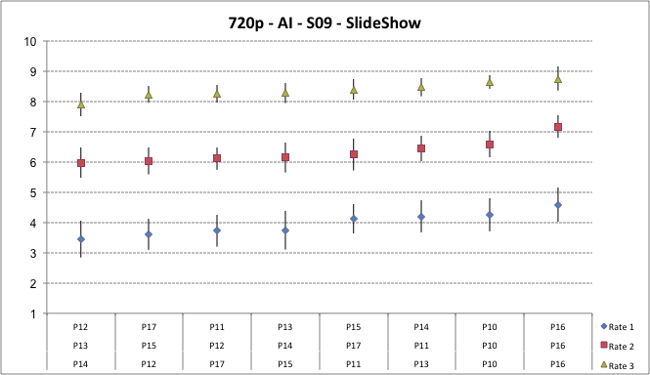

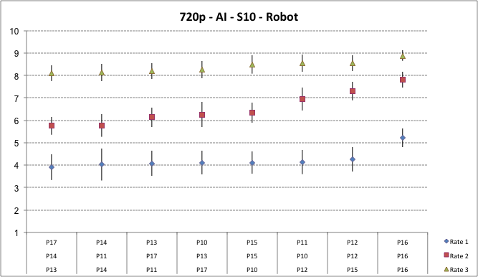

# Conclusions

From the results of objective (PSNR vs. bit rate) testing of the submitted proposals, substantial bit rate savings were observed to indicate a potential benefit of dedicated tools for screen content coding. The result of the formal subjective assessment also showed a clear improvement for several proposals in comparison to the anchor. Furthermore, various cases showed a visual quality very close to full transparency – even for lossy coding.

Therefore, after the submissions to the CfP provided evidence that significant improvements in coding efficiency can be obtained by exploiting the characteristics of screen content with novel dedicated coding tools, it was planned to develop an extension of the High Efficiency Video Coding (HEVC) standard that provides the following:

* Compression tools with a benefit in compression performance for video with screen content or mixed content characteristics:
  + These compression tools shall serve the intended target applications in terms of required quality and bit rate in the lossy and/or in the (visually) lossless range;
  + These compression tools shall support various operation modes, such as random access and low delay;
  + These compressions tools shall be designed in a way that they deliver an acceptable trade-off complexity versus performance for various platforms.
* A minimum set of profiles for maximum interoperability between devices in the foreseen application domains is targeted.

This extension will be developed by JCT-VC as a twin text specification, extending HEVC( Rec. ITU-T H.265| ISO/IEC 23008-2), with Consent expected to be achieved in late 2014 or early 2015.

Appendix A – DCR test method

The test method adopted for this evaluation was DCR (Degradation Category Rating) [2].

A.1 Degradation Category Rating (DCR)

This test method is commonly adopted when the material to be evaluated shows a range of visual quality that well distributes across all quality scales.

This method is to be used under the schema of evaluation of the quality (and not of the impairment); for this reason a quality rating scale made of 11 levels was adopted, ranging from "0" (lowest quality) to "10" (highest quality). The test was held in different laboratories located in countries speaking different languages: This implies that it is better not to use categorical adjectives (e.g. excellent good fair etc.) to avoid any bias due to a possible different interpretation by naive subjects speaking different languages.

All the video material used for these tests consisted of video clips of 10 seconds duration.

The structure of the Basic Test Cell (BTC) of DCR method is made of the following steps (see Figure 4):

* A mid grey screen showing the letter “A” in the middle (1 second);
* the SRC video clip (original not coded);
* A mid grey screen showing the letter “B” in the middle (1 second);
* The coded video clip to evaluate;
* A mid grey screen showing the message “Vote_N”, where N is a progressive number indicating the BTC to vote.



B

A

Figure 4 – DCR BTC

A.2 How to express the visual quality opinion with DCR

The viewers were asked to express their vote putting a number inside a box on the scoring sheet, made of a numbered section for each BTC; each section has a box wherein which the viewer would write the score ranging from 0 to 10 (see Figure 5) [2]. By writing a score of “10”, the subject would express an opinion of “best” quality, while by writing a score of “0” the subject would express an opinion of “worst” quality.

The vote was instructed to be written when the message "Vote N" appears on the screen. The number "N" is a numerical progressive indication on the screen aiming to help the viewing subjects to use the appropriate box of the scoring sheet.

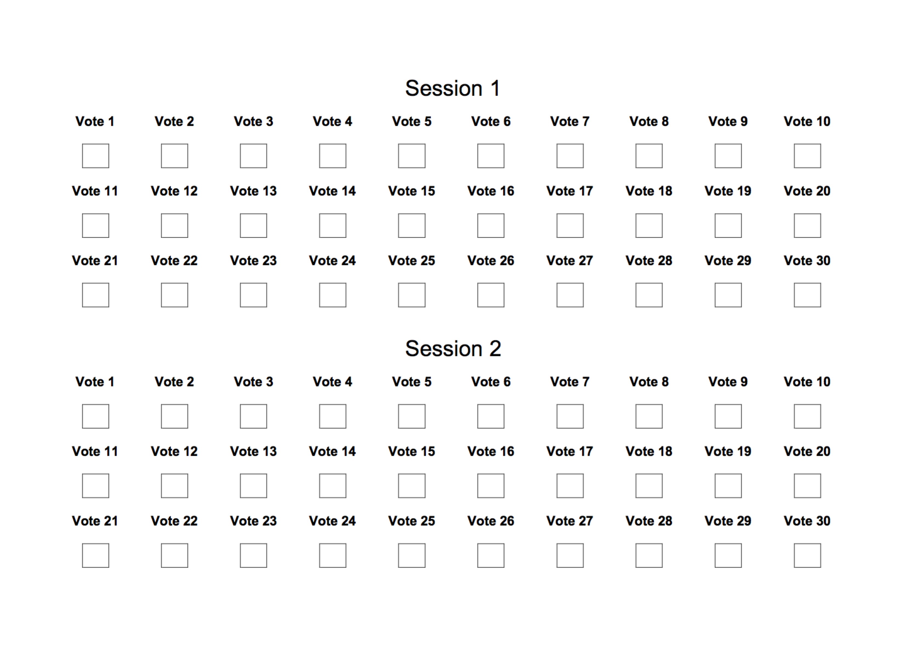

Figure 5 -Example of DCR test method scoring sheet for 30 BTC test sessions

A.4 Training of the test subjects

A good outcome of a test is highly dependent on a proper training of the test subjects.

For this purpose, each subject has to be trained by means of a short practice (training) session. In the case of the SCC test the training was particularly accurate and focused on the detection of area where degradations between source and coded video clips could be more easily visible. To better train the viewing subjects a snapshot of each source video clips was prepared highlighting the areas of “major interest”.

The current literature suggests that video material used for the training session to be different from those of the test, but the impairments introduced by the coding have to be as much as possible similar to those in the test. In the case of the SCC test the level of difficulty in detecting the impairment was so high that it was agreed to use the same content of the actual test.

Being that the training phase very long and accurate, no stabilization phase was applied at the beginning of the SCC test sessions; this choice allowed to make the test sessions more short and easier for naïve viewers.

Appendix B – Short Test Laboratories setup description

B.1 EPFL

Experiments were conducted at EPFL’s MMSPG test laboratory, which fulfils the recommendations for the subjective evaluation of visual data issued by ITU-R [1].

*B 1.1 Laboratory set-up*

The test room is equipped with a controlled lighting system with a 6500 K colour temperature and an ambient luminance at 15% of the maximum screen luminance, whereas the colour of all the background walls and curtains present in the test area are in mid grey. The laboratory setup is intended to ensure the reproducibility of the subjective tests results by avoiding unintended influence of external factors.

To display the test stimuli, three Eizo CG301W LCD monitors with a native resolution of 2560×1600 pixels were used. The monitors were calibrated using an X-Rite i1Display Pro colour calibration device according to the following profile: sRGB gamut, D65 white point, 120 cd/m2 brightness, and minimum black level.

The experiment involved two subjects per monitor assessing the test material. The subjects were seated in a row perpendicular to the centre of the monitor, at a distance of about 4.8 and 3.2 times the picture height for the 720p and 1080p contents, respectively, as suggested in [2].

*B 1.2 Test session*

The overall experiment was split into 12 sessions. Each session was composed of 20 basic test cells (BTC), corresponding to approximately 10 minutes each. For each resolution, the test material was randomly distributed over six test sessions. To reduce contextual effects, the stimuli orders of display were randomized applying different permutation for each group of subjects, whereas the same content was never shown consecutively.

Each subject took part to exactly three sessions and evaluated contents corresponding to only one resolution. Between the sessions, the subjects took a 10 minutes break.

A total of 72 naive subjects (38 females and 34 males) took part in the experiments, leading to a total of 18 ratings per test sample. Subjects were between 18 and 33 years old with an average of 23.3 years of age. All subjects were screened for correct visual acuity and colour vision using Snellen and Ishiara charts, respectively.

B.2 QMUL

The tests at QMUL were done in the Multimedia and Vision Lab within the School of Electronic Engineering and Computer Science, Queen Mary University of London.

*B 2.1 Laboratory set-up*

The test room was set to a uniform brightness of 15 lux. This was measured at all the points where people were seated using a Minolta Autometer IIIF. The maximum screen luminance of both displays was calibrated using an X-Rite i1Display Pro colour calibration device according to the following profile: sRGB gamut, D65 white point, 120 cd/m2 brightness, and minimum black level. Grey panels were used as a background to the displays to set the correct environment for the tests.

The displays used for the test are those depicted in Figure **6**; in details they are:

* Display 1: 58”, resolution 1920x1080, Panasonic TH 58PZ800B Plasma screen
* Display 2: 27”, resolution 2560x1440, Dell UltraSharp U2713HM​

The experiment involved three subjects in front of Display 1, and one subject in front of Display 2 assessing the test material. The subjects in front of display 1 were seated at a distance of about 2.5 the height of the display, while the subjects in front of display 2 were seated at a distance of about 1.5 the height of the display, as suggested by the Test Coordinator.

The laboratory set-up at QMUL is depicted in Figure 6.

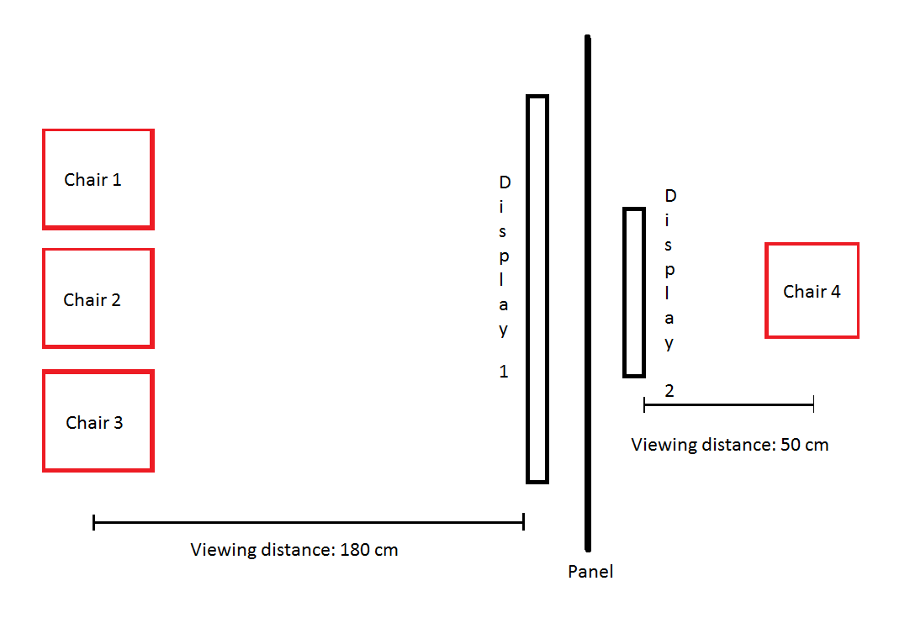

Figure 6 – Laboratory set-up at QMUL

*B 2.2 Test session*

The overall experiment was split into 8 sessions. Each session was composed of 30 basic test cells (BTC), corresponding to approximately 13 minutes each. Participants were sitting in the random positions in each session. Also, to reduce contextual effects in each session, a random selection of test points was shown in a random order.

Each subject took part in all eight sessions and evaluated all the content. Between the sessions, the subjects took a 15 minutes break.

A total of 16 naive subjects (9 females and 7 males) took part in all the sessions, leading to a total of 16 ratings per test sample. Subjects were between 21 and 30 years old, with an average of 26.8 years of age. All subjects were screened for correct visual acuity and colour vision using Snellen and Ishiara charts, respectively.

B.3 UWS

The tests were performed at the premises of the School of Computing, University of West of Scotland (UWS).

*B 3.1   Laboratory set-up*

The test room was equipped with two LCD monitor HPZR30W receiving input from a high performance servers that was able to play Full HD raw content in real time. The ambient lighting consisted of neon lamps with 6500 K colour temperature and the wall colour was mid grey. One subject per monitor is allowed to sit of each screen at a distance about 3 times the height of the stimuli however they are allowed to move forward or backward on the fixed chair. Both the screen are separated by wall panel.

The subjective evaluation at UWS for 720p (AI and LD) was split into 6 sessions. Each session was composed of 40 stimuli of approximately 20 minutes each. For each configuration (AI and LD), the test material was randomly distributed over six test sessions. The stimuli orders in each test sessions were randomized.

All the subjects were screened, before running the test, using Snellen Chart and Ishiara tables; the average age of the subject was 26.5 years.

B.4 FUB Laboratory set-up

The DCR test sessions were run using a brand new 47” TV set (LG 47LA740).

All the local post-processing and filter features were disabled.

The display mode was set to “research only” for an optimal use of the screen.

Two subjects were seated at 1.5 H from the monitor.

A total of 8 sessions of 30 BTC each were run with the participation of 16 valid viewing subjects all screened for visual acuity and colour blindness.

The subjects had ages between 18 and 24, with 12 males and 4 females. The majority of the subjects were university students.

For the Side-by-Side test sessions a brand new 27” Philips 2560 x 1400 resolution monitor (272P4QPJKES) was used, and for the SbS test sessions only one subject at a time was seated in front of the monitor and interacted with the player.

Background luminance was 14 lux. Peak luminance of the displays was 300 cd/m² for the 27” monitor and 220 cd/m² for the LG TV set.

References

[1] ISO/IEC JTC1/SC29/WG11 and ITU-T Q6/SG16, MPEG2014/N14175 / VCEG-AW90 “Joint Call for Proposals for Coding of Screen Content”; January 2014, San Jose, USA.

[2] International Telecommunication Union Standardization Sector; Recommendation ITU-T P.910 “Subjective video quality assessment methods for multimedia applications”.

[3] ITU-R BT.2022, “General viewing conditions for subjective assessment of quality of SDTV and HDTV television pictures on flat panel displays,” International Telecommunication Union, August 2012.

[4] JCTVC-Q0031 / ISO/IEC JTC1/SC29/WG11/m32877, J. Chen, Y. Chen, T. Hsieh, R. Joshi, M. Karczewicz, W.-S. Kim, X. Li, C. Pang, W. Pu, K. Rapaka, J. Sole, L. Zhang, F. Zou: “Description of screen content coding technology proposal by Qualcomm”; March 2014, Valencia, ES.

[5] JCTVC-Q0032 / ISO/IEC JTC1/SC29/WG11/m32858, C.-C. Chen, T.-S. Chang, R.-L. Liao, C.-W. Kuo, W.-H. Peng, H.-M. Hang, Y.-J. Chang, C.-H. Hung, C.-C. Lin, J.-S. Tu, E.-C. Ke, J.-Y. Kao, C.-L. Lin, F.-D. Jou, F.-C. Chen: “Description of screen content coding technology proposal by NCTU and ITRI International”; March 2014, Valencia, ES.

[6] JCTVC-Q0033 / ISO/IEC JTC1/SC29/WG11/m32905, P. Lai, T.-D. Chuang, Y.-C. Sun, X. Xu, J. Ye, S.-T. Hsiang, Y.-W. Chen, K. Zhang, X. Zhang, S. Liu, Y.-W. Huang, S. Lei: “Description of screen content coding technology proposal by MediaTek”; March 2014, Valencia, ES.

[7] JCTVC-Q0034 / ISO/IEC JTC1/SC29/WG11/m32878, Z. Ma, W. Wang, M. Xu, X. Wang, H. Yu: “Description of screen content coding technology proposal by Huawei Technologies (USA)”; March 2014, Valencia, ES.

[8] JCTVC-Q0035 / ISO/IEC JTC1/SC29/WG11/m32882, B. Li, J. Xu, F. Wu, X. Guo, G. J. Sullivan: “Description of screen content coding technology proposal by Microsoft”; March 2014, Valencia, ES.

[9] JCTVC-Q0036 / ISO/IEC JTC1/SC29/WG11/m32852, R. Cohen, A. Minezawa, X. Zhang, K. Miyazawa, A. Vetro, S. Sekiguchi, K. Sugimoto, T. Murakami: “Description of screen content coding technology proposal by Mitsubishi Electric Corporation”; March 2014, Valencia, ES.

[10] JCTVC-Q0037 / ISO/IEC JTC1/SC29/WG11/m32880, X. Xiu, C.-M. Tsai, Y. He, Y. Ye: “Description of screen content coding technology proposal by InterDigital”; March 2014, Valencia, ES.