|  |  |
| --- | --- |
| **ITU – Telecommunications Standardization Sector**  STUDY GROUP 16 Question 6  **Video Coding Experts Group (VCEG)**  72nd Meeting: 24-28 April 2023, Antalya | Document VCEG-BT02 |

|  |  |  |  |
| --- | --- | --- | --- |
| Question: | Q.6/SG16 (VCEG) | | |
| Source: | **Keisuke Nonaka, Ryota Koiso,  Kei Kawamura, Haruhisa Kato (KDDI)** | Tel:  Email: | {ki-nonaka, ry-koiso, ki-kawamura}@kddi.com |
| Title: | **Object-wave compression framework for computer generated holography based on conventional video codec** | | |
| Purpose: | Proposal | | |

_____________________________

# Abstract

This contribution proposes an object-wave compression framework based on conventional video codecs for computer-generated holography.

# Introduction

Computer holography is a promising 3D display technology that reconstructs highly realistic 3D images by taking a 3D model as input and recording its light propagation information in a digital inference fringe called a computer-generated hologram (CGH). This technology can reconstruct 3D images that satisfy all the cues of human depth perception, thus resolving the conflict between convergence and accommodation, i.e., eliminating user symptoms of concern with existing 3D display technologies, such as virtual reality sickness. In other words, it is a video technology that delivers a realistic visual experience without elements that burden the user and is not inferior to the real world. Because of these characteristics, computer holography is strongly desired for practical use in various imaging fields, such as stereoscopic image communication, remote education and health care, and digital signage. On the other hand, large screen sizes and wide viewing angles are required to apply computer holography for such applications, which means CGH has an extremely large number of pixels and fine pixel pitch. It causes an increase in computation and data size for CGH generation. The CGH generation process is shown in Fig. 1.

The following issues should be addressed in order to realize CGH applications via a network.

1. The CGH calculation requires a huge amount of computation and computing resources, and it is hard to generate CGH and play it back by using received 3D model data on a low-performance user terminal such as a mobile device.
2. The CGH generation process requires information on the playback device (optical system), making it impossible to broadcast common data and play it back on multiple devices.

Considering these restrictions, we propose the following solutions.

First, a light wave distribution on a two-dimensional plane is introduced as an intermediate data called object-wave for CGH generation from a 3D model. This data representation is independent of the playback device optics; thus, transmitting object-wave to playback devices solves the problem of data versatility in a broadcast distribution described in item 2. In addition, the conversion process from object wave to CGH is much lighter than the calculation of object wave from a 3D model and is expected to be sufficiently processed by low-performance user terminals in the future. Thus, transmitting object-wave is a reasonable way to realize the practical use case of CGH in Fig. 2. Since object-wave is composed of amplitude and phase data in a two-dimensional plane, existing video codecs can be applied to object-wave compression. However, there has been no discussion on using specific data format standards for object waves by video codecs.

Based on the above discussion, this contribution proposes an initial standardization of coding object light waves, an intermediate representation of CGH, in the framework of conventional video codecs.

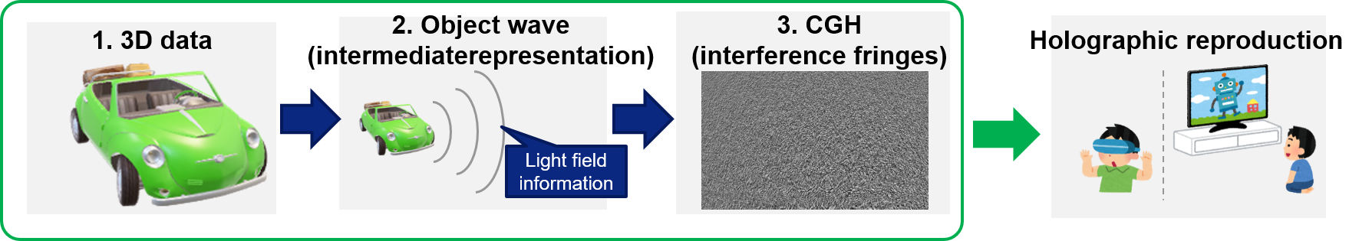

Figure 1 the flow for generration and reproduction of computer holography

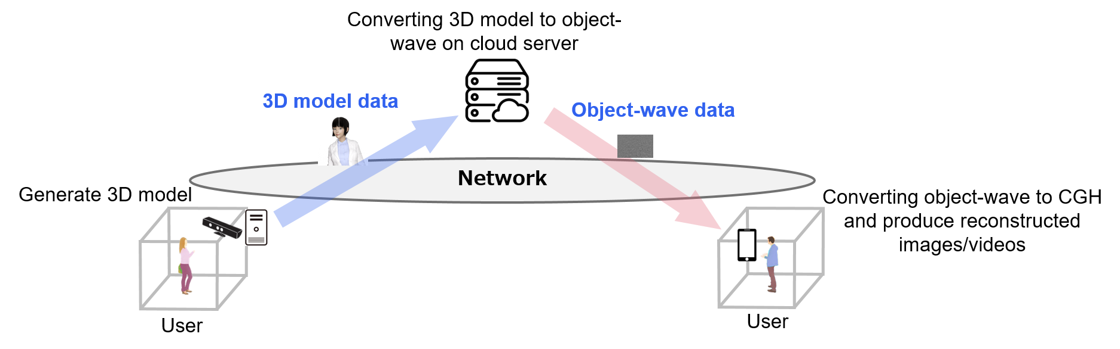

Figure 2 System configuration for practical CGH transmission use cases

1. **Holography Overview**

## Workflow in Object wave generation

CGH is generated using 3D models such as point clouds and meshes as input. Specifically, CGH calculates the propagation of light from an 3D model object to a certain two-dimentional plane by using light wave propagation techniques. For example, the point-based method is used to calculate light propagation for point clouds. The two-dimensional light wave distribution on the target plane in 3D space obtained is called "object-wave," which is given as light amplitude and phase distributions (in the actual calculation process, the amplitude and phase are converted to complex numbers). The interference pattern between this object-wave and the reference illumination light defined by the playback device optics is calculated, and this interference pattern is output as CGH.

## Input format

As described in Section 3.1, computer holograms use 3D models such as point clouds and meshes as input. The respective input formats are as follows.

|  |  |
| --- | --- |
| Type of 3D model | Data format |
| Point cloud | A set of points with geometry and attribute (mainly color) information. |
| Mesh | A set of polygons and textures for geometry and attribute information. |

## Complexity analysis

We analyzed the computational complexity of generating holograms. This preliminary study used a mesh model (Mitch sequence; 30 frames) specified in the V-DMC Common Test Conditions as input. The running times of calculation are measured for both the object wave from the 3D model and the CGH from the object wave using a hologram calculation library [1]. The number of polygons in the mesh model was reduced to 10,000 polygons from 30,000 polygons by the open-source software Meshlab [2] to ensure the stable operation of the library. The resolution on the object-wave plane is 4K x 4K. This experiment is conducted on a PC with AMD Ryzen Threadripper 3990X CPU and 256GB RAM. All the processes worked on the CPU with multithreading technology. We have room to accelerate the processing speed with GPU because light wave propagation can be calculated independently for each pixel.

|  |  |  |
| --- | --- | --- |
| For Mitch sequence | Average calculation time from 3D model to objedct wave among 30 frames | Average calculation time from object wave to CGH among 30 frames |
| Calcutation time | 211.43 seconds / frame | 1.96 seconds / frame |

1. **Use cases**

Computer holography transmission is expected to realize the development of user-friendly stereoscopic image communication and the stereoscopic image industry in the future. Three typical use cases are shown in Fig. 3 and described below.

## Workstyle

In the workstyle field, advanced remote work will become possible, enabling comfortable remote collaboration while still feeling the other person's presence. To achieve sustained communication equal to or better than face-to-face communication, the visual representation provided by CGH, which minimizes eye and brain fatigue and makes the other person appear as if they are there, is necessary.

## Education

In education, the computer holography communication service will enable remote education through safe and secure 3D image presentation. In particular, the use of holography is expected to expand among young people, as the conflict between convergence and accommodation, which was feared to have a negative impact on children, will be eliminated. It will be possible to encourage active learning in which children acquire knowledge through an immersive visual experience.

## Healthcare

In the healthcare field, it will contribute to the development of telemedicine. The realization of holographic communication that can provide more accurate depth perception to doctors is expected to contribute to the practical application and generalization of remote surgery.



Figure 3 Three use-cases realized by holography transmission

1. **Requirements**

Object-wave transmission requirements are identified to realize the above use cases.

* High compression rate
* Use existing video codecs, as it is essential to be immediately marketable
* Include metadata necessary for CGH

The table below is an example of a data format that includes the required metadata.

|  |  |
| --- | --- |
| Data | Format |
| Object wave (a series of 2D image) | As in the video, a set of sampling points distribution in an object plane to each frame consists of RGB color planes. Each sampling point is recorded in a floating point and has independent amplitude and phase data. |
| RGB color wavelengths (metadata) | Information on the respective RGB wavelengths used to calculate object-wave from 3D models. |
| Pixel pitch (metadata) | The physical distance of sampling points used to calculate object-wave on an object plane. |

Generally, the object-wave data is calculated as complex numbers for calculating object waves from a 3D model. However, amplitude and phase format as the coding target is desirable instead of complex numbers because amplitude and phase information is used for calculating CGH from object light.

1. **Proposal**

This contribution proposes the standardization of the compression on coding object-wave, an intermediate representation of CGH, leveraged by the framework of existing video codecs.

As for the standardization, the high compression rate described in the Requirements is achieved using existing video codecs. In addition, associated metadata is needed to realize CGH use. Thus, defining metadata formats stored in VUI and SEI of the video codecs is desired. We also need to decide assessment method that evaluates the final reconstruction images and videos.

As a preliminary study, the following experiments were performed on the object wave and CGH obtained from the experiments described in Section 3.3.

We have experimented with VVC reference software to encode the amplitude and phase of the object wave, the real and imaginary parts of the complex number of the object wave, and CGH, respectively. In this case, each data was linearly quantized to 8 bits from 0 to 255. In addition, the quality of the simulated image after coding was evaluated by generating a simulated image of the reconstruction from the object wave and CGH using the library [1]. An image reconstruction simulation from the object wave and CGH gives the ground truth. The results of simulated reconstruction images are shown in Fig. 4.

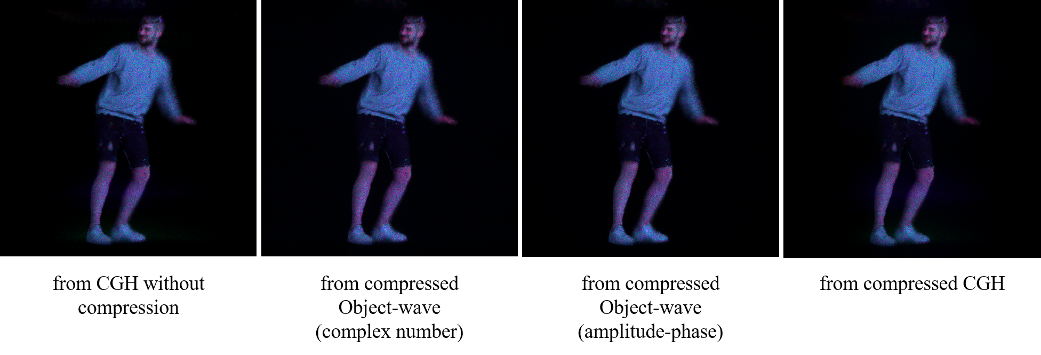

Figure 4 Simulated reconstruction images from object-wave or CGH

|  |  |  |  |
| --- | --- | --- | --- |
|  | Object-wave  (amplitude-phase) | Object-wave  (complex number) | CGH |
| PSNR [dB] | 32.184 | 30.636 | 34.074 |

In this contribution, we also distribute the data, 3D model, object-wave as amplitude-phase expression, object-wave as complex number expression, and CGH.

1. **Timeline**

In this contribution, we also distribute the data, 3D model, object-wave as amplitude-phase expression, object-wave as complex number expression, and CGH.

We propose the AAP Consent on 2025-10 for standardization.

1. **Conclusion**

In this contribution, we propose the object-wave compression framework for computer-generated holography based on existing video codecs and initiate a discussion for applying the existing video codecs to the object wave.

**References**

[1] Kyoji Matsushima,“WaveField Tools,“ Kansai University, http://www.laser.ee.kansai-u.ac.jp/wavefieldtools/, accessed on April 2023.

[2] P. Cignoni, M. Callieri, M. Corsini, M. Dellepiane, F. Ganovelli, G. Ranzuglia, “MeshLab: an Open-Source Mesh Processing Tool,“ Sixth Eurographics Italian Chapter Conference, page 129-136, 2008.

________________________