ITU - Telecommunications Standardization Sector  STUDY GROUP 16  Video Coding Experts Group (Question 15)  _________________  Eighth Meeting: Berlin, 03-06 August, 1999 | Document Q15-H-20  Filename: q15h20r1.doc  Generated: 26 July ’99

Question: | Q.15/SG16
Source: | J. Shen and J. Ribas-Corbera  Sharp Labs of America  5750 NW Pacific Rim Blvd  Camas, WA 98607, USA | Tel:  Fax:  Email: | (360) 817 8487  (360) 817 8436  jordi@sharplabs.com
Title: | Adaptive motion accuracy (AMA) in Telenor’s proposal
Purpose: | Proposal
_____________________________

1. Introduction

The current codec proposed by Telenor for H.26L [1,2,3] achieves high compression efficiency, both in terms of PSNR and subjective image quality, with a reasonable level of computational complexity. In the inter-coded frames, Telenor’s proposal consists of :
- a) a motion compensation scheme that uses variable block sizes (16x16 or smaller), an improved filter interpolator, and 1/3-pel motion accuracy, and
- b) a prediction error encoder that applies an integer transform on each 4x4 block, quantizes the transform coefficients, and then codes the quantized coefficients with VL codes.
In this contribution, we explore the benefits of adapting motion accuracy at each 16x16 macroblock in Telenor’s codec. Specifically, we modified the software in [3] to compute and encode motion vectors with 1/2, 1/3, and 1/6 pixel accuracy. The encoder selects the best motion vector for each macroblock using Telenor’s RD criteria and encodes the accuracy mode and vector/s for the macroblock using the codec’s single VLC table.
In complex video sequences, the adaptive motion accuracy or AMA technique provided coding gains of about 0.5-1 dB in PSNR over Telenor’s, which corresponded to bit rate savings in the range of 5-13 percent. These gains represented approximately 30-50 percent of the total gain over the anchor.
In easier scenes, the gains were not significant, but the performance was always as good or better than Telenor’s without AMA.
AMA requires a very small change in the bit stream syntax of Telenor’s proposal and does not increase the decoder’s complexity. Also, with appropriate fast-search strategies, the complexity of the encoder increases only moderately. Finally, the relative gains of AMA remain similar whether the encoder uses one or multiple reference frames.

- Adaptive Motion Accuracy (AMA)

Most video codecs use motion vectors with 1/2-pel (i.e., half pixel) accuracy and bilinear interpolation. In fact, the first version of Telenor’s proposal [1] also used 1/2-pel motion vectors and bilinear interpolation, but the latest version [2,3] incorporated 1/3-pel vectors and cubic-like interpolation because of the additional compression gains. In this contribution, we explore the benefits of letting the encoder choose between 1/2, 1/3, and 1/6-pel accurate motion vectors on a macroblock-by-macroblock basis.
Our work is motivated by the techniques in [5,6], which achieved significant compression gains by adapting motion accuracy according to the complexity and compression noise in the video sequence. To be more concrete, the methods in [5,6] showed that when a scene is complex (i.e., with much motion and texture) higher motion vector accuracy lead to bit rate savings, particularly at higher bit rates. Conversely, low motion accuracy saved bit rate for easy scenes encoded at low bit rates.
Next we describe the few changes necessary to implement our AMA technique into Telenor’s decoder. Later, we also discuss several encoder implementations of AMA.

2.1 Decoder
We modified the decoder of Telenor’s software [3] at the macroblock layer. The decoder finds the motion accuracy of the vector/s in the macroblock by decoding 1 or 3 bits at the marcroblock layer according to Table 1. Such table contains the first three entries from Telenor’s unique VLC [1]. Coding performance would improve using DPCM or using a table with code lengths {1, 2, 2}, but we use Telenor’s VLC directly to keep things simple, and so that only one code is used for coding all parameters.
Code | Motion Accuracy
1 | 1/2-pel
001 | 1/3-pel
011 | 1/6-pel
Table 1. VLC table to indicate the accuracy mode for a given macroblock.

The following bits in the macroblock layer will indicate the value of the vector/s in the respective accuracy space. The key idea is that these bits are interpreted differently depending on the motion accuracy for the macroblock. For example, if the motion accuracy is 1/3 and the code bits for the x component of the difference motion vector are 00001, the x component of the vector is vx= 2/3. If the accuracy is 1/2, such code corresponds to vx= 1.
Once the motion vector is decoded, the associated block in the previous frame is reconstructed using a typical 4-tap cubic interpolator [6]. There is a different 4-tap filter for each motion accuracy. Currently, Telenor’s codec uses a cubic-like, 4-tap filter for the 1/3-pel case.
Observe that AMA does not increase decoding complexity, because the number of operations needed to reconstruct the predicted block are the same, regardless of the motion accuracy.

2.2 Encoder
In the first step of Telenor’s motion estimation, the encoder searches for the best pixel-accurate motion vector V₁ that minimizes an effective RD criteria. In the second step, it searches for the best sub-pixel accurate vector V_{1/3} in a grid of 1/3-pixel resolution that is centered on V₁. A total of 8 sub-pixel locations are selected, as illustrated in Figure 1. Since the grid can contain a circle of 1 unit radius, we will say that such grid is of 1/3-pixel resolution and radius 1.

Figure 1. Illustration of full-pel and 1/3-pel locations in velocity space. Telenor’s codec finds the the best 1/3-pel motion vector in the 8 locations around the best full-pel vector V₁.

In order to implement AMA, we modified the second (sub-pixel) step of this process, so that the encoder also searches for motion vector candidates in other sub-pixel locations in the velocity space. We considered full search and fast search strategies, which we describe next.

2.2.1 Full-search AMA
In this case, the encoder checks all the motion vector candidates in a grid of 1/6-pixel resolution of radius 5 and selects the best vector, i.e., the one that minimizes the RD criteria. This approach is computationally complex since it searches 120 sub-pixel candidates, as shown in Figure 2. Nevertheless, we used it to explore the full potential of our method.
In general, any RD criteria of the type “distortion + Lambda*bits” would work with our approach. However, with AMA the number of bits for a motion vector candidate should include the bits for the vector and those for its accuracy mode. In fact, observe that some candidates can have several bit values, because they can have several accuracy modes. For example, the candidate at location (1/2, -1/2) can be thought of having 1/2 or 1/6 pixel accuracy.

2.2.2 Fast-search AMA
In the fast-search case, the encoder checks only a small set of the motion vector candidates in Figure 1. We describe this strategy in the following 3 steps:
- Check the 8 motion vector candidates in a grid of 1/2-pixel resolution of radius 1, which is centered on V₁. Let V₂ denote the candidate that has the smallest RD cost (i.e., the best of the 8 previous vectors and V₁) and go to step 2.
- Check the 8 motion vector locations in a grid of 1/6-pixel resolution of radius 1 that is now centered on V₂. If V₂ has the smallest RD cost, stop and select V₂ as the motion vector for the block. Otherwise, let V₃ denote the best motion vector of the 8 and go to step 3.
- Check the new motion vector candidates in the grid of 1/6-pixel resolution of radius 1 that is centered on V₃. Observe that some of the candidates in the grid have already been tested and can be skipped. The candidate with the smallest RD cost in this last step is selected as the motion vector for the block.
In our experiments, we noted that, on average, this simple fast search approach typically checks the RD cost of about 18 locations in sub-pixel space (10 more than Telenor’s), and hence the overall computational complexity is only moderately increased. Figure 3 illustrates the locations of the motion vector candidates in velocity space for the fast-search approach.

Figure 2. Location of motion vector candidates for full-search in sub-pixel velocity space.

Figure 3. An example of the location of motion vector candidates for fast-search in sub-pixel velocity space.

3. Experimental Results
We tested Telenor’s codec with and without AMA in a variety of video sequences, resolutions, and frame rates, as described in Table 2. Sections 3.1 and 3.2 show rate-distortion (RD) plots for each case. Section 3.1 presents the results for the H.26L common testing conditions, which correspond to the top six experiments in the table. Section 3.2 presents some additional tests on more complex video sequences. Each rate-distortion plot includes the following curves :
- Anchor : RD points from optimized H.263+ . Available only for Section 3.1.
- Telenor 1/2+b : Telenor with 1/2-pel vectors and bilinear interpolation.
- Telenor 1/3 : Current Telenor proposal
- Telenor+AMA+c: Current Telenor proposal with our new AMA
We do not have the anchor points for the tests in Section 3.2. Nevertheless, we found that TMN8’s RD curve was slightly below and within 0.5 dB of “Telenor 1/2+b”, which suggests that for such tests “Telenor 1/2+b” curve should be near the anchor’s.
Unless specified, the full-search version of AMA was the encoder strategy used in the experiments. All of the test results were cross-checked at the encoder and decoder.

Video sequence | Resolution | Frame rate
Container | QCIF | 10
Foreman | QCIF | 10
News | QCIF | 10
Silent | QCIF | 10
Hall | QCIF | 10
Paris | CIF | 15
Mobile | QCIF | 10
Garden | SIF | 15
 | QCIF | 15
Tempete | SIF | 15
 | QCIF | 15
Paris shaked | QCIF | 10
Table 2. Description of the experiments
The video sequences “mobile”, “garden” and “tempete” are well known by the video coding community. They are harder to compress than the sequences in the testing conditions, since they are more complex than typical video phone scenes. They contain the kind of complex motion and textures present in many video sources for multimedia applications, and hence we also use them as part of our experiments. We obtained “mobile” (QCIF) from the MPEG4 set and “garden” (SIF) and “tempete” (SIF) from the RPI ftp site at “ipl.rpi.edu”. We down-sampled “garden” and “tempete” to QCIF using the default Lanczos filter from Image Magick (v. 4.2.8).
The “paris_shaked” sequence is a synthetic sequence obtained by shifting the sequence “paris” by a motion vector whose X and Y components take a random value within [-1,1]. The sub-pixel locations were interpolated using a cubic interpolator. This synthetic sequence simulates small movements caused by a hand-held camera in a typical video phone scene.
3.1 Experimental results on common testing conditions
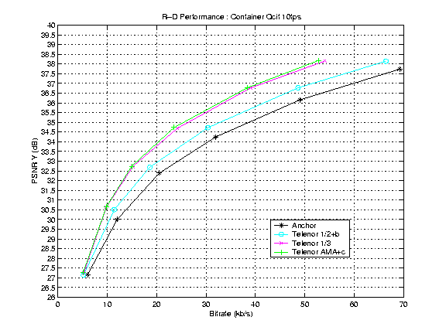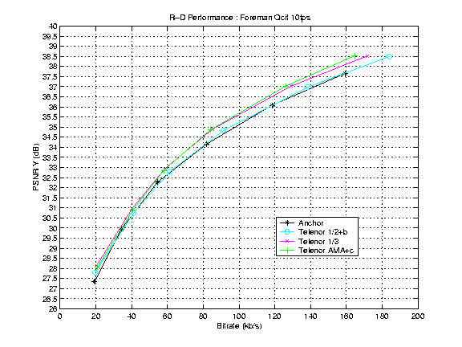
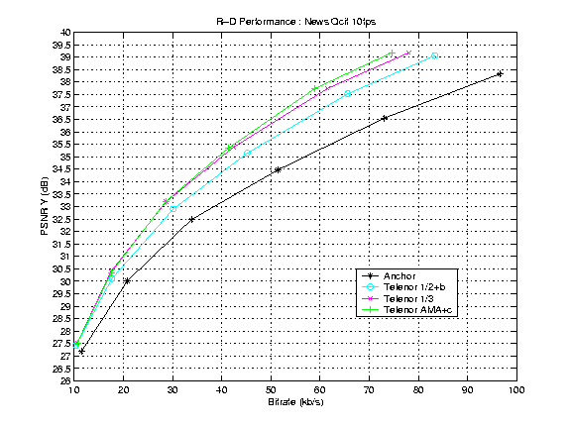
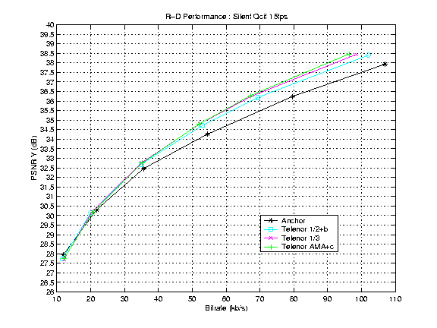
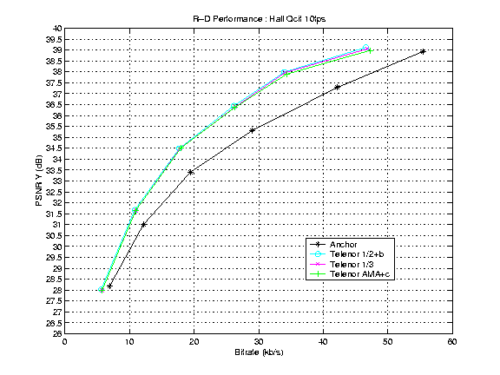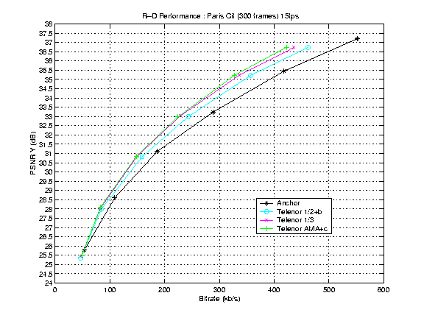

3.2 Experimental results on complex video sequences
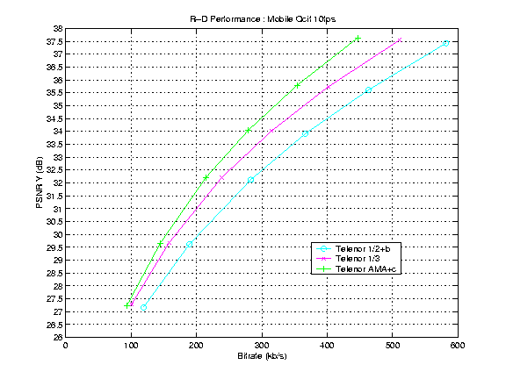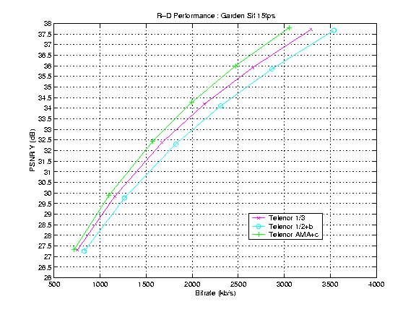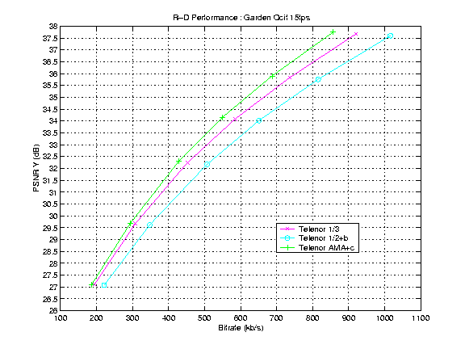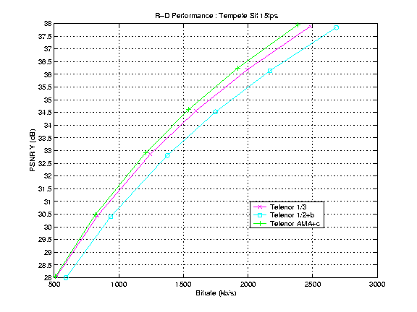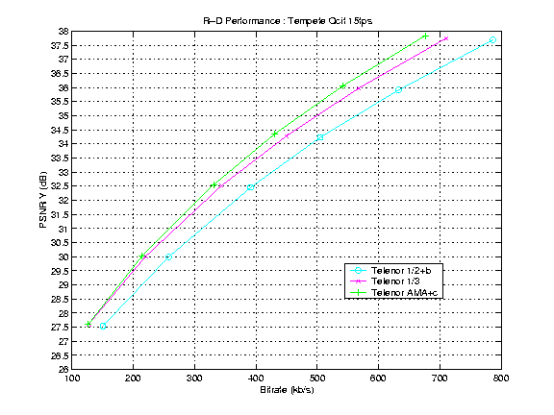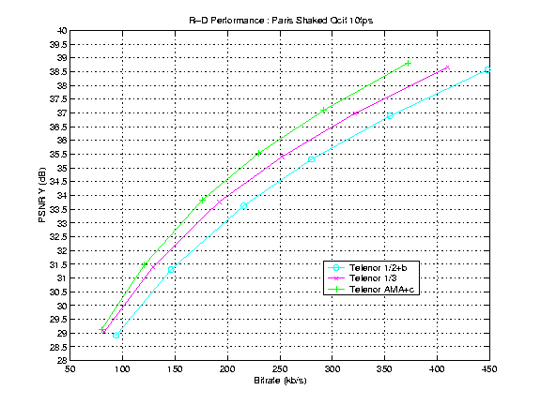
3.3 Comparison of full-search and fast-search AMA

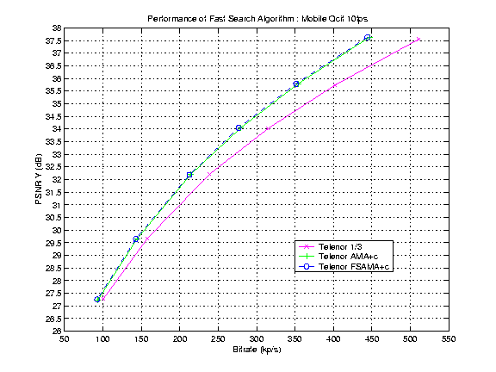
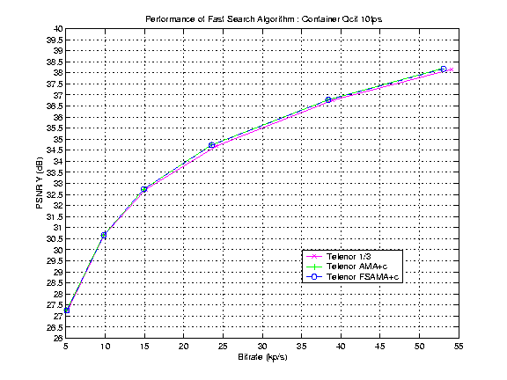

These experiments show that the encoder performance with our fast-search (Telenor FSAMA+c) and full-search (Telenor AMA+c) strategies for AMA is practically the same. This may not be too surprising, since the prediction error energy in the sub-pixel velocity space follows a smooth convex curve [4] whose minimum should be easy to find with some simple gradient-like, fast-search scheme like ours.
3.4 Combining AMA and multiple reference frames

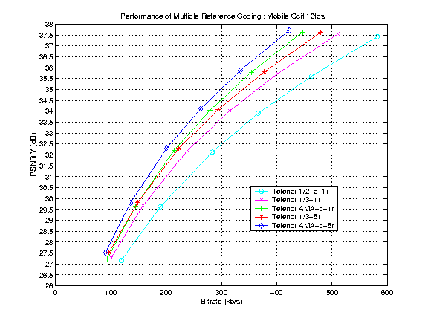

In the plot, the curves whose names include the label “1r” used only one reference frame for the motion compensation, so these curves are the same as those presented for “mobile” in Section 3.2. The curves with the label “5r” used 5 reference frames.

The experiments show that the gains with AMA add to those obtained using multiple reference frames. The gain from AMA in the one-reference case can be measured by comparing the green and pink curves, and the gain in the five-reference case can be measured between the blue and red curves.

3.5 Frame-adaptive vs. macroblock-adaptive AMA.
In this contribution, AMA is applied at macroblock level, i.e., the motion accuracy can be modified at each macroblock. AMA could also be applied at frame level, so that different frames could use different motion accuracies, but within a frame all motion vectors would use the same accuracy. The motion vector accuracy would then be signaled only once at the frame layer.
Our preliminary experiments and the findings in [4] indicate that using the best, fixed motion accuracy for the whole frame should produce similar compression gains as those presented here for the macroblock-adaptive case. In fact, sometimes the coding performance may be a little better, because of the reduction of the accuracy-mode bit overhead.
The frame-based case could be implemented in the following scenarios:
- The encoder could do motion compensation on the entire frame with the different vector accuracies and then select the best accuracy according to the RD criteria. This approach is not suitable for pipeline, one-pass encoders, but it could be appropriate for software-based or more complex encoders.
- The encoder could use previous statistics and/or formulas to predict what will be the best accuracy for a given frame (e.g., one could use the formulas in [4] or a variation thereof). This approach would be well-suited for one-pass encoders, but its performance gains would depend on the precision of the formulas used for the prediction.
At this time, we have focused on the more practical macroblock-based version of AMA, because it can be implemented in one-pass encoders using an effective and relatively simple fast-search strategy. Nevertheless, we encourage the video group to consider frame-based AMA as an additional possibility.

4. Conclusions

- AMA provides significant compression gains in complex video scenes. For example, we obtained PSNR gains of about 0.5-1 dB (i.e., about 5-13 percent in bit rate savings) for complex video sequences such as “mobile”, “garden”, “tempete”, and “paris_shaked”.
- These gains represented about 30-50 percent of the gain over the anchor-like case that used 1/2-pel vectors and bilinear interpolation.
- Easy video sequences such as most of those in the testing conditions don’t benefit much from AMA, but the performance is always as good or better.
- AMA does not increase the complexity of the decoder.
- With fast-search encoding strategies, the increase in encoder complexity is moderate. Specifically, the current Telenor codec checks 8 candidate vectors in the sub-pixel velocity space for each block and, on average, our fast-search AMA checks only 10 more candidates.
- There are practically no changes in the bit stream syntax. The only change is the insertion of a simple code at macroblock level to indicate that macroblock’s motion accuracy. This code is obtained from the single VLC table in Telenor’s codec.
As a result, we propose to incorporate this technology into the set of tools for consideration in the H.26L standardization efforts.

5. References

[1] G. Bjontegaard, “Response to call for proposals for H.26L,” ITU-T SG16/Q15, doc. Q15-F-11, Seoul, Oct. 98.
[2] G. Bjontegaard, “Enhancement of the Telenor proposal for H.26L,” ITU-T SG16/Q15, doc. Q15-G-25, Monterey, Feb. 99.
[3] I. Lille-Langoy et al., “Telenor H.26L proposal and software,” ITU-T SG16/Q15 doc. Q15-H-08, Berlin, Aug. 99.
[4] J. Ribas-Corbera and D. Neuhoff, “On the optimal motion vector accuracy for block-based, motion-compensated video coders,” Proc. SPIE 2727 (Digital video compression: algorithms and technologies), pp. 811-817, March 96.
[5] J. Ribas-Corbera and D. Neuhoff, “Optimizing block-size in motion-compensated video coding,” Journal of Electronic Imaging, 7 (1), pp. 155-165, Jan. 98.
[6] R.G. Keys, “Cubic convolution interpolation for digital image processing.” IEEE trans. on Acoustics Speech and Si gnal Processing, Vol. 29, pp. 1153-1160, Dec. 81.

Observe that this code is the fourth entry (code number 3) of Telenor’s VLC table in [1].
This not yet the case for all the RD points of “Telenor 1/2+b”. We are still cross-checking some of them.

