ITU - Telecommunications Standardization Sector  STUDY GROUP 16  Video Coding Experts Group (Question 15)  _________________  Ninth Meeting: Red Bank, New Jersey, 19-22 October, 1999 | Document Q15-I-35  Filename: q15i35r1.doc  Generated: 08 Oct. ’99

Question: | Q.15/SG16
Source: | Thomas Wedi  Institut für Theor. Nachrichtntechnik und Informationsverarbeitung, Uni Hannover  Appelstr. 9A  D-30167 Hannover, Germany | Tel:  Fax:  Email: | +49 511 7625304  +49 511 7625333  wedi@tnt.uni-hannover.de
Title: | Motion and Aliasing Compensated prediction for H.26L
Purpose: | Proposal
_____________________________

Introduction

The current H.26L codec [1] is based on motion compensated prediction with displacement vector resolution of 1/3-pel. In order to estimate and compensate 1/3-pel displacements, the image signal between the sampled positions (subpel positions) has to be interpolated. In the current H.26L codec this is done by a cubic interpolation filter [2,3].

In this contribution a motion compensated prediction is proposed for the H.26L codec, which uses

- a motion compensated prediction with 1/4 or 1/8 pel resolution of the displacements, and
- a wiener interpolation filter, which was developed to interpolate the image signal on subpel positions while compensating aliasing in the image signal.

Since the new prediction approach compensates both, motion and aliasing, it is called Motion and Aliasing Compensated Prediction (MACP). Both items, listed above, are explained in the following sections 2 and 3 in detail. In section 4 the experimental results with the achieved gain and in section 5 the summary is presented.

Motion Compensation

In this contribution the motion vector resolution of the displacement vectors for motion compensated prediction is increased from 1/3-pel to 1/4 and 1/8-pel.

The 1/4-pel displacement vector resolution is also part of MPEG-4 Version 2 [4] were block sizes down to 8x8 pels are used. Since the 8x8 blocks in combination with the used translational motion model is only an approximation of the real motion in the sequence, the accuracy of the prediction is limited. Significant errors which result from this inaccurate motion model are the reason, that more accurate displacement vector resolutions do not lead to further coding gains.

Since the new H.26L codec uses block sizes down to 4x4 pels, the motion model is more accurate. Therefore the more accurate displacement vector resolution of 1/8-pel can lead to further coding gains. An analytical description of the above mentioned dependency between the block size and the displacement vector accuracy are given in [6].

In order to interpolate the image signal on subpel positions a Wiener Filter and a Bilinear Filter is used. The interpolation is equivalent to an upsampling of the frame. The following Figures show the upsampling process for the two displacement vector resolutions of 1/4-pel and 1/8-pel.

Figure 1: Upsampling of a frame by the factor of 4 (for 1/4-pel vectors).

Figure 2: Upsampling of a frame by the factor of 8 (for 1/8-pel vectors).

In case of displacement vectors with 1/4-pel resolution (Figure 1), the frame has to be sampled up by the factor of 4 (4:1 resolution). This is done by a Wiener Filter followed by a Bilinear Filter. Figure 2 shows the upsampling of a frame by the factor of 8 for 1/8-pel displacement vectors. This is done by two times Wiener filtering followed by a bilinear filter. The Wiener-Filter, which is used in the upsampling process is presented in the following section 3.

Aliasing Compensation

Due to non ideal low-pass filters in the image acquisition process, there is aliasing in the sampled image signal. The aliasing disturbs the interpolation of the image signal on subpel positions during the motion compensated prediction. Even an ideal LP-filter can not interpolate the signal on subpel positions perfectly [7]. Therefore the accuracy of the motion compensated prediction and the coding efficiency is limited.

In order to reduce the effect caused by aliasing, a wiener filter was developed [5]. The filter compensates the aliasing and thus leads to a more accurate motion compensated prediction. The used wiener interpolation filter has the coefficients

(-8,24,-48,160,160,-48,24,-8)/256.

With this coefficients the filter can be represented by shift and adds only, so the increased complexity compared to Bilinear or cubic interpolation is limited.

Experimental Results

For the experimental results, the sequences Container, Basketball, Flower Garden, Mobile & Calendar, each at CIF format and 25Hz are used.

The presented MACP approach (1/4 and 1/8-pel with Wiener Filter) was integrated in the current H.26L software (encoder and decoder). The new codec was cross-checked and the obtained operational rate-distortion curves are given in the following figures. Each plot includes the following curves:

- 1/3-pel, cubic int.: Current H.26L codec with 1/3-pel vectors and cubic interpolation
- 1/4-pel, MACP: Proposed H.26L codec with 1/4-pel vectors and wiener interpolation filter
- 1/8-pel, MACP: Proposed H.26L codec with 1/8-pel vectors and wiener interpolation filter

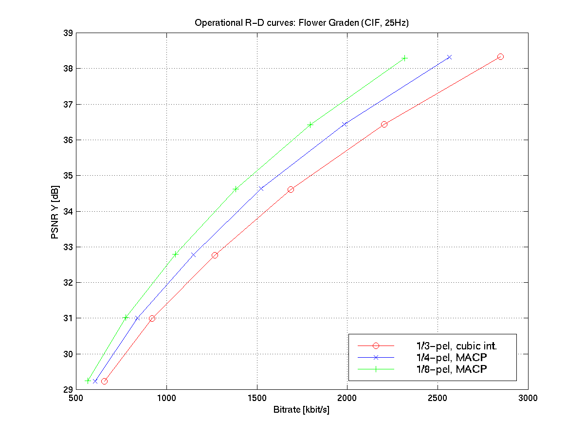

Summary

- 1/4-pel MACP, which is part of MPEG-4 Version 2, leads to a coding gain up to 1.0 dB compared to the current 1/3-pel prediction with cubic interpolation.

- 1/8-pel MACP benefits from the small block sizes of 4x4 pels and leads to an additional coding gain up to 0.8 dB compared to 1/4-pel MACP.

- An overall-gain up to 1.8 dB is obtained by 1/8-pel MACP compared to the current 1/3-pel prediction with cubic interpolation.

References

[1] G. Bjontegaard, “H.26L Test Model Long Term Number 1 (TML-1) draft 2”, ITU-T SG16/Q15, doc. Q15-H-36d1, Berlin, Aug. 99.
[2] G. Bjontegaard, “Enhancement of the Telenor proposal for H.26L,” ITU-T SG16/Q15, doc. Q15-G-25, Monterey, Feb. 99.
[3] I. Lille-Langoy et al., “Telenor H.26L proposal and software,” ITU-T SG16/Q15 doc. Q15-H-08, Berlin, Aug. 99.
[4] MPEG-4: ISO/IEC, “Final Proposed Draft Amendment 1 for ISO/IEC 14496-2”, Doc. ISO/IEC/JTC1/SC 29/WG11 N2802, Vancouver, Jul. 1999.
[5] U. Benzler, O. Werner, “Improving multiresolution motion compensating hybrid coding by drift reduction”, Picture Coding Symposium 1996, March 1996, Melbourne.
[6] R. Buschmann, “Efficiency of displacement estimation techniques”, Image Communication, 10/1997, pp. 43-61.
[7] A.V. Oppenheim, R.W. Schäfer, ”Discrete-Time Signal Processing”, Prentice Hall, ISBN 0-13-216292-X, 1989.

