ITU - Telecommunications Standardization Sector  STUDY GROUP 16  Video Coding Experts Group (Question 15)  _________________  Ninth Meeting: Red Bank, New Jersey, 19-22 October, 1999 | Document Q15-I-37  Filename: q15i37.doc  Generated: 9 Oct. ’99

Question: | Q.15/SG16
Source: | J. Shen and J. Ribas-Corbera  Sharp Labs of America  5750 NW Pacific Rim Blvd  Camas, WA 98607 | Tel:  Fax:  Email: | (360) 817-8487  (360) 817-8436  jordi@sharplabs.com
Title: | Low-complexity 1/3-pel motion estimation for H.26L
Purpose: | Information
_____________________________

1. Introduction

The current test model TML1 for H.26L [1] estimates 1/3-pel motion vectors using cubic-like interpolation for as many as seven block-size patterns at each macroblock.

In order to find the best 1/3-pel vectors, one could perform the interpolations whenever they are needed. For a given block-size pattern, since 8 motion candidates of 1/3-pel accuracy are checked around the best full-pel motion vector, the encoder would need to perform 8 cubic interpolations per pixel. Since there are seven block-size patterns, a total of up to 56 cubic interpolations would be necessary. As a result, the encoder would be very complex.

To avoid such high computation, TML1 up-samples each reference frame by 3x3 using the cubic interpolator, and the best 1/3-pel motion vectors are found by searching in the up-sampled frame. This approach requires only 8 interpolations per pixel for the up-sampling, and hence it is significantly faster than the previous method (which needed 56 interpolations per pixel). However, the drawback of this approach is that the interpolated frame is 9 times the size of the original and needs to be stored in fast or cache memory for an optimum performance. When five reference frames are considered, the memory requirements are forty-five times the size of a frame, as shown in Table 1.

 | Fast memory required in TML1
size of reference frame | 1 reference frame  (9*size) | 5 reference frames  (45*size)
qcif = 176x144 | 228 Kbytes | 1.1 Mbytes
cif = 352x288 | 912 Kbytes | 4.5 Mbytes

Table 1. Fast or cache memory requirements for current implementation in TML1

In our implementation of H26L, we compute motion vectors with 1/2-pel, bilinear accuracy, select the best block-size pattern for the macroblock using these vectors, and finally refine the vectors to 1/3-pel, cubic accuracy. We will show that this method significantly reduces the cache memory requirements and provides the additional benefit of decreasing the number and computational complexity of the interpolations. Our technique could further reduce memory requirements by storing only part of the interpolated frame at a time.

2. A low-complexity TML1

Our method can be explained in the following three steps:

- Up-sample the reference frame using bilinear interpolation (instead of TML1’s cubic-like filter) and only by 2x2 (instead of 3x3).
- At each macroblock, use 1/2-pel motion vectors to decide which is the best block-size pattern (e.g., 16x16, four 8x8, etc.)
- Do a small search (only 3 or 4 locations) around the best 1/2-pel vector to find the best 1/3 motion vector for each sub-block in the macroblock (now using TML1’s cubic-like filter). This final step is explained in more detailed in the appendix.

Table 2 compares the computation and memory requirements of the current TML1 and this new simple approach.

 | Fast memory | Interpolations  (per pixel)
TML1 | 9*size | 8 cubic
Low-complex. TML1 | 4*size | 3 bilinear + {3,4} cubic
Table 2.

Observe that the memory requirement is reduced by a factor 2.25 (i.e., 9/4) and that there are fewer and simpler interpolations.

3. Experimental Results

We performed a variety of experiments using Telenor’s test model TML1 and two variations of our approach. Specifically, we tested the following three methods :

- Telenor: The test model for H.26L.

- Telenor LC+1/2 bilinear: The low complexity version proposed in this contribution.

- Telenor LC+1/2 cubic: Same as 2, but all interpolations are cubic.

The third method was examined in order to see the loss from using bilinear interpolation for up-sampling the reference frames.

The rate-distortion performance using one reference frame on eight well-known video sequences is shown in Figures 1-8. The title of each plot indicates the name, resolution, and frame rate of the coded sequence. From these plots we conclude that our approach provides essentially no loss in PSNR quality.

In Figure 8, the PSNR of methods 2 and 3 is actually slightly higher than that of method 1. This is possible because Step 3 (in Section 2) may check motion candidates that are different from those checked by TML1.

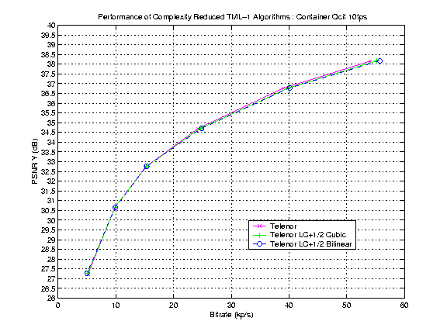
Figure 1
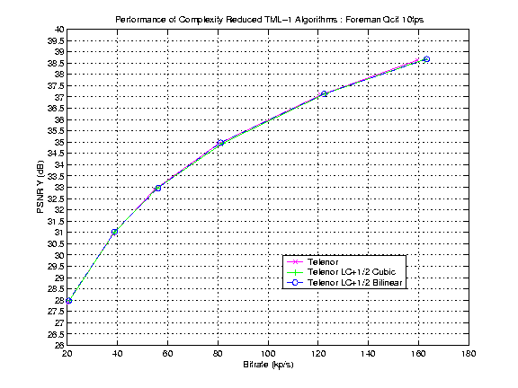
Figure 2
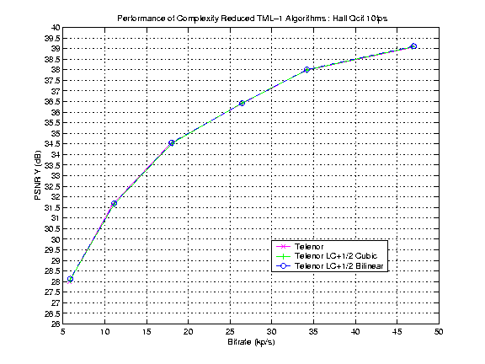
Figure 3
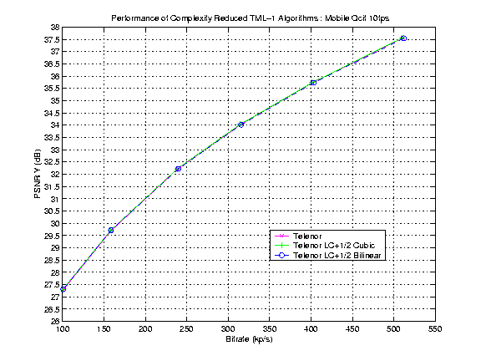
Figure 4
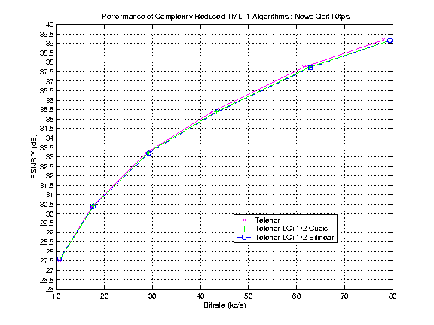
Figure 5
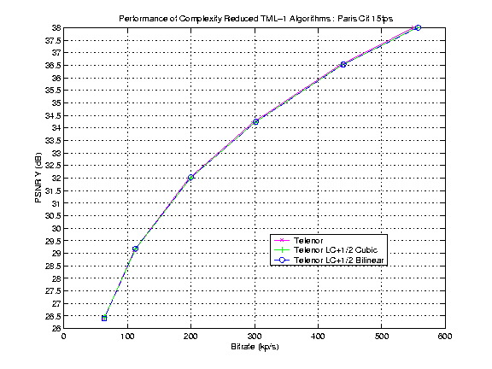
Figure 6
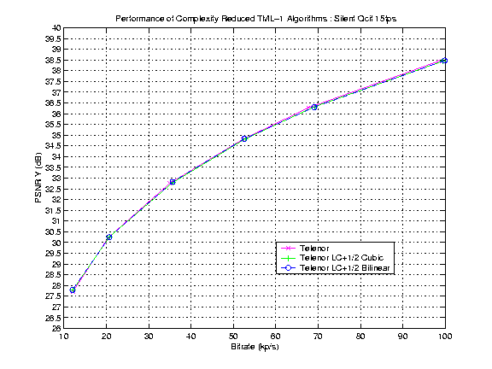
Figure 7
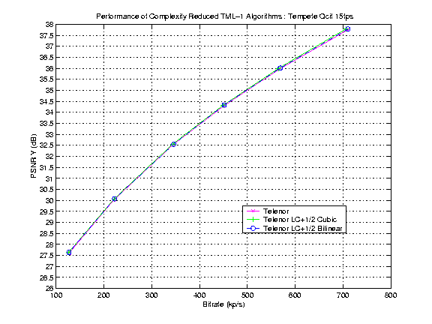
Figure 8

The plots in Figures 9-10 show the running time of each of the three methods in a Sun Ultra 10 workstation. The time was obtained from the time utility in Telenor’s TML1 codec. Observe that the computation reduction lead to savings in running time by up to 23 percent. In fact, we believe that these savings could be even larger on a regular PC, because the cache memory size is typically smaller there (an effective PC implementation is underway). We used sums and divisions (not shifts, etc.) in the bilinear interpolations, for a fair comparison.

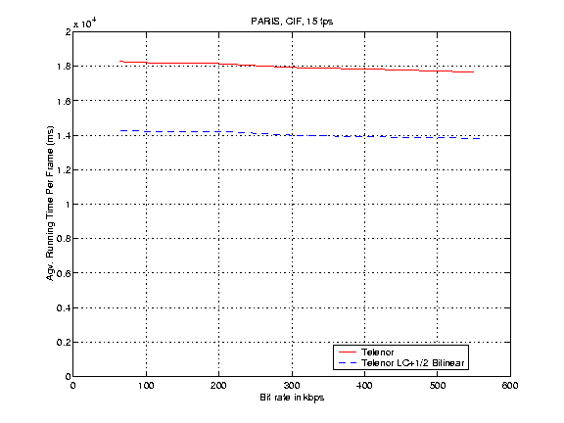
Figure 9

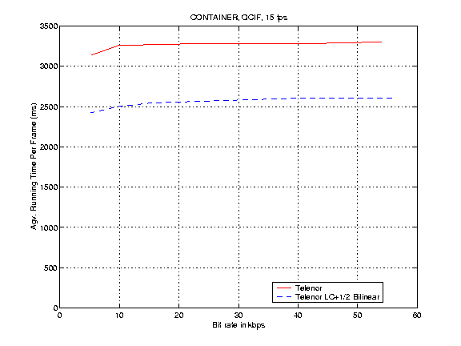
Figure 10

Finally, figures 11-12 show comparisons when using five reference frames. The PSNR loss from our approach is a little bit more (e.g., 0.1-0.2 dB), but the cache memory savings in this case are also more significant (i.e., from 45*size to 20*size). In fact, we could use more reference frames if we wanted to further improve PSNR, and we would still be using much less fast memory.

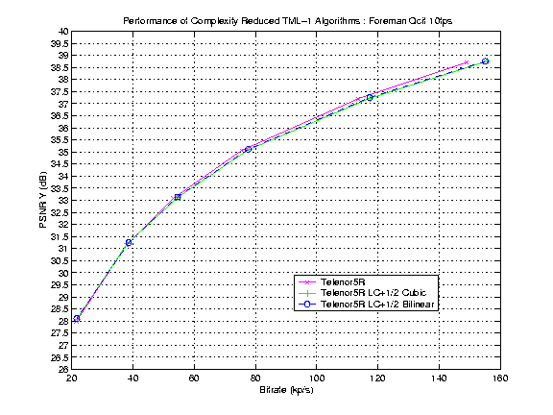
Figure 11

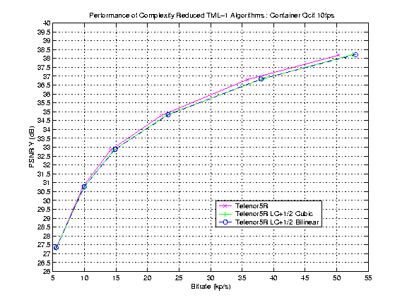
Figure 12

Finally, Figure 13 shows the savings in running time when five reference frames are used for the container video sequence. In general, since the total running time increases significantly when using multiple reference frames, the percentage of savings in running time will not be as high. Nevertheless, the savings are still significant (about 15 percent).

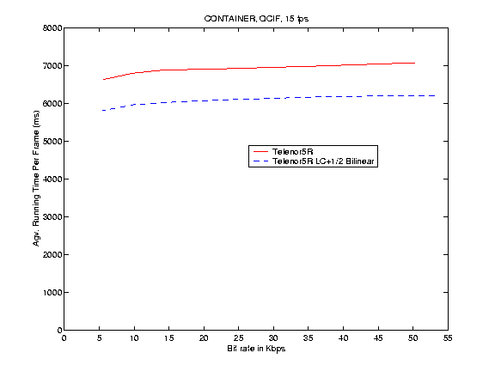
Figure 13

4. Conclusions

We have presented a new technique for implementing 1/3-pel motion estimation in the test model of H26L.

The benefits of this method are the following:

- It reduces the fast memory requirements by a factor of 2.25, i.e., from 9*framesize down to 4*framesize.

- It decreases the number of interpolations (per pixel) from 8 cubic interpolations to 3 bilinear and {3, 4} cubic interpolations.

- In a Sun Ultra 10 workstation, the running time was reduced by about 20 percent. The running time savings should increase for PC’s with lower cache memory.

- It has no or very little loss of PSNR (typically less than 0.1 dB). In one case, the PSNR was actually a little higher.

We propose to include this approach as information in the TML document and suggest to implement it as either the default or a low-complexity case in the test model software.

Appendix

This section discusses a more detailed description of Step 3 from Section 2.

Let n be the current macroblock. Imagine that Step 2 selected the block-size pattern of four 8x8 blocks for such macroblock and the best 1/2-pel motion vector for each block. In this step we refine each of these vectors into vectors of 1/3-pel accuracy. More specifically, for each block in the n-th macroblock, we check a few 1/3-pel motion vector candidates around the 1/2-pel vector and select the 1/3-pel candidate with the lowest RD cost. We consider three cases:

CASE 1: The best 1/2-pel vector is at the integer-pel location.
Check the closest three 1/3rd locations between the integer location and the 1/2-pel location with the 2nd lowest RD cost. For example:

X X X

X O X
C C C
X O2 X

Where:
X = 1/2-pel motion candidates in sub-pixel velocity space
O = best 1/2-pel motion vector (now same as integer-pel)
O2= 2nd best 1/2-pel motion vector
C = 1/3-pel locations to be checked

The best 1/3-pel motion vector is the one that has the lowest RD cost (now using the cubic-like interpolation) among O and the three C locations. When O2 is at a corner, the C locations wrap around O, e.g. :

X X X

X O C X
C C
X X O2

CASE 2: The best 1/2-pel vector is at one of the four corners.
Check the four 1/3-pel locations around O and select the best out of the four, e.g. :

X X X

X X X
C C
O X X
C C

O = best 1/2-pel motion vector
C = 1/3-pel locations to be checked

CASE 3: The best 1/2-pel vector is between two corners
Check which of the two corners has lower RD cost and check four 1/3-pel vectors between the best 1/2-pel vector and that corner. For example:

X X X

X X C O C
C C
X X A

Where:
O = best 1/2-pel motion vector
A = corner of O with lower RD cost
C = 1/3-pel locations to be checked.

References

[1] Test model TML1, ITU-T SG16/Q15, doc. Q15-H-36, Berlin, Aug. 1999.

Note that this is not straightforward though, since one must account for the motion search range, avoid delays due to data transfer, and minimize computation from repeated interpolations at the memory boundaries.
We used the version 1.0 with 7 block-size patterns.

