ITU - Telecommunications Standardization Sector Document: Q15-B-xx
STUDY GROUP 16 (Draft16 of H.263+)
Video Coding Experts Group (Q.15/16)
Title: Draft 16 Text of H.263+
Source: H.263+ Video Group
Contact: Gary J. Sullivan Voice: +1 508 623 4324
PictureTel Corp. M/S 635, 3B28 Fax: +1 508 749 2804
100 Minuteman Road Email: garys@pictel.com
Andover, MA 01810 USA
1. Changes in draft16 relative to the determined output of the Geneva SG16 meeting (draft11):
- Clarification of reference section to refer only to ITU-R Recommendation BT.601-4 “Encoding Parameters of Digital Television for Studios” as a normative reference, clarification of which aspects are defined normatively using that standard (only the color space and 8-bit integer representation), and removal of H.320 from the reference list since H.320 is not mentioned anywhere in the rest of H.263 (Gary Sullivan 4/8/97 18:24, Mike Whybray 4/9/97 11:41).
- Replacement of Figure 6 with new complete syntax diagrams (Sunriver).
- Simplification of the method for indicating the type of picture among I, P, Improved PB, B, EI, and EP, and changing the indication of SNR vs. Spatial scalability to be implicitly inferred from the picture size rather than explicitly signaled (Peter List 4/30/97 15:33, Fernando Martins 4/10/97 9:49, Torbjorn Einarsson, etc.).
- A change to the definition of the Picture Height Indication field within the Custom Picture Format specification, in order to prevent a possible start-code emulation (Q15a54, Q15a56).
- Changes to the implied picture format inference rules regarding scalability picture types to make operation the same regardless of whether separate logical channel operation or single logical channel operation is in use (Gary Sullivan 4/10/97 19:50). Further clarification to specify how mode inference rules operate in bitstreams containing a mix of pictures both with and without the use of extended PTYPE (Toshihisa Nakai 5/19/97 21:04, Gary Sullivan 5/19/97 12:06, Karl Lillevold 6/6/97 09:54, Q15a03, Q15a56).
- The CPM and SBI fields in the picture header and slice header were moved to allow proper parsing, and were added to the back-channel syntax. A QCIF restriction was removed on CPM operation, end-of-sub-bitstream codes were added, slice and GOB mixing for different sub-bitstreams was prohibited. [Ed. Note: Can an EOSBS code be mistaken for anything else, such as a slice start code?] (Gary Sullivan 7/31/97 14:42, Tom-Ivar Johansen 8/1/97 15:47, Toshihisa Nakai 8/8/97 16:19, Tom-Ivar Johansen 8/28/97 09:35, Tom-Ivar Johansen 8/29/97 15:26, Q15a46, Stephan Wenger 7/2/97 23:06, Tom-Ivar Johansen 7/7/97 13:25, Tom-Ivar Johansen 7/31/97 20:11, Tom-Ivar Johansen 8/29/97 15:26, Sunriver).
- Modification of the description of the RLNUM field to allow suppression of the RLNUM field in B pictures in which the reference layer number is equal to the enhancement layer number (Q15a24, Q15a56). [Ed. Note: The editor is not certain that the text as written is entirely clear and workable and would appreciate the close examination of this passage by the experts.] (Gary Sullivan 8/28/97 15:05, Torbjorn Einarsson 8/29/97 11:41).
- Alteration of the Reference Picture Selection Mode Flags (RPSMF) definition to prevent start code emulation after the addition of UUI field (Sunriver).
- Reduction of the maximum value of the TR_{B} field from 32 to 31 since 32 not representable (Gary Sullivan 8/26/97 17:07).
- Modification of the description of motion vector median prediction to consider the case in which MV1 is out of the slice at the left side (Akira Nakagawa 8/8/97 22:13).
- Modification of the method of round-off for half-pixel motion compensation (and Reference Picture Resampling) to use alternating-bias round-off in order to prevent artifacts from the constant bias method previously used. It was shown at the Portland meeting that reddish chroma artifacts could be produced when a) few Intra blocks were sent, and b) the quantization step size is large, and c) a continuously moving object is present in the scene. The new method was adopted for all pictures using the extended PTYPE picture header format, rather than being a separately-negotiable mode. Special treatment was given to B pictures and the B part of Improved PB pictures (Q15a35, Q15a56, Sunriver).
- Addition of a stipulation in section 5.3.2 that if an Improved PB-frame (Annex M) is indicated by MPPTYPE Bits 1-3 and Custom Source Format is indicated in OPPTYPE Bits 1-3, then MBA shall not indicate Stuffing before the first macroblock of the picture — in order to prevent a start code emulation (Q15a54, Q15a56).
- Clarification added to description of Continuous Presence Multipoint operation (Annex C) to make it clear that the sub-bitstreams of a CPM bitstream operate as completely independent H.263 bitstreams, including the mode inference rules regarding the use of the extended picture type in the picture header (Q15a46, Q15a56).
- Simplification of the motion vector range in the Unrestricted Motion Vector mode (Annex D) when PLUSPTYPE is present, so that the range of motion vectors does not depend on the motion vector prediction value. Also, as part of that change, enlarging the absolute range of motion vectors for picture sizes bigger than CIF and allowing an unlimited range if externally negotiated (Torbjorn Einarsson 7/31/97 17:46, Torbjorn Einarsson 7/31/97 15:30, Gisle Bjontegaard 8/5/97 08:42, Torbjorn Einarsson 8/6/97 16:13, Karl Lillevold 8/19/97 09:22, Matt Bace 8/19/97 13:32, Michael Chen 8/19/97 14:10, Matt Bace 8/19/97 18:10, Tom-Ivar Johansen 8/20/97 07:57, Gisle Bjontegaard 8/20/97 07:19, Sunriver).
- Addition of a cumf_MODB_M table within the Syntax-based Arithmetic Coding mode (Annex E) for use with Improved PB frames mode (Annex M) (Peter List 8/26/97 10:26).
- Modification of the macroblock type codes which can be used when the extended picture type code (PLUSPTYPE) is present and either the Advanced Prediction mode (Annex F) or the Deblocking Filter mode (Annex J) is in use, to allow a macroblock having 4V+Q. Mention of this added to section 5.3.2, along with a caveat regarding the first macroblock of a picture. This allows a step size to be changed for a macroblock which also uses four motion vectors, simplifying mode selection and rate control for some implementations. Support added in SAC model operation. (Wilson Chung 4/2/97 11:02, Guy Coté 8/22/97 12:43, Q15a23, Q15a54, Q15a56, Sunriver).
- Addition of a restriction that the new INTER4V+Q macroblock type code cannot be allowed to follow seven consecutive zeros in the bitstream as can be caused by certain values of INTRADC followed by COD=0. MCBPC stuffing when needed can be used to prevent this (Toshihisa Nakai 8/27/97 11:30, Gary Sullivan 8/27/97 13:37).
- Further editorial clarification of section F.3 OBMC description for the Advanced Prediction mode (Annex F) regarding half-pel interpolation (in response to phone calls to the editor asking for verbal clarification of the prior language).
- Clarification of section F.3 OBMC description for the Advanced Prediction mode (Annex F) regarding remote motion vector use when the Independent Segment Decoding mode (Annex R) is in use, replacing the use of the term GOB with “picture segment” [Ed. Note: Please check the editor’s interpretation on this] (Sunriver).
- A simplifying change to the “oddification” rule for the Advanced Intra Coding mode (Annex I) to fix a neglected special case (Gisle Bjontegaard 5/5/97 6:41).
- Clarification of the description of Advanced Intra Coding (Annex I) to specify that prediction always uses the same component (Y, CB, or CR) as the data being predicted.
- Clarification of sections I.2 and I.3 regarding the Advanced Intra Coding (Annex I) macroblock layer syntax and semantics (Guy Coté 8/5/97 12:30, Gary Sullivan 8/25/97 13:00).
- Addition of a clarifying note in the description of the Advanced Intra Coding mode (Annex I) to specify that the inverse quantization process for the B part of an Improved PB frame (see Annex M) is not altered by the use of the Advanced Intra Coding mode (Q15a56).
- Clarification of the meaning of the “/” operator in Advanced Intra Coding mode (Annex I) DC prediction (Toshihisa Nakai 7/16/97 14:04).
- Clarification of the meaning of the “/” operator in the Deblocking Filter mode (Annex J) to specify truncation toward zero as opposed to truncation toward minus infinity (Matt Bace 7/14/97 15:59).
- A modification of the Deblocking Filter mode (Annex J) was made to improve its subjective performance (Gisle Bjontegaard 5/5/97 17:24, 5/14/97 11:16, 5/22/97 11:59, Torbjorn Einarsson 5/9/97 18:41, Q15a03, Q15a12, Q15a56).
- Clarification of the clipd1(x, lim) function in the Deblocking Filter mode (Annex J) to specify clipping x to the range +/- abs(lim) rather than +/-lim and simplification of the comments regarding the need to specify the order of filtering (Kui Zhang 8/1/97 17:53, Karl Lillevold 8/1/97 10:50, Kui Zhang 8/2/97 11:36, Gisle Bjontegaard 8/4/97 10:29).
- Conditional addition of a second emulation prevention bit in the slice header format of the Slice Structured mode (Annex K) and in the corresponding section specifying the forward channel syntax for the Reference Picture Selection mode (Annex N) when the MBA field width is greater than 12 bits, in order to prevent a possible picture start code emulation (Q15a54, Q15a56). This was later modified to insert the second emulation prevention bit when the MBA field is greater than 11 bits (although not strictly necessary — a change needed only in Annex K since Annex N references Annex K for its definition of this syntax. Also addition of a third emulation prevention bit SEPB3 between SWI and GSBI — a change needed in both annexes (Torbjorn Einarsson 8/19/97, Toshihisa Nakai 8/21/97 17:12). Clarification of which emulation prevention bits are needed for the slice which follows the picture start code (Sunriver).
- Addition of a one-bit flag for chroma keying (Annex L) which indicates that the reference picture is to be held as the background of the current and subsequent pictures (Peter List 5/12/97 09:02, 5/13/97 11:32, Tsuhan Chen 5/12/97 10:22, 5/12/97 14:28, 5/13/97 13:04, Gary Sullivan 5/12/97 13:40, Q15a03, Q15a56).
- Fixes made for some editorial inconsistencies regarding the description of (Annex L) chroma keying information, a) “DSIZE shall be in the range of 1 to 9 (inclusive) for chroma keying information... b) for T1 and T2 two bytes to “specify [each of] the flagged thresholds, c) changed second use of Z to X’ (Toshihisa Nakai 5/19/97 21:04, Gary Sullivan 5/19/97 12:06, Q15a03, Q15a56).
- Prevention of start-code emulation after PSUPP data defined by Supplemental Enhancement Information (Annex L) caused by inclusion of new macroblock modes by changing maximum number of trailing zeros without a “Do Nothing” from 5 to 4; and clarification of e.g., “32 bits that follow” to read “four octets of PSUPP data that follow” so that the impression is not formed that these bits are contiguous in the bitstream (Gary Sullivan 8/19/97 12:06).
- Within the definition of the Supplemental Enhancement Information (Annex L) functions, the specification of five-second/five-picture timeout periods for all relevant functions. [Ed. Note: The editor encourages close examination of whether the “should” phrase in the timeout definition of chroma keying information should be replaced by “shall” and whether the concept of default or hold-over values for key colors and thresholds should be abolished.] (Joerg Ott 8/2/97 18:10, Gary Sullivan 8/4/97 10:14, Tsuhan Chen 8/6/97 01:14, Stephan Wenger 8/6/97 16:44).
- Modification of the description of decoding the B part of the Improved PB frames mode (Annex M) to add a simple predictor for the value of forward motion vector values (Q15a36, Q15a56). Initialization of this predictor to zero if no vector to the left is available (Peter List 7/31/97 14:02, Gary Sullivan 7/31/97 11:15, Karl Lillevold 8/8/97 12:19).
- Addition of a backward prediction mode with a zero motion vector to the Improved PB frames mode (Annex M). Support also added for SAC mode (Annex E) to operate with the new backward prediction (Sunriver).
- Changes to the syntax for back-channel data in section N.4.2 of the Reference Picture Selection mode (Annex N) to improve parsing ability and stuffing behavior (Toshihisa Nakai 3/12/97 18:38, also 5/14/97 14:58).
- Change to the Back-Channel message Indication BCI field for the Reference Picture Selection mode (Annex N) in Annex N and section 5.1.16, in order to prevent start code emulation. Modification of the Temporal Reference for Prediction TRP field to a constant 10 bits. Addition of emulation prevention bits. Addition of Temporal Reference TR field for improved error detection (Toshihisa Nakai 5/23/97 14:24, Q15a03, Q15a28, Q15a56).
- Liberalizing the description of the decoder frame storage policy in Reference Picture Selection mode (Annex N) to allow for future extensibility (Stephan Wenger 7/4/97, Toshihisa Nakai 7/12/97 11:25, Toshihisa Nakai 8/7/97 20:26, Stephan Wenger 8/22/97 19:55, Toshihisa Nakai 8/27/97 07:04).
- Addition of a couple of sentences to the decoder processing section of the Reference Picture Selection mode (Annex N) to tersely describe the use of “Video Redundancy Coding” (Sunriver).
- Changes to Annex O where it says ELNUM and RLNUM “are not present” in I and P pictures to “shall not be present,” and adding clarification to Annex O indicating that a custom picture format must be used for a spatial scalability enhancement layer for a base-layer bitstream of SQCIF format (Toshihisa Nakai 5/19/97 21:04, Gary Sullivan 5/19/97 12:06, Q15a03, Q15a56).
- Alteration of Annex O to state in O.4.3 and O.4.4 that CBPC and CBPY are present only if indicated by MBTYPE. Added discussion of desirability of deblocking filter for B pictures in Annex O. (Peter List 6/3/97 11:27, Gisle Bjontegaard 6/3/97 13:10, Q15a03, Q15a56).
- Alteration of Annex O to allow motion vectors over picture boundaries in all B and EP pictures (Peter List 6/4/97 16:37, Karl Lillevold 6/5/97 08:45, Torbjorn Einarsson 6/5/97 18:13, Q15a03, Q15a56).
- Editorial correction of the column header in Table O.3 of Annex O from MBTYPE to MCBPC (Carrson Fung 7/3/97 11:46, Karl Lillevold 7/3/97 09:10).
- Alteration of the VLC code for MCBPC in EI pictures in Table O.3 of Annex O to prevent start code emulation caused by having way too many leading zeros (Torbjorn Einarsson 8/19/97 16:44, Gary Sullivan 8/28/97 18:37, Torbjorn Einarsson 8/29/97 13:33).
- Alteration of Annex O to change the forward, backward, and bi-directional “skipped” macroblock types in B pictures to specify that a motion vector is sent, but no difference-data coefficients are sent (Torbjorn Einarsson 6/5/97 18:13, Q15a03, Q14a21, Q15a56).
- Alteration of Annex O to simplify the description regarding the disposable nature of B pictures, to clarify that an EI picture may be upward predicted from a P picture, and that an EP picture may be upward predicted from an I picture (Q15a24, Q15a56).
- Clarification of Annex O to state that a PB or Improved PB frame may occur in the base layer of a scalable bitstream (Q15a56).
- Renaming of some Annex O macroblock prediction codes to distinguish between “skipped” meaning COD=1 and “no texture” meaning motion but no texture. Also addition of an “index” column to Annex O VLC tables (Peter List 7/3/97 13:43, Peter List 7/31/97 14:14).
- Alteration of layer numbering for Temporal, SNR, and Spatial Scalability (Annex O) so that base layer is number 1, in order to prevent start code emulation in the picture header (Torbjorn Einarsson 8/19/97 16:44).
- Replacement of the FLC for CBPY in Annex O by use of the VLC defined elsewhere for CBPY, preventing start code emulation (Torbjorn Einarsson 8/19/97 16:44, Torborn Einarsson 8/29/97 13:33, Gary Sullivan 8/29/97 14:20). Later refinement of this definition to specify that bi-directionally predicted macroblocks in EP pictures should use the INTRA definition for CBPY (Q15b22, Sunriver).
- Addition of 1-D spatial scalability to the Temporal, SNR, and Spatial Scalability mode (Annex O) (Q15b30, Sunriver).
- A new method of performing bilinear frame warping for the Reference Picture Resampling mode (Annex P), using a “virtual frame” warp technique was adopted to reduce the computational requirements of the decoder (Q15a34, Q15a56, Q15b11, Sunriver).
- Syntax change to Reference Picture Resampling mode (Annex P) to use new table defined in Unrestricted Motion Vector mode (Annex D) Table D.3 so that one table could be eliminated, and changes for start code emulation prevention (Sunriver).
- Clarification added to state that in the Reference Picture Resampling mode (Annex P), the reference picture used by a B picture should not be one that has been resampled for use by a temporally-subsequent P or EP picture. Further clarification added to correct list of which types of picture that the RPR mode can be applied to and how and whether the warping parameters and RPR bit are sent in these pictures (Miska Hannuksela 5/16/97 15:37, Gary Sullivan 5/15/97 15:16, Q15a03, Q15a56).
- Clarification of the definition of Reference Picture Resampling mode (Annex P) to visually distinguish between the use of the “/” operator which is normally defined to use truncation toward zero and the operation used in this annex which uses truncation toward minus infinity. The special operator used in Annex P is now called the “///” operator.
- Fixing start code emulation in Reference Picture Resampling mode (Annex P) by swapping two values of fill_mode and inserting emulation prevention bits prior to fill color fields. Also giving WPCODE+WPVLC a larger range of values since these represent only half-integer offsets (Torbjorn Einarsson 8/19/97 16:44, Gary Sullivan 8/27/97 19:03).
- Clarification of the definition of Reduced Resolution Update mode (Annex Q) to more properly define the use of the “/” operator where it occurs.
- Alteration of the application to the Reduced Resolution Updated mode (Annex Q) of the Deblocking Filter mode (Annex J), such that STRENGTH is infinite when RRU and DF are used together, which simplifies and perceptually improves the result (Sunriver).
- Editorial change to replace all occurrences of “Independently Segmented Decoding” (Annex R) with “Independent Segment Decoding” (Sunriver).
- A problem was pointed out by Yi-Tong Tse and discussed by Gary Sullivan regarding the ability of the decoder to know the shape of a picture segment in Independent Segment Decoding mode (Annex R) prior to the parsing of the entire picture segment bitstream. This affects motion compensation segment extrapolation and also upward prediction using spatial scalability. The group also decided in Sunriver to restrict ISD segmentation shapes to be essentially rectangular in order to simplify ISD operation. The group also decided in Sunriver to prohibit the use of the ISD mode with the use of the Slice Structured mode (Annex K) unless the Rectangular Slice submode of the Slice Structured mode is also in use to prevent strange extrapolation rules and conditions. (Yi-Tong Tse 7/7/97 13:47, Gary Sullivan 7/14/97 11:56, Toshihisa Nakai 7/16/97 14:50, Niko Faerber 7/16/97 11:19, Gary Sullivan 7/16/97 11:13, Samson Cheung 7/16/97 12:41, Niko Faerber 7/17/97 09:34, Q15b11, Sunriver).
- Clarification to ensure that when in Independent Segment Decoding mode (Annex R), the block boundary filter operation specified in the Reduced Resolution Update mode (Annex Q) is not applied across the picture segment boundaries (Akira Nakagawa 8/27/97 17:57).
- Addition to the Alternative Inter VLC mode (Annex S) definition of a more efficient definition of the CBPY encoding method, using INTRA CBPY VLC encoding when CBPC = “11” (Sunriver).
- Alteration of the description of the chrominance quantization part of the Modified Quantization mode (Annex T) to specify that QUANT_C (rather than QUANT) shall be used for the application of the deblocking filter to the chrominance coefficients (editorial note in prior draft, Gisle Bjontegaard 6/3/97 14:52, Q15a03, Q15a56).
- Alteration of the Modified Quantization mode (Annex T) to define a more moderate relationship between the step size used for luminance and chrominance quantization (Q15a03, Q15a40, Q15a56).
- Alteration of the Modified Quantization mode (Annex T) to rotate coefficient value words by one additional bit, in order to prevent start code emulation (Q15a54, Q15a56).
- Alteration of the DQUANT table in the Modified Quantization mode (Annex T) to provide more conservative changes in step size for larger QUANT values and to allow QUANT to reach precisely 31 using only a number of two bit DQUANT steps from any starting value of QUANT (Peter List 8/18/97 16:45, Torbjorn Einarsson 8/19/97 11:44, Q15b11, Q15b68, Sunriver).
- Addition of a non-normative Appendix describing Recommended Optional Mode Enhancement (Appendix III) (Q15a56, Q15a57, Q15b04, Q15b53, Q15b69, Sunriver).
- In Sunriver, the group decided to try to capture in some form a prior understanding reached at the Nice meeting (which was intended to have been placed in H.245 or H.324 or some other higher-level standard, but which was apparently lost) which involved requiring support for smaller standard picture formats at equivalent or higher frame rates when custom picture formats are supported. This has been incorporated into the text as part of Appendix III. [Ed. Note: The editor seeks the advice of the experts as to whether this ought to appear as normative rather than simply advisory content. His prior understanding from the Nice meeting was that it was expected to be a normative terminal requirement. Whether that translates into a normative video standard requirement or not is an open question, but it does not appear to have been adopted in any form in any terminal requirements.] (Sunriver).
2. Other comments on editorial status
- The syntax diagrams of Figure 6 are missing BCPM and label BSBI as GSBI. The editor asks the experts to check the definition and use of BCPM and BSBI.
- The editor is considering changing “intra” and “inter” to “INTRA” and “INTER” in all cases, as in the previous Recommendation, since the text is not currently consistent in this regard.
- The editor needs to check his notes to ensure that no additional decisions reached at Sunriver have been left out.
- The editor thinks the draft would still benefit from a few good linear read-throughs by the right people.
3. Summary of New “H.263+” Extension Features
These revisions add optional features to Recommendation H.263 in order to broaden its range of useful application and to improve its compression performance. The additional optional feature set can be summarized in terms of the new types of pictures it can use, the new coding modes which can be applied to those pictures, and the definition of backward-compatible supplemental enhancement information which can be added into the video bitstream.
3.1. New types of pictures
3.1.1. Scalability pictures

Scalable video coding has potential for improving the delivery of video in error-prone, packet-loss-ridden, and heterogenous networks. It allows the video bitstream to be separated into multiple logical channels, so that some data can be lost or discarded without irreparable harm to the video representation. Three types of scalability pictures were added in this revision, one which provides temporal scalability and two which provide SNR or Spatial scalability:

- B: A picture having two reference pictures, one of which temporally precedes the B picture and one of which is temporally subsequent to the B picture;
- EI: A picture having a temporally simultaneous reference picture; and
- EP: A picture having two reference pictures, one of which temporally precedes the EP picture and one of which is temporally simultaneous.
3.1.2. Improved PB frames
The existing Recommendation H.263 contains a special frame type called a “PB frame”, which enables an increase in perceived frame rate with only a moderate increase in bit rate. However, recent investigations have indicated that the PB-frame as it exist is not sufficiently robust for continual use. Encoders wishing to use PB frames are limited in the types of prediction that a PB frame can use, which results in a lack of usefulness for PB frames in some situations. An improved, more robust type of PB frame has been added to enable heavier, higher-performance use of the PB frame design. It is a small modification of the existing PB frames mode.
3.1.3. Custom Source Formats
The existing Recommendation H.263 is very limited in the types of video input to which it can be applied. It allows only five video source formats defining the picture size, picture shape, and picture clock frequency. The new H.263+ feature set allows a wide range of optional custom source formats in order to make the standard apply to a much wider class of video scenes. These modifications help make the standard respond to the new world of resizable computer window-based displays, high refresh-rates, and wide format viewing screens.
3.2. New coding modes
This set of optional extensions of the H.263 video coding syntax also includes nine new coding modes that can be applied to the pictures in the bitstream:
- Advanced Intra Coding (AIC): A mode which improves the compression efficiency for Intra macroblock encoding by using spatial prediction of DCT coefficient values;
- Deblocking Filter (DF): A mode which reduces the amount of block artifacts in the final image by filtering across block boundaries using an adaptive filter;
- Slice Structured (SS): A mode which allows a functional grouping of a number of macroblocks in the picture, enabling improved error resilience, improved transport over packet networks, and reduced delay;
- Reference Picture Selection (RPS): A mode which improves error resilience by allowing a temporally previous reference picture to be selected which is not the most recent encoded picture that can be syntactically referenced;
- Reference Picture Resampling (RPR): A mode which allows a resampling of a temporally previous reference picture prior to its use as a reference for encoding, enabling global motion compensation, predictive dynamic resolution conversion, predictive picture area alteration and registration, and special-effect warping;
- Reduced-Resolution Update (RRU): A mode which allows an encoder to maintain a high frame rate during heavy motion by encoding a low-resolution update to a higher-resolution picture while maintaining high resolution in stationary areas;
- Independent Segment Decoding (ISD): A mode which enhances error resilience by ensuring that corrupted data from some region of the picture cannot cause propagation of error into other regions;
- Alternative Inter VLC (AIV): A mode which reduces the number of bits needed for encoding predictively-coded blocks when there are many large coefficients the block; and
- Modified Quantization (MQ): A mode which improves the control of the bit rate by changing the method for controlling the quantizer step size on a macroblock basis, reduces the prevalence of chrominance artifacts by reducing the step size for chrominance quantization, increases the range of representable coefficient values for use with small quantizer step sizes, and increases error detection performance and reduces decoding complexity by prohibiting certain unreasonable coefficient representations.
3.3. Supplemental Enhancement Information
This revision also allows the addition of supplemental enhancement information to the video bitstream. Although this information does not affect the semantics for decoding the bitstream, it can enable enhanced features for systems which understand the optional additional information (while being discarded harmlessly by systems that do not understand it). This allows a variety of picture freeze and release commands, tagging information associated synchronously with the pictures in the bitstream for external use, and video transparency by use of chroma key information.

 | INTERNATIONAL TELECOMMUNICATION UNION

ITU-T DRAFT H.263
TELECOMMUNICATION (18 September, 1997)
STANDARDIZATION SECTOR
OF ITU

LINE TRANSMISSION
OF NON-TELEPHONE SIGNALS

VIDEO CODING
FOR LOW BITRATE COMMUNICATION

DRAFT ITU-T Recommendation H.263

* Contact Person: Gary J. Sullivan Tel: +1 508 623 4324

PictureTel Corporation Fax: +1 508 749 2804
100 Minuteman Rd. Email: garys@pictel.com
Andover, MA, 01810 USA

FOREWORD
The ITU Telecommunication Standardization Sector (ITU-T) is a permanent organ of the International Telecommunication Union. The ITU-T is responsible for studying technical, operating and tariff questions and issuing Recommendations on them with a view to standardizing telecommunications on a worldwide basis.
The World Telecommunication Standardization Conference (WTSC), which meets every four years, established the topics for study by the ITU-T Study Groups which, in their turn, produce Recommendations on these topics.
ITU-T Recommendation H.263 was prepared by the ITU-T Study Group 15 (199x-199x) and was approved by the WTSC (Place, Month xx-xx, 199x).

___________________

NOTES

© ITU 199x
All rights reserved. No part of this publication may be reproduced or utilized in any form or by any means, electronic or mechanical, including photocopying and microfilm, without permission in writing from the ITU.

CONTENTS
Page
1. Scope
2. References
3. Brief Specification
3.1. Video input and output
3.2. Digital output and input
3.3. Sampling frequency
3.4. Source coding algorithm
3.5. Bit rate
3.6. Buffering
3.7. Symmetry of transmission
3.8. Error handling
3.9. Multipoint operation
4. Source Coder
4.1. Source format
4.2. Video source coding algorithm
4.3. Coding control
4.4. Forced updating
4.5. Byte alignment of start codes
5. Syntax and Semantics
5.1. Picture layer
5.2. Group of Blocks Layer
5.3. Macroblock layer
5.4. Block layer
6. Decoding process
6.1. Motion compensation
6.2. Coefficients decoding
6.3. Reconstruction of blocks
Annex A. Inverse transform accuracy specification
Annex B. Hypothetical Reference Decoder
Annex C. Considerations for Multipoint
Annex D. Unrestricted Motion Vector mode
D.1. Motion vectors over picture boundaries
D.2. Extension of the motion vector range
Annex E. Syntax-based Arithmetic Coding mode
E.1. Introduction
E.2. Specification of SAC encoder
E.3. Specification of SAC decoder
E.4. Syntax
E.5. PSC_FIFO
E.6. Fixed Length Symbols
E.7. Non-Fixed Length Symbols
E.8. SAC Models
Annex F. Advanced Prediction mode
F.1. Introduction
F.2. Four motion vectors per macroblock
F.3. Overlapped motion compensation for luminance
Annex G. PB-frames mode
G.1. Introduction.
G.2. PB-frames and INTRA blocks
G.3. Block Layer
G.4. Calculation of vectors for the B-picture in a PB-frame
G.5. Prediction of a B-block in a PB-frame
Annex H. Forward Error Correction for coded video signal
H.1. Introduction
H.2. Error correction framing
H.3. Error correcting code
H.4. Relock time for error corrector framing
Annex I. Advanced Intra Coding mode
I.1. Introduction
I.2. Syntax
I.3. Decoding Process
Annex J. Deblocking Filter Mode
J.1. Introduction
J.2. Relation to UMV and AP modes (Annexes D and F)
J.3. Definition of the deblocking edge filter
Annex K. Slice Structured Mode
K.1. Introduction
K.2. Structure of slice layer
Annex L. Supplemental Enhancement Information Specification
L.1. Introduction
L.2. PSUPP Format
L.3. Do Nothing
L.4. Full-Picture Freeze Request
L.5. Partial-Picture Freeze Request
L.6. Resizing Partial-Picture Freeze Request
L.7. Partial-Picture Freeze-Release Request
L.8. Full-Picture Snapshot Tag
L.9. Partial-Picture Snapshot Tag
L.10. Video Segment Start Tag
L.11. Video Segment End Tag
L.12. Progressive Refinement Segment Start Tag
L.13. Progressive Refinement Segment End Tag
L.14. Chroma Keying Information
L.15. Extended Function Type
Annex M. Improved PB-frames mode
M.1. Introduction
M.2. B_{PB}-frame prediction modes
M.3. Calculation of vectors for bidirectional prediction of a the B-macroblock
M.4. MODB table
Annex N. Reference Picture Selection Mode
N.1. Introduction
N.2. Video source coding algorithm
N.3. Channel for Back-Channel messages
N.4. Syntax
N.5. Decoder Process
Annex O. Temporal, SNR, and Spatial Scalability Mode
O.1. Overview
O.2. Transmission order of pictures
O.3. Picture Layer Syntax
O.4. Macroblock Layer Syntax
O.5. Motion vector decoding
O.6. Interpolation filters
Annex P. Reference Picture Resampling
P.1. Introduction
P.2. Syntax
P.3. Resampling algorithm
P.4. Example of implementation
P.5. Factor-of-4 resampling
Annex Q. Reduced-Resolution Update Mode
Q.1. Introduction
Q.2. Decoding Procedure
Q.3. Extension of Referenced Picture
Q.4. Reconstruction of motion vectors
Q.5. Enlarged overlapped motion compensation for luminance
Q.6. Upsampling of the reduced-resolution reconstructed prediction error
Q.7. Block boundary filter
Annex R. Independent Segment Decoding Mode
R.1. Introduction
R.2. Mode Operation
R.3. Constraints on Usage
Annex S. Alternative Inter VLC Mode
S.1. Introduction
S.2. Alternative INTER VLC for coefficients
S.3. Alternative INTER VLC for CBPY
Annex T. Modified Quantization Mode
T.1. Introduction
T.2. Modified DQUANT Update
T.3. Altered quantization step size for chrominance coefficients
T.4. Modified coefficient range
T.5. Usage Restrictions
Appendix I List of patent holders
Appendix II Error Tracking
Appendix III Recommended Optional Mode Enhancement
III.1. Introduction
III.2. Levels of Preferred Mode Support
III.3. Picture Formats and Picture Clock Frequencies

Summary
This Recommendation specifies a coded representation that can be used for compressing the moving picture component of audio-visual services at low bitrates. The basic configuration of the video source coding algorithm is based on ITU-T Recommendation H.261 and is a hybrid of inter-picture prediction to utilize temporal redundancy and transform coding of the remaining signal to reduce spatial redundancy. The source coder can operate on five standardized video source formats: sub-QCIF, QCIF, CIF, 4CIF and 16CIF, and can also operate using a broad range of custom video formats.
The decoder has motion compensation capability, allowing optional incorporation of this technique in the coder. Half pixel precision is used for the motion compensation, as opposed to Recommendation H.261 where full pixel precision and a loopfilter are used. Variable length coding is used for the symbols to be transmitted.
In addition to the basic video source coding algorithm, fifteen negotiable coding options are included for improved compression performance and the support of additional capabilities. Additional supplemental information may also be included in the bitstream for enhanced display capability and for external usage.
Recommendation H.263
Video coding for LOW BITRATE communication
(Place, 199x)

1. Scope
This Recommendation specifies a coded representation that can be used for compressing the moving picture component of audio-visual services at low bitrates. The basic configuration of the video source coding algorithm is based on ITU-T Recommendation H.261. Fifteen negotiable coding options are included for improved performance
and increased functionality. This Recommendation contains Version 2 of Recommendation H.263, which is fully compatible with the original Recommendation, adding only optional features to the original Version 1 content of the Recommendation.

2. References
The following ITU-R Recommendations contain provisions which, through reference in this text, constitute provisions of this Recommendation. At the time of publication, the editions indicated were valid. All Recommendations and other references are subject to revision; all users of this Recommendation are therefore encouraged to investigate the possibility of applying the most recent edition of the Recommendations and other references listed below. A list of the currently valid ITU-R Recommendations is regularly published.
[1] ITU-R Recommendation BT.601-4 (199x): “Encoding Parameters of Digital Television for Studios”
Reference [1] is normatively referenced herein to define the (Y, CB, CR) color space and its 8-bit integer representation for pictures used by video codecs designed according to this Recommendation. (Reference [1] is not used to define any other aspects of this Recommendation.)
The following additional ITU-T Recommendations are mentioned for illustration purposes in this text, however they do not constitute provisions of this Recommendation. At the time of publication, the editions indicated were valid. All Recommendations and other references are subject to revision; all users of this Recommendation are therefore encouraged to investigate the possibility of applying the most recent edition of the Recommendations and other references listed below. A list of the currently valid ITU-T Recommendations is regularly published.
[2] ITU-T Recommendation H.223 (199x): "Multiplexing protocol for low bitrate multimedia communication"
[3] ITU-T Recommendation H.242 (199x): "System for establishing communication between audiovisual terminals using digital channels up to 2 Mbit/s"
[4] ITU-T Recommendation H.245 (199x): "Control protocol for multimedia communication"
[5] ITU-T Recommendation H.261 (199x): "Video codec for audiovisual services at px64 kbit/s"
[6] ITU-T Recommendation H.262 (199x): "Generic coding of moving pictures and associated audio: video" (ISO/IEC 13818-2)

[7] ITU-T Recommendation H.324 (199x): "Terminal for low bitrate multimedia communication"

3. Brief Specification
An outline block diagram of the codec is given in Figure 1.

3.1. Video input and output
To permit a single Recommendation to cover use in and between regions using 625- and 525-line television standards, the standardized source format on which the source coder operates is based on a common intermediate format (CIF). It is also possible using external negotiation (for example Recommendation H.245), to enable the use of a wide range of optional custom source formats. The standards of the input and output television signals, which may, for example, be composite or component, analogue or digital and the methods of performing any necessary conversion to and from the source coding format are not subject to recommendation.

3.2. Digital output and input
The video coder provides a self-contained digital bit stream which may be combined with other multi-facility signals (for example as defined in Recommendation H.223). The video decoder performs the reverse process.

3.3. Sampling frequency
Pictures are sampled at an integer multiple of the video line rate. This sampling clock and the digital network clock are asynchronous.
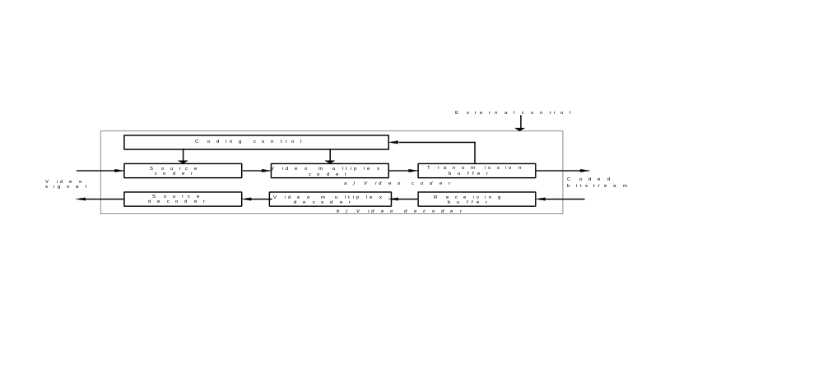
FIGURE 1/H.263
Outline block diagram of the video codec

3.4. Source coding algorithm
A hybrid of inter-picture prediction to utilize temporal redundancy and transform coding of the remaining signal to reduce spatial redundancy is adopted. The decoder has motion compensation capability, allowing optional incorporation of this technique in the coder. Half pixel precision is used for the motion compensation, as opposed to Recommendation H.261 where full pixel precision and a loopfilter are used. Variable length coding is used for the symbols to be transmitted.
In addition to the core H.263 coding algorithm, fifteen negotiable coding options can be used, either together or separately (subject to certain restrictions). Additional supplemental information may also be included in the bitstream for enhanced display capability and for external usage. The negotiable coding options and the supplemental information syntax and semantics are described in the subsequent subsections.

3.4.1. Unrestricted Motion Vector mode
In this optional mode motion vectors are allowed to point outside the picture. The edge pixels are used as prediction for the “non-existing” pixels. With this mode a significant gain is achieved if there is movement across the edges of the picture, especially for the smaller picture formats (see also Annex D). Additionally, this mode includes an extension of the motion vector range so that larger motion vectors can be used. This is especially useful in case of camera movement and large picture formats.

3.4.2. Syntax-based Arithmetic Coding mode
In this optional mode arithmetic coding is used instead of variable length coding. The SNR and reconstructed pictures will be the same, but significantly fewer bits will be produced (see also Annex E).

3.4.3. Advanced Prediction mode
In this optional mode overlapped block motion compensation (OBMC) is used for the luminance part of P-pictures (see also Annex F). Four 8x8 vectors instead of one 16x16 vector are used for some of the macroblocks in the picture. The encoder has to decide which type of vectors to use. Four vectors use more bits, but give better prediction. The use of this mode generally gives a considerable improvement. A subjective gain is achieved because OBMC results in less blocking artifacts.

3.4.4. PB-frames mode
A PB-frame consists of two pictures being coded as one unit. The name PB comes from the name of picture types in Recommendation H.262 where there are P-pictures and B-pictures. Thus a PB-frame consists of one P-picture which is predicted from the previous decoded P-picture and one B-picture which is predicted from both the previous decoded P-picture and the P-picture currently being decoded. The name B-picture was chosen because parts of B-pictures may be bidirectionally predicted from the past and future pictures. With this coding option, the picture rate can be increased considerably without substantially increasing the bitrate (see also Annex G). However, an Improved PB frames mode is also provided (see also Annex M). The original PB frames mode is retained herein only for purposes of compatibility with systems made prior to the adoption of the Improved PB frames mode.

3.4.5. Advanced Intra Coding mode
In this optional mode, intra blocks are first predicted from neighboring intra blocks prior to coding (see also Annex I). Separate variable length code (VLC) tables are defined for the intra blocks. The technique is applied to intra-macroblocks within intra-frames and to intra-macroblocks within inter-frames. This mode significantly improves the compression performance over the intra coding of the core H.263 syntax.

3.4.6. Deblocking Filter mode
In this optional mode, a filter is applied across the 8x8 block edge boundaries of decoded I- and P-pictures to reduce blocking artifacts (see also Annex J). The purpose of the filter is to mitigate the occurrence of block edge artifacts in the decoded picture. The filter affects the picture that is used for the prediction of subsequent pictures and thus lies within the motion prediction loop.

3.4.7. Slice Structured mode
In this optional mode, a “slice” layer is substituted for the GOB layer of the bitstream syntax (see also Annex K). The purposes of this mode are to provide enhanced error resilience capability, to make the bitstream more amenable to use with an underlying packet transport delivery, and to minimize video delay. A slice is similar to a GOB, in that it is a layer of the syntax that lies between the picture layer and the macroblock layer. However, the use of a slice layer allows a flexible partitioning of the picture, in contrast with the fixed partitioning and fixed transmission order required by the GOB structure.

3.4.8. Supplemental Enhancement Information
Additional supplemental information may be included in the bitstream to signal enhanced display capability or to provide information for external usage (see also Annex L). This supplemental information can be used to signal a full-picture or partial-picture freeze or freeze-release request with or without resizing, can also be used to tag particular pictures or picture sequences within the video stream for external usage, and can be used to convey chroma key information for video compositing. The supplemental information may be present in the bitstream even though the decoder may not be capable of providing the enhanced capability to use it, or even to properly interpret it — simply discarding the supplemental information is allowable by decoders unless a requirement to provide the requested capability has been negotiated by external means.

3.4.9. Improved PB-frames mode
This optional mode represents an improvement compared to the PB-frames mode option (see also annexes G and M). The main difference between the two modes is that in the Improved PB-frames mode, each B-block may be forward predicted using a separate motion vector or backward predicted with a zero vector. This significantly improves coding efficiency in situations in which downscaled P-vectors are not good candidates for B-prediction. The backward prediction is particularly useful when there is a scene cut between the previous P-frame and the BPB-frame.

3.4.10. Reference Picture Selection mode
An optional mode is provided which improves the performance of real-time video communication over error-prone channel by allowing temporal prediction from pictures other than the most recently-sent reference picture (see also Annex N). This mode can be used with back-channel status messages which are sent back to the encoder to inform it about whether its bitstream is being properly received. In error-prone channel environments, this mode allows the encoder to optimize its video encoding for the conditions of the channel.

3.4.11. Temporal, SNR and Spatial Scalability mode
In this optional mode there is support for temporal, SNR, and spatial scalability (see also Annex O). Scalability implies that a bitstream is composed of a base layer and one or more associated enhancement layers. The base layer is a separately decodable bitstream. The enhancement layers can be decoded in conjunction with the base layer to increase perceived quality by either increasing the picture rate, increasing the picture quality, or increasing the picture size. SNR scalability refers to enhancement information to increase the picture quality without increasing picture resolution. Spatial scalability refers to enhancement information to increase the picture quality by increasing picture resolution either horizontally, vertically, or both. There is also support for temporal scalability by the use of B pictures. A B picture is a scalability enhancement containing pictures that can be bi-directionally predicted from two pictures in a reference layer, one temporally previous to the current picture and one temporally subsequent. B pictures allows enhancement layer information to be used to increase perceived quality by increasing the picture rate of the displayed enhanced video sequence. This mode can be useful for heterogenous networks with varying bandwidth capacity and also in conjunction with error correction schemes.

3.4.12. Reference Picture Resampling mode
A syntax is provided for supporting an optional mode for which the reference picture used for video image prediction is processed by a resampling operation prior to its use in forming a predictor for the current input picture (see also Annex P). This allows efficient dynamic selection of an appropriate image resolution for video encoding, and can also support picture warping for use as a global motion compensator or special-effect generator.

3.4.13. Reduced-Resolution Update mode
An optional mode is provided which allows reduced resolution updates to a reference picture having a higher resolution (see also Annex Q). This mode is expected to be used when encoding a highly active scene, and allows an encoder to increase the picture rate at which moving parts of a scene can be represented, while maintaining a higher resolution representation in more static areas of the scene.

3.4.14. Independent Segment Decoding mode
An optional mode is provided which allows a picture to be constructed without any data dependencies which cross GOB or multi-GOB picture segments or slice boundaries (see also Annex R). This mode provides error robustness by preventing the propagation of erroneous data across the boundaries of the picture segment areas.

3.4.15. Alternative Inter VLC mode
An optional mode is provided which improves the efficiency of Inter picture coding when significant changes are evident in the picture (see also Annex S). This efficiency improvement is obtained by allowing a VLC code originally designed for Intra pictures to be used for some Inter picture coefficients as well.

3.4.16. Modified Quantization mode
An optional mode is provided which improves the bit-rate control ability for encoding, reduces chrominance quantization error, expands the range of representable DCT coefficients, and places certain restrictions on coefficient values (see also Annex T). This mode modifies the semantics of the differential quantization step size parameter of the bitstream by broadening the range of step size changes that can be specified. It also reduces the quantization step size used for chrominance data. The range of DCT coefficient levels is broadened to ensure that any possible coefficient value can be encoded to within the accuracy allowed by the step size. Certain restrictions are also placed on coefficients in this mode to increase error detection performance and minimize decoder complexity.

3.5. Bit rate
The transmission clock is provided externally. The video bitrate may be variable. In this Recommendation no constraints on the video bitrate are given; constraints will be given by the terminal or the network.

3.6. Buffering
The encoder shall control its output bitstream to comply with the requirements of the hypothetical reference decoder defined in Annex B. Video data shall be provided on every valid clock cycle. This can be ensured by MCBPC stuffing (see Tables 7 and 8) or, when forward error correction is used, also by forward error correction stuffing frames (see Annex H).
The number of bits created by coding any single picture shall not exceed a maximum value specified by the parameter BPPmaxKb which is measured in units of 1024 bits. The minimum allowable value of the BPPmaxKb parameter depends on the largest picture size that has been negotiated for use in the bitstream (see Table 1). The picture size is measured as the picture width times height for the luminance (Y) component, measured in pixels. An encoder may use a larger value for BPPmaxKb than as specified in Table 1, provided the larger value is first negotiated by external means, for example Recommendation H.245.
When the Temporal, SNR, and Spatial Scalability mode (Annex O) is employed, the number of bits sent for each picture in each enhancement layer shall not exceed the maximum value specified by BPPmaxKb.
TABLE 1/H.263
Minimum BPPmaxKb for different source picture formats
Y Picture Size in Pixels | Minimum BPPmaxKb
up to 25,344 (or QCIF) | 64
25,360 to 101,376 (or CIF) | 256
101,392 to 405,504 (or 4CIF) | 512
405,520 and above | 1024

3.7. Symmetry of transmission
The codec may be used for bidirectional or unidirectional visual communication.

3.8. Error handling
Error handling should be provided by external means (for example Recommendation H.223). If it is not provided by external means (for example in Recommendation H.221) the optional error correction code and framing as described in Annex H can be used.
A decoder can send a command to encode one or more GOBs (or slices if Annex K is employed) of its next picture in INTRA mode with coding parameters such as to avoid buffer overflow. A decoder can also send a command to transmit only non-empty GOB headers if the Slice Structured mode (see Annex K) is not in use. The transmission method for these signals is by external means (for example Recommendation H.245).

3.9. Multipoint operation
Features necessary to support switched multipoint operation are included in Annex C.

4. Source Coder

4.1. Source format
The source coder operates on non-interlaced pictures having a source format which is defined in terms of 1) the picture format, as determined by the number of pixels per line, the number of lines per picture, and the pixel aspect ratio, and 2) the timing between pictures, as determined by the picture clock frequency (PCF). For example, the common intermediate format (CIF) has 352 pixels per line, 288 lines, a pixel aspect ratio of 12:11, and a picture clock frequency of 30 000/1001 pictures per second.
The source coder operates on non-interlaced pictures occurring at a picture clock frequency (PCF) of 30 000/1001 (approximately 29.97) times per second, termed the CIF PCF. It is also possible to negotiate the use of an optional custom PCF by external means. A custom PCF is given by 1 800 000 / (clock divisor * clock conversion factor) where clock divisor can have values of 1 through 127 and clock conversion factor can either be 1000 or 1001. The tolerance on the picture clock frequency is ± 50 ppm.
Pictures are coded as luminance and two colour difference components (Y, CB and CR). These components and the codes representing their sampled values are as defined in ITU-R Recommendation BT.601-4.
Black = 16
White = 235
Zero colour difference = 128
Peak colour difference = 16 and 240.
These values are nominal ones and the coding algorithm functions with input values of 1 through to 254.
There are five standardized picture formats: sub-QCIF, QCIF, CIF, 4CIF and 16CIF. It is also possible to negotiate a custom picture format. For all of these picture formats, the luminance sampling structure is dx pixels per line, dy lines per picture in an orthogonal arrangement. Sampling of each of the two colour difference components is at dx/2 pixels per line, dy/2 lines per picture, orthogonal. The values of dx, dy, dx/2 and dy/2 are given in Table 2 for each of the standardized picture formats.
TABLE 2/H.263
Number of pixels per line and number of lines for the standardized H.263 picture formats
Picture Format | number of pixels for luminance (dx) | number of lines for luminance (dy) | number of pixels for chrominance (dx/2) | number of lines for chrominance (dy/2)
sub-QCIF | 128 | 96 | 64 | 48
QCIF | 176 | 144 | 88 | 72
CIF | 352 | 288 | 176 | 144
4CIF | 704 | 576 | 352 | 288
16CIF | 1408 | 1152 | 704 | 576

For all picture formats, colour difference samples are sited such that their block boundaries coincide with luminance block boundaries as shown in Figure 2. The pixel aspect ratio is the same for each of the standardized picture formats and is the same as defined for QCIF and CIF in Recommendation H.261: (288/3):(352/4), which simplifies to 12:11 in relatively prime numbers. The picture area covered by all of the standardized picture formats, except the sub-QCIF picture format, has an aspect ratio of 4:3.
Custom picture formats can have a custom pixel aspect ratio as described in Table 3, if the custom pixel aspect ratio use is first negotiated by external means. Custom picture formats can have any number of lines and any number of pixels per line, provided that the number of lines is divisible by four and is in the range [4,...,1152], and provided that the number of pixels per line is also divisible by four and is in the range [4,...2048]. For picture formats having a width or height that is not divisible by 16, the picture is decoded in the same manner as if the width or height had the next larger size that would be divisible by 16 and then the picture is cropped at the right and the bottom to the proper width and height for display purposes only.
TABLE 3/H.263
Custom Pixel Aspect Ratios
Pixel Aspect Ratio | Pixel Width : Pixel Height
Square | 1:1
CIF | 12:11
525-type for 4:3 picture | 10:11
CIF for 16:9 picture | 16:11
525-type for 16:9 picture | 40:33
Extended PAR | m:n, m and n are relatively prime

All decoders and encoders shall be able to operate using the CIF picture clock frequency. Some decoders and encoders may also support custom picture clock frequencies. All decoders shall be able to operate using the sub-QCIF picture format. All decoders shall also be able to operate using the QCIF picture format. Some decoders may also operate with CIF, 4CIF, 16CIF, or custom picture formats. Encoders shall be able to operate with one of the picture formats sub-QCIF and QCIF. The encoders determine which of these two formats are used, and are not obliged to be able to operate with both. Some encoders can also operate with CIF, 4CIF, 16CIF, or custom picture formats. Which optional formats and picture clock frequencies can be handled by the decoder is signalled by external means, for example Recommendation H.245. For a complete overview of possible picture formats and video coding algorithms refer to the terminal description, for example Recommendation H.324.
Note – For CIF, the number of pixels per line is compatible for practical purposes with sampling the active portions of the luminance and colour difference signals from 525- or 625-line sources at 6.75 and 3.375 MHz respectively. These frequencies have a simple relationship to those in ITU-R Recommendation BT.601-4.
Means shall be provided to restrict the maximum picture rate of encoders by having a minimum number of non-transmitted pictures between transmitted ones. Selection of this minimum number shall be by external means (for example Recommendation H.245). For the calculation of the minimum number of non-transmitted pictures in PB-frames mode, the P-picture and the B-picture of a PB-frames unit are taken as two separate pictures.
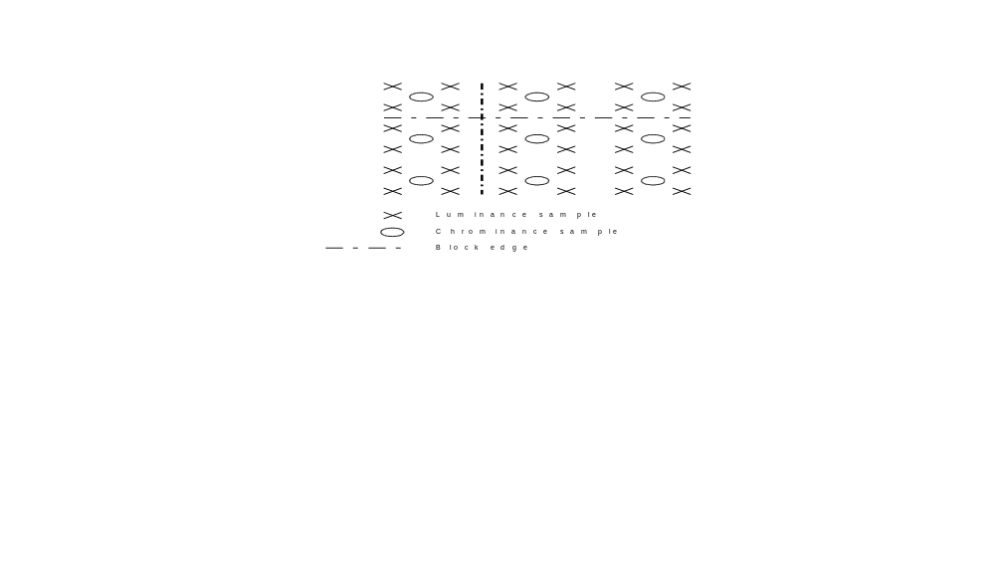
FIGURE 2/H.263
Positioning of luminance and chrominance samples

4.2. Video source coding algorithm
The source coder is shown in generalized form in Figure 3. The main elements are prediction, block transformation and quantization.
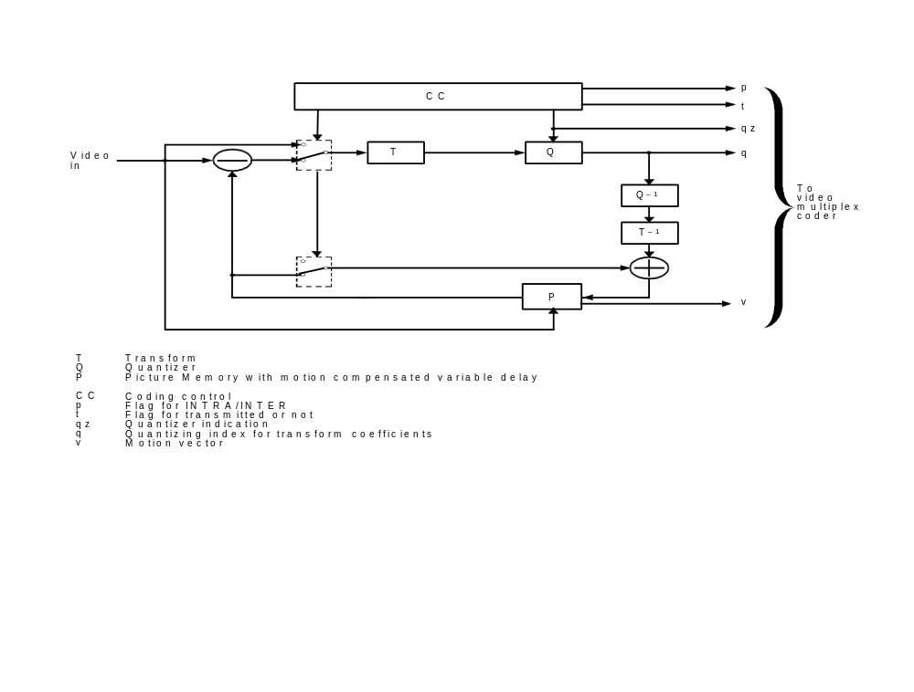
FIGURE 3/H.263
Source coder

4.2.1. GOBs, slices, macroblocks and blocks
Each picture is divided either into groups of blocks (GOBs) or into slices.
A group of blocks (GOB) comprises of up to k*16 lines, where k depends on the number of lines in the picture format and depends on whether the optional Reduced-Resolution Update mode is in use (see Annex Q). The dependencies are shown in Table 4. If the number of lines is less than 500 and the optional Reduced-Resolution Update mode is not in use, then k = 1. If the number of lines is less than 996 and the optional Reduced-Resolution Update mode is in use or the number of lines is at least 500, then k=2. If the number of lines is at least 996, then k=4. When using custom picture sizes, the number of lines in the last (bottom-most) GOB may be less than k*16 if the number of lines in the picture is not divisible by k*16. However, every GOB in each of the standardized picture formats has k*16 lines, as the number of lines in each standardized picture format is an integer multiple of k*16. Thus, for example, if the optional Reduced-Resolution mode is not in use, the number of GOBs per picture is 6 for sub-QCIF, 9 for QCIF, and 18 for CIF, 4CIF and 16CIF. The GOB numbering is done by use of vertical scan of the GOBs, starting with the upper GOB (number 0) and ending with the bottom-most GOB. An example of the arrangement of GOBs in a picture is given for the CIF picture format in Figure 4. Data for each GOB consists of a GOB header (may be empty) followed by data for macroblocks. Data for GOBs is transmitted per GOB in increasing GOB number.
TABLE 4/H.263
Parameter k for GOB size definition

Number of Lines dy | Value of k when not in RRU mode | Value of k when in RRU mode
4,…,496 | 1 | 2
500,…,992 | 2 | 2
996,…,1152 | 4 | 4

The Slice Structured mode is described in Annex K. Slices are similar to GOBs in that they are a multi-macroblock layer of the syntax, but slices have a more flexible shape and usage than GOBs, and slices may appear in the bitstream in any order, under certain conditions.

0
1
2
3
4
5
6
7
8
9
10
11
12
13
14
15
16
17
FIGURE 4/H.263
Arrangement of Groups of Blocks in a CIF picture
Each GOB is divided into macroblocks.
The macroblock structure depends on whether the optional Reduced-Resolution Update (RRU) mode is in use (see Annex Q). Unless in RRU mode, each macroblock relates to 16 pixels by 16 lines of Y and the spatially corresponding 8 pixels by 8 lines of C_{B} and C_{R}. Further, a macroblock consists of four luminance blocks and the two spatially corresponding colour difference blocks as shown in Figure 5. Each luminance or chrominance block thus relates to 8 pixels by 8 lines of Y, C_{B} or C_{R}. Unless in RRU mode, a GOB comprises one macroblock row for sub-QCIF, QCIF and CIF, two macroblock rows for 4CIF and four macroblock rows for 16CIF.
When in RRU mode, a macroblock relates to 32 pixels by 32 lines of Y and the spatially corresponding 16 pixels by 16 lines of C_{B} and C_{R}, and each luminance or chrominance block relates to 16 pixels by 16 lines of Y, C_{B} or C_{R}. Furthermore, a GOB comprises one macroblock row for CIF and 4CIF, and two macroblock rows for 16CIF.
The macroblock numbering is done by use of horizontal scan of the macroblock rows from left to right, starting with the upper macroblock row and ending with the lower macroblock row. Data for the macroblocks is transmitted per macroblock in increasing macroblock number. Data for the blocks is transmitted per block in increasing block number (see Figure 5).
The criteria for choice of mode and transmitting a block are not subject to recommendation and may be varied dynamically as part of the coding control strategy. Transmitted blocks are transformed and resulting coefficients are quantized and entropy coded.

1
2
5
6
3
4

C_{R}
C_{B}
Y

FIGURE 5/H.263
Arrangement of blocks in a macroblock

4.2.2. Prediction
The primary form of prediction is inter-picture and may be augmented by motion compensation (see section 4.2.3). The coding mode in which temporal prediction is applied is called INTER; the coding mode is called INTRA if no temporal prediction is applied. The INTRA coding mode can be signalled at the picture level (INTRA for I-pictures or INTER for P-pictures) or at the macroblock level in P-pictures. In the optional PB-frames mode B-pictures are always coded in INTER mode. The B-pictures are partly predicted bidirectionally (refer to Annex G).
In total, H.263 has seven basic picture types (of which only the first two are mandatory) which are defined primarily in terms of their prediction structure:
- Intra: A picture having no reference picture(s) for prediction (also called an I picture);
- Inter: A picture using a temporally-previous reference picture (also called a P picture);
- PB: A frame representing two pictures and having a temporally-previous reference picture (see Annex G);
- Improved PB: A frame functionally similar but normally better than a PB frame (see Annex M);
- B: A picture having two reference pictures, one of which temporally precedes the B picture and one of which temporally succeeds the B picture and has the same picture size (see Annex O);
- EI: A picture having a temporally simultaneous reference picture which has either the same or a smaller picture size (see Annex O); and
- EP: A picture having two reference pictures, one of which temporally precedes the EP picture and one of which is temporally simultaneous and has either the same or a smaller picture size (see Annex O).
As used herein, a “reference” or “anchor” picture is a picture that contains data which can be used by reference as a basis for the decoding of another picture. This use by reference is also known as “prediction”, although it sometimes may actually indicate use in a reverse-temporal direction.

4.2.3. Motion compensation
The decoder will accept one vector per macroblock or, if the Advanced Prediction mode or the Deblocking Filter mode is used, one or four vectors per macroblock (see Annexes F and J). If the PB-frames mode is used, one additional delta vector can be transmitted per macroblock for adaptation of the motion vectors for prediction of the B-macroblock. Similarly, an Improved PB-frame macroblock (see Annex M) can include an additional forward motion vector. B-picture macroblocks (see Annex O) can be transmitted together with a forward and a backward motion vector, and EP-pictures can be transmitted with a forward motion vector.
Both horizontal and vertical components of the motion vectors have integer or half integer values. In the default prediction mode, these values are restricted to the range [-16,15.5] (this is also valid for the forward and backward motion vector components for B-pictures).
In the Unrestricted Motion Vector mode however, the maximum range for vector components is increased. If PLUSPTYPE is absent, the range is [-31.5,31.5], with the restriction that only values that are within a range of [-16,15.5] around the predictor for each motion vector component can be reached if the predictor is in the range [-15.5,16]. If PLUSPTYPE is absent and the predictor is outside [-15.5,16], all values within the range [-31.5,31.5] with the same sign as the predictor plus the zero value can be reached. If PLUSPTYPE is present, the motion vector values are less restricted (see also Annex D).
In the Reduced-Resolution Update mode, the motion vector range is enlarged to approximately double size, and each vector component is restricted to have only a half-integer or zero value. Therefore the range of each motion vector component is [-31.5, 30.5] in the default Reduced-Resolution Update mode (see Annex Q) and a larger range if the Unrestricted Motion Vector mode is also used (see Annex D).
A positive value of the horizontal or vertical component of the motion vector signifies that the prediction is formed from pixels in the referenced picture which are spatially to the right or below the pixels being predicted.
Motion vectors are restricted such that all pixels referenced by them are within the coded picture area, except when the Unrestricted Motion Vector mode
, the Advanced Prediction mode, or the Deblocking Filter mode is used (see Annexes D, F, and J), or in B and EP pictures of the Temporal, SNR, and Spatial Scalability mode (see Annex O).

4.2.4. Quantization
Unless the optional Advanced Intra Coding mode or Modified Quantization mode is in use, the number of quantizers is 1 for the first coefficient of INTRA blocks and 31 for all other coefficients. Within a macroblock the same quantizer is used for all coefficients except the first one of INTRA blocks. The decision levels are not defined. The first coefficient of INTRA blocks is nominally the transform dc value uniformly quantized with a step size of 8. Each of the other 31 quantizers use equally spaced reconstruction levels with a central dead-zone around zero and with a step size of an even value in the range 2 to 62. For the exact formulas refer to section 6.2. For quantization using the Advanced Intra Coding mode, refer to Annex I. For quantization using the Modified Quantization mode, refer to Annex T.
Note – For the smaller quantization step sizes, the full dynamic range of the transform coefficients cannot be represented
unless the optional Modified Quantization mode is in use.

4.3. Coding control
Several parameters may be varied to control the rate of generation of coded video data. These include processing prior to the source coder, the quantizer, block significance criterion and temporal subsampling. The proportions of such measures in the overall control strategy are not subject to recommendation.
When invoked, temporal subsampling is performed by discarding complete pictures.
A decoder can signal its preference for a certain tradeoff between spatial and temporal resolution of the video signal. The encoder shall signal its default tradeoff at the beginning of the call and shall indicate whether it is capable to respond to decoder requests to change this tradeoff. The transmission method for these signals is by external means (for example Recommendation H.245).

4.4. Forced updating
This function is achieved by forcing the use of the INTRA mode of the coding algorithm. The update pattern is not defined. To control the accumulation of inverse transform mismatch error, each macroblock shall be coded in INTRA mode at least once every 132 times when coefficients are transmitted for this macroblock in P-pictures.
A similar requirement applies when using optional EP pictures (see Annex O), for which each macroblock shall be coded in an INTRA or upward mode at least once every 132 times when coefficients are transmitted for the macroblock.

4.5. Byte alignment of start codes
Byte alignment of start codes is achieved by inserting a stuffing codeword consisting of less than 8 zero-bits before the start code such that the first bit of the start code is the first (most significant) bit of a byte. A start code is therefore byte aligned if the position of its most significant bit is a multiple of 8-bits from the first bit in the H.263 bitstream. All picture and slice start codes shall be byte aligned, and GOB and EOS and EOSBSi (i=0, 1, 2, 3) start codes may be byte aligned.
Note 1 – The number of bits spent for a certain picture is variable but always a multiple of 8 bits.
Note 2 – H.324 requires H.263 encoders to align picture start codes with the start of logical information units passed to the Adaptation Layer (AL_SDU’s).

5. Syntax and Semantics
The video syntax is arranged in a hierarchical structure with four primary layers. From top to bottom the layers are:
• Picture,
• Group of Blocks or Slice or Video Picture Segment,
• Macroblock,
• Block.
The syntax diagram is shown in Figure 6. For diagramming purposes a “layer” is used to refer to any part of the syntax which can be understood and diagrammed as a separate entity. Abbreviations and semantics are defined in later sections. Syntax element fields shown with square-edged boundaries in Figure 6 indicate fixed-length fields, and those with rounded boundaries indicate variable-length fields. (A fixed-length field is defined to be a field for which the length of the field is not dependent on the data in the content of the field itself.) Arrow paths show the possible flows of syntax elements. Any syntax element which has zero length is considered absent for diagramming purposes (thus, for example, there is an arrow path bypassing PSTUF despite the mandatory nature the PSTUF field since the length of the PSTUF field may be zero). Any syntax element having a thick boundary in the figure denotes a syntax element that was also present in Version 1 of this Recommendation, with thin boundary lines denoting new elements specific to the additional optional features added in Version 2.
Unless specified otherwise the most significant bit is transmitted first. This is bit 1 and is the left most bit in the code tables in this Recommendation. Unless specified otherwise all unused or spare bits are set to “1”. Spare bits shall not be used until their functions are specified by the ITU.

5.1. Picture layer
Data for each picture consists of a picture header followed by data for Groups of Blocks or for slices, eventually followed by an end-of-sequence code and stuffing bits. The structure is shown in Figure 7 for pictures that do not include the optional PLUSPTYPE data field. PSBI is only present if indicated by CPM. TR_{B} and DBQUANT are only present if PTYPE indicates use of the ‘PB-frame’ mode (unless the PLUSPTYPE field is present and the use of DBQUANT is indicated therein).
The optional PLUSPTYPE data field is present when so indicated in bits 6-8 of PTYPE. When present, an additional set of data is included in the bitstream, which immediately follows PTYPE and precedes PQUANT. In addition, the CPM and PSBI fields are moved forward in the picture header when PLUSPTYPE is present, so that they appear immediately after PLUSPTYPE rather than being located after PQUANT. The format for the additional data following PLUSPTYPE is shown in Figure 8. All fields in this additional picture header data after PLUSPTYPE are optional, depending on whether their presence is indicated in PLUSPTYPE. When the Slice Structured mode (see Annex K) is in use, slices are substituted for GOBs in the location shown in Figure 7.
Combinations of PSUPP and PEI may not be present, and may be repeated when present. EOS and EOSBSi (i = 0, 1, 2, or 3) may not be present, while ESTUF may be present only if EOS or EOSBSi (i = 0, 1, 2, or 3) is present. Picture headers for dropped pictures are not transmitted.
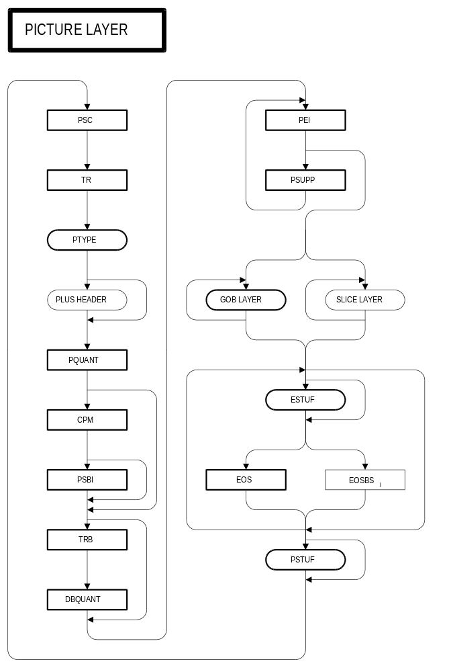
FIGURE 6/H.263
Syntax diagram for the video bitstream (part 1 of 6 parts)
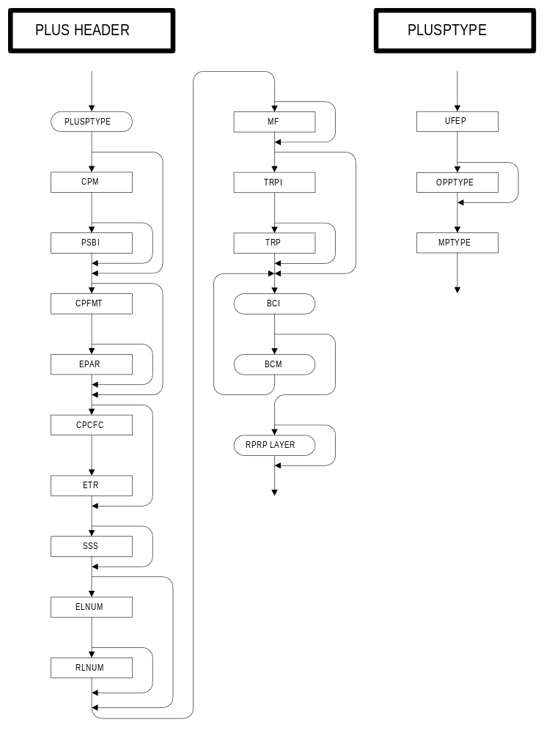
FIGURE 6/H.263 (continued)
Syntax diagram for the video bitstream (part 2 of 6 parts)
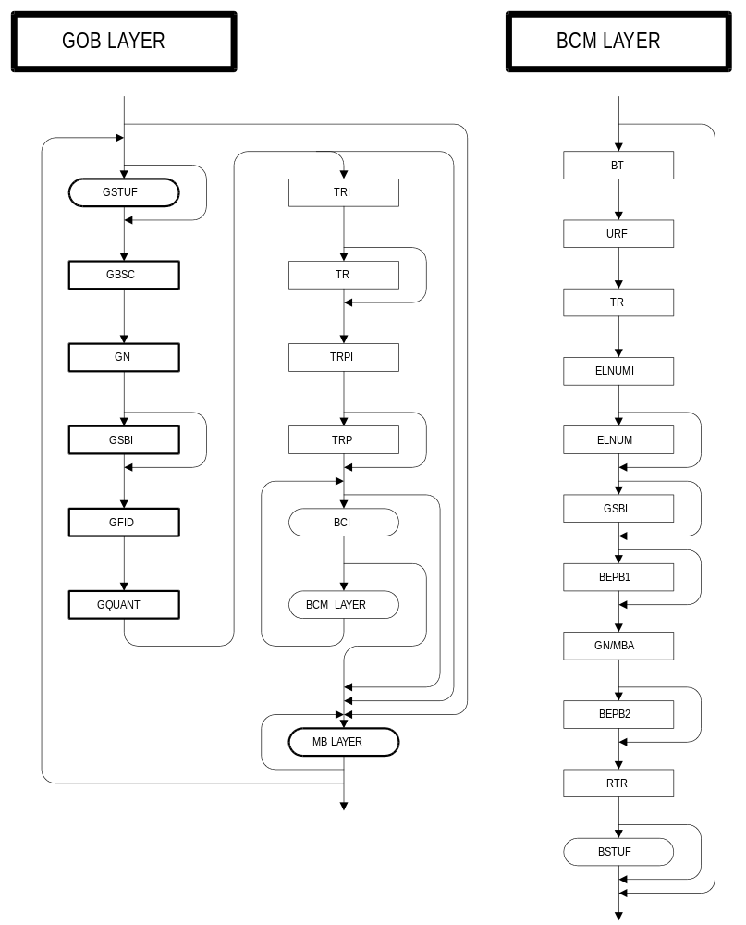
FIGURE 6/H.263 (continued)
Syntax diagram for the video bitstream (part 3 of 6 parts)
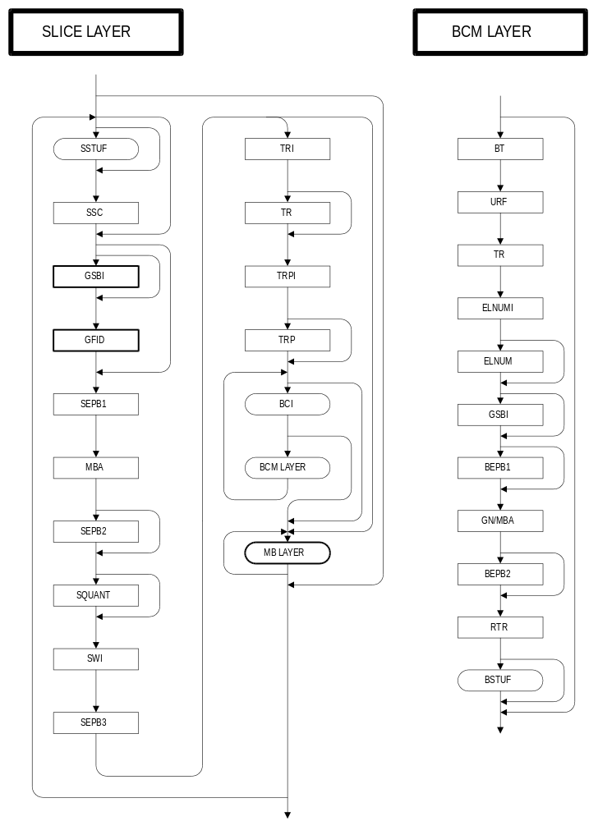
FIGURE 6/H.263 (continued)
Syntax diagram for the video bitstream (part 4 of 6 parts)
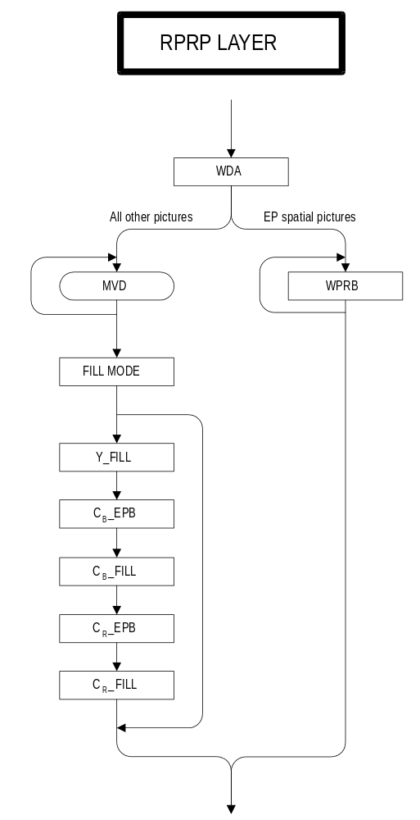
FIGURE 6/H.263 (continued)
Syntax diagram for the video bitstream (part 5 of 6 parts)
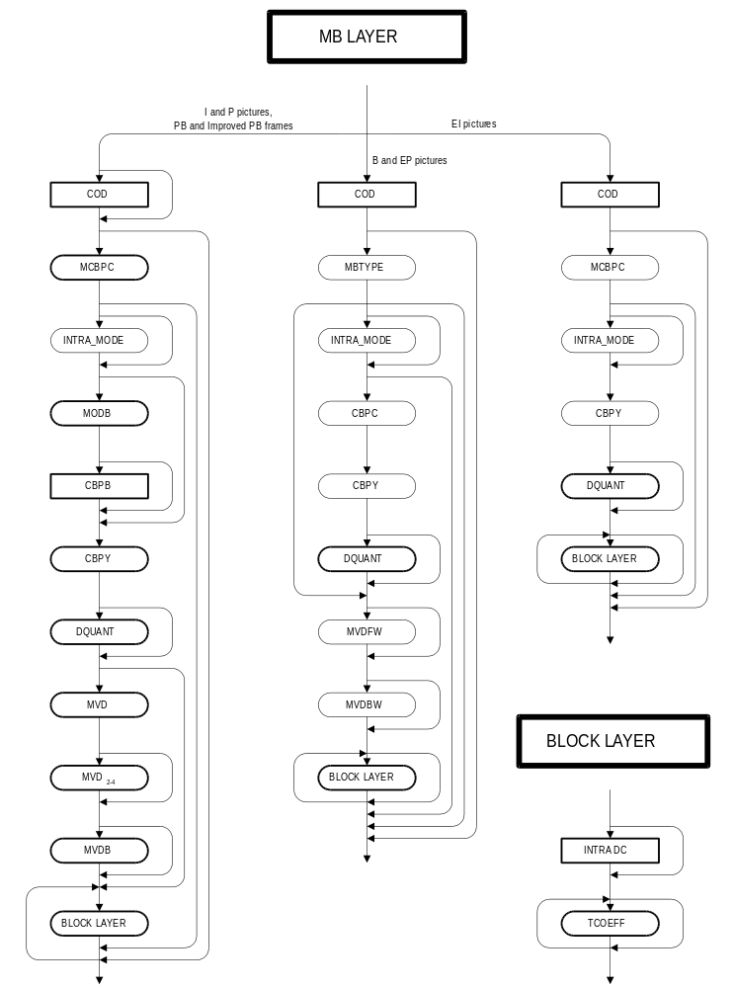
FIGURE 6/H.263 (continued)
Syntax diagram for the video bitstream (part 6 of 6 parts)

PSC | TR | PTYPE | PQUANT | CPM | PSBI | TR_{B} | DBQUANT | PEI |  | PSUPP | PEI |  | GOBs | ESTUF | EOS | PSTUF
FIGURE 7/H.263
Structure of picture layer
(without optional PLUSPTYPE-related fields)

… | PLUSPTYPE | CPM | PSBI | CPFMT | EPAR | CPCFC | ETR | SSS | ELNUM | RLNUM

RPSMF | TRPI | TRP | BCI |  | BCM | BCI |  | RPRP | …

FIGURE 8/H.263
Structure of optional PLUSPTYPE-related fields
(located immediately after PTYPE when present)

5.1.1. Picture Start Code (PSC) (22 bits)
PSC is a word of 22 bits. Its value is 0000 0000 0000 0000 1 00000. All picture start codes shall be byte aligned. This shall be achieved by inserting PSTUF bits as necessary before the start code such that the first bit of the start code is the first (most significant) bit of a byte.

5.1.2. Temporal Reference (TR) (8 bits)
The value of TR is formed by incrementing its value in the temporally-previous reference picture header by one plus the number of skipped or non-reference pictures at the picture clock frequency since the previously transmitted one. The interpretation of TR depends on the active picture clock frequency. Under the standard CIF picture clock frequency, TR is a 8-bit number which can have 256 possible values. The arithmetic is performed with only the eight LSBs. If a custom picture clock frequency is signalled in use, Extended TR in section 5.1.8 and TR form a 10-bit number where TR stores the eight LSBs and ETR stores the 2 MSBs. The arithmetic in this case is performed with the ten LSBs. In the optional PB-frames or Improved PB-frames mode, TR only addresses P-pictures; for the temporal reference for the B-picture part of PB or Improved PB frames refer to section 5.1.22.

5.1.3. Type Information (PTYPE) (Variable Length)
Information about the complete picture:
Bit 1 Always “1”, in order to avoid start code emulation.
Bit 2 Always “0”, for distinction with H.261,
Bit 3 Split screen indicator, “0” off, “1” on,
Bit 4 Document camera indicator, “0” off, “1” on,
Bit 5 Full-Picture Freeze Release, “0” off, “1” on,
Bit 6-8 Source Format, “000” forbidden, “001” sub-QCIF, “010” QCIF, “011” CIF, “100” 4CIF, “101” 16CIF, “110” reserved, “111” extended PTYPE,
If bits 6-8 are not equal to “111” (which indicates an extended PTYPE) the following five bits are also present in PTYPE:
Bit 9 Picture Coding Type, “0” INTRA (I-picture), “1” INTER (P-picture),
Bit 10 Optional Unrestricted Motion Vector mode (see Annex D), “0” off, “1” on,
Bit 11 Optional Syntax-based Arithmetic Coding mode (see Annex E), “0” off, “1” on,
Bit 12 Optional Advanced Prediction mode (see Annex F), “0” off, “1” on,
Bit 13 Optional PB-frames mode (see Annex G), “0” normal I- or P-picture, “1” PB-frame.
Split screen indicator is a signal that indicates that the upper and lower half of the decoded picture could be displayed side by side. This bit has no direct effect on the encoding or decoding of the picture.
Freeze Picture Release is a signal from an encoder which responds to a request for packet retransmission (if not acknowledged) or fast update request (see also Annex C) or picture freeze request (see also Annex L) and allows a decoder to exit from its freeze picture mode and display decoded pictures in the normal manner.
If bit 6-8 indicate a different source format than in the previous picture header, the current picture shall be an I-picture, unless an extended PTYPE is indicated in bits 6-8 and the capability to use the optional Reference Picture Resampling mode (see Annex P) has been negotiated externally (for example Recommendation H.245).
Bit 10-13 refer to optional modes that are only used after negotiation between encoder and decoder (see also the Annexes D, E, F and G, respectively). If bit 9 is set to “0”, bit 13 shall be set to “0” as well.
Bit 6-8 shall not have a value of ‘111’ unless the capability has been negotiated externally (for example Recommendation H.245) to use one or more of the optional modes available only by the use of an extended PTYPE (see Annexes I through T). Whenever bit 6-8 do not have a value of ‘111’, all of the additional modes available only by the use of an extended PTYPE shall be considered to have been set to an “off” state and shall be inferred to remain “off” unless explicitly switched on later in the bitstream.

5.1.4. Plus PTYPE (PLUSPTYPE) (Variable Length)
A codeword of 12 or 30 bits which is present only if the presence of extended PTYPE is indicated in bits 6-8 of PTYPE.
PLUSPTYPE is comprised of up to three subfields, UFEP, OPPTYPE, and MPPTYPE. OPPTYPE is present only if UFEP has a particular value.

5.1.4.1. Update Full Extended PTYPE (UFEP) (3 bits)
A fixed length codeword of 3 bits which is present only if Òextended PTYPEÓ is indicated in PTYPE bits 6-8. When set to Ò000Ó, it indicates that only those extended PTYPE fields which need to be signaled in every picture header are included in the current picture header. When set to Ò001Ó, indicates that all extended PTYPE fields are included in the current picture header. If the picture type is INTRA or EI, this field shall be set to Ò001Ó. In addition, this field shall be set to “001” at least once in every picture having temporal reference fields within each 5-second interval or once in every 5 pictures, whichever is a larger interval of time. Encoders should set UFEP to “001” more often in error-prone environments. Values of UFEP other than ‘000’ and ‘001’ are reserved.

5.1.4.2. The optional part of PLUSPTYPE (OPPTYPE) (18 bits)
If UFEP is “001”, then the following bits are present in PLUSPTYPE:
Bit 1-3 Source Format, “000” reserved, “001” sub-QCIF, “010” QCIF, “011” CIF, “100” 4CIF, “101” 16CIF, “110” custom source format, “111” reserved,
Bit 4 Optional Custom PCF, “0” CIF PCF, “1” custom PCF.,
Bit 5 Optional Unrestricted Motion Vector (UMV) mode (see Annex D), “0” off, “1” on,
Bit 6 Optional Syntax-based Arithmetic Coding (SAC) mode (see Annex E), “0” off, “1” on,
Bit 7 Optional Advanced Prediction (AP) mode (see Annex F), “0” off, “1” on,
Bit 8 Optional Advanced Intra Coding (AIC) mode (see Annex I), “0” off, “1” on,
Bit 9 Optional Deblocking Filter (DF) mode (see Annex J), “0” off, “1” on,
Bit 10 Optional Slice Structured (SS) mode (see Annex K), “0” off, “1” on,
Bit 11 Optional Reference Picture Selection (RPS) mode (see Annex N), “0” off, “1” on,
Bit 12 Optional Independent Segment Decoding (ISD) mode (see Annex R),“0” off, “1” on,
Bit 13 Optional Alternative Inter VLC (AIV) mode (see Annex S), “0” off, “1” on,
Bit 14 Optional Modified Quantization (MQ) mode (see Annex T), “0” off, “1” on,
Bit 15 Equal to “1” to prevent start code emulation,
Bit 16 Reserved, shall be equal to “0”,
Bit 17 Reserved, shall be equal to “0”.
Bit 18 Reserved, shall be equal to “0”.

5.1.4.3. The mandatory part of PLUSPTYPE when PLUSPTYPE present (MPPTYPE) (9 bits)
Regardless of the value of UFEP, the following 9 bits are also present in PLUSPTYPE:
Bit 1-3 Picture Type Code:
“000” I-picture (INTRA),
“001” P-picture (INTER),
“010” Improved PB frame (see Annex M),
“011” B-picture (see Annex O),
“100” EI-picture (see Annex O),
“101” EP-picture (see Annex O),
“110” reserved,
“111” reserved
Bit 4 Optional Reference Picture Resampling (RPR) mode (see Annex P), “0” off, “1” on,
Bit 5 Optional Reduced-Resolution Update (RRU) mode (see Annex Q), “0” off, “1” on,
Bit 6 Rounding Type (RTYPE) (see section 6.1.2),
Bit 7 Reserved, shall be equal to “0”,
Bit 8 Reserved, shall be equal to “0”,
Bit 9 Equal to Ò1Ó to prevent start code emulation.
The encoder should control the rounding type so that P pictures, Improved PB frames, and EP pictures have different values for Bit 6 (Rounding Type for P-Pictures) from their reference pictures for motion compensation. Bit 6 can have an arbitrary value if the reference picture is an I or an EI picture. Bit 6 can be set to “1” only when Bits 1-3 indicate a P Picture, Improved PB frame, or EP Picture. For other types of pictures, this bit shall always be set to “0”.

5.1.4.4. The semantics of PLUSPTYPE
The mandatory part of PLUSPTYPE consists of features which are likely to be changed on a picture-by-picture basis. Primarily, these are the bits that indicate the picture type among I, P, Improved PB, B, EI, and EP. (Note that the PB-frames mode of Annex G cannot be used with PLUSPTYPE present—the Improved PB frames mode of Annex M should be used instead.) However, they also include indications for the use of the RPR and RRU modes, as these may change from picture to picture as well.
Features that are likely to remain in use rather than being changed from one picture to another (except in obvious ways as discussed in section 5.4.4.5), have been placed in the optional part of PLUSPTYPE. When UFEP is 000, the missing mode information is inferred from the type of picture and from the mode information sent in a previous PLUSPTYPE with UFEP equal to 001.
If PLUSPTYPE is present but UFEP is 000, then
- For a P picture or Improved PB frame (see Annex M), the pixel aspect ratio, picture width, and picture height are unchanged from those of the reference picture.
- For a temporal-scalability B picture (see Annex O), the reference layer number (RLNUM) is the same as the enhancement layer number (ELNUM) if there exist temporally surrounding I/P/EI/EP-pictures in the same layer. The pixel aspect ratio, picture width and picture height are unchanged from those of the temporally subsequent reference layer picture.
- For a SNR/Spatial scalability EP picture (see Annex O), the pixel aspect ratio, picture width and picture height are unchanged from those of the temporally previous reference picture in the same enhancement layer.

5.1.4.5. Mode restrictions for certain picture types and mode inference rules
Certain modes do not apply to certain types of pictures. Particularly, these restrictions apply:
- The following modes do not apply within I (Intra) pictures: Unrestricted Motion Vector (see Annex D), Advanced Prediction (see Annex F), Alternative Inter VLC (see Annex S), Reference Picture Resampling (see Annex P), and Reduced Resolution Update (see Annex Q).
- The following modes do not apply within B pictures (see Annex O): Syntax-based Arithmetic Coding (see Annex E), Deblocking Filter (see Annex J), and Advanced Prediction (see Annex F).
- The following modes do not apply within EI pictures (see Annex O): Unrestricted Motion Vector (see Annex D), Syntax-based Arithmetic Coding (see Annex E), Advanced Prediction (see Annex F), Reference Picture Resampling (see Annex P), Reduced Resolution Update (see Annex Q), and Alternative Inter VLC (see Annex S).
- The following modes do not apply within EP pictures (see Annex O): Syntax-based Arithmetic Coding (see Annex E) and Advanced Prediction (see Annex F).
One or more of the modes listed in the above four-item list may have a mode flag having a value “1” in the optional part of PLUSPTYPE within a picture of a type that is prohibited for that mode (types I, B, EI, or EP). This condition is allowed and shall be interpreted subject to the mode inference rules which follow in the next paragraph.
Mode states are subject to the following mode inference rules:
- Once a mode flag has been set to “1” in the optional part of PLUSPTYPE, the current picture and each subsequent picture in the bitstream shall be assigned a state of “on” for that mode.
- An inferred state of “off” shall be assigned to any mode which does not apply within a picture having the current picture type code. However, each subsequent picture in the bitstream shall have an inferred state of “on” for that mode (unless this too results in an obvious conflict—which shall be resolved in the same way). In the case of layered scalable bitstreams (see Annex O), the mode state shall be inferred only from within the same layer of the bitstream.
- The inference of state shall continue until another picture containing the optional part of PLUSPTYPE is sent or until a picture which does not contain PLUSPTYPE at all is sent, whichever comes first. If a new picture containing the optional part of PLUSPTYPE is sent, the state sent in the new message shall override the old state. If a picture is sent which does not contain PLUSPTYPE (a picture in which bit 6-8 of PTYPE is not ‘111’), a state of “off” shall be assigned to all modes not explicitly set to “on” in the PTYPE field, and all modes shall continue to have an inferred state of “off” until a new picture containing the optional part of PLUSPTYPE is sent.

5.1.4.6. Mode interaction restrictions
Certain modes cannot be used in combination with certain other modes.
- The Syntax-based Arithmetic Coding mode (see Annex E) shall not be used with the Alternative Inter VLC mode (see Annex S) or the Modified Quantization mode (see Annex T).
- If PLUSPTYPE is present, the Unrestricted Motion Vector mode (see Annex D) shall not be used with the Syntax-based Arithmetic Coding mode (see Annex E).
- The Independent Segment Decoding mode (see Annex R) shall not be used with the Reference Picture Resampling mode (see Annex P).
- The Independent Segment Decoding mode (see Annex R) shall not be used with the Slice Structured mode without the simultaneous use of the Rectangular Slice submode of the Slice Structured mode (see Annex K).

5.1.4.7. The picture header location of CPM (1 bit) and PSBI (2 bits)
The location of the CPM and PSBI fields in the picture header depends on whether or not PLUSPTYPE is present (see sections 5.1.20 and 5.1.21). If PLUSPTYPE is present, then CPM follows immediately after PLUSPTYPE in the picture header. If PLUSPTYPE is not present, then CPM follows immediately after PQUANT in the picture header. PSBI always follows immediately after CPM (if PSBI is present).

5.1.5. Custom Picture Format (CPFMT) (23 bits)
A fixed length codeword of 23 bits that is present only if the use of a custom picture format is signaled in PLUSPTYPE and UFEP is ‘001’. When present, CPFMT consists of:
Bit 1-4 Pixel Aspect Ratio Code: A 4-bit index to the PAR value in Table 5. For extended PAR,
the exact pixel aspect ratio shall be specified in EPAR (section 5.1.6).,
Bit 5-13 Picture Width Indication: Range [0,...,511]; Number of pixels per line = (PWI+1)*4,
Bit 14 Equal to “1” to prevent start code emulation,
Bit 15-23 Picture Height Indication: Range [1,...,288]; Number of lines = PHI*4.
TABLE 5/H.263
PAR Code Definition
PAR Code | Pixel Aspect Ratios
0000 | forbidden
0001 | 1:1 (Square)
0010 | 12:11 (CIF for 4:3 picture)
0011 | 10:11 (525-type for 4:3 picture)
0100 | 16:11 (CIF stretched for 16:9 picture)
0101 | 40:33 (525-type stretched for 16:9 picture)
0110-1110 | reserved
1111 | extended PAR

5.1.6. Extended Pixel Aspect Ratio (EPAR) (16 bits)
A fixed length codeword of 16 bits that is present only if CPFMT is present and extended PAR is indicated therein. When present, EPAR consists of:
Bit 1-8 PAR Width: “0” is forbidden. The natural binary representation of the PAR width,
Bit 9-16 PAR Height: “0” is forbidden. The natural binary representation of the PAR height.
The PAR Width and PAR Height shall be relatively prime.

5.1.7. Custom Picture Clock Frequency Code (CPCFC) (8 bits)
A fixed length codeword of 8 bits that is present only if PLUSPTYPE is present and UFEP is 001 and a custom picture clock frequency is signalled in PLUSPTYPE. When present, CPCFC consists of:
Bit 1 Clock Conversion Code: “0” indicates a clock conversion factor of 1000 and “1” indicates 1001.
Bit 2-8 Clock Divisor: “0” is forbidden. The natural binary representation of the value of the clock divisor.
The custom picture clock frequency is given by 1 800 000/(clock divisor * clock conversion factor) Hz.
The temporal reference counter shall count in units of the inverse of the picture clock frequency, in seconds. When the PCF changes from that specified for the previous picture, the temporal reference for the current picture is measured in terms of the prior PCF, so that the new PCF takes effect only for the temporal reference interpretation of future pictures.

5.1.8. Extended Temporal Reference (ETR) (2 bits)
A fixed length codeword of 2 bits which is present only if a custom picture clock frequency is in use (regardless of the value of UFEP). It is the two MSBs of the 10-bit number defined in section 5.1.2.

5.1.9. Unlimited Unrestricted Motion Vectors Indicator (UUI) (Variable Length)
A variable length codeword of 1 or 2 bits that is present only if the optional Unrestricted Motion Vector mode is indicated in PLUSPTYPE and UFEP is 001. When UUI is present it indicates the effective limitation of the range of the motion vectors being used.
UUI = “1” : The motion vector range is limited according to Tables D.1 and D.2.
UUI = “01” : The motion vector range is not limited except by the picture size.

5.1.10. Slice Structured submode bits (SSS) (2 bits)
A fixed length codeword of 2 bits which is present only if the optional Slice Structured mode (see Annex K) is indicated in PLUSPTYPE and UFEP is 001. If the Slice Structured mode is in use but UFEP is not 001, the last values sent for SSS shall remain in effect.
Bit 1 Rectangular Slices, “0” indicates free-running slices, “1” indicates rectangular slices.
Bit 2 Arbitrary Slice Ordering, “0” indicates sequential order, “1” indicates arbitrary order.

5.1.11. Enhancement layer number (ELNUM) (4 bits)
A fixed length codeword of 4 bits which is present only if the optional Temporal, SNR, and Spatial Scalability mode is in use (regardless of the value of UFEP). The particular enhancement layer is identified by an enhancement layer number, ELNUM. Picture correspondence between layers is achieved via the temporal reference. Picture size is either indicated within each enhancement layer using the existing source format fields or is inferred by the relationship to the reference layer. The first enhancement layer above the base layer is designated as Enhancement Layer Number 2, and the base layer has number 1.

5.1.12. Reference layer number (RLNUM) (4 bits)
A fixed length codeword of 4 bits which is present only if the optional Temporal, SNR, and Spatial Scalability mode is in use and UFEP is 001, and, for B-pictures, only if there are not temporally surrounding non-B pictures in the same enhancement layer. In the case of such surrounding non-B pictures, RLNUM is suppressed since it is always equal to ELNUM. The layer number for the pictures used as reference anchors is identified by a reference layer number (RLNUM). Time correspondence between layers is achieved via the temporal reference.

5.1.13. Reference Picture Selection Mode Flags (RPSMF) (3 bits)
A fixed length codeword of 3 bits that is present only if the Reference Picture Selection mode is in use and UFEP is 001. When present, RPSMF indicates which type of back-channel messages are needed by the encoder. If the Reference Picture Selection mode is in use but RPSMF is not present, the last value of RPSMF that was sent shall remain in effect.
100: neither ACK nor NACK signals needed
101: need ACK signals to be returned
110: need NACK signals to be returned
111: need both ACK and NACK signals to be returned
000-011: reserved

5.1.14. Temporal reference for prediction indication (TRPI) (1 bit)
A fixed length codeword of 1 bit that is present only if the optional Reference Picture Selection mode is in use (regardless of the value of UFEP). When present, TRPI indicates the presence of the following TRP field.
0: TRP field is not present.
1: TRP field is present.
TRPI shall be 0 whenever the picture header indicates an I or EI picture.

5.1.15. Temporal Reference for Prediction (TRP) (8/10 bits)
A fixed length codeword of 8 or 10 bits that is present only if TRPI signals the existence of TRP field. TRP indicates the Temporal Reference of the video picture segment which is used for prediction in the encoding of the current video picture segment (see Annex R for a definition of video picture segment), except for in the case of B pictures. For B pictures, the picture having the temporal reference TRP is used for the prediction in the forward direction. TRP is an eight bit number unless a custom picture clock frequency is in use, in which case it is a ten bit number consisting of the concatenation of ETR and TR.

5.1.16. Back-Channel message Indication (BCI) (Variable Length)
A variable length field of one or two bits that is present only if the optional Reference Picture Selection mode is in use. When set to "1", this signals the presence of the following optional video back-channel message (BCM) field. "01" indicates the absence or the end of the video back-channel message field. Combinations of BCM and BCI may not be present, and may be repeated when present. BCI shall be set to "01" if the videomux submode of the optional Reference Picture Selection mode is not in use.

5.1.17. Back-Channel Message (BCM) (Variable Length)
The Back-Channel message with syntax as specified in section N.4.2, which is present only if the preceding BCI field is present and is set to "1".

5.1.18. Reference Picture Resampling Parameters (RPRP) (Variable Length)
A variable length field that is present only if the optional Reference Picture Resampling mode bit is set in PLUSPTYPE. This field carries the parameters of the Reference Picture Resampling mode (see Annex P). Note that the Reference Picture Resampling mode can also be invoked implicitly by the occurrence of a picture header for an Inter coded picture having a picture size which differs from that of the previous encoded picture, in which case the RPRP field is not present and the Reference Picture Resampling mode bit is not set.

5.1.19. Quantizer Information (PQUANT) (5 bits)
A fixed length codeword of 5 bits which indicates the quantizer QUANT to be used for the picture until updated by any subsequent GQUANT or DQUANT. The codewords are the natural binary representations of the values of QUANT which, being half the step sizes, range from 1 to 31.

5.1.20. Continuous Presence and Multiplex (CPM) (1 bit)
A codeword of 1 bit that signals the use of the optional Continuous Presence and Multiplex mode (CPM); “0” is off, “1” is on. For the use of CPM refer to Annex C. CPM follows immediately after PLUSPTYPE if PLUSPTYPE is present, but follows PQUANT in the picture header if PLUSPTYPE is not present.

5.1.21. Picture Sub Bitstream Indicator (PSBI) (2 bits)
A fixed length codeword of 2 bits that is only present if Continuous Presence Multipoint and Video Multiplex mode is indicated by CPM. The codewords are the natural binary representation of the sub-bitstream number for the picture header and all following information until the next Picture or GOB start code (see also Annex C). PSBI follows immediately after CPM if CPM is “1” (the location of CPM and PSBI in the picture header depend on whether PLUSPTYPE is present).

5.1.22. Temporal Reference for B-pictures in PB-frames (TR_{B}) (3/5 bits)
TRB is present if PTYPE or PLUSPTYPE indicates ‘PB-frame’ or ‘Improved PB-frame’ (see also Annexes G and M) and indicates the number of non-transmitted or non-reference pictures (at 29.97 Hz or the custom picture clock frequency indicated in CPCFC) since the last P- or I-picture or P part of a PB or Improved PB frame and before the B part of the PB- or Improved PB-frame. The codeword is the natural binary representation of the number of non-transmitted pictures plus one. It is 3-bits long for standard CIF picture clock frequency and is extended to five bits when a custom picture clock frequency is in use. The maximum number of non-transmitted pictures is 6
for the standard CIF picture clock frequency and 30 when a custom picture clock frequency is used.

5.1.23. Quantization information for B-pictures in PB frames (DBQUANT) (2 bits)
DBQUANT is present if PTYPE or PLUSPTYPE indicates ‘PB-frame’ or ‘Improved PB-frame’ (see also Annexes G and M). In the decoding process a quantization parameter QUANT is obtained for each macroblock. With PB-frames QUANT is used for the P-block, while for the B-block a different quantization parameter BQUANT is used. QUANT ranges from 1 to 31. DBQUANT indicates the relation between QUANT and BQUANT as defined in Table 6. In this table, “/” means division by truncation. BQUANT ranges from 1 to 31; if the value for BQUANT resulting from Table 6 is greater than 31, it is clipped to 31.
TABLE 6/H.263
DBQUANT codes and relation between QUANT and BQUANT
DBQUANT | BQUANT
00 | (5xQUANT)/4
01 | (6xQUANT)/4
10 | (7xQUANT)/4
11 | (8xQUANT)/4

5.1.24. Extra Insertion Information (PEI) (1 bit)
A bit which when set to "1" signals the presence of the following optional data field.

5.1.25. Supplemental Information (PSUPP) (0/8/16 . . . bits)
If PEI is set to "1", then 9 bits follow consisting of 8 bits of data (PSUPP) and then another PEI bit to indicate if a further 9 bits follow and so on. Encoders shall use PSUPP as specified in Annex L. Decoders which do not support the extended capabilities described in Annex L shall be designed to discard PSUPP if PEI is set to 1. This enables backward compatibility for the extended
capabilities of Annex L so that a bitstream which makes use of the extended capabilities can also be used without alteration by decoders which do not support those capabilities.

5.1.26. Stuffing (ESTUF) (Variable length)
A codeword of variable length consisting of less than 8 zero-bits. Encoders may insert this codeword directly before an EOS or EOSBSi (i = 0, 1, 2, or 3) codeword. If ESTUF is present, the last bit of ESTUF shall be the last (least significant) bit of a byte, so that the start of the EOS or EOSBSi codeword is byte aligned. Decoders shall be designed to discard ESTUF. See Annex C for a description of EOSBSi and its use.

5.1.27. End Of Sequence (EOS) (22 bits)
A codeword of 22 bits. Its value is 0000 0000 0000 0000 1 11111. It is up to the encoder to insert this codeword or not. EOS may be byte aligned. This can be achieved by inserting ESTUF before the start code such that the first bit of the start code is the first (most significant) bit of a byte.

5.1.28. Stuffing (PSTUF) (Variable length)
A codeword of variable length consisting of less than 8 zero-bits. Encoders shall insert this codeword for byte alignment of the next PSC. The last bit of PSTUF shall be the last (least significant) bit of a byte, so that the video bitstream including PSTUF is a multiple of 8 bits from the first bit in the H.263 bitstream. Decoders shall be designed to discard PSTUF.
If for some reason the encoder stops encoding pictures for a certain time period and resumes encoding later, PSTUF shall be transmitted before the encoder stops, to prevent that the last up to 7 bits of the previous picture are not sent until the coder resumes coding.

5.2. Group of Blocks Layer
Data for each group of blocks (GOB) consists of a GOB header followed by data for macroblocks. The structure is shown in Figure 9. Each GOB contains one or more rows of macroblocks. For the first GOB in each picture (with number 0), no GOB header shall be transmitted. For all other GOBs, the GOB header may be empty, depending on the encoder strategy. A decoder can signal the remote encoder to transmit only non-empty GOB headers by external means, for example Recommendation H.245. GSTUF may be present when GBSC is present. GN, GFID and GQUANT are present when GBSC is present. GSBI is present when CPM is “1" in the Picture header.

GSTUF | GBSC | GN | GSBI | GFID | GQUANT | Macroblock Data
FIGURE 9/H.263
Structure of GOB layer

5.2.1. Stuffing (GSTUF) (Variable length)
A codeword of variable length consisting of less than 8 zero-bits. Encoders may insert this codeword directly before a GBSC codeword. If GSTUF is present, the last bit of GSTUF shall be the last (least significant) bit of a byte, so that the start of the GBSC codeword is byte aligned. Decoders shall be designed to discard GSTUF.

5.2.2. Group of Block Start Code (GBSC) (17 bits)
A word of 17 bits. Its value is 0000 0000 0000 0000 1. GOB start codes may be byte aligned. This can be achieved by inserting GSTUF before the start code such that the first bit of the start code is the first (most significant) bit of a byte.

5.2.3. Group Number (GN) (5 bits)
A fixed length codeword of 5 bits. The bits are the binary representation of the number of the Group of Blocks. For the GOB with number 0, the GOB header including GSTUF, GBSC, GN, GSBI, GFID and GQUANT is empty; group number 0 is used in the PSC. Group number 31 is used in the EOS, and group numbers 27 through 30 are used in the EOSBSi
codes for i = 0, 1, 2, and 3 (see Annex C).

5.2.4. GOB Sub Bitstream Indicator (GSBI) (2 bits)
A fixed length codeword of 2 bits that is only present if CPM is “1” in the picture header. The codewords are the natural binary representation of the sub-bitstream number for the GOB header and all following information until the next Picture or GOB start code (see also Annex C).

5.2.5. GOB Frame ID (GFID) (2 bits)
A fixed length codeword of 2 bits. GFID shall have the same value in every GOB header of a given picture. Moreover, if PTYPE as indicated in a picture header is the same as for the previous transmitted picture, GFID shall have the same value as in that previous picture, provided PLUSPTYPE is not present. However, if PTYPE in a certain picture header differs from the PTYPE in the previous transmitted picture header, the value for GFID in that picture shall differ from the value in the previous picture.
If PLUSPTYPE is present, the value of GFID shall be the same as that for the previous picture (in the same layer) if the PTYPE, and PLUSPTYPE, and all of the present fields among CPFMT, EPAR, CPCFC, SSS, ELNUM, RLNUM, UUI, RPSMF, and RPRP remain in effect as for the previous picture; otherwise, GFID shall be different than that for the previous picture.

5.2.6. Quantizer Information (GQUANT) (5 bits)
A fixed length codeword of 5 bits which indicates the quantizer QUANT to be used for the remaining part of the picture until updated by any subsequent GQUANT or DQUANT. The codewords are the natural binary representations of the values of QUANT which, being half the step sizes, range from 1 to 31.

5.3. Macroblock layer
Data for each macroblock consists of a macroblock header followed by data for blocks. The structure is shown in Figure 10. COD is only present in pictures that are not of type ‘INTRA’, for each macroblock in these pictures. MCBPC is present when indicated by COD or when the picture is of type ‘INTRA’. MODB is present for MB-type 0-4 if PTYPE indicates ‘PB-frame’. CBPY, DQUANT, MVD and MVD₂₋₄ are present when indicated by MCBPC. CBPB and MVDB are only present if indicated by MODB. Block Data is present when indicated by MCBPC and CBPY. MVD₂₋₄ are only present when in Advanced Prediction mode (see Annex F) or Deblocking Filter mode (see Annex J). MODB, CBPB and MVDB are only present in PB-frames mode (refer to Annex G). For coding of the symbols in the Syntax-based Arithmetic Coding mode refer to Annex E. For coding of the macroblock layer in B, EI, and EP pictures, see Annex O.

COD | MCBPC | MODB | CBPB | CBPY | DQUANT | MVD | MVD₂ | MVD₃ | MVD₄ | MVDB | Block Data
FIGURE 10/H.263
Structure of macroblock layer

5.3.1. Coded macroblock indication (COD) (1 bit)
A bit which when set to "0" signals that the macroblock is coded. If set to "1", no further information is transmitted for this macroblock; in that case the decoder shall treat the macroblock as an INTER macroblock with motion vector for the whole block equal to zero and with no coefficient data. COD is only present in pictures that are not of type ‘INTRA’, for each macroblock in these pictures.
Notes – In Advanced Prediction mode (see Annex F), overlapped motion compensation is also performed if COD is set to “1”; and in Deblocking Filter mode (see Annex J), the deblocking filter is also performed if COD is set to “1”.

5.3.2. Macroblock type & Coded block pattern for chrominance (MCBPC) (Variable length)
A variable length codeword giving information about the macroblock type and the coded block pattern for chrominance. The codewords for MCBPC are given in Tables 7 and 8. MCBPC is always included in coded macroblocks.
An extra codeword is available in the tables for bit stuffing. This codeword should be discarded by decoders. If an Improved PB-frame is indicated by MPPTYPE Bits 1-3 and Custom Source Format is indicated in OPPTYPE Bits 1-3, then MBA shall not indicate Stuffing before the first macroblock of the picture (in order to prevent start code emulation).
The macroblock type gives information about the macroblock and which data elements are present. Macroblock types and included elements are listed in Tables 9 and 10. Macroblock type 5 (indices 21-24 in Table 8) shall not be present unless an extended PTYPE (PLUSPTYPE) is present in the picture header and either the Advanced Prediction mode (see Annex F) or the Deblocking Filter mode (see Annex J) is in use, and shall not be present for the first macroblock of a picture. Also, encoders shall not allow an MCBPC code for macroblock type 5 to immediately follow seven consecutive zeros in the bitstream (as can be caused by particular INTRADC codes followed by COD=0), in order to prevent start code emulation. Codes for macroblock type 5 can be preceded by stuffing when necessary to fulfill this requirement (for macroblocks other than the first of a picture).

TABLE 7/H.263
VLC table for MCBPC (for I-pictures)
Index | MB type | CBPC  (56) | Number of bits | Code
0 | 3 | 00 | 1 | 1
1 | 3 | 01 | 3 | 001
2 | 3 | 10 | 3 | 010
3 | 3 | 11 | 3 | 011
4 | 4 | 00 | 4 | 0001
5 | 4 | 01 | 6 | 0000 01
6 | 4 | 10 | 6 | 0000 10
7 | 4 | 11 | 6 | 0000 11
8 | Stuffing | -- | 9 | 0000 0000 1

The coded block pattern for chrominance signifies C_{B} and/or C_{R} blocks when at least one non-INTRADC transform coefficient is transmitted (INTRADC is the dc-coefficient for INTRA blocks, see section 5.4.1), unless the optional Advanced Intra Coding mode is in use. CBPC_{N} = 1 if any non-INTRADC coefficient is present for block N, else 0, for CBPC₅ and CBPC₆ in the coded block pattern. If Advanced Intra Coding is in use, the usage is similar, but the INTRA DC coefficient is indicated in the same way as the other coefficients (see Annex I). Block numbering is given in Figure 5. When MCBPC=Stuffing, the remaining part of the macroblock layer is skipped. In this case, the preceding COD=0 is not related to any coded or not-coded macroblock and therefore the macroblock number is not incremented. For P-pictures, multiple stuffings are accomplished by multiple sets of COD=0 and MCBPC=Stuffing.
TABLE 8/H.263
VLC table for MCBPC (for P-pictures)
Index | MB type | CBPC  (56) | Number of bits | Code
0 | 0 | 00 | 1 | 1
1 | 0 | 01 | 4 | 0011
2 | 0 | 10 | 4 | 0010
3 | 0 | 11 | 6 | 0001 01
4 | 1 | 00 | 3 | 011
5 | 1 | 01 | 7 | 0000 111
6 | 1 | 10 | 7 | 0000 110
7 | 1 | 11 | 9 | 0000 0010 1
8 | 2 | 00 | 3 | 010
9 | 2 | 01 | 7 | 0000 101
10 | 2 | 10 | 7 | 0000 100
11 | 2 | 11 | 8 | 0000 0101
12 | 3 | 00 | 5 | 0001 1
13 | 3 | 01 | 8 | 0000 0100
14 | 3 | 10 | 8 | 0000 0011
15 | 3 | 11 | 7 | 0000 011
16 | 4 | 00 | 6 | 0001 00
17 | 4 | 01 | 9 | 0000 0010 0
18 | 4 | 10 | 9 | 0000 0001 1
19 | 4 | 11 | 9 | 0000 0001 0
20 | Stuffing | -- | 9 | 0000 0000 1
21 | 5 | 00 | 11 | 0000 0000 010
22 | 5 | 01 | 13 | 0000 0000 0110 0
23 | 5 | 10 | 13 | 0000 0000 0111 0
24 | 5 | 11 | 13 | 0000 0000 0111 1

TABLE 9/H.263
Macroblock types and included data elements for normal pictures
Picture type | MB type | Name | COD | MCBPC | CBPY | DQUANT | MVD | MVD₂₋₄
INTER | not coded | - | X
INTER | 0 | INTER | X | X | X |  | X
INTER | 1 | INTER+Q | X | X | X | X | X
INTER | 2 | INTER4V | X | X | X |  | X | X
INTER | 3 | INTRA | X | X | X
INTER | 4 | INTRA+Q | X | X | X | X
INTER | 5 | INTER4V+Q | X | X | X | X | X | X
INTER | stuffing | - | X | X
INTRA | 3 | INTRA |  | X | X
INTRA | 4 | INTRA+Q |  | X | X | X
INTRA | stuffing | - |  | X
Note: “x” means that the item is present in the macroblock
TABLE 10/H.263
Macroblock types and included data elements for PB-frames
Picture type | MB type | Name | COD | MCBPC | MODB | CBPY | CBPB | DQUANT | MVD | MVDB | MVD₂₋₄
INTER | not coded | - | X
INTER | 0 | INTER | X | X | X | X | (X) |  | X | (X)
INTER | 1 | INTER+Q | X | X | X | X | (X) | X | X | (X)
INTER | 2 | INTER4V | X | X | X | X | (X) |  | X | (X) | X
INTER | 3 | INTRA | X | X | X | X | (X) |  | X | (X)
INTER | 4 | INTRA+Q | X | X | X | X | (X) | X | X | (X)
INTER | 5 | INTER4V+Q | X | X | X | X | (X) | X | X | (X) | X
INTER | stuffing | - | X | X
Note 1: “x” means that the item is present in the macroblock
Note 2: CBPB and MVDB are only present if indicated by MODB
Note 3: B-blocks are always coded in INTER mode, even if the macroblock type of the PB-macroblock indicates INTRA

5.3.3. Macroblock mode for B-blocks (MODB) (Variable length)
MODB is present for MB-type 0-4 if PTYPE indicates ‘PB-frame’ and is a variable length codeword indicating whether CBPB is present (indicates that B-coefficients are transmitted for this macroblock) and/or MVDB is present. In Table 11 the codewords for MODB are defined. MODB is coded differently for Improved PB frames, as specified in Annex M.
TABLE 11/H.263
VLC table for MODB
Index | CBPB | MVDB | Number of bits | Code
0 |  |  | 1 | 0
1 |  | X | 2 | 10
2 | X | X | 2 | 11
Note: “x” means that the item is present in the macroblock

5.3.4. Coded block pattern for B-blocks (CBPB) (6 bits)
CBPB is only present in PB-frames mode if indicated by MODB. CBPB_{N} = 1 if any coefficient is present for B-block N, else 0, for each bit CBPB_{N} in the coded block pattern. Block numbering is given in Figure 5, the utmost left bit of CBPB corresponding with block number 1.

5.3.5. Coded block pattern for luminance (CBPY) (Variable length)
Variable length codeword giving a pattern number signifying those Y blocks in the macroblock for which at least one non-INTRADC transform coefficient is transmitted (INTRADC is the dc-coefficient for INTRA blocks, see § 5.4.1), unless the Advanced Intra Coding mode is in use. If Advanced Intra Coding is in use, INTRA DC is indicated in the same manner as the other coefficients (see Annex I).
CBPY_{N} = 1 if any non-INTRADC coefficient is present for block N, else 0, for each bit CBPY_{N} in the coded block pattern. Block numbering is given in Figure 5, the utmost left bit of CBPY corresponding with block number 1. For a certain pattern CBPY_{N}, different codewords are used for INTER and INTRA macroblocks as defined in Table 1
3.

5.3.6. Quantizer Information (DQUANT) (Variable Length)
If the Modified Quantization mode is not in use, DQUANT is a two bit code to define a change in QUANT. In Table 12 the differential values for the different codewords are given. QUANT ranges from 1 to 31; if the value for QUANT after adding the differential value is less than 1 or greater than 31, it is clipped to 1 and 31 respectively. If the Modified Quantization mode is in use, DQUANT is a variable length codeword as specified in Annex T.
TABLE 12/H.263
DQUANT codes and differential values for QUANT
Index | Differential value | DQUANT
0 | -1 | 00
1 | -2 | 01
2 | 1 | 10
3 | 2 | 11
TABLE 13/H.263
VLC table for CBPY
Index | CBPY(INTRA)  (12  34) |  | CBPY(INTER)  (12  34) |  | Number  of bits |  | Code
0 | 00  00 | 11  11 |  | 4 |  | 0011
1 | 00  01 | 11  10 |  | 5 |  | 0010 1
2 | 00  10 | 11  01 |  | 5 |  | 0010 0
3 | 00  11 | 11  00 |  | 4 |  | 1001
4 | 01  00 | 10  11 |  | 5 |  | 0001 1
5 | 01  01 | 10  10 |  | 4 |  | 0111
6 | 01  10 | 10  01 |  | 6 |  | 0000 10
7 | 01  11 | 10  00 |  | 4 |  | 1011
8 | 10  00 | 01  11 |  | 5 |  | 0001 0
9 | 10  01 | 01  10 |  | 6 |  | 0000 11
10 | 10  10 | 01  01 |  | 4 |  | 0101
11 | 10  11 | 01  00 |  | 4 |  | 1010
12 | 11  00 | 00  11 |  | 4 |  | 0100
13 | 11  01 | 00  10 |  | 4 |  | 1000
14 | 11  10 | 00  01 |  | 4 |  | 0110
15 | 11  11 | 00  00 |  | 2 |  | 11

5.3.7. Motion vector data (MVD) (Variable length)
MVD is included for all INTER macroblocks (in PB-frames mode also for INTRA macroblocks) and consists of a variable length codeword for the horizontal component followed by a variable length codeword for the vertical component. Variable length codes are given in Table 14. If the Unrestricted Motion Vector mode is used and PLUSPTYPE is present, motion vectors are coded using Table D.3 instead of Table 14 (see Annex D).

TABLE 14/H.263
VLC table for MVD
Index | Vector | differences | Bit number | Codes
0 | -16 | 16 | 13 | 0000 0000 0010 1
1 | -15.5 | 16.5 | 13 | 0000 0000 0011 1
2 | -15 | 17 | 12 | 0000 0000 0101
3 | -14.5 | 17.5 | 12 | 0000 0000 0111
4 | -14 | 18 | 12 | 0000 0000 1001
5 | -13.5 | 18.5 | 12 | 0000 0000 1011
6 | -13 | 19 | 12 | 0000 0000 1101
7 | -12.5 | 19.5 | 12 | 0000 0000 1111
8 | -12 | 20 | 11 | 0000 0001 001
9 | -11.5 | 20.5 | 11 | 0000 0001 011
10 | -11 | 21 | 11 | 0000 0001 101
11 | -10.5 | 21.5 | 11 | 0000 0001 111
12 | -10 | 22 | 11 | 0000 0010 001
13 | -9.5 | 22.5 | 11 | 0000 0010 011
14 | -9 | 23 | 11 | 0000 0010 101
15 | -8.5 | 23.5 | 11 | 0000 0010 111
16 | -8 | 24 | 11 | 0000 0011 001
17 | -7.5 | 24.5 | 11 | 0000 0011 011
18 | -7 | 25 | 11 | 0000 0011 101
19 | -6.5 | 25.5 | 11 | 0000 0011 111
20 | -6 | 26 | 11 | 0000 0100 001
21 | -5.5 | 26.5 | 11 | 0000 0100 011
22 | -5 | 27 | 10 | 0000 0100 11
23 | -4.5 | 27.5 | 10 | 0000 0101 01
24 | -4 | 28 | 10 | 0000 0101 11
25 | -3.5 | 28.5 | 8 | 0000 0111
26 | -3 | 29 | 8 | 0000 1001
27 | -2.5 | 29.5 | 8 | 0000 1011
28 | -2 | 30 | 7 | 0000 111
29 | -1.5 | 30.5 | 5 | 0001 1
30 | -1 | 31 | 4 | 0011
31 | -0.5 | 31.5 | 3 | 011
32 | 0 |  | 1 | 1
33 | 0.5 | -31.5 | 3 | 010
34 | 1 | -31 | 4 | 0010
35 | 1.5 | -30.5 | 5 | 0001 0
36 | 2 | -30 | 7 | 0000 110
37 | 2.5 | -29.5 | 8 | 0000 1010
38 | 3 | -29 | 8 | 0000 1000
39 | 3.5 | -28.5 | 8 | 0000 0110
40 | 4 | -28 | 10 | 0000 0101 10
41 | 4.5 | -27.5 | 10 | 0000 0101 00
42 | 5 | -27 | 10 | 0000 0100 10
43 | 5.5 | -26.5 | 11 | 0000 0100 010
44 | 6 | -26 | 11 | 0000 0100 000
45 | 6.5 | -25.5 | 11 | 0000 0011 110
46 | 7 | -25 | 11 | 0000 0011 100
47 | 7.5 | -24.5 | 11 | 0000 0011 010
48 | 8 | -24 | 11 | 0000 0011 000
49 | 8.5 | -23.5 | 11 | 0000 0010 110
50 | 9 | -23 | 11 | 0000 0010 100
51 | 9.5 | -22.5 | 11 | 0000 0010 010
52 | 10 | -22 | 11 | 0000 0010 000
53 | 10.5 | -21.5 | 11 | 0000 0001 110
54 | 11 | -21 | 11 | 0000 0001 100
55 | 11.5 | -20.5 | 11 | 0000 0001 010
56 | 12 | -20 | 11 | 0000 0001 000
57 | 12.5 | -19.5 | 12 | 0000 0000 1110
58 | 13 | -19 | 12 | 0000 0000 1100
59 | 13.5 | -18.5 | 12 | 0000 0000 1010
60 | 14 | -18 | 12 | 0000 0000 1000
61 | 14.5 | -17.5 | 12 | 0000 0000 0110
62 | 15 | -17 | 12 | 0000 0000 0100
63 | 15.5 | -16.5 | 13 | 0000 0000 0011 0

5.3.8. Motion vector data (MVD₂₋₄) (Variable length)
The three codewords MVD₂₋₄ are included if indicated by PTYPE and by MCBPC, and consist each of a variable length codeword for the horizontal component followed by a variable length codeword for the vertical component of each vector. Variable length codes are given in Table 14. MVD₂₋₄ are only present when in Advanced Prediction mode (see Annex F) or Deblocking Filter mode (see Annex J).

5.3.9. Motion vector data for B-macroblock (MVDB) (Variable length)
MVDB is only present in PB-frames or Improved PB-frames mode if indicated by MODB, and consists of a variable length codeword for the horizontal component followed by a variable length codeword for the vertical component of each vector. Variable length codes are given in Table 14. For the use of MVDB refer to Annex G and Annex M.

5.4. Block layer
If not in PB-frames mode, a macroblock comprises four luminance blocks and one of each of the two colour difference blocks (see Figure 5). The structure of the block layer is shown in Figure 11. INTRADC is present for every block of the macroblock if MCBPC indicates macroblock type 3 or 4 (see Tables 7 and 8). TCOEF is present if indicated by MCBPC or CBPY.
In PB-frames mode, a macroblock comprises twelve blocks. First the data for the six P-blocks is transmitted as in the default H.263 mode, then the data for the six B-blocks. INTRADC is present for every P-block of the macroblock if MCBPC indicates macroblock type 3 or 4 (see Tables 7 and 8). INTRADC is not present for B-blocks. TCOEF is present for P-blocks if indicated by MCBPC or CBPY; TCOEF is present for B-blocks if indicated by CBPB.
For coding of the symbols in the Syntax-based Arithmetic Coding mode refer to Annex E.

INTRADC | TCOEF
FIGURE 11/H.263
Structure of block layer

5.4.1. DC coefficient for INTRA blocks (INTRADC) (8 bits)
A codeword of 8 bits. The code 0000 0000 is not used. The code 1000 0000 is not used, the reconstruction level of 1024 being coded as 1111 1111 (see Table 15).
TABLE 15/H.263
Reconstruction levels for INTRA-mode DC coefficient
Index | FLC | Reconstruction level
 |  | into inverse transform
0 | 0000 0001 (1) | 8
1 | 0000 0010 (2) | 16
2 | 0000 0011 (3) | 24
. | . . | .
. | . . | .
126 | 0111 1111 (127) | 1016
127 | 1111 1111 (255) | 1024
128 | 1000 0001 (129) | 1032
. | . . | .
. | . . | .
252 | 1111 1101 (253) | 2024
253 | 1111 1110 (254) | 2032

5.4.2. Transform coefficient (TCOEF) (Variable length)
The most commonly occurring EVENTs are coded with the variable length codes given in Table 16. The last bit “s” denotes the sign of the level, “0” for positive and “1” for negative.
An EVENT is a combination of a last non-zero coefficient indication (LAST; “0”: there are more nonzero coefficients in this block, “1”: this is the last nonzero coefficient in this block), the number of successive zeros preceding the coded coefficient (RUN), and the non-zero value of the coded coefficient (LEVEL).
The remaining combinations of (LAST, RUN, LEVEL) are coded with a 22 bit word consisting of 7 bits ESCAPE, 1 bit LAST, 6 bits RUN and 8 bits LEVEL. Use of this 22-bit word for encoding the combinations listed in Table 16 is not prohibited. For the 8-bit word for LEVEL, the code 0000 0000 is forbidden, and the code 1000 0000 is forbidden unless the Modified Quantization mode is in use (see Annex T). The codes for RUN and for LEVEL are given in Table 17.
TABLE 16/H.263
VLC table for TCOEF
INDEX | LAST | RUN | |LEVEL| | BITS | VLC CODE |  | INDEX | LAST | RUN | |LEVEL| | BITS | VLC CODE
0 | 0 | 0 | 1 | 3 | 10s |  | 58 | 1 | 0 | 1 | 5 | 0111 s
1 | 0 | 0 | 2 | 5 | 1111 s |  | 59 | 1 | 0 | 2 | 10 | 0000 1100 1s
2 | 0 | 0 | 3 | 7 | 0101 01s |  | 60 | 1 | 0 | 3 | 12 | 0000 0000 101s
3 | 0 | 0 | 4 | 8 | 0010 111s |  | 61 | 1 | 1 | 1 | 7 | 0011 11s
4 | 0 | 0 | 5 | 9 | 0001 1111 s |  | 62 | 1 | 1 | 2 | 12 | 0000 0000 100s
5 | 0 | 0 | 6 | 10 | 0001 0010 1s |  | 63 | 1 | 2 | 1 | 7 | 0011 10s
6 | 0 | 0 | 7 | 10 | 0001 0010 0s |  | 64 | 1 | 3 | 1 | 7 | 0011 01s
7 | 0 | 0 | 8 | 11 | 0000 1000 01s |  | 65 | 1 | 4 | 1 | 7 | 0011 00s
8 | 0 | 0 | 9 | 11 | 0000 1000 00s |  | 66 | 1 | 5 | 1 | 8 | 0010 011s
9 | 0 | 0 | 10 | 12 | 0000 0000 111s |  | 67 | 1 | 6 | 1 | 8 | 0010 010s
10 | 0 | 0 | 11 | 12 | 0000 0000 110s |  | 68 | 1 | 7 | 1 | 8 | 0010 001s
11 | 0 | 0 | 12 | 12 | 0000 0100 000s |  | 69 | 1 | 8 | 1 | 8 | 0010 000s
12 | 0 | 1 | 1 | 4 | 110s |  | 70 | 1 | 9 | 1 | 9 | 0001 1010 s
13 | 0 | 1 | 2 | 7 | 0101 00s |  | 71 | 1 | 10 | 1 | 9 | 0001 1001 s
14 | 0 | 1 | 3 | 9 | 0001 1110 s |  | 72 | 1 | 11 | 1 | 9 | 0001 1000 s
15 | 0 | 1 | 4 | 11 | 0000 0011 11s |  | 73 | 1 | 12 | 1 | 9 | 0001 0111 s
16 | 0 | 1 | 5 | 12 | 0000 0100 001s |  | 74 | 1 | 13 | 1 | 9 | 0001 0110 s
17 | 0 | 1 | 6 | 13 | 0000 0101 0000s |  | 75 | 1 | 14 | 1 | 9 | 0001 0101 s
18 | 0 | 2 | 1 | 5 | 1110 s |  | 76 | 1 | 15 | 1 | 9 | 0001 0100 s
19 | 0 | 2 | 2 | 9 | 0001 1101 s |  | 77 | 1 | 16 | 1 | 9 | 0001 0011 s
20 | 0 | 2 | 3 | 11 | 0000 0011 10s |  | 78 | 1 | 17 | 1 | 10 | 0000 1100 0s
21 | 0 | 2 | 4 | 13 | 0000 0101 0001s |  | 79 | 1 | 18 | 1 | 10 | 0000 1011 1s
22 | 0 | 3 | 1 | 6 | 0110 1s |  | 80 | 1 | 19 | 1 | 10 | 0000 1011 0s
23 | 0 | 3 | 2 | 10 | 0001 0001 1s |  | 81 | 1 | 20 | 1 | 10 | 0000 1010 1s
24 | 0 | 3 | 3 | 11 | 0000 0011 01s |  | 82 | 1 | 21 | 1 | 10 | 0000 1010 0s
25 | 0 | 4 | 1 | 6 | 0110 0s |  | 83 | 1 | 22 | 1 | 10 | 0000 1001 1s
26 | 0 | 4 | 2 | 10 | 0001 0001 0s |  | 84 | 1 | 23 | 1 | 10 | 0000 1001 0s
27 | 0 | 4 | 3 | 13 | 0000 0101 0010s |  | 85 | 1 | 24 | 1 | 10 | 0000 1000 1s
28 | 0 | 5 | 1 | 6 | 0101 1s |  | 86 | 1 | 25 | 1 | 11 | 0000 0001 11s
29 | 0 | 5 | 2 | 11 | 0000 0011 00s |  | 87 | 1 | 26 | 1 | 11 | 0000 0001 10s
30 | 0 | 5 | 3 | 13 | 0000 0101 0011s |  | 88 | 1 | 27 | 1 | 11 | 0000 0001 01s
31 | 0 | 6 | 1 | 7 | 0100 11s |  | 89 | 1 | 28 | 1 | 11 | 0000 0001 00s
32 | 0 | 6 | 2 | 11 | 0000 0010 11s |  | 90 | 1 | 29 | 1 | 12 | 0000 0100 100s
TABLE 16/H.263
VLC table for TCOEF (concluded)
INDEX | LAST | RUN | |LEVEL| | BITS | VLC CODE |  | INDEX | LAST | RUN | |LEVEL| | BITS | VLC CODE
33 | 0 | 6 | 3 | 13 | 0000 0101 0100s |  | 91 | 1 | 30 | 1 | 12 | 0000 0100 101s
34 | 0 | 7 | 1 | 7 | 0100 10s |  | 92 | 1 | 31 | 1 | 12 | 0000 0100 110s
35 | 0 | 7 | 2 | 11 | 0000 0010 10s |  | 93 | 1 | 32 | 1 | 12 | 0000 0100 111s
36 | 0 | 8 | 1 | 7 | 0100 01s |  | 94 | 1 | 33 | 1 | 13 | 0000 0101 1000s
37 | 0 | 8 | 2 | 11 | 0000 0010 01s |  | 95 | 1 | 34 | 1 | 13 | 0000 0101 1001s
38 | 0 | 9 | 1 | 7 | 0100 00s |  | 96 | 1 | 35 | 1 | 13 | 0000 0101 1010s
39 | 0 | 9 | 2 | 11 | 0000 0010 00s |  | 97 | 1 | 36 | 1 | 13 | 0000 0101 1011s
40 | 0 | 10 | 1 | 8 | 0010 110s |  | 98 | 1 | 37 | 1 | 13 | 0000 0101 1100s
41 | 0 | 10 | 2 | 13 | 0000 0101 0101s |  | 99 | 1 | 38 | 1 | 13 | 0000 0101 1101s
42 | 0 | 11 | 1 | 8 | 0010 101s |  | 100 | 1 | 39 | 1 | 13 | 0000 0101 1110s
43 | 0 | 12 | 1 | 8 | 0010 100s |  | 101 | 1 | 40 | 1 | 13 | 0000 0101 1111s
44 | 0 | 13 | 1 | 9 | 0001 1100 s |  | 102 | ESCAPE |  |  | 7 | 0000 011
45 | 0 | 14 | 1 | 9 | 0001 1011 s
46 | 0 | 15 | 1 | 10 | 0001 0000 1s
47 | 0 | 16 | 1 | 10 | 0001 0000 0s
48 | 0 | 17 | 1 | 10 | 0000 1111 1s
49 | 0 | 18 | 1 | 10 | 0000 1111 0s
50 | 0 | 19 | 1 | 10 | 0000 1110 1s
51 | 0 | 20 | 1 | 10 | 0000 1110 0s
52 | 0 | 21 | 1 | 10 | 0000 1101 1s
53 | 0 | 22 | 1 | 10 | 0000 1101 0s
54 | 0 | 23 | 1 | 12 | 0000 0100 010s
55 | 0 | 24 | 1 | 12 | 0000 0100 011s
56 | 0 | 25 | 1 | 13 | 0000 0101 0110s
57 | 0 | 26 | 1 | 13 | 0000 0101 0111s

TABLE 17/H.263
FLC table for RUNS and LEVELS
Index | Run | Code |  | Index | Level | Code
0 | 0 | 000 000 |  | - | -128 | see text
1 | 1 | 000 001 |  | 0 | -127 | 1000 0001
2 | 2 | 000 010 |  | . | . | .
. | . | . |  | 125 | -2 | 1111 1110
. | . | . |  | 126 | -1 | 1111 1111
63 | 63 | 111 111 |  | - | 0 | FORBIDDEN
 |  |  |  | 127 | 1 | 0000 0001
 |  |  |  | 128 | 2 | 0000 0010
 |  |  |  | . | . | .
 |  |  |  | 253 | 127 | 0111 1111

6. Decoding process

6.1. Motion compensation
In this section, the motion compensation for the default H.263 prediction mode is described. For a description of motion compensation in the Unrestricted Motion Vector mode refer to Annex D. For a description of motion compensation in the Advanced Prediction mode refer to Annex F.
For a description of motion compensation in the Reduced-Resolution Update mode refer to Annex Q.

6.1.1. Differential motion vectors
The macroblock vector is obtained by adding predictors to the vector differences indicated by MVD (see Table 14 and Table D.3). For differential coding with four vectors per macroblock refer to Annex F. In case of one vector per macroblock, the candidate predictors for the differential coding are taken from three surrounding macroblocks as indicated in Figure 12. The predictors are calculated separately for the horizontal and vertical components.
In the special cases at the borders of the current GOB, slice, or picture the following decision rules are applied in increasing order:
- When the corresponding macroblock was coded in INTRA mode (if not in PB-frames mode) or was not coded (COD=1), the candidate predictor is set to zero.
- The candidate predictor MV1 is set to zero if the corresponding macroblock is outside the picture or the slice (at the left side).
- Then, the candidate predictors MV2 and MV3 are set to MV1 if the corresponding macroblocks are outside the picture (at the top) or outside the GOB (at the top) if the GOB header of the current GOB is non-empty; or outside the slice when in Slice Structured mode,
- Then, the candidate predictor MV3 is set to zero if the corresponding macroblock is outside the picture (at the right side).
For each component, the predictor is the median value of the three candidate predictors for this component.

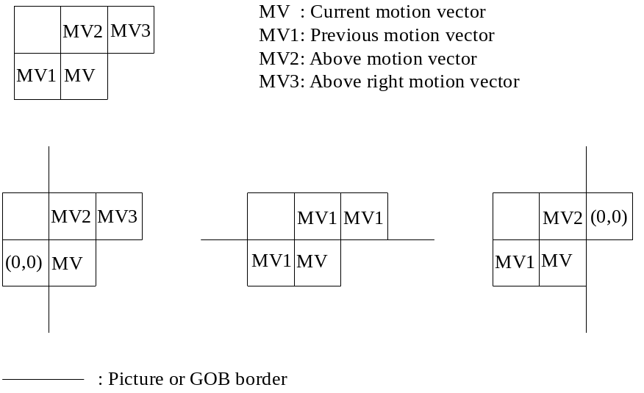
FIGURE 12/H.263
Motion vector prediction
Advantage is taken of the fact that the range of motion vector component values is constrained. Each VLC word for MVD represents a pair of difference values. Only one of the pair will yield a macroblock vector component falling within the permitted range [-16,15.5]. A positive value of the horizontal or vertical component of the motion vector signifies that the prediction is formed from pixels in the previous picture which are spatially to the right or below the pixels being predicted. If the unrestricted motion vector mode (see Annex D) is used, the decoding of motion vectors shall be performed as specified in section D.2.
The motion vector is used for all pixels in all four luminance blocks in the macroblock. Motion vectors for both chrominance blocks are derived by dividing the component values of the macroblock vector by two, due to the lower chrominance format. The component values of the resulting quarter pixel resolution vectors are modified towards the nearest half pixel position as indicated in Table 1
8.
TABLE 18/H.263
Modification of quarter pixel resolution chrominance vector components
quarter pixel position | 0 | 1/4 | 1/2 | 3/4 | 1
resulting position | 0 | 1/2 | 1/2 | 1/2 | 1

6.1.2. Interpolation for subpixel prediction
Half pixel values are found using bilinear interpolation as described in Figure 13. “/” indicates division by truncation.
The value of RCONTROL is equal to the value of the rounding type (RTYPE) bit (bit 6) in MPPTYPE (see section 5.1.4.3), when the Source Format field (bits 6-8) in PTYPE indicates “extended PTYPE”. Otherwise RCONTROL has an implied value of 0. Regardless of the RTYPE bit, the value of RCONTROL is set to 0 for the B-part of Improved PB frames (see Annex M).

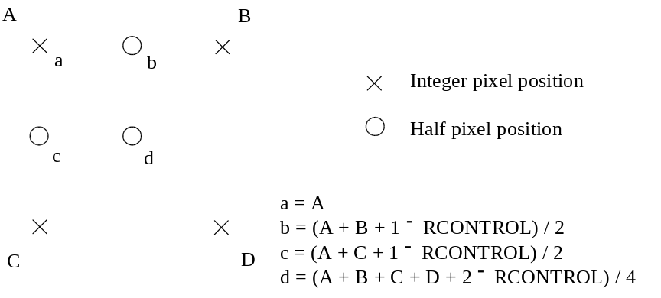
FIGURE 13/H.263
Halfpixel prediction by bilinear interpolation

6.2. Coefficients decoding

6.2.1. Inverse Quantization
The inverse quantization process is described in this section, except for when the optional Advanced Intra Coding mode is in use (see Annex I). If LEVEL = “0”, the reconstruction level REC = “0”. The reconstruction level of INTRADC is given by Table 15. The reconstruction levels of all non-zero coefficients other than the INTRADC one are given by the following formulas:
|REC| = QUANT · (2 · |LEVEL| + 1) if QUANT = “odd”
|REC| = QUANT · (2 · |LEVEL| + 1) - 1 if QUANT = “even”
Note that this process disallows even valued numbers. This has been found to prevent accumulation of IDCT mismatch errors. After calculation of |REC|, the sign is added to obtain REC: REC = sign(LEVEL) · |REC|
Sign(LEVEL) is given by the last bit of the TCOEF code (see Table 1
6) or by Table 17.

6.2.2. Clipping of reconstruction levels
After inverse quantization, the reconstruction levels of all coefficients other than the INTRADC one are clipped to the range -2048 to 2047.

6.2.3. Zig-zag positioning
The quantized transform coefficients are placed into an 8x8 block according to the sequence given in Figure 14, unless the optional Advanced Intra Coding mode is in use (see Annex I). Coefficient 1 is the dc-coefficient.

1 | 2 | 6 | 7 | 15 | 16 | 28 | 29
3 | 5 | 8 | 14 | 17 | 27 | 30 | 43
4 | 9 | 13 | 18 | 26 | 31 | 42 | 44
10 | 12 | 19 | 25 | 32 | 41 | 45 | 54
11 | 20 | 24 | 33 | 40 | 46 | 53 | 55
21 | 23 | 34 | 39 | 47 | 52 | 56 | 61
22 | 35 | 38 | 48 | 51 | 57 | 60 | 62
36 | 37 | 49 | 50 | 58 | 59 | 63 | 64
FIGURE 14/H.263
Zig-zag positioning of quantized transform coefficients

6.2.4. Inverse transform
After inverse quantization and zigzag of coefficients, the resulting 8x8 blocks are processed by a separable two-dimensional inverse discrete cosine transform of size 8 by 8. The output from the inverse transform ranges from
-256 to +255 after clipping to be represented with 9 bits. The transfer function of the inverse transform is given by:
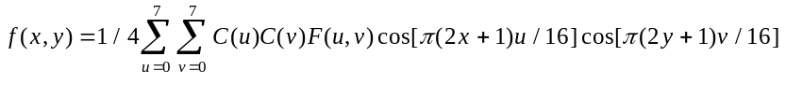
with u, v, x, y = 0, 1, 2, . . ., 7
where x,y = spatial coordinates in the pixel domain,
u,v = coordinates in the transform domain,
C(u) = for u = 0, otherwise 1,
C(v) = for v = 0, otherwise 1.
Note – Within the block being transformed, x = 0 and y = 0 refer to the pixel nearest the left and top edges of the picture respectively.
The arithmetic procedures for computing the inverse transform are not defined, but should meet the error tolerance specified in Annex A.

6.3. Reconstruction of blocks

6.3.1. Summation
After motion compensation and coefficients decoding (inverse transform included), a reconstruction is formed for each luminance and chrominance block. For INTRA blocks, the reconstruction is equal to the result of the inverse transformation. For INTER blocks, the reconstruction is formed by summing the prediction and the result of the inverse transformation. The summation is performed on a pixel basis.
For the summation in the Reduced-Resolution Update mode refer to Annex Q.

6.3.2. Clipping
To prevent quantization distortion of transform coefficient amplitudes causing arithmetic overflow in the encoder and decoder loops, clipping functions are inserted. The clipper operates after the summation of prediction and reconstructed prediction error on resulting pixel values less than 0 or greater than 255, changing them to 0 and 255 respectively.
Annex A.
Inverse transform accuracy specification
(This annex forms an integral part of this Recommendation.)
A.1. Generate random integer pixel data values in the range −L to +H according to the random number generator given below (“C” version). Arrange into 8 by 8 blocks. Data set of 10 000 blocks should each be generated for (L = 256, H = 255), (L = H = 5) and (L = H = 300).

A.2. For each 8 by 8 block, perform a separable, orthonormal, matrix multiply, forward discrete cosine transform using at least 64-bit floating point accuracy.
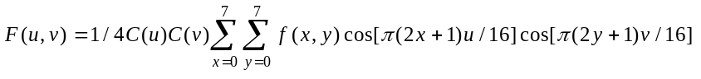
with u, v, x, y = 0, 1, 2, . . .,7
where x,y = spatial coordinates in the pixel domain,
u,v = coordinates in the transform domain,
C(u) = for u = 0, otherwise 1,
C(v) = for v = 0, otherwise 1.

A.3. For each block, round the 64 resulting transformed coefficients to the nearest integer values. Then clip them to the range −2048 to +2047. This is the 12-bit input data to the inverse transform.

A.4. For each 8 by 8 block of 12-bit data produced by § A.3, perform a separable, orthonormal, matrix multiply, inverse discrete transform (IDCT) using at least 64-bit floating point accuracy. Round the resulting pixels to the nearest integer and clip to the range −256 to +255. These blocks of 8 × 8 pixels are the reference IDCT output data.

A.5. For each 8 by 8 block produced by § A.3, apply the IDCT under test and clip the output to the range −256 to +255. These blocks of 8 × 8 pixels are the test IDCT output data.

A.6. For each of the 64 IDCT output pixels, and for each of the 10,000 block data sets generated above, measure the peak, mean and mean square error between the reference and the test data.

A.7. For any pixel, the peak error should not exceed 1 in magnitude.
For any pixel, the mean square error should not exceed 0.06.
Overall, the mean square error should not exceed 0.02.
For any pixel, the mean error should not exceed 0.015 in magnitude.
Overall, the mean error should not exceed 0.0015 in magnitude.

A.8. All zeros in shall produce all zeros out.

A.9. Re-run the measurements using exactly the same data values of step 1, but change the sign on each pixel.

"C" program for random number generation

/* L and H shall be long, that is 32 bits */
long rand (L,H)
long L,H;
{
static long randx = 1; /* long is 32 bits */
static double z = (double) 0x7fffffff;
long i,j;
double x; /* double is 64 bits */
randx = (randx * 1103515245) + 12345;
i = randx & 0x7ffffffe; /* keep 30 bits */
x = ( (double)i ) / z; /* range 0 to 0.99999 ... */
x *= (L+H+1); /* range 0 to < L+H+1 */
j = x; /* truncate to integer */
return(j - L); /* range -L to H */
}

Annex B.
Hypothetical Reference Decoder
(This annex forms an integral part of this Recommendation.)
The Hypothetical Reference Decoder (HRD) is defined as follows.
B.1. The HRD and the encoder have the same clock frequency as well as the same picture clock frequency, and are operated synchronously.
B.2. The HRD receiving buffer size is (B + BPPmaxKb * 1024 bits) where (BPPmaxKb * 1024) is the maximum number of bits per picture that has been negotiated for use in the bitstream (see section 3.6). The value of B is defined as follows:
B = 4 . Rmax / PCF
where PCF is the effective picture clock frequency, and Rmax is the maximum video bitrate during the connection in bits per second. The effective picture clock frequency is the standard CIF picture clock frequency unless a custom PCF is specified in the CPCFC field of the picture header. This value for B is a minimum. An encoder may use a larger value for B, provided the larger number is first negotiated by external means, for example Recommendation H.245.
The value for R_{max} depends on the system configuration (for example GSTN or ISDN, single or multi-link) and may be equal to the maximum bitrate supported by the physical link. Negotiation of R_{max} is done by external means, for example Recommendation H.245.
B.3. The HRD is initially empty.
B.4. The HRD buffer is examined at picture clock intervals (1000 / PCF ms). If at least one complete coded picture is in the buffer then all the data for the earliest picture in bitstream order is instantaneously removed (e.g. at tn+1 in Figure B.1). Immediately after removing the above data the buffer occupancy must be less than B. This is a requirement on the coder output bitstream including coded picture data and MCBPC and STUF stuffing but not error correction framing bits, fill indicator (Fi), fill bits or error correction parity information described in Annex H.
For the purposes of this definition, unless the optional Temporal, SNR, and Spatial Scalability mode is in use, a complete coded picture is one normal I- or P-picture, or a PB-frame or Improved PB-frame.
When the Temporal, SNR, and Spatial Scalability mode is in use (see Annex O), each enhancement layer is given an additional HRD, for which a complete coded picture is one EI, EP, or B picture. The base layer buffer shall hold the bits of the picture header as they arrive, until a sufficient amount of the picture header has arrived to determine whether the picture is a base layer or enhancement layer picture, and the number of the enhancement layer. When it can be determined that the arriving picture belongs to an enhancement layer, all bits for that picture shall be instantly transferred to the appropriate enhancement layer HRD, and any later bits which arrive continue to be placed into the enhancement layer HRD until a sufficient amount of some new picture header has arrived to determine that the bistream should again be re-routed into another HRD buffer. The process of enhancement layer identification is instantaneous and asynchronous, independent of the picture clock interval checking times.
To meet this requirement the number of bits for the (n+1)th coded picture dn+1 must satisfy:
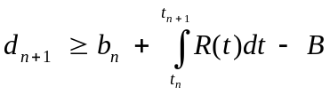
where
bn is the buffer occupancy just after time tn;
tn is the time the nth coded picture is removed from the HRD buffer;
R(t) is the video bitrate at time t.

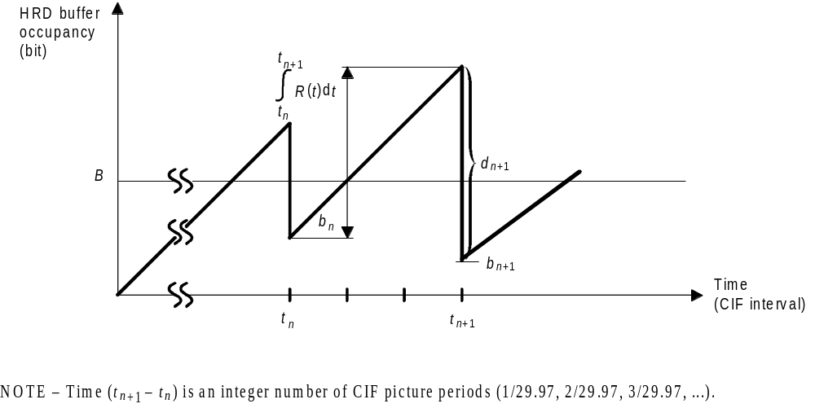
FIGURE B.1/H.263
HRD buffer occupancy

Annex C.
Considerations for Multipoint
(This annex forms an integral part of this Recommendation.)
The following facilities are provided to support switched multipoint operation.

C.1. Freeze picture request
Causes the decoder to freeze its displayed picture until a freeze picture release signal is received or a time-out period of at least six seconds has expired. The transmission of this signal is by external means (for example Recommendation H.245).

C.2. Fast update request
Causes the encoder to encode its next picture in INTRA mode with coding parameters such as to avoid buffer overflow. The transmission method for this signal is by external means (for example Recommendation H.245).

C.3. Freeze picture release
A signal from an encoder which has responded to a fast update request and allows a decoder to exit from its freeze picture mode and display decoded pictures in the normal manner. This signal is transmitted by PTYPE (see § 5.1.3) in the picture header of the first picture coded in response to the fast update request.

C.4. Continuous Presence Multipoint and Video Multiplexing (CPM) (not used for H.324)
In H.263 a negotiable Continuous Presence Multipoint and Video Multiplexing mode is provided in which up to four independent H.263 bitstreams can be multiplexed as independent ‘Sub-Bitstreams’ in one new video bitstream with use of the PSBI and GSBI fields. Capability exchange for this mode is done by external means (for example Recommendation H.242). Reference Picture Selection back-channel data for responding to independent Sub-Bitstreams is supported using the BCPM and BSBI fields.
When in CPM mode, the CPM field shall be set to “1” in each of the independent H.263 bitstreams. Sub-Bitstreams are identified by a stream identifier number sent in the Sub-Bitstream indicators (SBIs) in the Picture and GOB or slice headers of each H.263 bitstream. The SBI indicates the number of the H.263 bitstream to which that header and all following information until the next Picture or GOB header or slice header in the composed video bitstream belongs.
Each Sub-Bitstream is considered as a normal H.263 bitstream and shall therefore comply to the capabilities that are exchanged by external means. The information for the different H.263 bitstreams is not transmitted in any special predefined order, an SBI can have any value independent from preceding SBIs and the picture rates for the different H.263 bitstreams may be different. The information in each individual bitstream is also completely independent from the information in the other bitstreams (with one restriction as described in section C.4.2). For example, the GFID codewords in one Sub-Bitstream are not influenced by GFID or PTYPE codewords in other Sub-Bitstreams. Similarly, the mode state inference rules when using an extended picture type (PLUSPTYPE) in the picture header and all other aspects of the video bitstream operation shall operate independently and separately for each Sub-Bitstream.
As a matter of convention, the Sub-Bitstream with the lowest stream identifier number (sent in SBI) is considered to have the highest priority in situations in which some conflict of resource requirements may necessitate a choice of priority (unless a different priority convention is established by external means).

C.4.1. End Of Sub-Bitstream codes (EOSBS0, EOSBS1, EOSBS2, and EOSBS3) (22 bits each)
When operating in CPM mode, four optional additional codewords may be used, which provide the same function as the EOS code, but mark the end of each sub-bitstream rather than the end of the entire stream. These are the EOSBS codes, denoted EOSBSi. One EOSBS is available for each stream identifier number (i = 0, 1, 2, or 3, as sent in SBI). The EOSBS codes signify that the end of the associated sub-bitstream is indicated, such that any subsequent picture(s) with the same stream identifier number (SBI) shall be distinct and independent from the prior data. See Table C.1/H.263 for the EOSBS codes. The transmission of an EOS code corresponds to sending EOSBS codes for all active sub-bitstreams, and thus makes EOSBS redundant at the end of a video session.
Each EOSBS code is a codeword of 22 bits. It is up to the encoder to insert this codeword or not. EOSBS codes should not be sent unless at least one picture header has previously been sent for the same sub-bitstream. EOSBS codes may be byte aligned. This can be achieved by inserting ESTUF before the EOSBS start code such that the first bit of the EOSBS start code is the first (most significant) bit of a byte.
Control and other information associated with the video bitstream in general without specification of which sub-bitstreams these codes are meant to apply (such as a Freeze Picture Request or a Fast Update Request) should be presumed to apply to only the active sub-bitstreams. A sub-bitstream is considered active if at least one picture start code has been received for the sub-bitstream and the last data sent for that sub-bitstream was not an EOS or EOSBS code.
TABLE C.1/H.263
EOSBS codes (may be used when CPM = “1”)
Sub-Bitstream Identifier (SBI) | End of Sub-Bitstream Code Name | Codeword Binary Value | Corresponding Group Number
0 | EOSBS0 | 0000 0000 0000 0000 1 11011 | 27
1 | EOSBS1 | 0000 0000 0000 0000 1 11100 | 28
2 | EOSBS2 | 0000 0000 0000 0000 1 11101 | 29
3 | EOSBS3 | 0000 0000 0000 0000 1 11110 | 30

C.4.2. Restriction regarding Slice and GOB interaction
The only syntactical restriction regarding the operation of the various Sub-Bitstreams is a requirement that none of the active Sub-Bitstreams shall use the Slice Structured mode (see Annex K) unless all of the active Sub-Bitstreams use the Slice Structured mode. A sub-bitstream is considered active if at least one picture start code has been received for the sub-bitstream and the last data sent for that sub-bitstream was not an EOS or EOSBS code. The purpose of this restriction is to prevent situations in which a slice header for one Sub-Bitstream may be interpreted as a GOB header for another Sub-Bitstream (or vice versa).

Annex D.
Unrestricted Motion Vector mode
(This annex forms an integral part of this Recommendation.)
This annex describes the optional Unrestricted Motion Vector mode of H.263. The capability of this mode of H.263 is signalled by external means (for example Recommendation H.245). The use of this mode is indicated in PTYPE or PLUSPTYPE.
The range of motion vectors and the VLC table used for coding the motion vector differences for the Unrestricted Motion Vector mode depend on whether the PLUSPTYPE field of the picture header is present. When PLUSPTYPE is present, the range of motion vectors also depends on the picture size and the value of the UUI field in the picture header.

D.1. Motion vectors over picture boundaries
In the default prediction mode of H.263, motion vectors are restricted such that all pixels referenced by them are within the coded picture area (see section 4.2.3). In the Unrestricted Motion Vector mode however this restriction is removed and therefore motion vectors are allowed to point outside the picture. When a pixel referenced by a motion vector is outside the coded picture area, an edge pixel is used instead. This edge pixel is found by limiting the motion vector to the last full pixel position inside the coded picture area. Limitation of the motion vector is performed on a pixel basis and separately for each component of the motion vector.
For example, if the Unrestricted Motion Vector mode is used for a QCIF picture, the referenced pixel value for the luminance component is given by the following formula:
Rumv(x, y) = R(x', y'),
where
x, y, x', y' = spatial coordinates in the pixel domain,
Rumv(x, y) = pixel value of the referenced picture at (x, y) when in Unrestricted Motion Vector mode,
R(x', y') = pixel value of the referenced picture at (x', y') when in Unrestricted Motion Vector mode,

x' = 0 if x < 0
= 175 if x > 175
= x otherwise,

y' = 0 if y < 0
= 143 if y > 143
= y otherwise,
and the coded picture area of R(x', y') is 0 <= x' <= 175, 0 <= y' <= 143. The given boundaries are integer pixel positions; however, (x’,y’) can also be a half pixel position within these boundaries.

D.1.1. Restrictions for motion vector values
If PLUSPTYPE is present in the picture header, the motion vector values are restricted such that no element of the 16×16 (or 8×8) region that is selected shall have a horizontal or vertical distance more than 15 pixels outside the coded picture area. Note that this is a smaller extrapolation range than when PLUSPTYPE is not present.
Note — When PLUSPTYPE is absent, the extrapolation range is a maximum of 31.5 pixels outside the coded picture area when the Unrestricted Motion Vector mode is used, and 16 pixels outside the coded picture area when the Advanced Prediction mode (see Annex F) is used without the Unrestricted Motion Vector mode.

D.2. Extension of the motion vector range
In the default prediction mode, the values for both horizontal and vertical components of the motion vectors are restricted to the range [-16,15.5] (this is also valid for the forward and backward motion vector components for B-pictures). In the Unrestricted Motion Vector mode however, the maximum range for vector components is extended.
If the PLUSPTYPE field is not present in the picture header, the motion vector range is extended to [-31.5,31.5], with the restriction that only values that are within a range of [-16,15.5] around the predictor for each motion vector component can be reached if the predictor is in the range [-15.5,16]. If the predictor is outside [-15.5,16], all values within the range [-31.5,31.5] with the same sign as the predictor plus the zero value can be reached. So, if MV_{C} is the motion vector component and P_{C} is the predictor for it, then
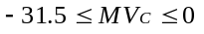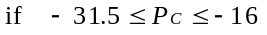
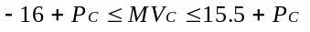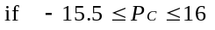
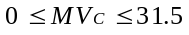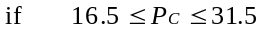
In the Unrestricted Motion Vector mode, the interpretation of Table 14 for MVD, MVD₂₋₄ and MVDB is as follows:
- If the predictor for the motion vector component is in the range [-15.5,16], only the first column of vector differences applies;
- If the predictor for the motion vector component is outside the range [-15.5,16], the vector difference from Table 14 shall be used that results in a vector component inside the range [-31.5,31.5] with the same sign as the predictor (including zero).
The predictor for MV_{D} and MVD₂₋₄ is defined as the median value of the vector components MV1, MV2 and MV3 as defined in section 6.1.1 and F.2. For MVDB the predictor P_{C} = (TR_{B} x MV) / TR_{D} where MV represents a vector component for an 8*8 luminance block in a P-picture (see also section G.4).
If PLUSPTYPE is present, the motion vector range does not depend on the motion vector prediction value. If the UUI field is set to ”1” the motion vector range depends on the picture format. For standardized picture formats up to CIF the range is [-32,32], for those up to 4CIF the range is [-64,64], and for those up to 16CIF the range is [-128,128], and for even larger custom picture formats the range is [-256,256]. The horizontal and vertical motion vector ranges may be different for custom picture formats. The horizontal and vertical ranges are specified in Tables D.1 and D.2.
TABLE D.1/H.263
Horizontal Motion Vector Range when PLUSPTYPE present and UUI = 1
Picture width | Horizontal motion vector range
4, …, 352 | [-32,32]
356, …, 704 | [-64,64]
708, …, 1408 | [-128,128]
1412 ,…, 2048 | [-256,256]
TABLE D.2/H.263
Vertical Motion Vector Range when PLUSPTYPE present and UUI = 1
Picture height | Vertical motion vector range
4, …, 288 | [-32,32]
292, …, 576 | [-64,64]
580, …, 1152 | [-128,128]

In the Reduced-Resolution Update mode, the specified range applies to the pseudo motion vectors. This implies that the resulting actual motion vector range is enlarged to approximately double size (see also Annex Q).
If UUI is set to ”01”, the motion vectors are not limited except by their distance to the coded area border as explained in section D.1.1. The same limitation applies to the actual motion vectors (not just the pseudo motion vectors) in the Reduced-Resolution Update mode.
To encode the motion vectors when PLUSPTYPE is present, Table D.3 is used to encode the difference between the motion vector and the motion vector prediction. Every entry in Table D.3 has a single value (in contrast to Table 14). The motion vector range and the use of Table D.3 to encode motion vector data apply to all picture types when PLUSPTYPE is present.
Motion vectors differences are always coded as a pair of a horizontal and a vertical component. If a pair equals (0.5,0.5) six consecutive zeros are produced. To prevent start code emulation, this occurrence shall be followed by one bit set to ”1”. This corresponds to sending one additional zero motion vector component.
TABLE D.3/H.263
Motion Vector Table used when PLUSPTYPE present
Absolute value of vector difference  in half-pixel units | number of bits | Codes
0 | 1 | 1
1 | 3 | 0s0
“x₀”+2 (2:3) | 5 | 0x₀1s0
“x₁x₀”+4 (4:7) | 7 | 0x₁1x₀1s0
“x₂x₁x₀”+8 (8:15) | 9 | 0x₂1x₁1x₀1s0
“x₃x₂x₁x₀”+16 (16:31) | 11 | 0x₃1x₂1x₁1x₀1s0
“x₄x₃x₂x₁x₀”+32 (32:63) | 13 | 0x₄1x₃1x₂1x₁1x₀1s0
“x₅x₄x₃x₂x₁x₀”+64 (64:127) | 15 | 0x₅1x₄1x₃1x₂1x₁1x₀1s0
“x₆x₅x₄x₃x₂x₁x₀”+128 (128:255) | 17 | 0x₆1x₅1x₄1x₃1x₂1x₁1x₀1s0
“x₇x₆x₅x₄x₃x₂x₁x₀”+256 (256:511) | 19 | 0x₇1x₆1x₅1x₄1x₃1x₂1x₁1x₀1s0
“x₈x₇x₆x₅x₄x₃x₂x₁x₀”+512 (512:1023) | 21 | 0x₈1x₇1x₆1x₅1x₄1x₃1x₂1x₁1x₀1s0
“x₉x₈x₇x₆x₅x₄x₃x₂x₁x₀”+1024 (1024:2047) | 23 | 0x₉1x₈1x₇1x₆1x₅1x₄1x₃1x₂1x₁1x₀1s0
“x₁₀x₉x₈x₇x₆x₅x₄x₃x₂x₁x₀”+2048 (2048:4095) | 25 | 0x₁₀1x₉1x₈1x₇1x₆1x₅1x₄1x₃1x₂1x₁1x₀1s0

Table D.3 is a regularly constructed reversible table. Each row represents an interval of motion vector differences in half-pixel units. The bits “…x₁x₀” denote all bits following the leading “1” in the binary representation of the absolute value of the motion vector difference. The bit “s” denotes the sign of the motion vector difference, “0” for positive and “1” for negative. The binary representation of the motion vector difference is interleaved with bits that indicate if the code continues or ends. For example, the motion vector difference −13 has sign s=1 and binary representation 1x₂x₁x₀ =1101. It is encoded as 0 x₂1 x₁1 x₀1 s0 = 0 11 11 01 10. The 0 in the second position of the last group of two bits indicates the end of the code.

Annex E.
Syntax-based Arithmetic Coding mode
(This annex forms an integral part of this Recommendation.)

E.1. Introduction
In the variable length coding/decoding (VLC/VLD) as described in section 5 of this Recommendation, a symbol is VLC encoded using a specific table based on the syntax of the coder. This table typically stores lengths and values of the VLC code words. The symbol is mapped to an entry of the table in a table look-up operation, and then the binary code word specified by the entry is sent out normally to a buffer for transmitting to the receiver. In VLD decoding, the received bitstream is matched entry by entry in a specific table based on the syntax of the coder. This table must be the same as the one used in the encoder for encoding the current symbol. The matched entry in the table is then mapped back to the corresponding symbol which is the end result of the VLD decoder and is then used for recovering the video pictures. This VLC/VLD process implies that each symbol must be encoded into a fixed integral number of bits. Removing this restriction of fixed integral number of bits for symbols can lead to reductions of resulting bitrates, which can be achieved by arithmetic coding.
This Annex describes the optional Syntax-based Arithmetic Coding (SAC) mode of H.263. In this mode, all the corresponding variable length coding/decoding operations of H.263 are replaced with arithmetic coding/decoding operations. The capability of this mode of H.263 is signalled by external means (for example Recommendation H.245). The use of this mode is indicated in PTYPE.

E.2. Specification of SAC encoder
In SAC mode, a symbol is encoded by using a specific array of integers (or a model) based on the syntax of the coder and by calling the following procedure which is specified in C.

#define q1 16384
#define q2 32768
#define q3 49152
#define top 65535
static long low, high, opposite_bits, length;
void encode_a_symbol(int index, int cumul_freq[ ])
{
length = high - low + 1;
high = low - 1 + (length * cumul_freq[index]) / cumul_freq[0];
low += (length * cumul_freq[index+1]) / cumul_freq[0];
for ( ; ; ) {
if (high < q2) {
send out a bit “0” to PSC_FIFO;
while (opposite_bits > 0) {
send out a bit “1” to PSC_FIFO;
opposite_bits--;
}
}
else if (low >= q2) {
send out a bit “1” to PSC_FIFO;
while (opposite_bits > 0) {
send out a bit “0” to PSC_FIFO;
opposite_bits--;
}
low -= q2;
high -= q2;
}
else if (low >= q1 && high < q3) {
opposite_bits += 1;
low -= q1;
high -= q1;
}
else break;
low *= 2;
high = 2*high+1;
}
}
The values of low, high and opposite_bits are initialized to 0, top and 0, respectively. PSC_FIFO is a FIFO for buffering the output bits from the arithmetic encoder. The model is specified through cumul_freq[ ], and the symbol is specified using its index in the model.

E.3. Specification of SAC decoder
In SAC decoder, a symbol is decoded by using a specific model based on the syntax and by calling the following procedure which is specified in C.

static long low, high, code_value, bit, length, index, cum;
int decode_a_symbol(int cumul_freq[ ])
{
length = high - low + 1;
cum = (-1 + (code_value - low + 1) * cumul_freq[0]) / length;
for (index = 1; cumul_freq[index] > cum; index++);
high = low - 1 + (length * cumul_freq[index-1]) / cumul_freq[0];
low += (length * cumul_freq[index]) / cumul_freq[0];
for ( ; ; ) {
if (high < q2) ;
else if (low >= q2) {
code_value -= q2;
low -= q2;
high -= q2;
}
else if (low >= q1 && high < q3) {
code_value -= q1;
low -= q1;
high -= q1;
}
else break;
low *= 2;
high = 2*high + 1;
get bit from PSC_FIFO;
code_value = 2*code_value + bit;
}
return (index-1);
}
Again the model is specified through cumul_freq[ ]. The decoded symbol is returned through its index in the model. PSC_FIFO is a FIFO for buffering the incoming bitstream. The decoder is initialized to start decoding an arithmetic coded bitstream by calling the following procedure.

void decoder_reset( )
{
code_value = 0;
low = 0;
high = top;
for (int i = 1; i <= 16; i++) {
get bit from PSC_FIFO;
code_value = 2 * code_value + bit;
}
}

E.4. Syntax
As in VLC table mode of H.263, the syntax of the symbols is partitioned into four layers: Picture, Group of Blocks, Macroblock and Block. The syntax of the top three layers remain exactly the same. The syntax of the Block layer also remains quite similar, but is illustrated in Figure E.1.
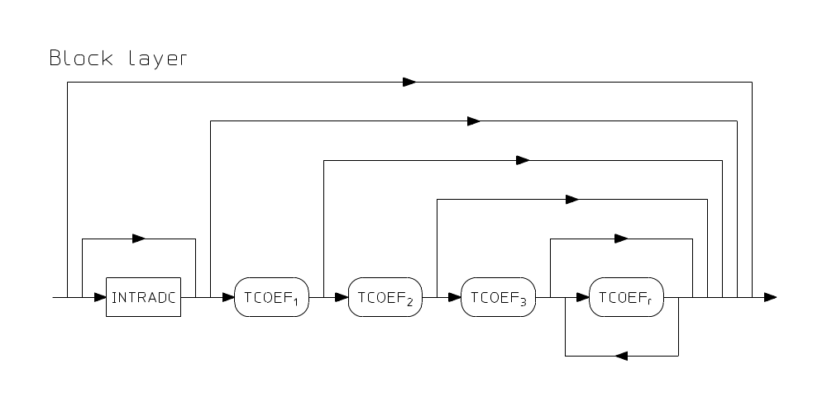
FIGURE E.1/H.263
Structure of SAC Block layer
In Figure E.1, TCOEF1, TCOEF2, TCOEF3 and TCOEFr are Last-Run-Level symbols as defined in section 5.4.2, and are the possible 1st, 2nd, 3rd and rest of the symbols, respectively. TCOEF1, TCOEF2, TCOEF3 and TCOEFr are only present when one, two, three or more coefficients are present in the block layer, respectively.

E.5. PSC_FIFO
PSC_FIFO in encoder or decoder is a FIFO of size > 17 bits. In PSC_FIFO of encoder, illegal emulations of PSC and GBSC are located and are avoided by stuffing a “1” after each successive appearance of 14 “0”s (which are not part of PSC or GBSC). In PSC_FIFO of the decoder, the first “1” after each string of 14 “0”s is deleted; if instead a string of 14 “0”s is followed by a “0”, it indicates that a legal PSC or GBSC is detected. The exact location of the PSC or GBSC is determined by the next “1” following the string of zeros.

E.6. Fixed Length Symbols
Fixed length symbols form three possible strings, PSC--TR--PTYPE--PQUANT--CPM--(PSBI)--(TRB-DBQUANT)--PEI--(PSUPP--PEI--...), (GSTUF)--GBSC--GN--(GSBI)--GFID--GQUANT, and (ESTUF)--(EOS)--(PSTUF). These strings are directly sent to PSC_FIFO as in the normal VLC table mode of H.263 at encoder side, and are directly sent out from PSC_FIFO in the decoder after a legal PSC or GBSC or EOS is detected.
If a fixed length symbol string is not the first in a video session, the arithmetic encoder needs to be reset before sending the fixed length symbol string by calling the following procedure. This procedure shall also be called at the end of a video session or before EOS.

void encoder_flush( )
{
opposite_bits++;
if (low < q1) {
send out a bit “0” to PSC_FIFO;
while (opposite_bits > 0) {
send out a bit “1” to PSC_FIFO;
opposite_bits--;
}
}
else {
send out a bit “1” to PSC_FIFO;
while (opposite_bits > 0) {
send out a bit “0” to PSC_FIFO;
opposite_bits--;
}
}
low = 0;
high = top;
}
In the decoder, after each fixed length symbol string, procedure decoder_reset is called.

E.7. Non-Fixed Length Symbols
Models for the non-fixed length symbols are included in section E8. The indices as given in the VLC tables of section 5 are used for the indexing of the integers in the models.
The model for COD in P-pictures is named cumf_COD.. The index for COD being “0” is 0, and is 1 for COD being “1”.
The model for MCBPC in P pictures is named cumf_MCBPC_no4MVQ unless PLUSPTYPE is present in the picture header and either the Advanced Prediction mode (Annex F) or the Deblocking Filter mode (Annex J) is in use, in which case the model is named cumf_MCBPC_4MVQ The indexes for MCBPC are defined in Table 7 for I-pictures and Table 8 for P-pictures. The model for MCBPC in I-pictures is named by cumf_MCBPC_intra.
The model for MODB is cumf_MODB_G if Annex G is used or cumf_MODB_M if Annex M is used. The indexes for MODB are defined in Table 11 or Table M.1, respectively. The model for CBPBn, n=1,2,...,4, is cumf_YCBPB, and the model for CBPBn, n=5,6, is cumf_UVCBPB, with index 0 for CBPBn=0 and index 1 for CBPBn=1.
The model for CBPY is cumf_CBPY in INTER macroblocks and cumf_CBPY_intra in INTRA macroblocks. The model for DQUANT is cumf_DQUANT. The indexing for CBPY and DQUANT is defined in Tables 13 and 12, respectively.
The model for MVD, MVD2-4 and MVDB is cumf_MVD and the model for INTRADC is cumf_INTRADC. The indexing is defined in Tables 14 and 15, respectively.
A non-escaped TCOEF consists of a symbol for TCOEF1/2/3/r followed by a symbol, SIGN, for the sign of the TCOEF. The models for TCOEF1, TCOEF2, TCOEF3 and TCOEFr in INTER blocks are cumf_TCOEF1, cumf_TCOEF2, cumf_TCOEF3, cumf_TCOEFr. The models for INTRA blocks are cumf_TCOEF1_intra, cumf_TCOEF2_intra, cumf_TCOEF3_intra, cumf_TCOEFr_intra. For all TCOEFs the indexing is defined in Table 16. The model for SIGN is cumf_SIGN. The indexing for SIGN is 0 for positive sign and 1 for negative sign.
The models for LAST, RUN, LEVEL after ESCAPE are cumf_LAST (cumf_LAST_intra), cumf_RUN (cumf_RUN_intra), cumf_LEVEL (cumf_LEVEL_intra) for INTER (INTRA) blocks. The indexing for LAST is 0 for LAST=0 and 1 for LAST=1, while the indexing for RUN and LEVEL is defined in Table 17.
The model for INTRA_MODE is cumf_INTRA_AC_DC. The indexing is defined in Table I.1.

E.8. SAC Models
int cumf_COD[3]={16383, 6849, 0};

int cumf_MCBPC_no4MVQ[22]={16383, 4105, 3088, 2367, 1988, 1621, 1612, 1609, 1608, 496, 353, 195, 77, 22, 17, 12, 5, 4, 3, 2, 1, 0};

int cumf_MCBPC_4MVQ[26]={16383, 6880, 6092, 5178, 4916, 3965, 3880, 3795, 3768, 1491, 1190, 889, 655, 442, 416, 390, 360, 337, 334, 331, 327, 326, 88, 57, 26, 0};

int cumf_MCBPC_intra[10]={16383, 7410, 6549, 5188, 442, 182, 181, 141, 1, 0};

int cumf_MODB_G[4]={16383, 6062, 2130, 0};

int cumf_MODB_M[7] = {16383, 6717, 4568, 2784, 1370, 655, 0};

int cumf_YCBPB[3]={16383, 6062, 0};

int cumf_UVCBPB[3]={16383, 491, 0};

int cumf_CBPY[17]={16383, 14481, 13869, 13196, 12568, 11931, 11185, 10814, 9796, 9150, 8781, 7933, 6860, 6116, 4873, 3538, 0};

int cumf_CBPY_intra[17]={16383, 13619, 13211, 12933, 12562, 12395, 11913, 11783, 11004, 10782, 10689, 9928, 9353, 8945, 8407, 7795, 0};

int cumf_DQUANT[5]={16383, 12287, 8192, 4095, 0};

int cumf_MVD[65]={16383, 16380, 16369, 16365, 16361, 16357, 16350, 16343, 16339, 16333, 16326, 16318, 16311, 16306, 16298, 16291, 16283, 16272, 16261, 16249, 16235, 16222, 16207, 16175, 16141, 16094, 16044, 15936, 15764, 15463, 14956, 13924, 11491, 4621, 2264, 1315, 854, 583, 420, 326, 273, 229, 196, 166, 148, 137, 123, 114, 101, 91, 82, 76, 66, 59, 53, 46, 36, 30, 26, 24, 18, 14, 10, 5, 0};

int cumf_INTRADC[255]={16383, 16380, 16379, 16378, 16377, 16376, 16370, 16361, 16360, 16359, 16358, 16357, 16356, 16355, 16343, 16238, 16237, 16236, 16230, 16221, 16220, 16205, 16190, 16169, 16151, 16130, 16109, 16094, 16070, 16037, 16007, 15962, 15938, 15899, 15854, 15815, 15788, 15743, 15689, 15656, 15617, 15560, 15473, 15404, 15296, 15178, 15106, 14992, 14868, 14738, 14593, 14438, 14283, 14169, 14064, 14004, 13914, 13824, 13752, 13671, 13590, 13515, 13458, 13380, 13305, 13230, 13143, 13025, 12935, 12878, 12794, 12743, 12656, 12596, 12521, 12443, 12359, 12278, 12200, 12131, 12047, 12002, 11948, 11891, 11828, 11744, 11663, 11588, 11495, 11402, 11288, 11204, 11126, 11039, 10961, 10883, 10787, 10679, 10583, 10481, 10360, 10227, 10113, 9961, 9828, 9717, 9584, 9485, 9324, 9112, 9019, 8908, 8766, 8584, 8426, 8211, 7920, 7663, 7406, 7152, 6904, 6677, 6453, 6265, 6101, 5904, 5716, 5489, 5307, 5056, 4850, 4569, 4284, 3966, 3712, 3518, 3342, 3206, 3048, 2909, 2773, 2668, 2596, 2512, 2370, 2295, 2232, 2166, 2103, 2022, 1956, 1887, 1830, 1803, 1770, 1728, 1674, 1635, 1599, 1557, 1500, 1482, 1434, 1389, 1356, 1317, 1284, 1245, 1200, 1179, 1140, 1110, 1092, 1062, 1044, 1035, 1014, 1008, 993, 981, 954, 936, 912, 894, 876, 864, 849, 828, 816, 801, 792, 777, 756, 732, 690, 660, 642, 615, 597, 576, 555, 522, 489, 459, 435, 411, 405, 396, 387, 375, 360, 354, 345, 344, 329, 314, 293, 278, 251, 236, 230, 224, 215, 214, 208, 199, 193, 184, 178, 169, 154, 127, 100, 94, 73, 37, 36, 35, 34, 33, 32, 31, 30, 29, 28, 27, 26, 20, 19, 18, 17, 16, 15, 9, 0};

int cumf_TCOEF1[104]={16383, 13455, 12458, 12079, 11885, 11800, 11738, 11700, 11681, 11661, 11651, 11645, 11641, 10572, 10403, 10361, 10346, 10339, 10335, 9554, 9445, 9427, 9419, 9006, 8968, 8964, 8643, 8627, 8624, 8369, 8354, 8352, 8200, 8192, 8191, 8039, 8036, 7920, 7917, 7800, 7793, 7730, 7727, 7674, 7613, 7564, 7513, 7484, 7466, 7439, 7411, 7389, 7373, 7369, 7359, 7348, 7321, 7302, 7294, 5013, 4819, 4789, 4096, 4073, 3373, 3064, 2674, 2357, 2177, 1975, 1798, 1618, 1517, 1421, 1303, 1194, 1087, 1027, 960, 890, 819, 758, 707, 680, 656, 613, 566, 534, 505, 475, 465, 449, 430, 395, 358, 335, 324, 303, 295, 286, 272, 233, 215, 0};

int cumf_TCOEF2[104]={16383, 13582, 12709, 12402, 12262, 12188, 12150, 12131, 12125, 12117, 12113, 12108, 12104, 10567, 10180, 10070, 10019, 9998, 9987, 9158, 9037, 9010, 9005, 8404, 8323, 8312, 7813, 7743, 7726, 7394, 7366, 7364, 7076, 7062, 7060, 6810, 6797, 6614, 6602, 6459, 6454, 6304, 6303, 6200, 6121, 6059, 6012, 5973, 5928, 5893, 5871, 5847, 5823, 5809, 5796, 5781, 5771, 5763, 5752, 4754, 4654, 4631, 3934, 3873, 3477, 3095, 2758, 2502, 2257, 2054, 1869, 1715, 1599, 1431, 1305, 1174, 1059, 983, 901, 839, 777, 733, 683, 658, 606, 565, 526, 488, 456, 434, 408, 380, 361, 327, 310, 296, 267, 259, 249, 239, 230, 221, 214, 0};

int cumf_TCOEF3[104]={16383, 13532, 12677, 12342, 12195, 12112, 12059, 12034, 12020, 12008, 12003, 12002, 12001, 10586, 10297, 10224, 10202, 10195, 10191, 9223, 9046, 8999, 8987, 8275, 8148, 8113, 7552, 7483, 7468, 7066, 7003, 6989, 6671, 6642, 6631, 6359, 6327, 6114, 6103, 5929, 5918, 5792, 5785, 5672, 5580, 5507, 5461, 5414, 5382, 5354, 5330, 5312, 5288, 5273, 5261, 5247, 5235, 5227, 5219, 4357, 4277, 4272, 3847, 3819, 3455, 3119, 2829, 2550, 2313, 2104, 1881, 1711, 1565, 1366, 1219, 1068, 932, 866, 799, 750, 701, 662, 605, 559, 513, 471, 432, 403, 365, 336, 312, 290, 276, 266, 254, 240, 228, 223, 216, 206, 199, 192, 189, 0};

int cumf_TCOEFr[104]={16383, 13216, 12233, 11931, 11822, 11776, 11758, 11748, 11743, 11742, 11741, 11740, 11739, 10203, 9822, 9725, 9691, 9677, 9674, 8759, 8609, 8576, 8566, 7901, 7787, 7770, 7257, 7185, 7168, 6716, 6653, 6639, 6276, 6229, 6220, 5888, 5845, 5600, 5567, 5348, 5327, 5160, 5142, 5004, 4900, 4798, 4743, 4708, 4685, 4658, 4641, 4622, 4610, 4598, 4589, 4582, 4578, 4570, 4566, 3824, 3757, 3748, 3360, 3338, 3068, 2835, 2592, 2359, 2179, 1984, 1804, 1614, 1445, 1234, 1068, 870, 739, 668, 616, 566, 532, 489, 453, 426, 385, 357, 335, 316, 297, 283, 274, 266, 259, 251, 241, 233, 226, 222, 217, 214, 211, 209, 208, 0};

int cumf_TCOEF1_intra[104]={16383, 13383, 11498, 10201, 9207, 8528, 8099, 7768, 7546, 7368, 7167, 6994, 6869, 6005, 5474, 5220, 5084, 4964, 4862, 4672, 4591, 4570, 4543, 4397, 4337, 4326, 4272, 4240, 4239, 4212, 4196, 4185, 4158, 4157, 4156, 4140, 4139, 4138, 4137, 4136, 4125, 4124, 4123, 4112, 4111, 4110, 4109, 4108, 4107, 4106, 4105, 4104, 4103, 4102, 4101, 4100, 4099, 4098, 4097, 3043, 2897, 2843, 1974, 1790, 1677, 1552, 1416, 1379, 1331, 1288, 1251, 1250, 1249, 1248, 1247, 1236, 1225, 1224, 1223, 1212, 1201, 1200, 1199, 1198, 1197, 1196, 1195, 1194, 1193, 1192, 1191, 1190, 1189, 1188, 1187, 1186, 1185, 1184, 1183, 1182, 1181, 1180, 1179, 0};

int cumf_TCOEF2_intra[104]={16383, 13242, 11417, 10134, 9254, 8507, 8012, 7556, 7273, 7062, 6924, 6839, 6741, 6108, 5851, 5785, 5719, 5687, 5655, 5028, 4917, 4864, 4845, 4416, 4159, 4074, 3903, 3871, 3870, 3765, 3752, 3751, 3659, 3606, 3580, 3541, 3540, 3514, 3495, 3494, 3493, 3474, 3473, 3441, 3440, 3439, 3438, 3425, 3424, 3423, 3422, 3421, 3420, 3401, 3400, 3399, 3398, 3397, 3396, 2530, 2419, 2360, 2241, 2228, 2017, 1687, 1576, 1478, 1320, 1281, 1242, 1229, 1197, 1178, 1152, 1133, 1114, 1101, 1088, 1087, 1086, 1085, 1072, 1071, 1070, 1069, 1068, 1067, 1066, 1065, 1064, 1063, 1062, 1061, 1060, 1059, 1058, 1057, 1056, 1055, 1054, 1053, 1052, 0};

int cumf_TCOEF3_intra[104]={16383, 12741, 10950, 10071, 9493, 9008, 8685, 8516, 8385, 8239, 8209, 8179, 8141, 6628, 5980, 5634, 5503, 5396, 5327, 4857, 4642, 4550, 4481, 4235, 4166, 4151, 3967, 3922, 3907, 3676, 3500, 3324, 3247, 3246, 3245, 3183, 3168, 3084, 3069, 3031, 3030, 3029, 3014, 3013, 2990, 2975, 2974, 2973, 2958, 2943, 2928, 2927, 2926, 2925, 2924, 2923, 2922, 2921, 2920, 2397, 2298, 2283, 1891, 1799, 1591, 1445, 1338, 1145, 1068, 1006, 791, 768, 661, 631, 630, 615, 592, 577, 576, 561, 546, 523, 508, 493, 492, 491, 476, 475, 474, 473, 472, 471, 470, 469, 468, 453, 452, 451, 450, 449, 448, 447, 446, 0};

int cumf_TCOEFr_intra[104]={16383, 12514, 10776, 9969, 9579, 9306, 9168, 9082, 9032, 9000, 8981, 8962, 8952, 7630, 7212, 7053, 6992, 6961, 6940, 6195, 5988, 5948, 5923, 5370, 5244, 5210, 4854, 4762, 4740, 4384, 4300, 4288, 4020, 3968, 3964, 3752, 3668, 3511, 3483, 3354, 3322, 3205, 3183, 3108, 3046, 2999, 2981, 2974, 2968, 2961, 2955, 2949, 2943, 2942, 2939, 2935, 2934, 2933, 2929, 2270, 2178, 2162, 1959, 1946, 1780, 1651, 1524, 1400, 1289, 1133, 1037, 942, 849, 763, 711, 591, 521, 503, 496, 474, 461, 449, 442, 436, 426, 417, 407, 394, 387, 377, 373, 370, 367, 366, 365, 364, 363, 362, 358, 355, 352, 351, 350, 0};

int cumf_SIGN[3]={16383, 8416, 0};

int cumf_LAST[3]={16383, 9469, 0};

int cumf_LAST_intra[3]={16383, 2820, 0};

int cumf_RUN[65]={16383, 15310, 14702, 13022, 11883, 11234, 10612, 10192, 9516, 9016, 8623, 8366, 7595, 7068, 6730, 6487, 6379, 6285, 6177, 6150, 6083, 5989, 5949, 5922, 5895, 5828, 5774, 5773, 5394, 5164, 5016, 4569, 4366, 4136, 4015, 3867, 3773, 3692, 3611, 3476, 3341, 3301, 2787, 2503, 2219, 1989, 1515, 1095, 934, 799, 691, 583, 435, 300, 246, 206, 125, 124, 97, 57, 30, 3, 2, 1, 0};

int cumf_RUN_intra[65]={16383, 10884, 8242, 7124, 5173, 4745, 4246, 3984, 3034, 2749, 2607, 2298, 966, 681, 396, 349, 302, 255, 254, 253, 206, 159, 158, 157, 156, 155, 154, 153, 106, 35, 34, 33, 32, 31, 30, 29, 28, 27, 26, 25, 24, 23, 22, 21, 20, 19, 18, 17, 16, 15, 14, 13, 12, 11, 10, 9, 8, 7, 6, 5, 4, 3, 2, 1, 0};

int cumf_LEVEL[255]={16383, 16382, 16381, 16380, 16379, 16378, 16377, 16376, 16375, 16374, 16373, 16372, 16371, 16370, 16369, 16368, 16367, 16366, 16365, 16364, 16363, 16362, 16361, 16360, 16359, 16358, 16357, 16356, 16355, 16354, 16353, 16352, 16351, 16350, 16349, 16348, 16347, 16346, 16345, 16344, 16343, 16342, 16341, 16340, 16339, 16338, 16337, 16336, 16335, 16334, 16333, 16332, 16331, 16330, 16329, 16328, 16327, 16326, 16325, 16324, 16323, 16322, 16321, 16320, 16319, 16318, 16317, 16316, 16315, 16314, 16313, 16312, 16311, 16310, 16309, 16308, 16307, 16306, 16305, 16304, 16303, 16302, 16301, 16300, 16299, 16298, 16297, 16296, 16295, 16294, 16293, 16292, 16291, 16290, 16289, 16288, 16287, 16286, 16285, 16284, 16283, 16282, 16281, 16280, 16279, 16278, 16277, 16250, 16223, 16222, 16195, 16154, 16153, 16071, 15989, 15880, 15879, 15878, 15824, 15756, 15674, 15606, 15538, 15184, 14572, 13960, 10718, 7994, 5379, 2123, 1537, 992, 693, 611, 516, 448, 421, 380, 353, 352, 284, 257, 230, 203, 162, 161, 160, 133, 132, 105, 104, 103, 102, 101, 100, 99, 98, 97, 96, 95, 94, 93, 92, 91, 90, 89, 88, 87, 86, 85, 84, 83, 82, 81, 80, 79, 78, 77, 76, 75, 74, 73, 72, 71, 70, 69, 68, 67, 66, 65, 64, 63, 62, 61, 60, 59, 58, 57, 56, 55, 54, 53, 52, 51, 50, 49, 48, 47, 46, 45, 44, 43, 42, 41, 40, 39, 38, 37, 36, 35, 34, 33, 32, 31, 30, 29, 28, 27, 26, 25, 24, 23, 22, 21, 20, 19, 18, 17, 16, 15, 14, 13, 12, 11, 10, 9, 8, 7, 6, 5, 4, 3, 2, 1, 0};

int cumf_LEVEL_intra[255]={16383, 16379, 16378, 16377, 16376, 16375, 16374, 16373, 16372, 16371, 16370, 16369, 16368, 16367, 16366, 16365, 16364, 16363, 16362, 16361, 16360, 16359, 16358, 16357, 16356, 16355, 16354, 16353, 16352, 16351, 16350, 16349, 16348, 16347, 16346, 16345, 16344, 16343, 16342, 16341, 16340, 16339, 16338, 16337, 16336, 16335, 16334, 16333, 16332, 16331, 16330, 16329, 16328, 16327, 16326, 16325, 16324, 16323, 16322, 16321, 16320, 16319, 16318, 16317, 16316, 16315, 16314, 16313, 16312, 16311, 16268, 16267, 16224, 16223, 16180, 16179, 16136, 16135, 16134, 16133, 16132, 16131, 16130, 16129, 16128, 16127, 16126, 16061, 16018, 16017, 16016, 16015, 16014, 15971, 15970, 15969, 15968, 15925, 15837, 15794, 15751, 15750, 15749, 15661, 15618, 15508, 15376, 15288, 15045, 14913, 14781, 14384, 13965, 13502, 13083, 12509, 12289, 12135, 11892, 11738, 11429, 11010, 10812, 10371, 9664, 9113, 8117, 8116, 8028, 6855, 5883, 4710, 4401, 4203, 3740, 3453, 3343, 3189, 2946, 2881, 2661, 2352, 2132, 1867, 1558, 1382, 1250, 1162, 1097, 1032, 967, 835, 681, 549, 439, 351, 350, 307, 306, 305, 304, 303, 302, 301, 300, 299, 298, 255, 212, 211, 210, 167, 166, 165, 164, 163, 162, 161, 160, 159, 158, 115, 114, 113, 112, 111, 68, 67, 66, 65, 64, 63, 62, 61, 60, 59, 58, 57, 56, 55, 54, 53, 52, 51, 50, 49, 48, 47, 46, 45, 44, 43, 42, 41, 40, 39, 38, 37, 36, 35, 34, 33, 32, 31, 30, 29, 28, 27, 26, 25, 24, 23, 22, 21, 20, 19, 18, 17, 16, 15, 14, 13, 12, 11, 10, 9, 8, 7, 6, 5, 4, 3, 2, 1, 0};
int cumf_INTRA_AC_DC[4]={16383, 9229, 5461, 0};

Annex F.
Advanced Prediction mode
(This annex forms an integral part of this Recommendation.)

F.1. Introduction
This annex describes the optional Advanced Prediction mode of H.263, including overlapped block motion compensation and the possibility of four motion vectors per macroblock. The capability of this mode is signalled by external means (for example Recommendation H.245). The use of this mode is indicated in PTYPE. In the Advanced Prediction mode, motion vectors are allowed to cross picture boundaries as is the case in the Unrestricted Motion Vector mode (for the description of this technique refer to Annex D, section D.1). The extended motion vector range feature of the Unrestricted Motion Vector mode is not automatically included in the Advanced Prediction mode, and only is active if the Unrestricted Motion Vector mode is selected. If the Advanced Prediction mode is used in combination with the PB-frames mode, overlapped motion compensation is only used for prediction of the P-pictures, not for the B-pictures.

F.2. Four motion vectors per macroblock
In H.263, one motion vector per macroblock is used except when in Advanced Prediction mode or Deblocking Filter mode. In this mode, the one/four vectors decision is indicated by the MCBPC codeword for each macroblock. If only one motion vector is transmitted for a certain macroblock, this is defined as four vectors with the same value. If MCBPC indicates that four motion vectors are transmitted for the current macroblock, the information for the first motion vector is transmitted as the codeword MVD and the information for the three additional motion vectors is transmitted as the codewords MVD2-4 (see also section 5.3.7 and 5.3.8).
The vectors are obtained by adding predictors to the vector differences indicated by MVD and MVD2-4 in a similar way as when only one motion vector per macroblock is present, according to the decision rules given in section 6.1.1. Again the predictors are calculated separately for the horizontal and vertical components. However, the candidate predictors MV1, MV2 and MV3 are redefined as indicated in Figure F.1. If only one vector per macroblock is present, MV1, MV2 and MV3 are defined as for the 8*8 block numbered 1 in Figure 5 (this definition is given in the upper left of the four sub-figures of Figure F.1).
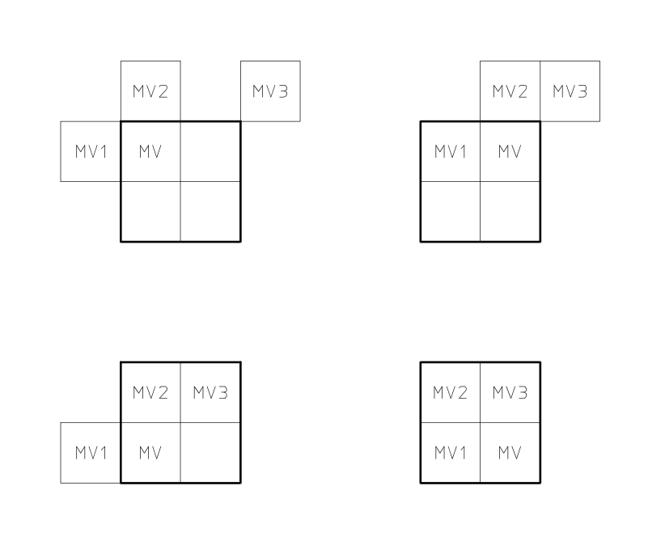
FIGURE F.1/H.263
Redefinition of the candidate predictors MV1, MV2 and MV3
for each of the luminance blocks in a macroblock
If four vectors are used, each of the motion vectors is used for all pixels in one of the four luminance blocks in the macroblock. The numbering of the motion vectors is equivalent to the numbering of the four luminance blocks as given in Figure 5. Motion vector MVDCHR for both chrominance blocks is derived by calculating the sum of the four luminance vectors and dividing this sum by 8; the component values of the resulting sixteenth pixel resolution vectors are modified towards the nearest half pixel position as indicated in Table F.1.

TABLE F.1/H.263
Modification of sixteenth pixel resolution chrominance vector components
sixteenth pixel position | 0 | 1 | 2 | 3 | 4 | 5 | 6 | 7 | 8 | 9 | 10 | 11 | 12 | 13 | 14 | 15 | /16
resulting position | 0 | 0 | 0 | 1 | 1 | 1 | 1 | 1 | 1 | 1 | 1 | 1 | 1 | 1 | 2 | 2 | /2

Half pixel values are found using bilinear interpolation as described in section 6.1.2. In Advanced Prediction mode, the prediction for luminance is obtained by overlapped motion compensation as described in section F.3. The prediction for chrominance is obtained by applying the motion vector MVDCHR to all pixels in the two chrominance blocks (as it is done in the default prediction mode).

F.3. Overlapped motion compensation for luminance
Each pixel in an 8*8 luminance prediction block is a weighted sum of three prediction values, divided by 8 (with rounding). In order to obtain the three prediction values, three motion vectors are used: the motion vector of the current luminance block, and two out of four "remote" vectors:
• the motion vector of the block at the left or right side of the current luminance block;
• the motion vector of the block above or below the current luminance block.

For each pixel, the remote motion vectors of the blocks at the two nearest block borders are used. This means that for the upper half of the block the motion vector corresponding to the block above the current block is used, while for the lower half of the block the motion vector corresponding to the block below the current block is used (see Figure F.3). Similarly, for the left half of the block the motion vector corresponding to the block at the left side of the current block is used, while for the right half of the block the motion vector corresponding to the block at the right side of the current block is used (see Figure F.4).
Let (x,y) be a position in a picture measured in integer pixel units.
Let (m,n) be an integer block index in a picture, as given by
m = x / 8 and n = y / 8,
where “/” denotes division with truncation.
Let (i,j) be an integer pixel location in an 8×8 block, given by
i = x − m·8 and j = y − n·8,
resulting in
(x,y) = (m·8+i, n·8+j).
Let (MV^{k}_{x}, MV^{k}_{y}) be a motion vector, which may contain full-pixel or half pixel offsets, with k = 0, 1, or 2. For example, (MV^{k}_{x}, MV^{k}_{y}) can be equal to (-7.0, 13.5). Here, (MV⁰_{x,} MV⁰_{y}) denotes the motion vector for the current block (m,n), (MV¹_{x,} MV¹_{y}) denotes the motion vector of the block either above or below, and (MV²_{x,} MV²_{y}) denotes the motion vector either to the left or right of the current block (m,n) as defined above.

Then the creation of each pixel, P(x,y), in an 8×8 luminance prediction block with block index (m,n) is governed by the following equation:

P(x,y) = (q(x,y) · H₀(i,j) + r(x,y) · H₁(i,j) + s(x,y) · H₂(i,j) + 4)/8,
where q(x,y), r(x,y) and s(x,y) are the prediction values taken from the referenced picture as defined by

q(x,y) = p(x + MV⁰_{x}, y + MV⁰_{y}),
r(x,y) = p(x + MV¹_{x}, y + MV¹_{y}),
s(x,y) = p(x + MV²_{x}, y + MV²_{y}),
where p(x+MV^{k}_{x}, y+MV^{k}_{y}) is the prediction value at position (x+MV^{k}_{x}, y+MV^{k}_{y}) in the referenced picture. Note that (x+MV^{k}_{x}, y+MV^{k}_{y}) may be outside the picture and can be at a full or half pixel position. In cases using half pixel motion vectors, p(x+MV^{k}_{x}, y+MV^{k}_{y}) refers to the value obtained after the interpolation process described in section 6.1.2 is applied.

The matrices H₀(i,j), H₁(i,j) and H₂(i,j) are defined in Figures F.2, F.3, and F.4, where (i,j) denotes the column and row, respectively, of the matrix.
When neither the Slice Structured mode (see Annex K) nor the Independent Segment Decoding mode (see Annex R) are in use, remote motion vectors from other picture segments are used in the same way as remote motion vectors inside the current GOB. If either the Slice Structured mode or the Independent Segment Decoding mode are in use, the remote motion vectors corresponding to blocks from other picture segments are set to the motion vector of the current block, regardless of the other conditions described in the next paragraph. (See Annex R for the definition of a picture segment.)
If one of the surrounding macroblocks was not coded, the corresponding remote motion vector is set to zero. If one of the surrounding blocks was INTRA coded, the corresponding remote motion vector is replaced by the motion vector for the current block except when in PB-frames mode. In this case (INTRA block in PB-frame mode), the INTRA block’s motion vector is used (also see Annex G). If the current block is at the border of the picture and therefore a surrounding block is not present, the corresponding remote motion vector is replaced by the current motion vector. In all cases, if the current block is at the bottom of the macroblock (for block number 3 or 4, see Figure 5), the remote motion vector corresponding with an 8*8 luminance block in the macroblock below the current macroblock is replaced by the motion vector for the current block.
The weighting values for the prediction are given in Figures F.2, F.3, and F.4.

4 | 5 | 5 | 5 | 5 | 5 | 5 | 4
5 | 5 | 5 | 5 | 5 | 5 | 5 | 5
5 | 5 | 6 | 6 | 6 | 6 | 5 | 5
5 | 5 | 6 | 6 | 6 | 6 | 5 | 5
5 | 5 | 6 | 6 | 6 | 6 | 5 | 5
5 | 5 | 6 | 6 | 6 | 6 | 5 | 5
5 | 5 | 5 | 5 | 5 | 5 | 5 | 5
4 | 5 | 5 | 5 | 5 | 5 | 5 | 4
FIGURE F.2/H.263
Weighting values, H₀ , for prediction with motion vector of current luminance block

2 | 2 | 2 | 2 | 2 | 2 | 2 | 2
1 | 1 | 2 | 2 | 2 | 2 | 1 | 1
1 | 1 | 1 | 1 | 1 | 1 | 1 | 1
1 | 1 | 1 | 1 | 1 | 1 | 1 | 1
1 | 1 | 1 | 1 | 1 | 1 | 1 | 1
1 | 1 | 1 | 1 | 1 | 1 | 1 | 1
1 | 1 | 2 | 2 | 2 | 2 | 1 | 1
2 | 2 | 2 | 2 | 2 | 2 | 2 | 2
FIGURE F.3/H.263
Weighting values, H₁ , for prediction with motion vectors of the luminance blocks
on top or bottom of current luminance block

2 | 1 | 1 | 1 | 1 | 1 | 1 | 2
2 | 2 | 1 | 1 | 1 | 1 | 2 | 2
2 | 2 | 1 | 1 | 1 | 1 | 2 | 2
2 | 2 | 1 | 1 | 1 | 1 | 2 | 2
2 | 2 | 1 | 1 | 1 | 1 | 2 | 2
2 | 2 | 1 | 1 | 1 | 1 | 2 | 2
2 | 2 | 1 | 1 | 1 | 1 | 2 | 2
2 | 1 | 1 | 1 | 1 | 1 | 1 | 2
FIGURE F.4/H.263
Weighting values, H₂ , for prediction with motion vectors of the luminance blocks
to the left or right of current luminance block

Annex G.
PB-frames mode
(This annex forms an integral part of this Recommendation.)

G.1. Introduction.
This annex describes the optional PB-frames mode of H.263. The capability of this mode is signalled by external means (for example Recommendation H.245). The use of this mode is indicated in PTYPE.
A PB-frame consists of two pictures being coded as one unit. The name PB comes from the name of picture types in Recommendation H.262 where there are P-pictures and B-pictures. Thus a PB-frame consists of one P-picture which is predicted from the previous decoded P-picture and one B-picture which is predicted both from the previous decoded P-picture and the P-picture currently being decoded. The name B-picture was chosen because parts of B-pictures may be bidirectionally predicted from the past and future pictures. The prediction process is illustrated in Figure G.1.
An improved version of the PB frames mode, termed the “Improved PB frames mode,” is described in Annex M. The PB frames mode as described in this annex is retained herein only for purposes of compatibility with systems designed prior to the adoption of the Improved PB frames mode. For this reason, the PB frames mode as described in this annex cannot be used with the additional features of the syntax which require the use of PLUSPTYPE.
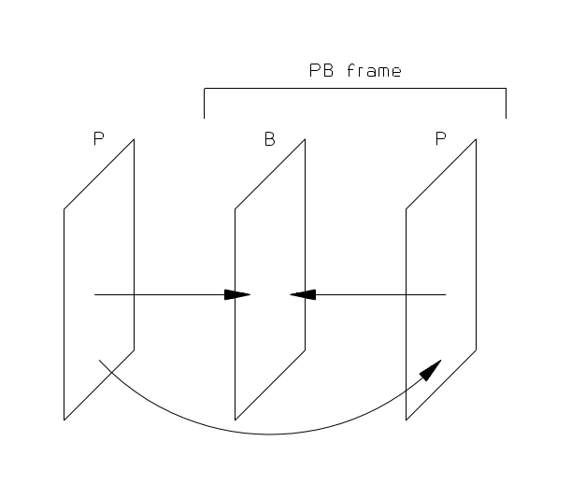
FIGURE G.1/H.263
Prediction in PB-frames mode

G.2. PB-frames and INTRA blocks
When PB-frames are used the coding mode INTRA has the following meaning (see also section 5.3.2):
• The P-blocks are INTRA coded.
• The B-blocks are INTER coded with prediction as for an INTER block.
If PB-frames are used, motion vector data (MVD) is included also for INTRA macroblocks in pictures for which PTYPE indicates ‘INTER’. In this case the vector is used for the B-blocks only. The codewords MVD2-4 are never used for INTRA (see also Table 10). When in both the Advanced Prediction mode and the PB-frames mode, and one of the surrounding blocks was coded in INTRA mode, the corresponding remote motion vector is not replaced by the motion vector for the current block. Instead, the remote ‘INTRA’ motion vector is used.

G.3. Block Layer
In a PB-frame, a macroblock comprises twelve blocks. First the data for the six P-blocks is transmitted as in the default H.263 mode, then the data for the six B-blocks (see also section 5.4). The structure of the block layer is shown in Figure 11. INTRADC is present for every P-block of the macroblock if MCBPC indicates macroblock type 3 or 4 (see Tables 7 and 8). INTRADC is not present for B-blocks. TCOEF is present for P-blocks if indicated by MCBPC or CBPY; TCOEF is present for B-blocks if indicated by CBPB.

G.4. Calculation of vectors for the B-picture in a PB-frame
The vectors for the B-picture are calculated as follows (see also section 6.1.1). Assume we have a vector component MV in half pixel units to be used in the P-picture (MV represents a vector component for an 8*8 luminance block; if only one vector per macroblock is transmitted, MV has the same value for each of the four 8*8 luminance blocks). For prediction of the B-picture we need both forward and backward vector components MVF and MVB. These forward and backward vector components are derived from MV and eventually enhanced by a delta vector given by MVDB.

TR_{D}: The increment of the temporal reference TR (or the combined extended temporal reference ETR and temporal reference TR in an Improved PB frame when a custom picture clock frequency is in use) from the last picture header (see section 5.1.2). If TR_{D} is negative then TR_{D} = TR_{D} + d where d = 256 for CIF picture frequency and 1024 for any custom picture clock frequency
TRB: See section 5.1.21.
Assume that MV_{D} is the delta vector component given by MVDB and corresponding with vector component MV. If MVDB is not present, MV_{D} is set to zero. If MVDB is present, the same MV_{D} given by MVDB is used for each of the four luminance B-blocks within the macroblock.
Now MVF and MVB are given in half pixel units by the following formulas:
MV_{F} = (TR_{B} x MV) / TR_{D} + MV_{D}
MV_{B} = ((TR_{B} - TR_{D}) x MV) / TR_{D} if MV_{D} is equal to 0
MV_{B} = MV_{F} - MV if MV_{D} is unequal to 0
where “/” means division by truncation. It is assumed that the scaling reflects the actual position in time of P- and B-pictures. Advantage is taken of the fact that the range of values for MV_{F} is constrained. Each VLC word for MVDB represents a pair of difference values. Only one of the pair will yield a value for MV_{F} falling within the permitted range (default [-16,15.5]; in Unrestricted Motion Vector mode [-31.5,31.5]). The formulas for MV_{F} and MV_{B} are also used in the case of INTRA blocks where the vector data is used only for predicting B-blocks.
For chrominance blocks, MV_{F} is derived by calculating the sum of the four corresponding luminance MV_{F} vectors and dividing this sum by 8; the resulting sixteenth pixel resolution vector components are modified towards the nearest half pixel position as indicated in Table F.1. MV_{B} for chrominance is derived by calculating the sum of the four corresponding luminance MV_{B} vectors and dividing this sum by 8; the resulting sixteenth pixel resolution vector components are modified towards the nearest half pixel position as indicated in Table F.1.
A positive value of the horizontal or vertical component of the motion vector signifies that the prediction is formed from pixels in the referenced picture which are spatially to the right or below the pixels being predicted.

G.5. Prediction of a B-block in a PB-frame
In this section a block means an 8x8 block. The following procedure applies for luminance as well as chrominance blocks. First, the forward and backward vectors are calculated. It is assumed that the P-macroblock (luminance and chrominance) is first decoded, reconstructed and clipped (see section 6.3.2). This macroblock is called P_{REC}. Based on P_{REC} and the prediction for P_{REC}, the prediction for the B-block is calculated.

The prediction of the B-block has two modes that are used for different parts of the block:
• For pixels where the backward vector - MVB -points inside P_{REC}, use bi-directional prediction. This is obtained as the average of the forward prediction using MVF relative to the previous decoded picture, and the backward prediction using MVB relative to P_{REC}. The average is calculated by dividing the sum of the two predictions by two (division by truncation).
• For all other pixels, forward prediction using MVF relative to the previous decoded picture is used.
Figure G.2 indicates which part of a block is predicted bidirectionally (shaded part of the B-block) and which part with forward prediction only (rest of the B-block).

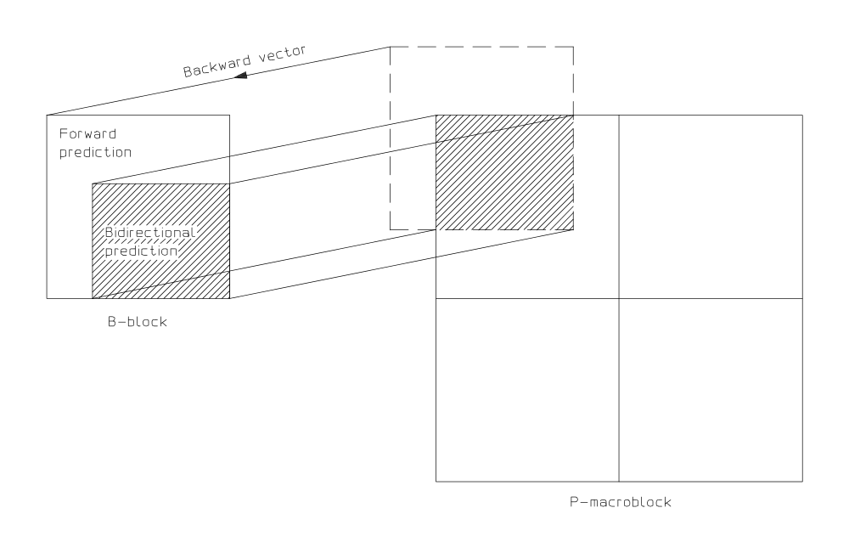
FIGURE G.2/H.263
Forward and bidirectional prediction for a B-block
Bi-directional prediction is used for pixels where the backward vector - MVB -points inside P_{REC}. These pixels are defined by the following procedures which are specified in C.

Definitions: nh: horizontal position of block within a macroblock (0 or 1).
nv: vertical position of block within a macroblock (0 or 1).
mh(nh,nv): horizontal vector component of block (nh,nv) in half pixel units.
mv(nh,nv): vertical vector component of block (nh,nv) in half pixel units.
mhc: horizontal chrominance vector component.
mvc: vertical chrominance vector component.

Procedure for luminance
for (nh = 0; nh <= 1; nh++) {
for (nv = 0; nv <= 1; nv++) {
for (i = nh*8 + max(0,(-mh(nh,nv)+1)/2 - nh*8);
i <= nh*8 + min(7,15-(mh(nh,nv)+1)/2 - nh*8); i++) {
for (j = nv*8 + max(0,(-mv(nh,nv)+1)/2 - nv*8);
j <= nv*8 + min(7,15-(mv(nh,nv)+1)/2 - nv*8); j++) {
predict pixel (i,j) bidirectionally
}
}
}
}
Procedure for chrominance
for (i = max(0,(-mhc+1)/2); i <= min(7,7-(mhc+1)/2); i++) {
for (j = max(0,(-mvc+1)/2); j <= min(7,7-(mvc+1)/2); j++) {
predict pixel (i,j) bidirectionally;
}
}
Pixels not predicted bidirectionally are predicted with forward prediction only.

Annex H.
Forward Error Correction for coded video signal
(This annex forms an integral part of this Recommendation.)

H.1. Introduction
This annex describes an optional forward error correction method (code and framing) for transmission of H.263 encoded video data. This forward error correction may be used in situations where no forward error correction is provided by external means, for example at the multiplex or system level. It is not used for H.324. Both the framing and the forward error correction code are the same as in H.261.

H.2. Error correction framing
To allow the video data and error correction parity information to be identified by a decoder an error correction framing pattern is included. This pattern consists of multiframes of eight frames, each frame comprising 1 bit framing, 1 bit fill indicator (Fi), 492 bits of coded data (or fill all 1s) and 18 bits parity (see Figure H.1). For each multiframe the frame alignment pattern formed by the framing bits of the eight individual frames is:
(S1S2S3S4S5S6S7S8) = (00011011).
The fill indicator (Fi) can be set to zero by an encoder. In this case 492 consecutive fill bits (fill all 1s) are used instead of 492 bits of coded data. This may be used for stuffing data (see section 3.6).

H.3. Error correcting code
The error correction code is a BCH (511,493) forward error correction code. Use of this by the decoder is optional. The parity is calculated against a code of 493 bits, comprising 1 bit fill indicator (Fi) and 492 bits of coded video data.
The generator polynomial is: g(x) = (x9 + x4 + 1)(x9 + x6 + x4 + x3 + 1) .
Example: for the input data of “01111 . . . 11” (493 bits) the resulting correction parity bits are “011011010100011011” (18 bits).

H.4. Relock time for error corrector framing
Three consecutive error correction frame alignment patterns (24 bits) should be received before frame lock is deemed to have been achieved. The decoder should be designed such that frame lock will be re-established within 34 000 bits after an error corrector framing phase change.
Note – This assumes that the video data does not contain three correctly phased emulations of the error correction framing sequence during the relocking period.
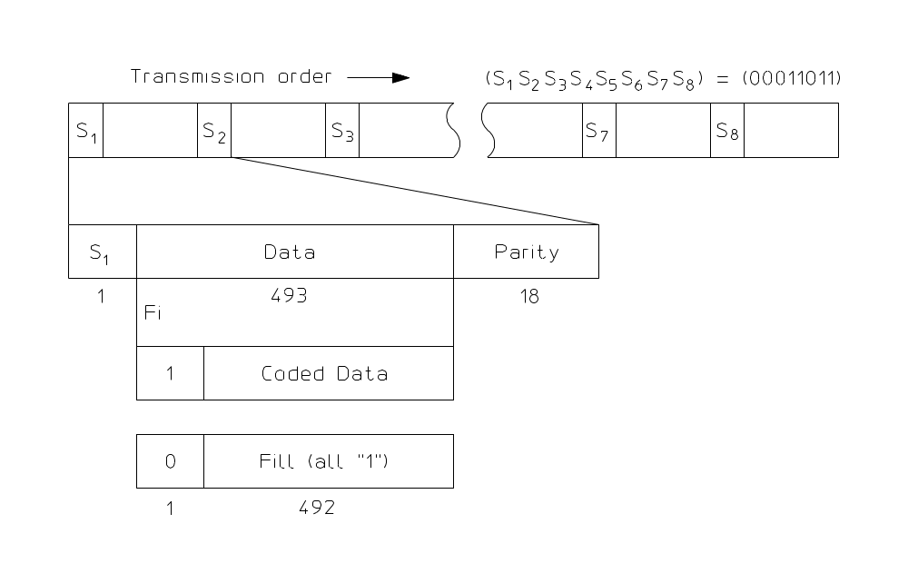
FIGURE H.1/H.263
Error correcting frame

Annex I.
Advanced Intra Coding mode
(This annex forms an integral part of this Recommendation.)
This annex describes the optional Advanced Intra Coding mode of H.263. The capability of this mode of H.263 is signaled by external means (for example Recommendation H.245). The use of this mode is indicated in the PLUSPTYPE field of the picture header.

I.1. Introduction
This optional mode alters the decoding of macroblocks of type ‘INTRA’ (macroblocks of other types are not affected). The coding efficiency of INTRA macroblocks is improved by using
- Intra-block prediction using neighboring intra blocks for the same component (Y, CB, or CR),
- Modified inverse quantization for INTRA coefficients, and
- A separate VLC for INTRA coefficients.
A particular intra-coded block may be predicted from the block above the current block being decoded, from the block to the left of the current block being decoded, or from both. Special cases exist for situations in which the neighboring blocks are not intra coded or are not in the same picture segment. Block prediction always uses data from the same luminance or color difference component (Y, CB, or CR) as the block being decoded. In prediction, DC coefficients are always predicted. The first row or column of AC coefficients may or may not be predicted, as signaled on a macroblock-by-macroblock basis. The remaining AC coefficients are never predicted. Inverse quantization of the INTRA DC coefficient is modified to allow a varying quantization step size, unlike in the main text of this recommendation where a fixed step size of 8 is used for INTRA DC coefficients. Inverse quantization of all INTRA coefficients is performed without a “dead-zone” in the quantizer reconstruction spacing.

I.2. Syntax
When using the Advanced Intra Coding mode, the macroblock layer syntax is altered as specified in Figure I.1. The syntax as shown in Figure I.1 is the same as that defined in section 5.3 except for the insertion of an additional INTRA_MODE field for INTRA macroblocks. INTRA_MODE is present only when MCBPC indicates a macroblock of type INTRA (macroblock type 3 or 4). The prediction mode is coded using the variable length code shown in Table I.1. One prediction mode is transmitted per intra macroblock.

COD | MCBPC | INTRA_MODE | MODB | CBPB | CBPY | DQUANT

MVD | MVD₂ | MVD₃ | MVD₄ | MVDB | Block Data
FIGURE I.1/H.263
Structure of macroblock layer
TABLE I.1/H.263
VLC for INTRA_MODE
Index | Prediction Mode | VLC
0 | 0 (DC Only) | 0
1 | 1 (Vertical DC & AC) | 10
2 | 2 (Horizontal DC & AC) | 11

I.3. Decoding Process
Two scans in addition to the zigzag scan are employed; all three scans are shown in Figure I.2, parts (a), (b) and (c).
For intra coded blocks, if Prediction Mode=0, the zigzag scan is selected for all blocks in the macroblock, otherwise, the prediction direction is used to select a scan for the macroblock. For instance, if the prediction refers to the horizontally adjacent block, an alternate-vertical scan is selected for the current block, otherwise (for prediction referring to the vertically adjacent block), the alternate-horizontal scan is used for the current block.
For non intra blocks, the 8x8 blocks of transform coefficients are scanned with “zigzag” scanning as listed in Figure I.2 part (c).

0 | 1 | 2 | 3 | 10 | 11 | 12 | 13 |  | 0 | 4 | 6 | 20 | 22 | 36 | 38 | 52
4 | 5 | 8 | 9 | 17 | 16 | 15 | 14 |  | 1 | 5 | 7 | 21 | 23 | 37 | 39 | 53
6 | 7 | 19 | 18 | 26 | 27 | 28 | 29 |  | 2 | 8 | 19 | 24 | 34 | 40 | 50 | 54
20 | 21 | 24 | 25 | 30 | 31 | 32 | 33 |  | 3 | 9 | 18 | 25 | 35 | 41 | 51 | 55
22 | 23 | 34 | 35 | 42 | 43 | 44 | 45 |  | 10 | 17 | 26 | 30 | 42 | 46 | 56 | 60
36 | 37 | 40 | 41 | 46 | 47 | 48 | 49 |  | 11 | 16 | 27 | 31 | 43 | 47 | 57 | 61
38 | 39 | 50 | 51 | 56 | 57 | 58 | 59 |  | 12 | 15 | 28 | 32 | 44 | 48 | 58 | 62
52 | 53 | 54 | 55 | 60 | 61 | 62 | 63 |  | 13 | 14 | 29 | 33 | 45 | 49 | 59 | 63
(a) Alternate-Horizontal scan (b) Alternate-Vertical scan (as in Recommendation H.262)

0 | 1 | 5 | 6 | 14 | 15 | 27 | 28
2 | 4 | 7 | 13 | 16 | 26 | 29 | 42
3 | 8 | 12 | 17 | 25 | 30 | 41 | 43
9 | 11 | 18 | 24 | 31 | 40 | 44 | 53
10 | 19 | 23 | 32 | 39 | 45 | 52 | 54
20 | 22 | 33 | 38 | 46 | 51 | 55 | 60
21 | 34 | 37 | 47 | 50 | 56 | 59 | 61
35 | 36 | 48 | 49 | 57 | 58 | 62 | 63
(c) Zigzag scan.
FIGURE I.2/H.263
DCT Scanning patterns for Advanced Intra Coding
A separate VLC table is used for all INTRA DC and AC coefficients. This table is specified in Table I.2. Note that the VLC codeword entries used in Table I.2 are the same as those used in the normal TCOEF table (Table 16) used when Advanced Intra Coding is not in use, but with a different interpretation of LEVEL and RUN.
Depending on the value of INTRA_MODE either one or eight coefficients are prediction residuals that must be added to a predictor as described below. Figure I.3 shows three blocks of final reconstructed DCT levels for the same component (Y, CB, or CR), labeled RecA’(u,v), RecB’(u,v) and RecC’(u,v), where u and v are row and column indices, respectively. The reconstruction process differs from the processing described in section 6.2.1. INTRADC residuals are reconstructed differently by use of a variable step size, as opposed to using Table 15, and then a predictor is added to the residual values to obtain the final coefficient reconstruction value. INTRA coefficients other than INTRA DC are also reconstructed differently than in section 6.2.1, using a reconstruction spacing without a “dead-zone” and then in some cases adding a predictor to obtain the final coefficient reconstruction value. The block may contain both DC and AC prediction residuals.
The definitions of MCPBC and CBPY are changed when Advanced Intra Coding is in use. When Advanced Intra Coding is in use, INTRA DC transform coefficients are no longer handled as a separate case, but are instead treated in the same way as the AC coefficients in regard to MCPBC and CBPY. This means that a zero INTRA DC will not be coded as a LEVEL, but will simply increase the run for the following AC coefficients.
The inverse quantization process for the B part of an Improved PB frame (see Annex M) is not altered by the use of the Advanced Intra Coding mode.

 |  |  |  |  |  |  |  |  |  |  | v | 0 | 1 | 2 | 3 | 4 | 5 | 6 | 7
 |  |  |  |  |  |  |  |  |  |  |  | •
 |  |  |  |  |  |  |  |  |  |  |  |  |  |  |  |  |  |  |  | Block A
 |  |  |  |  |  |  |  |  |  |  |  |  |  |  |  |  |  |  |  | RecA’(u,v)
 | u
 | 0 | • |  |  |  |  |  |  |  |  |  | •
 | 1
Block B | 2 |  |  |  |  |  |  |  |  |  |  |  |  |  |  |  |  |  |  | Block C
RecB’(u,v) | 3 |  |  |  |  |  |  |  |  |  |  |  |  |  |  |  |  |  |  | RecC’(u,v)
 | 4
 | 5
 | 6
 | 7
FIGURE I.3/H.263
Three Neighboring blocks in the DCT domain
Define RecC(u,v) to be the reconstructed coefficient residuals of the current block. For all INTRA coefficients, the reconstructed residual value is obtained by
RecC(u,v) = 2 * QUANT * LEVEL(u,v) u=0,…,7, v=0,…,7.
(Note that LEVEL(u,v) denotes a quantity having both a magnitude and a sign in the above equation.)
Define RecC’(u,v) to be the final reconstructed coefficient values of the current block (after adjustments for prediction, oddification as described below, and clipping). The final reconstructed coefficient values RecC’(u,v) are recovered by adding RecC(u,v) to the appropriate prediction as signaled in the INTRA_MODE field, altering the least-significant bit if needed for oddification of the DC coefficient, and clipping.
RecA’(u,v) denotes the final reconstructed coefficient values for the block immediately above the current block. RecB’(u,v) denotes the final reconstructed coefficient values of the block immediately to the left of the current block.
The ability to use the reconstructed coefficient values for blocks A and B in the prediction of the coefficient values for block C depends on whether blocks A and B are in the same picture segment as block C. A block is defined to be “in the same picture segment” as another block only if the following conditions are fulfilled:
- The relevant block is within the boundary of the picture, and
- If not in Slice Structured mode (see Annex K), the relevant block is either within the same GOB or no GOB header is present for the current GOB, and
- If in Slice Structured mode, the relevant block is within the same slice.
The block C to be decoded is predicted only from INTRA blocks within the same picture segment as block C, as shown below.
If Prediction Mode = 0 is used (DC prediction only) and blocks A and B are both INTRA blocks within the same picture segment as block C, then the DC coefficient of block C is predicted from the average (with truncation) of the DC coefficients of blocks A and B. If only one of the two blocks A and B is an INTRA block within the same picture segment as block C, then the DC coefficient of only this one of the two blocks is used as the predictor for Prediction Mode = 0. If neither of the two blocks A and B are INTRA blocks within the same picture segment as block C, then the prediction uses the value of 1024 as the predictor for the DC coefficient.
If Prediction Mode = 1 or 2 (vertical DC & AC or horizontal DC & AC prediction) and the referenced block (block A or block B) is not an INTRA block within the same picture segment as block C, then the prediction uses the value of 1024 as the predictor for the DC coefficient and the value of 0 as the predictor for the AC coefficients of block C.
A process of “oddification” is applied to the DC coefficient in order to minimize the impact of IDCT mismatch errors. Certain values of coefficients can cause a round-off error mismatch between different IDCT implementations, especially certain values of the (0,0), (0,4), (4,0), and (4,4) coefficients. For example, a DC coefficient of 8k+4 for some integer k results in an inverse-transformed block having a constant value k+0.5, for which slight errors can cause rounding in different directions on different implementations.
Define the clipAC() function to indicate clipping to the range -2048 to 2047. Define the clipDC() function to indicate clipping to the range 0 to 2047. Define the oddifyclipDC(x) function as
If (x is even) {
result = clipDC(x+1)
} else {
result = clipDC(x)
}
The reconstruction for each intra prediction mode is then specified as follows, in which the operator “/” is defined as division by truncation:
mode 0: DC prediction only.
RecC’(u,v) = clipAC( RecC(u,v) ) (u,v) ≠ (0,0), u = 0, …, 7, v = 0, …, 7.
If (block A and block B are both intra coded and are both in the same picture segment as block C) {
tempDC = RecC(0,0) + ( RecA’(0,0) + RecB’(0,0) ) / 2
} else {
If (block A is intra coded and is in the same picture segment as block C) {
tempDC = RecC(0,0) + RecA’(0,0)
} else {
If (block B is intra coded and is in the same picture segment as block C) {
tempDC = RecC(0,0) + RecB’(0,0)
} else {
tempDC = RecC(0,0) + 1024
}
}
}
RecC’(0,0) = oddifyclipDC( tempDC )
mode 1: DC and AC prediction from the block above.
If (block A is intra coded and is in the same picture segment as block C) {
tempDC = RecC(0,0) + RecA’(0,0)
RecC’(0,v) = clipAC( RecC(0,v) + RecA’(0,v) ) v = 1, …, 7,
RecC’(u,v) = clipAC( RecC(u,v) ) u = 1, …, 7, v = 0, …, 7.
} else {
tempDC = RecC(0,0) + 1024
RecC’(u,v) = clipAC( RecC(u,v) ) (u,v) ≠ (0,0), u = 0, …,7, v = 0, …, 7
}
RecC’(0,0) = oddifyclipDC( tempDC )
mode 2: DC and AC prediction from the block to the left.
If (block B is intra coded and is in the same picture segment as block C) {
tempDC = RecC(0,0) + RecB’(0,0)
RecC’(u,0) = clipAC( RecC(u,0) + RecB’(u,0) ) u = 1, …, 7,
RecC’(u,v) = clipAC( RecC(u,v) ) u = 0, …, 7, v = 1, …, 7.
} else {
tempDC = RecC(0,0) + 1024
RecC’(u,v) = clipAC( RecC(u,v) ) (u,v) ≠ (0,0), u = 0, …, 7, v = 0, …, 7
}
RecC’(0,0) = oddifyclipDC( tempDC )
TABLE I.2/H.263
VLC for INTRA TCOEF

INDEX | LAST | RUN | |LEVEL| | BITS | VLC CODE |  | INDEX | LAST | RUN | |LEVEL| | BITS | VLC CODE
0 | 0 | 0 | 1 | 3 | 10s |  | 58 | 1 | 0 | 1 | 5 | 0111 s
1 | 0 | 1 | 1 | 5 | 1111 s |  | 59 | 1 | 14 | 1 | 10 | 0000 1100 1s
2 | 0 | 3 | 1 | 7 | 0101 01s |  | 60 | 1 | 20 | 1 | 12 | 0000 0000 101s
3 | 0 | 5 | 1 | 8 | 0010 111s |  | 61 | 1 | 1 | 1 | 7 | 0011 11s
4 | 0 | 7 | 1 | 9 | 0001 1111 s |  | 62 | 1 | 19 | 1 | 12 | 0000 0000 100s
5 | 0 | 8 | 1 | 10 | 0001 0010 1s |  | 63 | 1 | 2 | 1 | 7 | 0011 10s
6 | 0 | 9 | 1 | 10 | 0001 0010 0s |  | 64 | 1 | 3 | 1 | 7 | 0011 01s
7 | 0 | 10 | 1 | 11 | 0000 1000 01s |  | 65 | 1 | 0 | 2 | 7 | 0011 00s
8 | 0 | 11 | 1 | 11 | 0000 1000 00s |  | 66 | 1 | 5 | 1 | 8 | 0010 011s
9 | 0 | 4 | 3 | 12 | 0000 0000 111s |  | 67 | 1 | 6 | 1 | 8 | 0010 010s
10 | 0 | 9 | 2 | 12 | 0000 0000 110s |  | 68 | 1 | 4 | 1 | 8 | 0010 001s
11 | 0 | 13 | 1 | 12 | 0000 0100 000s |  | 69 | 1 | 0 | 3 | 8 | 0010 000s
12 | 0 | 0 | 2 | 4 | 110s |  | 70 | 1 | 9 | 1 | 9 | 0001 1010 s
13 | 0 | 1 | 2 | 7 | 0101 00s |  | 71 | 1 | 10 | 1 | 9 | 0001 1001 s
14 | 0 | 1 | 4 | 9 | 0001 1110 s |  | 72 | 1 | 11 | 1 | 9 | 0001 1000 s
15 | 0 | 1 | 5 | 11 | 0000 0011 11s |  | 73 | 1 | 12 | 1 | 9 | 0001 0111 s
16 | 0 | 1 | 6 | 12 | 0000 0100 001s |  | 74 | 1 | 13 | 1 | 9 | 0001 0110 s
17 | 0 | 1 | 7 | 13 | 0000 0101 0000s |  | 75 | 1 | 8 | 1 | 9 | 0001 0101 s
18 | 0 | 0 | 3 | 5 | 1110 s |  | 76 | 1 | 7 | 1 | 9 | 0001 0100 s
19 | 0 | 3 | 2 | 9 | 0001 1101 s |  | 77 | 1 | 0 | 4 | 9 | 0001 0011 s
20 | 0 | 2 | 3 | 11 | 0000 0011 10s |  | 78 | 1 | 17 | 1 | 10 | 0000 1100 0s
21 | 0 | 3 | 4 | 13 | 0000 0101 0001s |  | 79 | 1 | 18 | 1 | 10 | 0000 1011 1s
22 | 0 | 0 | 5 | 6 | 0110 1s |  | 80 | 1 | 16 | 1 | 10 | 0000 1011 0s
23 | 0 | 4 | 2 | 10 | 0001 0001 1s |  | 81 | 1 | 15 | 1 | 10 | 0000 1010 1s
24 | 0 | 3 | 3 | 11 | 0000 0011 01s |  | 82 | 1 | 2 | 2 | 10 | 0000 1010 0s
25 | 0 | 0 | 4 | 6 | 0110 0s |  | 83 | 1 | 1 | 2 | 10 | 0000 1001 1s
26 | 0 | 5 | 2 | 10 | 0001 0001 0s |  | 84 | 1 | 0 | 6 | 10 | 0000 1001 0s
27 | 0 | 5 | 3 | 13 | 0000 0101 0010s |  | 85 | 1 | 0 | 5 | 10 | 0000 1000 1s
28 | 0 | 2 | 1 | 6 | 0101 1s |  | 86 | 1 | 4 | 2 | 11 | 0000 0001 11s
29 | 0 | 6 | 2 | 11 | 0000 0011 00s |  | 87 | 1 | 3 | 2 | 11 | 0000 0001 10s
30 | 0 | 0 | 25 | 13 | 0000 0101 0011s |  | 88 | 1 | 1 | 3 | 11 | 0000 0001 01s
31 | 0 | 4 | 1 | 7 | 0100 11s |  | 89 | 1 | 0 | 7 | 11 | 0000 0001 00s
32 | 0 | 7 | 2 | 11 | 0000 0010 11s |  | 90 | 1 | 2 | 3 | 12 | 0000 0100 100s
(continued below)

TABLE I.2/H.263 (Continued)
VLC for INTRA TCOEF (Continued)

INDEX | LAST | RUN | LEVEL | BITS | VLC CODE |  | INDEX | LAST | RUN | LEVEL | BITS | VLC CODE
33 | 0 | 0 | 24 | 13 | 0000 0101 0100s |  | 91 | 1 | 1 | 4 | 12 | 0000 0100 101s
34 | 0 | 0 | 8 | 7 | 0100 10s |  | 92 | 1 | 0 | 9 | 12 | 0000 0100 110s
35 | 0 | 8 | 2 | 11 | 0000 0010 10s |  | 93 | 1 | 0 | 8 | 12 | 0000 0100 111s
36 | 0 | 0 | 7 | 7 | 0100 01s |  | 94 | 1 | 21 | 1 | 13 | 0000 0101 1000s
37 | 0 | 2 | 4 | 11 | 0000 0010 01s |  | 95 | 1 | 22 | 1 | 13 | 0000 0101 1001s
38 | 0 | 0 | 6 | 7 | 0100 00s |  | 96 | 1 | 23 | 1 | 13 | 0000 0101 1010s
39 | 0 | 12 | 1 | 11 | 0000 0010 00s |  | 97 | 1 | 7 | 2 | 13 | 0000 0101 1011s
40 | 0 | 0 | 9 | 8 | 0010 110s |  | 98 | 1 | 6 | 2 | 13 | 0000 0101 1100s
41 | 0 | 0 | 23 | 13 | 0000 0101 0101s |  | 99 | 1 | 5 | 2 | 13 | 0000 0101 1101s
42 | 0 | 2 | 2 | 8 | 0010 101s |  | 100 | 1 | 3 | 3 | 13 | 0000 0101 1110s
43 | 0 | 1 | 3 | 8 | 0010 100s |  | 101 | 1 | 0 | 10 | 13 | 0000 0101 1111s
44 | 0 | 6 | 1 | 9 | 0001 1100 s |  | 102 | ESCAPE |  |  | 7 | 0000 011
45 | 0 | 0 | 10 | 9 | 0001 1011 s
46 | 0 | 0 | 12 | 10 | 0001 0000 1s
47 | 0 | 0 | 11 | 10 | 0001 0000 0s
48 | 0 | 0 | 18 | 10 | 0000 1111 1s
49 | 0 | 0 | 17 | 10 | 0000 1111 0s
50 | 0 | 0 | 16 | 10 | 0000 1110 1s
51 | 0 | 0 | 15 | 10 | 0000 1110 0s
52 | 0 | 0 | 14 | 10 | 0000 1101 1s
53 | 0 | 0 | 13 | 10 | 0000 1101 0s
54 | 0 | 0 | 20 | 12 | 0000 0100 010s
55 | 0 | 0 | 19 | 12 | 0000 0100 011s
56 | 0 | 0 | 22 | 13 | 0000 0101 0110s
57 | 0 | 0 | 21 | 13 | 0000 0101 0111s

Annex J.
Deblocking Filter Mode
(This annex forms an integral part of this Recommendation.)

J.1. Introduction
This annex describes the use of an optional block edge filter within the coding loop. The main purpose of the block edge filter is to reduce blocking artifacts. The filtering is performed on 8x8 block edges. Motion vectors may have either 8x8 or 16x16 resolution (see section J.2). The processing described in this annex applies only for the P, I, EP, or EI pictures. (Possible filtering of B-pictures or the B-picture part of an Improved PB frame is not a matter for standardization, however some type of filtering is recommended for improved picture quality.) The capability of this mode is signaled by external means (for example Recommendation H.245). The use of this mode is indicated in the PLUSPTYPE field of the picture header.

J.2. Relation to UMV and AP modes (Annexes D and F)
The use of the deblocking filter mode has similar effects on picture quality as overlapped block motion compensation (OBMC) as defined in Annex F when used alone. When both techniques are used together, a further improvement in picture quality can be obtained. The Advanced Prediction mode (see also Annex F) consists of three elements:
- Four motion vectors per macroblock as defined in section F.2
- Overlapped motion compensation for luminance as defined in section F.3
- Motion vectors over picture boundaries as defined in section D.1
In order for the Deblocking Filter mode to be able to provide maximum performance when complexity considerations may prevent use of the OBMC part of the Advanced Prediction mode, the Deblocking Filter mode includes the ability to use four motion vectors per macroblock and motion vectors over picture boundaries.
In summary, the three options defined in annexes D, F and J contain the following five coding elements:
- Motion vectors over picture boundaries (D.1)
- Extension of motion vector range (D.2)
- Four motion vectors per macroblock (F.2)
- Overlapped motion compensation for luminance (F.3)
- Deblocking edge filter (J.3)
Table J.1 indicates which of the five elements are turned on depending on which of the three options defined in annexes D, F and J are turned on.
TABLE J.1/H.263
Feature Elements for UMV, AP, and DF modes

Unrestricted Motion Vector mode | Advanced prediction mode | Deblocking Filter mode | Motion vectors over picture boundaries | Extension of motion vector range | Four motion vectors per macroblock | Overlapped motion compensation for luminance | Deblocking edge filter
OFF | OFF | OFF | OFF | OFF | OFF | OFF | OFF
OFF | OFF | ON | ON | OFF | ON | OFF | ON
OFF | ON | OFF | ON | OFF | ON | ON | OFF
OFF | ON | ON | ON | OFF | ON | ON | ON
ON | OFF | OFF | ON | ON | OFF | OFF | OFF
ON | OFF | ON | ON | ON | ON | OFF | ON
ON | ON | OFF | ON | ON | ON | ON | OFF
ON | ON | ON | ON | ON | ON | ON | ON

J.3. Definition of the deblocking edge filter
The filter operations are performed across 8x8 block edges at the encoder as well as on the decoder side. The reconstructed image data (the sum of the prediction and reconstructed prediction error) are clipped to the range of 0 to 255 as described in section 6.3.2. The filtering alters the picture that is to be stored in the picture store for future prediction. Notice that the filtering operations include an additional clipping to ensure that resulting pixel values stay in the range 0...255. No filtering is performed across a picture edge, and when the Independent Segment Decoding mode is in use, no filtering is performed across slice edges when the Slice Structured mode is in use (see Annexes K and R) or across the top boundary of GOBs having GOB headers present when the Slice Structured mode is not in use (see Annex R). Chrominance as well as luminance data are filtered.
When the mode described in this Annex is used together with the Improved PB-frames mode of Annex M, the backward prediction of the B-macroblock is based on the reconstructed P-macroblock (named P_{REC} in section G.5) after the clipping operation but before the deblocking edge filter operations. The forward prediction of the B-macroblock is based on the filtered version of the previous decoded picture (the same picture data that are used for prediction of the P-macroblock).
The deblocking filter operates using a set of four (clipped) pixel values on a horizontal or vertical line of the reconstructed picture, denoted as A, B, C and D, of which A and B belong to one block called block1 and C and D belong to a neighboring block called block2 which is to the right of or below block1. Figure J.1 shows examples for the position of these pixels.

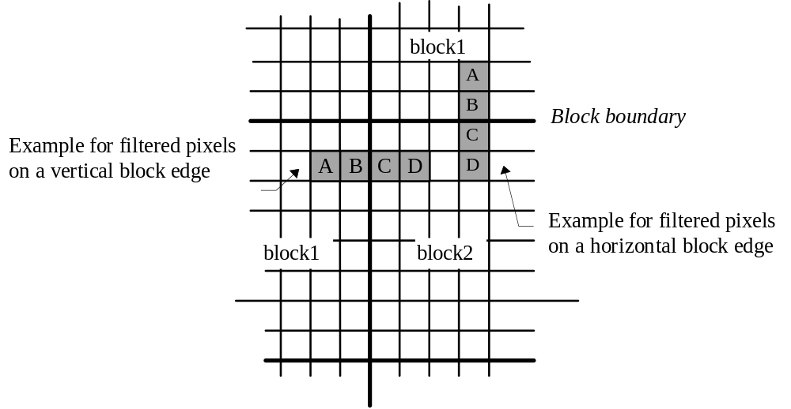
FIGURE J.1/H.263
Examples of positions of filtered pixels

One or both of the following conditions must be fulfilled in order to turn the filter on for a particular edge:
Condition 1: block1 belongs to a coded macroblock (COD==0 || MB-type == INTRA )
Condition 2: block2 belongs to a coded macroblock (COD==0 || MB-type == INTRA )
A, B, C, and D shall be replaced by A1, B1, C1, D1 where:
B1 = clip(B + d1)
C1 = clip(C − d1)
A1 = A − d2
D1 = D + d2
d = (A−4B+4C−D) / 8
d1 = UpDownRamp(d, STRENGTH)
d2 = clipd1((A − D) / 4, d1/2)
UpDownRamp(x, STRENGTH) = SIGN(x) * ( MAX( 0, abs(x)−MAX( 0, 2*(abs(x) − STRENGTH))))
STRENGTH depends on QUANT and determines the amount of filtering. The relation between STRENGTH and QUANT is given in Table J.2.
QUANT = quantization parameter used for block2 if block2 belongs to a coded macroblock
QUANT = quantization parameter used for block1 if block2 does not belong to a coded macroblock (but block1 does)
The function clip(x) is defined according to section 6.3.2, and the function clipd1(x, lim) clips x to the range ± abs(lim). The symbol “/” denotes division by truncation toward zero.
Figure J.2 shows how the value of d1 varies as a function of d. As a result, the filter has an effect only if d is smaller than 2*STRENGTH (and different from zero). This is to prevent the filtering of strong true edges in the picture content. . However, if the Reduced-Resolution Update mode is in use, STRENGTH is set to infinity, and as a result, the value of d1 is always equal to the value of d (see section Q.7.2 in Annex Q).

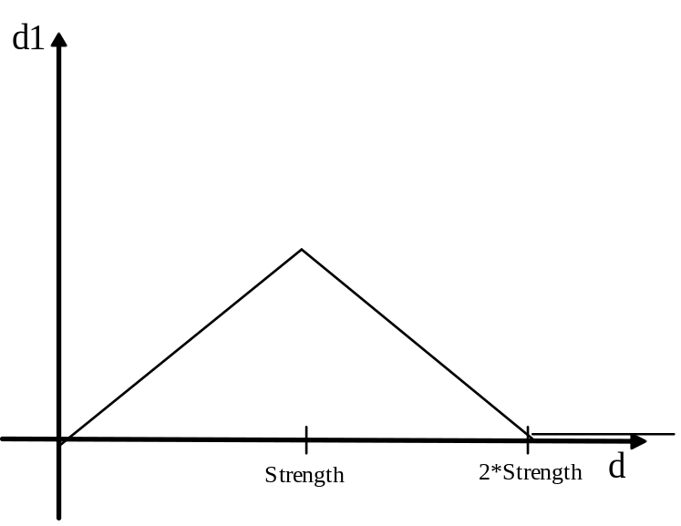
FIGURE J.2/H.263
Parameter d1 as a function of parameter d for deblocking filter mode
TABLE J.2/H.263
Relationship between QUANT and STRENGTH of Filter

QUANT | STRENGTH | QUANT | STRENGTH
1 | 1 | 17 | 8
2 | 1 | 18 | 8
3 | 2 | 19 | 8
4 | 2 | 20 | 9
5 | 3 | 21 | 9
6 | 3 | 22 | 9
7 | 4 | 23 | 10
8 | 4 | 24 | 10
9 | 4 | 25 | 10
10 | 5 | 26 | 11
11 | 5 | 27 | 11
12 | 6 | 28 | 11
13 | 6 | 29 | 12
14 | 7 | 30 | 12
15 | 7 | 31 | 12
16 | 7

The definition of d1 is designed to ensure that small mismatches between the encoder and decoder will remain small and will not build up over multiple pictures of a video sequence. This would be a problem, for example, with a condition that simply switches the filter on or off, because a mismatch of only ±1 for d could then cause the filter to be switched on at the encoder side and off at the decoder side, or vice versa.
Due to rounding effects, the order of edges where filtering is performed must be specified.
Filtering across horizontal edges:
Basically this process is assumed to take place first. More precisely, the pixels 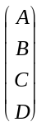 that are used in filtering
across a horizontal edge shall not have been influenced by previous filtering across a vertical edge.
Filtering across vertical edges:
Before filtering across a vertical edge using pixels (A,B,C,D), all modifications of pixels (A,B,C,D) resulting
from filtering across a horizontal edge shall have taken place.
Note that if one or more of the pixels (A,B,C,D) taking part in a filtering process are outside of a picture, no filtering takes place. Also, if the Independent Segment Decoding Mode is in use (see Annex R) and one or more of the pixels (A,B,C,D) taking part in a filtering process are in different video picture segments (see Annex I, section I.3 concerning when a block is considered to be in the same picture segment), no filtering is performed.

Annex K.
Slice Structured Mode
(This annex forms an integral part of this Recommendation.)

K.1. Introduction
This annex describes the optional Slice Structured mode of H.263. The capability of this mode of H.263 is signaled by external means (for example Recommendation H.245). The use of this mode is indicated in the PLUSPTYPE field of the picture header. In order to facilitate optimal usage in a number of environments, this mode contains two submodes which are also capable of being signalled by external means (for example Recommendation H.245). These two submodes are used to indicate whether or not rectangular slices will be used and/or whether the slices will be transmitted in sequential order or sent in an arbitrary order.
A slice is defined as a slice header followed by consecutive macroblocks in scanning order. An exception is for the slice that immediately follows the picture start code in the bitstream for a picture (which is not necessarily the slice starting with macroblock 0). In this case only part of the slice header is transmitted as described in section K.2. The slice layer defines a picture segment, and is used in place of the GOB layer in this optional mode. A slice picture segment starts at a macroblock boundary in the picture and contains a number of macroblocks. Different slices within the same picture shall not overlap with each other, and every macroblock shall belong to one and only one slice.
This mode contains two submodes, which are signaled in the SSS field of the picture header:
- The Rectangular Slice submode (RS). When RS is in use, the slice shall occupy a rectangular region of width specified by the SWI parameter of the slice header in units of macroblocks, and contains a number of macroblocks in scanning order within the rectangular region. When the Rectangular Slice submode is not in use, the SWI field is not present in the slice header and a slice contains a number of macroblocks in scanning order within the picture as a whole.
- The Arbitrary Slice Ordering submode (ASO). When ASO is in use, the slices may appear in any order within the bitstream.
Slice boundaries are treated differently than simple macroblock boundaries in order to allow slice header locations within the bitstream to act as resynchronization points for bit error and packet loss recovery and in order to allow out-of-order slice decoding within a picture. Thus, no data dependencies can cross the slice boundaries within the current picture, except for the Deblocking Filter mode which, when in use without the Independent Segment Decoding mode, filters across the boundaries of the blocks in the picture. However, motion vectors within a slice can cause data dependencies which cross the slice boundaries in the reference picture used for prediction purposes, unless the optional Independent Segment Decoding mode is in use.
The following rules are adopted to ensure that slice boundary locations can act as resynchronization points and to ensure that slices can be sent out of order without causing additional decoding delays:
- The prediction of motion vector values are the same as if a GOB header were present (see section 6.1.1), preventing the use of motion vectors of blocks outside the current slice for the prediction of the values of motion vectors within the slice.
- The Advanced Intra Coding mode (see Annex I) treats the slice boundary as if it were a picture boundary with respect to the prediction of intra block DCT coefficient values.
- The assignment of remote motion vectors for use in overlapped block motion compensation within the Advanced Prediction mode also prevents the use of motion vectors of blocks outside the current slice for use as remote motion vectors (see section F.3).

K.2. Structure of slice layer
The structure of the slice layer of the syntax is shown in Figure K.1 for all slices except the slice that immediately follows the picture start code in the bitstream for a picture. For the slice following the picture start code, only the emulation prevention bits (SEPB1, SEPB3, and conditionally SEPB2 as specified below), the MBA field and, when in the RS submode, also the SWI field are included.

SSTUF | SSC | GSBI | GFID | SEPB1 | MBA | SEPB2 | SQUANT | SWI | SEPB3 | Macroblock Data
FIGURE K.1/H.263
Structure of slice layer
Refer to section 5.2.4 for definition of GSBI, section 5.2.5 for GFID, and section 5.3 for description of Macroblock layer.

K.2.1. Stuffing (SSTUF) (Variable Length)
A codeword of variable length consisting of less than 8 bits. Encoders shall insert this codeword directly before an SSC codeword whenever needed to ensure that SSC is byte-aligned. If SSTUF is present, the last bit of SSTUF shall be the last (least significant) bit of a byte, so that the start of the SSC codeword is byte aligned. Decoders shall be designed to discard SSTUF. Notice that 0 is used for stuffing within SSTUF.

K.2.2. Slice Start Code (SSC) (17 bits)
A word of 17 bits. Its value is 0000 0000 0000 0000 1. Slice start codes shall be byte aligned. This can be achieved by inserting SSTUF before the start code such that the first bit of the start code is the first (most significant) bit of a byte.

K.2.3. Slice Emulation Prevention Bit 1 (SEPB1) (1 bit)
A single bit always having the value of “1”, which is included to prevent start code emulation.

K.2.4. Macroblock Address (MBA) (5/6/7/9/11/13/14 bits)
A codeword having a length that is dependent on the current picture size and whether the Reduced Resolution Update mode is in effect (see Annex Q). The bits are the binary representation of the macroblock number of the first macroblock in the current slice as counted from the beginning of the picture in scanning order, starting with macroblock number 0 at the upper left corner. MBA uniquely identifies which macroblock in the picture the current slice starts with. Codeword lengths for this codeword are provided in Table K.1. For custom picture sizes, the field width is given by the first entry in the table that has a larger number of macroblocks, and the maximum value is the number of macroblocks in the current picture minus one. When in the Reduced Resolution Update mode, the relevant picture size is the lower resolution update picture size rather than the picture size indicated in the picture header (see Annex Q).

K.2.5. Slice Emulation Prevention Bit 2 (SEPB2) (1 bit)
A single bit always having the value “1”, which is included under certain conditions to prevent start code emulation. For slices other than the one following the picture start code, SEPB2 is included only if the MBA Field Width is greater than 11 bits. For the slice following the picture start code, SEPB2 is included only if the Rectangular Slice submode is in use.

K.2.6. Quantizer Information (SQUANT) (5 bits)
A fixed length codeword of 5 bits which indicates the quantizer QUANT to be used for that slice until updated by any subsequent DQUANT. The codewords are the natural binary representations of the values of QUANT which, being half the step sizes, range from 1 to 31.

K.2.7. Slice Width Indication in Macroblocks (SWI) (3/4/5/6/7 bits)
A codeword which is present only if the Rectangular Slice submode is active, and having a length which depends on the current picture size and whether the Reduced Resolution Update mode is active, as specified in Table K.2. For custom picture sizes, the field width is given by the next wider standard format size (QCIF, CIF, …), and the maximum value is the total number of macroblocks across the picture minus one. The last row of the table indicates the field width for picture sizes wider than 16CIF. SWI refers to the width of the current rectangular slice having its first macroblock (upper left) specified by MBA. The calculation of the actual slice width is given by
Actual Slice Width = SWI + 1
When in the Reduced Resolution Update mode, the relevant picture size is that of the lower resolution picture size for the update information, rather than the picture size indicated in the picture header.

K.2.8. Slice Emulation Prevention Bit 3 (SEPB3) (1 bit)
A single bit always having the value of “1” in order to prevent start code emulation.
TABLE K.1/H.263
Specification of MBA parameter

 | Default |  | RRU mode
Picture Format | Max Value | Field Width | Max Value | Field Width
sub-QCIF | 47 | 6 | 11 | 5
QCIF | 98 | 7 | 29 | 5
CIF | 395 | 9 | 98 | 7
4CIF | 1583 | 11 | 395 | 9
16CIF | 6335 | 13 | 1583 | 11
2048x1152 | 9215 | 14 | 6335 | 13
TABLE K.2/H.263
Specification of SWI parameter

 | Default |  | RRU mode
Picture Format | Max Value | Field Width | Max Value | Field Width
sub-QCIF | 7 | 4 | 3 | 3
QCIF | 10 | 4 | 5 | 3
CIF | 21 | 5 | 10 | 4
4CIF | 43 | 6 | 21 | 5
16CIF | 87 | 7 | 43 | 6
1412...2048 pixels wide | 127 | 7 | 63 | 6

Annex L.
Supplemental Enhancement Information Specification
(This annex forms an integral part of this Recommendation.)

L.1. Introduction
This annex describes the format of the supplemental enhancement information sent in the PSUPP field of the picture layer of H.263. The capability of a decoder to provide any or all of the enhanced capabilities described in this annex may be signaled by external means (for example Recommendation H.245). Decoders which do not provide the enhanced capabilities may simply discard any PSUPP information bits that appear in the bitstream. The presence of this supplemental enhancement information is indicated in PEI, and an additional PEI bit is inserted between every octet of PSUPP data, as described in sections 5.1.24 and 5.1.25.
In this annex, a distinction is made between the “decoded picture” and the “displayed picture”. For purposes of this annex, the “displayed picture” is a picture having the same picture format as specified by the PTYPE of the current picture layer of the video bitstream syntax, and is constructed from the decoded picture, the prior displayed picture, and the additional supplementary data as described in this annex.

L.2. PSUPP Format
The PSUPP data consists of a four-bit function type indication FTYPE, followed by a four-bit parameter data size specification DSIZE, followed by DSIZE octets of function parameter data, optionally followed by another function type indication, and so on. One function type indication value is defined as an escape code to provide for future extensibility to allow definition of more than fifteen different functions. A decoder which receives a function type indication which it does not support can discard the function parameter data for that function and then check for a subsequent function type indication which may be supported. The defined FTYPE values are shown in Table L.1.
TABLE L.1/H.263
FTYPE Function Type Values
0 | Reserved
1 | Do Nothing
2 | Full-Picture Freeze Request
3 | Partial-Picture Freeze Request
4 | Resizing Partial-Picture Freeze Request
5 | Partial-Picture Freeze-Release Request
6 | Full-Picture Snapshot Tag
7 | Partial-Picture Snapshot Tag
8 | Video Segment Start Tag
9 | Video Segment End Tag
10 | Progressive Refinement Segment Start Tag
11 | Progressive Refinement Segment End Tag
12 | Chroma Key Information
13 | Reserved
14 | Reserved
15 | Extended Function Type

L.3. Do Nothing
No action is requested by the Do Nothing function. This function is used to prevent start code emulation. Whenever the last five or more bits of the final octet of the previous PSUPP octet are all zero and no additional PSUPP function requests are to be sent, the Do Nothing function shall be inserted into PSUPP to prevent the possibility of start code emulation. The Do Nothing function may also be sent when it is not required by rule expressed in the previous sentence. DSIZE shall be zero for the Do Nothing function.

L.4. Full-Picture Freeze Request
The full-picture freeze request function indicates that the contents of the entire prior displayed video picture shall be kept unchanged, without updating the displayed picture using the contents of the current decoded picture. The displayed picture shall then remain unchanged until the freeze picture release bit in the current PTYPE or in a subsequent PTYPE is set to 1, until a partial-picture freeze-release request is received, until the source format specified in a picture header differs from that of previous picture headers, or until timeout occurs, whichever comes first. Any change in the picture source format shall act as a full-picture freeze release. The request shall lapse due to timeout after five seconds or five pictures, whichever is a longer period of time. The timeout can be prevented by the issuance of another full-picture freeze request prior to expiration of the timeout period. DSIZE shall be zero for the full-picture freeze request function.

L.5. Partial-Picture Freeze Request
The partial-picture freeze request function indicates that the contents of a specified rectangular area of the prior displayed video picture should be kept unchanged, without updating the specified area of the displayed picture using the contents of the current decoded picture. The specified area of the displayed picture shall then remain unchanged until the freeze picture release bit in the current PTYPE or in a subsequent PTYPE is set to 1, until a partial-picture freeze-release request affecting the specified area is received, until the source format specified in a picture header differs from that of previous picture headers, or until timeout occurs, whichever comes first. Any change in the picture source format shall act as a full-picture freeze release. The request shall lapse due to timeout after five seconds or five pictures, whichever is a longer period of time. The timeout can be prevented by the issuance of identical partial-picture freeze request prior to expiration of the timeout period. DSIZE shall be equal to 4 for the partial-picture freeze request. The four octets of PSUPP that follow contain the horizontal and vertical location of the upper left corner of the frozen picture rectangle, and the width and height of the rectangle, respectively, using eight bits each and expressed in units of eight pixels. For example, a 24-pixel wide and 16 pixel tall area in the upper left corner of the video display is specified by the four parameters (0, 0, 3, 2).

L.6. Resizing Partial-Picture Freeze Request
The resizing partial-picture freeze request function indicates that the contents of a specified rectangular area of the prior displayed video picture should be resized to fit into a smaller part of the displayed video picture, which should then be kept unchanged, without updating the specified area of the displayed picture using the contents of the current decoded picture. The specified area of the displayed picture shall then remain unchanged until the freeze release bit in the current PTYPE or in a subsequent PTYPE is set to 1, until a partial-picture freeze-release request affecting the specified area is received, until the source format specified in a picture header differs from that of previous picture headers, or until timeout occurs, whichever comes first. Any change in the picture source format shall act as a full-picture freeze release. The request shall lapse due to timeout after five seconds or five pictures, whichever is a longer period of time. The timeout can be prevented by the issuance of a partial-picture freeze request for the affected area of the displayed picture prior to expiration of the timeout period. DSIZE shall be equal to 8 for the resizing partial-picture freeze request. The eight octets of PSUPP data that follow contain 32 bits used to specify the rectangular region of the affected area of the displayed picture, and then 32 bits used to specify the corresponding rectangular region of the affected area of the decoded picture. The width and height of the rectangular region in the decoded picture shall both be equal to 2^{i} times the width and height specified for the rectangular region in the displayed picture, where i is an integer in the range of 1 to 8. The location and size of each of these two rectangular regions is specified using the same format as such a region is specified in the partial-picture freeze request function.

L.7. Partial-Picture Freeze-Release Request
The partial-picture freeze-release request function indicates that the contents of a specified rectangular area of the displayed video picture shall be updated by the current and subsequent decoded pictures. DSIZE shall be equal to 4 for the partial-picture freeze-release request. The four octets of PSUPP data that follow specify a rectangular region of the displayed picture in the same format as such a region is specified in the partial-picture freeze request function.

L.8. Full-Picture Snapshot Tag
The full-picture snapshot tag function indicates that the current picture is labeled for external use as a still-image snapshot of the video content. DSIZE shall be equal to 4 for the full-picture snapshot tag function. The four octets of PSUPP data that follow specify a snapshot identification number for external use.

L.9. Partial-Picture Snapshot Tag
The partial-picture snapshot tag function indicates that a specified rectangular area of the current picture is labeled for external use as a still-image snapshot of the video content. DSIZE shall be equal to 8 for the partial-picture snapshot tag function. The first four octets of PSUPP data that follow specify a snapshot identification number for external use, and the remaining four octets of PSUPP data that follow specify a rectangular region of the decoded picture in the same format as such a region is specified in the partial-picture freeze request function.

L.10. Video Segment Start Tag
The video segment start tag function indicates that the beginning of a specified sub-sequence of video data is labeled as a useful section of video content for external use, starting with the current picture. The tagged sub-sequence of video data shall continue until stopped by the receipt of a matching video segment end tag function or until timeout, whichever comes first. The tagged sub-sequence shall end due to timeout after five seconds or five pictures, whichever is a longer period of time. The timeout can be prevented by the issuance of an identical video segment start tag function prior to expiration of the timeout period. DSIZE shall be equal to 4 for the video segment start tag function. The four octets of PSUPP data that follow specify a video segment identification number for external use.

L.11. Video Segment End Tag
The video segment end tag function indicates that the end of a specified sub-sequence of video data is labeled as a useful section of video content for external use, ending with the previous picture. DSIZE shall be equal to 4 for the video segment start tag function. The four octets of PSUPP data that follow specify a video segment identification number for external use.

L.12. Progressive Refinement Segment Start Tag
The progressive refinement segment start tag function indicates the beginning of a specified sub-sequence of video data which is labeled as the current picture followed by a sequence of zero or more pictures of refinement of the quality of the current picture, rather than as a representation of a continually moving scene. The tagged sub-sequence of video data shall continue until stopped by the receipt of a matching progressive refinement segment end tag function or until timeout, whichever comes first. The tagged sub-sequence shall end due to timeout after five seconds or five pictures, whichever is a longer period of time. The timeout can be prevented by the issuance of an identical progressive refinement segment start tag function prior to expiration of the timeout period. DSIZE shall be equal to 4 for the video segment start tag function. The four octets of PSUPP data that follow specify a progressive refinement segment identification number for external use.

L.13. Progressive Refinement Segment End Tag
The progressive refinement segment end tag function indicates the end of a specified sub-sequence of video data which is labeled as an initial picture followed by a sequence of zero or more pictures of the refinement of the quality of the initial picture, and ending with the previous picture. DSIZE shall be equal to 4 for the video segment start tag function. The four octets of PSUPP data that follow specify a progressive refinement identification number for external use.

L.14. Chroma Keying Information
The Chroma Keying Information Function (CKIF) indicates that the “chroma keying” technique is used to represent “transparent” and “semi-transparent” pixels in the decoded video pictures. When being presented on the display, “transparent” pixels are not displayed. Instead, a background picture which is externally controlled is revealed. Semi-transparent pixels are displayed by blending the pixel value in the current picture with the corresponding value in the background picture. One octet is used to indicate the keying color value for each component (Y, CB, or CR) which is used for chroma keying. To represent pixels that are to be “semi-transparent,” two threshold values, denoted as T1 and T2, are used. Let α denote the transparency of a pixel; α = 255 indicates that the pixel is opaque, and α = 0 indicates that the pixel is transparent. For other values of α, the resulting value for a pixel should be a weighted combination of the pixel value in the current picture and the pixel value from the background picture (which is specified externally). The values of α may be used to form an image that is called an “alpha map.” Thus the resulting value for each component may be
[α·X + (255-α)·Z] / 255
where X is the decoded pixel component value (for Y, CB, or CR), and Z is the corresponding pixel component value from the background picture.
The α value can be calculated as follows. First, the distance of the pixel color from the key color value is calculated:
in which XY, XB, and XR are the Y, CB, and CR values of the decoded pixel color, KY, KB, and KR are the corresponding key color parameters, and AY, AB, and AR. are keying flag bits which indicate which color components are used as keys. Once the distance d is calculated, the α value may be computed as specified in the following pseudo-code:
s = 255/(T₂-T₁)
for each pixel
if (d<T₁) then α = 0;
else if (d>T₂) then α = 255;
else α = floor[s⋅(d-T₁)]
However, the precise method for performing the chroma keying operation in the decoder is not specified herein, since normative specification of the method is not needed for interoperability. The process described here is provided for illustration purposes in order to convey the intended interpretation of the data parameters.
Since the derived α value is simply a function of XY, XB, and XR, a look-up table (LUT) can be built to achieve the above operation. Such an LUT has 2^{8xN} entries corresponding to all pixel values, where N is the number of color components used as keys. Each entry in the LUT would then contain the corresponding α value.
DSIZE shall be in the range of 1 to 9 (inclusive) for chroma keying information, according to the amount of data sent with the CKIF. No more than one CKIF shall be sent with a picture.
The first octet following the DSIZE octet shall contain the representation order of the current picture—streams having a lower representation order are assumed to form the background picture for streams having a higher representation order.
If DSIZE is greater than one, the next octet after the representation order octet shall be used to send six flag bits defined as:
bit 0 : AY : A flag bit indicating the presence of a KY key parameter for luminance Y values
bit 1 : AB : A flag bit indicating the presence of a KB key parameter for chroma CB values
bit 2 : AR : A flag bit indicating the presence of a KR key parameter for chroma CR values
bit 3 : A1 : A flag bit indicating the presence of a T1 threshold parameter for transparency
bit 4 : A2 : A flag bit indicating the presence of a T2 threshold parameter for opacity
bit 5 : RPB: A flag bit indicating the use of the reference picture as a background picture
bit 6 : reserved
bit 7 : reserved
DSIZE shall be equal to 1 or shall be equal to 2 plus the number of flag bits among AY, AB, and AR which are set to 1, plus 2 times the number of bits among A1 and A2 which are set to 1. If DSIZE is greater than 1, then an additional octet shall be sent to specify the value of each color component for each of the flag bits AY, AB, and AR which are set to one and two additional octets shall be sent to specify each of the flagged threshold values among T1 and T2. These octets shall follow in the same order as the flag bits.
If DSIZE is equal to 1, or if all three keying color flag bits AY, AB, and AR, are zero, the keying flag bits AY, AB, and AR and keying colors KY, KB, and KR which were used for the previous keyed picture should also be used for the current picture. If no previous values have been sent for the video sequence, the default keying flag bits AY = 1, AB = 1, and AR = 1 and the default key colors KY = 50, KB = 220, and KR = 100 should be used as the previous values.
If DSIZE is equal to 1, or if both of the keying threshold flag bits A1 and A2 are zero, the keying threshold values T1 and T2 which were used for the previous keyed picture should also be used for the current picture. If no previous values have been sent for the video sequence, the default threshold values T1 = 48 and T2 = 75 should be used as the previous values.
In the portion where the pixels are “semi-transparent” (i.e., when 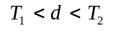), the decoded pixels typically contain the chroma key color in components where chroma keys are used. This may result in certain color artifacts. To address this problem, these pixel values may be adjusted before they are blended with the background color. Such a correction process may be applied to color components being used in the chroma key operation as indicated by the flag bits. The process is as follows:
X’ = K + (T₂/d) (X−K)
where X is the original decoded pixel component value, and X’ is the corrected value.
Since the adusted pixel values X’Y, X’B, and X’R are functions of XY, XB, and XR, the color correction can be achieved by using an LUT. This LUT would have 2^{8N} entries corresponding to all pixel values, where N is the number of color components used as keys. Each entry would then contain the corresponding corrected values.
If the reference picture background (RPB) flag bit is set to ‘1’, this indicates that the temporally-previous reference picture (prior to any Annex P resampling performed for the current picture) should be held as the (opaque) background of the current picture and of all subsequent chroma keyed pictures, until replaced by the arrival of another picture having an RPB flag set to ‘1’. If the RPB flag bit is set to ‘0’, this indicates that background should remain as previously controlled (either under external control or using a reference picture which was previously stored upon receipt of a prior picture having RPB set to ‘1’).
The use of the chroma keying which is invoked by the issuance of the chroma keying information function shall start with the current picture and shall continue until a subsequent picture of type INTRA or EI occurs or until a timeout period expires, whichever comes first. The use of chroma keying shall end due to timeout after five seconds or five pictures, whichever is a longer period of time. The timeout can be prevented by the issuance of an identical chroma keying information function prior to expiration of the timeout period. The encoder should send sufficient information with the chroma keying information function for complete resynchronization to occur with each picture of type INTRA or EI and within each timeout interval (it should not rely on using stored or default values of the key colors or thresholds).

L.15. Extended Function Type
The extended function type indication is used to signal that the following PSUPP octet contains an extended function. The usage of extended functions is reserved for the ITU to have a later ability to define a larger number of backward-compatible PSUPP data functions. DSIZE shall be equal to zero for the extended function type indication. In order to allow backward compatibility of future use of the extended function type indication, decoders shall treat the second set of four bits in the octet which follows the extended function type indication as a DSIZE value indicating the number of subsequent octets of PSUPP that are to be skipped for extended function parameter data, which may be followed by additional FTYPE indications.
Annex M.
Improved PB-frames mode
(This annex forms an integral part of this Recommendation.)

M.1. Introduction
This annex describes an optional Improved PB-frames mode of H.263. It is therefore considered to be advantageous to use the present Improved PB-frames mode instead of the PB-frames mode defined in Annex G. The capability of this mode is signaled by external means (for example Recommendation H.245). The use of this mode is indicated in the PLUSPTYPE field of the picture header.
Most parts of this option are similar to the PB-frame option defined in Annex G.
To avoid confusion with B pictures as defined in Annex O, the notion of B-picture, B-frame, B-macroblock, and B-block will not be used in this annex. Instead, we will use the notion B_{PB} to mean the “B-part” of PB. When reference is made to Annex G, B-picture and B-block shall be read as B_{PB}-picture and B_{PB}-block.
The main difference is that the B_{PB}-macroblock has a forward and a backward prediction mode in addition to the bi-directional prediction mode. In this Annex, MVDB (when present) refers to a forward motion vector. (Note that in Annex G MVDB was used to refer to an enhancement of the downscaled forward and backward vectors for bidirectional prediction, rather than a distinct forward motion vector.)
All the differences from Annex G are identified in this annex. When nothing is indicated, it means that the same procedure as described in Annex G is used.

M.2. B_{PB}-frame prediction modes
There are three different ways of coding a B_{PB}-macroblock. The different coding modes are signaled by the parameter MODB. The B_{PB}-macroblock coding modes are:

M.2.1. Bidirectional prediction
Prediction is done from the P-frames before and after the B_{PB}-frame. This prediction is equivalent to the prediction defined in Annex G when MVD =0. Notice that in this mode (and only in this mode), motion vector data (MVD) of the PB-macroblock must be included even if the P-macroblock is INTRA coded. (Notice the difference between MVD - motion vector data - and MVD - delta vector - defined in Annex G).

M.2.2. Forward prediction
In this prediction mode the vector data contained in MVDB are used for forward prediction from the previous P-frame. This means that there is always only one 16x16 vector for the B_{PB}-macroblock in this prediction mode.
A simple predictor is used for coding of the forward motion vector. The rule for this predictor is that if the current macroblock is not at the far left edge of the picture or slice and the macroblock to the left has a forward motion vector, then the predictor of the forward motion vector for the current macroblock is set to the value of the forward motion vector of the block to the left; otherwise the predictor is set to zero. The difference between the predictor and the desired motion vector is then VLC coded in the same way as vector data to be used for the P-frame (MVD).
Concerning motion vectors over picture boundaries defined in section D.1, the described technique also applies for the forward B_{PB}-vector if this feature is in use (this applies for forward as well as for bidirectional prediction mode).

M.2.3 Backward prediction
In this mode the prediction of the B_{PB} macroblock is identical to P_{REC} (defined in section G.5). No motion vector data is used for the backward prediction.

M.3. Calculation of vectors for bidirectional prediction of a the B-macroblock
In case bidirectional prediction is used, the scaled forward and backward vectors are calculated as described in Annex G when MVD = 0.

M.4. MODB table
A new definition for MODB (replacing Table 11) is shown in Table M.1. It indicates the possible coding modes for a B_{PB}-block.
TABLE M.1/H.263
MODB table for Improved PB-frames mode

Index | CBPB | MVDB | Number  of bits | Code | Coding Mode
0 |  |  | 1 | 0 | Bidirectional prediction
1 | x |  | 2 | 10 | Bidirectional prediction
2 |  | x | 3 | 110 | Forward prediction
3 | x | x | 4 | 1110 | Forward prediction
4 |  |  | 5 | 11110 | Backward prediction
5 | x |  | 5 | 11111 | Backward prediction

Annex N.
Reference Picture Selection Mode
(This annex forms an integral part of this Recommendation.)

N.1. Introduction
This annex describes the optional Reference Picture Selection mode of H.263, which operates using a modified interframe prediction method called “NEWPRED.” The capability of this mode of H.263 is signaled by external means (for example Recommendation H.245). The amount of additional picture memory accommodated in the decoder may also be signaled by external means to help the memory management at the encoder. This mode can use backward channel messages sent from a decoder to an encoder to inform the encoder which part of which pictures have been correctly decoded at the decoder. The use of this mode is indicated in the PLUSPTYPE field of the picture header. This mode has two back-channel mode switches which define whether a backward channel is used and what kind of messages are returned on that backward channel from the decoder, and has another submode defined in terms of the channel for the backward channel messages.
The two back-channel mode switches of this mode determine the type of messages sent on the back-channel, specifying whether ACK (acknowledgment messages), or NACK (non-acknowledgment messages) are sent. Together, the two switches define four basic methods of operation:
- NEITHER: In which no back-channel data is returned from the decoder to the encoder,
- ACK: In which the decoder returns only acknowledgment messages,
- NACK: In which the decoder returns only non-acknowledgment messages, and
- ACK+NACK: In which the decoder returns both acknowledgment and non-acknowledgment messages.
There are also two methods of operation in terms of the channel for backward channel messages:
- Separate Logical Channel mode: This method of operation delivers back-channel data through a separate logical channel in the multiplex layer of the system, and
- VideoMux mode: This method of operation delivers back-channel data for received video within the forward video data of a video stream of encoded data.
The specific type of operation as outlined above is indicated in the picture header. This annex specifies a syntax for the backward channel messages as well as for forward channel data.

N.2. Video source coding algorithm
The source coder of this mode is shown in generalized form in Figure N.1. This figure shows a structure which uses a number of picture memories. The source coder may select one of the picture memories to suppress the temporal error propagation due to the inter-frame coding. The Independent Segment Decoding mode (see Annex R), which treats boundaries of GOBs with non-empty headers or slices as picture boundaries, can be used to avoid error propagation due to motion compensation across the boundaries of the GOBs or slices when this mode is applied to a smaller unit than a picture, such as a GOB or slice. The information to signal which picture is selected for prediction is included in the encoded bitstream. The strategy used by the encoder to select the picture to be used for prediction is out of the scope of this Recommendation.
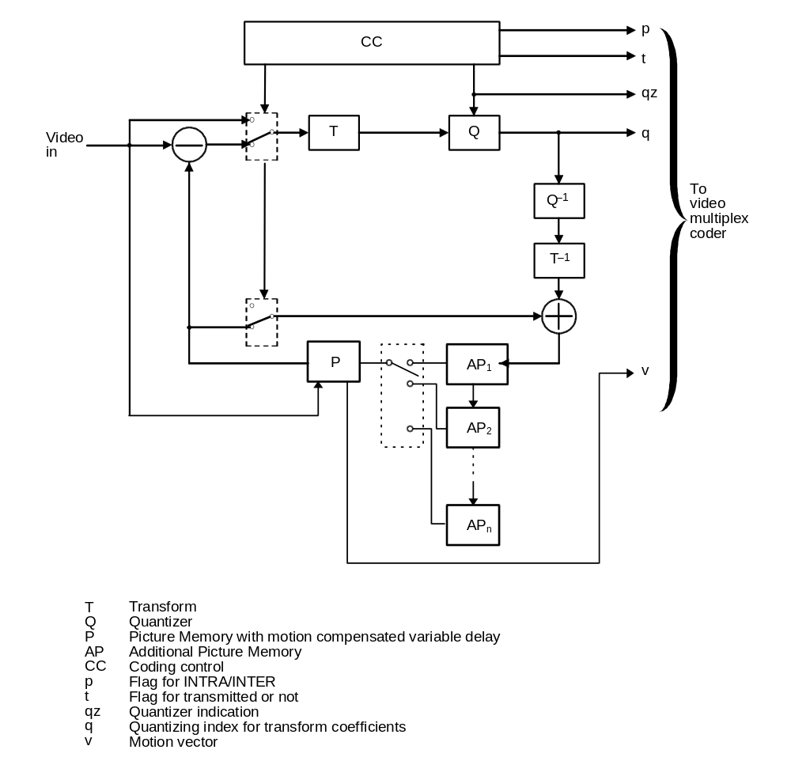
FIGURE N.1/H.263
Source coder for NEWPRED

N.3. Channel for Back-Channel messages
This mode has two methods of operation in terms of the type of channel for back-channel messages. One is the separate logical channel mode and the other is the videomux mode. The separate logical channel mode is a preferred mode and delivers the back-channel message defined in N.4.2 through the dedicated logical channel. The videomux mode is prepared for the system which cannot set up the separate extra channel for the back-channel messages due to the restriction of the number of channels’ combinations. The videomux mode delivers the back-channel messages through the same logical channel with the forward video data in the opposite direction.

N.3.1 Separate Logical Channel Mode
The separate logical channel mode delivers back-channel messages through a dedicated logical channel opened only for the purpose of the back-channel messages. The association mechanism with the forward channel which delivers video data is provided by external means (for example Recommendation H.245).

N.3.2 VideoMux Mode
The videomux mode delivers the back-channel messages through the same logical channel with the forward video data in the opposite direction. The syntax of the multiplexed bitstream is described in the section N.4.1. The back-channel messages may be inserted by using the Back-Channel message Indication (BCI) in the part of GOB or slice header.

N.4. Syntax

N.4.1. Forward Channel
The syntax for the forward channel data which conveys the compressed video signal is the same as shown in Figure 6 except for the Group of Blocks (GOB) layer. The syntax of the GOB layer is illustrated in Figure N.2. The fields of TRPI, TRP, BCI, and BCM are added to Figure 9.

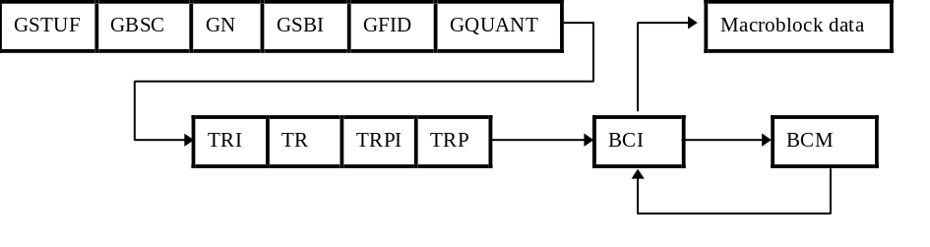
FIGURE N.2/H.263
Structure of GOB layer for NEWPRED
When the optional Slice Structured mode (see Annex K) is in use, the syntax of the slice layer is modified in the same way as the GOB layer. The syntax is illustrated Figure N.3.

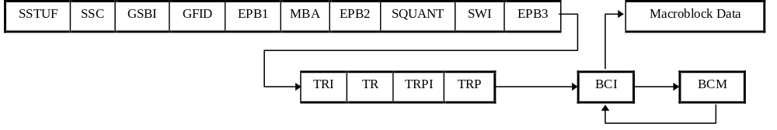
FIGURE N.3/H.263
Structure of Slice layer for NEWPRED
N.4.1.1. TRI (Temporal Reference Indicator) (1 bit)
TRI indicates whether or not the following TR field is present.
0: TR field is not present.
1: TR field is present.
N.4.1.2. Temporal Reference (TR) (8/10 bits)
When present, TR is an eight bit number unless a custom picture clock frequency is in use, in which case it is a ten bit number consisting of the concatenation of ETR and TR of the picture header.

N.4.1.3. TRPI (Temporal Reference for Prediction Indicator) (1 bit)
TRPI indicates whether or not the following TRP field is present.
0: TRP field is not present.
1: TRP field is present.
TRPI shall be equal to zero whenever the picture is an I or EI picture.

N.4.1.4. Temporal Reference for Prediction (TRP) (10 bits)
When present, TRP indicates the Temporal Reference which is used for prediction of the encoding, except for in the case of B pictures. For B pictures, the picture having the temporal reference TRP is used for the prediction in the forward direction. (Prediction in the reverse-temporal direction always uses the immediately temporally-subsequent picture.) TRP is a ten bit number. If a custom picture clock frequency was not in use for the reference picture, the two MSBs of TR are zero and the LSBs contain the eight bit TR found in the picture header of the reference picture. If a custom picture clock frequency was in use for the reference picture, TR is a ten bit number consisting of the concatenation of ETR and TR from the reference picture header.

N.4.1.5. Back-Channel message Indication (BCI) (Variable Length)
This field contains one or two bits, when set to "1", it signals the presence of the following optional video Back-Channel Message (BCM) field. Otherwise, the field value is "01", which indicates the absence or the end of the video back-channel message field. Combinations of BCM and BCI may not be present, and may be repeated when present. BCI shall always be set to "01" if the videomux mode is not in use.

N.4.1.6. Back-Channel Message (BCM) (Variable Length)
The Back-Channel Message having syntax as defined in the section N.4.2, which is present only if the preceding BCI field is set to "1".

N.4.2. Back-Channel Message (BCM) Syntax
The syntax for the back-channel which conveys the acknowledgment/non-acknowledgment messages is illustrated in Figure N.4. This message is returned from a decoder to an encoder in order to tell whether a forward channel data was correctly decoded or not.

BT | URF | TR | ELNUMI | (ELNUM) | GSBI | BEPB1 | GN/MBA | BEPB2 | RTR | BSTUF
FIGURE N.4/H.263
Structure of back-channel message (BCM) syntax for NEWPRED

N.4.2.1. Back-channel message Type (BT) (2 bits)
Back-channel message type indicates if the corresponding part of the encoded message is correctly decoded or not. Which type of message is required for the encoder is indicated in the picture header of the forward channel.
00: reserved for future use
01: ACK. It indicates the correct decoding of the corresponding part of the forward channel data.
10: NACK. It indicates the erroneous decoding of the corresponding part of the forward channel data.
11: reserved for future use

N.4.2.2. Unreliable Flag (URF) (1 bit)
The Unreliable Flag is set to 1 when a reliable value for TR or GN/MBA is not available to the decoder. (When BT is NACK, a reliable TR may not be available at the decoder.)
0: reliable
1: unreliable

N.4.2.3. Temporal Reference (TR) (10 bits)
Temporal reference contains the TR information of the video picture segment for which the ACK/NACK is indicated in the back-channel message. Note: The meaning of the term “video picture segment” as used herein is defined in Annex R. If a custom picture clock frequency was not in use for the reference picture, the two MSBs of TR are zero and the LSBs contain the eight bit TR found in the picture header of the reference picture. If a custom picture clock frequency was in use for the reference picture, TR is a ten bit number consisting of the concatenation of ETR and TR from the reference picture header.

N.4.2.4. Enhancement Layer Number Indication (ELNUMI) (1 bit)
The enhancement layer number indication is “0” unless the optional Temporal, SNR and Spatial Scalability mode (Annex O) is used in the forward channel data and some enhancement layers of the forward channel are combined on one logical channel and the back-channel message refers to an enhancement layer (rather than the base layer), in which case the enhancement layer number indication shall be “1”.

N.4.2.5. Enhancement Layer Number (ELNUM) (4bits)
Enhancement layer number is present if and only if ELNUMI is “1”, in which case it contains the layer number of the enhancement layer referred to in the back-channel message.

N.4.2.6. BCPM (1 bit)
BCPM is “0” unless the CPM mode is used in the forward channel data, in which case it is “1”. If BCPM is “1”, this indicates that BSBI is present.

N.4.2.7. Back-channel Sub Bitstream Indicator (BSBI) (2 bits)
A fixed length codeword of 2 bits that is only present if BCPM is “1”. ACK/NACK message is indicated in the back-channel message. The BSBI is the natural binary representation of the appropriate Sub-Bitstream number in the forward channel data for which the ACK/NACK message is indicated in the back-channel message as described in section 5.2.4 and Annex C.

N.4.2.8. Back-channel Emulation Prevention Bit 1 (BEPB1) (1 bit)
A field which is present if and only if the videomux mode is in use. This field is always set to “1” to prevent a start code emulation.

N.4.2.9. GOB Number/Macroblock Address (GN/MBA) (5/6/7/9/11/13/14 bits):
A GOB number or Macroblock address is present in this field. If the optional Slice Structured mode (see Annex K) is not in use, this field contains the GOB number of the beginning of the video picture segment for which the NACK/ACK message is indicated in the back-channel message. If the optional Slice Structured mode is in use, this field contains the macroblock address of the beginning of the slice for which the NACK/ACK message is indicated in the back-channel message. The length of this field is the length specified elsewhere in this Recommendation for GN or MBA.

N.4.2.10. Back-channel Emulation Prevention Bit 2 (BEPB2) (1 bit)
A field which is present if and only if the videomux mode is in use. This field is always set to “1” to prevent a start code emulation.

N.4.2.11. Requested Temporal Reference (RTR) (10 bits)
Requested temporal reference is present only if BT is NACK. RTR indicates the requested temporal reference of the GOB or slice associated with the NACK. Typically it is the TR of the last correctly decoded video picture segment of the corresponding position at the decoder. If a custom picture clock frequency was not in use for the requested reference picture, the two MSBs of RTR are zero and the LSBs contain the eight bit TR found in the picture header of the requested reference picture. If a custom picture clock frequency was in use for the requested reference picture, RTR is a ten bit number consisting of the concatenation of ETR and TR from the requested reference picture header.

N.4.2.12. Stuffing (BSTUF) (Variable Length)
This field is present if and only if the separate logical channel mode is in use. BSTUF consists of a codeword of variable length consisting of zero or more bits of value “0”.

N.5. Decoder Process
The decoder of this mode may need an additional number of picture memories to store the correctly decoded video signals and their Temporal Reference (TR) information. The decoder uses the stored picture for which the TR is TRP as the reference picture for inter-frame decoding instead of the last decoded picture, if the TRP field exists in the forward channel data. When the picture for which the TR is TRP is not available at the decoder, the decoder may send a forced intra update signal to the encoder by external means (for example Recommendation H.245). Unless a different frame storage policy is negotiated by external means, correctly decoded video picture segments shall be stored into memory for use as later reference pictures on a first-in, first-out basis as shown in Figure N.1 (except for B pictures, which are not used as reference pictures).
An acknowledgment message (ACK) and a non-acknowledgment message (NACK) are defined as back-channel messages. An ACK may be returned when the decoder decodes a video picture segment successfully. NACKs may be returned when the decoder fails to decode a video picture segment, and may continue to be returned until the decoder gets the expected forward channel data which includes the requested TRP or an Intra update. Which types of message shall be sent is indicated in the RPSMF field of the picture header of the forward channel data.
In a usage scenario known as “Video Redundancy Coding”, the Reference Picture Selection mode may be used by some encoders in a manner in which more than one representation is sent for the pictured scene at the same temporal instant (usually using different reference pictures). In such a case in which the Reference Picture Selection mode is in use and in which adjacent pictures in the bitstream have the same temporal reference, the decoder shall regard this occurrence as an indication that redundant copies have been sent of approximately the same pictured scene content, and shall decode and use the first such received picture while discarding the subsequent redundant pictures.

Annex O.
Temporal, SNR, and Spatial Scalability Mode
(This annex forms an integral part of this Recommendation.)
This annex describes the optional mode of H.263 in support of Temporal, SNR, and Spatial Scalability. This mode may also be used in conjunction with error control schemes. The capability of this mode and the extent to which its features are supported is signaled by external means (for example Recommendation H.245). The use of this mode is indicated in PLUSPTYPE.

O.1. Overview
Scalability allows for the decoding of a sequence at more than one quality level. This is done by using a hierarchy of pictures and enhancement pictures partitioned into one or more layers. There are three types of pictures used for scalability: B, EI, and EP pictures, as explained below. Each of these has an enhancement layer number ELNUM that indicates to which layer it belongs, and a reference layer number RLNUM that indicates which layer is used for its prediction. The lowest layer is called the base layer, and has layer number 1.
Scalability is achieved by three basic methods: temporal, SNR, and spatial enhancement.

O.1.1. Temporal scalability
Temporal scalability is achieved using bi-directionally predicted pictures, or B-pictures. B-pictures allow prediction from either or both a previous and subsequent reconstructed picture in the reference layer. This property generally results in improved compression efficiency as compared to that of P pictures. These B-pictures differ from the B-picture part of a PB (or Improved PB) frame (see Annexes G and M) in that they are separate entities in the bitstream: they are not syntactically intermixed with a subsequent P (or EP) picture.
B pictures (and the B part of PB or Improved PB frames) are not used as reference pictures for the prediction of any other pictures. This property allows for B-pictures to be discarded if necessary without adversely affecting any subsequent pictures, thus providing temporal scalability. Figure O.1 illustrates the predictive structure of P and B pictures.

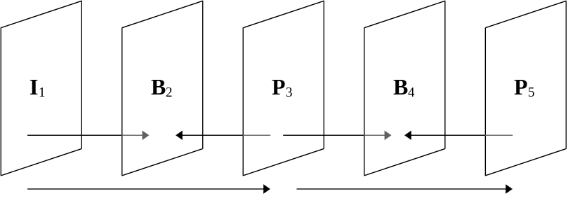
FIGURE O.1/H.263
Illustration of B picture prediction dependencies
The location of B pictures in the bitstream is in a data-dependence order rather than in strict temporal order. (This rule is consistent with the ordering of other pictures in the bitstream, but for all picture types other than the B picture, no such conflict arises between the data-dependence order and the temporal order.) For example, if the pictures of a video sequence were numbered 1, 2, 3, …, then the bitstream order of the encoded pictures would be I₁, P₃, B₂, P₅, B₄, …, where the subscript refers to the original picture number (as illustrated in Figure O.1).
There is no limit to the number of B pictures that may be inserted between pairs of reference pictures in the reference layer (other than what is necessary to prevent temporal ambiguity from overflows of the temporal reference field in the picture header). However, a maximum number of such pictures may be signaled by external means (for example Recommendation H.245).
Motion vectors are allowed to extend beyond the picture boundaries of B pictures.

O.1.2. SNR scalability
The other basic method to achieve scalability is through spatial/SNR enhancement. Spatial scalability and SNR scalability are equivalent except for the use of interpolation as is described shortly. Because compression introduces artifacts and distortions, the difference between a reconstructed picture and its original in the encoder is (nearly always) a nonzero-valued picture, containing what can be called the coding error. Normally, this coding error is lost at the encoder and never recovered. With SNR scalability, these coding error pictures can also be encoded and sent to the decoder, producing an enhancement to the decoded picture. The extra data serves to increase the signal-to-noise ratio of the video picture, and hence the term SNR scalability. Figure O.2 illustrates the data flow for SNR scalability. The vertical arrows from the lower layer illustrate that the picture in the enhancement layer is predicted from a reconstructed approximation of that picture in the reference (lower) layer.
If prediction is only formed from the lower layer, then the enhancement layer picture is referred to as an EI picture. It is possible, however, to create a modified bi-directionally predicted picture using both a prior enhancement layer picture and a temporally simultaneous lower layer reference picture. This type of picture is referred to as an EP picture or “Enhancement” P-picture. The prediction flow for EI and EP pictures is shown in Figure O.2. (Although not specifically shown in Figure O.2, an EI picture in an enhancement layer may have a P picture as its lower layer reference picture, and an EP picture may have an I picture as its lower-layer enhancement picture.)
For both EI and EP pictures, the prediction from the reference layer uses no motion vectors. However, as with normal P pictures, EP pictures use motion vectors when predicting from their temporally-prior reference picture in the same layer.

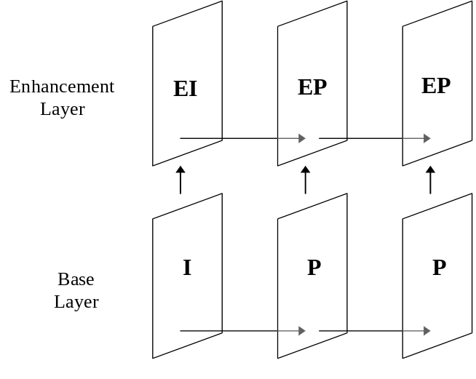
FIGURE O.2/H.263
Illustration of SNR scalability

O.1.3. Spatial scalability
The third and final scalability method in the Temporal, SNR, and Spatial Scalability mode is spatial scalability, which is closely related to SNR scalability. The only difference is that before the picture in the reference layer is used to predict the picture in the spatial enhancement layer, it is interpolated by a factor of two either horizontally or vertically (1-D spatial scalability), or both horizontally and vertically (2-D spatial scalability). The interpolation filters for this operation are defined in section O.6. For a decoder to be capable of some forms of spatial scalability, it may also need to be capable of custom picture formats. For example, if the base layer is sub-QCIF (128x96), the 2-D spatial enhancement layer picture would be 256x192, which does not correspond to a standard picture format. Another example would be if the base layer were QCIF (176x144), with the standard pixel aspect ratio of 12:11. A 1-D horizontal spatial enhancement layer would then correspond to a picture format of 352x144 with a pixel aspect ratio of 24:11. Thus a custom picture format would have to be used for the enhancement layer in these cases. An example which does not require a custom picture format would be the use of a QCIF base layer with a CIF 2-D spatial enhancement layer. Spatial scalability is illustrated in Figure O.3.
Other than requiring an upsampling process to increase the size of the reference layer picture prior to its use as a reference for the encoding process, the processing and syntax for a spatial scalability picture is functionally identical to that for an SNR scalability picture.
Since there is very little syntactical distinction between pictures using SNR scalability and pictures using spatial scalability, the pictures used for either purpose are called EI and EP pictures.
The picture in the base layer which is used for upward prediction in an EI or EP picture may be an I picture, a P picture, or the P part of a PB or Improved PB frame (but shall not be a B picture or the B part of a PB or Improved PB frame).

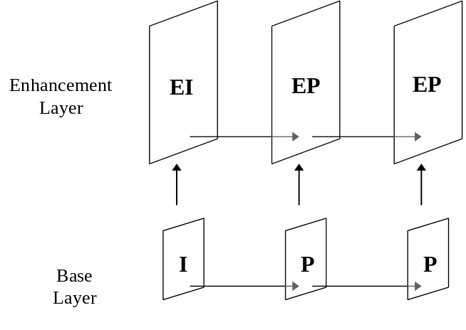
FIGURE O.3/H.263
Illustration of Spatial Scalability

O.1.4. Multilayer scalability
It is possible not only for B pictures to be temporally inserted between pictures of types I, P, PB, and Improved PB, but also between pictures of types EI and EP, whether these consist of SNR or spatial enhancement pictures. It is also possible to have more than one SNR or spatial enhancement layer in conjunction with a base layer. Thus a multilayer scalable bitstream can be a combination of SNR layers, spatial layers, and B pictures. The size of a picture cannot decrease, however, with increasing layer number. It can only stay the same or increase by a factor of two in one or both dimensions. Figure O.4 illustrates a multilayer scalable bit stream.
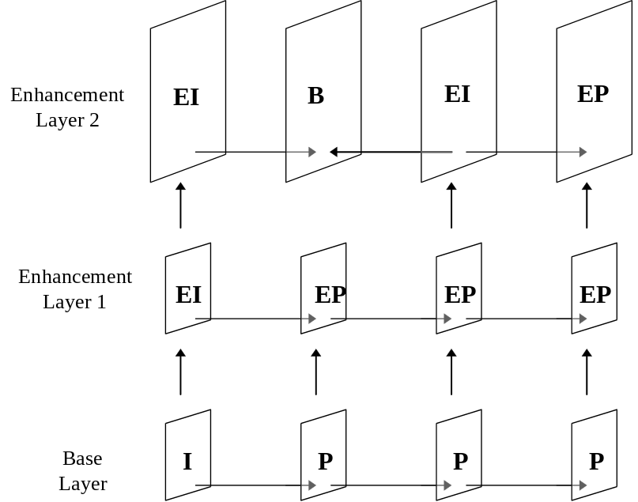
FIGURE O.4/H.263
Illustration of multilayer scalability
In the case of multilayer scalability, the picture in a reference layer which is used for upward prediction in an EI or EP picture may be a I, P, EI, or EP picture, or may be the P part of a PB or Improved PB frame in the base layer (but shall not be a B picture or the B part of a PB or Improved PB frame).
As with the two layer case, B pictures may occur in any layer. However, any picture in an enhancement layer which is temporally simultaneous with a B picture in its reference layer must be a B picture or the B picture part of an PB or Improved PB frame. This is to preserve the disposable nature of B pictures. Note, however, that B pictures may occur in layers that have no corresponding picture in lower layers. This allows an encoder to send enhancement video with a higher picture rate than the lower layers.
The enhancement layer number and the reference layer number for each enhancement picture (B, EI, or EP) are indicated in the ELNUM and RLNUM fields, respectively, of the picture header.

O.2. Transmission order of pictures
Pictures which are dependent on other pictures shall be located in the bitstream after the pictures on which they depend.
The bitstream syntax order is specified such that for reference pictures (i.e., picture having types I, P, EI, or EP, or the P part of PB or Improved PB), the following two rules shall be obeyed:
- All reference pictures with the same temporal reference shall appear in the bitstream in increasing enhancement layer order (since each lower layer reference picture is needed to decode the next higher layer reference picture).
- All temporally simultaneous reference pictures as discussed in item 1 above shall appear in the bitstream prior to any B pictures for which any of these reference pictures is the first temporally subsequent reference picture in the reference layer of the B picture (in order to reduce the delay of decoding all reference pictures which may be needed as references for B pictures).
Then, the B-pictures with earlier temporal references shall follow (temporally ordered within each enhancement layer).
The bitstream location of each B picture shall comply with the following rules:
- Its bitstream location shall be after that of its first temporally subsequent reference picture in the reference layer (since the decoding of the B picture generally depends on the prior decoding of that reference picture).
- Its bitstream location shall be after that of all reference pictures that are temporally simultaneous with the first temporally subsequent reference picture in the reference layer (in order to reduce the delay of decoding all reference pictures which may be needed as references for B pictures)
- Its bitstream location shall precede the location of any additional temporally subsequent pictures other than B pictures in its reference layer (since to allow otherwise would increase picture-storage memory requirements for the reference layer pictures).
- Its bitstream location shall be after that of all EI and EP pictures that are temporally simultaneous with the first temporally subsequent reference picture.
- Its bitstream location shall precede the location of all temporally subsequent pictures within its same enhancement layer (since to allow otherwise would introduce needless delay and increase picture-storage memory requirements for the enhancement layer).
Figure O.5 illustrates two allowable picture transmission orders given by the rules above for the layering structure shown therein (with numbers in dotted-line boxes indicating the bitstream order, separated by commas for the two alternatives).
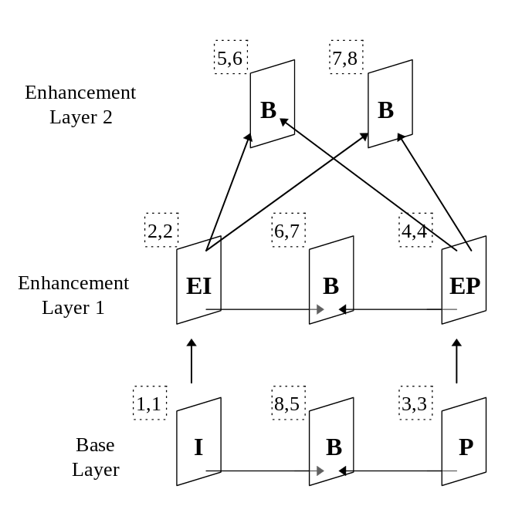
FIGURE O.5/H.263
Example of picture transmission order

O.3. Picture Layer Syntax
The Enhancement Layer Number (ELNUM, section 5.1.11) is always present in any enhancement (B, EI, or EP) picture and shall not be present in I or P pictures, or in PB or Improved PB frames. The Reference Layer Number (RLNUM, section 5.1.12) is present for some enhancement pictures and is inferred for others, as described in section 5.1.12.
There is exactly one base layer and it has ELNUM and RLNUM equal to 1. The RLNUM gives the enhancement layer number of the forward and backward reference pictures for B-pictures, for the upward reference picture for EI and EP-pictures. The reference pictures of the base layer may consist of I, PB, Improved PB, and P pictures, none of which include ELNUM or RLNUM in the picture header (their implied values are 1).
For B-pictures, RLNUM must be less or equal to ELNUM, while for EI and EP-pictures, RLNUM must be smaller than ELNUM.
ELNUM may be different from the layer number used at the system level. Since B-pictures have no other pictures dependent on themselves, they may even be put in a separate enhancement layer by system components external to H.263 (for example Recommendations H.245 and H.223). Moreover, it is up to the implementor as to whether the enhancement pictures are sent in separate video channels or remain multiplexed together with the base layer pictures.
As stated in section 5.1.4.5, the Deblocking Filter mode (see Annex J) does not apply within B pictures. This is because B pictures are not used for the prediction of any other pictures, and thus the application of a deblocking filter to these pictures is entirely a post-processing technique which is outside the scope of this Recommendation. However, the use of some type of deblocking filter for B pictures is encouraged, and a filter such as that described in Annex J may in fact be a good design to use for that purpose.
The Temporal Reference (TR) (see section 5.1.2) is defined exactly as for I and P pictures.
There shall be no TRB (see section 5.1.22) or DBQUANT (see section 5.1.23) fields in the picture header of B, EI or EP-pictures.

O.4. Macroblock Layer Syntax
The macroblock layer syntax for B and EP-pictures is the same, since each uses two reference pictures in a similar way. However, the interpretation varies slightly depending on the picture type. Figure O.6 indicates the B and EP syntax. The MBTYPE field indicates whether there is direct-mode prediction, forward prediction, backward/upward prediction, or bi-directional prediction. The MBTYPE is defined differently for B and EP-pictures as described below.
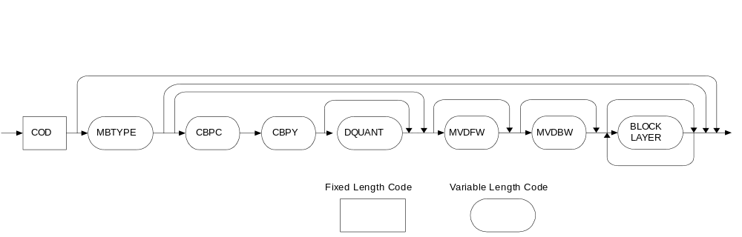
FIGURE O.6/H.263
Macroblock syntax for EP and B pictures
The direct prediction mode is only available for B-pictures. It is a bi-directional prediction mode similar to the bi-directional mode in Improved PB-frames mode (Annex M). The only difference is that there is no restriction on which pixels can be backward predicted since the complete backward prediction image is known at the decoder. Bi-directional mode uses separate motion vectors for forward and backward prediction. In both direct and bi-directional mode, the prediction pixel values are calculated by averaging the forward and backward prediction pixels. The average is calculated by dividing the sum of the two predictions by two (division by truncation). In direct mode, when there are four motion vectors in the reference macroblock, then all four motion vectors are used as in Improved PB-frames mode (Annex M).
For B pictures, forward prediction means prediction from a previous reference picture in the reference layer. Backward prediction means prediction from a temporally subsequent reference picture in the reference layer.
For EP-pictures, forward prediction means prediction from a previous EI or EP picture in the same layer, while upward prediction is used to mean prediction from the temporally simultaneous (possibly interpolated) reference picture in the reference layer. No motion vector is used for the upward prediction (which is syntactically in the same place as backward prediction for B pictures), although one can be used for the forward prediction.
The macroblock syntax for EI-pictures is slightly different. As shown in Figure O.7, the MBTYPE and CBPC are combined into an MCBPC field. No forward prediction is used, only upward prediction from the temporally simultaneous reference picture in the reference layer. No motion vector is used.
In B and EP pictures, motion vectors over picture boundaries may be used as described in section D.1 of Annex D (although extension of the motion vector range as described in section D.2 is only active if the Unrestricted Motion Vector mode is also in use).
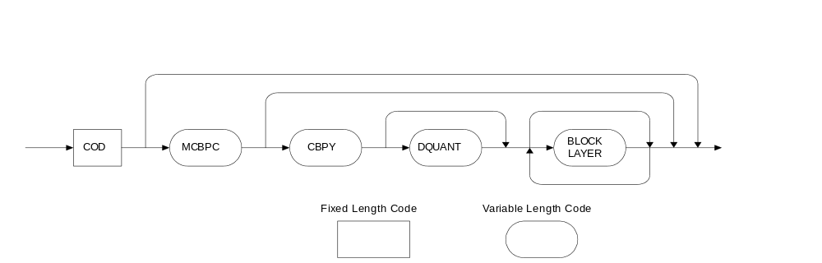
FIGURE O.7/H.263
Macroblock syntax for EI pictures

O.4.1. Coded macroblock indication (COD) (1 bit)
A bit which when set to “0” signals that the macroblock is coded. If set to “1”, no further information is transmitted for this macroblock and the macroblock is handled as “skipped” as described below.

O.4.2. MBTYPE/MCBPC (VLC)
There are different MBTYPE tables for B and EP pictures. For EI pictures, there is instead a MCBPC table. Table O.1 is the MBTYPE table for B-pictures. Table O.2 is the MBTYPE table for B pictures. Table O.3 is the MCBPC table for EI pictures.
For B pictures, the “Direct (skipped)” prediction type indicates that neither MBTYPE, nor any data is transmitted in the macroblock and that the decoder derives forward and backward motion vectors and the corresponding bi-directional prediction. This is signaled by the COD bit. The “Forward (no texture)”, the “Backward (no texture)”, and the “Bi-dir (no texture)” prediction types for a B picture indicate forward, backward, and bi-directional prediction with no coefficients, and with one transmitted motion vector for forward and backward prediction, and two transmitted motion vectors for bi-directional prediction.
For EP pictures, the “Forward (skipped)” prediction type indicates that no additional data is sent for the macroblock, so that the decoder should use forward prediction with a zero motion vector and no coefficients. The “Upward (no texture)” and “Bi-dir (no texture)” prediction types for an EP picture indicate upward and bi-directional prediction with no coefficients, and with zero motion vector(s).
For EI pictures, the “Upward (skipped)” prediction type indicates that no additional data is sent for the macroblock, so that the decoder should use upward prediction with a zero motion vector and no coefficients.

TABLE O.1/H.263
MBTYPE VLC codes for B pictures

Index | Prediction Type | MVDFW | MVDBW | CBPC +  CBPY | DQUANT | MBTYPE | Bits
— | Direct (skipped) |  |  |  |  | (COD=1) | 0
0 | Direct |  |  | X |  | 11 | 2
1 | Direct + Q |  |  | X | X | 0001 | 4
2 | Forward (no texture) | X |  |  |  | 100 | 3
3 | Forward | X |  | X |  | 101 | 3
4 | Forward + Q | X |  | X | X | 0011 0 | 5
5 | Backward (no texture) |  | X |  |  | 010 | 3
6 | Backward |  | X | X |  | 011 | 3
7 | Backward + Q |  | X | X | X | 0011 1 | 5
8 | Bi-Dir (no texture) | X | X |  |  | 0010 0 | 5
9 | Bi-Dir | X | X | X |  | 0010 1 | 5
10 | Bi-Dir + Q | X | X | X | X | 0000 1 | 5
11 | Intra |  |  | X |  | 0000 01 | 6
12 | Intra + Q |  |  | X | X | 0000 001 | 7
13 | Stuffing |  |  |  |  | 0000 0000 1 | 9

TABLE O.2/H.263
MBTYPE VLC codes for EP pictures

Index | Prediction Type | MVDFW | MVDBW | CBPC +  CBPY | DQUANT | MBTYPE | Bits
— | Forward (skipped) |  |  |  |  | (COD=1) | 0
0 | Forward | X |  | X |  | 1 | 1
1 | Forward + Q | X |  | X | X | 001 | 3
2 | Upward (no texture) |  |  |  |  | 010 | 3
3 | Upward |  |  | X |  | 011 | 3
4 | Upward + Q |  |  | X | X | 0000 1 | 5
5 | Bi-Dir (no texture) |  |  |  |  | 0001 0 | 5
6 | Bi-Dir | X |  | X |  | 0001 1 | 5
7 | Bi-Dir + Q | X |  | X | X | 0000 01 | 6
8 | Intra |  |  | X |  | 0000 001 | 7
9 | Intra + Q |  |  | X | X | 0000 0001 | 8
10 | Stuffing |  |  |  |  | 0000 0000 1 | 9

TABLE O.3/H.263
MCBPC VLC codes for EI pictures

Index | Prediction Type | Code block pattern (56) | CBPY | DQUANT | MCBPC | Bits
— | Upward (skipped) |  |  |  | (COD = 1) | 0
0 | Upward | 00 | X |  | 1 | 1
1 | Upward | 01 | X |  | 001 | 3
2 | Upward | 10 | X |  | 010 | 3
3 | Upward | 11 | X |  | 011 | 3
4 | Upward + Q | 00 | X | X | 0001 | 4
5 | Upward + Q | 01 | X | X | 0000 001 | 7
6 | Upward + Q | 10 | X | X | 0000 010 | 7
7 | Upward + Q | 11 | X | X | 0000 011 | 7
8 | Intra | 00 | X |  | 0000 0001 | 8
9 | Intra | 01 | X |  | 0000 1001 | 8
10 | Intra | 10 | X |  | 0000 1010 | 8
11 | Intra | 11 | X |  | 0000 1011 | 8
12 | Intra+Q | 00 | X | X | 0000 1100 | 8
13 | Intra+Q | 01 | X | X | 0000 1101 | 8
14 | Intra+Q | 10 | X | X | 0000 1110 | 8
15 | Intra+Q | 11 | X | X | 0000 1111 | 8
16 | Stuffing |  |  |  | 0000 0000 1 | 9

O.4.3. Coded Block Pattern for Chrominance (CBPC) (Variable Length)
When present, CBPC indicates the coded block pattern for chrominance blocks as described in Table O.4. CBPC is present only for EP and B pictures, when its presence is indicated by MBTYPE (see Tables O.1 and O.2).
TABLE O.4/H.263
CBPC VLC codes

Index | Code block pattern (56) | CBPC | Bits
0 | 00 | 0 | 1
1 | 01 | 10 | 2
2 | 10 | 111 | 3
3 | 11 | 110 | 3

O.4.4. Coded Block Pattern for Luminance(CBPY) (Variable Length)
When present, CBPY indicates which blocks in the luminance portion of the macro block are present. CBPY is present only when its presence is indicated by MBTYPE (see Tables O.1, O.2 and O.3). CBPY is coded as described in section 5.3.5 and Table 13. Upward predicted macroblocks in EI and EP pictures, bi-directional predicted macroblocks in EP pictures, and Intra macroblocks in EI, EP, and B pictures use the CBPY definition for Intra macroblocks, and other macroblock types in EI, EP, and B pictures use the CBPY definition for Inter macroblocks.

O.4.5. Quantizer Information (DQUANT) (2 bits/6 bits)
DQUANT is used as in other picture macroblock types. See section 5.3.6 and Annex T.

O.4.6. Motion vector data (MVDFW, MVDBW) (Variable Length)
MVDFW is the motion vector data for the forward vector, if present. MVDBW is the motion vector data for the backward vector, if present (allowed only in B pictures). The variable length codewords are given in Table 14, or Table D.3 if the Unrestricted Motion Vector mode is used (see Annex D).

O.5. Motion vector decoding

O.5.1. Differential Motion Vectors
Motion vectors for forward, backward or bi-directionally predicted blocks are differentially encoded. To recover the macroblock motion vectors, a prediction is added to the motion vector differences. The predictions are formed in a similar manner to that described in section 6.1.1, except that forward motion vectors are predicted only from forward motion vectors in surrounding macroblocks, and backward motion vectors are predicted only from backward motion vectors in surrounding macroblocks. The same decision rules apply for the special cases at picture, GOB or slice borders as described in section 6.1.1. If a neighboring macroblock does not have a motion vector of the same type (forward or backward), the candidate predictor for that macroblock is zero for that motion vector type.

O.5.2. Motion vectors in direct mode
For macroblocks coded in direct mode, no vector differences are transmitted. Instead, the forward and backward motion vectors are directly computed from the temporally consecutive P-vector as described in G.4 with the restriction that MVD is always zero. These derived vectors are not used for prediction of other motion vectors.

O.6. Interpolation filters
The method by which a picture is interpolated for 2-D spatial scalability is shown in Figures O.8 and O.9. The first figure shows the interpolation for interior pixels, while the second one shows the interpolation close to picture boundaries. This is the same technique used in Annex Q and in some cases in Annex P. The method by which a picture is interpolated for 1-D spatial scalability is shown in Figures O.10 and O.11. Figure O.10 shows the interpolation for interior pixels in the horizontal direction. The interpolation for the vertical direction is analogous. Figure O.11 shows the interpolation for pixels at picture boundaries. Again, the interpolation for the vertical direction is analogous. Again, this is the same technique use in some cases in Annex P.

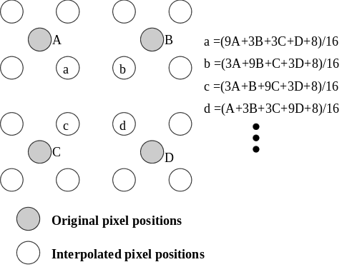
FIGURE O.8/H.263
Method for interpolating pixels for 2-D scalability

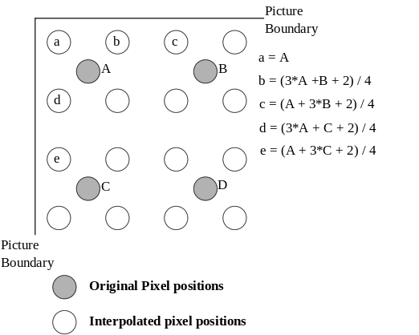
FIGURE O.9/H.263
Method for 2-D interpolation at boundaries

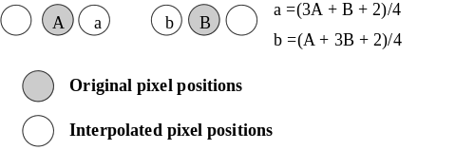
FIGURE O.10/H.263
Method for interpolating pixels for 1-D scalability

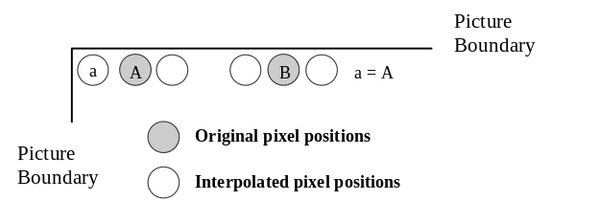
FIGURE O.11/H.263
Method for 1-D interpolation at picture boundaries.

Annex P.
Reference Picture Resampling
(This annex forms an integral part of this Recommendation.)

P.1. Introduction
This annex describes the use and syntax of a resampling process which can be applied to the previous decoded reference picture in order to generate a “warped” picture for use in predicting the current picture. This resampling syntax can specify the relationship of the current picture to a prior picture having a different source format, and can also specify a “global motion” warping alteration of the shape, size, and location of the prior picture with respect to the current picture. In particular, the Reference Picture Resampling mode can be used to adaptively alter the resolution of pictures during encoding. A fast algorithm is used to generate bilinear interpolation coefficients. The capability to use this mode and the extent to which its features are supported is negotiated externally (for example Recommendation H.245). This mode may be used in restricted scenarios that may be defined during capability negotiation (e.g., to support only factor-of-four picture resizing, to support only half-pixel resolution picture warping, or to support arbitrary image size resizing and displacements).
Note: The default image transformation between pictures of differing resolutions is defined to maintain the spatial alignment of the edges of the picture area and of the relative locations of the luminance and chrominance samples. This may have implications on the design of any resampling operations used for generating pictures of various resolutions at the encoder and for displaying pictures of various resolutions after decoding (particularly regarding shifts in spatial location caused by phase shifts induced in resampling). Also, since this mode can be used for dynamic adaptive picture resolution changes, operation with this mode may benefit from external negotiation to display the decoded picture at a higher resolution than its encoded picture size, in order to allow switching between encoded picture sizes without resizing the picture display.
If the Reference Picture Resampling bit in the PLUSPTYPE field is not set but the picture is an Inter, B, or EP picture or an Improved PB frame, and the picture size differs from that of the temporally previous encoded picture, this condition invokes Reference Picture Resampling with warping parameters (see section P.2.2) set equal to zero, fill mode (see section P.2.3) set to clip, and displacement accuracy (see section P.2.1) set to 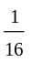-pixel accuracy. This causes the resampling process to easily act as a predictively-encoded change in picture resolution. In simple factor-of-four resolution change cases such as transitions between CIF and 4CIF, the resampling process reduces to the same simple filter used for Spatial Scalability (Annex O) or for Reduced Resolution Update (Annex Q), except for the application of rounding control.
If the picture is an EP picture and the Reference Picture Resampling bit is set in the PLUSPTYPE field of the picture header of the reference layer, this bit shall also be set in the picture header of the EP picture in the enhancement layer.
If a B-picture uses the Reference Picture Resampling mode, the resampling process shall be applied to the temporally previous anchor picture and not to the temporally subsequent one. The temporally previous anchor picture to which the resampling process is applied shall be the decoded picture (i.e., prior to any resampling applied by Reference Picture Resampling if this mode is also invoked for the subsequent reference picture). The temporally subsequent anchor picture shall have the same picture size as the B picture.
If the Reference Picture Resampling mode is invoked for an Improved PB frame, one set of warping parameters is sent and the resampled reference picture is used as the reference for both the B and P part of the Improved PB frame.
The Reference Picture Resampling is defined in terms of the displacement of the four corners of the current picture area. For the luminance field of the current picture with horizontal size H and vertical size V, four conceptual motion vectors ⁰⁰, ^{H0}, ^{0V}, and ^{HV} are defined for the upper left, upper right, lower left, and lower right corners of the picture, respectively. These vectors describe how to move the corners of the current picture to map them onto the corresponding corners of the previous decoded picture, as shown in Figure P.1. The units of these vectors are the same as those in the reference picture grid. To generate a vector (x,y) at some real-valued location (x, y) in the interior of the current picture, an approximation to bilinear interpolation is used, i.e., as in

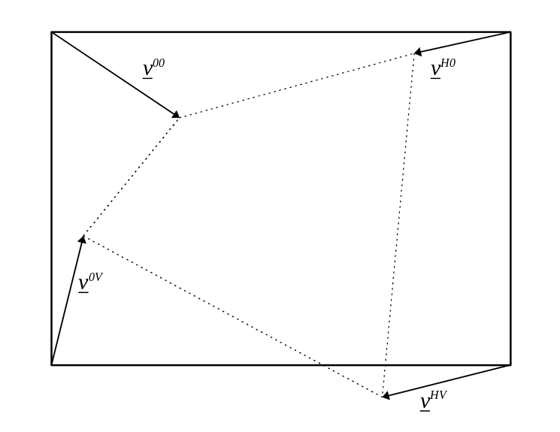
FIGURE P.1/H.263
Example of conceptual motion vectors used for warping
The horizontal size H and vertical size V of the current picture, and the horizontal size H_{R} and vertical size V_{R} of the reference picture are those indicated by the picture header, regardless of whether these values are divisible by 16 or not. If the picture width or height is not divisible by 16, the additional area shall be generated by adding pixels to the resampled picture using the same fill mode as used in the resampling process.
For the simplicity of description, the resampling vectors r⁰, r^{x} , r^{y} , and r^{xy} are defined as
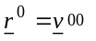
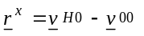
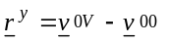
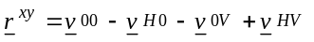.
Using this definition, the equation for bilinear interpolation is rewritten as
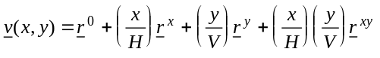
For warping purposes, it is assumed that the coordinates of the upper left corner of the picture area are (x, y)=(0,0) and that each pixel has unit height and width, so that the centers of the pixels lie at the points (x, y)=(i_{L} + , j_{L} + ) for i_{L} = 0, …, H – 1 and j_{L} = 0, …, V – 1, where the L subscript indicates that i_{L} and j_{L} pertain to the luminance field. (As the pixel aspect ratio is usually constant or the conversion of the aspect ratio is performed by this resampling, there is no need to consider the actual pixel aspect ratio for these purposes.) Using this convention, the x- and y-displacements at the locations of interest in the luminance field of the reference picture are
Because all positions and phases must be computed relative to the center of the upper-left corner pixel, which has the coordinate (x, y)=(,), the quantities of primary interest are
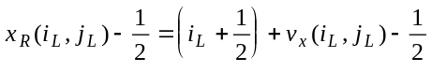
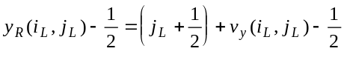
Once a location has been determined in the prior decoded reference picture using an approximation of these equations, bilinear interpolation as specified later in this annex shall be used to generate a value for the resampled pixel.
Each resampling vector can be decomposed into two components, with the first component describing the geometrical warping and the second component accounting for any difference in size between the predicted picture (horizontal size H and vertical size V) and the reference picture (horizontal size H_{R} and vertical size V_{R}). This decomposition is as follows:
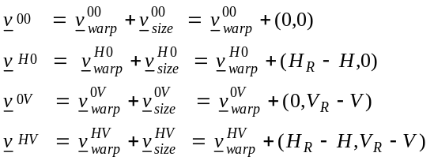

P.2. Syntax
Whenever the reference picture resampling bit is set in the PLUSTPYPE field of the picture header, the RPRP field of the picture header includes parameters which control the Reference Picture Resampling process. This includes a two-bit warping displacement accuracy (WDA) field, may include eight warping parameters or one-bit warping parameter refinements, and includes a fill mode, as described in this section.

P.2.1. Warping Displacement Accuracy (WDA) (2 bits)
A two bit warping displacement accuracy field WDA appears first in the RPRP field of the bitstream, and indicates the accuracy of the displacements for each pixel. A value of “10” indicates that the x- and y-displacements for each pixel are quantized to half-pixel accuracy. A value of “11” indicates that the displacements are quantized to 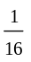-pixel accuracy. The use of other values is reserved.

P.2.2. Warping Parameters (Variable Length)
When the Reference Picture Resampling parameters are sent for an Inter or B picture, or an Improved PB frame, eight warping parameters are included in the picture header using the variable length code (VLC) shown in Table D.3. For an EP picture using SNR scalability, the warping parameters of the lower layer are used and no warping parameters are transmitted. If the Reference Picture Resampling bit is set in the PLUSPTYPE field of the picture header for an EP picture using spatial scalability, the warping parameters of the lower layer are refined to the accuracy needed for the current layer by multiplying the warping parameter for each up-sampled dimension (warping parameters with subscript x and/or y) of the lower layer by two and adding the value of one additional bit that is sent in place of the associated warping parameter to define the least significant bit of the warping parameter.
The eight integer warping parameters (or their one-bit refinements) are sent in the following order:
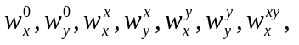 and 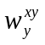.
When not a one-bit refinement, these parameters are sent in a similar manner as motion vector differences in the Unrestricted Motion Vector mode when PLUSPTYPE is present, using Table D.3 with no restriction on the range of the parameters (i.e., a range of −4095 to +4095). As when encoding motion vector difference pairs, an emulation prevention bit shall be added as needed after each pair of warping parameters is sent, such that if the all-zero codeword (the value +1 in half-pixel units) of Table D.3 is used for both warping parameters in the pair (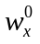and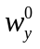,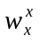and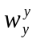, or 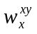and), the pair of codewords is followed by a single bit equal to 1 to prevent start code emulation.
These eight warping parameters are interpreted as picture corner displacements relative to the displacements that would be induced by removing the resizing component of the resampling vectors. The warping parameters are scaled to represent half-pixel offsets in the luminance field of the current picture, and the range for the values of these paramenters is −4095 to +4095. The warping parameters are defined using the resampling vectors by the relations

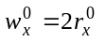 | 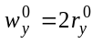
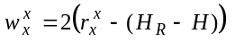 | 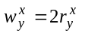
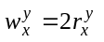 | 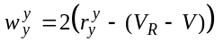
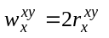 | 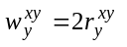
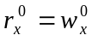 | 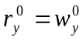
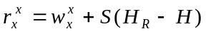 | 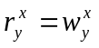
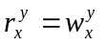 | 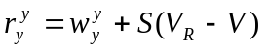
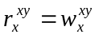 | 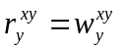

P.2.3. Fill Mode (FILL_MODE) (2 bits)
For an Inter or B picture or an Improved PB frame, immediately following the VLC-coded warping parameters in the picture header are two bits which define the fill-mode action to be taken for the values of pixels for which the calculated location in the reference picture lies outside of the reference picture area. The meaning of these two bits is shown in Table P.1 and their location is shown in Figure P.2. For an EP picture, the fill-mode action is the same as that for the reference layer, and the two fill-mode bits are not sent.
TABLE P.1/H.263
Fill mode bits/action

fill-mode bits | fill action
0 0 | color
0 1 | black
1 0 | gray
1 1 | clip

If the fill mode is clip, the coordinates of locations in the prior reference picture are independently limited as in the Unrestricted Motion Vector mode so that pixel values outside of the prior reference picture area are estimated by extrapolation from the values of pixels at the image border. If the fill mode is black, luminance samples outside of the prior reference picture area are assigned a value of Y = 16 and chrominance samples are assigned a value of C_{B} = C_{R}= 128. If the fill mode is gray, luminance and chrominance values are assigned a value of Y = C_{B} =C_{R} = 128. If the fill mode is color, then additional fields are sent to specify a fill color, as described in the next section.

P.2.4. Fill Color Specification (Y_FILL, CB_EPB, CB_FILL, CR_EPB, CR_FILL) (27 bits)
If the fill mode is color and the picture is not an EP picture, then the fill-mode bits are followed in the bitstream by three eight-bit integers, Y_fill, C_{B}_ fill, and C_{R}_ fill, which specify a fill color precisely. Between these three eight-bit integers are two emulation prevention bits (CB_EPB and CR_EPB) each of which is equal to 1. The format of this color specification, which is present only when the fill mode is color, is shown in Figure P.2. Each eight-bit integer field is sent using its natural representation. For an EP picture, the fill-mode action (and fill color) is the same as that for the reference layer, and the fill color specification is not sent.

FILL_MODE | Y_FILL | CB_EPB | CB_FILL | CR_EPB | CR_FILL
FIGURE P.2/H.263
Format of fill mode and fill color specification data

P.3. Resampling algorithm
The method described in this section shall be mathematically equal in result to that used to generate the samples of the resampled reference picture. Using the integer warping parameters 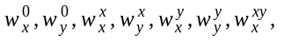 and 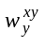, integer parameters 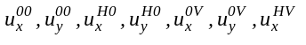, and 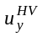 which denote the x- and y-displacements at the corners of the luminance field in 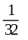-pixel accuracy (the actual displacements are obtained by dividing these values by 32) are defined as
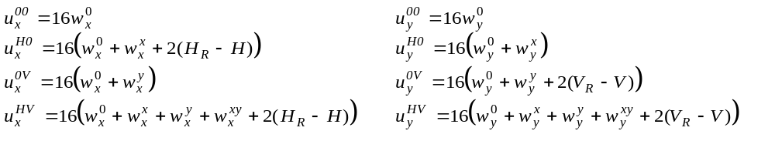
Next, H’ and V’, which denote the horizontal and vertical size of the virtual frame, are defined as the smallest integers that satisfy the following condition
By applying bilinear extrapolation to these vectors, the integer parameters 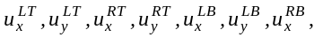 and 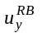 which denote the x- and y-displacements of the luminance field at the virtual points (x, y) = (0, 0), (H’, 0), (0, V’), and (H’, V’) in -pixel accuracy (the actual displacements are obtained by dividing these values by 32) are defined as
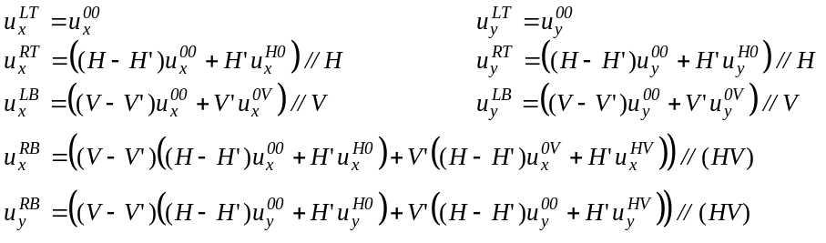
where “//” denotes integer division that rounds the quotient to the nearest integer, and rounds half integer values away from 0.
In the remainder of this annex, it is assumed that the centers of the pixels lie at the points (x, y)=(i + , j + ) for both the luminance and chrominance fields. Integer parameters i, j are defined as
- i = 0, …, H – 1 and j = 0, …, V – 1 for luminance, and
- i = 0, …, 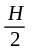– 1 and j = 0, …, – 1 for chrominance.
This implies that different coordinate systems are used for luminance and chrominance as shown in Figure P.3. Using the coordinate system for chrominance, the integer parametersand defined above can also be regarded as the x- and y-displacements of the chrominance field at virtual points (x, y)=(0, 0), (H’/2, 0), (0, V’/2), and (H’/2, V’/2) in 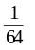-pixel accuracy (the actual displacements are obtained by dividing these values by 64). Using these parameters and a an additional parameter S, which is defined as 2 for luminance and as 1 for chrominance, the resampling algorithm for the luminance and chrominance fields are defined using common equations.

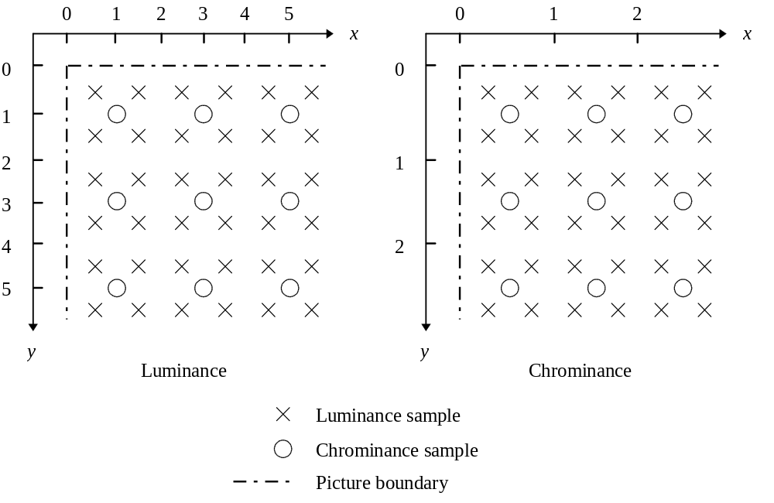
FIGURE P.3/H.263
Coordinate systems for luminance and chrominance fields
The integer parameters 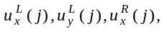and 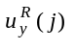which denote the x- and y-displacements of the picture field at (x, y)=(0, j+) and (SH’/2, j+) in 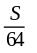-pixel accuracy (the actual displacements are obtained by dividing these values by 64/S) are defined using one dimensional linear interpolation as
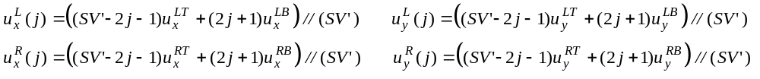
where “//” denotes integer division that rounds the quotient to the nearest integer, and rounds half integer values away from 0.
Finally, the parameters that specify the transformed position in the reference picture become
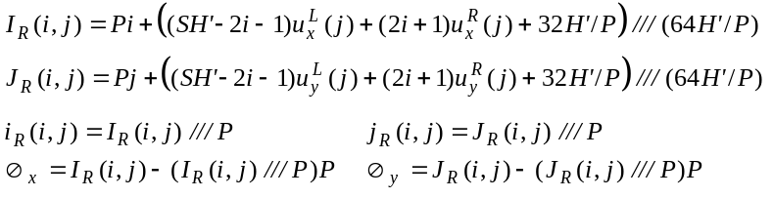
where
“///”: integer division with truncation towards the negative infinity,
“/”: integer division (in this case resulting in no loss of accuracy),
P: accuracy of x- and y-displacements (P=2 when WDA=“10” and P=16 when WDA=“11”, see section P.2.1 for the definition of WDA),
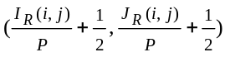: (x, y) location of the transformed position (both I_{R}(i, j) and J_{R}(i, j) are integers),
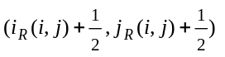: (x, y) location of the sampling point near the transformed position (both i_{R}(i, j) and j_{R}(i, j) are integers),
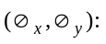 bilinear interpolation coefficients of the transformed position (both 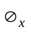 and 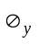 are integers).
The computation of this equation can be simplified by replacing the divisions by shift operations, since 64H’/P =2^{m+2} when P=16 and 64H’/P =2^{m+5} when P=2.
Using these parameters, the sample value, E_{P}(i, j), of the pixel located at (x, y)=(i+, j+) in the resampled picture is obtained using bilinear interpolation by
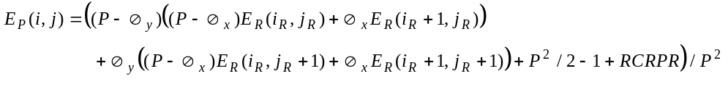
where “/” denotes division by truncation. i_{R} and j_{R} are simplified notations for i_{R}(i, j) and j_{R}(i, j), and E_{R}(i_{R}, j_{R}) denotes the sample value of the pixel located at (x, y)=(i_{R}+, j_{R}+) in the reference picture after extrapolation using the proper fill mode if necessary. The value of parameter RCRPR is defined as follows:
- For a B-picture (or the B-part of an Improved PB frame) which has a P-picture as its temporally subsequent anchor picture, RCRPR is equal to the rounding type (RTYPE) bit in MPPTYPE (see section 5.1.4.3) of this temporally subsequent P-picture. This implies that for Improved PB frames, RCRPR has the same value for the P-part and the B-part.
- For other types of pictures, RCRPR is equal to the RTYPE bit of the current picture.

P.4. Example of implementation
In this section, an implementation example of the algorithm described in the previous section is provided as pseudo-code.

P.4.1. Displacements of virtual points
When a large picture is coded, a straightforward implementation of the equation for obtaining parameters 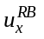 and shown in section P.3 may necessitate the usage of variables requiring more that 32 bits for their binary representation. For systems which cannot easily use 64 bit integer or floating point registers, an example of an algorithm which does not require variables with more than 32 bits for the calculation of and is shown below.
Since H, V, H’, and V’ are divisible by 4, the definition of can be rewritten as
where H_{Q}=H/4, V_{Q}=V/4, H_{Q}’=H’/4, V_{Q}’=V’/4, A=H_{Q}V_{Q}, and “//” denotes integer division that rounds the quotient to the nearest integer, and rounds half integer values away from 0. Next, parameters T_{T} and T_{B} are defined as
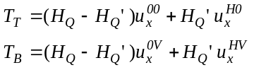
for simplicity of description. Using operator “///” which denotes integer division with truncation towards the negative infinity, and operator “%” which is defined as a % b = a − (a /// b) b, the value of can be obtained via the following pseudo-code:
q = (V_{Q} − V_{Q}’)*(T_{T} /// A)+ V_{Q}’*(T_{B} /// A) + ((V_{Q} − V_{Q}’)*(T_{T} % A)+ V_{Q}’ *(T_{B} % A)) /// A;
r = ((V_{Q} − V_{Q}’)*(T_{T} % A)+ V_{Q}’ *(T_{B} % A)) % A;
if (q < 0)
= q+(r+(A-1)/2)/A;
else
= q+(r+A/2)/A;
The value of 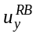 can also be calculated using this algorithm.

P.4.2. Resampling algorithm
To simplify the description of the algorithm, a function prior_sample is defined. Its purpose is to generate a pixel value for any integer location (i_{p}, j_{p}) relative to the prior reference picture sampling grid:
clip(x_{min}, x, x_{max}) {
if (x < x_{min}) {
return x_{min};
} else if (x > x_{max}) {
return x_{max};
} else {
return x;
}
}
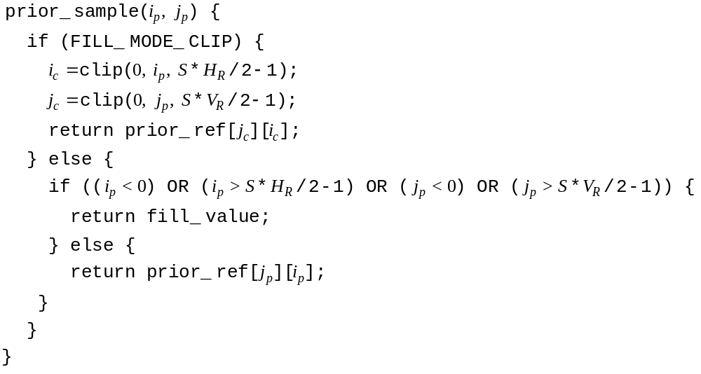
Next, a filter function that implements the bilinear interpolation described in section P.3 is defined. It is assumed that the bilinear interpolation coefficients, Ø_{x} and Ø_{y}, are quantized in the range 0,…,P−1 (inclusive).
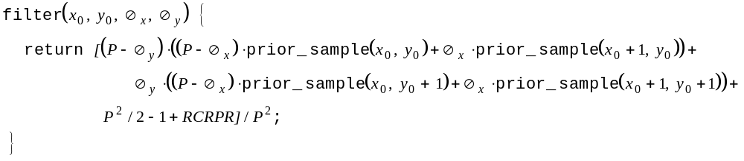
Finally, the method for warping the reference picture to generate a prediction for the current picture can be specified in terms of these functions. The pixels of the prediction picture can be generated in a raster scan order. It is assumed that the values 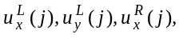and 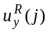are already calculated and loaded into variables 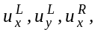 and 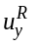. Defining parameter D as D = 64H’ /P and noting that H’=2^{m}, the sample values of the pixels in the j th line of the resampled field (the topmost line is defined as the 0th line) is obtained by the following pseudo-code:
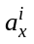 = D * P + 2 * (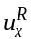 − 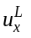);
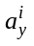 = 2 * ( − 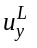);
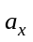 = 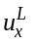 * S * 2^{m} + ( − )+ D / 2;
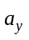 = j * D * P + * S * 2^{m} + (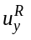 − )+ D / 2;
for (i = 0; i < S * H / 2; i++) {
I_{R} = /// D;
J_{R} = /// D;
i_{R} = I_{R} /// P;
j_{R} = J_{R} /// P;
Ø_{x} = I_{R} − (i_{R} * P);
Ø_{y} = J_{R} − (j_{R} * P);
new_ref[j][i] = filter(i_{R}, j_{R}, Ø_{x}, Ø_{y});
+= ;
+= ;
}
where all the variables used in this code are integer variables. According to the definition of the parameters, all the divisions in this code can be replaced by binary shift operations. For example, when P=16,
I_{R} = /// D;
J_{R} = /// D;
i_{R} = I_{R} /// P;
j_{R} = J_{R} /// P;
Ø_{x} = I_{R} − (i_{R} * P);
Ø_{y} = J_{R} − (j_{R} * P);
can be rewritten, assuming that , , I_{R}, and J_{R} are binary-coded integer variables in two’s complement representation, as
I_{R} = >> (m+2);
J_{R} = >> (m+2);
i_{R} = I_{R} >> 4;
j_{R} = J_{R} >> 4;
Ø_{x} = I_{R} & 15;
Ø_{y} = J_{R} & 15;
where “>> N_{shift}” denotes a right arithmetic binary shift by N_{shift} bits (N_{shift} is a positive integer), and “&” denotes a bit-wise AND operation.

P.5. Factor-of-4 resampling
Factor-of-4 resampling, which converts both the horizontal and vertical size of the picture by a factor of 2 or , is a special case of the resampling algorithm described in section P.3. The simplified description of the resampling algorithm for this special case is provided in this section.
The value of the parameter RCRPR used in the following figures is determined by the rounding type (RTYPE) bit in MPPTYPE (see section 5.1.4.3) as described in section P.3. Additionally, “/” in the following figures indicates division by truncation.

P.5.1. Factor-of-4 upsampling
The pixel value interpolation method used in factor-of-4 upsampling for internal pixels are shown in Figure P.4 By assuming the existence of pixels outside the picture according to the selected fill mode (see sections P.2.3 and P.2.4), the same interpolation method is applied for boundary pixels The interpolation method for boundary pixels when clip is selected as the fill mode is shown in Figure P.5. Since precise factor-of-4 upsampling requires x- and y- displacements with at least -pixel accuracy, the warping displacement accuracy (WDA) field specified in section P.2.1 shall be set to “11” to use this upsampling method.

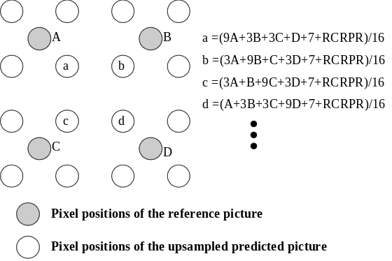
FIGURE P.4/H.263
Factor-of-4 upsampling for pixels inside the picture
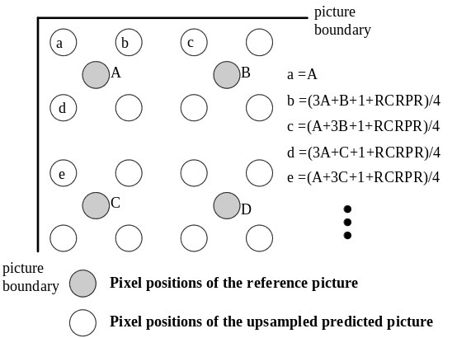
FIGURE P.5/H.263
Factor-of-4 upsampling for pixels at the picture boundary (fill mode = clip)

P.5.2. Factor-of-4 downsampling
The pixel value interpolation method for factor-of-4 downsampling is shown in Figure P.6. Since x- and y- displacements with -pixel accuracy is sufficient for precise factor-of-4 downsampling, both “10” and “11” are allowed as the value of the displacement accuracy (WDA) field specified in section P.2.1.

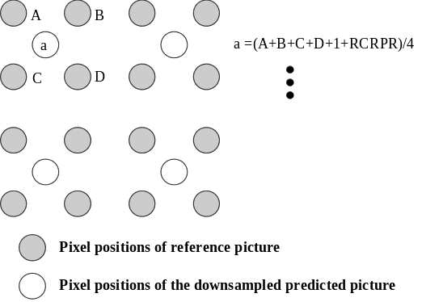
FIGURE P.6/H.263
Factor-of-4 downsampling

Annex Q.
Reduced-Resolution Update Mode
(This annex forms an integral part of this Recommendation.)

Q.1. Introduction
This annex describes an optional Reduced-Resolution Update mode of H.263. The capability of this mode is signaled by external means (for example Recommendation H.245). The use of this mode is indicated in the PLUSPTYPE field of the picture header.
The Reduced-Resolution Update mode is expected to be used when encoding a highly active scene, and provides the opportunity to increase the coding picture rate while maintaining sufficient subjective quality. This mode allows the encoder to send update information for a picture that is encoded at a reduced resolution, while preserving the detail in a higher resolution reference image to create a final image at the higher resolution.
The syntax of the bitstream in this mode is identical to the syntax for coding without the mode, but the semantics, or interpretation of the bitstream is somewhat different. In this mode, the portion of the picture covered by a macroblock is twice as wide and twice as high. Thus, there is approximately one-quarter the number of macroblocks as there would be without this mode. Motion vector data also refers to blocks of twice the normal height and width, or 32x32 and 16x16 instead of the normal 16x16 and 8x8. On the other hand, the DCT or texture data should be thought of as describing 8x8 blocks on a reduced resolution version of the picture. To produce the final picture, the texture data is decoded at a reduced resolution and then up-sampled to the full resolution of the picture. After upsampling, the full resolution texture image is added to the (already full resolution) motion compensated image to create the image for display and further reference.
In this mode, a picture which has the horizontal size H and vertical size V as indicated in the picture header is created as a final image for display.
In this mode, a referenced picture used for prediction and created for further decoding has a horizontal size H_{R} and a vertical size V_{R} which are the same as in the default mode as defined in section 4.1. That is, the H_{R} and V _{R} are,
H_{R} = ((H + 15) / 16) * 16
V_{R} = ((V + 15) / 16) * 16
where H and V are the horizontal size and the vertical size as indicated in the picture header and “/” is defined as division by truncation.
Then in this annex, the texture is coded at a reduced resolution with height and width of H_{C} and V_{C} where
H_{C} = ((H_{R} + 31) / 32) * 32
V_{C} = ((V_{R} + 31) / 32) * 32
and “/” is defined as division by truncation.
If H_{C} and H_{R}, or V_{C} and V_{R} are not identical to each other, such as in the QCIF format, an extension of the referenced picture is performed , and the picture is decoded in the same manner as if the width and height are H_{C} and V_{C}. Then the resulting picture which is tiled by 32*32 macroblocks is cropped at the right and the bottom to the width H_{R} and height V_{R}, and this cropped picture is stored as a reference picture for further decoding.
If both H and V are the same as those of a resulting picture having the width H_{C} and the height V_{C}, this resulting picture is used for display. Otherwise, this resulting picture is further cropped to the size H*V, and the cropped picture here is used for display purpose only.
If the Temporal, SNR, and Spatial Scalability mode (Annex O) or Reference Picture Resampling mode (Annex P) is also used with this option, the source format of the current picture might be different from that of the reference picture. In this case, the resampling of the reference picture shall be performed before decoding.
Note: This mode can be used with the Reference Picture Selection mode (see Annex N) without modification, since the reference picture (after possible resampling by the Reference Picture Resampling mode) has the same size as indicated in the current picture header when this option is used.

Q.2. Decoding Procedure
Figure Q.1 shows the block diagram of the block decoding in the Reduced-Resolution Update mode.

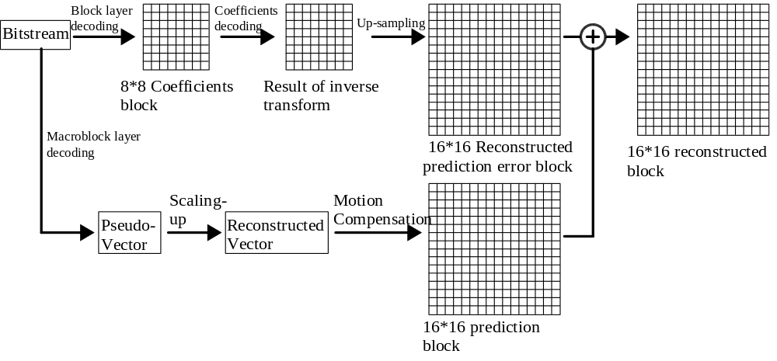
FIGURE Q.1/H.263
Block diagram of block decoding in Reduced-Resolution Update mode
The decoding procedure is given in the following sections:
Q.2.1. Reference Preparation
In some cases, the available reference picture has different size from H_{C} and V_{C}. Then the reference picture shall be converted before decoding procedure according to Q.2.1.1 or Q.2.1.2.
Q.2.1.1. Reference Picture Resampling
If the Temporal, SNR, and Spatial Scalability mode (Annex O) or Reference Picture Resampling mode (Annex P) is also used with this option, the source format of the current picture might be different from that of the reference picture. In this case, the resampling of the reference picture according to each Annex shall be performed first.
Q.2.1.2. Extension of Reference Picture
If H_{R} or V_{R} is not divisible by 32, such as with the QCIF format, the reference picture is extended. The detailed procedure for this extension is defined in section Q.3.
Q.2.2. Macroblock layer decoding
Decoding can be thought of as operating on “enlarged” blocks of size 32x32 in luminance and 16x16 in chrominance. The texture and motion data for each enlarged block is decoded to create a 32x32 motion block and a 32x32 texture block, as described in Q.2.2.1. and Q.2.2.2. respectively. These motion and texture blocks are then added as described in Q.2.2.3.
Q.2.2.1. Motion Compensation
First, Each component of the macroblock motion vector (or four macroblock motion vectors) is formed from MVD (and possibly MVD₂₋₄). If in Improved PB-Frames mode, MV_{F} and MV_{B} for B-Picture is also formed from MVDB. The detailed procedure for this motion vector formation is defined in section Q.4. If the current picture mode is a B picture or EP-picture, the motion vector for forward and backward are also obtained according to section Q.4.
The motion vector for the two chrominance blocks of the macroblock is obtained from the macroblock motion vector according to section 6.1.1. If either the Advanced Prediction mode or the Deblocking Filter mode is in use and thus four motion vectors are defined for the macroblock, the motion vector for both chrominance blocks is obtained from the four motion vectors according to section F.2. If in the Improved PB-frames mode the creation of the chrominance vector is specified in Annex M. If a B picture or EP-picture is used, the creation of the chrominance vector is specified in Annex O.
Then, a prediction is formed from the motion vector for a INTER Macroblock. Four 16×16 luminance prediction blocks are obtained from the macroblock motion vector, and two 16×16 chrominance prediction blocks are obtained from the chrominance motion vector. For interpolation for subpixel prediction refer to section 6.1.2. If Advanced Prediction mode is also used, an enlarged overlapped motion compensation is performed to obtain four 16×16 luminance prediction blocks using enlarged weighting matrices, for which a detailed procedure is defined in section Q.5. If the current picture mode is an Improved PB-frame, B-picture, or EP-picture, the prediction is obtained according to the other relevant Annexes, except that the size of the predicted blocks is 16×16 instead of 8×8.
Q.2.2.2. Texture decoding
First, the bitstream of the block layer is decoded according to section 5.4. Then coefficients are decoded and the 8×8 reduced-resolution reconstructed prediction error blocks are obtained as the result of inverse transform according to section 6.2.
Then the 16×16 reconstructed prediction error blocks are obtained by upsampling the 8×8 reduced-resolution reconstructed prediction error blocks. For the creation of the edge pixels in each 16×16 reconstructed prediction error block, only the pixels which belong to the corresponding block are used. The detailed procedure is defined in section Q.6.
Q.2.2.3. Reconstruction of block
For each luminance and chrominance block, a summation of the prediction and prediction error is performed. The procedure is identical to section 6.3.1, except that the size of blocks is 16×16 instead of 8×8. Then the clipping is performed according to the section 6.3.2.
Then a block boundary filter is applied to the boundary pixels of the 16×16 reconstructed blocks. The detailed procedure is described in section Q.7.
Q.2. 3. Picture Store
If both H_{R} and V_{R} are divisible by 32, such as with the CIF format, the resulting picture reconstructed as described in section Q.2.2 is stored as a reference picture as it is for further decoding. Otherwise, such as the QCIF format, the reconstructed picture which is just covered with 32×32 macroblocks is cropped at the right and the bottom to the width H_{R} and height V_{R}, and this cropped picture is stored as a reference picture for further decoding.
Q.2.4. Display
If both H and V are the same as H_{C} and V_{C}, the resulting picture in section Q.2.2 is used for display purposes as it is. Otherwise, this resulting picture is further cropped to the size H×V, and the cropped picture is used for display purpose only.

Q.3. Extension of Referenced Picture
If H_{R} or V_{R} is not divisible by 32, such as with the QCIF format, the extension of the referenced picture is performed before decoding macroblock/block layer. The width and the height of the extended reference picture for luminance are the next larger size that would be divisible by 32, and those for chrominance are the next larger size that would be divisible by 16.
Note: The width and height of the referenced picture in the default mode are always extended to be divisible by 16 even if picture formats has a width or height that is not divisible by 16, because the picture shall be decoded as if the width or height had the next larger size that would be divisible by 16. See section 4.1/H.263.
If neither Unrestricted Motion Vector mode, Advanced Prediction mode nor Deblocking Filter mode is used with this option, the extended pixels can be arbitrary values, because the extended pixels will be never used as a reference pixels of the decoded picture to be reconstructed and displayed.
If either Unrestricted Motion Vector mode, Advanced Prediction mode or Deblocking Filter mode is also used with this option, the extension of the referenced picture is performed by duplicating the edge pixel of the referenced picture, in order to ensure the decoding when motion vectors point outside the right and bottom edge of the picture.
For example, if the Reduced-Resolution Update mode is used for a QCIF, the width of the referenced picture is 176 and the height is 144, which are not divisible by 32. In order to cover a QCIF picture with 32×32 sized macroblocks, the number of macroblock row should be 6, and the number of macroblock column should be 5. Therefore the width of the extended referenced picture is 192 and the height is 160.

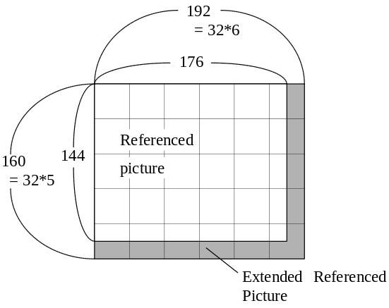
FIGURE Q.2/H.263
Extension of referenced picture for QCIF picture size
The extension of the referenced picture in QCIF is illustrated in Figure Q.2. The extended referenced picture for luminance is given by the following formula:

R_{RRU}(x, y) = R(x', y'),
where
x, y = spatial coordinates of the extended referenced picture in the Pixel domain,
x', y' = spatial coordinates of the referenced picture in the pixel domain,
R_{RRU}(x, y) = pixel value of the extended referenced picture at (x, y),
R(x', y') = pixel value of the referenced picture at (x', y'),

x' = 175 if x > 175 and x < 192
= x otherwise,

y' = 143 if y > 143 and y < 160
= y otherwise,

The referenced pictures for chrominance is also extended in the same manner.

Q.4. Reconstruction of motion vectors
In Reduced-Resolution Update mode, the motion vector range is enlarged to approximately double size in both the horizontal and vertical directions. In order to realize an enlarged range using the VLC for MVD defined in Table 14, each vector component is restricted to be only half-pel or zero value. Therefore the range of each motion vector component is [-31.5, 30.5] in the default Reduced-Resolution Update mode. If the Unrestricted Motion Vector mode is used, the vector range [-limit,limit] as defined in section D.2 applies to the pseudo-motion vectors and translates into [-(2*limit-0.5),2*limit-0.5] for the motion vectors. For CIF this means that the pseudo-motion vector range is [-32,32] and the motion vector range is [-63.5,63.5]. If the UUI field is set to “01”, the motion vectors are unlimited. However, the motion vectors (not just the pseudo-motion vectors) are always limited to point not more than 15 pixels outside the coded area as described in section D.1.1. Figure Q.3 illustrates the possible positions of macroblock motion vector or four motion vector predictions around the (0, 0) vector value. The dashed lines indicate the integer coordinates.
For the macroblock using differential motion vectors in a B picture, the motion vector for forward and backward prediction are obtained independently. In the Reduced-Resolution Update mode, the motion vector component MVc for a luminance block is reconstructed from MVD and MVD₂₋₄ as follows;
- Pseudo- prediction vector component pseudo-P_{C} is created from the prediction vector component P_{C}.
pseudo-P_{C} = 0 if P_{C} = 0
pseudo-P_{C} = sign(P_{C}) * (|P_{C}| + 0.5) / 2.0 if P_{C} ≠ 0
“/” indicates floating-point division (without loss of accuracy). The prediction vector component P_{C} is defined as the median value of the vector components MV1, MV2 and MV3 as defined in section 6.1.1/H.263 and F.2/H.263.
- Pseudo- macroblock vector component pseudo-MV_{C} is obtained by adding one of the vector difference pair of corresponding MVD and MVD₂₋₄ from Table 14 to the pseudo-P_{C}.
In the default Reduced-Resolution Update mode, the value of pseudo-MV_{C} is restricted to the range [-16, 15.5]. Only one of the pair will yield a pseudo-MV_{C} falling within the permitted range. The procedure is performed in the similar way as defined in section 6.1.1/H.263.
If the Unrestricted Motion Vector mode is also used with the Reduced-Resolution Update mode, pseudo-MV_{C} is obtained by adding one of the vector difference pair of corresponding MVD and MVD₂₋₄ from Table D.3.
If four motion vectors are present, the procedure is performed in the similar way as defined in section F.2/H.263
- Motion vector component MV_{C} is obtained from pseudo-MV_{C} in the following formula:
MV_{C} = 0 if pseudo-MV_{C} = 0
MV_{C} = sign(pseudo-MV_{C}) * (2.0 * |pseudo-MV_{C}| - 0.5) if pseudo-MV_{C} ≠ 0
As a result, each vector component is restricted to have a half-integer or zero value, and the range of each motion vector component is enlarged to approximately twice the pseudo-motion vector range.
- If the current picture mode is an Improved PB frame, or when the MBTYPE indicates the direct mode in a B picture, the motion vector components MV_{F} and/or MV_{B} for forward and backward prediction are created.
First, pseudo motion vector components pseudo-MV_{F} and/or pseudo-MV_{B} are calculated based on the rules for the prediction modes defined in Annex O or Annex M.
In the case of the Bidirectional prediction in the Improved PB-frames mode (section M.2.1) or when the MBTYPE indicates the direct mode in a B picture (section O.5.2), pseudo-MV_{F} and pseudo-MV_{B} are calculated from pseudo-MV_{D} and pseudo-MV_{C} assuming that pseudo-MV_{D} is zero and pseudo-MV_{C} is MV, as defined in Annex G and Annex M.
In the case of forward prediction in the Improved PB-frames mode (section M.2.2), pseudo-MV_{DB} is obtained by decoding the variable length code MVDB according to Table 13. Then pseudo-MV_{F} is obtained by adding the pseudo-MV_{DB} to the pseudo-Predictor. In order to form the pseudo-Predictor, the predictor obtained according to the procedure defined in section M.2.2 of Annex M is converted to the pseudo-Predictor vector according to the formula defined in item 1 of this section.
In the case of Backward prediction in the Improved PB-frames mode (section M.2.3), pseudo-MV_{B} is set to zero.
Then the motion vectors MV_{F} and/or MV_{B} for forward and backward prediction are obtained from pseudo-MV_{F} and/or pseudo-MV_{B} according to the formula defined in item 3 of this section.

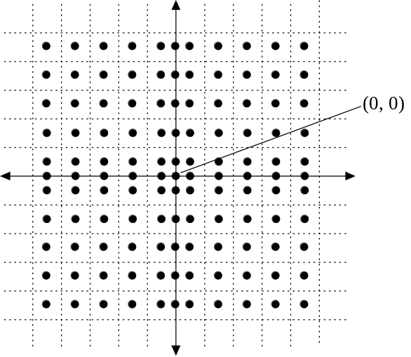
FIGURE Q.3/H.263
Reconstruction of motion vector

Q.5. Enlarged overlapped motion compensation for luminance
If Advanced Prediction mode is also used with Reduced-Resolution Update mode, enlarged matrices of weighting values are used to perform the overlapped motion compensation. Except that the size of each block and weighting matrices is 16×16, the procedure of the creation of each prediction block is identical to the description of F.3 in Annex F.
The enlarged matrices of weighting values for the16×16 luminance prediction are given in Figures Q.4, Q.5, and Q.6.

4 | 4 | 5 | 5 | 5 | 5 | 5 | 5 | 5 | 5 | 5 | 5 | 5 | 5 | 4 | 4
4 | 4 | 5 | 5 | 5 | 5 | 5 | 5 | 5 | 5 | 5 | 5 | 5 | 5 | 4 | 4
5 | 5 | 5 | 5 | 5 | 5 | 5 | 5 | 5 | 5 | 5 | 5 | 5 | 5 | 5 | 5
5 | 5 | 5 | 5 | 5 | 5 | 5 | 5 | 5 | 5 | 5 | 5 | 5 | 5 | 5 | 5
5 | 5 | 5 | 5 | 6 | 6 | 6 | 6 | 6 | 6 | 6 | 6 | 5 | 5 | 5 | 5
5 | 5 | 5 | 5 | 6 | 6 | 6 | 6 | 6 | 6 | 6 | 6 | 5 | 5 | 5 | 5
5 | 5 | 5 | 5 | 6 | 6 | 6 | 6 | 6 | 6 | 6 | 6 | 5 | 5 | 5 | 5
5 | 5 | 5 | 5 | 6 | 6 | 6 | 6 | 6 | 6 | 6 | 6 | 5 | 5 | 5 | 5
5 | 5 | 5 | 5 | 6 | 6 | 6 | 6 | 6 | 6 | 6 | 6 | 5 | 5 | 5 | 5
5 | 5 | 5 | 5 | 6 | 6 | 6 | 6 | 6 | 6 | 6 | 6 | 5 | 5 | 5 | 5
5 | 5 | 5 | 5 | 6 | 6 | 6 | 6 | 6 | 6 | 6 | 6 | 5 | 5 | 5 | 5
5 | 5 | 5 | 5 | 6 | 6 | 6 | 6 | 6 | 6 | 6 | 6 | 5 | 5 | 5 | 5
5 | 5 | 5 | 5 | 5 | 5 | 5 | 5 | 5 | 5 | 5 | 5 | 5 | 5 | 5 | 5
5 | 5 | 5 | 5 | 5 | 5 | 5 | 5 | 5 | 5 | 5 | 5 | 5 | 5 | 5 | 5
4 | 4 | 5 | 5 | 5 | 5 | 5 | 5 | 5 | 5 | 5 | 5 | 5 | 5 | 4 | 4
4 | 4 | 5 | 5 | 5 | 5 | 5 | 5 | 5 | 5 | 5 | 5 | 5 | 5 | 4 | 4

FIGURE Q.4/H.263
Weighting values, H₀, for prediction with motion vector of current 16×16 luminance block

2 | 2 | 2 | 2 | 2 | 2 | 2 | 2 | 2 | 2 | 2 | 2 | 2 | 2 | 2 | 2
2 | 2 | 2 | 2 | 2 | 2 | 2 | 2 | 2 | 2 | 2 | 2 | 2 | 2 | 2 | 2
1 | 1 | 1 | 1 | 2 | 2 | 2 | 2 | 2 | 2 | 2 | 2 | 1 | 1 | 1 | 1
1 | 1 | 1 | 1 | 2 | 2 | 2 | 2 | 2 | 2 | 2 | 2 | 1 | 1 | 1 | 1
1 | 1 | 1 | 1 | 1 | 1 | 1 | 1 | 1 | 1 | 1 | 1 | 1 | 1 | 1 | 1
1 | 1 | 1 | 1 | 1 | 1 | 1 | 1 | 1 | 1 | 1 | 1 | 1 | 1 | 1 | 1
1 | 1 | 1 | 1 | 1 | 1 | 1 | 1 | 1 | 1 | 1 | 1 | 1 | 1 | 1 | 1
1 | 1 | 1 | 1 | 1 | 1 | 1 | 1 | 1 | 1 | 1 | 1 | 1 | 1 | 1 | 1
1 | 1 | 1 | 1 | 1 | 1 | 1 | 1 | 1 | 1 | 1 | 1 | 1 | 1 | 1 | 1
1 | 1 | 1 | 1 | 1 | 1 | 1 | 1 | 1 | 1 | 1 | 1 | 1 | 1 | 1 | 1
1 | 1 | 1 | 1 | 1 | 1 | 1 | 1 | 1 | 1 | 1 | 1 | 1 | 1 | 1 | 1
1 | 1 | 1 | 1 | 1 | 1 | 1 | 1 | 1 | 1 | 1 | 1 | 1 | 1 | 1 | 1
1 | 1 | 1 | 1 | 2 | 2 | 2 | 2 | 2 | 2 | 2 | 2 | 1 | 1 | 1 | 1
1 | 1 | 1 | 1 | 2 | 2 | 2 | 2 | 2 | 2 | 2 | 2 | 1 | 1 | 1 | 1
2 | 2 | 2 | 2 | 2 | 2 | 2 | 2 | 2 | 2 | 2 | 2 | 2 | 2 | 2 | 2
2 | 2 | 2 | 2 | 2 | 2 | 2 | 2 | 2 | 2 | 2 | 2 | 2 | 2 | 2 | 2

FIGURE Q.5/H.263
Weighting values, H₁, for prediction with motion vector of current 16×16 luminance blocks on top or bottom of current 16×16 luminance block

2 | 2 | 1 | 1 | 1 | 1 | 1 | 1 | 1 | 1 | 1 | 1 | 1 | 1 | 2 | 2
2 | 2 | 1 | 1 | 1 | 1 | 1 | 1 | 1 | 1 | 1 | 1 | 1 | 1 | 2 | 2
2 | 2 | 2 | 2 | 1 | 1 | 1 | 1 | 1 | 1 | 1 | 1 | 2 | 2 | 2 | 2
2 | 2 | 2 | 2 | 1 | 1 | 1 | 1 | 1 | 1 | 1 | 1 | 2 | 2 | 2 | 2
2 | 2 | 2 | 2 | 1 | 1 | 1 | 1 | 1 | 1 | 1 | 1 | 2 | 2 | 2 | 2
2 | 2 | 2 | 2 | 1 | 1 | 1 | 1 | 1 | 1 | 1 | 1 | 2 | 2 | 2 | 2
2 | 2 | 2 | 2 | 1 | 1 | 1 | 1 | 1 | 1 | 1 | 1 | 2 | 2 | 2 | 2
2 | 2 | 2 | 2 | 1 | 1 | 1 | 1 | 1 | 1 | 1 | 1 | 2 | 2 | 2 | 2
2 | 2 | 2 | 2 | 1 | 1 | 1 | 1 | 1 | 1 | 1 | 1 | 2 | 2 | 2 | 2
2 | 2 | 2 | 2 | 1 | 1 | 1 | 1 | 1 | 1 | 1 | 1 | 2 | 2 | 2 | 2
2 | 2 | 2 | 2 | 1 | 1 | 1 | 1 | 1 | 1 | 1 | 1 | 2 | 2 | 2 | 2
2 | 2 | 2 | 2 | 1 | 1 | 1 | 1 | 1 | 1 | 1 | 1 | 2 | 2 | 2 | 2
2 | 2 | 2 | 2 | 1 | 1 | 1 | 1 | 1 | 1 | 1 | 1 | 2 | 2 | 2 | 2
2 | 2 | 2 | 2 | 1 | 1 | 1 | 1 | 1 | 1 | 1 | 1 | 2 | 2 | 2 | 2
2 | 2 | 1 | 1 | 1 | 1 | 1 | 1 | 1 | 1 | 1 | 1 | 1 | 1 | 2 | 2
2 | 2 | 1 | 1 | 1 | 1 | 1 | 1 | 1 | 1 | 1 | 1 | 1 | 1 | 2 | 2
FIGURE Q.6/H.263
Weighting values, H₂, for prediction with motion vector of 16×16 luminance blocks to the left or right of current 16×16 luminance block

Q.6. Upsampling of the reduced-resolution reconstructed prediction error
The 16×16 reconstructed prediction error block is obtained by upsampling the 8×8 reduced-resolution reconstructed prediction error block. In order to realize a simple implementation, filtering is closed within a block which enables to perform an individual upsampling on block basis. Figure Q.7 shows the positioning of samples. The upsampling procedure for the luminance and chrominance pixels which are inside the 16×16 reconstructed prediction error blocks is defined in section Q.6.1. For the creation of the luminance and chrominance pixels which are at the boundary of 16×16 reconstructed prediction error block, the procedure is defined in section Q.6.2. Chrominance blocks as well as luminance blocks are up-sampled. The symbol “/” in Figures Q.8 and Q.9 indicates division by truncation.
FIGURE Q.7/H.263
Positioning of samples in 8×8 reduced-resolution reconstructed prediction error block and
16×16 reconstructed prediction error block

Q.6.1. Upsampling procedure for the pixels inside a 16x16 reconstructed prediction error block
The creation of reconstructed prediction error for pixels inside block is described in Figure Q.8. "/” indicates division by truncation.
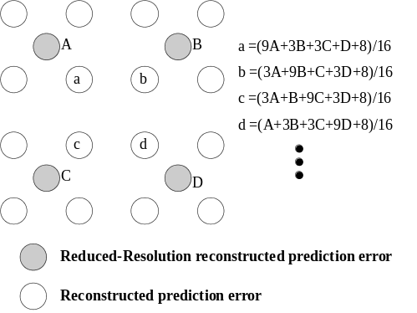
FIGURE Q.8/H.263
Creation of reconstructed prediction error for pixels inside block

Q.6.2. Upsampling procdedure for the pixels at the boundary of 16x16 reconstructed prediction error block
The creation of reconstructed prediction error for pixels of a 16x16 block is shown in Figure Q.9.

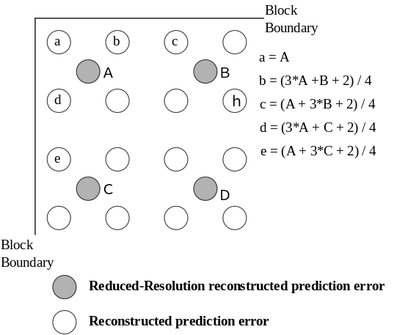
FIGURE Q.9/H.263
Creation of reconstructed prediction error
for pixels at the block boundary

Q.7. Block boundary filter
The filter operations are performed along the edges of the 16×16 reconstructed blocks at the encoder as well as on the decoder side. There are two alternative of filtering, depending on whether Deblocking Filter mode is used or not.
The default filtering in Reduced-Resolution Update mode is performed according to section Q.7.1.
If Deblocking Filter mode is also used with Reduced-Resolution Update mode, the filtering is performed according to section Q.7.2.
In both cases, filtering is performed on the complete reconstructed image data before storing the data in the picture store for future prediction. No filtering is performed across picture edges, slice edges in Slice Structured mode (see Annex K), or GOB boundaries having GOB headers present in Independent Segment Decoding mode (see Annex R). Chrominance as well as luminance data is filtered.
Q.7.1. Definition of the default block boundary filter
In the Reduced-Resolution Update mode, the default filtering is performed according to this section.
If A and B are two pixel values on a line — horizontal or vertical — of the reconstructed picture, and A belongs to one 16×16 block called block1 whereas B belongs to a neighboring 16×16 block called block2 which is to the right or below of block1. Figure Q.10 shows examples for the position of these pixels.

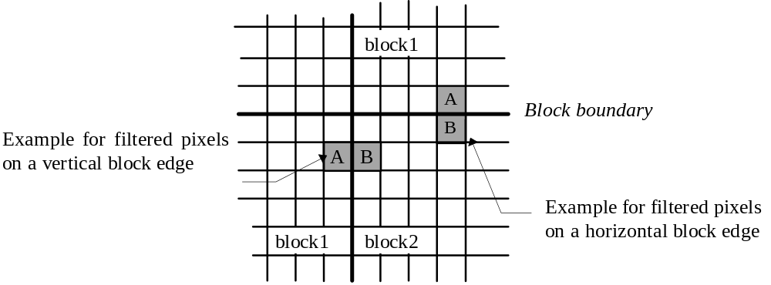
FIGURE Q.10/H.263
Default block boundary filter
One of the following conditions must be fulfilled in order to turn the filter on for a particular edge:
- block1 belongs to a coded macroblock (COD==0 || MB-type == INTRA ) or
- block2 belongs to a coded macroblock (COD==0 || MB-type == INTRA )

A shall be replaced by A1 and B shall be replaced by B1. “/” indicates division by truncation.
A1 = (3*A + B + 2) / 4
B1 = (A + 3*B + 2) / 4
The order of edges where filtering is performed is identical to the description provided in section J.3 of Annex J.
Q.7.2. Definition of the block boundary filter when Deblocking Filter mode is used
If the Deblocking Filter mode (see Annex J) is used with the Reduced-Resolution Update mode, the filtering which is defined in Annex J with one modification is performed on the boundary pixels of 16×16 luminance and chrominance blocks, in place of the filtering described in section Q.7.1. The one modification of the filtering in Annex J is that the parameter STRENGTH is given the value of positive infinity. This implies that the function UpDownRamp(x, STRENGTH) defined in section J.3 becomes a linear function of x.
As a result, the procedure of the deblocking filter described in section J.3 is redefined in the following manner;
B1 = clip(B + d1)
C1 = clip(C − d1)
A1 = A − d2
D1 = D + d2
d1 = (A−4B+4C−D) / 8
d2 = clipd1((A − D) / 4, d1/2)

Annex R.
Independent Segment Decoding Mode
(This annex forms an integral part of this Recommendation.)

R.1. Introduction
This annex describes the optional Independent Segment Decoding mode of H.263, which allows a picture to be decoded without the presence of any data dependencies across slice boundaries or across GOB boundaries having non-empty GOB headers. The use of this mode is indicated in the PLUSPTYPE field of the picture header. The capability to use this optional mode is negotiated by external means (for example Recommendation H.245).
When the use of this mode is indicated, the video picture segment boundaries (as defined by the boundaries of the slices or the upper boundaries of the GOBs for which GOB headers are sent, or the boundaries of the picture, whichever bounds a region in the smallest way) are treated as picture boundaries when decoding, including the treatment of motion vectors which cross those boundaries (which result in boundary extrapolation when the Unrestricted Motion Vector mode, the Advanced Prediction mode, or the Deblocking Filter mode are in use, and which are prohibited when none of those optional modes are in use).

R.2. Mode Operation
A video picture segment is defined by the following:
If the Slice Structured mode (see Annex K) is not in use, then one GOB or a plural number of consecutive GOBs forms one video picture segment. The location of the top of each video picture segment is indicated by the presence of a non-empty GOB header for which the border of the video segment lies just above the macroblocks in the GOB for which a header is present, or the top of the picture, whichever is lower. The location of the bottom of each video picture segment is defined by the top of the next video picture segment, or the bottom of the picture, whichever is uppermost.
If the Slice Structured mode (see Annex K) is in use, then each slice forms one video picture segment.
In the Independent Segment Decoding mode, each video picture segment is decoded with complete independence from all other video picture segments, and is also independent of all data outside the same video picture segment location in the reference picture(s). This includes:
- No use of motion vectors outside of the current video picture segment for motion vector prediction (as in section 6.1.1)
- No use of motion vectors outside of the current video picture segment as remote motion vectors for overlapped block motion compensation when the Advanced Prediction mode is in use (see section F.3)
- No deblocking filter operation across video picture segment boundaries (see section J.3)
- No use of motion vectors which reference data outside the current video picture segment unless the Unrestricted Motion Vector mode (see Annex D), the Advanced Prediction mode (see Annex F), the Deblocking Filter mode (see Annex J) or the Temporal, SNR, and Spatial Scalability mode (see Annex O) are in use; in which case the borders of the current video picture segment in the prior picture are extrapolated as described in Annex D to form predictions of the pixels which reference the out-of-bounds region.
- No bilinear interpolation across the boundaries of the ¼-size or ½-size region corresponding to the current picture segment for upward prediction in spatial scalability EI and EP pictures (as defined in Annex O).
- When the Reduced Resolution Update mode (see Annex Q) is in use, no block boundary filter operation across video picture segment boundaries.

R.3. Constraints on Usage
Certain restrictions are placed on the use of other aspects of the video coding syntax when the Independent Segment Decoding mode is in use. These restrictions are made to prevent two pathological cases which otherwise would make operation of the Independent Segment Decoding mode difficult.

R.3.1. Constraint on segment shapes
In the use of the Slice Structured mode (Annex K) without the use of the Rectangular Slice submode (section K.1), there can arise cases in which the shape of a video picture segment may be non-convex (having “inside corners”, or even comprising two distinct and separated regions of the picture).
Therefore, the Independent Segment Decoding mode shall not be used with the Slice Structured mode without the simultaneous use of the Rectangular Slice submode of the Slice Structured mode (see Annex K). This constraint is mandated to prevent the need for difficult special-case treatment in order to determine how and when to perform extrapolation of each picture segment.

R.3.2. Constraint on changes of segment shapes
If the shape of the video picture segments were allowed to change in any way from picture to picture in the bitstream, there could arise cases in which the bitstream would be difficult to decode. This is because in such cases the bitstream content is not sufficient to determine the shape of each video picture segment prior to the possible appearance of motion vectors in the bitstream which require knowledge of the video picture segment shape for proper interpretation.
Therefore, when the Independent Segment Decoding mode is in use, the video picture segmentation for all pictures and frames allowing temporal prediction (i.e., all P, B, and EP pictures and all Improved PB frames) shall be the same as that used in its temporal reference picture. Also, when the Independent Segment Decoding mode is in use, the video picture segmentation for all EI pictures shall either be the same or shall differ only by sub-dividing the video picture segmentation used in its reference picture. As a result of this constraint, the shape of the video picture segments in the Independent Segment Decoding mode shall never change from picture to picture except as changed in I and EI pictures (and the manner in which EI pictures can change segmentation is itself also somewhat constrained).

Annex S.
Alternative Inter VLC Mode
(This annex forms an integral part of this Recommendation.)

S.1. Introduction
This annex describes an optional Alternative Inter VLC mode of H.263, which improves the efficiency of Inter picture coding when significant changes are evident in the picture. This efficiency improvement is obtained by allowing some VLC codes originally designed for Intra pictures to be used for some Inter picture coefficients and CBPY data as well. The use of this mode is indicated in the PLUSPTYPE field of the picture header. The capability to use this optional mode is negotiated by external means (for example Recommendation H.245). The mode contains two syntax alterations, one for the encoding of INTER coefficients and another for the encoding of the INTER CBPY values.

S.2. Alternative INTER VLC for coefficients
The concept behind the design of the INTRA VLC table of Annex I is to use the same codewords as in the original INTER VLC but with a different interpretation of LEVEL and RUN. The INTRA VLC is better suited in cases where there are many and/or large-valued coefficients.
The INTRA VLC is constructed so that codewords have the same value for LAST (0 or 1) in both the INTER and INTRA tables. The INTRA table is therefore produced by "reshuffling" the meaning of the codewords with the same value of LAST. Furthermore, for events with large LEVEL the INTRA table uses a codeword which in the INTER table has a large RUN. In INTER blocks having a large number of large-magnitude coefficients, it can sometimes be more efficient to use the INTRA table than the INTER table, and in some such cases the choice of the VLC table can be apparent to the decoder since decoding using the INTER table would result in RUN values so large as to indicate the presence of more than 64 coefficients for a block. Under these circumstances, the INTRA table can be used to improve the efficiency of INTER coding.

S.2.1. Encoder action.
The encoder may use the INTRA VLC table for coding an INTER block whenever the decoder can detect its use—in other words, whenever decoding using the INTER VLC table would cause coefficients outside the 64 coefficients of a block to be addressed.
The encoder would normally choose to use the INTRA VLC table for coding an INTER block only when the above condition is satisfied and also when the INTRA VLC usage results in fewer bits than the INTER VLC for the same coefficient values. This will often be the case when there are many large coefficients, due to the way the INTRA VLC was produced (since the ordinary INTER VLC table contains long run-lengths for the same codewords in which the INTRA VLC contains large coefficient amplitudes ).

S.2.2. Decoder action
The decoding process is as follows:
- The decoder first receives all coefficient codes of a block.
- The codewords are then interpreted assuming that INTER VLC is used. If the addressing of coefficients stays inside the 64 coefficients of a block, the VLC decoding is finished.
- If coefficients outside the block are addressed, the codewords shall be interpreted according to the INTRA VLC.

S.3. Alternative INTER VLC for CBPY
The INTER CBPY codewords (Table 13) are designed with the assumption that there are more Y blocks with all zero coefficients than there are with at least one non-zero coefficient. When both CB and CR blocks have at least one non-zero coefficient, i.e., CBPC5 = CBPC6 = 1, this assumption no longer holds. In this case, the INTRA CBPY codewords as defined in Table 13 shall be used for INTER macroblocks as well when the Alternative Inter VLC mode is in use.
Annex T.
Modified Quantization Mode
(This annex forms an integral part of this Recommendation.)

T.1. Introduction
This annex describes an optional Modified Quantization mode of H.263, which modifies quantizer operation. The use of this mode is indicated in the PLUSPTYPE field of the picture header. The capability to use this optional mode is negotiated by external means (for example Recommendation H.245).
This mode includes four key features:
- The bit-rate control ability for encoding is improved by altering the syntax for the DQUANT field,
- Chrominance fidelity is improved by specifying a smaller step size for chrominance than that for luminance data,
- The range of representable coefficient values is extended to allow the representation of any possible true coefficient value to within the accuracy allowed by the quantization step size,
- The range of quantized coefficient levels is restricted to those which can reasonably occur, to improve the detectability of errors and minimize decoding complexity.

T.2. Modified DQUANT Update
This mode modifies the semantics of the DQUANT field. With this mode, it is possible to use DQUANT either to modify QUANT by plus or minus a small amount, or to signal any specific new value for QUANT. The size of the small amount of modification depends on the current value of QUANT. By use of this mode, more flexible control of the quantizer step size can be specified in the DQUANT field.
The codeword for DQUANT is no longer fixed to 2 bits in this mode. It can either be 2 bits or 6 bits. Whether it is 2 or 6 bits depends on the first bit of the code. The description below is therefore split into two sections, depending on the first bit.

T.2.1. Small-step QUANT alteration
When the first bit of the DQUANT field is 1, only one additional bit is sent in DQUANT. The single additional bit is used to modify QUANT by a differential value. The change in the value of QUANT is dependent on the second bit of DQUANT and on the prior value of QUANT, as shown in Table T.1.
Example: If the previous value of QUANT is 29 and DQUANT is signalled with the codeword ‘11’, then the differential value is +2, and thus the resulting new QUANT value is 31.
TABLE T.1/H.263
Semantics of small-step QUANT alteration

 | Change of QUANT
Prior QUANT | DQUANT = 10 | DQUANT = 11
1 | +2 | +1
2−10 | −1 | +1
11−20 | −2 | +2
21−28 | −3 | +3
29 | −3 | +2
30 | −3 | +1
31 | −3 | −5

T.2.2. Arbitrary QUANT selection
When the first bit of the DQUANT field is 0, five additional bits are sent in DQUANT. The following five bits represent a new QUANT as defined in section 5.1.19.
Example: Regardless of the current value of QUANT, if DQUANT is signaled with the code word ‘001111’, then the new value of QUANT is 15.

T.3. Altered quantization step size for chrominance coefficients
When the modified quantization mode is in use, the quantization parameter of the chrominance coefficients is different from the quantization parameter of the luminance. The luminance quantization parameter is signaled in the bitstream. It is called QUANT. When this mode is in use, a different quantization parameter termed QUANT_C is used for the inverse quantization of chrominance coefficients. The relation between QUANT and QUANT_C is given in Table T.2. If the deblocking filter mode (see Annex J) is in use, QUANT_C shall also be used for the application of the deblocking filter to the chrominance data. Whenever QUANT is discussed herein in any other context, it shall mean the quantization step size of the luminance.
TABLE T.2/H.263
Relationship between QUANT and QUANT_C
Range of QUANT | Value of QUANT_C
1−6 | QUANT_C = QUANT
7−9 | QUANT_C = QUANT − 1
10−11 | 9
12−13 | 10
14−15 | 11
16−18 | 12
19−21 | 13
22−26 | 14
27−31 | 15

T.4. Modified coefficient range
When the Modified Quantization mode is in use, quantized DCT coefficients having quantization level magnitudes greater than 127 can be represented in the bitstream. This has two advantages:
- Encoder performance is improved by allowing the true full range of possible coefficient values to be represented, and
- Encoder complexity is reduced by eliminating the need to increase the quantization step size upon encountering certain large coefficient values which would otherwise be unrepresentable.
It is possible that the correct value of a DCT coefficient prior to quantization in the encoder will have a magnitude as high as 2040. Thus, a range of –127 to +127 for LEVEL is insufficient to cover the entire range of possible coefficient values whenever the quantization parameter QUANT or QUANT_C is less than 8. The expanded coefficient range broadens the range of LEVEL to allow any true coefficient value to be more properly encoded.
When the Modified Quantization mode is in use, the meaning of the LEVEL field following an ESCAPE code (0000 011, as per section 5.4.2) is altered. In this mode, rather than being forbidden, the bit sequence 1000 0000 is used to represent an EXTENDED-ESCAPE code. An AC coefficient of magnitude greater than 127 is represented by sending an EXTENDED-ESCAPE code, immediately followed a fixed-length EXTENDED-LEVEL field of 11 bits. An extended coefficient value is encoded into the EXTENDED-LEVEL field by taking the least significant 11 bits of the 2’s-complement binary representation of LEVEL and cyclically rotating them to the right by 5 bit positions. This rotation is necessary to prevent start code emulation. The cyclic rotation is illustrated in Figure T.1.
Bits of LEVEL field
b10 | b9 | b8 | b7 | b6 | b5 | b4 | b3 | b2 | b1 | b0

Bits of EXTENDED-LEVEL field
b4 | b3 | b2 | b1 | b0 | b10 | b9 | b8 | b7 | b6 | b5
FIGURE T.1/H.263
Cyclic rotation of coefficient representation

T.5. Usage Restrictions
When the Modified Quantization mode is in use, certain restrictions are placed on the encoded coefficient values. This has several benefits:
- The detectability of bit errors is improved by prohibiting certain unreasonable coefficient values, thus allowing these values to be recognized as bit errors by the decoder; and
- Decoder complexity is reduced by reducing the wordlength necessary for inverse quantization prior to clipping.
- Start-code emulation is prevented for coefficients encoded using the EXTENDED-ESCAPE mechanism described in section T.4.
These restrictions are as follows. When the Modified Quantization mode is in use:
- For any coefficient, the reconstruction level magnitude |REC| produced by the inverse quantization process described in section 6.2.1 using the current value of QUANT or QUANT_C as appropriate, and the encoded value of LEVEL, shall be less than 4096. This additional restriction applies to all coefficients, regardless of whether the coefficient is sent using the EXTENDED-ESCAPE mechanism or not.
- The bitstream shall not use either the normal ESCAPE code or the EXTENDED-ESCAPE code to encode a combination of LAST, RUN, and LEVEL for which there exists a codeword entry in the applicable VLC table, which is either Table 16 (section 5.4.2) or Table I.2 (section I.3).
- The EXTENDED-ESCAPE code shall be used only when the quantization parameter for the coefficient (QUANT or QUANT_C) is less than eight (8).
- The EXTENDED-ESCAPE code shall be used only when it is followed by an EXTENDED-LEVEL field representing a value of LEVEL which is outside of the range –127 to +127.

Appendix I
List of patent holders
(This appendix does not form an integral part of this Recommendation)

[Ed. Note: Appendix I should be kept the same as in the existing published Recommendation H.263 version 1, provided it exists. If Appendix I does not exist, then the content shown below as Appendix III should be adopted as Appendix I.]
Appendix II
Error Tracking
(This appendix does not form an integral part of this Recommendation)

[Ed. Note: Appendix II should be kept the same as in the existing published Recommendation H.263 version 1. (It does exist.)]
Appendix III
Recommended Optional Mode Enhancement
(This appendix does not form an integral part of this Recommendation)

III.1. Introduction
With the variety of optional modes available in this Recommendation (H.263 version 2), it is crucial that several preferred mode combinations for operation be defined, so that option-enhanced terminals will have a high probability of connecting to each other using some syntax better than the “baseline.” This appendix contains a list of preferred mode combinations, structured into three “levels” of support. Each level includes support for the levels below it, creating an “onion peel” structure of capabilities. The primary objective of this appendix is to describe the order in which modes should be supported in decoders, rather than to enforce a particular small set of mode combinations upon encoders.
In determining which modes would be placed into this level structure, the primary criteria used were performance-related: improvement in subjective quality, impact on delay, and impact on complexity (this includes computational burden, data dependencies, and ease of implementation). However, because this appendix seeks to address a wide variety of applications and transport layers, features addressing error resilience and ease of packetization were also incorporated into the same level structure. In keeping with these objectives, the levels of support described in this appendix are intended to be universal, so that the means of transport will not be an issue and the need for application-specific “profiles” will be minimized. This universality is seen as a key to promoting good interoperability across different types of terminals and networks. To maintain universality, several optional features have not been included in the level structure described herein. The absence of these features is not meant to be a condemnation of their usage; instead, their absence reflects only a collective opinion about the likelihood of widespread adoption of these features across a full spectrum of terminals, networks, and applications.

III.2. Levels of Preferred Mode Support
Each optional mode described in this appendix has been categorized into one of three levels of support. While the ratio of performance improvement to computational complexity was a major criterion used in this categorization, utility for packetization and error resilience were also considered. Decoder support for a given level implies support for all lower levels. Furthermore, decoder support for a given level implies support for all subset combinations of the constituent modes of that level and all lower levels. This last requirement exists so that the limitations placed upon an encoder’s choice of mode combinations is minimized. This is in keeping with the primary objective of this appendix, which is to describe the order in which modes should be supported at the decoder, rather than to enforce a particular small set of mode combinations upon the encoder.
Backward compatibility is also an important issue to consider. For this reason, a preferred mode combination including only the Advanced Prediction mode (Annex F) is also recommended (although this recommendation falls outside the level structure defined below), since Advanced Prediction is regarded as the most beneficial of the optional modes in the original edition (Version 1) of this Recommendation.

III.2.1. Level 1 Preferred Modes
The first level of support is composed of the following modes:
- Advanced Intra Coding (Annex I). Use of this mode improves the coding efficiency for INTRA macroblocks (whether within INTRA pictures or predictively-coded pictures). The additional computational requirements of this mode are minimal at both the encoder and decoder (perhaps at most as low as 8 additions/subtractions in the encoding and decoding processes plus the use of a different but very similar VLC table in order to obtain a significant improvement in coding efficiency). For these reasons, Advanced Intra Coding is included at this lowest level of support.
- Deblocking Filter (Annex J). Because of the significant subjective quality improvement that may be realized with a deblocking filter, these filters are already widely in use as a method of post-processing in video communication terminals. Annex J represents the preferred mode of operation for a deblocking filter because it places the filter within the coding loop. This placement eases the implementation of the filter (by reducing the memory requirement) and somewhat improves the coding performance over a post-procesing implementation. As with the Advanced Prediction mode, this mode also includes the four-motion-vector-per-macroblock feature and picture extrapolation for motion compensation, both of which can further improve coding efficiency. The computational requirements of the deblocking filter are several hundred operatons per coded macroblock, but memory accesses and computational dependencies are uncomplicated. This last point is what makes the Deblocking Filter preferable to Advanced Prediction. Also, the benefits of Advanced Prediction are not as substantial when the Deblocking Filter is used as well. Thus, the Deblocking Filter is included at this lowest level of support while Advanced Prediction is deferred to Level 3.
- Supplemental Enhancement Information (Full-Frame Freeze Only) (Annex L Section L.4). The full-frame freeze is very simple to implement, requiring only that the decoder be able to stop the transfer of data from its output buffer to the video display. This sub-mode is useful for preventing the display of low-fidelity pictures while the encoder is building up a higher fidelity picture.
- Modified Quantization (Annex T). This mode includes an extended DCT coefficient range, modified DQUANT syntax, and a modified step size for chrominance. The first two features allow for more flexibility at the encoder and may actually decrease the encoder’s computational load (by eliminating the need re-encode macroblocks when coefficient level saturation occurs). The third feature noticeably improves chrominance fidelity, typically with little added bit-rate cost and with virtually no increase in computation. At the decoder, the only significant computational burden is the ability to parse several new bitstream symbols.

III.2.2. Level 2 Preferred Modes
The second level of support is composed of the following modes:
- Unrestricted Motion Vectors (With UUI = “1” Sufficient) (Annex D). Annex D has two primary features: (1) picture boundary extrapolation, and (2) longer motion vector support. The first is already supported by the inclusion of Annex J in the first level of support. The longer motion vector support can provide a significant improvement in coding efficiency, especially for large picture sizes, rapid motion, camera movement, and low picture rates. When used with PLUSPTYPE present, this mode also allows for longer motion vector differences, which can significantly simplify encoder operation. The longer motion vectors do present a potential problem for the decoder in terms of memory access, but frame-size-dependent limits on the maximum motion vector size prevent this problem from becoming an appreciable obstacle to implementation.
- Slice Structured Mode (Annex K). For compatibility with packet-based transport layers, the Slice Structured mode is included here. All submodes of Annex K are to be supported, including the Rectangular Slice submode and the Arbitrary Slice Ordering submode. The additional computational burden imposed by the Slice Structured mode is minimal, limited primarily to bitstream generation and parsing.
- Reference Picture Resampling (Implicit Factor-of-4 Mode Only) (Annex P). The implicit factor-of-4 mode of Reference Picture Resampling allows for automatic reference picture resampling only when the size of the new frame is changed, as indicated in the picture header. No bitstream overhead is required for this mode of operation. Predictive dynamic resolution changes allow an encoder to make intelligent trade-offs between temporal and spatial resolution. Furthermore, this simplest mode of operation for Annex P (factor of 4 upsampling or downsampling only) adds only a modest amount of computational complexity to both the encoder or decoder, since the factor of 4 case uses a simple fixed FIR filter (requiring roughly 4 operations per pixel, at most). The need for the factor-of-4 resampling must be independently switchable on a picture-by-picture basis regardless of the combination of other modes used from this list in order to claim level 2 (or level 3) support.

III.2.3. Level 3 Preferred Modes
The third and final level of support is composed of the following modes:
- Advanced Prediction (Annex F). From a coding efficiency standpoint, this mode is the most important of the modes available in the prior version (version 1) of this Recommendation. It includes overlapped block motion compensation, the four-motion-vector-per-macroblock feature, and it allows for motion vectors to point outside of the picture boundaries. The use of Advanced Prediction results in significant improvements in both subjective and objective performance. It does, however, require an appreciable increase in computation. More importantly, the data dependencies introduced by Advanced Prediction result in a complicated order of processing at the decoder. Coupled with the fact that the quality improvements are not as obvious when the Deblocking Filter is also in use, these complexity considerations are the reason this mode is part of the third support level, rather than the first. However, since implementations of Recommendation H.263 that were designed prior to the adoption of the other modes in this list might have implemented Advanced Prediction by itself, Advanced Prediction-only operation is also recommended for maximal backward compatibility.
- Improved PB-frames (Annex M). The Improved PB-frames mode represents a substantial improvement over the basic PB-frames mode (Annex G) and has been demonstrated to significantly improve the coding efficiency for video sequences with a low degree of motion. While the basic version of PB-frames had problems in handling scene cuts and irregular motion, the Improved PB-frames mode may be used effectively at all times. In terms of computational burden, this mode is roughly neutral (especially for macroblock-pipelined architectures). However, because the Improved PB-frames mode can have a negative impact on delay and because it requires an additional frame store to implement (at both the encoder and decoder), it is placed in a higher layer.
- Independent Segment Decoding (Annex R). While the Independent Segment Decoding mode does introduce a significant amount of complexity (in terms of ease of implementation), it also significantly improves the error robustness of a video decoder, particularly in the presence of packet losses. For this reason, it is likely that many applications in which data can be lost in transmission (whether through packet loss or channel interference) will make use of the Independent Segment Decoding mode, especially in combination with the Slice Structured mode.
- Alternate Inter VLC (Annex S). This mode has been demonstrated to improve coding efficiency especially for pictures with heavy motion which are coded with high fidelity. This mode uses the same VLC table as the Advanced Intra Coding mode and is also simple from a computational standpoint (for each block, it requires at most one additional pass over the parsed symbols to decode them into DCT coefficients). However, it is possible that this mode could lead to some difficulty in implementation (especially on highly pipelined architectures), which is why it is not included at the lower levels of support.

III.3. Picture Formats and Picture Clock Frequencies
To ensure a high quality level of interoperability, encoders and decoders supporting a large standard picture format (QCIF, CIF, 4CIF, 16CIF) should support all smaller standard picture formats. (As specified elsewhere in this Recommendation, decoders shall support SQCIF and QCIF, and encoders shall support SQCIF or QCIF.) Decoders should be capable of operation with a smaller picture format at maximum frame rates no lower than the maximum frame rate for which it is capable of operation with a larger standard picture format. For example, a decoder capable of decoding 4CIF pictures at 15 fps should also be able to decode CIF, QCIF and SQCIF pictures at least 15 fps.
Encoders and decoders supporting custom picture formats and/or custom picture clock frequencies are recommended to follow the guidelines below:
- An encoder or decoder which supports a custom picture format should support all standard picture formats equal or smaller in both height and width than those of any supported custom picture format. For example, an encoder supporting a custom picture format of 256×256 should support QCIF and SQCIF picture encoding.
- An encoder or decoder which supports a custom picture clock frequency for a standard picture format should support a higher or equal frame rate at the standard picture clock frequency (approximately 29.97 Hz) for the same picture format. For example, if a decoder supports QCIF pictures at 12.5 fps with a 25 Hz picture clock, it should at least be able to decode QCIF pictures at 15 fps at 29.97 Hz. If a custom picture format is used, all supported smaller or equal standard picture formats should be capable of operating at frame rates at the standard picture clock frequency no lower than the maximum frame rate of the custom picture format.

